

Investigation of Accessibility Provision in Urban Environments through Spatial Data Analysis

Christian Butler
N0211989
Supervisor: Cyril Connolly
Second Reader: Sue Reardon

Year 4 2024/25
DL836 BSc (Hons) in Creative Computing
Abstract
This document contains research and investigates accessibility provision in urban environments using spatial data analysis and other analytical methods. The project was developed using spatial data and data visualization technologies such as the proprietary Tableau software and the open-source R language. The findings established that spatial analysis is a useful tool for identifying accessibility provision within urban environments.

Acknowledgements
I would like to express my ssincere appreciation to my supervisors Cyril Connolly and Sue Reardon for their guidance and support for this entire project. This project would not have been a success without their knowledge and feedback.
I would also like to thank my lectures who I had the privilege of studying under over the last four years at IADT giving me a wide variety of skillsets. Additionally, I would like to thank John Montayne for his direction and organization of the major project.
Finally, I would like to thank my family and friends who have provided support, guidance and encouragement throughout the last four years to accomplish what I have achieved.

The incorporation of material without formal and proper acknowledgement (even with no deliberate intent to cheat) can constitute plagiarism.
If you have received significant help with a solution from one or more colleagues, you should document this in your submitted work and if you have any doubt as to what level of discussion/collaboration is acceptable, you should consult your lecturer or the Course Director.
WARNING: Take care when discarding program listings lest they be copied by someone else, which may well bring you under suspicion. Do not to leave copies of your own files on a hard disk where they can be accessed by other. Be aware that removable media, used to transfer work, may also be removed and/or copied by others if left unattended.
Plagiarism is considered to be an act of fraudulence and an offence against Institute discipline.
Alleged plagiarism will be investigated and dealt with appropriately by the Institute. Please refer to the Institute Handbook for further details of penalties.
The following is an extract from the B.Sc. in Creative Computing (Hons) course handbook. Please read carefully and sign the declaration below
Collusion may be defined as more than one person working on an individual assessment. This would include jointly developed solutions as well as one individual giving a solution to another who then makes some changes and hands it up as their own work.
DECLARATION:
I am aware of the Institute’s policy on plagiarism and certify that this thesis is my own work.
Student : Christian Butler
Signed: Christian Butler

Failure to complete and submit this form may lead to an investigation into your work.

Table of Contents
1 Introduction 1
2 Research 1
2.1 Introduction 1
2.2 Accessible Provision for Special Populations in Urban Environments 2
2.2.1 Navigation 2
2.2.2 Transport 2
2.3 Integration of Spatial Data Analysis and Data Visualization 3
2.3.1 What is Data Visualization 3
2.3.2 What is spatial data analysis 4
2.3.3 How Spatial Data Analysis could be applied in Data Visualisation. 4
2.3.4 How Spatial Data Analysis Could Solve the Problem of Accessibility Provision 4
2.4 Usability and Accessibility in Mapping Software for Special Populations 5
2.4.1 WCAG 5
2.4.2 A11Y 5
2.5 Conclusion 5
3 Requirements 6
3.1 Introduction 6
3.2 Exisiting Dashboards 6
3.2.1 New Zealand Trade Intelligence 6
3.2.2 CBA Tool Dashboard - Berkely Centre of Built Environment 7
3.2.3 Berkley Materials Project 8
3.3 3.3 Requirements 9
3.3.1 Personas 10
3.3.2 User Requirements 10
3.3.3 Functional Requirements 11
3.3.4 Non Functional Requirements 11
3.4 Conclusion 11
4 Design 12
4.1 Introduction 12
4.2 Program Design 12
4.2.1 Technologies 12
4.2.2 R Technologies 12
4.2.3 Mapping and Chart Design 12
4.3 User Interface Design 14
4.3.1 Wireframes 14
4.4 Conclusion 15
5 Implementation 16
5.1 Introduction 16
5.1 Sprint 1- Learning about Spatial Mapping, Data Collection and Sourcing of Files 16
5.1.1 Goal- Learning about Spatial Mapping and sourcing our data from public databases. 16
5.1.2 -Learning about spatial mapping and language 16
5.1.3 - Sourcing our data and shape files from public databases. 16
5.2 Sprint 2 17
5.2.1 Goal - Processing and Loading, visualising Data in Tableau 17
5.2.1 Importing the Data and processing the files for visulisation and plotting. 17
5.2.2 Visualise and plot the joined data on a tableau worksheet 19
5.3 Sprint 2 - Adding layers and filters 19
5.3.1 Goal - Essential services plotted and interactive filters 19
5.3.2 . Implement spatial data layers 19
5.3.3 Adding filters to the visualization of data and points/lines 20
5.4 Sprint 4 21
5.4.1 Goal - Adding Buffers and Line Distances 21
5.4.2 Calculated fields and buffer function 21
5.5 Sprint 5 23
5.5.1 Goal - Loading and processing the data in R Studio using packages such as sf and openxlsx to generate spatial plot in mapview 23
5.5.2 Loading and processing the data files into R 24
5.5.3 Plotting and visualising our data 24
5.5.4 Adding Essential services shape files 26
5.6 Sprint 6 27
5.6.1 Goal - Loading and Processing Health Data into a mapview plot 27
5.6.2 Adding our health data and plotting in mapview package 27
5.6.3 Plotting the Health Data 28
5.6.4 Adding Health Services Points 29
5.7 Sprint 7 30
5.7.1 Goal- Adding Flex Dashboard with leaflet and ggplot 30
5.7.2 Refactoring Disability script to run with leaflet 30
5.7.3 Disability Essential Services Point 31
5.7.4 Color Range Breaks and Leaflet Plotting 31
5.7.5 Running Flex Dashboard 32
5.8 Sprint 8 33
5.8.1 Goal - Adding the health data to the dashboard and refactoring to work with leaflet. 33
5.8.2 Adding and processing the health data to the dashboard 33
5.8.3 Health Essential Services 34
5.8.4 Color Breaks and Leaflet 35
5.8.5 Adding to Flex Dashboard 36
5.9 Sprint 9 37
5.9.1 Goal - Adding Disablity data charts to our disability dashboard page 37
5.9.2 Creating the GP Plot using ggplot 2 r package 37
5.9.3 Creating the Pharamcies Plot 38
5.10 Sprint 10 40
5.10.1 Goal- Adding the Health Data charts to our health data dashboard 40
5.10.2 Creating the Hospital Plot using ggplot2 40
5.10.3 Creating the Health Centres Plot using ggplot2 40
5.11 Sprint 11 41
5.11.1 Goal-Adding all our charts to the various dashboard pages 41
5.11.2 Adding the GP's and Pharamcies Charts to the Disability Data page 41
5.11.3 . Adding the hospital and health centre plots to the health data page. 41
5.12 5.12 Sprint 12 41
5.12.1 Goal - Creating a Shiny Dashboard and a pivot table for disability data 41
5.12.2 Creating the pivot table to filter through our data Shiny 41
5.12.3 5.12.3 Creating our Leaflet Map for our disability data in Shiny 43
5.13 5 Conclusion 45
6 Testing 46
6.1 Introduction 46
6.2 Functional Testing 46
6.2.1 Navigation 46
6.2.2 User Interactivity and Interface 47
6.2.3 6.2 User interactivity and interface 47
6.3 User Testing 47
6.4 Conclusion 48
7 Project Management 49
7.1 Introduction 49
7.2 Project Proposal 49
7.3 SCRUM Methodology 49
7.4 Project Management Tools 49
7.4.1 Notebook and Weekly Meetings 49
7.4.2 Miro 49
7.5 Reflection 50
7.5.1 Your views on the project 50
7.5.2 Working with a supervisor 50
7.5.3 Technical skills 50
7.6 Conclusion 50
8 Conclusion 51
References 52
9 Figures 54

Introduction
Accessibility and spatial data analysis are overly broad subjects. The topics and areas within them are extensive based on many years of research. The project focuses and investigates the intersection of these two topics. Throughout my research, results [demonstrate that spatial data analysis is a fundamental technology in the investigation of disability needs. According to the WHO, 1.3 billion people globally live with and are affected by a disability (WHO, Disability 2023). Therefore, it is important for society and our cities to ensure that we have the proper support for this substantial portion of our population. These supports can vary from funding for wheelchairs to building accessible infrastructure and supports. The research section of this paper investigates accessibility provisions in urban environments and the main sectors where problems occur. The literature review explored how navigation and transportation are the primary problem areas for accessibility provision with our cities. Furthermore, it investigates what spatial data analysis is, its applications and uses in identifying accessibility provision in urban environments. The latter half of the paper discusses the importance of WCAG and the A11y project in designing user accessible data dashboards and user interfaces. Furthermore, it discusses fundamentals of accessibility in web applications such as perceivability, operability, understandability, and robustness.

The original aim of this project was to improve access to urban environments and public spaces through a navigation application. The application would display accessible transport routes and essential services nearby. However, it was found through research that there is a lacking data on accessible spaces and urban environments. As a result, the project's proposal and scope changed to a focus on investigating disability within urban environments and how to identify problems. The project will be developed using R and Tableau to create a data visualization and spatial analysis of the issue under consideration.

The project proposal came from working alongside children with disabilities and accessibility needs during my summers. I learned and observed the challenges that people with disabilities face in daily life and the accessibility needs they require to live independently. Additionally, I wanted to investigate how we can improve accessibility within our cities and how well provisioned our cities are. Throughout my research, the importance of accessible urban infrastructure that is easily navigable. Additionally it was found how transport can empower or bring challenges to those with accessibility needs.

Research

Introduction

The intial research for the project focused on the issues of disability in modern society and barriers to accessible living. Furthermore, investigations into how spatial analysis could be utlised as a tool and method to identify solutions or problems for those with disabilites. The first focus was on the accessibility of navigating urban environments and provision on public transport for those with disabilites. The objective was to examine the relationship between well provisoned navigable infrastructure and independent living.Analysis of studies on urban environments and public transport had shown well enginered urban infrastructure such as tactile paving, dropped curbs alongside acesssible public transit.

Accessible Provision for Special Populations in Urban Environments

Accessibility provisions for special populations empower independent living and freedom to integrate better and be functioning members of society. Such provisions within urban environments include dropped curbs, level transit boarding, and audio and physical cues at pedestrian crossings. In the following sections, we will discuss these two aspects further and how they can be the primary areas for special populations in accessibility challenges.

Navigation
Examples of such studies include (Beale et al., 2006) which conducted a GIS analysis survey of urban environments to a (Stjernborg, 2019) research report on identifying acessibility variations across the Swedish rail network. The objective of the paper by Beale et al., 2006), was to investigate environmental and physical barriers to accessibility within urban environments. The research methods utilised spatial analysis and GIS surverys to create databases for pathfinding. Pathfinding was used to develop mapping software for acessibility purposes and empower those with disabilities to live independently. Secondly (Stjernborg, 2019), examines how existing acessible transport and infrastructure can present inconsistencies. One major issue identified was the lack of assistance boarding and deboarding trains across the network. Therefore, it is understood the importance of acessibility of urban environments and methods such as spatial analyis can identify gaps in acessibility provisions.

In addition, further examples of spatial analysis can improve access to our cities and essential services are studies such as (Scott & Horner, 2008). The paper underlines the link between acess to essential services and higher opportunities within cities. The study examined how urban citizens who lived in high-density neighborhoods had higher access to essential services. In addition, a study completed (Le Texier et al., 2018) examined the level of access to green spaces in Brussels, Belgium for those with disabilities.

Transport

Transportation is another aspect of daily life where challenges for accessibility can arise. Problems can vary from boarding public transport to accessing assistance to navigating public transport hubs. In the research report (Stjernborg, 2019), it was identified that there were variations in accessibility across Sweden, where the report was conducted. Results show that the primary barriers were during the primary boarding and deboarding phase. Furthermore, it was also shown that a lack of assistance was provided to reinforce existing social barriers. This illustrates the importance of providing better infrastructure and accessible assistance to special populations. Otherwise, we are already reemphasizing special populations' barriers to an independent life. This is also discussed in navigation, where mobility with no barriers can empower accessible movement around cities (Beale et al., 2006). As we can see, transport and navigation are intertwined to allow access to an accessible daily life.

Also (Lindsay & Lamptey 2018) discuss these problems and the interventions we can implement. Reports and studies are showing repeatedly the variations and failures of accessible environments—the paper aimed to investigate best practices and outcomes for effective navigation and public transit usage. Results showed an increase in safety, general navigation skills and routing knowledge. In addition, the study concluded a potential increase in participation and inclusion in daily life. In consideration, accessibility provision is possible and can be achieved with proper support. Moreover, accessible transport and navigation are the keys to allowing special populations an excellent quality of life and independent living.

Integration of Spatial Data Analysis and Data Visualization
Spatial data analysis and visualization are tools we can use to identify patterns and observations in our physical or spatial environment. These patterns and observations can be made from simple lines of latitude and longitude to spatial data grid cells. Charts and geo-maps can be generated from these lines to bring about scientific hypotheses and results. This is extremely valuable when identifying problems and solutions, particularly concerning accessibility.

What is Data Visualization
Data visualization is an important aspect of statistics, communication of research results, and data gathering. It illustrates charts, lines, graphs and maps for scientific research and business. The paper (Muskan et al., 2022) discusses data visualization as a key component of corporate business and scientific research with key relations to decision-making and generating scientific hypotheses. It also discusses the rising need for this technology due to the increasing volume of data we process yearly. Furthermore, according to (Unwin, 2020), the field of data visualisation is ever-increasing in technological development. Coding languages and software such as R, Tableau, and Plotly have allowed precise production and higher standards in data visualisation. Secondly, with the advancement in computer technology, computer scientists can now process large datasets and display graphics that are difficult to draw previously.

What is spatial data analysis
Spatial data analysis can be observed as data in a series of shapes, lines, points, spatial joins, and geometries etc. They can be used to analyze and investigate spatial relationships and patterns around us in our environment. This can be displayed through software such as Tableau or through dashboards created with the R language. According to the R spatial book, spatial data (Pebesma & Bivand, 2023) describes spatial data as "observation are often associated with spatial lines, areas, or grid cells, spatial distances between observations". This spatial analysis can range from simple points on a map within a polygon shape to a intersection of lines of latitude and longitude. Furthermore, it can also range to added layers of polygon, choropleth map, circles etc.

How Spatial Data Analysis could be applied in Data Visualisation.

According to (Anselin et al., 2009), data visualisation could be applied to spatial data analysis by creating various mapping capabilities to illustrate geographic data results. This can be especially useful when identifying issues in a geographic space, particularly concerning accessibility within urban environments. In addition, using technologies such as R, graphic data visualizations can be created to communicate spatial data analysis results.

How Spatial Data Analysis Could Solve the Problem of Accessibility Provision

Spatial analysis has the potential to identify issues with accessibility and identify potential solutions, as discussed in previous sections. Firstly, patterns and variables among points in geographic data. Secondly, using geo-visualisation, comprehensive results and findings can illustrated to identify barriers to accessibility. The research paper (Scott & Horner, 2008) used spatial data analysis to measure opportunities for those with accessibility needs. The study measured opportunities as access to essential services such as grocery stores, schools, hospitals and more. Results showed that those in lower socio-economic backgrounds had better access to essential services due to their relative closeness to the location in a dense inner city.
In comparison, citizens who lived on the urban outskirts had lower access to essential services than those of lower urban density levels. From this, it can be concluded that access to opportunities is one key factor in accessibility provision. Also, in the study (Le Texier et al., 2018), investigations were conducted to measure accessible access to green spaces within Brussels. The investigation found inconsistencies and variables in access to the city's parks. Proper access to a city's social places is critical to allow special populations to integrate into society daily. Without it, they may feel stigma and ostracized, unable to live a fulfilling, independent life.

Usability and Accessibility in Mapping Software for Special Populations

WCAG

The WCAG is the primary source for guidelines on building accessible software for all. Guidelines, W. A. (n.d.). How to meet WCAG (quick reference). Firstly, WCAG states that all content and information needs to be easily perceivable to the user. The organization interprets this information and UI as easily presentable and readable. Secondly, the user interface layout and navigation must be easy to use and operable. This can vary from the font size to the design of navigation links. Thirdly, the software must be easily understandable to the user throughout the application. Fourthly, the application must be robust and compatible with accessibility software.

Moreover, these guidelines must be implemented, mainly when designing for accessibility across the user interface. Without it, users would be unable to understand, perceive, or use mapping software that would empower them to navigate independently.

A11Y
A11y stands for accessibility, with 11 referring to the number of characters in the word. It is an ongoing project driven for the community by a community. The project ideals are centered around Disability, Law, Inclusion, Opportunity, and Community A11y. (n.d.). Home - the A11Y project. Home - The A11Y Project. The project ideas are applicable to accessibility provision in urban cities. We can improve accessibility provision through community-driven efforts and legal legislation.

Conclusion

Many methods and ways exist to improve accessibility for special populations within our cities. However, community-driven activism and the use of spatial data analysis are exceptional ways to improve potential positive outcomes for those with accessibility needs.

As discussed throughout, spatial data analysis within data visualization is an invaluable tool identifying outcomes and results from research studies. We can map out relations among spatial data and identify environmental barriers for special populations to live independently. Furthermore, we can use spatial data to generate geo-maps and mapping software to empower them to route around urban environments better.

Also, through usage of WCAG and community driven projects such as A11Y, we can raise awareness around accessibility. In addition, through the usage of GIS software and languages such as R we empower special populations to identify barriers when they arise.

Requirements

Introduction

The purpose of this project is to investigate the level of accessibility provision provided in urban environments and identify problems that currently exist within these areas. The aim is to develop an interactive dashboard illustrating disability levels in relation to essential services within urban areas across Ireland. Furthermore, the dashboard would include options to search areas of Ireland and filter various data points for the user to select.
Taking all of this into account, the following technologies, data, and packages were chosen to develop the application:
- Data Sources:
  - CSO Census
  - Geohive Hub
- Dashboard Technologies
  - Tableau Desktop
  - R Studio
- Packages
  - Leaflet
  - readxlsx
  - mapview
  - csodata
  - st
  - R shiny
  - FlexDashboard

Exisiting Dashboards

3.2.1 New Zealand Trade Intelligence
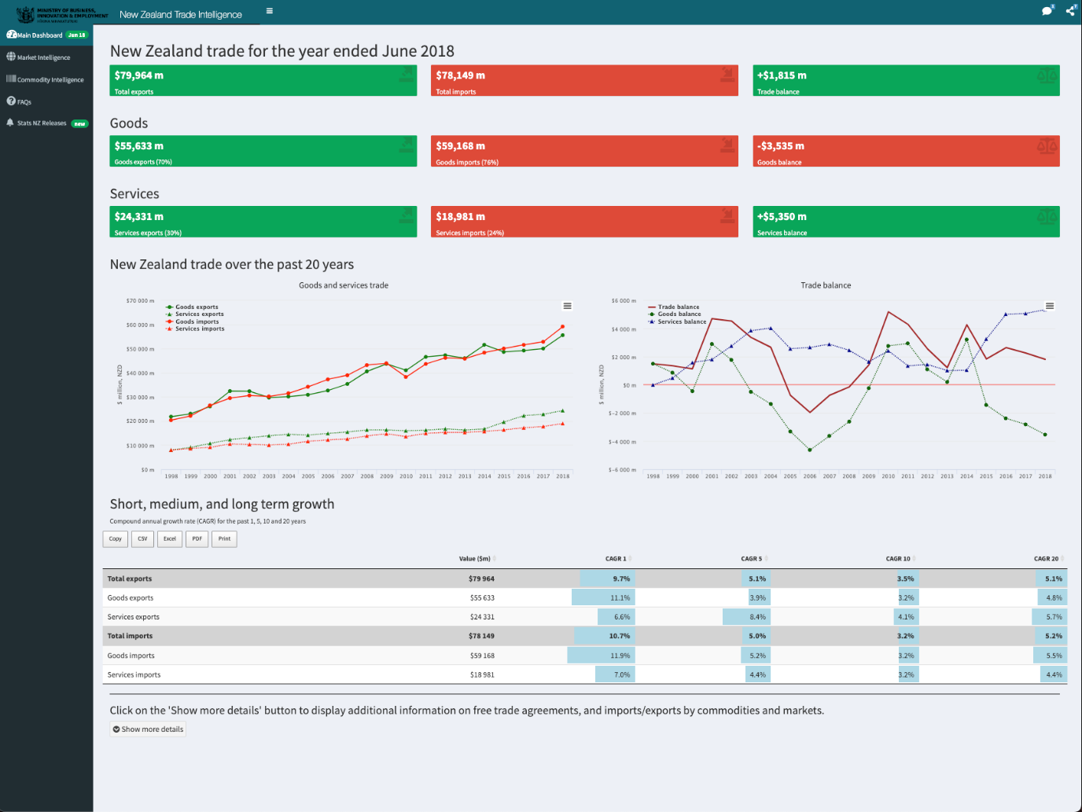
Figure 1-New Zealand Government Dashboard
Features:
- Ability to generate, export and download the data reports in various formats such as CSV, PDF, and Excel,
- View trade relations and data based on markets and regions selected by a user.
Pros:
- Free
- Simple to acess reports and trade data
- Ability to filter based on relevance and regions.
Cons:
- User interface is cluttered and difficult to navigate
- Lack of user interactivity

3.2.2 CBA Tool Dashboard - Berkely Centre of Built Environment

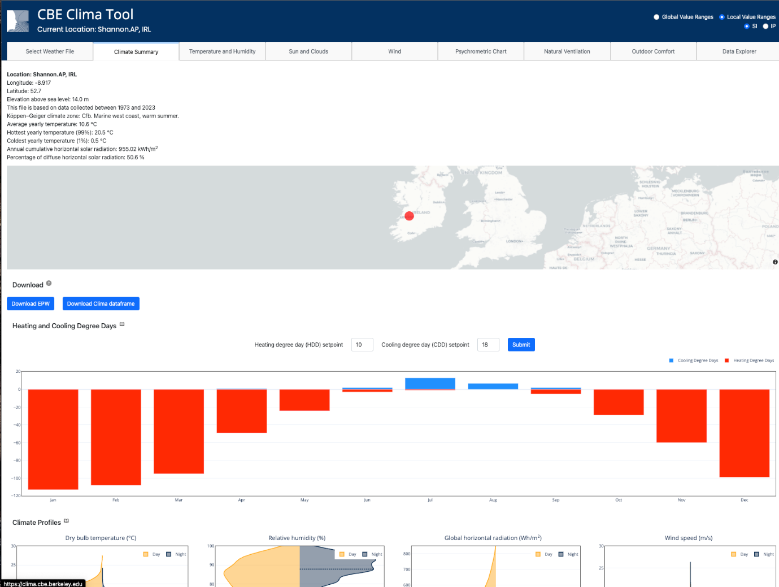
Figure 2-CBA Tool Dashboard-Berkely Centre of Built Environment
Features:
- Ability to select and view climate data globally and filter based on weather type
- Able to export data for selected region

Pros:
- Good visualization of climate data with acess to data points globally
- Has variations in data displayed based on region selection and climate type

Cons:
- User interface is cluttered with charts that are not well organised and layed out.

3.2.3 Berkley Materials Project
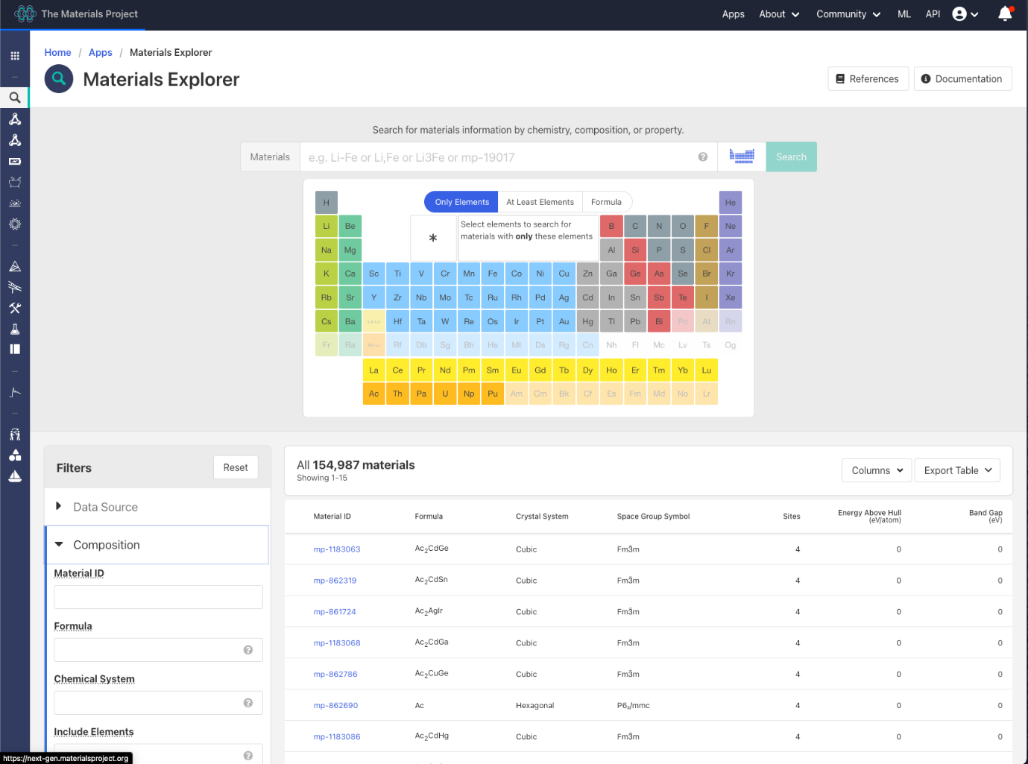
Figure 3-Berkley Materials Project
Features:
- Ability to search various scientific elements and materials by properties, structure, and composition.
- Users interactivity with periodic table allowing user to filter by element.

Pros:
- Dashboard interface is easy to navigate and not cluttered for the user to use.
- Ability to generate reports and charts based on user selection.

Cons:
- Requires previous knowledge of a STEM field to use

3.3 Requirements
Based comparison of existing dashboards and literature review of the topic, a list of requirements for the project were created. They are sorted into four categories of requirements such user, functional, and non functional requirements.

3.3.1 Personas
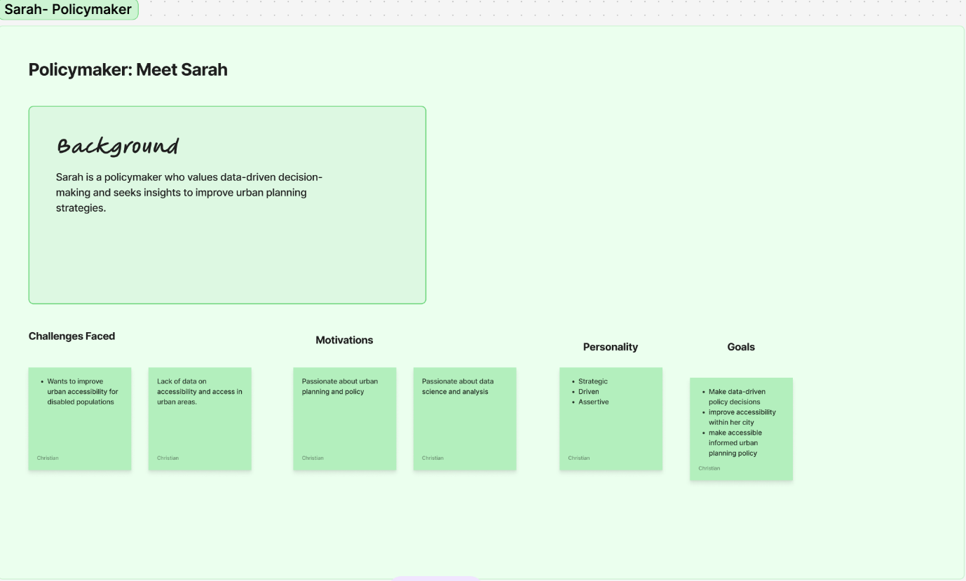
Figure 4-Sarah Persona-Policymaker
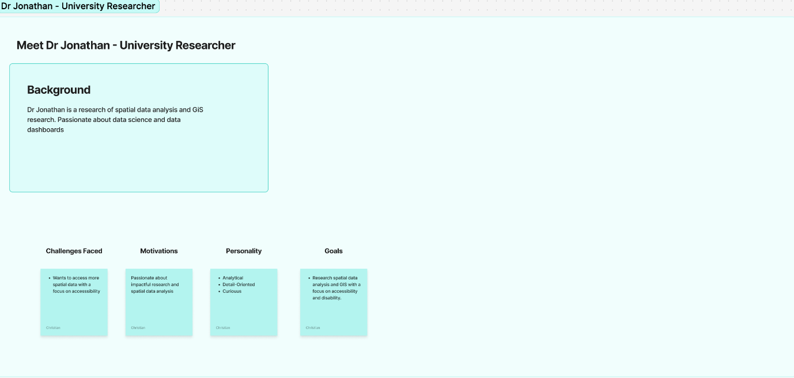
Figure 5-Jonathan -Reseacher Persona

3.3.2 User Requirements
User requirements are used to determine how the user interacts with a program like the actions they can complete.
The dashboard should be able to:

- Let the user move across the map and view the data displayed
- Enable user to filter by urban region
- View data by gender or health status
- Select various map layers and turn on/off as desired.
- Filter data on a nightlight table to view disability status by region.

3.3.3 Functional Requirements
Functional requirements are segments or features the program must offer to a user. They are created in a list of highest priority to lowest. These requirements were developed using research gathered from the literature review and comparison of existing applications.
The program should :
- Load and read spatial files alongside data files in csv or excel format.
- Should do spatial join between a data file and spatial file
- The spatial join should render a range of polygons with color representing the data that has been joined
- The map should plot along the republic Ireland across points of longitude and latitude.
- The program should allow map layers displaying essential services such as GP's and Pharmacies.

3.3.4 Non Functional Requirements
The non functional requirements define how scalable and performative the program needs to be. The application would still run without these requirements but it would not be at it's full performance. These requirements differ from the functional and user requirements that outline behaviors and functionality expected.
The program should have a :
- User friendly interactive dashboard that is easy to navigate.
- Load the mapping data with ease and quickly.
- The dashboard should filter data displayed based region and gender/health status.
- The dashboard visualizes the trend of disability across Ireland.

Conclusion

Throughout this section, we examined existing dashboards and how they visualized data. Additionally, we analyzed the features they had, the pro/cons of the design and program. Furthermore, we defined how a user may interact with the program and their user needs. Also, we also specified how the program should function and the features that should be included within the program.

Design

Introduction

After completing the research and requirements, it was then able to move into the project's design phase. This section is divided into various parts such as system application design, user interface design etc. This chapter's goal is to develop the designs necessary for the project established in the requirements phase. The chapter will be broken down into two sections which will be system application design and user interface design

Program Design

4.2.1 Technologies
The technologies used to develop our interactive dashboard are Tableau Desktop, R Studio, Leaflet, mapview, dyphr and csodata Api. Data will also be sourced from the CSO website and mapping files from Geohive. Tableau Desktop will be used initially to develop the mvp dashboard and view the data pulled from CSO and GeoHive. Tableau is an interactive data visualization software created by Salesforce used to query, process, and visualize substantial amounts of data. The software includes features such as mapping capabilities, data calculations and various chart formats.

4.2.2 R Technologies
Developing the application using the R language requires the usage of various R packages listed in the previous section. These packages range from sf or open xlsx for reading our data to ggplot and mapview/leaflet for plotting our data. The sf package incorporates functions and features to read spatial data from spatial files. The files are plotted either in shapes of polygons or points or lines of latitude and longitude. The openxlsx pacakge renders and processes numerical data into our R code to be plotted. The spatial data plotting uses mapview or leaflet with both having functionality to visualise our data. These plotting packages visualize our data in diverse ways. Mapview abstracts the plotting functionality of our data in comparison to leaflet. The mapview package creates our maps with one simple r function with ease in comparison to leaflet. The leaflet package requires individual functions for each functionality you implement.

4.2.3 Mapping and Chart Design
Data charts are basic of how we visualize the data we collect and surround us. Charts can range from pie charts, bar charts, line graphs, table charts etc. The choice of charts depends and ranges on the data being displayed such as financial data or level of disability by area ( see figure). As shown, the table chart visualizes the population amount with a level of disability by small area. Furthermore, the data can be filtered based on the specific urban region selected such as Galway.

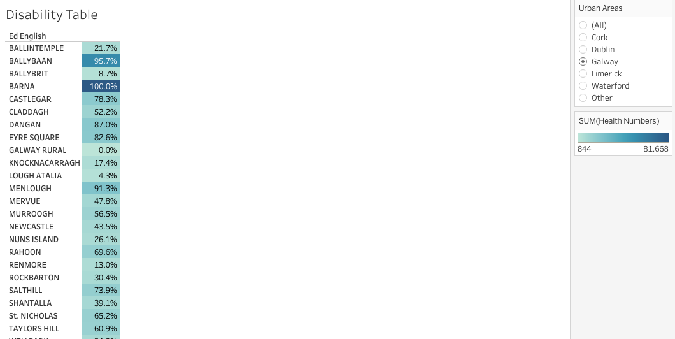
Figure 6-Disability Dashboard in Tableau
Also, mapping data is another method we can use and view data in our environment. Mapping visualization can manifest in shapes of polygons, lines, and points. In addition, these visualizations can form heatmaps, choropleths maps, flow maps etc. As per (figure), a choropleth map was chosen to better represent the range of disability in a city such as Cork. Furthermore, points data and polygons form the foundation of the data visualization within the spatial data. In addition, we can filter and map layers to add interactivity for the user.
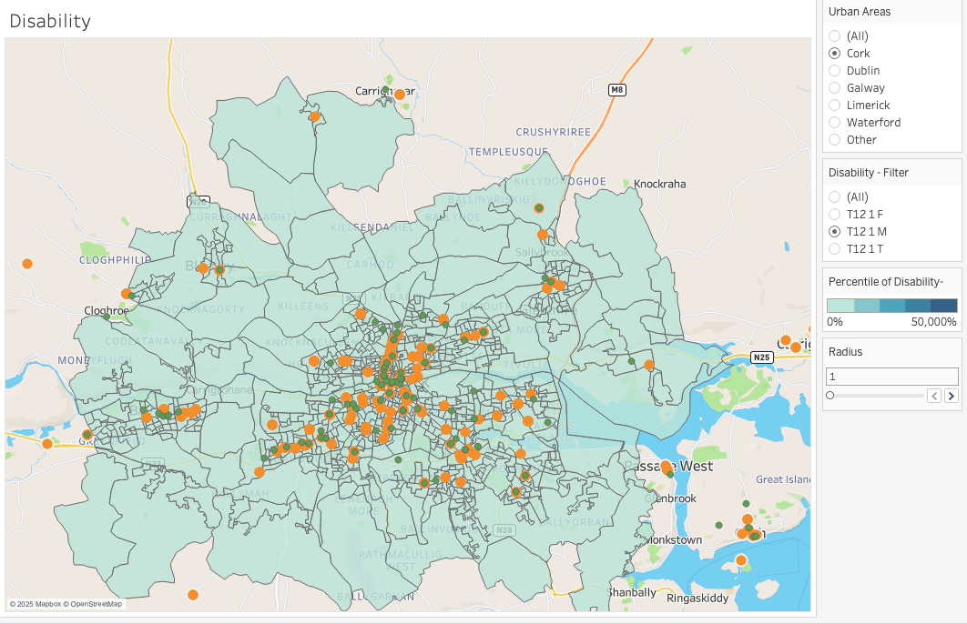
Figure 7-Tableau Spatial map of cork with filters

4.3 User Interface Design
After competition of the system application design, the user interface is the next stage of the design process. Throughout this section, the overall dashboard design will be designed from a wireframe to a final low fidelity design based off user requirements and existing dashboards.

4.3.1 Wireframes
The first task of the user interface design phase was to create a wireframe to represent how the program should appear. The top bar of the dashboard contains the basic navigation for the user interface. The main section contains the data visualization charts such as the map and the highlight table to display the plotting data and disability/health data. In addition, beside the main section is the filters and dropdown for data manipulation and navigation between our datasets.
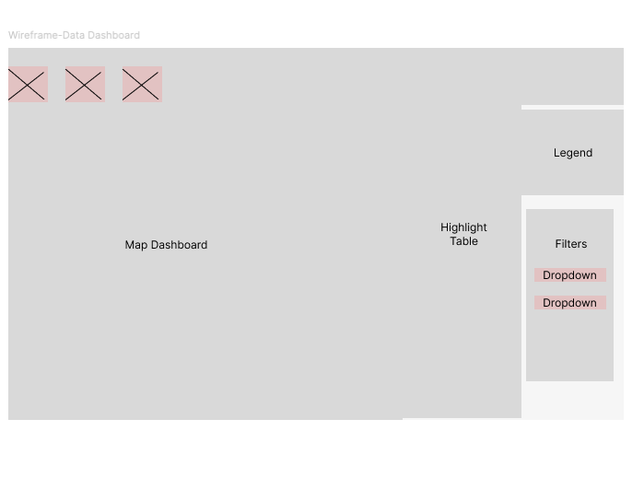
Figure 8- Dashboard-Wireframe
In the second iteration of the UI design, more detail was added to the dashboards, and a slider was added to the filter section. The top bar now contains buttons to navigate to various data worksheets for the user to view. The main sections now contain the map chart and highlight table to visualize the level of disability/health. On the right-hand side of the dashboard contains our various filters dropdowns and slider buttons for interactivity for the user. 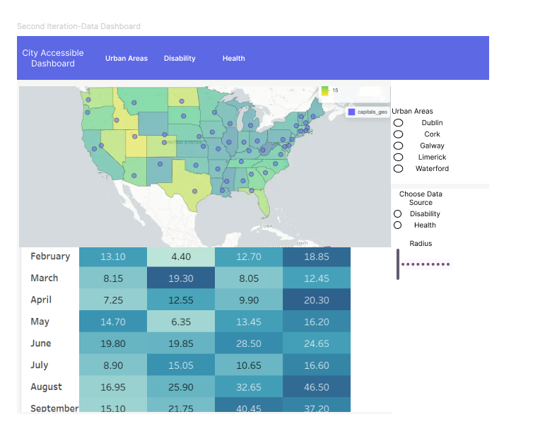
Figure 9-Dashboard Design

4.4 Conclusion
The design of the systems and user interface provides a clear picture of how the program should be developed, designed, and implemented. The technologies and mapping design demonstrate how the dashboards function to provide an accurate visualization.
Additionally, the section also considered the overall user interface of the program. The wireframes and system design dictated the interactivity and layout of the program for the overall user experience.

Implementation

5.1 Introduction

The next stage in the process was to start implementing the program. This involved processing, loading, and visualizing the data on a dashboard through Tableau Desktop and R Studio. The first initial steps involved processing the data to conduct a spatial join to allow a spatial visualization. Then secondly, rendering the data in shapes of polygons on points of latitude and longitude. Subsequently, various mapping layers were generated with legends and filters to provide context and interactivity for the user.

Sprint 1- Learning about Spatial Mapping, Data Collection and Sourcing of Files

Goal- Learning about Spatial Mapping and sourcing our data from public databases.
The goal for the sprint was to research the language of spatial analylsis and source our data files from various public databases such as the CSO and GeoHIve.

-Learning about spatial mapping and language
As we learned in our research section, spatial mapping can be referred to " observations are often associated with spatial lines, areas, or grid cells, spatial distances between observations" as stated in the R spatial book (Pebesma & Bivand, 2023). Throughout this sprint, I aimed to further understand the language of spatial data analysis and how R language can be utilized to visualize spatial data. The sprint started by reading an eBook called "The Language of spatial analysis" by ERSI, a gis software company. The eBook started with an introduction to spatial analysis and how we define spatial data.Later, it discussed the language of spatial analysis and it's six categories. The book lists the categories as understanding where, measuring size, shape, determine place relation, detecting patterns and so forth. These categories can be analyzed using points, polygons, spatial joins, line distances and lines of latitude or longitude etc.
A book by Edzer J. Pebesma " Spatial Data Science: With Applications in R " discusses how R can be applied to spatial data analysis. Within the R language, concepts such maps, projections, vectors etc. form the basis of spatial data analysis. Additionally, the sf package is also used to read and write geometries from various data sources. Furthermore, the st_join function is used to plot spatial data onto map alongside packages such as leaflet and mapview which we will discuss in further sprints.

- Sourcing our data and shape files from public databases.
The second half of the sprint started with the required data files needed to plot our disability and health data to our maps. We first started by sorting the CSO databases to find data on disability and health status across Ireland. The CSO has data and statistics gathered from various government departments and agencies as well as the Census. The main data files we pulled were Persons with a disability and current health status of of respondents. Additionally, we also sorted through Geohive which is a governmental database of geospatial data. The main shp files we sourced were polygons of various regions across Ireland and points of essential services such as gp's and hospitals.
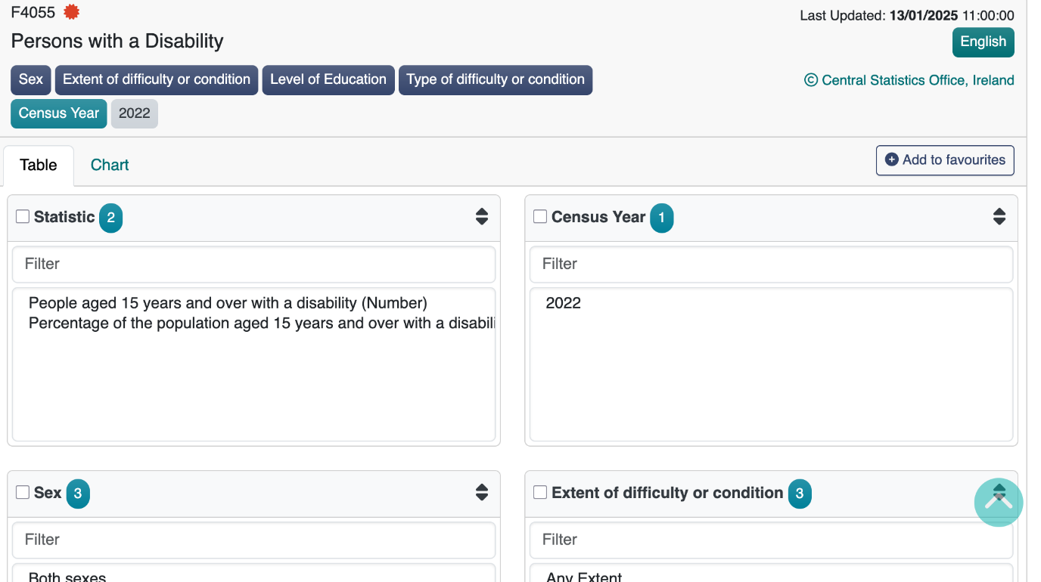
Figure 10-CSO Databases File
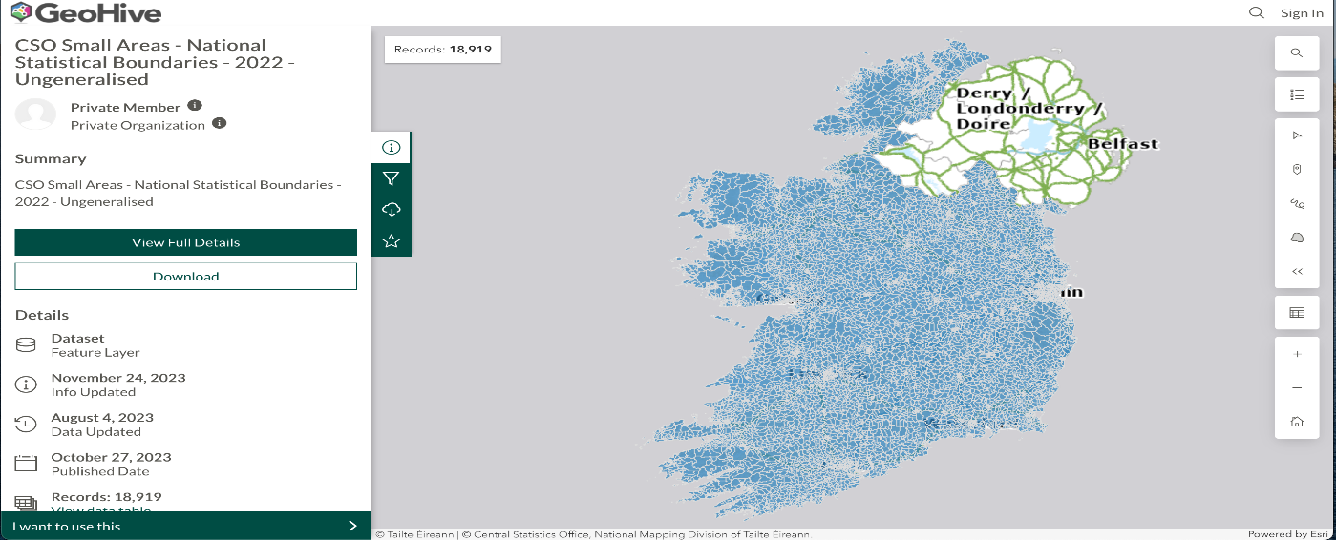
Figure 11-Geohive Spatial Map

Sprint 2

5.2.1 Goal - Processing and Loading, visualising Data in Tableau

Importing the Data and processing the files for visulisation and plotting.
Tableau Desktop software allows quick for data visualization with minimal setup required. The spatial and data files were sourced from CSO and Geohive database to imported into the software. Following this, spatial joins were completed using calculations using the calculated field features. Alongside this, data was cleaned and processed into a pivot table for improved analysis and data filtering.
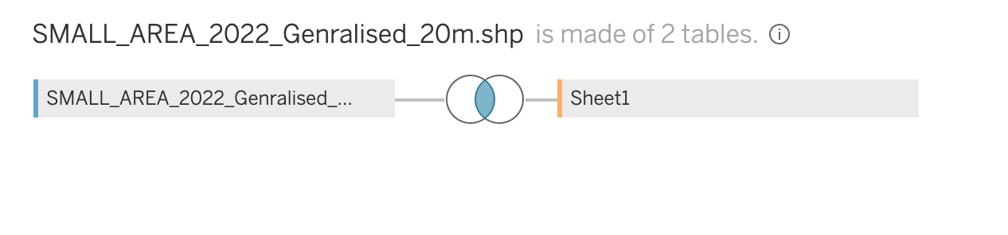
Figure 12-Tableau Spatial Join
As we can see from the figure above (insert figure), the small areas shape file has been joined with an excel data file. The type of join that is shown is an inner join which combines two data souces using a common field. After this, we processed the data into a pivot table as discussed above (see figure).
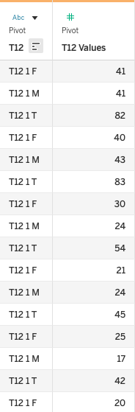
Figure 13-Pivot table of data in long format

Visualise and plot the joined data on a tableau worksheet

Following the data processing and loading of the various files, the data was then plotted on a tableau worksheet along lines of latitude and longitude (see figure). The data would be visualised in shapes of polygons with a colour range representing the data. Alongside the plotted data are various filters that change the data based on gender and region.
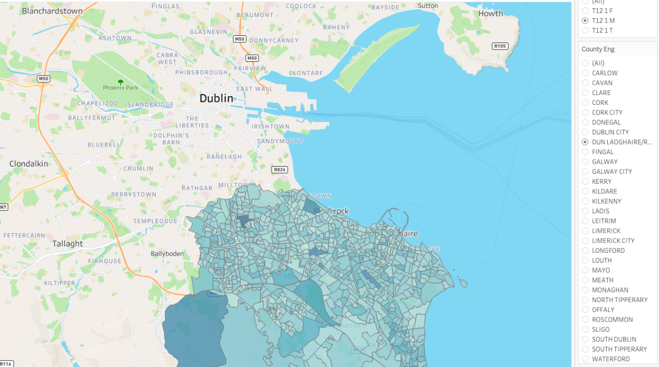
Figure 14-Polgyon Layers of Southeast Dublin

Sprint 2 - Adding layers and filters

Goal - Essential services plotted and interactive filters
The goal for this sprint is to implement the essential services map plots as spatial data layers. Additionally, filters for the map layers are needed to be implemented for interactivity and data visualization.

. Implement spatial data layers
The sprint started with retrieving the relevant files from the geohive website to import them into tableau for a spatial join. Next, the essential services spatial file is joined up with the small areas data from sprint 2. Subsequently, the file is plotted onto the visualisation in a series of points layered onto the polygon shapes.
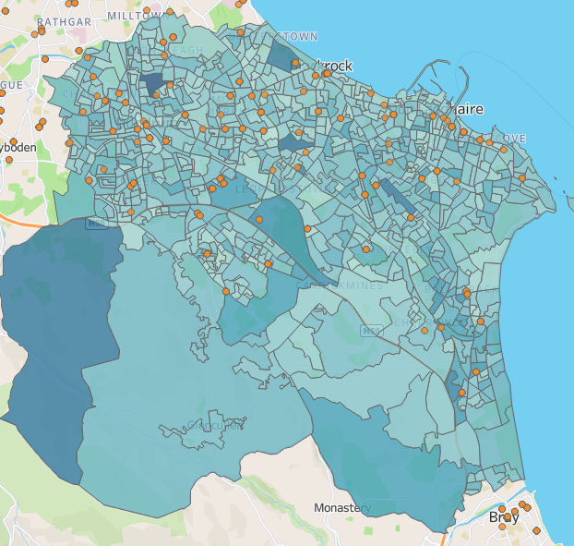
Figure 15-Layers of Polygons and Spatial Points of SE Dublin

Adding filters to the visualization of data and points/lines

Succeeding adding additional mapping layers, data filters were added to better visualise the data being displayed. The filters created focused on the visualised data by gender and urban region. As a result, the user can manipulate and dynamic filter the data visualisation on the dashboard.
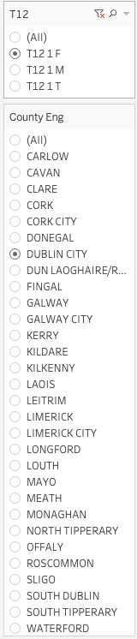
Figure 16-Spatial Filter for Gender and Location

Sprint 4

Goal - Adding Buffers and Line Distances
The next steps and main goal in sprint 4 were to implement spatial functions such as buffers, line distances and custom parameters. The aim was to visualise the relational distances between essential services and access to those with disabilities in urban regions.

Calculated fields and buffer function
The sprint started with creating the calcuations to map the distances and radius between points or lines on the visualisation. The calculations extracted the spatial data from the spatial file to plot the necessary points. Next, distance calculations were conducted to find the length between the different points. This calculation charts the intersection points among essential services on the map. Subsequently, the buffer spatial function was made to visualise the intersection points amid the plotted essential services. Following this, a line distance plot was made to visualise the length between the buffers and their intersections. Lastly, a custom parameter was made to add interactivity for the user to allow them to control the size of the buffers.

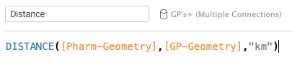
Figure 17-Distance Calculation to view the distance between points

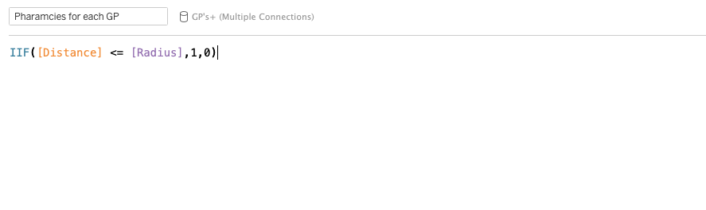
Figure 18-Calculation to find the intersect point for buffers

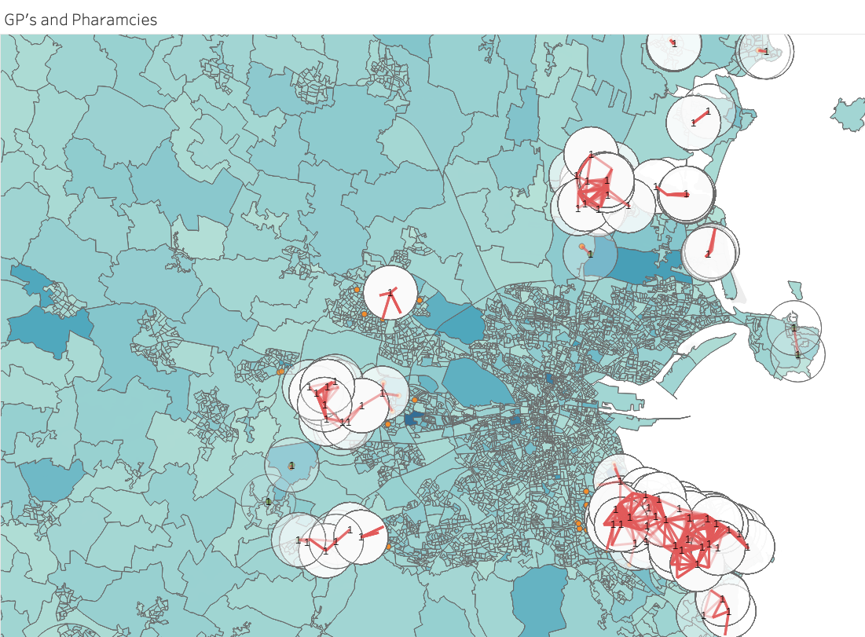
Figure 19-Map of Dublin with Polygons and Line Buffers
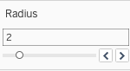
Figure 20-Buffer Radius filter to adjust buffer size

Sprint 5

Goal - Loading and processing the data in R Studio using packages such as sf and openxlsx to generate spatial plot in mapview
The goal of this sprint was to implement the mapping data visualisation in R like Tableau in previous sprints. This would enable deeper levels of interactivity and visualisation for the end user.

Loading and processing the data files into R
The sprint started with installing the necessary packages into R studio to load our files. The packages we used were our sf which reads spatial files and readxlsx which reads excel files. Following this, we imported the data using the included functions from the downloaded packages.

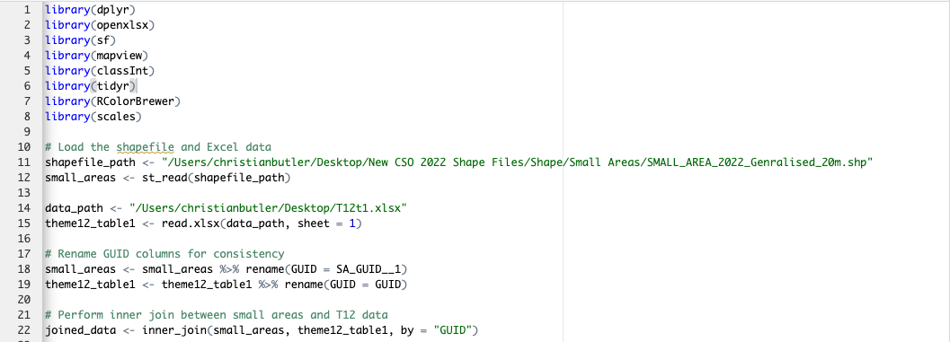
Figure 21-Loading Libraries and inital data

The first eight lines consists of importing the required libraries for data processing and visualisations. In this sprint, the libraires that would be used are dplyr, mapview and the ones mentioned above. The following code loaded the shape files as a variable to render the data. The excel files were imported and processed similarily. Following this, both files GUID column was renmamed to maintain consistency and reduce errors when performing the inner join. The two files were joined using the sf package inner join function. The joined data was then rendered and logged in the console.
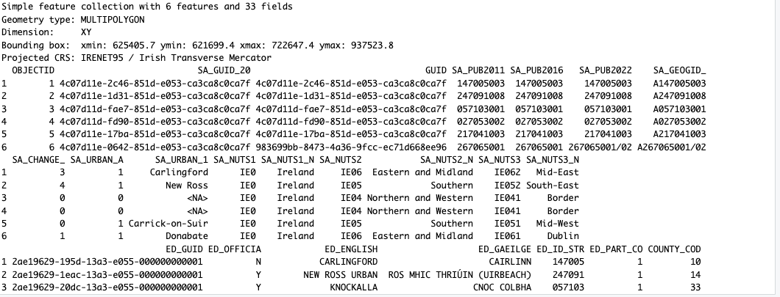
Figure 22-Console Spatial output of our data

Plotting and visualising our data
The following lines logged the outpot of the joined data as seen in the previous item. Following this, mapview package was used to plot our data in shapes of polgyons with colours broken into ranges. The color breaks represent the level of disability in different areas across Ireland. Additionally, mapview has built in functionality for viewing different map types and filtering mapping layers.

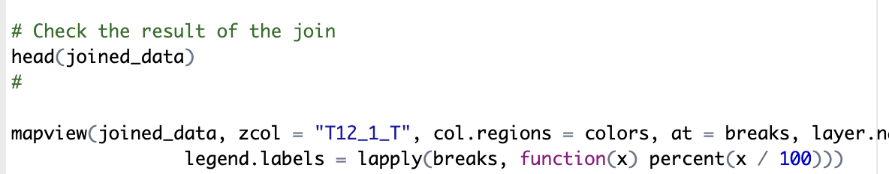
Figure 23-Mapview Function to generate our chloropleth map in R with polygons
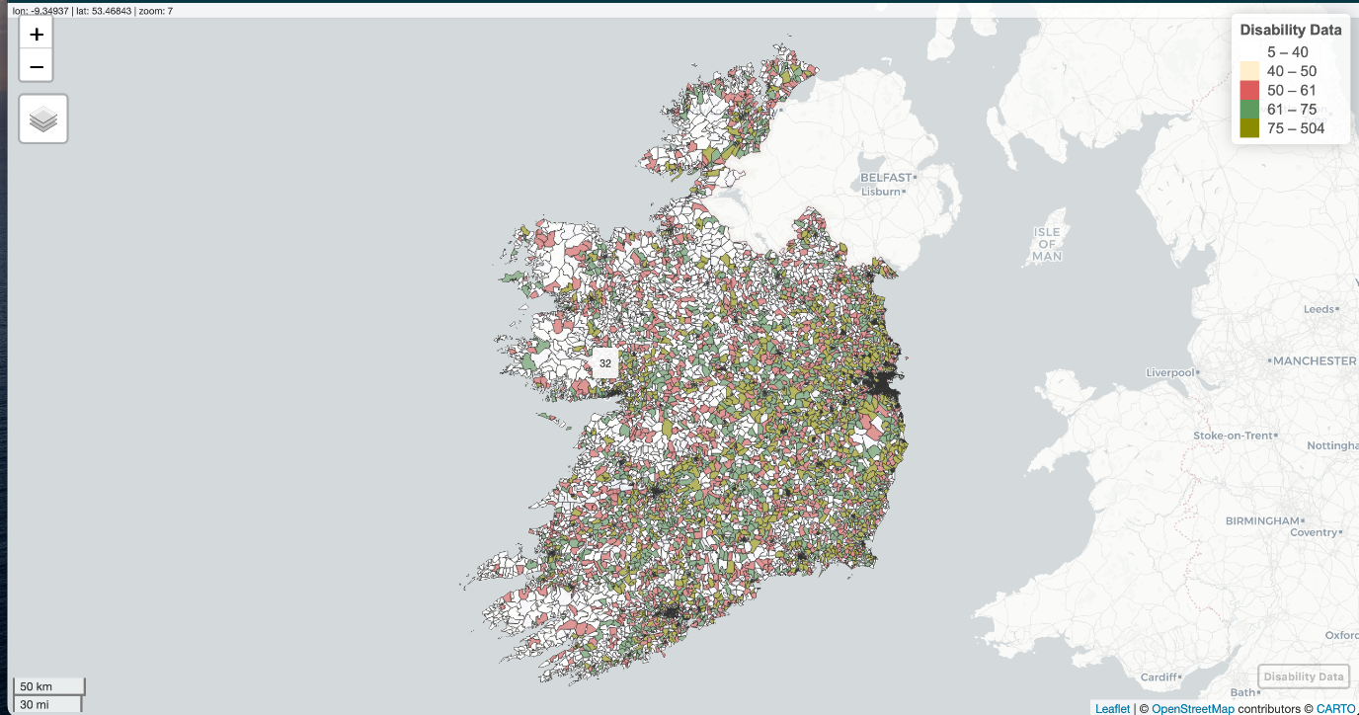
Figure 24-Generated Mapview Sketch
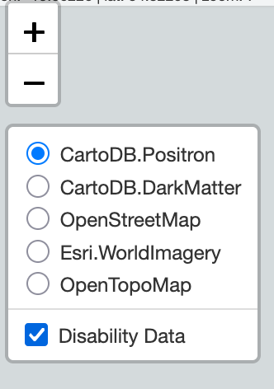
Figure 25-Map type filters

Adding Essential services shape files
Following the visualising of our data and areas, adding our essential service was the next step of the process. The gp and pharamcies shp files were loaded similarily to our small areas file was processed into our R script. The visualisation of these files onto our joined data required cleaning and standarising of our geometries. Subsequently, both files were interjoined with our joined data. Once our additional shp files were processed and joined, a buffer was created to demostrate the distance between the different points on the map. In the following lines, additional color breaks are added to the plot and popup text is also added. Also, additonal mapview functions are added to plot the gp and pharamcy points.

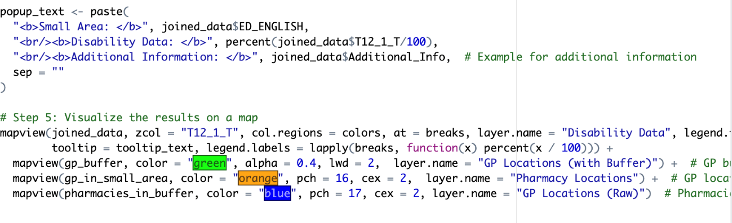
Figure 26-Adding a modal to our polygons to give context for the user
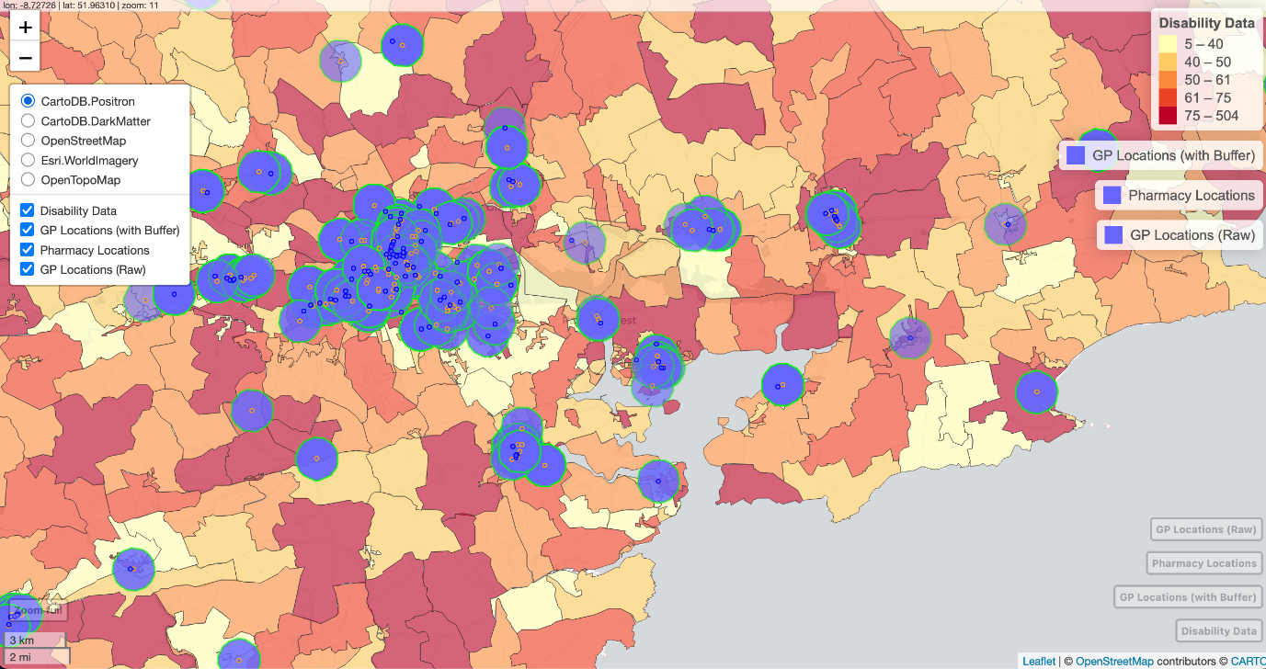
Figure 27-GP and Pharamcy services with buffers

Sprint 6

Goal - Loading and Processing Health Data into a mapview plot
The goal for sprint 5 was like the previous sprint, however we wanted to implement and visualise our health data instead. The same degree of interacvity and visualisation would be present.

Adding our health data and plotting in mapview package
The first item completed during sprint 5 was to load and process our health data files to visualised and cleaned. We started with loading our small areas shp file and excel file as before using the sf and openxlsx package.
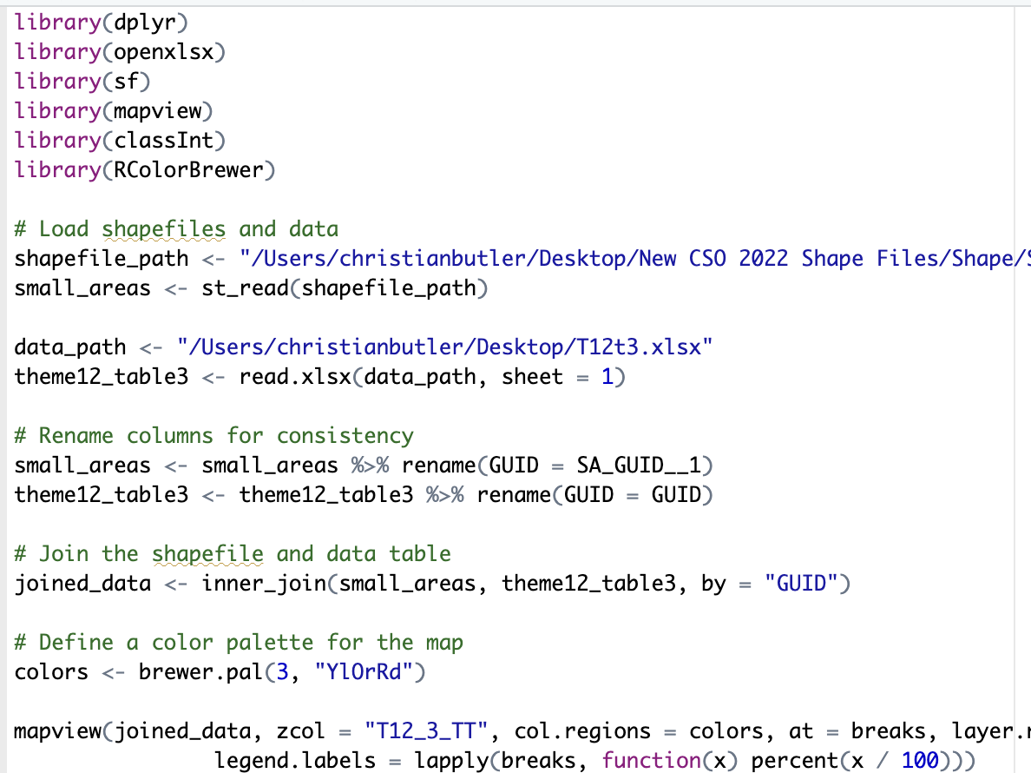
Figure 28-Adding Health Data map in mapview

Plotting the Health Data
The first 5 lines loaded and processed data as variables using the packages we discussed.Following this, we renamed the guid columns in both files to ensure consistency and reduce conflicts in the data. After this was completed, we joined files to be plotted using the sf package. Again, the color breaks represent the range of health level in our plot alongside the layer selection functionality discussed in the previous sprint.

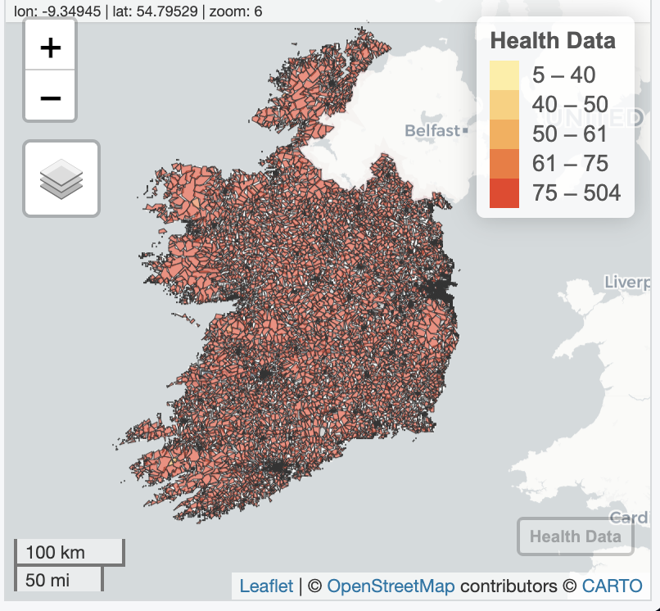
Figure 29-Health Data chloropleth map with polygons

Adding Health Services Points
Subsequently, the hospital and health centre shp files we needed were added and processed as per the previous sprint.The geometries of both files were cleaned and standardized as per the previous sprint before being joined with the health data. Furthermore, a buffer was created around health centre locations to mark the distance and intersection points between our health shp files. In addition to the buffers, we added our colour break points and additional mapview plot functions to map our additional shp files.
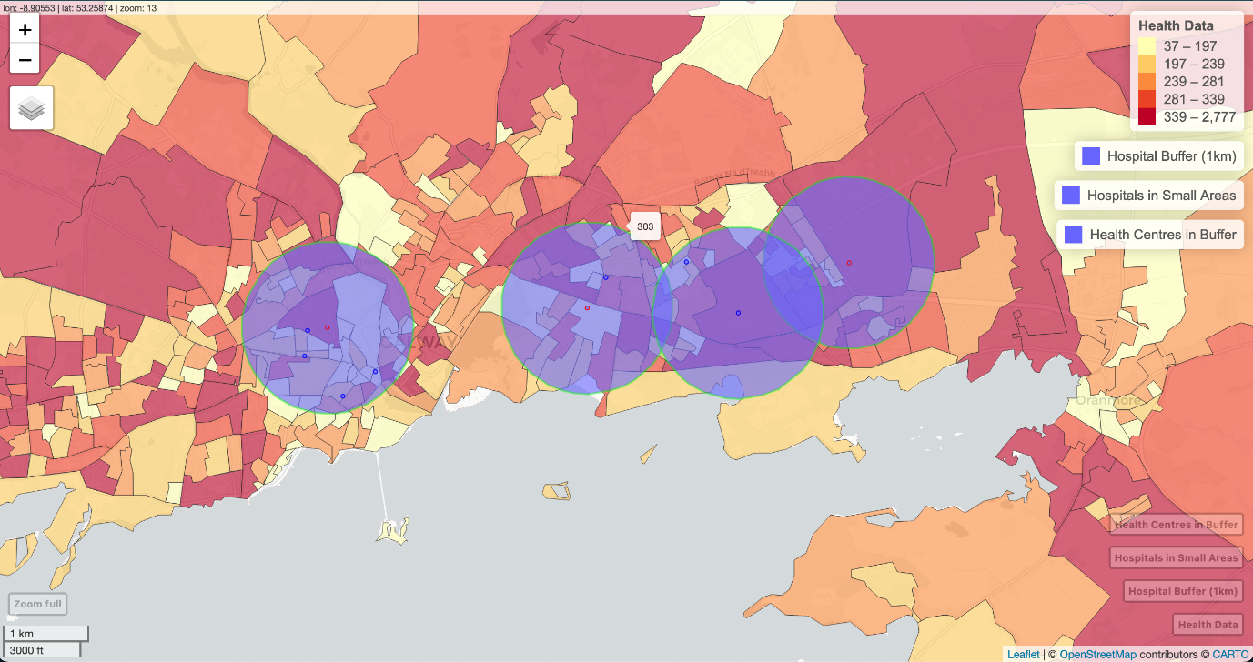
Figure 30-Hospitals and Health Centres

Sprint 7

Goal- Adding Flex Dashboard with leaflet and ggplot
The main goal for the sprint was to create a dashboard that a user could interact with and visualise the datasets from our code. The dashboard would contain maps for the data and charts for visualising the number of services by small area. Additionally, we rewrote our disability code to render with leaflet. Previously, we used mapview to visualise our data with a simple function, however we encountered errors when running the script in flex dashboard. Upon further investigation, we found that this was due to incompatibility with the required dependencies such as htmlwidgets for flex dashboard to run. Mapview plots spatial data using one simple function with additional parameters for spatial mapping such as label, map types, legend and so forth. Leaflet in comparison requires multiple functions to render spatial data such as addPolygons, addLabels, addLegened and so forth.

Refactoring Disability script to run with leaflet
The first item of the sprint was to load and process our data like how it was processed in mapview. The data was loaded,processed and logged as before in the other sprints however errors had arisen with joining the data. The console outputs a degenerate and invalid geomerty errors. As a result, the data files required standardisation for the data to be joined. The below code example demonstrates a helper function ensure no inconsistencies with the coordinates in our data
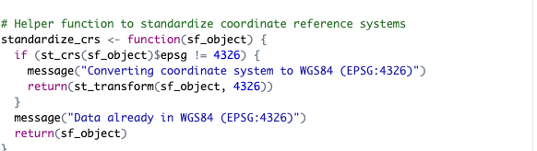
Figure 31-Standarised and simplified our geometries for leaflet package.
Following the helper function, we continued loading in our data into our script checking for errors and invalid geometries. Additionally, a simplified function from the sf package to streamline the processing of small area and disability data file. Once, we standarised and simplified our geometries, an inner join of the two files was completed with its output logged in the console.
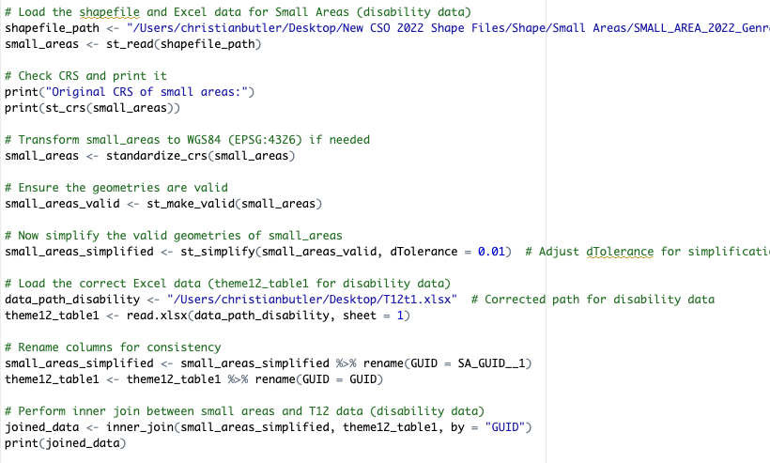
Figure 32-Loading our small areas and disability data file.

Disability Essential Services Point
Similarly, we load the gp and pharamcies shp file into our leaflet script to plot our points onto the joined data polygons. The loaded shp files were standardised as per small area code with sf package functions. Following the shp files being streamlined, we joined the shp files with our joined data.
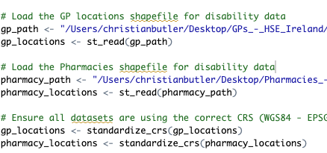
Figure 33-Loading and processing our gp and pharmacy files.

Color Range Breaks and Leaflet Plotting
After we joined our disability services shp files, we started to create our color breaks for our plot to illustrate the range of disability within small areas.The breaks were split into numeric intervals of five using the classInterval package.Following the defining of our colour breaks, we set our colour palette and our map type. Additionally, we added our polygon shapes for our joined data alongside our points for the essential services as circle markers.Also, we added a reference legend for our joined data and essential services.
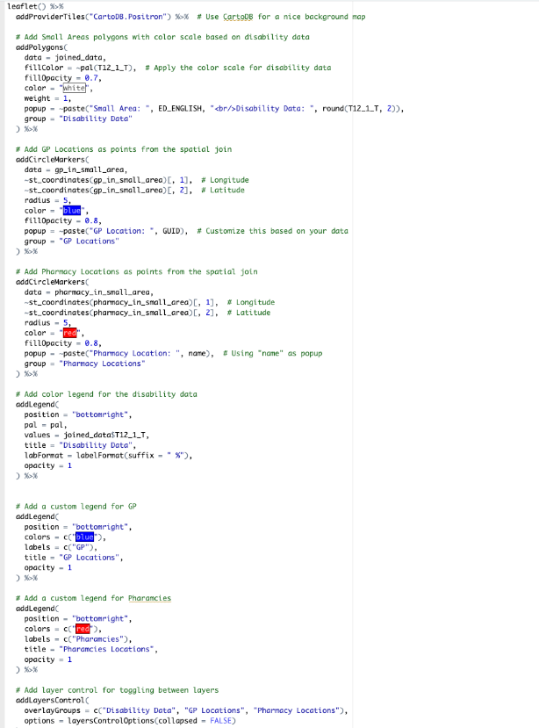
Figure 34-Adding our Leaflet map functionality

Running Flex Dashboard
After creating the leaflet map script, we started constructing the dashboard for better visualisation of our data. Flex Dashboard utilises r markdown to render the r scripts into a dashboard with various customisable chart styles.We first started with defining the layout we needed for our maps and charts using flex dashboard functions. After defining the UI layout of our dashboards, we loaded the necessary libraries for our charts and data to be displayed. Following this, we displayed the disability data map and charts on the first page of the dashboard.
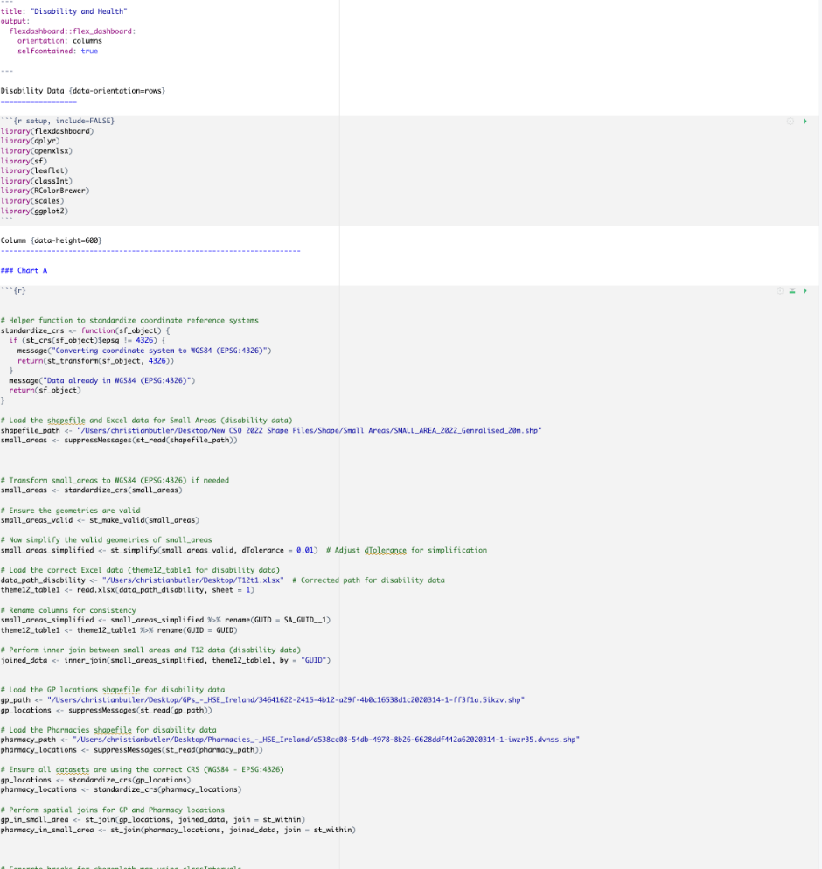
Figure 35-Flex Dashboard Functionality

Sprint 8

Goal - Adding the health data to the dashboard and refactoring to work with leaflet.
The goal for this sprint was similarily to sprint 6 was to add the health data to the dashboards with all relevant charts and maps.This would bring deep visualisation and interactivity for the user.

Adding and processing the health data to the dashboard
The sprint started with refactoring our health data code to run with leaflet mapping package. We started the refactoring with adding a helper function to standarise the geomerty coordinates from the irish system to the international coordinate system. Following this we added and processed our small areas and health excel file to be read and standarised. This was done using the sf and openxlsx packages.After this, we checked and simplified the geometries in the loaded files to joined as per previous sprints. Prior to the prepartion of the join, we renamed the GUID columns for consistency to prevent errors when intersecting our data.
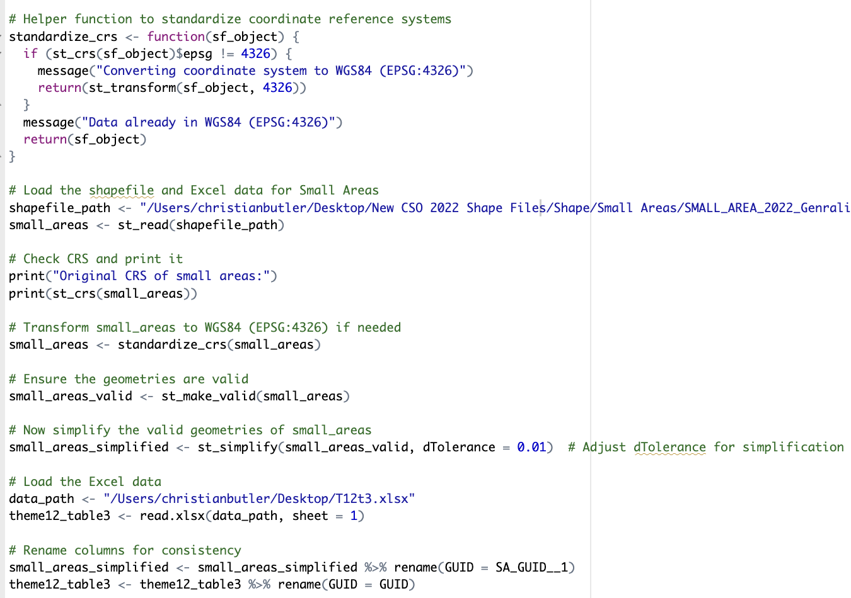
Figure 36-Simplifying and Standarising our Geometry coordinates

Health Essential Services

Following the join of our data, we began to load our hosptial and health centre into our code. We started with reading and standarising our data using the simplify and read functions built into the sf package in R studio. After this was completed, the shp files were joined with our health data in our small areas to be plotted as points.
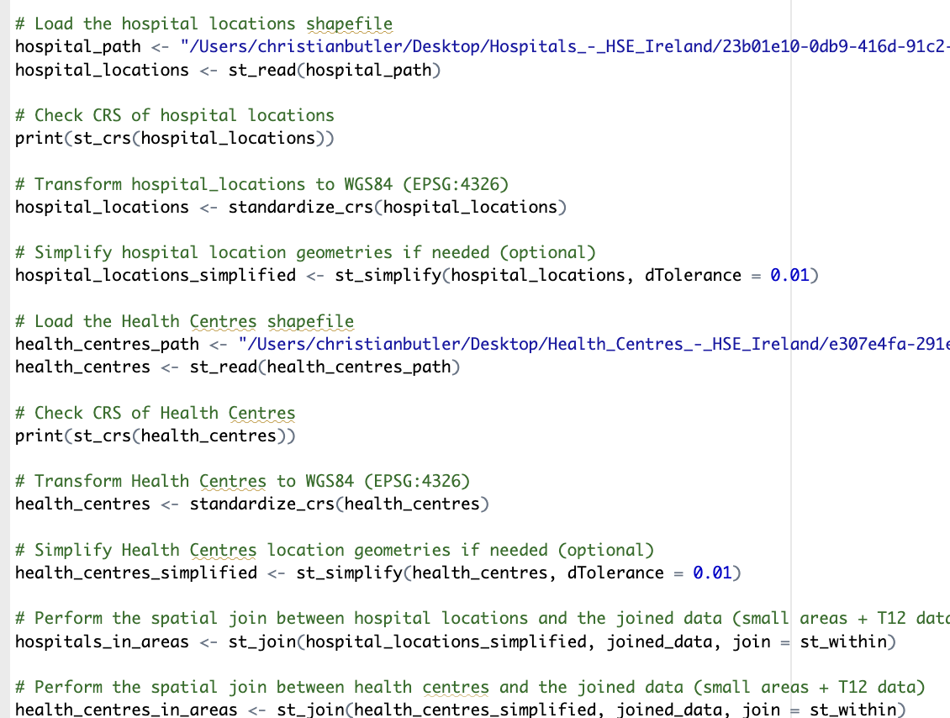
Figure 37-Loading, processing, and spatial join of our health data shape files

Color Breaks and Leaflet
Following the join of all our necessary files and standarisation, we started to add color palettes and breaks for our map. This was necessary to illustrate the range of health levels within certain regions across Ireland. This was completed using classInterval and Rcolorbrewer package with range based on joined data. Subsequently, we began to create our leaflet plot starting with our map type and polygons.The addProviderTiles and addPolygons functionaility in leaflet allows us to add various map types and polygon shapes with custom styling. After creating the polygons, we added the addCircleMarkers for our essential services alongside our addLegend functions for differentiation of the various data sources. Finally, layer control was created to allow the user to toggle between the different data sources.
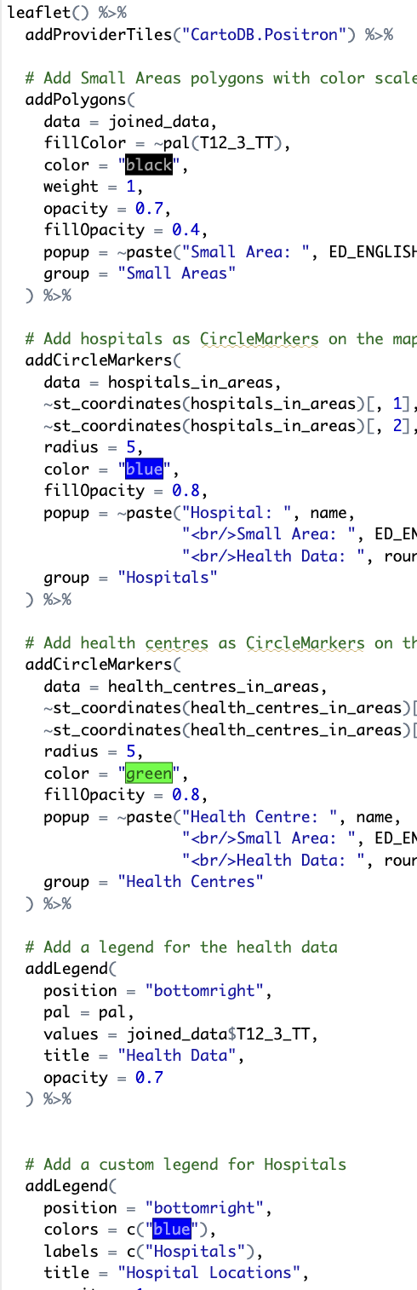
Figure 38- Generating our Health Data leaflet map

Adding to Flex Dashboard
After the leaflet plotting and color breaks were added, we began to implement the health data into the second page of our flex dashboard. We started with loading our necessary data as per the previous items alongside the libaries required for the map to render. Subsequently, the map with its data sources was displayed on the second page of our dashboard.
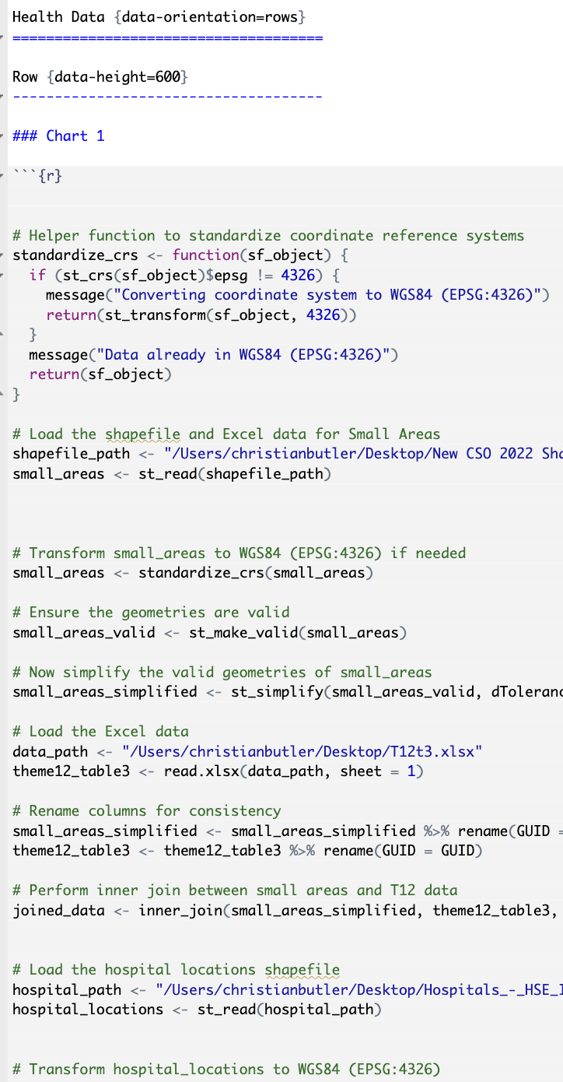
Figure 39-Standarising our geometeries in flex dashboard

Sprint 9

Goal - Adding Disability data charts to our disability dashboard page
The primary goal for this sprint was to add bar charts for our gp's and pharamcies data sources to illustrate the number of essential services per small area across Ireland.

Creating the GP Plot using ggplot 2 r package
The sprint started with loading the required libaries needed to create a chart to visualise the amount of gps per small area. These included dplyr, openxlsx, sf and ggplot2. The script started with a helper function to standarise crs coordinates like previous sprints alongside a simplifer function to ensure no invalid geometries. The small areas shp file is then loaded and checked for issues with its geometries. After this, the gp shp files were loaded and processed similarly to the joined data. The gp shp file was then interjoined with the joined data. Following the joins of our data, we calculated the amount of gps that were in each small area in the count function. Subsequently, we used ggplot2 built in functions to plot our count calculations with small areas on the x axis and gp count on the y axis.
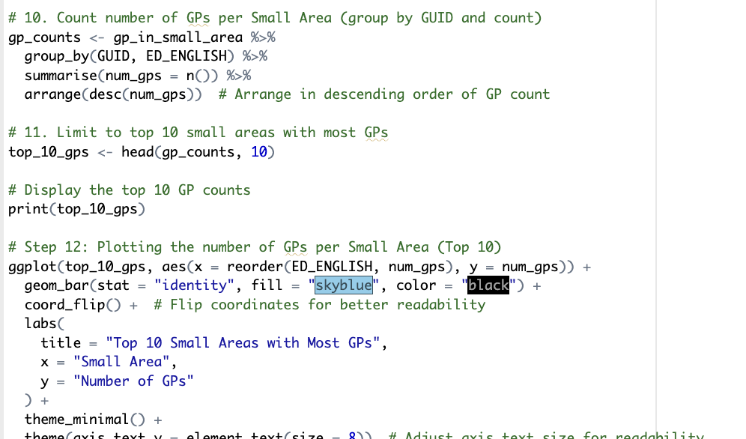
Figure 40-Creating bar charts for our gp shp files

Creating the Pharamcies Plot
Simarily to the gp's, we created a plot to visualise the amount of pharamcies per small area using the packages we discussed previously. Firstly, we created helper functions to standardise and simplify our geometries within our shp files. Following this, we loaded and processed our disability data. The excel file was loaded soon after which was joined with the small areas as a joined data variable. This was followed by the pharmacy shp being loaded into the r script to standardised and joined with the joined data variable. The amount of pharmacies per small area count function was then created to be used with ggplot 2 functions to visualise our data.
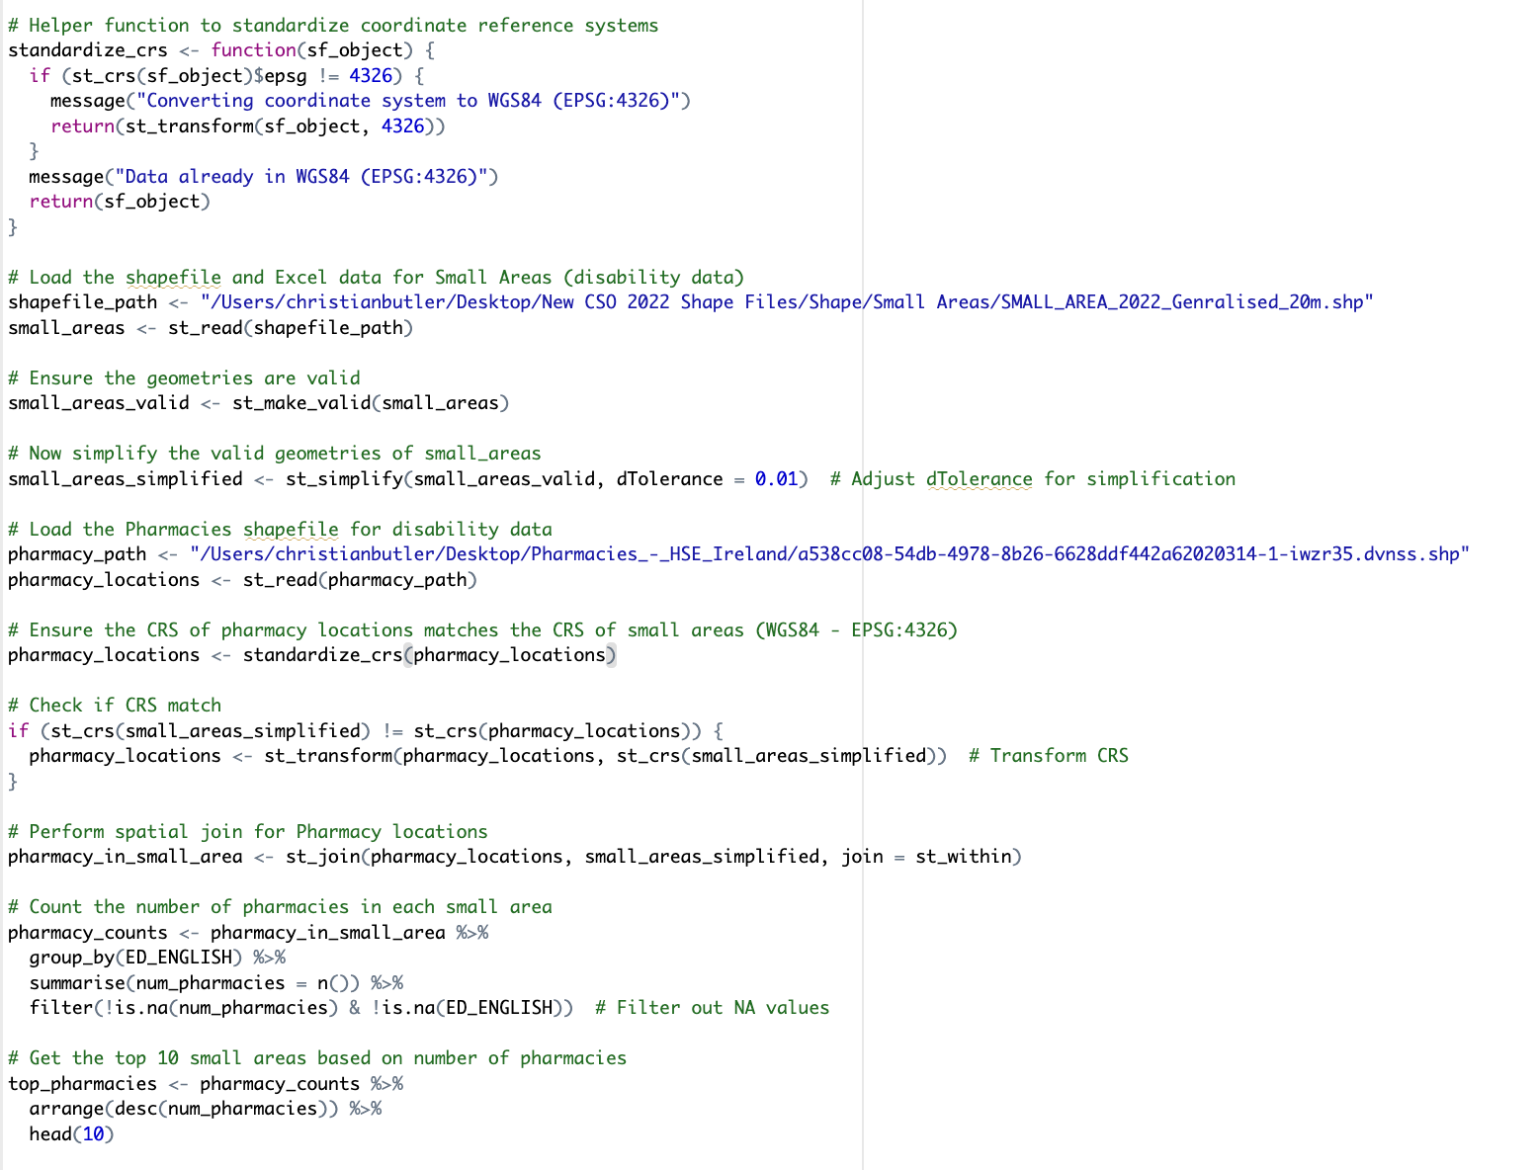
Figure 41-Creating our pharamcy barchart plot
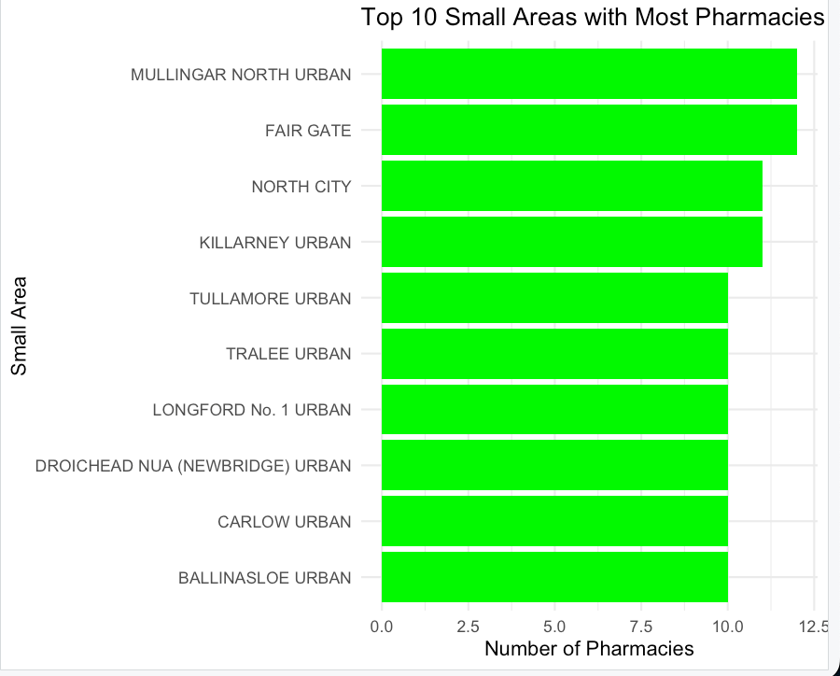
Figure 42-Pharamcy Barchart Plot

Sprint 10

Goal- Adding the Health Data charts to our health data dashboard
The goal for this print was to add health data charts to illustrate the amount of health essential services per small area like the disability charts.

Creating the Hospital Plot using ggplot2
The sprint started first with creating a plot to visualise the amount of hospitals per small area using our small area and hospital shp files.We started by creating our helper functions to standarise and simplify the geometries in our data.After this was completed, we loaded and processed our small areas data into our R script.Following this we checked for errors and invalid geometries in the data files. Additionally, we loaded the health data excel file alongside the small areas file to be joined together for the plot. Following this, we loaded the hospital shp file after the small area join. The shp file was checked for invalid geometries similarily to the small area's files. We then joined the hospital shp file with the small areas joined data. A count function was created to check the number of hospitals in each small area. Next, we created a ggplot2 function to plot our data along the x and y axes to be visualised. The small areas were visualised on the x axis and the the number of hospitals on the y axis.

Creating the Health Centres Plot using ggplot2
Similarity to the hospital plot, similar method was used to create the plot. A helper function was created to standarise and simplify the geometries in our data that was to be used.Following this,we loaded our small areas file to be read into our script and then standarised the geometries in the file. After, we also loaded the health data file to be joined with the small area file as a joined data variable. Next, we added our health centre shp file to be loaded in and joined with our joined data variable. A count function was added after to calcuate the number of health centers per small area.Later, we started to make the ggplot with an our small areas as our y and count of health centres as our x axis.

Sprint 11

Goal-Adding all our charts to the various dashboard pages
The goal for this sprint was to add the charts we created using ggplot2 in sprint six and seven to our dashboards to visualise the level of essential services access across Ireland.

Adding the GP's and Pharamcies Charts to the Disability Data page
We started the sprint by adding the plots using the disability data to our disability dashboard page in flex dashboard. This started with copying the r script into a r markdown file we created previously to first create the dashboard using flex dashboard. We loaded the necessary libaries for these charts to render correctly such as ggplot2, sf and openxlsx. Flex dashboard splits plots into different sections such as Chart A, B and C. We placed GP's plot in chart B and Pharamcies plot in chart C.

. Adding the hospital and health centre plots to the health data page.
Similarly to the disability data plots, we added our hospital and health centre plots to our health data dashboard page. We started by bringing over our R script into the r markdown file as we did above with the gps and pharamcies.We then processed the libaries as before into the markdown file to render the plots.Following this, hospital chart was placed into chart A and health centre chart was placed in chart c.

5.12 Sprint 12

Goal - Creating a Shiny Dashboard and a pivot table for disability data

Creating the pivot table to filter through our data Shiny
We started the first item of sprint 11 by loading and standarising our shp or data files as done in previous sprints. Firstly the small areas and excel data file was added like sprint 7 and 8. Following this, we conducted a join of the two files and standarise the data to check for errors and validity.
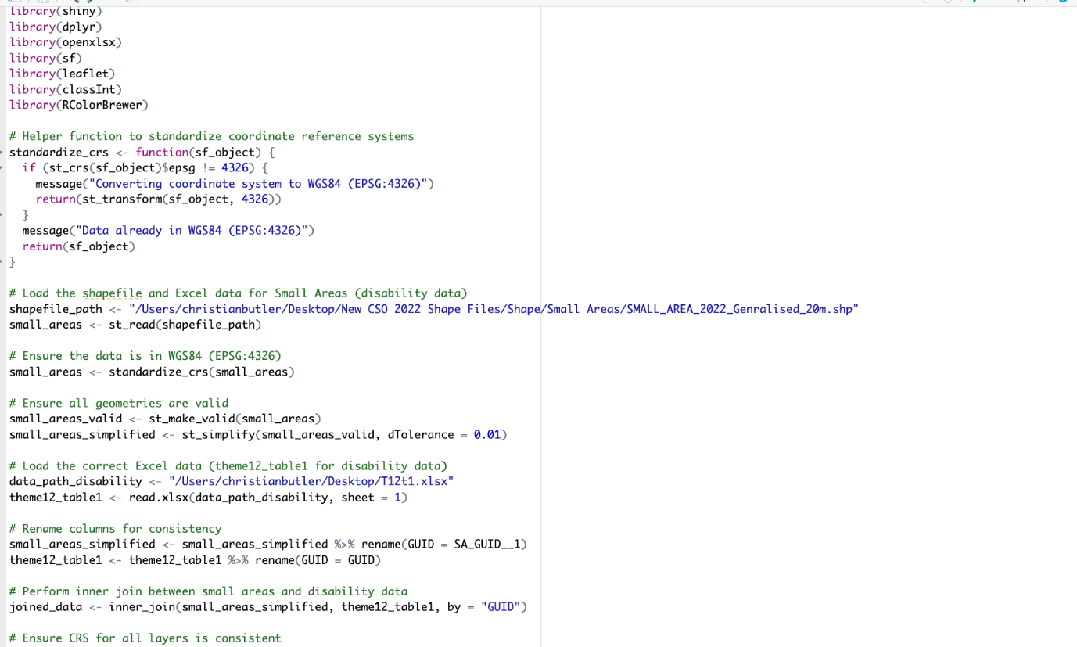
Figure 43-Disability data functionality being loaded in shiny
We continued after with loading our gp and pharamcy data using the sf package to read the files and standardised the geometries. After, we joined the two files into a joined data variable with our two files from earlier. Subsequently, we began to create our UI for our data dashboard using Shiny's built-in functionality. This started with making the sidebar for our filtered data through a dropdown which a user could select. We also coded the functionality to display our map using the main panel function.
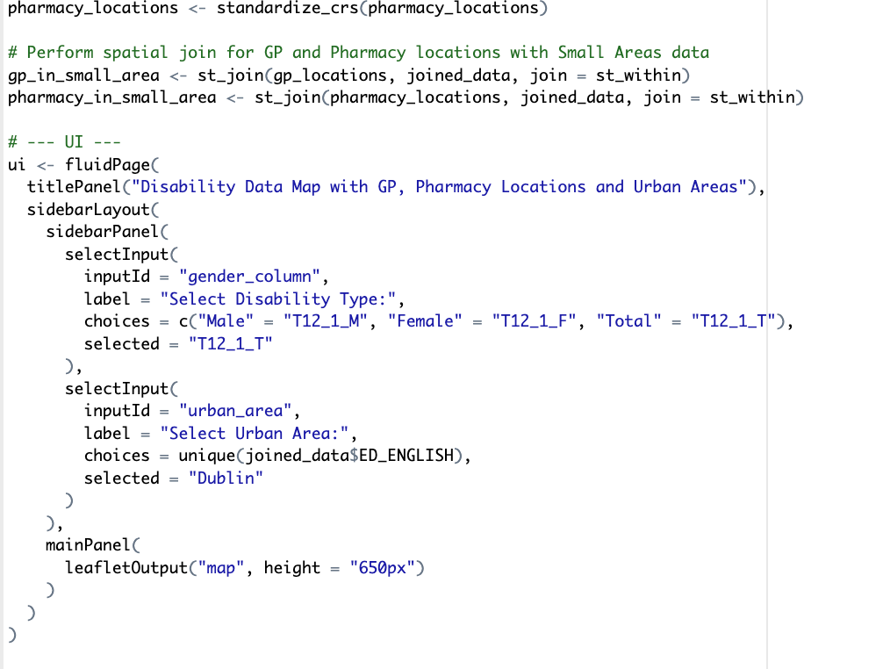
Figure 44-Creating the Shiny UI Layout

Once the UI was created for the dashboard, we started to begin coding the server functionality. We began by creating the filter function to filter through the joined data object on select of the dropdown. The dropdown would display options to view level of disability among gender and total amount. Once we coded the filter functionality, we started to generate our spatial map for our disability data. This started with creating our colour palette for polygons and adding our leaflet function to generate the map.

5.12.3 Creating our Leaflet Map for our disability data in Shiny
We continued from the first item of the sprint was finishing the creation of the leaflet map. Following us adding the leaflet function, we added the addPolygons function to generate our small areas shp file with its data, then our markers for our gps and pharamcies with layer control. We then added the run shiny app function at the end to render our shiny dashboard.
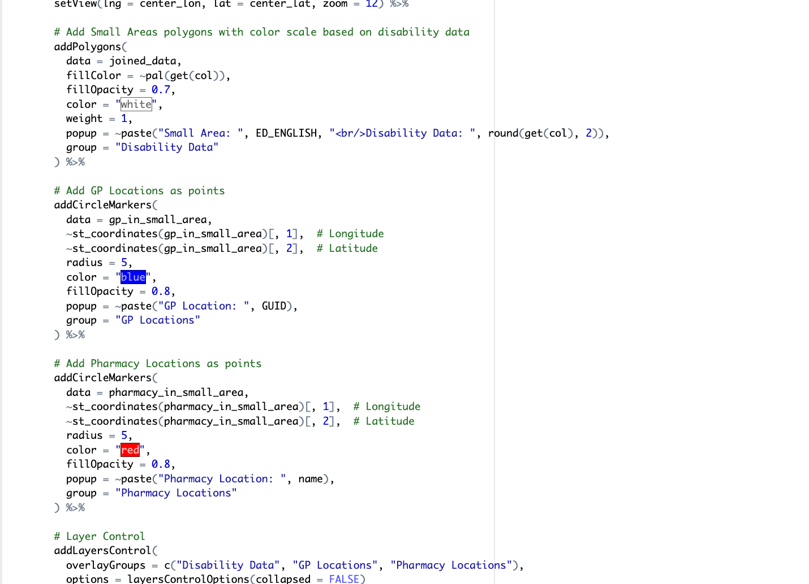
Figure 45-Leaflet Functionality in Shiny Server
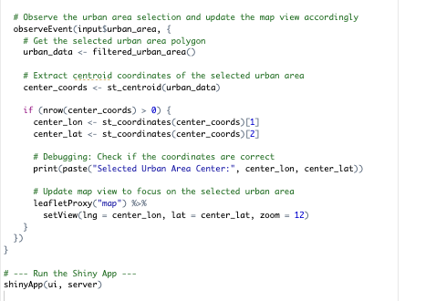
Figure 46-running the shiny app command and centering the view

5 Conclusion
This chapter has shown a range of different analytical approached using a range of data sourses [I have collected, researched, processed, and plotted various amounts of data]. The implementation started with sourcing and processing our files from various sources such as the CSO and Geohive. Various shp and excel files were downloaded and processed using R Studio or Tableau. This was followed by creating spatial maps visualising our data sources as polygons, points, lines of latitude and longitude and so forth. Furthermore, I have become famililar with the use of R language and tableau alongside the creation of interactive dashboards in tableau desktop and R Studio through flex dashboard package. Additionally, we also developed an interactive filter to display disability by gender through the R shiny package. We also experimented with creating interactive dashboards through Shiny server which allows us to host our dashboards on the web.

Testing

Introduction

Throughout this chapter, testing was conducted for the application. The purpose of testing is to evaluate how well the program functions as expected. Testing is beneficial to catch errors and malfunctions throughout the application we developed. Additionally, the process can further enhance the development cycle and quality of our software.
The testing methods primarily focused on functional testing of the application focusing the dashboard and map interface. The methods were based on the program requirements in the project's requirements section. The main aim of this test was to outline and investigate any potential issues with the code and our dashboard.
Additionally, user testing is another testing method used in ux design to assess usability of our program and its user interface. This is conducted by giving a list of tasks to a user for them to complete and rate their ability to complete them.

Functional Testing

We carried out functional testing was conducted to understand if the program functioned as we expected. The testing method that we used was creating a series of tasks to be carried out and have an expected outcome. The testing was focused on mapping navigation, user interaction and user interface.

Navigation
Test No. | Test  Description | Input | Expected  Outcome | Resulted  Outcome
1. | Navigate to Dublin using the trackpad and zoom function | Drag using mouse and zoom input | Should be able to navigate to Dublin area and view desired info | Correct result was outputted and able to view the data on the dashboard
2. | Toggle Data and Shape Layers | Click on the Data Layers | Ability to toggle different data on and off | Expected outcome was a success and could select data layers
3. | Select small area and view tooltip information | Navigate using mouse and left click on shape | Tooltip should appear on selection of small area | Tooltip appears with the small area name and disability/health data

User Interactivity and Interface

6.2 User interactivity and interface
Test No. | Test  Description | Input | Expected  Outcome | Resulted Outcome
1. | Select a Pharamcy and view tooltip info | Navigate to a Pharamcy location and select | Ability to view pharamcy data and name | Visualising pharamcy data was successful
2. | Select a GP and view tooltip info | Navigate to a GP location and select | Ability to view GP data and name | Selecting GP was successful, but data was not outputted as expected
3. | Navigate between disability and health dashboard data | Select the toolbar buttons for disability and health data | Ability to navigate between the two dashboards | Navigating between disability and health data dashboards was successful

User Testing
User testing was conducted on 2 individuals on laptop given to them with the dashboard running. An explanation of the program and overall project was given before testing.

6.3.1 User Interface

6.3.2 User Experience

Conclusion

Functional Testing was conducted throughout the dashboard and user interface which acknowledged that the program worked as expected. The testing phase gave us an invaluable insight into how the function worked and areas that could be improved. Overall, this section provided valuable information on the functions of our data dashboard and if it performed as we anticipated it to.

Project Management

Introduction

The project management section discusses how the project was run and managed throughout each section. The project was broken down into the sprint method. The various how the project was conducted are outlined in the following sections

Project Proposal

The project proposal involved planning project ideas for the thesis. The topic of accessibility and disability was appealing, and we wanted to create a project around these areas. As the proposal evolved, the project began to focus on data visualisation of level of disability and accessibility across Ireland.

SCRUM Methodology

The Scrum method of sprinting was used throughout the entire project from start to finish. The sprints brought structure and direction to the thesis with immense success. Each task and requirement could be broken into small pieces for each sprint and if one could not be completed, it was moved to the next one.

Project Management Tools

Notebook and Weekly Meetings
Personal notebook and weekly meetings with the project supervisor were important throughout the project. This assisted with project direction, feedback and making notes of issues that had arisen.

Miro
Miro is a digital whiteboarding software and was primarily for documentation and project research in the initial stages. The software was particularly useful for producing ideas for the project and direction in the planning and proposal phases. Additionally, it was used initially for documentation of the project, especially developing the initial prototype.

Reflection

Your views on the project
In general, we felt the project went well. All desired functionality and the program were completed as planned. The overall cycle of the application development was demanding but fulfilling, especially working shape files in generating the maps for our data.

Working with a supervisor
Working alongside the main project supervisor and second reader was a rewarding and great learning experience throughout the project. Feedback and guidance from project supervisors were significant for the project's success.

Technical skills
The main technical skills developed and improved throughout this project were working with the R language and spatial data analysis. The student had limited experience in developing within the R language and spatial data files for creating mapping data. It was a challenging but rewarding experience overall. Additionally, prior experience working with the tableau software was also improved upon.

Conclusion
Completing and conducting this project was a rewarding and a great learning experience overall. Weekly meetings and notes with the project supervisors made the management of the direction and success of the project straightforward. The supervisors' guidance and feedback were invaluable and contributed to the project's success. Throughout every stage, many requirements and overall skills were improved, especially working with spatial files.

Conclusion

The project's aim was to investigate disability and accessibility provision through spatial data analysis with a focus on spatial data. The approach of the project was to create dashboard with mapping data visualising level of disability using a choropleth maps. Additionally, various data charts were utilised such as highlight tables and bar charts.
The application was developed initially through the tableau software which is a data visualisation program. Tableau was used to develop the initial prototype dashboard to learn and interact with spatial data at first. Following this, the application was further developed in the R Studio using the R language and its various packages.
The initial research section focuses on applications of spatial data analysis and its applications for identifying accessibility provision. This phase of the project formed the core of the project proposal and its requirements.
The requirements section set out the key factors of the application for the application to be successful and function as expected.
The design phase of the project outlined the technologies required to develop the project and its functions. Wireframes and existing dashboards assisted in the direction and development of the program.
The project's implementation phase discussed the program's development in the SCRUM methodology framework. Each phase of the development cycle was broken down into sprints with each task laid out for that specific sprint. This method assisted with the direction and development deadlines.
The testing phase of the project detailed the various testing methods conducted to investigate how effectively the project aligned with requirements set out. Additionally, the phase ensured all functions of the dashboard worked as expected.
Further development of the dashboard and the overall project could be considered in a variety of ways. This would include increased interactivity within the data dashboard itself allowing a user to filter different data and select different regions. Additionally, the program could also be developed to have route mapping using the r routing package. This additional functionality would allow a user to navigate from point to point on the mapping dashboard. Overall, the student is satisfied with the finished program and dashboard. The project has aligned with the requirements and is substantial portion for illustrating the importance of disability within Ireland. Furthermore, it illustrates further how spatial data analysis can form a great tool for investigating problems within our environment. Various hard and soft skills were developed throughout this project especially in the spatial data space. Communicating with supervisors, receiving feedback, learning about the R language and spatial data analysis
Lastly throughout this project, We have learned about spatial language and data, spatial mapping, dashboard design etc. Furthermore, the language of spatial analysis various from polygon shapes to, points to geometric variables. Additionally, we also explored creating spatial maps with laye filtering. Also, we developed interactive visual dashboards with flex dashboard and R shiny.

Finally, we concluded that spatial data analysis can be a great tool for to investigate accessibility provision and detect coloration between access to services and rates of disability.

References

WHO. (2023, March). Disability. World Health Organization. https://www.who.int/news-room/fact-sheets/detail/disability-and-health#:~:text=An%20estimated%201.3%20billion%20people,earlier%20than%20those%20without%20disabilities.
Pebesma, E., & Bivand, R. (2023, December 6). Spatial Data Science With Applications in R. Spatial data science. https://r-spatial.org/book/

A11y. (n.d.). Home - the A11Y project. Home - The A11Y Project. https://www.a11yproject.com/
Anselin, L., Syabri, I., & Kho, Y. (2009). Geoda: An introduction to spatial data analysis. Handbook of Applied Spatial Analysis, 73–89. https://doi.org/10.1007/978-3-642-03647-7_5
Argaw, D. M., Heilbron, F. C., Lee, J.-Y., Woodson, M., & Kweon, I. S. (2022). The anatomy of video editing: A dataset and benchmark suite for AI-assisted video editing. Lecture Notes in Computer Science, 201–218. https://doi.org/10.1007/978-3-031-20074-8_12
Beale, L., Field, K., Briggs, D., Picton, P., & Matthews, H. (2006). Mapping for wheelchair users: Route navigation in Urban Spaces. The Cartographic Journal, 43(1), 68–81. https://doi.org/10.1179/000870406x93517
Blythe, P. (2010). ITS applications in public transport: Improving the service to the transport system. Journal of Advanced Public Transport. https://onlinelibrary.wiley.com/doi/10.1002/atr.5670340302
Duggin, A. (2016, May 16). What we mean when we talk about accessibility. Accessibility in government. https://accessibility.blog.gov.uk/2016/05/16/what-we-mean-when-we-talk-about-accessibility-2/
Evans, G. (2015). Accessibility and user needs: Pedestrian mobility and Urban Design in the UK. Proceedings of the Institution of Civil Engineers - Municipal Engineer, 168(1), 32–44. https://doi.org/10.1680/muen.14.00012
Forghani, R. (2020). Machine learning and other artificial intelligence applications, an issue of neuroimaging clinics of North America, E-book (Vol. 30–4). Elsevier Health Sciences.
Guidelines, W. A. (n.d.). How to meet WCAG (quick reference). How to Meet WCAG (Quickref Reference). https://www.w3.org/WAI/WCAG22/quickref/
ICO. (n.d.). How do we ensure individual rights in our AI systems? https://ico.org.uk/for-organisations/uk-gdpr-guidance-and-resources/artificial-intelligence/guidance-on-ai-and-data-protection/how-do-we-ensure-individual-rights-in-our-ai-systems/
Le Texier, M., Schiel, K., & Caruso, G. (2018). The provision of urban green space and its accessibility: Spatial Data Effects in Brussels. PLOS ONE, 13(10). https://doi.org/10.1371/journal.pone.0204684
Lindsay, S., & Lamptey, D.-L. (2018). Pedestrian navigation and public transit training interventions for youth with disabilities: A systematic review. Disability and Rehabilitation, 41(22), 2607–2621. https://doi.org/10.1080/09638288.2018.1471165
Lloyd, C. D. (2010). Spatial Data Analysis: An introduction for GIS users. Oxford University Press.
Muskan, Singh, G., Singh, J., & Prabha, C. (2022). Data Visualization and its Key Fundamentals: A Comprehensive Survey. 2022 7th International Conference on Communication and Electronics Systems (ICCES), 1710–1714. https://doi.org/10.1109/icces54183.2022.9835803
Ntoutsi, E., Fafalios, P., Gadiraju, U., Iosifidis, V., Nejdl, W., Vidal, M., Ruggieri, S., Turini, F., Papadopoulos, S., Krasanakis, E., Kompatsiaris, I., Kinder‐Kurlanda, K., Wagner, C., Karimi, F., Fernandez, M., Alani, H., Berendt, B., Kruegel, T., Heinze, C., … Staab, S. (2020). Bias in data‐driven Artificial Intelligence Systems—an introductory survey. WIREs Data Mining and Knowledge Discovery, 10(3). https://doi.org/10.1002/widm.1356
Pebesma, E., & Bivand, R. (2023, December 6). Spatial Data Science With Applications in R. Spatial data science. https://r-spatial.org/book/
Saif, M. A. (2017). Public Transport Accessibility: A Literature Review (dissertation).
Scott, D., & Horner, M. (2008). Examining the role of urban form in shaping people’s accessibility to opportunities: An exploratory spatial data analysis. Journal of Transport and Land Use, 1(2). https://doi.org/10.5198/jtlu.v1i2.25
Stjernborg, V. (2019). Accessibility for all in public transport and the overlooked (social) dimension—a case study of Stockholm. Sustainability, 11(18), 4902. https://doi.org/10.3390/su11184902
University, O. M., Miesenberger, K., Penaz, P., & Kobayashi, M. (2024). International Conference on Computers Helping People with Special Need. In Computers helping people with special needs: 19th International Conference, ICCHP 2024, Linz, Austria, July 8-12, 2024, Proceedings. part II. Linz; ICCHP.
Unwin, A. (2020). Why is data visualization important? what is important in data visualization? Harvard Data Science Review. https://doi.org/10.1162/99608f92.8ae4d525
Yin, L., Patterson, K., Silverman, R., Wu, L., & Zhang, H. (2020). Neighbourhood accessibility and walkability of subsidised housing in shrinking US cities. Sage Journals, 59(2), 323–340. https://doi.org/10.1177/0042098020962413

Figures

Figure 1-New Zealand Government Dashboard 3
Figure 2-CBA Tool Dashboard-Berkely Centre of Built Environment 4
Figure 3-Berkley Materials Project 5
Figure 4-Sarah Persona-Policymaker 6
Figure 5-Jonathan -Reseacher Persona 6
Figure 6-Disability Dashboard in Tableau 9
Figure 7-Tableau Spatial map of cork with filters 9
Figure 8- Dashboard-Wireframe 10
Figure 9-Dashboard Design 11
Figure 10-CSO Databases File 13
Figure 11-Geohive Spatial Map 13
Figure 12-Tableau Spatial Join 14
Figure 13-Pivot table of data in long format 14
Figure 14-Polgyon Layers of Southeast Dublin 15
Figure 15-Layers of Polygons and Spatial Points of SE Dublin 16
Figure 16-Spatial Filter for Gender and Location 17
Figure 17-Distance Calculation to view the distance between points 18
Figure 18-Calculation to find the intersect point for buffers 18
Figure 19-Map of Dublin with Polygons and Line Buffers 19
Figure 20-Buffer Radius filter to adjust buffer size 19
Figure 21-Loading Libraries and inital data 20
Figure 22-Console Spatial output of our data 20
Figure 23-Mapview Function to generate our chloropleth map in R with polygons 21
Figure 24-Generated Mapview Sketch 21
Figure 25-Map type filters 22
Figure 26-Adding a modal to our polygons to give context for the user 22
Figure 27-GP and Pharamcy services with buffers 23
Figure 28-Adding Health Data map in mapview 24
Figure 29-Health Data chloropleth map with polygons 25
Figure 30-Hospitals and Health Centres 25
Figure 31-Standarised and simplified our geometries for leaflet package. 26
Figure 32-Loading our small areas and disability data file. 27
Figure 33-Loading and processing our gp and pharmacy files. 27
Figure 34-Adding our Leaflet map functionality 28
Figure 35-Flex Dashboard Functionality 29
Figure 36-Simplifying and Standarising our Geometry coordinates 30
Figure 37-Loading, processing and spatial join of our health data shape files 31
Figure 38- Generating our Health Data leaflet map 32
Figure 39-Standarising our geometeries in flex dashboard 33
Figure 40-Creating bar charts for our gp shp files 34
Figure 41-Creating our pharamcy barchart plot 35
Figure 42-Pharamcy Barchart Plot 36
Figure 43-Disability data functionality being loaded in shiny 38
Figure 44-Creating the Shiny UI Layout 39
Figure 45-Leaflet Functionality in Shiny Server 40
Figure 46-running the shiny app command and centering the view 40

