# Subtlety and Nuance in Character Performance

# Video Submission Transcript

Link to Video Thesis:

[Subtlety and Nuance in Character Performance](https://1drv.ms/v/s!AmHHYW37igfd6yycy4c8zO5HRW2c?e=EJYZwa)

**Abstract**

## What is it that makes a convincing character performance? What are the techniques that when used by a skilled actor, provides their character humanity on screen. I argue that it the use of subtlety and nuance in a performance that elevates it to greatness. It was the cast of Vince Gilligan’s *Breaking Bad*’s employment of these methods that helped solidify the series as one of the greatest crime dramas ever produced for television.

I will study the history of performance and analyse how prominent figures such as Francois Delsarte and Konstantin Stanislavski have impacted the world of actor training. Their philosophies of acting, what it was they believed to make a deeply impactful portrayal of human emotion, has profoundly influenced how all modern actors approach performance. We can apply their teachings to the cast of *Breaking Bad* to see their methods in use and its subsequent effects on character acting.

The cast of *Breaking Bad* employs a variety of techniques throughout the series. I will focus my study onto three members of the main cast, Bryan Cranston, Aaron Paul and Giancarlo Esposito. I will prove that their approach to performance and the preparation they take before appearing on screen is crucial to the appeal of their characters. It is because they provide a nuanced depiction of human flaws, that the audience can remain attached to their characters, despite the horrible actions they take.

I will show these techniques of subtle performance through three key scenes of character acting. Building intensity, minor movements and timing are the pillars of what makes these scenes so impactful to the audience. I will show that these techniques when combined creates what I call *Layered Acting*. This technique when used by the cast creates a greatly enjoyable experience for the audience. It also allows the actors to provide their characters with an amazing level of depth through its nuance.

## Vince Gilligan’s *Breaking Bad* connected to its audience like never before. The television series' exploration of character was bolstered by the actor’s nuanced performance. It is through these tenants of acting that this series has remained a critical success.

# Introduction

Looking back to the television of the late 2000s and early 2010s, there is one stand out series that everyone was talking about, a series that captured a global audience like nothing had done before. This is the 2008, 12-time Prime Time Emmy award winning show *Breaking Bad*, a series that continues to have an active fan base and spin off series more than 15 years after its release. There were several other great television shows airing around this time such as *The Sopranos* or *Mad Men*. Both examples were very successful and are still remembered as excellent dramas. However, this thesis will argue that *Breaking Bad* has qualities which make it the most compelling. Qualities that have maintained it as a well-respected crime drama after all these years. The story writing, themes of morality and mortality, and the actors’ physicality on screen have remained outstanding as well as my enthusiasm for its nuanced approach to character. I suggest, for example, that it was the actors’ use of gesture and nuance that made this series so memorable. Throughout the series, we as the audience begin to understand these characters innately. Their mannerisms became a language we can decipher and find nuance in. At the core of this thesis is the idea that it is often what a character doesn’t say, and what it is that they are trying to conceal that is more revealing.

Written and produced by acclaimed screen writer Vince Gilligan, the series follows the story of an ordinary man who becomes the king pin of a drug empire. Gilligan had previous television writing experience through working on *The* *X-Files* and *The Lone Gunmen.* He joined the writing crew of *The* *X-Files* season two, but quickly rose in its ranks writing 29 episodes and becoming an executive producer on 40 episodes throughout the series. His work with X-Files ended in 2002, and he continued to work on other projects. Gilligan would go on to develop a pitch for a new series, one that would go against the status quo of long form serialised television. As Andrew Romano described it: "Television is historically good at keeping its characters in a self-imposed stasis so that shows can go on for years or even decades... How can I do a show in which the fundamental drive is toward change?"[1] *Breaking Bad* began airing in early 2008 and continued for 5 seasons having 62 episodes in total before ending in late 2013. It made the unique choice to show a character arc in reverse, to show a man that “transforms himself from Mr. Chips into Scarface.”[2].This complex character study is not easily achieved, but I believe it was the exemplary talent of the actors that won this show its reputation. The actors of course are given the opportunity to shine due to the series outstanding writing and overall production. However, I will be focusing on the actors’ performance choices in this thesis. My analysis aims to focus on the skilful talent of the actors which I claim was key to keeping an audience devoted to these characters even after they do horrible and illegal actions.

Chapter One will explore the history of acting philosophies with particular focus on the methods of Delsarte and Stanislavski. I will discuss what their teachings emphasised in performance. Delsarte put importance on gesture and believed posing to be the most crucial identifier of emotion in people. Stanislavski however, instead taught his students to create a mental link between themselves and the role they were playing. He believed that this was the only way to make a convincing replica to complex human emotion. The teachings of these two prominent actors have had a major influence on the community of acting, and as a result have impacted how all modern-day actors approach their work.

Chapter Two will discuss the application of these acting techniques in *Breaking Bad*. I foreground the work of three members of the main cast, Bryan Cranston, Aaron Paul and Giancarlo Esposito as examples of these methods. This acting preparation can take many forms, but it must aim to deepen an actor’s understanding of their character. They must create a foundation from which to build the character on.

In Chapter Three I will apply the previous chapters findings on to three key scenes of interest. Which I find highlights the actors skilful use of these teachings. I will analyse scenes from *Problem Dog, Phoenix,* and *Box Cutter.* Each of these examples showcases a different aspect of performance; building of intensity, minor movements, and pauses and timing respectively. The combination of these core principles is what I believe makes the character acting in *Breaking Bad* so impactful. I aim to prove that it was these nuanced, subtle moments that revealed so much more than could be explained through words. The result, I will conclude, is the legacy of a cast of characters remembered as deeply influential in modern television.

# Chapter One

# The History of Acting Philosophy

*“Why don’t you try acting, dear boy? – It’s much easier!” [3]*

Throughout the decades of performance on screen, there have been many ideas of what it means to be an actor. Of what it takes to create a true, proper performance. Prominent figures, such as Konstantin Stanislavski have gained fame and respect not just as actors but also teachers and philosophers of acting techniques. I will examine their teachings on the acting in *Breaking Bad,* specifically the importance of physicality in performance. As well as the thought processes that compel an actor to move the way they do. The concept of “Never breaking character” is not my area of discussion for this essay. I am more interested in examining the result of these acting choices, how they affect the scene being portrayed and how these choices impact a character’s development throughout the story. With these parameters in mind, I begin this analysis with a historical examination of the philosophy of Francois Delsarte.

## ***Delsartism***

Francois Delsarte was a French singer born in 1811. Delsarte studied people, observing ordinary behaviours and mundane interactions. From this analysis he came to emphasise gesture when teaching acting to his students and devised what would become known as the *Delsarte System*, or *Delsartism*.[4] Helen Thomas writes: “Delsarte believed that through his observations and cataloguing of gestures, attitudes, tone and manner of voice, he had discovered scientific ‘laws’ that governed human expression.” [5] Delsarte put great emphasis on the emotional connection to movement, he believed that not only would recreating certain movements conjure up past feelings in the actor, but that these poses would instinctively communicate the emotions to the audience as well. Nancy Lee Chalfa Ruyter broke down the teachings of Delsarte in her book *The Delsarte Heritag*e, “'To each grand function of the body, corresponds a spiritual act.' … a rigid structure in which minute or total body position or movement meant a certain thing*.*” [6]

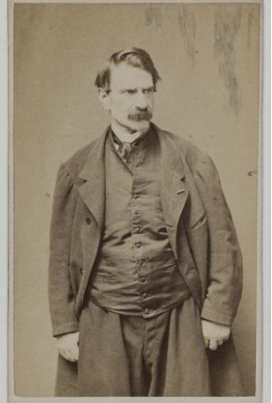

*Fig.1*

*Francois Delsarte*

Delsarte approached acting as a science. His notes were incredibly detailed, breaking down the body into individual parts each one having its own ability to communicate emotion. Although Delsarte didn’t write any of his teachings into a comprehensive text, his philosophies were passed on by his students - such as Genevieve Stebbins and Steele Mackaye. “*Delsarte System of Oratory*” [7], see (Fig 2. & 3.). This is an illustration from the book intended to demonstrate how the position of the legs affects the emotion being portrayed. Even the slightest shift of an actor’s weight or the angle in which they faced portrayed very contrasting emotions. (See also Fig.4) This is an excerpt from the book *Gesture and Pantomimic Action* [8].

Delsarte places great emphasis on conscious and careful use of posing. His student Genevieve Stebbins illustrates his ideology in her book “*Delsarte System of Expression*” [9]. They show that the body is made up of emotional tools that can be honed and used to convey emotions through physicality alone. It also displays that body language is an additive method of acting, meaning that it is something that can be built upon and layered for a more complex emotional range. I call this use of body language, *layered acting*.

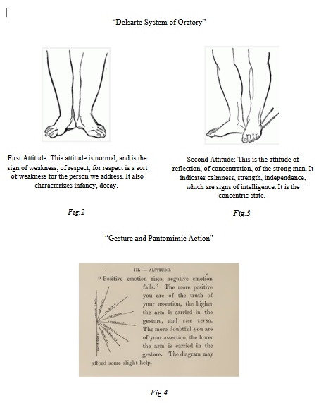

This idea of approaching performance through gesture was revolutionary for its time, and it received great popularity as a result. However, it also had its detractors, an exact guideline didn’t allow for improvisation and could result in stale, predictable performances. According to Helen Thomas, “Delsarte rejected the artifice of convention by attempting to discover the ‘real’ relations of movement and meaning through observing ordinary behaviour. But by categorising gestures… Delsarte’s system of expression became a formalism in itself” [10] New techniques would form to fill this gap of improvisation. Where Delsarte was rigid, others would embrace spontaneity.

## ***Stanislavski’s System***

Konstantin Stanislavski (Fig.5) was born in 1863 in Moscow, Russia. He devoted himself to the performing arts and rose to prominence through his dedication to perfecting his craft. He saw theatre as not just an entertainment but as an art form. In 1898 he co-founded the Moscow Art Theatre (MAT) and through his directing began developing what would be known as the *Stanislavski System*. [11]

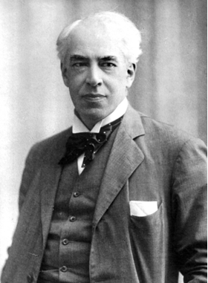

*Fig.5*

*Konstantin Stanislavski*

In his system Stanislavski put emphasis on the inner preparation of actors. [12] Whereas Delsarte had devised poses for an actor to recreate to evoke an emotion, Stanislavski instead put focus on an actor embodying their role so that the emotional acting would happen subconsciously. His ideology was that if an actor is fully immersed in their work then their acting would be fluid and “realistic”. Because their subconscious actions would lend to a naturalistic performance.

Stanislavski believed that for an actor to create a great performance they first must analyze the text, a process known as *Active Analysis*. He stated: “The verbal text of a play, especially one by a genius, is the manifestation of the clarity, the subtlety, the concrete power to express invisible thoughts and feelings of the author himself.” [13] He saw previous techniques of acting to be mechanical in execution. He called them the “Art of Representation”. This methodology would simply depict the scene as written. He proposed instead a technique of the “Art of Experiencing”; where actors would draw from their own life as inspiration for their depiction. This allowed more variety in expression. “In the language of an actor, to know is synonymous with to feel” [14]. Actors would prepare for their scene by using a technique called “Emotion Memory” or “Affective Memory”; which was the process of engaging themselves with an emotional link to their past. They would call onto this memory when performing to conjure up the emotion it was tied to.

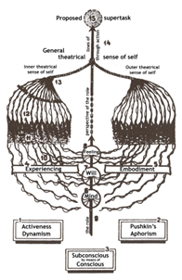

*Fig.6*

*Diagram of Stanislavski’s System*

This philosophy of performing became one of the most widely spread and impactful teachings within the acting community. His theatre group MAT travelled the world and through their performances inspired the audience of actors to follow in their footsteps. American actors who were inspired by the MATs tour of America, or those who were taught by his students; seem to be encouraged to act more freely and improve with their co-stars. This is because they are trained in the “*System”* and always embody their character. This also encourages them to do a lot of introspection and flesh out the character in their minds, they take the character work off screen to prepare. “As Wexman has pointed out, the British tradition is often seen as concentrating on external technique and craft, whereas the American tradition has emphasised an internal truth.” [15]

# Chapter Two

# Application Of Acting Techniques by The Cast of Breaking Bad

“The more well written the script is, the less work an actor has to do” [16]

Walter White, played by Bryan Cranston; is a man who has just turned fifty years old, is struggling financially and has just been given a terminal lung cancer diagnosis. Jessie Pinkman, played by Aaron Paul, is a young drug addict and dealer who begins producing crystal meth with Walter. Gus Fring, played by Giancarlo Esposito; is the king pin overlord running the New Mexico drug cartel under the DEA’s noses. He becomes Walt’s and Jessie’s boss turned rival throughout the series. All these characters are complex, each with their own opposing motives and morals. The actors must not only perform their own role but also manage to balance playing alongside the other equally elaborate characters. How does an actor begin to prepare for such a role?

## ***Stanislavski and The Script***

To begin they must analysis the text. As discussed, Stanislavski considered the actor’s understanding of the text to be crucial to performance. Because one cannot portray the complexities of human emotion without having a complete understanding of what it is that makes a character behave in such a way. Bryan Cranston mirrors this importance of script writing, and he thanks the series writer Vince Gilligan for doing most of the work for him.

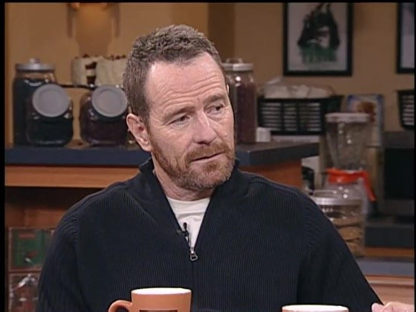

*VC.1*

*AMC Shootout Interview: DVD Boxset Featurette*[17]

Gilligan has created the character arcs that Cranston will act in, the overall structure of the series is already set. Cranston therefore needs to bring his own experience in performing to the table in this production. He begins a form of Active Analysis. As Allison Hodge explains in her book *Twentieth Century Actor Training*, ”In active analysis, actors grasp a play’s anatomy before memorizing lines. To do so, they read a play as if it were a system of clues that imply potential performance.” [18] There are many forms this analysis can take. Cranston chooses to journal his process. “My goal when I prepare isn’t to plot out each action and reaction, but to think: What are the possible emotional levels my character *could* experience?... I stay open to the moment, susceptible to whatever comes.” [19]

This is an example of “The Act of Experiencing” that Stanislavski wrote about by seeing opportunities for inspiration in all everyday things and using time off stage to deepen your understanding of the character. “A character is outside of me. And then I go to my actor’s palette-which is comprised of personal experience, research, talent, and imagination- and the base begins.” [20] By applying his own life experiences and drawing from everyday people he breathes life into the text. In Alexander Knox’s paper “Acting and Behaving”, Knox describes how an actor must be fully engaged with the scene. “Acting and behaving. The difference is not only aesthetic, it is also psychological”. [21] Knox argues that actors who are truly engaged with their role expand upon the scene by bringing in their own creative license, by building upon the script, and being additive. He states that great actors should add deeper meaning in an acting performance, to be conscious and deliberate in interpreting how this character would act in response. ‘Acting seems to me to be behaving plus interpretation”.[22]

Giancarlo, in his performance of Gus Fring, follows this principle as he made every movement deliberate.

VC.2

**Giancarlo Esposito Breaks Down His Most Iconic Characters | GQ**[23]

Esposito speaks about working *with* the script not against it, to instead change the timing of the dialogue. He brings his theater experience into play, referencing the playwright, Harold Pinter. Ahmed Khalid Buraa Buraa discusses the use of techniques like Pinter’s in their paper *The Dramatic Value of Body Language and Pauses in the Theatre of Absurd: A Thematic Study of Samuel Beckett’s Happy Days and Footfalls*. “Pinter as a famous British playwright who has his unique new style called Pinteresque, this study deals also with silences, language and pauses, and how he uses them.” [24] Giancarlo takes inspiration from Pinter’s experimentation with dialogue, specially creating space without it. Leaving time in the performance for the spoken word to breath gives the words spoken more gravity and forces the audience to really listen to what the script is trying to convey.

The reference to Pinter recalls the difference in techniques used by actors with various social and professional backgrounds. Cranston has been primarily a television actor; his work allows him spontaneity in that regard. In Cranston’s process he writes the many ways a scene can be played and is able to explore the effects of each when filming across multiple takes. This form of acting is seen as a more “American” approach, as the theatre training spoken about by Esposito is traditionally British. Esposito must adopt a more contemplative approach, on stage you must be consistent. Trevor Rawlins explores this difference in his paper “Screen Acting and Performance Choices”. Rawlins explains; “American actors seem to be encouraged to act "on the fly" and use improv. This is because they are trained in the Stanislavsky “Method” and always embody their character and can improve easier. This also encourages them to do a lot of introspection and flesh out the character in their minds, they take the character work off screen to prepare.” [25] It’s interesting to consider how Cranston and Esposito differ in process and how this is reflected on the character’s they portray on screen. Cranston plays Walter as if his developmental arc is ever unfolding. He goes into a scene not entirely sure where the emphasis will land, and that works for the characterisation of Walter. He is a man thrown into the deep end of drug pedalling and although he tries to keep everything under control, he is in over his head. Gus Fring however is everything Walter White wants to be, he is calculated and always 2 steps ahead. Gus has everything planned out for his foreseeable future. Nothing is left to chance, and he never takes an uncalculated risk. Esposito is mirroring Gus in his preparation process. Esposito describes an impactful moment when playing Gus in a different segment of his GQ interview (V.C 3)[26].

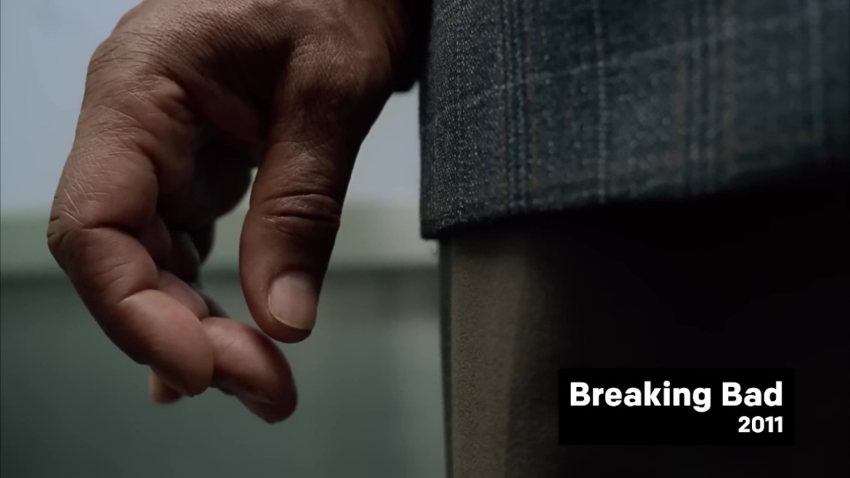

VC.3

**Giancarlo Esposito Breaks Down His Most Iconic Characters | GQ**

## ***Character Physicality***

The physical preparation of active analysis is also a key element. Take costuming for example. Cranston works with the costuming team and director Vince Gilligan to create a visual analysis of Walter White. The visuals of Walter tell us who he is by a glance. As Cranston says in his book, *A Life in Parts,* “So I sank into Walt. I dressed badly. I gained weight. Every aspect of Walt was an expression of the fact that he’d given up.” [27] The costuming is used to reveal a deeper more unspoken truth to a character.

*VC.4*

*Bryan Cranston Breaks Down His Most Iconic Characters | GQ*[28]

|  |  |
| --- | --- |
|  |  |
| *Fig.1*  *Walter White-Breaking Bad-Season 1 Episode 1* | *Fig.2*  *Jesse Pinkman-Breaking Bad-Season 2 Episode 6* |

There is also the building of a character’s mannerisms. Aaron Paul brought an amazing physicality to the role. Jesse is a man of action, never still and never able to hide how he is feeling. He is pacing, pulling at his face, wringing his hands; and through these actions the audience is connected to Jesse. Throughout the series we see how he reacts to situations, and we understand him innately, as we recognize his emotions through his mannerisms. Walt is the opposite, stoic and able to hide his stress with much more grace. This creates an interesting dynamic, even though Walter is our protagonist, we as the audience will look to Jesse as the emotional core of a scene. How he reacts gives us a glimpse into his own inner psyche but also into Walt’s, who may not show it externally. Paul’s use of movement exemplifies what Delsarte taught; Paul’s mannerisms are pillars to understanding his headspace. As Edward B. Warman put in his book about Delsarte, “The Delsarte system is founded on the great principle of the law of correspondence; that is, every expression of the face, every gesture, every posture of the body corresponds to... an inner emotion or condition of the mind”. [29] Each one of Jesse’s actions is directly influenced by his emotions, he does not just react to the situation, but acts based on how the situation affects his emotions. Jesse Pinkman was written to be a side character to Walt, his role was to introduce him to the world of methamphetamine and give him the opportunity to become a drug producer. However, Aaron Paul did not know going into the audition that his character was intended to be short lived. Paul proved to be phenomenal as Jesse. Gilligan had to change the story on the fly because it was clear that Paul was too good of an asset to let go after only seven episodes. “My intention was that at the end of season one, Jesse would die horribly, which would make Walt feel really guilty and force him to question his criminality, but it became clear to me that Aaron Paul was an absolute asset to the show. I’d no more kill him off now than cut off one of my pinkies.” [30] Jesse became a vital component to the identity of Breaking Bad. He wasn’t a comedic sidekick designed to die for Walter’s developmental arc. He became a character all his own. Where Walter’s story was of a man diving into criminality for his own gain, Jesse is sympathetic. Jesse in many ways is developing in contrast to Walter, as a man trying to break his cycle of addiction but constantly dragged back in by Walter. He becomes a hero of the story despite the fact he was written to only be a footnote of the series.

# Chapter Three

# Analysis of Performance

“Choices - even seemingly minor choices - matter. Details matter.” [31]

The best scenes are the ones that build in intensity, they are not flat in execution. They follow a rise and fall till reaching their climax and bringing a satisfying conclusion. I argue that it is through an actor's use of *layered acting* they can achieve this performance. Layered acting is a term I use to describe the many small acting choices that are joined together to create the larger action. It is a process that involves using a variety of physical movements to build an emotional response. This connection of physicality and feeling is shown in the teachings of Delsarte, and it is through an actor’s preparation, as emphasized by Stanislavski, that they can create these movements that evoke emotion. Rhonda Blair discusses the interconnection of emotions on expression in her book *Theatre and Embodiment*, “First as an emotion, which rises to the level of feeling... This then leads to behavior.” [32]  In layered acting therefore, a person’s mannerisms are intrinsically tied to their emotional state.

## ***Building Intensity***

I will analyze and show the actors’ use of layered acting in the series *Breaking Bad,* and how this methodology achieves key moments of performance that develop their character further. “*Problem Dog"*. This scene takes place in an addiction support group meeting. Jesse has been attending these meetings for quite some time, although he is not especially there for support. Instead he has been using the group as a covert advertising opportunity. A chance to lure the at-risk group members to try his product and boost sales. Despite his plan of peddling drugs, Jesse does find some solace from this group. He is battling within himself because he has taken advantage of the people who attend it. He is also struggling to cope with the fact that he shot and killed Gale, a possible replacement for Walter in Gus Fring’s drug production. He was manipulated by Walt to protect them through violence. But his actions weigh heavily on him. He uses this meeting as an attempt to process his guilt and shame, under the guise of “killing a dog”.

Jesse begins the scene slouched back in his chair. He looks dazed and unalert. The group leader calls on him, snapping him back to reality. He begins to tell a story of having killed a dog a couple of weeks previously. The incident has clearly been weighing him down as he was distracted by the memory. His dialogue is filled with many pauses between his words, partially because he needs to tell this story without letting slip that his dog was in fact a person. But also because it takes a great deal of effort to relive the haunting experience. He makes very little eye contact, mostly looking down at the floor. It implies he feels lesser than them, and ashamed of what he’s done. As he speaks the tension in his body rises, he begins squirming in his chair, uncomfortable in the conversation taking place. Aaron Paul began this scene by using primarily facial expressions. As he continues the performance, and as the conflict builds he incorporates more of his body into his performance. He wrings his hands and fidgets and shifts in his chair. His anxiety doesn’t allow him to sit still, and it moves through his body in increasing strength. He displays Jesse’s discomfort through labored breathing. He has to take deep breaths to calm himself, as he searches for the words to explain himself. Pain is seen on his face; he recoils at the thought of what happened and what he has done. Paul contorts his muscles to show the strain of this moment. These are the foundational expressions of this scene. The intensity of his acting continues to build from this base, strengthened because the groundwork of the emotional core is already laid.

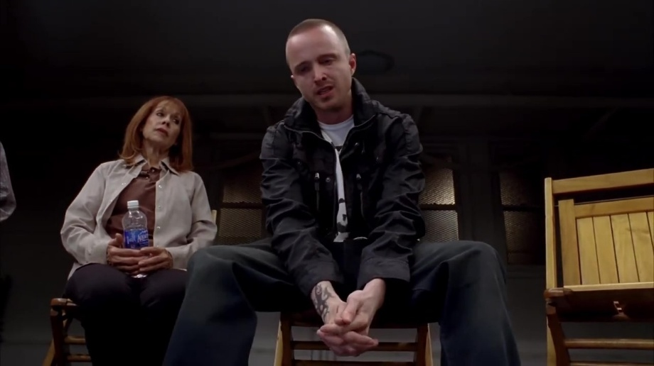

*V.C 1*

*Breaking Bad Season 4 Episode 7: “Problem Dog”*[33]

When Jesse physically shifts forward in his chair, it creates even more of a dissonance between him and the other group members. He is distancing himself from their judgement. He is becoming more entrenched in his memory. Anxiety surges through him again, shown by him stretching out his limbs to ease the tension. The muscles in his jaw and neck get rigid. This creates a physical tension in the character’s body mirroring the emotional distress he is in. As he grows more agitated, his body jerks in sharp, punctuated movements. The intensity of his movements increases as he pushes his neck out with each sentence, his shoulders now moving more to emphasize his words. The scene’s rising conflict is reflected in Jesse’s body, its building potential energy waiting to explode. Paul contorts his mouth and flexes his facial muscles. His lips move rapidly from pursed to pushed out towards the others. He almost gnaws on his words and spits them out. Jesse upon being confronted by another member switches focus. The anger of what he has done and the refusal of the group leader to shame him brings him to a point of no return. Jesse makes direct eye contact with the leader; the person who brought all these feelings to the forefront of his mind. He shifts all his anger onto the group leader and then he projects his feelings onto him as a scapegoat.

At this point Paul also begins to show tears in his eyes and is now moving more sporadically. The emotions have forced themselves to the surface. Paul mirrors this shift by raising his voice. He appears like he is begging for meaning, questioning emphatically the ideals of the leader’s “self-acceptance”. Jesse expresses all the hate he has for himself through attacking the leader. He chooses to drag up his own trauma of his dead daughter as retaliation. Wanting to make him hurt as much as he himself is hurting. Finally, he confesses that he has taken advantage of these vulnerable people. A last dig at the group leader, condemning him for his lack of control and through his laid-back attitude gave Jesse the opportunity to deal drugs to the members. Crucially, this admission is cementing Jesse as the monster he sees himself to be. He storms out of the room. Jesse is forever changed by this scene, he had burned bridges and severed himself from his only lifeline of support. His anger manifests into a self-destructive attack at those who could have helped him.

This is layered acting. Each of Aaron Paul’s choices accumulate to show a nuanced depiction of human emotion. Paul used his skill and knowledge of acting techniques to convey a gradual escalation of conflict. By employing these techniques of increasing movement, it gave the scene an arc of emotion to follow and lead it to a satisfying conclusion.

## ***Minor Movements***

Every movement has the potential further the story. If used correctly the slightest flicker of expression can completely alter the emotional context of a scene. The use of smaller movements, when layered together can reveal more about a character than just dialogue alone. As Buraa explains in their book discussing theatre performance, “The language of the body and the gestures that are used such as pauses and silences are not only in the theatre but also they are found in daily life and contain signs and evidence in which there are several expressions and interpretations. Therefore, the body language always exceeds the meaning.”[34] Bryan Cranston shows this skill in his performance in the episode *Phoenix*.

This scene focuses on Walt attempting to confront Jesse. Their dynamic has changed because Jesse has now begun dating Jane. She is a recovering addict but when she meets with Jesse, they both relapse. She has created a divide. Walt blames her for getting Jesse on heroin, and she wants to get Jesse away from Walt and his life of crime. So they can leave everything behind and start a new life. Jane blackmails Walt to get their share of the drug money, but Walt returns to the apartment at night to try and reconcile with Jesse. Walter makes his way in through the back door of the apartment directly to where Jesse and Jane are asleep. He sees the needles on the bedside table, further confirming Jesse’s addiction and making Jane even more of an enemy to Walt. He tries to stir him out of sleep, but he is too intoxicated and won’t wake up; however, this causes Jane to turn onto her back. Walter sits in contemplation. This drug problem is a serious threat to his plans. Then Jane begins to choke. Walt had not intended to roll her onto her back. He rushes to her side, his arms outstretched to save her life. But stops himself. If he lets nature take its course, his problem will be fixed.

This thought shocks him. He freezes, taken off guard by his own brutal realisation. His eyes move rapidly, each glance around the room representing a different thought. We see Walt struggle with his own morality in this moment. It’s a painful moment to watch as all the while Jane continues to choke. His humanity is in conflict. He wants to save her, but he is fighting the cold realisation that this could be a solution. He looks around the room as if searching for a sign, something to convince himself that shouldn’t let his girl die. His gaze shifts slowly, it is now fully fixed onto Jane, he has made up his mind. This slow shift in his gaze demonstrating his final decision. Having not found any logical reason. He decides to do nothing.

This moment is starkly still in comparison to his frantic movements before. He is shocked at his own cruelty; at the monster he has become. He stands over Jane having the power to prevent this young girl’s tragic passing. Instead, he is watching all this unfold as if it is outside of his control. His lip quivers as the emotion becomes too much, he reaches his hand up to cover his mouth and a tear rolls down his cheek. “And then, somehow, as she was fading, she wasn’t herself anymore. I wasn’t looking at Jane, or Jesse’s girlfriend, or the actor Krysten Ritter. I was looking at Taylor, my daughter, my real daughter.” [35] Cranston in this moment, without warning saw his own young daughter choking. Although the audience wouldn‘t know this until he spoke of the experience in interviews later on. It did however create a brutal depiction of grief and horrifying sadness. Cranston was deeply entrenched in his work, as Stanislavski had preached. But this came with the dire cost of seeing the most horrible thing for a parent to see. Their own child dying.

This gesture, of raising the hand to cover his mouth represents him silencing his conscience. Pushing it down in favour of his brutal logic. Aswell as stopping his sobs of pain from escaping him. Shame and disgust washes over him. He has changed, deeply and completely from the man he once was. His face twitching as he tries to come to terms with what he has done. How could he be so cruel? So utterly callous. He takes a deep breath. He has justified this action, he had no other choice, and he accepts it. Walter is able to create his own narrative, he did want he had to, it was a kindness to not extend her suffering. She would have died of an overdose anyway, why not now?

Cranston uses minor movements of his face to display a wide range of complex emotions, each action revealing a deep insight into the character of Walter White. His layered acting makes this scene a deeply impactful moment not just as an emotional character death, but also as a character study of Walter’s descent into depravity. Without the need for any dialogue Cranston conveys a great deal of storytelling through character acting. Surprise, shock, confusion, disgust and despair are all emotions that Cranston portrays in this scene within the span of two minutes, and all done without saying any dialogue. His silence can say more than words, as his use of facial expressions reveal a deep understanding of the character’s inner psyche.

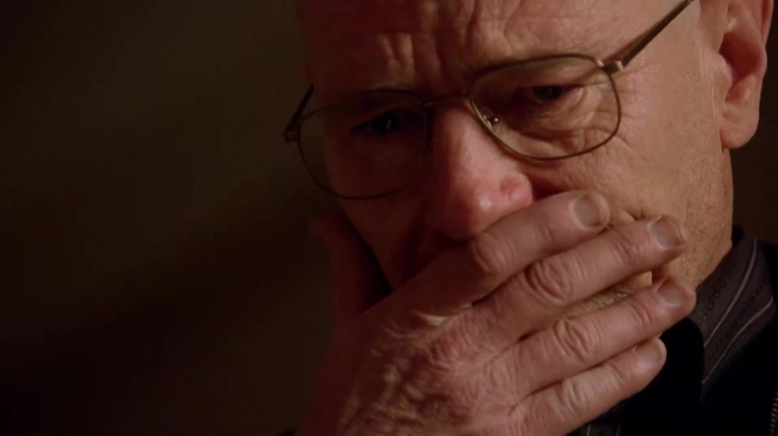

*V.C 2*

*Breaking Bad Season 2 Episode 12: “Phoenix”*[36]

## ***Pauses and Timing***

Dialogue as the last scene demonstrated, is not always needed to convey a message. “Silence means stopping verbal speech, not psychological speech.” [37] Gus Fring is a man of few words, but he makes up for it by having an imposing screen presence. When he is not speaking, he is still an active member of any scene. He is cunning and observant, he feels like a predator stalking its prey. Always one step ahead and a constant unassuming threat to the main characters. The audience must observe Gus in response to try and piece together what he is thinking. What is it he isn’t saying? Giancarlo Esposito used pauses in his dialogue and long-drawn-out silences to create this sense of danger in Gus.

As discussed in *Building Intensity* Jesse when pressured by Walt killed Gale. He was a possible replacement for Walt as he was also an experienced scientist and highly skilled. Jesse arrived at his door and shot him. Gus Fring, their drug kingpin needs to make a statement, that he will not tolerate Walt and Jesse interfering with his plans and taking out his staff. *Box Cutter* takes place at the beginning of Season four, directly following Gale’s murder in season three. They belittled his authority, went against him, and for that they must be punished. Walt and Jesse are brought to the lab following Gale’s murder, they are sat with Gus’ henchmen Viktor and Mike watching over them. Walt attempts to convince Gus that he needs to keep them alive, they may have killed Gale, but they are the producers of his high-quality product. But Viktor reveals that he has been studying Walt. He could make the same meth that he can, implying that Gus should kill the threat and make him the new cook.

Gus doesn't speak at all in this scene from Box Cutter. He is seen in the background of the shot, pulling on a protective jumpsuit. While Walt and Jesse are sitting in wait for his approach. We do not know why he is putting on this overall, his actions and thought process is unclear. Even when he is not the focus of the frame, he remains a constant looming presence. His calm exterior adds suspense, his actions are calculated and deliberate. He is letting them squirm. Walt argues his case, and Gus listens but provides no comment. He leaves them in waiting. He moves through the scene quietly, always observing the characters with an unknown intensity. He circles around the duo, akin to a shark circling its next victim. Giancarlo’s slowed timing of this scene gives Gus a great sense of power over the crew, he does not need to prove his authority with threats as his gaze is threat enough.

Gus goes through the lab drawers with no urgency. He remains calm. His exterior gives nothing away to his motives. He extends the box cutter’s knife. Gus’ first outward threat to the characters, he does not dramatize this moment, he doesn’t point it at the cast or make any remark. He does not need to; they already see this action as a threat. Their eyes all lock on to the knife’s blade. Their gaze follows him around the room. They are clearly distressed and lean away to create distance from Gus as he approaches. Even Mike who is portrayed as a hardened criminal is uncomfortable with Gus’ presence.

Gus is constantly sizing up the cast of characters, he analyses their every move. He does not act rashly, instead he contemplates and then moves with precise focus. Giancarlo’s actions in this scene reflect Gus’ character as a whole. A composed man with a hidden intent. As Giancarlo says, “Hiding in plain sight.”[38] That is what makes the following sequence so harrowing. We, the audience, have never seen Gus takes such drastic action before with his own hands. He has always been a dangerous man who orders for others to be killed, but the audience and characters would never expect him to draw blood himself. Especially not in such a violent way. He grabs Viktor from behind and slits his throat viscously. The way he kills Victor is slow and painful. He could have shot Victor from behind; he wouldn’t have suffered but instead he made an example of him. Brutally murdering him in front of the other characters, staring into them as he holds Victor up for them to see. He never breaks eye contact, never says a word. It's a clear message, he wants them to see how easy it was for him to kill. They are nothing but pawns to him, and if needed he will kill them just the same. He wants them to know that they could be in Victor’s position at any moment if they don’t stay in line. He is cold, taking a life is just a numbers game. Victor can be disposed of just like the rest of them can be. Gus unceremoniously pushes the man off him and allows him to hit the ground. The thud of his body acts like an exclamation point to his message. The act is done, and it meant nothing to Gus. He gave no reaction, even when Viktor struggled he held him close. His face never gave any possible hidden emotion away. Viktor lays bleeding on the floor, and Gus steps over his dying body. Leaving the characters in a state of shock. Gus Fring is a violent killer; we have seen plenty other killers in the series before this point. But none were as calculated and as unknowable as Gus Fring.

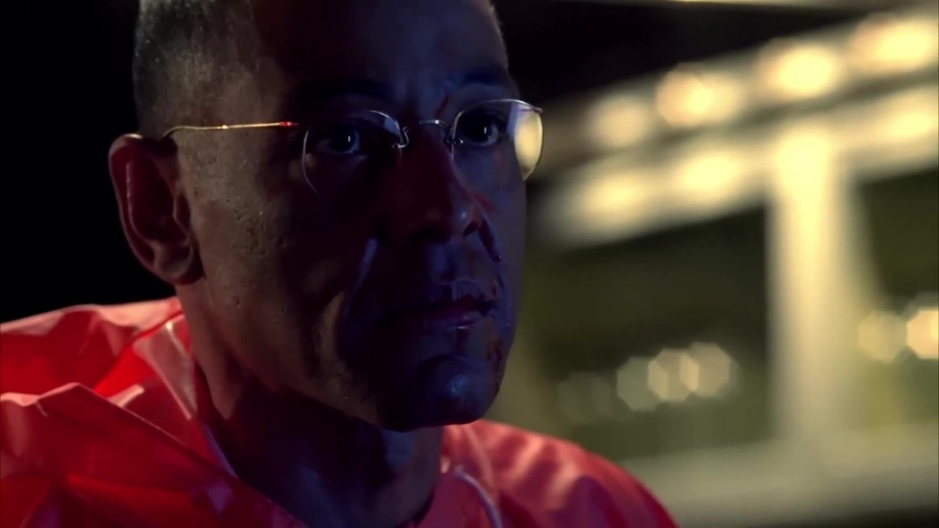

V.C 3

*Breaking Bad Season 4 Episode 1: “Box Cutter”*[39]

It is the accumulation of these techniques - building intensity, minor movements, pausing and timing - that form the principles of layered acting. This technique of performance allows the actors to create deeply impactful scenes. Their understanding of the emotional context, the mechanics of gesture, and their use of tactful timing is what makes this a standout performance.

# Conclusion

The cast of *Breaking Bad ‘*s use of layered acting creates nuanced scenes full of subtle moments that make watching their characters a fascinating experience. This thesis has argued that it is the actors skilled use of physical acting, such as gesture, minor movements, and timing. As well as their preparation for their role, helped to create a show which became renowned for its character writing and performances.

In Chapter one, through my study of acting philosophers Delsarte and Stanislavski, I correlated both of their methods of acting to the methodologies I perceive at work by cast of *Breaking Bad*. I suggested that it is their techniques of gesture acting and active analysis that deepens an actor's understanding of their role and provides a more complex and enjoyable performance.Delsarte and Stanislavski have revolutionized how the acting community has developed its skills, and this is reflected in how the *Breaking Bad* actors approach their own work. Their ideology encourages actors to use gesture with careful and deliberate consideration. As stated by Knox in *Acting and Behaving*, “Don't just react to what is happening, be conscious of how this particular character would act in response. Don't be passive, be active.”[40] The emphasis on how an actor's approach is a crucial step to impactful performances is seen through the performances of Cranston, Esposito and Paul.

Chapter Two explored these techniques in relation to the specific case of *Breaking Bad*. I applied Stanislavski’s method of *Active Analysis* to Cranston and Esposito’s preparation to play Walter White and Gus Fring. Looking at interviews between them and GQ, we can see that they take particular care to understand the script, the importance of the dialogue being said, and how these words would impact their character. They have a deep respect for Gilligan’s writing, and they are deliberate in how they portray his text. They show that the craft of performance is not just what is seen on screen. Cranston uses journaling to map out emotional possibilities for each scene. Esposito takes inspiration from his background in theatre and playwright Harold Pinter. We can also see the impact of physicality in performance through Aaron Paul. Delsarte’s teachings of gesture can be applied to the many mannerisms Paul employs when playing Jesse. He is a very active character, constantly voicing his thoughts and moving emphatically. Jesse’s physical expression is a major component to his character and thus Paul’s use of gesture is vital. Buraa Buraa in their study of body language references Raymond Federman and Lawrence Graver “The human body can speak through the conscious and unconscious movements, each of these physical movements of the body parts could be seen as separate words.”[41] Paul embodies this belief in how he behaves on screen. Jesse is the most outwardly expressive character in this trio, and the audience looks to him as the emotional core of the scene.

In Chapter Three, I applied my studies to some key scenes in the series. I focused my analysis on building intensity, minor movements and the use of pauses. As I feel these techniques are the core principles in making an impactful scene. I analyzed how Cranston, Paul and Esposito use these three techniques to fully convey what they interpret in the writing of these scenes. Paul employs great use of rising tension in *Problem Dog.* He begins the scene reserved and carefully escalates the energy as he progresses through his monologue. This provides a satisfying arc for the audience to experience. It also makes the end result of him storming out of frame even more enjoyable. Cranston uses a similar technique of control in *Phoenix* except he is instead focused on creating minor facial expressions. Cranston is able to portray a number of complex emotions throughout this scene. He uses a variety of micro movements to show Walter processing the situation in real time. Although Cranston does not have any spoken dialogue in this scene, he conveys an immense depth of Walter’s character. Esposito also has a scene with no dialogue in *Box Cutter.* Esposito plays with the timing of his actions instead. Coming from a background of performing on stage, he takes inspiration from Harold Pinter and gives his scenes time to settle. He places his emphasis on creating moments of silence and long-drawn-out pauses. He found this helped the character of Gus Fring to be more threatening without deliberate threat, as he is difficult to predict. The audience is left to speculate what Gus is thinking, and it makes the dialogue he does speak more impactful as you are forced to really take in what he says.

This thesis has aimed to study some of the complexities of screen acting, and to look at the components that make for a well-rounded character on screen. Physical performance was an essential part of what made *Breaking Bad* an impactful character study, but it was not the only factor. There are many other aspects of production that accentuate the skilled acting portrayed on screen, such as the amazing sets and special effects, or the comedic acting written for Jesse and Walt’s dynamic that gave a deep sense of comradery for the audience to root for. The actors were given an amazing script to work with. Vince Gilligan set the stage for the performers to shine. The work he put in to creating this story, the time it took to write, rewrite, edit and get the series into production should not be overlooked. His concept of pushing a man to his limits to see what he would do for his family, to see what he would become made for excellent television. The series also exemplified the benefits of writing long form serialised media, as it became possible to show a gradual development of specific personalities and traits in the characters, which has been the focus of my study. Where a film would have had to cut back some of these key scenes in favour of a more condensed story, television can present a much more realistic developmental arc and gradually develop and show all the small details that makes overall drastic changes of character more acceptable to audiences.

Cranston, Paul and Esposito are all skilled actors, their use of physical acting is what makes their series so impactful in my opinion. It is an engaging experience for the viewer to analyse the character’s behaviour, and to use their own understanding of their mannerisms to get an insight to their deeper emotions. Their use of gesture, both subtle and extreme allows layers of acting to take place. There is a deeper truth below the surface of these characters. The actors brought their own life experience and their previous acting backgrounds to the series. This gave them a unique perspective from which they could build their character from. By taking a methodical approach to character acting, such as studying the text, developing how the character presents themselves, and their mannerisms; it makes the characters grounded as examples of everyday people. Using Stanislavski’s System to analysis the text allows these actors to break down the essential emotional arcs that are needed in each scene and throughout the series as a whole. Each scene follows its own individual arc, it has its highs and lows. These preparations are reflected in their ability to display such micro emotional shifts in each scene. Through my examination of key scenes of character acting in the series, we can see all the theory discussed in use by the actors. We can see the direct influence of the techniques on screen. Even if the actor’s themselves were not directly influenced by the teachings of Delsarte or Stanislavski, their impact is still felt on a larger scale. Their work as mentors has made its way into the very fabric of acting as an art form. The scenes I selected cannot fully communicate the great depth of the series, but it serves to highlight the shows strengths and why it resonated with audiences so effectively. The show has continued to remain a subject of discussion and analysis for media scholars and serves as an example of a brilliant crime drama. The following series *Better Call Saul* was received by fans with great excitement as they could learn more about the characters from a different perspective.

Through the actor’s powerful performances, they drag us into the story. So that we experience what the character is feeling, we become invested in their lives. These characters are grounded through a familiarity, they are ordinary and relatable. As an audience we find ourselves rooting for these characters even when we hate their actions, we can’t help but want them to succeed. Because we have seen the journey they took to arrive to these choices. That is the power of a nuanced performance. Without realising it, us as an audience connect with the characters. They are real and flawed. Every minor choice the actors made, all the little mannerisms and quirks, it accumulates to make a deeply enjoyable character. *Breaking Bad* was an outstanding success at portraying one man’s story of doing whatever it takes for the sake of your family. It follows his journey from naiive high school chemistry teacher, to drug overlord. It asks the audience, would you do the same for your family. How far are you willing to fall if that means you leave behind a legacy. Even if it means you lose everything in the process.

Would you break bad?

1. Andrew Romano. ‘Breaking Bad: The Finest Hour on Television’. *Newsweek*, 26 June 2011, <https://www.newsweek.com/breaking-bad-finest-hour-television-67999>.
2. MacInnes Paul, “Breaking Bad Creator Vince Gilligan: The Man Who Turned Walter White from Mr. Chips into Scarface.” *The Guardian*, 18 May 2012, [www.theguardian.com/tv-and-radio/2012/may/19/vince-gilligan-breaking-bad](https://www.theguardian.com/tv-and-radio/2012/may/19/vince-gilligan-breaking-bad).
3. Quote from Lawrence Oliver towards his co-star Dustin Hoffman on the set of “Marathon Man”
4. Nancy LC Ruyter. ‘Essays on Delsarte: Introduction’. *Mime Journal*, vol. 23. Article 2, 2005, <https://doi.org/10.5642/mimejournal.20052301.02>.
5. Thomas, Helen. “Dance, Modernity and Culture: Explorations in the Sociology of Dance.” Routledge, 1995.
6. Ruyter, Nancy Lee Chalfa. “The Delsarte Heritage.” Dance Research: The Journal of the Society for Dance Research, vol. 14, no. 1, 1996, pp. 62–74. JSTOR, https://doi.org/10.2307/1290825.
7. Delsarte, Francois. ‘Delsarte System of Oratory’. Gutenberg.Org, 1811-1871, https://www.gutenberg.org/files/12200/12200-h/12200-h.htm#s1-bio.
8. Florence A.Fowle Adams. Gesture and Pantomimic Action. Second Edition. New York Edgar S. Werner, 1891. https://archive.org/download/gesturepantomimi00adam/gesturepantomimi00adam.pdf.
9. Genevieve Stebbins. The Delsarte System of Expression. Second Edition, Edgar S.Werner, 1887, https://ia801304.us.archive.org/4/items/delsartesysteme00delsgoog/delsartesysteme00delsgoog.pdf.
10. Thomas, Helen. “Dance, Modernity and Culture: Explorations in the Sociology of Dance.” Routledge, 1995.
11. Moore, Sonia. "Konstantin Stanislavsky". Encyclopedia Britannica, 3 Aug. 2024, https://www.britannica.com/biography/Konstantin-Stanislavsky. Accessed 6 November 2024.
12. Jean Benedetti. Jean Benedetti on Stanislavski. Audio Recording, 2007, https://www.theatrevoice.com/audio/jean-benedetti-on-stanislavski/
13. Konstantin Stanislavski. “Creating a Role”. Translated by Elizabeth Reynolds Hapgood, 1961.
14. Konstantin Stanislavski. “Creating a Role”. Translated by Elizabeth Reynolds Hapgood, 1961.
15. Rawlins, Trevor. “Screen Acting and Performance Choices.” Networking Knowledge: Journal of the MeCCSA Postgraduate Network, vol. 3, no. 2, Dec. 2010. DOI.org (Crossref), https://doi.org/10.31165/nk.2010.32.47.
16. Quote from Bryan Cranston in AMC Shootout Interview: Gilligan, Vince, et al. *Breaking Bad. The Complete Series* Uncut, uncensored. Box Set Featurette, Sony Pictures Home Entertainment, Incorporated, 2014.
17. Gilligan, Vince, et al. *Breaking Bad. The Complete Series* Uncut, uncensored. DVD Featurette AMC Shootout Interview 13:08-13:38: Sony Pictures Home Entertainment, Incorporated, 2014. DVD Box Set
18. Hodge, Alison. ‘Twentieth Century Actor Training’. *Routledge*, 1999, <https://doi.org/10.4324/9780203007600>.
19. Bryan Cranston. *A Life In Parts*. Seven Dials, 2017.pg.2
20. Bryan Cranston. *A Life In Parts*. Seven Dials, 2017.pg.199
21. Knox, Alexander. ‘Acting and Behaving’. *Hollywood Quarterly*, vol. 1, no. 3, 1946, pp. 260–69. *JSTOR*, <https://doi.org/10.2307/1209282>.
22. Knox, Alexander. ‘Acting and Behaving’. *Hollywood Quarterly*, vol. 1, no. 3, 1946, pp. 260–69. *JSTOR*, <https://doi.org/10.2307/1209282>.
23. “Giancarlo Esposito Breaks down His Most Iconic Characters | GQ.” *Www.youtube.com*, www.youtube.com/watch?v=CRBhL7ctydE. Accessed 8 Mar. 2023.
24. Buraa, Ahmed Khalid Buraa. ‘The Dramatic Value of Body Language and Pauses in the Theatre of Absurd: A Thematic Study of Samuel Beckett’s Happy Days and Footfalls’. *Department of English Language and Literature Faculty of Arts and Sciences Middle East University*, May 2019, p. 88.
25. Rawlins, Trevor. ‘Screen Acting and Performance Choices’. *Networking Knowledge: Journal of the MeCCSA Postgraduate Network*, vol. 3, no. 2, Dec. 2010. *DOI.org (Crossref)*, <https://doi.org/10.31165/nk.2010.32.47>.
26. “Giancarlo Esposito Breaks down His Most Iconic Characters | GQ.” *Www.youtube.com*, www.youtube.com/watch?v=CRBhL7ctydE. Accessed 8 Mar. 2023.
27. Bryan Cranston. *A Life In Parts*. Seven Dials, 2017.
28. GQ. “Bryan Cranston Breaks down His Most Iconic Characters | GQ.” *YouTube*, 23 Feb. 2023, 00:00 – 04:03 [www.youtube.com/watch?v=t_OsnMfKgt4](http://www.youtube.com/watch?v=t_OsnMfKgt4).
29. Warman A.M, Edward B. Gestures and Attitudes: An Exposition of The Delsarte Philosophy Of Expression Practical and Theoretical. Boston Lee and Shepard Publishers, 1892.
30. Rosenblum, Emma. “Aaron Paul on Playing Jesse Pinkman in ‘Breaking Bad’ -- New York Magazine - Nymag.” New York Magazine, 18 Mar. 2010, https://nymag.com/arts/tv/features/64941/.
31. Bryan Cranston. *A Life In Parts*. Seven Dials, 2017.
32. Blair, Rhonda. ‘Theatre and Embodiment’. *Theatre Symposium*, vol. 27, no. 1, 2019, pp. 11–23. *Project MUSE*, <https://muse.jhu.edu/pub/181/article/740146>.
33. *“Problem Dog”, Breaking Bad, created by Vince Gilligan, Season 4, Episode 7, Sony Pictures Entertainment, 28 August 2011*
34. Buraa, Ahmed Khalid Buraa. “The Dramatic Value of Body Language and Pauses in the Theatre of Absurd: A Thematic Study of Samuel Beckett’s Happy Days and Footfalls.” *Department of English Language and Literature Faculty of Arts and Sciences Middle East University*, May 2019, p. 10
35. Bryan Cranston. *A Life In Parts*. Seven Dials, 2017.pg.2
36. *“Phoenix”, Breaking Bad, created by Vince Gilligan, Season 2, Episode 12, Sony Pictures Entertainment, 24 May 2009*
37. Buraa, Ahmed Khalid Buraa. “The Dramatic Value of Body Language and Pauses in the Theatre of Absurd: A Thematic Study of Samuel Beckett’s Happy Days and Footfalls.” *Department of English Language and Literature Faculty of Arts and Sciences Middle East University*, May 2019, p. 19.
38. “Giancarlo Esposito Breaks down His Most Iconic Characters | GQ.” *Www.youtube.com*, www.youtube.com/watch?v=CRBhL7ctydE. Accessed 8 Mar. 2023.
39. *“Box Cutter”, Breaking Bad, created by Vince Gilligan, Season 4, Episode 1, Sony Pictures Entertainment, 17 July 2011*
40. Knox, Alexander. ‘Acting and Behaving’. Hollywood Quarterly, vol. 1, no. 3, 1946, pp. 260–69. JSTOR, https://doi.org/10.2307/1209282.
41. Federman, R.(2003). Robert Brustein in new republic. Samuel Beckett: The critical heritage, ed. Lawrence Graver and Raymond Federman (London: Routledge&Kegan Paul), p.259.