Disconsent forms: An eye-tracking study of the privacy paradox in academic information sheets and consent forms

Louis FitzGerald
N00222252

Research Supervisor:
Dr. Marian Mc Donnell

“Dissertation submitted as a requirement for the degree of BSc (Hons) in Applied Psychology, Dun Laoghaire Institute of Art, Design & Technology, 2026”

Acknowledgements

I always feel strange saying thank you, as if this is somehow the end of the journey, as I saw my last thanks disappear into the fog and never be seen again. Maybe that's just my dramatics, but I like to thank people through actions, and I have poured my heart, soul, and every waking thought into this work to produce something that I am immensely proud of. Whether you are currently reading and have no idea who I am or are a lifelong friend at the beginning of our journey, this thesis is for you.

To my closest friends, Christine, Alex, Arthur, and Molly, without whom I would never have become the person I am today, who have supported me when it's easy and hard and have pushed me to be the best version of myself, this thesis is for you.

To my friends, family and work who have put up with my stress and mania for the last year, who have given only the kindest words of support. To Nancy and Christy, who may never be able to read this thesis. To my supervisor, Marian, and all the staff in IADT who have played a role in making this thesis come together, this thesis is for you.

To louis, this thesis is for you.

Table of Contents 1
Abstract 3
Introduction 4
Information Privacy Behaviour Formation 4
The Privacy Paradox 5
Academic research 8
Method 12
Design 12
Ethics 12
Pilot study 12
Participants 13
Materials 14
Material development 15
Procedure 16
Results 18
Descriptive statistics 18
Demographics 18
Privacy concerns 19
Privacy Fatigue 21
Cookie selection 23
Reading duration 24
Inferential statistics 27
Discussion 32
Exploratory analysis 33
Theoretical Application 33
Strengths 34
Limitations 35
Future research 35
Conclusion 36

Abstract

Informed consent is the bedrock of ethical research. Yet despite the growing importance of data and the ongoing commodification of our data by businesses, there exists a “privacy paradox”, which states that people express concerns about privacy, yet rarely protect their data online. Given the importance of ethical research, this study examined how people engage with information sheets and consent forms. The current study examined whether common privacy predictors, including privacy concerns, privacy fatigue, age, and cookie-selection behaviour, influenced the duration a person spent reading the consent and information sheet of an academic study.
To build on previous studies and reduce the Hawthorne effect, this study employed deception and an eye tracker to study participants' actual behaviour unobtrusively. The study achieved a convenience sample of N=114 college students and found no significant correlation between any of the studied factors and the reading duration of the consent and information sheet. An exploratory analysis showed a significant difference in privacy concerns based on the privacy fatigue subscale of emotional exhaustion, F(2,111)= 9.98, sig <.001. These results provide quantitative and ecologically valid support for the presence of the privacy paradox in academic research, highlighting the potential interplay of psychological issues in obtaining valid informed consent in psychology research.

Introduction

“Data is the new oil” (Humby, 2006, as cited in University of Sheffield, n.d.) is a poignant quote that is used to describe the importance of personal data in the modern world. In Ireland, people's personal data, such as IP addresses, zip/postal codes, GPS locations, and browsing histories (Geoghegan, 2025), are bought and sold an average of 392 times a day to serve targeted ads (Ryan, 2022). Despite the growing importance of personal data, a “privacy paradox” exists in which people express concerns about privacy yet rarely or occasionally protect their data online (Boreman et al., 2018). However, the scale of data collection is not limited to companies; data also plays a key role in academic research. The National Institute for Health and Care Research (NIHR, n.d.) in England found that in the 2024/2025 financial year, 1,049,635 people participated in clinical research supported by the NIHR and the NHS, representing 1 in every 56 English people, based on the Office for National Statistics (ONS, 2024) population report. Given the focus on NHS clinical research, this data only represents a subset of academic research. This raises the question: Does this “privacy paradox” and the disregard for protecting personal data, as seen in commercial settings, translate to academic research?

Information Privacy Behaviour Formation

Paspatis et al. (2023) reviewed 226 papers examining information privacy formation, finding 11 clusters and factors that contribute to this process, displayed in Table 1. Of these, the researchers point to privacy concerns, e.g., how concerned a person is about their data, as an influential and most cited factor. Despite this, the paper identifies the contradiction in concerns and behaviour and highlights the need for more research into the area. Previous research by Baruh et al (2017) examined 166 papers specifically looking at privacy concerns in social network sites (SNS) and found that there is a correlation, albeit small to moderate, between privacy concerns and participants engaging in privacy protective behaviours in SNSs; however, this was not the case for SNS use. Both Baruh et al. (2017) and Paspatis et al. (2023) acknowledge that privacy formation is complex and multifaceted and not fully isolated,, and they discuss the role of motivations and the privacy paradox in relation to privacy concerns.

Table 1
Number of Articles Identified per Factor (Paspatis et al., 20023)
Cluster identified | Identified in
Financial Exchanges/benefits/usefulness | 31 articles
Privacy Risk Perception | 27 articles
Trust/Control/confidence/fear | 35 articles
Privacy Concerns | 63 articles
“Needs” psychological engagement/necessity | 16 articles
Sensitivity of information | 3 articles
Privacy Awareness | 21 articles
Time lapse | 7 articles
Education/Visualisation/Interaction/ Experience | 19 articles
Demographics (age/gender/country, political position, income, etc.) | 24 articles
Dimensionality/Complexity of a privacy decision-making | 10 articles

The Privacy Paradox

The “privacy paradox” refers to the disconnect between an individual's disposition toward privacy and their actual privacy behaviour (Memarian et al., 2025). The impacts of the privacy paradox affect how people interact in everyday life. However, the presence and extent of this paradox are still mixed. Kokolakis (2017) examined the privacy paradox and found that of the twenty-eight papers included, seventeen supported it, ten disputed it, with one finding mixed results. This paper further examines the theoretical approaches behind this privacy paradox and analyses 51 papers. The paper identified five research areas: (a)privacy calculus theory, (b) social theory, (c) cognitive biases and heuristics, (d) decision-making under bounded rationality and information asymmetry conditions, and (e) quantum theory homomorphism.
Privacy calculus proposed by Laufer and Wolfe (1977) states that users will make a qualified decision based on the benefits and risks of the action. In this scenario, a person may give up personal data for a reward they deem sufficient. However, this theory assumes that people know and have access to all the relevant information to make a risk assessment. Bounded rationality and decision bias assume this is not the case. It states instead that they rely on an incomplete understanding and are influenced by prejudice and bias to make their decisions.
These biases and prejudices are compounded by social theory and cognitive biases and heuristics, where decisions are not based solely on rational judgment but influenced by the norms and social theory of the environment and mental shortcuts. Barth & DeJong (2017) explored this concept by examining 32 papers and classifying them into irrational and rational decisions. Explaining that people may act in a rational capacity, such as privacy calculus above, or as in line with their findings, they make irrational risk-benefit calculations like bounded rationality theory, where choices are largely based on intuition and heuristic thinking. Interestingly, Quinn (2016), while looking at gratification in privacy concerns and behaviour, found that habitual use is negatively associated with privacy behaviour, indicating similar findings that heuristics and shortcuts may play a large role and that privacy behaviour may be an autonomic habit-like behaviour.
Lastly, Kokolakis (2017) synthesises research by Flender and Müller (2012), which explains that concepts from quantum theory can help explain the paradox, such as the indeterminacy, where the decision is only made at the time of making, and that people’s choices may be in a superpositional state prior to being acted on. Similar research by Memarian et al (2025) examined 51 papers on the privacy paradox using the Stimulus-Organism Response (S–O-R) framework and identified similar findings. Critiquing Kokolakis (2017) overemphasis on privacy calculus, the paper finds that 40 of the 51 papers examined user cognitive and psychological factors, finding that while privacy calculus remains a dominant theory, the role of heuristic cognitive biases plays a role in privacy formation. This study builds on the previous literature by examining the technology and environmental factors, finding that affordances in technology software are used to influence privacy behaviour both positively and negatively. The paper highlights the role AI may play in further creating individual experiences affecting privacy disclosure and critiques the current literature, highlighting the overemphasis on self-report data, the lack of a holistic approach and the neglect of cognitive bias theory in the literature.
These studies highlight the multifaceted approach and reinforce the notion that privacy behaviour is a complex, multidimensional factor. However, one interesting note is that the privacy paradox may not exist or may exist to a lesser extent due to methodological effects (Koklakis 2017), such as improper operationalisation of the variable, which can lead to data loss. This may be an example of the 'jingle fallacy' originally highlighted by Thorndike (1904), which states that utilising a broad concept, in this case privacy concerns and privacy behaviour, to describe a multifaceted concept, may lead to improper operationalising due to the grouping of similar yet distinct terms.
Despite the research into the privacy paradox, the research has been solely focused on commercial and organisational use. Memarian et al. (2025) examined 51 papers on the privacy paradox, 37% of which involved marketing and ecommerce, 25% of the studies examined social media, 18% studied the Internet of Things, while the remaining examined both government services and general online behaviour. They found 20% of these studies focused on personal and behavioural data, 18% looked at transaction and purchases data, 12% examined health data. The remaining focused on general and location data. This highlights the narrow focus on which the privacy paradox has so far been investigated.
Within these research fields, strides have been taken to protect user privacy. EU General Data Protection Regulation [GDPR] (2016) came into effect, mandating consent for the collection of personal data. This has led to pop-up cookie banners appearing on every website, allowing users to consent to data collection. Boerman et al. (2018) found that cookies are one of the top ways people protect their privacy, with 60% of people declining cookies (occasionally to very often). The study also found that people rarely /occasionally protect their data however, one limitation is that they use a self-report for behaviour, which, as Kokolakis (2017) and Memarian et al. (2025) argue, may not reflect the actual behaviour. Within this context, cookie banners fulfil an equivalent role to information sheets and consent forms in research.

Academic research
Informed consent is exemplified in the first principle of the PSI Code of Professional Ethics: “As far as possible, they shall ensure that clients understand and consent to whatever professional action they propose” (Psychological Society Ireland [PSI], 2025, p.3).) Point 1.3.4 highlights informed consent:
“Provide, in obtaining informed consent, as much information as a reasonable or prudent person, family, group, or community would want to know before making a decision or consenting to an activity. The psychologist relays this information in language which the persons understand and shall take whatever reasonable steps are necessary to ensure that the information is, in fact, understood” (PSI, 2025, p.6).
Dun Laoghaire Institute of Art, Design and Technology (IADT), where this study takes place, recognises the importance of consent in its ethics policy and highlights that informed consent is derived from the information sheet, consent form and debrief forms (Dun Laoghaire Institute of Art, Design and Technology [IADT], 2020). This ethics policy was due to be revised in 2022, but has yet to be updated. This provides a justification for this study and its goal of examining the privacy paradox in academic research. Informed consent also falls within GDPR (2016), requiring the lawful storage and collection of data.
However, academic research samples are not equal. Heinrich et al (2010) propose that an overreliance on Western, Educated, Industrialised, Rich, and Democratic (WEIRD) nations' samples limits the generalisability of most findings, given the social fabric and norms in these societies. Specifically, citing Arnett (2008), who examined 4037 articles from top psychology journals, found that 96% of participants were from WEIRD countries. They make the case that this population only accounts for 12% of the global population. Within this, the majority use convenience sampling of undergraduate students with 67% of American studies and 80% of other studies. However, Arnett's (2008) sample suffers from the same Western bias by examining six top American Psychological Association journals only. Thalmayer et al (2021) replicated the study 13 years later. This showed that while American authorship declines, it was mainly replaced by European and English papers. Interestingly, the reliance on undergraduate students has reduced to 39% for American studies and 54% for others. This has largely been due to Amazon Mechanical Turk, which accounts for 35% of the samples. While this shows a transition away from undergraduate students, they remain a key sample in psychology research.
Given IADT falls into this WEIRD population sample, this study has examined the use of consent forms in the BSc in Applied Psychology and the MSc in Cyberpsychology theses since 2021. The analysis looked at the theses uploaded to the IADT repository, Illustro (2025), which achieved a 2.1 final grade or above. 87 papers were identified and 69 included in the analysis. The inclusion criterion is displayed in Appendix A, with the reported N values in Appendix B. The data shows that over the past 5 years, the information sheet was used 7,056 times in 68 different studies, each containing an average of 103.8 students (min = 4, max = 273, Sd =57.9). However, data by the Higher Education Authority (HEA) (2025) shows that between 2021-2024 inclusive, 300 people graduated from these courses, while only 87 theses were published, representing only 29% of the total graduates, likely leading to this being underestimated. These numbers highlight the rationale for this study, and the targeted sample of IADT students, as they meet the typical sample used in most psychology studies (Thalmayer et al, 2021). However, as addressed, undergraduate students are overly studied; this may heighten the role privacy fatigue may play in their privacy behaviour.
Privacy fatigue is defined as people's inability and increased difficulty in making privacy decisions due to the feeling of exhaustion from data breaches (Chung, J., & Kwon, 2025). It is a result of when people are forced to deal with more information than they can handle in the decision-making process. Specifically, Shao et al. (2021) found that higher overload of information led to increased fatigue, resulting in less privacy behaviour. When further examining privacy fatigue and the privacy paradox, Tian et al (2022) looked at the two dimensions of privacy fatigue. The first one is emotional exhaustion, which is a response mechanism in which the participant uses an emotional response to distract and distance themselves consciously from the decision. Secondly, cynicism describes attitudes of distrust and helplessness when making a decision. The paper found that emotional exhaustion weakens the effect of privacy concerns on privacy behaviour. However, cynicism shows a reversal in which people with high cynicism have a negative relationship to privacy behaviour compared to the control group. Given the higher levels of privacy fatigue in IADT students due to them being overstudied, the current study aims to examine fatigue effects on privacy behaviour.

Current study

The current study aims to build upon existing knowledge surrounding the privacy paradox by examining it in a real setting. The study will improve on earlier studies by examining privacy concerns, privacy fatigue and age, which may play an important role when examining college students due to the high exposures to research studies. Based on current research, the following Research questions were developed and shown in Table 2

Table 2
Research questions and hypotheses for the current study
Research Questions | Hypotheses
RQ 1 Does privacy  concerns, privacy fatigue, cookie selection, and age impact the reading duration of consent forms | Ha₁, there is a correlation between privacy concerns, privacy fatigue, age, cookie selection, and participants' reading duration of the consent form
RQ 1a: Does privacy concerns impact the reading duration of consent forms | Ha_{1a} , there is a correlation between privacy concerns: awareness and participants’ reading duration of the consent form
Ha_{1b} , there is a correlation between privacy concerns:
Collection and participants' reading duration of the consent form

 | Ha_{1c} There is a correlation between privacy concerns: Control and participants' reading duration of the consent form
RQ 1b Does privacy fatigue impact the reading duration of the consent form | Ha_{1d} there is a correlation between privacy fatigue: cynicism, and participants' reading duration of the consent form
 | Ha_{1e} there is a correlation between privacy fatigue: emotional exhaustion and participants' reading duration of the consent form
RQ 1c Does age impact the reading duration of the consent form | Ha_{1f} there is a correlation between Participants age and participants total fixation duration in an information sheet and consent form
RQ 1d does cookie selection impact the reading duration of the consent form | Ha_{1g ,} there is a difference in correlation based on no cookie selection and participants' total fixation duration in an information sheet and consent form
 | Ha_{1h ,} there is a difference in correlation based on some cookie selection and participants total fixation duration in an information sheet and consent form

Method

Design
The research design was a quantitative observational eye-tracking study. The research design planned to use a linear multiple regression. The study looked at the factors of privacy concerns (IUIPC-8), cookie selection (none, some, all), privacy fatigue and age of participant. The target factor is the reading duration of the information sheet, and the consent form was measured using the total duration of fixations.

Ethics
To reduce the Hawthorne Effect which states that if participants know what they are being studied for, they may change their behaviour (Landsberger, 1958) the study used deception when describing the aims of the study in the information sheet. Participants were told that the research is about the impact of font choice on word game completion. This deception allowed the researcher to study the privacy paradox. The participant only received this fake information sheet (Appendix C) after eye tracker calibration had been completed. However, the participants were informed of how and what data would be collected when they initially signed up to the study through the Microsoft booking consent checkbox form (Appendix D). Alongside this, a debrief (Appendix E) was shown at the end of the study, and a physical copy was given to the participants. In developing these safeguards, the current study ensured compliance with the Psychological Society of Ireland specially article 1.3.4 as detailed above. This study was approved by the IADT psychology ethics committee (Appendix F)

Pilot study
A pilot study was conducted with 5 participants. The study identified issues with the explanation of the fake game of Wordle and informed the duration of the booking slots while confirming that the procedure and data collected ran smoothly

Participants
The population was limited to IADT college students who were 18+. Convenience sampling was used, with participants having to book their predetermined slot through the Microsoft booking software [Appendix D]. Fliers and posters [Appendix G] made by me advertising the Fake study and distributed around the college. A G*power analysis was conducted with K=8, the result indicated 109 participants would achieve strong power ($1-β$>.8) and a medium effect size ( $f^{2}=.15).$ In total, 114 participants were recruited; of these, the majority (59.6%) were female. Further distributions are shown in Figure 1. Participants' ages ranged from 18 to 68, with a mean of 22.02 and a standard deviation of 5.89. For both the privacy fatigue subscale items and the privacy concerns collection subscale, the singular missing values of four participants were replaced using the mean of the remaining items in the respective subscale. For age, three participants were excluded due to incomplete data.

Figure 1
Distribution of gender
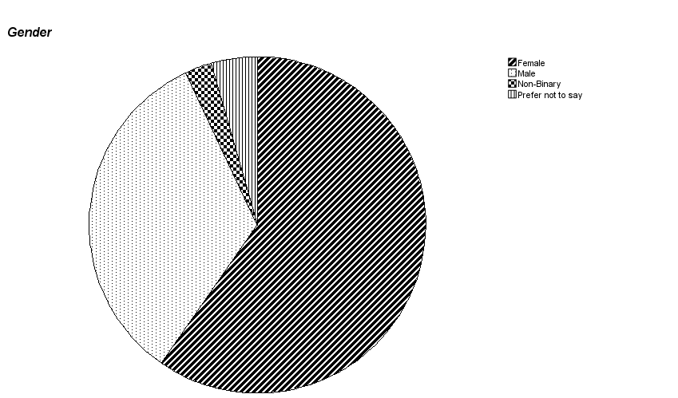

Materials
- Fake Information Sheet – with the fake aims of the study, investigating font choice on word puzzle completion, and fake information about the aims of the study [Appendix C]
- Game website – designed and hosted on Webflow. The website includes an embedded iframe game of a Wordle-like game and a fake, non-active cookie banner popup [appendix H]
- Internet Users Information privacy concerns scale (IUIPC-8) – Measures participants' privacy concerns along three subscales (collection, awareness, control). Consisting of questions such as “A good consumer online privacy policy should have a clear and conspicuous disclosure” rating their agreement on a 7-point Likert scale [Appendix I] The 8 items scale was adapted from the original IUIPC-10 (Malhotra et al 2004) one of the most used internet privacy concerns scales it removes two items [ctrl3] and [Awa3] to improve internal reliability. The Cronbach's alpha (α) and McDonald's Omega (ω) were calculated and compared to the reliability reported for the IPIUC- 10 (Gross 2021) and the IPIUC-8 gross (2021), this study reported higher α and ω than the IPICU – 10 in control and awareness and similar values for the collection subscale. This study reported similar α and ω to the IUIPC-8. Full values are displayed in Table 3.
- Privacy fatigue scale (Choi et al 2018)– measures participants' fatigue in relation to privacy and comprises two subscales (emotional exhaustion, cynicism). Participants answer questions such as “It is tiresome for me to care about online privacy” and rate their agreement on a 7-point Likert scale. [Appendix J] The current study found high internal reliability in the subscale’s exhaustion (a=.766) and cynicism (a=.803), which is in line with the original reliability (Choi et al 2018) of (α=.796) and (α=.791), respectively.
- Tobii Pro Spark eye tracker (2022) - a screen-based eye tracker was used to capture participants' gaze data at a sampling rate of 60Hz. The device was mounted to the bottom bezel of a 27” monitor with a 1920x 1080 resolution.
- Tobii Pro Lab (2025)(Version 25.23)- was used to export the primary metric reported, which was total fixation duration (TFD) in Areas of interest (AOIs). This was chosen as it accounts for the sum of fixations (active cognitive processing) within each AOI. This is backed by Bačić and Henry (2022). Who highlights TFD as an effective way of measuring cognitive effort, which would be associated with reading.
- Microsoft booking from- was used to book the time slots in the lab. It also served as the initial consent form to allow the researcher to collect eye tracking data prior to reading of the (Fake) information sheet. [Appendix D]
- Debrief sheet- explained the deception used, reminding Participants of their right to withdraw, as well as support services and the researcher's contact information [Appendix E]

Table 3
Reliability of IUIPC-10 vs IUIPC-8

Scale | IUIPC-10 (Gross 2021) |  | IUIPC-8 (Gross 2021) |  |  | IUIPC-8 (current study 2026)
 | α | ω |  | α | ω |  | α | ω
Ctrl | 0.62 | 0.66 |  | 0.72 | 0.72 |  | 0.68 | 0.68*
Aware | 0.64 | 0.66 |  | 0.76 | 0.78 |  | 0.84 | 0.84*
Collect | 0.91 | 0.91 |  | 0.91 | 0.91 |  | 0.86 | .86
*Two Item subscale, a tau- equivalent model was assumed, leading to ω = α

Material development
To identify the design of these cookie pop-ups, the top twenty websites by monthly search volume from Statista, SEMrush, and SimilarWeb were identified. 28 websites were identified, and 21 were used in the analysis inclusion criteria for the analysis are shown in Appendix K. Results show 80.5% had a cookie banner pop-up, 64.7% of which contained three options. The most common being 'accept all', 'reject all', and “more”. Many sites prompted the user to select favourable sections or used tactics such as colour to dissuade negative choices. Similarly, use of positive vs negative framing to push consumers' choices, such as "Accept only essential cookies” instead of the more common “Reject optional cookies. Based on this, the cookie banner for the study was designed as shown in Figure 2. To ensure ethical compliance with the IADT Psychology Ethics committee, every aspect must be optional; as such, people are allowed to not answer the cookie question, which is typically mandatory on websites.

Figure 2
Fake cookie pop up banner
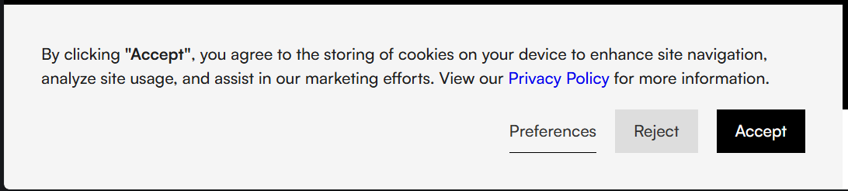

Procedure

- Participants were recruited by convenience sample and asked to book an eye tracking slot on the Microsoft booking form, where they give consent for eye-tracking data to be collected.
- Participants showed up to their booking on time and will be greeted by the researcher and given an instruction sheet [Appendix L] on how to begin the study
- Following these instructions, they will insert their unique code into the Topi Spark Pro software and begin the standard 5-point eye tracker calibration. Providing they achieve a data loss below 10%, they will continue; if not, the participant will redo this step.
- They will complete the fake information sheet [Appendix A] using the space for the next page and Y/N to give consent.
- The participants will be shown an information slide [appendix M] that explains the instructions for the following section
- The participant was guided to the website [appendix H], where they were instructed to make one attempt at the medium difficulty Wordle-like game. There was also a cookie banner. The researcher will give no guidance on this banner, and the Participant will have the choice to do as they want.
- The participant then filled in a Microsoft Forms containing demographic questions and reconfirmed their anonymised code, then they will complete the privacy fatigue scale [appendix J] and the privacy concerns scale [appendix I]
- Upon completion, the participant will be shown the debrief sheet [appendix E], which explains the deception. This will also be verbally explained by the researcher, and they will be given a physical copy to keep.
- They will then be asked to reconfirm their consent and thanked for taking part in the study

Results

Descriptive statistics

Demographics
Three participants were excluded for incomplete data n=111. The modal gender was female with 68 people, 36 men, 3 non-binary and 4 who preferred not to say. The study reports a mean age = 22.02 years (SD =5.86). Ages ranged from 18 to 68 of which 95% of the participants are under 27 years. A stacked histogram below shows the distribution mean and standard deviations of age by gender in the figure 3

Figure 3
Histogram showing gender by age

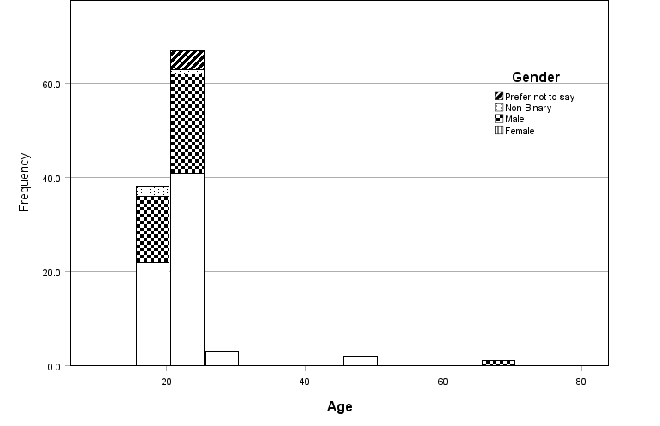

Privacy concerns
Privacy concerns were measured using the IUIPC- 8 (Gross, 2021) using three subscales: Control, M=10.67 (SD =2.20), Awareness, M= 12.67 (SD = 1.401), and Collection, M= 22.35 (SD = 4.75). Shapiro-Wilk test showed that normal distribution was violated across all three subscales, as indicated below in Table 5. All three subscales reported a negative skew, illustrated in Figures 4 and described in Table 6

Table 5
Tests of Normality
 | Shapiro-Wilk
 | W | Df |  | Sig.
Privacy concerns - Control | .953 | 114 |  | <.001
Privacy Concerns - Awareness | .771 | 114 |  | <.001
Privacy concerns - Collection | .907 | 114 |  | <.001

Table 6
Descriptive Statistics
 |  |  |  | Skewness |  | Kurtosis
 | N | M | SD | Statistic | Std. Error | Statistic | Std. Error
Privacy concerns - Control | 114 | 10.67 | 2.201 | -.403 | .226 | -.293 | .449
Privacy Concerns - Awareness | 114 | 12.90 | 1.401 | -1.259 | .226 | 1.162 | .449
Privacy concerns - Collection | 114 | 22.35 | 4.745 | -1.146 | .226 | 1.543 | .449

Figure 4
Set Histograms displaying privacy concerns subscales
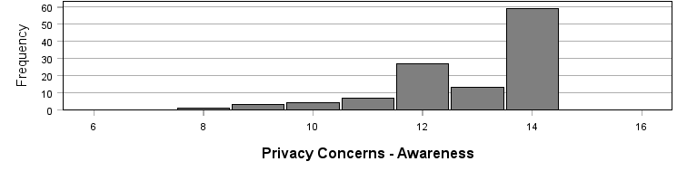
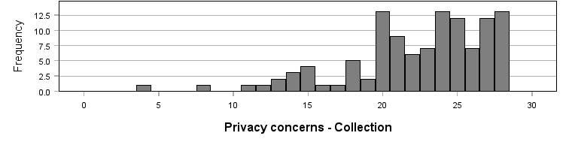
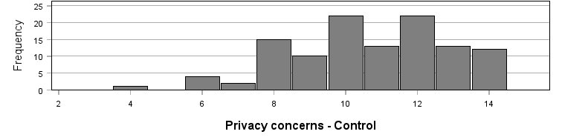

Total privacy concerns showed a mean = 45.92 (SD = 6.02), and a Shapiro-Wilk test showed normal distribution was violated, W (114)= .971, p =.014. The data has a slight platykurtic distribution with kurtosis of -.353 (SE.449) with a negligible negative skew of -.276 (SE=.226), as shown in Figure 5 below.

Figure 5
Histogram of privacy concerns
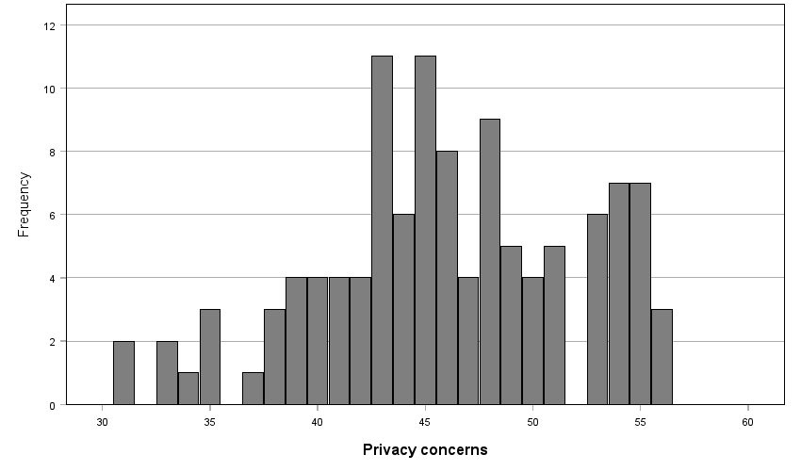

Privacy Fatigue
Privacy fatigue was measured using the Privacy Fatigue Scale (Choi et al 2018) with two subscales of emotional exhaustion, M = 13.56 (SD = 3.90), and Privacy cynicism, M = 11.19 (SD = 4.4). The Shapiro-Wilk test showed that the normal distribution was violated across both subscales and is indicated below in Table 7. Both subscales had a platykurtic distribution and small skewness, as shown in Table 8 and illustrated in Figure 6

Table 7
Tests of Normality
 | Shapiro-Wilk
 | Statistic | df |  | Sig.
Privacy fatigue - Cynicism | .972 | 114 |  | .017
Privacy fatigue - Emotional exhaustion | .977 | 114 |  | .047

Table 8
Descriptive Statistics
 |  |  |  | Skewness |  | Kurtosis
 | N | M | SD | Statistic | Std. Error | Statistic | Std. Error
Privacy fatigue - Emotional exhaustion | 114 | 13.56 | 3.904 | -.129 | .226 | -.677 | .449
Privacy fatigue - Cynicism | 114 | 11.19 | 4.476 | .159 | .226 | -.856 | .449

Figure 6
Set Histograms displaying privacy fatigue subscales
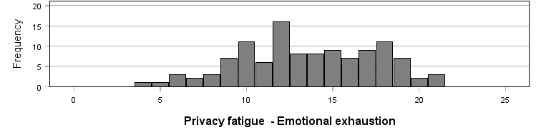
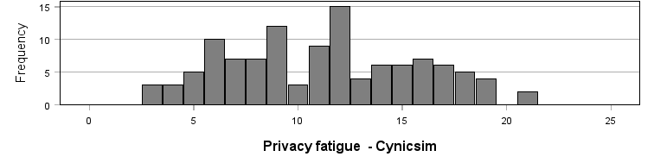

Total privacy concerns scores showed a mean = 24.75 (SD = 6.09), and a Shapiro-Wilk test showed the data followed a normal distribution, W (114)= .980, p =.087. The data has a slight leptokurtic distribution with kurtosis of .437 (SE.449) with a negligible positive skew of .076 (SE=.226), as shown in Figure 7 below.

Figure 7
Histogram displaying the total privacy fatigue

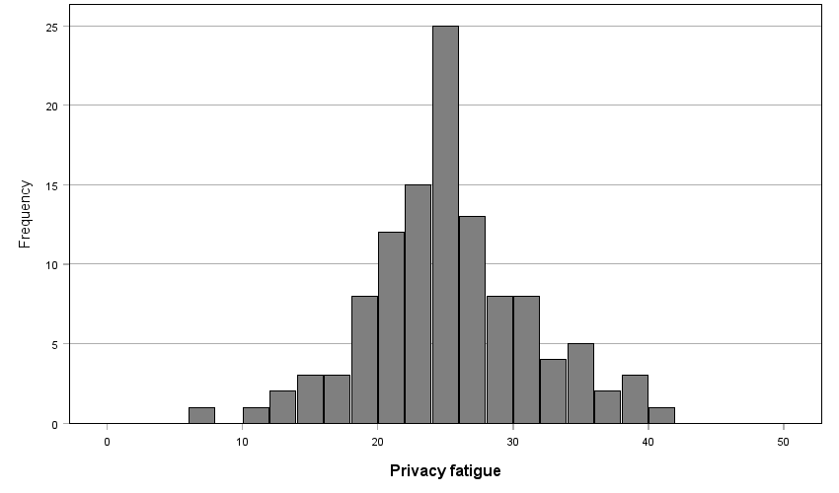

Cookie selection
When examining cookie selection, most people 62.3% selected all cookies, rejected all 28.1% and 8.8% ignoring the pop-up. Table 9 shows a breakdown by gender, and Figure 8 shows the distribution by age and gender

Table 9
Cookie selection * Gender Crosstabulation
 |  | Gender |  |  |  | Total
 |  | Female | Male | Non-Binary | Prefer not to say
Cookie selection | Accept all | 45 | 22 | 2 | 2 | 71
Cookie selection | Reject all | 16 | 13 | 1 | 2 | 32
Cookie selection | Ignore | 7 | 2 | 0 | 1 | 10
Total |  | 68 | 37 | 3 | 5 | 113

Figure 8
Cookie selection by gender and age
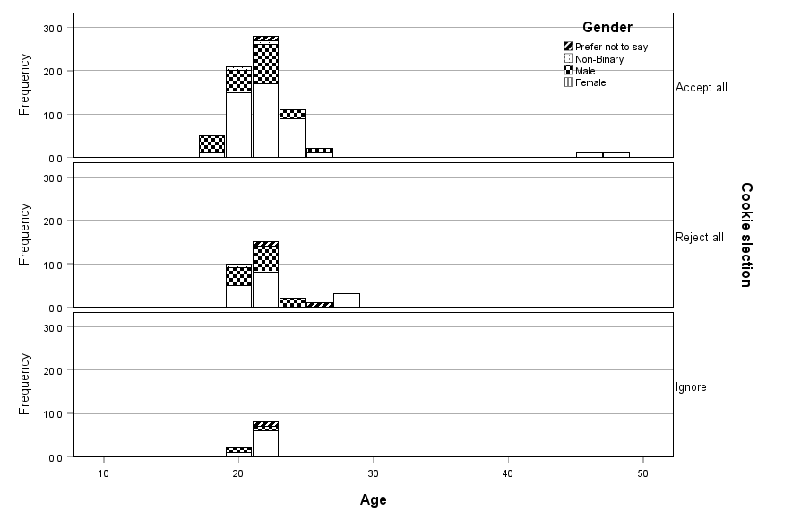

Reading duration
To examine participants' reading duration, the Tobii eye tracker collected fixation duration of the following sections: Title, headings, paragraphs, buttons, and the whole slide. When examining the total duration, a mean = 47,498Ms (SD = 37,263), and a Shapiro-Wilk test showed the data violated the assumption of normal distribution, W (114)= .890, p <.001. The data has a leptokurtic distribution with kurtosis of 1.58 (SE.449) with a positive negative skew of 1.28 (SE=.226), as shown in Figure 9 below.

Figure 9
Distribution of fixation durations
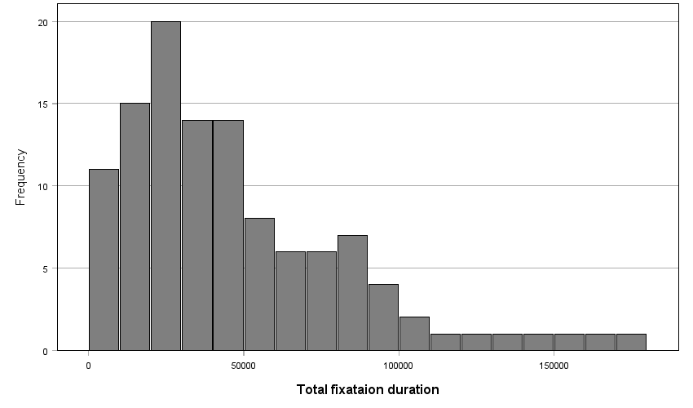
When breaking it down, participants spent most of their time looking at the Paragraphs 82%, 11% at the heading, 5% on the buttons, and 2% on the headings. All sections have a positive skew and high kurtosis; however, it is notably higher for titles and lower for the buttons. The full descriptive statistics are displayed in Table 10 below.The information sheet consisted of 5 separate slides, the titles of which the participants read through. Table 11 shows the M and SD of each slide, while Figure 10 shows the 65 % drop off in fixation duration from slide one to five

Table 10
Fixation durations by section of the information sheet
Fixations in Ms | N | M | SD | Skewness |  | Kurtosis
Fixations in Ms | Statistic | Statistic | Statistic | Statistic | SE | Statistic | SE
Total | 114 | 47498 | 36210 | 1.282 | .226 | 1.580 | .449
Titles | 114 | 844 | 1074 | 2.432 | .226 | 7.936 | .449
Headings | 114 | 4510 | 3504 | 1.224 | .226 | 1.176 | .449
Paragraphs | 114 | 34821 | 30772 | 1.352 | .226 | 1.675 | .449
Buttons | 114 | 2146 | 1130 | .744 | .226 | .595 | .449
Valid N | 114

Table 11
Means of each slide
 |  | N | Minimum | Maximum | Mean | Std. Deviation
Slide 5 Total |  | 114 | 100 | 22808 | 6484.59 | 4918.969
Slide 4 Total |  | 114 | 265 | 39745 | 6072.54 | 7999.219
Slide 3 Total |  | 114 | 83 | 42558 | 10137.11 | 8843.851
Slide 2 Total |  | 114 | 550 | 29690 | 6651.64 | 5248.745
Slide 1 Total |  | 114 | 541 | 119087 | 18152.18 | 16156.109

Figure 10
Line graph of the reading duration of each slide

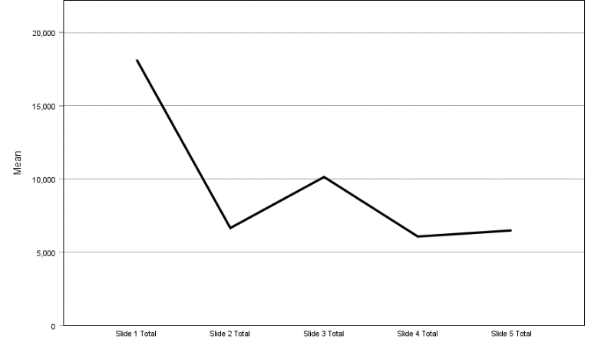

A quantitative analysis of the Heat maps shown below in Figure 11 shows the mean fixations of each slide. On each slide, a clear f-shaped reading pattern is observed, as well as a focus on the headings of each paragraph and the button on each slide

Figure 11
Slide 1 heat map with slides 2-5 presented below
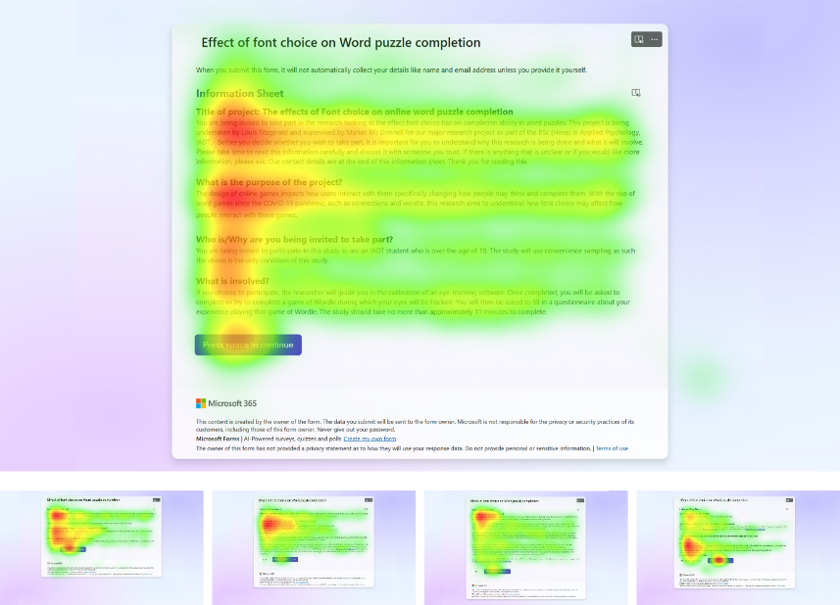

Inferential statistics
A multiple linear regression was intended to be conducted; the assumption of normal distribution of the target factor was violated, W (114)= .890, p <.001. As such, a series of Bivariate correlations was conducted to assess the next step. Results of these correlations are shown in Table 12 and show no significant correlation between the factors and the target factors, with significance ranging from .125 to .824 and are summarised graphically on the correlation matrix below in Figure 12.

Figure 12
Correlation matrix of target factors

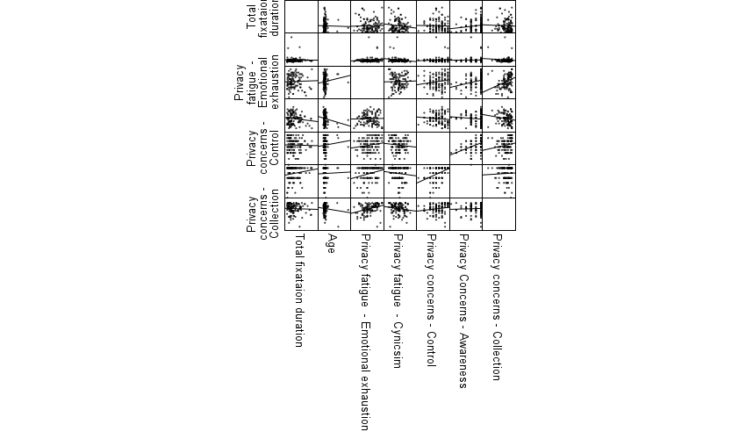

Table 12
 |  |  | Correlations
 |  |  |  | Privacy fatigue - Emotional exhaustion | Privacy fatigue - Cynicism | Privacy concerns - Control | Privacy Concerns - Awareness | Privacy concerns - Collection | Privacy concerns | Privacy fatigue | Cookie selection | Age | Total fixation duration
Privacy fatigue  - Emotional exhaustion |  | Pearson Correlation |  | --
 |  | N |  | 114
Privacy fatigue  - Cynicism |  | Pearson Correlation |  | .053 | --
 |  | Sig. (2-tailed) |  | .575
 |  | N |  | 114 | 114
Privacy concerns  - Control |  | Pearson Correlation |  | .165 | -.073 | --
 |  | Sig. (2-tailed) |  | .079 | .438
 |  | N |  | 114 | 114 | 114
Privacy Concerns  - Awareness |  | Pearson Correlation |  | .266** | -.084 | .423** | --
 |  | Sig. (2-tailed) |  | .004 | .372 | <.001
 |  | N |  | 114 | 114 | 114 | 114
Privacy concerns  - Collection |  | Pearson Correlation |  | .343** | -.142 | .172 | .049 | --
 |  | Sig. (2-tailed) |  | <.001 | .132 | .067 | .604
 |  | N |  | 114 | 114 | 114 | 114 | 114
Privacy concerns |  | Pearson Correlation |  | .393** | -.159 | .600** | .426** | .863** | --
 |  | Sig. (2-tailed) |  | <.001 | .092 | <.001 | <.001 | <.001
 |  | N |  | 114 | 114 | 114 | 114 | 114 | 114
Privacy fatigue |  | Pearson Correlation |  | .680** | .769** | .052 | .108 | .115 | .135 | --
 |  | Sig. (2-tailed) |  | <.001 | <.001 | .583 | .252 | .222 | .152
 |  | N |  | 114 | 114 | 114 | 114 | 114 | 114 | 114
Cookie selection |  | Spearman’s rho |  | .162 | -.154 | 0.37 | -.083 | .176 | .138 | -0.26 | --
 |  | Sig. (2-tailed) |  | .087 | .104 | .699 | .384 | .062 | .144 | .786
 |  | N |  | 113 | 113 | 113 | 113 | 113 | 113 | 113 | 113
Age |  | Pearson Correlation |  | .111 | -.167 | .084 | .024 | -.102 | -.045 | -051 | .021 | --
 |  | Sig.(2-tailed) |  | .247 | .081 | .383 | .801 | .289 | .641 | .595 | .827
 |  | N |  | 111 | 111 | 111 | 111 | 111 | 111 | 111 | 110 | 111
Total fixation duration |  | Pearson Correlation |  | .021 | -.142 | -.037 | .145 | -.043 | -.014 | -.091 | .067 | -.017 | --
 |  | Sig. (2-tailed) |  | .824 | .131 | .697 | .125 | .646 | .882 | .335 | .479 | .861
 |  | N |  | 114 | 114 | 114 | 114 | 114 | 114 | 114 | 113 | 111 | 114
 |  |  | **. Correlation is significant at the 0.01 level (2-tailed).

A power analysis was conducted for the bivariate correlational analysis results, which show all achieved a strong power >.80. Full results are shown in Table 13 below. N = 111 was used for age, and n =113 was used for cookie selection due to the exclusion of one participant based on incomplete data.

Table 13
Power Analysis Table
 | Power^{b} | Test Assumptions
 | Power^{b} | N | Null | Alternative | Sig.
Pearson Correlation | .906 | 114 | 0 | .3 | .05
Pearsons corelation | .898 | 111 | 0 | .3 | .05
Spearman’s rho | .888 | 113 | 0 | .3 | .05
a. Two-sided test.
b. Based on Fisher's z-transformation and normal approximation with bias adjustment.

Based on these results, the multiple regression was not progressed further. Upon examining the correlation, a significant correlation was found between the Privacy Fatigue subscale of Emotional Exhaustion and two of the three subscales of privacy concerns: Awareness and Collection. The total privacy concern scale also correlates; all three of these are reported to be significant at the 0.01 level. As such, the researcher deemed it justified to conduct an exploratory analysis to examine this correlation.

The study aimed to further examine this correlation. The participants were grouped into three groups: high emotional exhaustion, medium emotional exhaustion and low emotional exhaustion. The boundaries are based on M \+ 0.5 Sd, which results in >16 being higher, and 15-12 being medium, while <11 being lower.

Given the violation of the normal distribution in the subscales, a one-way ANOVA was conducted to examine whether there is a difference in participants' privacy concerns based on emotional exhaustion. The assumption of homogeneity was not violated, Levene's (2,11) = 1.02, p =.364. Findings show that there is a significant increase in privacy concerns based on emotional exhaustion, F(2,111)= 9.98, sig <.001. A post hoc test with Bonferroni adjustment was conducted, showing a significant difference between low and high (p <.001, 95% C.I. =[-8.77, -2.49]) and medium and high (p=.004, 95% C.I.=[-7.11,-1.04). There was no significant difference between low and medium. The means and standard deviations are displayed in Table 14 below and in Figure 13
Table 14
Descriptive statistics
 | N | Mean | Std. Deviation | Std. Error | 95% Confidence Interval for Mean
 |  |  |  |  | Lower Bound | Upper Bound
Low emotional exhaustion | 34 | 43.47 | 6.146 | 1.054 | 41.33 | 45.61
Medium emotional exhaustion | 41 | 44.98 | 4.907 | .766 | 43.43 | 46.52
High emotional exhaustion | 39 | 49.05 | 5.749 | .921 | 47.19 | 50.91
Total | 114 | 45.92 | 6.015 | .563 | 44.80 | 47.04

Figure 13
Line graph of means
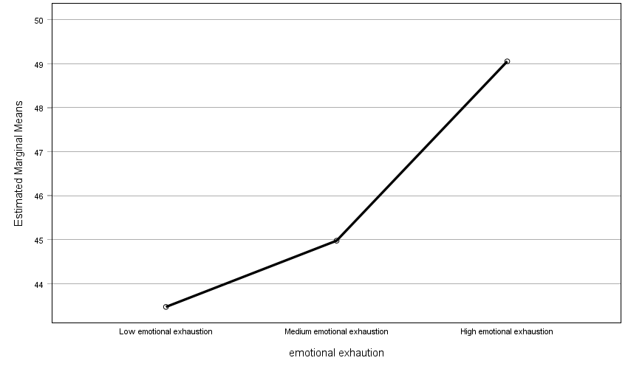

Discussion

The current study aimed to examine the privacy paradox in academic research by examining privacy concerns and privacy fatigue. Ha1: There is a correlation between privacy concerns, privacy fatigue, age, cookie selection, and participants' total fixation duration in an information sheet and consent form. The results of the study fail to reject the null hypotheses for the main hypotheses Ha1 and all sub-hypotheses A-H. No correlation was found between any factors and the target factor and reading duration. These findings are contrary to those of Paspatis et al. (2023) and Baruh et al (2017), both of which showed that these factors influence privacy behaviour formation, indicating the presence of the privacy paradox in academic research. The results have sufficient statistical power to show that if there was a small effect, one would have been found, allowing the study to report that these factors have no effect on reading duration.

While the IPUIC-8, Cronbach's alpha and McDonald's alpha were higher than those of the IPUIC-10 shown in table 3 (Gross 2021), the reduction of two questions could have led to low construct validity. This is backed up by the high kurtosis and skewness, which indicate a ceiling effect, in which participants are hitting the higher end score, which may not be an accurate reflection of privacy concerns. Particularly when examining individual subscales, for example, when looking at the awareness subscale, not a single participant fell below the 50% of scores, indicating this scale has not measured low privacy concerns, subscale of awareness.

Similarly, when looking at the descriptive statists of reading. It shows people spend a low amount of time reading content forms, with a mean time of 47.498 seconds. The results show a significant fall off in reading duration as the slides progress from slide 1 to 5, potentially indicating that the length of the form and attention or content may impact reading as they progress, aligning with the findings of Shao et al. (2021) that increased or too much information reduced privacy behaviour. Interestingly, privacy fatigue doesn’t show the ceiling effect to the same extent as privacy concerns. Privacy fatigue total was normally distributed, despite the subscales not being normally distributed.

Cookie selection aligned with the previous literature, with 60% people accepting all, similar to the findings of Boerman et al. (2018). Hhowever, this had no correlation with reading duration. This may suggest that cookie selection may not be driven from a privacy standpoint and could be an automatic process. Aligning with heuristic cognitive bias theory (Memarian et al., 2025). This may be a methodological artefact due to the role of cookies being less important on the laboratory computer, which was not the participant's own machine, and consequently, they had lower investments in sharing personal cookies.

Exploratory analysis
Given the inability to further explore the RQ and the correlational analysis of the factors of privacy behaviour formation, further exploratory analysis was conducted on the factors themselves. A correlation was noted between privacy concern subscales of awareness and collection and the privacy fatigue subscale of emotional exhaustion. Given the high significance at .001, the researcher found it justified to further examine this relationship. Based on the absence of any previous literature that groups participants based on emotional exhaustion, the participants were grouped into three groups: high emotional exhaustion, medium emotional exhaustion and low emotional exhaustion based on the standard Standard Error of Measurement M \+ 0.5 Sd. ). Results found a significant increase in participants' total privacy concerns based on the emotional exhaustion of privacy, specifically, when examining low to high and medium to high. This is in direct contrast to findings by Shao et al (2021), which found that emotional exhaustion reduced privacy concerns but still had a small positive correlation. This highlights the need for more research in the area.

Theoretical Application
The results of this study indicated support that the privacy paradox is present in informed consent collection, in line with Kokolakis (2017), with the current study finding no correlation between factors and reading. It highlights the incongruence between people's beliefs when it comes to intentions and actual behaviour in academic research. When examining this behaviour in terms of theoretical approaches these findings show a discrepancy with bounded rationality decision-making, as the participants were fully aware of everything. It suggests the larger role of social influence and heuristic thinking supports research(Memarian et al., 2025; Bath & DeJong, 2017). Similarly, Quinn (2016) examined habitual behaviour, which could explain the high percentage of cookies being rejected, but the low reading duration regardless. Both highlight the increased shift away from rational theories of choice to irrational ones and the importance of context and social theory.

While steps were taken to minimise the jingle problem (Thorndike 1904), by using the eye tracker, the validity of the scale and the ceiling effect may result in methodological artefacts as discussed in the limitations below. This study highlights the issues with gaining rational and informed consent when conducting undergraduate research and explores the flaws in the use of information sheets and consent forms. It proposes a question about the reliability of these tools to ensure informed consent, which remains a core foundation of ethical research.

Strengths
The study builds upon the previous research by conducting a quantitative observational eye-tracking study. Kokolakis (2017) points out the flaws in many of the papers with their over-reliance on self-report data. This study used deception to reduce the Hawthorne effect and eye tracking data to standardise the reading of information sheets to overcome these limitations and provided strong statistical support that enhances the body of literature around the privacy paradox.

This study identified a clear gap in the current literature by examining the privacy paradox in an academic setting (Meremian, 2025), using this sample due to its high overrepresentation in psychology studies (Thalamyer et al., 2021). To the best of the author's knowledge, the author was the first to study the paradox in this context. It provides a strong basis for the further study of consent forms and aligns with the current research shift towards heuristics and social theory (Meremian 2025).

Limitations
This study examined the privacy paradox only in IADT. While this is typically within the scope of research in an academic setting, it also limits the findings to the sample population by reducing the generalisability of the data across academic settings and study designs. One issue this could amplify is familiarity with the scientific processes; it may lead students to change their reading patterns. Despite this, the inclusion of this is analogous to real convenience sampling in which familiarity is not controlled for and may be a better representation of research participants.
Measurement of variables could also be seen as a weakness of this study. To obtain an eye tracking measure, the total fixation duration was used. This was chosen as it excludes the saccades between eye fixations, in which the eye does not process information. This gives a time that participants are looking and processing, but we cannot confirm that they are reading and may fall into the jingle problem (Thorndyke 1904), where unrelated users get grouped because of similar fields. While the F-patterns shown in Figure 11 indicate reading, this fails to account for comprehension and could just be a passive scanning pattern and heuristic processing.

Future research
This study has provided a strong and substantial foundation for examining the reading of consent forms and information sheets in research settings. Future research should further examine the factors above, examining them in relation to comprehension of consent forms, by potentially building in comprehension checks and examining how participants read and understand privacy information.

Future research should examine a wider set of factors, including previous knowledge of consent forms and course type, to examine the wider impacts. Most importantly, future studies should replicate this study in other higher education settings to assess its ecological validity, examining different contexts and information sheets, as well as how different populations affect the results. While this study used the IUIPC-8, it also brought concerns about its construct validity. Future research should aim to address this by examining the validity of the IUIPC-8 or examining privacy concerns using other scales and measures.

Conclusion
The study has provided support that the privacy paradox is present in academic research consent forms and information sheets, finding a lack of correlation between factors identified in previous literature and reading duration. The study aligns with the heuristics and social theory approach of the privacy paradox. It highlights the important need for more research into consent forms to design better tools for obtaining informed consent.

Reference list
** Amazon. (n.d.). Amazon homepage. Retrieved November 17, 2025, from https://www.amazon.com
Arnett, J. J. (2008). The neglected 95%: Why American psychology needs to become less American. American Psychologist, 63(7), 602–614. https://doi.org/10.1037/0003- 066X.63.7.602
Bačić, D., & Henry, R. (2022). Advancing our understanding and assessment of cognitive effort in the cognitive fit theory and data visualization context: Eye tracking-based approach. Decision Support Systems, 163, 113862.
** Baidu. (n.d.). Baidu homepage. Retrieved November 17, 2025, from https://www.baidu.com
Barth, S., & De Jong, M. D. (2017). The privacy paradox–Investigating discrepancies between expressed privacy concerns and actual online behaviour–A systematic literature review. Telematics and informatics, 34(7), 1038-1058.
Baruh, L., Secinti, E., & Cemalcilar, Z. (2017). Online privacy concerns and privacy management: A meta-analytical review. Journal of Communication, 67(1), 26–53. https://doi.org/10.1111/jcom.12276
** Bet.br. (n.d.). Bet.br homepage. Retrieved November 17, 2025, from https://www.bet.br
*Bickers, E. (2021). The relationship between self-efficacy, self-esteem and academic motivation [Bachelor’s thesis, Illustro/IADT]. http://hdl.handle.net/10779/iadt.25205699
** Bing. (n.d.). Bing search engine. Retrieved November 17, 2025, from https://www.bing.com
Boerman, S. C., Kruikemeier, S., & Zuiderveen Borgesius, F. J. (2018). Exploring Motivations for Online Privacy Protection Behavior: Insights From Panel Data. Communication Research, 48(7), 953- 977. https://doi.org/10.1177/0093650218800915 .
*Boucher, E. (2021). Job satisfaction and work engagement: The impact of gender and working from home in a COVID-19 environment [Bachelor’s thesis, Illustro/IADT]. https://hdl.handle.net/10779/iadt.25188776
*Boylan, L. (2024). Time to BeReal: Self-Perceived Authenticity Among SNS Users Across Platforms [Master’s thesis, Illustro/IADT]. http://hdl.handle.net/10779/iadt.30610613
*Branigan, E. (2023). Investigating the effect of lyrical and instrumental music on sport performance and performance anxiety in basketball players [Bachelor’s thesis, Illustro/IADT]. http://hdl.handle.net/10779/iadt.25219445
*Brennan, V. (2021). How the impacts of the Celtic Tiger on Irish culture and land is reflected in contemporary Irish art [Bachelor’s thesis, Illustro/IADT]. http://hdl.handle.net/10779/iadt.30601286
*Cannon, G.-K. (2024). Design's Deep Questions: Qualitative Insights from Technology Designers and Researchers on Existential HCI [Master’s thesis, Illustro/IADT]. http://hdl.handle.net/10779/iadt.30610640
*Carroll, C.-A. (2021). Investigating the effect of lyrical and instrumental music on sport performance and performance anxiety in basketball players [Bachelor’s thesis, Illustro/IADT]. http://hdl.handle.net/10779/iadt.25188800
*Chioato, C. (2021). The Centennials have come. The role of self-efficacy in proactive work behaviour through a generational cohort lens [Bachelor’s thesis, Illustro/IADT]. http://hdl.handle.net/10779/iadt.25188863
Chung, J., & Kwon, H. Y. (2025). Privacy fatigue and its effects on ChatGPT acceptance among undergraduate students: is privacy dead?. Education and Information Technologies, 30(9), 12321-12343.
Choi, H., Park, J., & Jung, Y. (2018). The role of privacy fatigue in online privacy behavior. Computers in Human Behavior, 81, 42-51.
*Corcoran, E. (2024). Do transparent artificial intelligence processes affect trust levels amongst end-users [Master’s thesis, Illustro/IADT]. https://hdl.handle.net/10779/iadt.30610682
*Curran, E. (2021). The relationship between self-esteem, extraversion, and life satisfaction in undergraduate students [Bachelor’s thesis, Illustro/IADT]. http://hdl.handle.net/10779/iadt.25205777
*Deveney, E. (2023). An investigation of the effect team selection and age has on athlete's grit [Bachelor’s thesis, Illustro/IADT]. http://hdl.handle.net/10779/iadt.25219460
*Doyle, B.-K. (2021). A correlational study of life satisfaction, materialism and a quiet ego [Bachelor’s thesis, Illustro/IADT]. https://hdl.handle.net/10779/iadt.25188926
*Doyle, C. J. (2021). Investigating the post-secondary education experience for students with Autism Spectrum Disorder [Bachelor’s thesis, Illustro/IADT]. https://hdl.handle.net/10779/iadt.25188887
** DuckDuckGo. (n.d.). DuckDuckGo privacy search. Retrieved November 17, 2025, from https://www.duckduckgo.com
Dun Laoghaire Institute of Art, Design and Technology. (2020). IADT ethics policy (Version 3)
*Dunne, D. (2021). Cyber harassment & celebrities: Exploring personality types, self- efficacy and the types and levels of cyber harassment experienced by celebrities across social media [Master’s thesis, Illustro/IADT]. https://hdl.handle.net/10779/iadt.25218242
*Feerick, E. (2024). Perceived Impact of Person-Centred Technology-Based AAC for adults with ASD [Master’s thesis, Illustro/IADT]. http://hdl.handle.net/10779/iadt.30610706
Flender, C., & Müller, G. (2012, June). Type indeterminacy in privacy decisions: the privacy paradox revisited. In International symposium on quantum interaction (pp. 148-159). Berlin, Heidelberg: Springer Berlin Heidelberg.
*Fortune, M. (2021). Social facilitation/ inhibition effects in remote usability testing [Bachelor’s thesis, Illustro/IADT]. https://hdl.handle.net/10779/iadt.25188941
Geoghegan, S. (2025, January 15). What is real time bidding? Electronic Privacy Information Center. https://epic.org/what-is-real-time-bidding/
*Goodall, I. (2023). An investigation into the differences, in personality traits and life satisfaction, between volunteer types [Bachelor’s thesis, Illustro/IADT]. http://hdl.handle.net/10779/iadt.25205114
** Google. (n.d.). Google search. Retrieved November 17, 2025, from https://www.google.com
Groß, T. (2021). Validity and reliability of the scale internet users’ information privacy concerns (iuipc). Proceedings on Privacy Enhancing Technologies.
Groß, T. (2023). Toward valid and reliable privacy concern scales: the example of iuipc-8. In Human Factors in Privacy Research (pp. 55-81). Cham: Springer International Publishing.
*Guest, R. (2022). Personality types and belief in conspiracy theories: A correlational study [Bachelor’s thesis, Illustro/IADT]. http://hdl.handle.net/10779/iadt.25204703
*Hale, C. (2021). An investigation into whether year of study in university and/ or hours of sleep affect undergraduate students' stress [Bachelor’s thesis, Illustro/IADT]. https://hdl.handle.net/10779/iadt.25189040
*Harcourt Thewlis, J. (2021). The role of online social support for individuals living with disabilities and chronic illness: Investigating stress, resilience and positive mental health [Master’s thesis, Illustro/IADT]. https://hdl.handle.net/10779/iadt.25218251
*Harley, E. (2021). The effects of contract-type and working hours on students' work engagement [Bachelor’s thesis, Illustro/IADT]. https://hdl.handle.net/10779/iadt.25189049
*Hayde, S. (2021). Am I what I wear? The relationship between clothing, mood enhancement and self-concept clarity [Bachelor’s thesis, Illustro/IADT]. https://hdl.handle.net/10779/iadt.25189088
Henrich, J., Heine, S. J., & Norenzayan, A. (2010). The weirdest people in the world?. Behavioral and brain sciences, 33(2-3), 61-83
*Horan Gahan, L. (2021). DBT therapist skill use, years of practice, and meaningful work: A correlational study [Bachelor’s thesis, Illustro/IADT]. http://hdl.handle.net/10779/iadt.25189112
*Hurba, K. (2023). Purpose, coherence, mattering and life crafting: The development and validation of a novel meaning-making intervention [Bachelor’s thesis, Illustro/IADT]. http://hdl.handle.net/10779/iadt.25205873
** Instagram. (n.d.). Instagram login. Retrieved November 17, 2025, from https://www.instagram.com
*Johnson, A. (2023). The relationship between self-efficacy, self-esteem, and academic motivation [Bachelor’s thesis, Illustro/IADT]. https://hdl.handle.net/10779/iadt.25205699
*Jones, C. (2021). The effect of empowered representation of women in media on female self- esteem [Bachelor’s thesis, Illustro/IADT]. https://hdl.handle.net/10779/iadt.25189163
*Kaczmarek-Gajewska, W. (2021). The effect of website colour saturation on trustworthiness and visual appeal impressions [Bachelor’s thesis, Illustro/IADT]. http://hdl.handle.net/10779/iadt.25189190
*Kavanagh, A. (2021). The anthropomorphic effect of chatbots using emoticons and emojis in conversation [Bachelor’s thesis, Illustro/IADT]. http://hdl.handle.net/10779/iadt.25189202
*Kelly, K. (2021). Diabetes technologies; An investigation into diabetes-related distress, satisfaction and perceived usability improvements [Master’s thesis, Illustro/IADT]. https://hdl.handle.net/10779/iadt.25218269
Kokolakis, S. (2017). Privacy attitudes and privacy behaviour: A review of current research on the privacy paradox phenomenon. Computers & Security, 64(1), 122–134. https://doi.org/10.1016/j.cose.2015.07.002
*Krstulovic, D. (2022). The effects of self-esteem and cultural orientation on conformity: A cross-cultural study [Bachelor’s thesis, Illustro/IADT]. https://hdl.handle.net/10779/iadt.25204598
Landsberger, H. A. (1958). Hawthorne revisited: Management and the worker, its critics, and developments in human relations in industry. Cornell University.
Laufer, R. S., & Wolfe, M. (1977). Privacy as a concept and a social issue: A multidimensional developmental theory. Journal of social Issues, 33(3), 22-42.
** LinkedIn. (n.d.). LinkedIn: Log in or sign up. Retrieved November 17, 2025, from https://www.linkedin.com
*Lu, Z. (2021). An investigation of individuals’ saving and spending attitude during COVID- 19 pandemic [Bachelor’s thesis, Illustro/IADT]. https://hdl.handle.net/10779/iadt.25195742
*Lynch, D. (2023). An investigation of the impact of soccer expertise on scan frequency, scan timing, and decision-making [Bachelor’s thesis, Illustro/IADT]. http://hdl.handle.net/10779/iadt.25219490
*MacHugh, J. (2021). The effects of interrupting and distracting notifications on flow and performance during multitasking [Bachelor’s thesis, Illustro/IADT]. http://hdl.handle.net/10779/iadt.25195763
*Mahady, L. (2021). Correlates of compliance with Covid-19 precautionary measures: empathy, age and gender [Bachelor’s thesis, Illustro/IADT]. https://hdl.handle.net/10779/iadt.25195868
*Mari, A. (2023). [Title Not Provided] [Master’s thesis, Illustro/IADT]. https://hdl.handle.net/10779/iadt.25218401
Malhotra, N. K., Kim, S. S., & Agarwal, J. (2004). Internet Users' Information Privacy Concerns (IUIPC): The Construct, the Scale, and a Causal Model. Information Systems Research, 15(4), 336–355. https://doi.org/10.1287/isre.1040.0032
*McCarthy, C. (2022). Investigating the impact of Tinder's user interface on choice and interaction with potential matches in online dating [Bachelor’s thesis, Illustro/IADT]. https://hdl.handle.net/10779/iadt.25204607
*McDonald, D. (2021). The effects of interrupting and distracting notifications on flow and performance during multitasking [Bachelor’s thesis, Illustro/IADT]. https://hdl.handle.net/10779/iadt.30610862
*McDonald, E. (2023). Exploring undergraduate students' attitudes towards class attendance and their motivations for attending [Bachelor’s thesis, Illustro/IADT]. https://hdl.handle.net/10779/iadt.25205750
*McDonnell, D. (2025). The effects of interrupting and distracting notifications on flow and performance during multitasking [Master’s thesis, Illustro/IADT]. https://hdl.handle.net/10779/iadt.30610862
*McEvoy, E. (2021). Investigating the relationship between social media and gratitude on materialism [Bachelor’s thesis, Illustro/IADT]. https://hdl.handle.net/10779/iadt.25196018
*Mc Grath, M. E. (2025). Queernormativity & freedom in Baldur's Gate 3: Enabling true self exploration & expression for queer players [Bachelor’s thesis, Illustro/IADT]. https://hdl.handle.net/10779/iadt.30610784
*McKeown, D. (2021). Investigation into the role of sport psychologists in esports [Bachelor’s thesis, Illustro/IADT]. https://hdl.handle.net/10779/iadt.25196270
*McLean, H. (2021). Investigating differences in first-year undergraduates' sense of community based on collaborative engagement, learning environment and lecture size [Bachelor’s thesis, Illustro/IADT]. https://hdl.handle.net/10779/iadt.25196294
*Meagher, J. (2021). The effect of work environment and gender on individuals' job satisfaction during the COVID-19 pandemic [Bachelor’s thesis, Illustro/IADT]. https://hdl.handle.net/10779/iadt.25196312
* Meta. (n.d.). Facebook homepage. Retrieved November 17, 2025, from https://www.facebook.com
*Melvin, E. (2023). The perfect game: the effect of perfectionism and performance, on game experiences [Master’s thesis, Illustro/IADT]. https://hdl.handle.net/10779/iadt.25218440
Memarian, S., Malgonde, O. S., & Kim, D. J. (2025). Unraveling the Privacy Paradox: a Comprehensive Review of Factors Behind the Discrepancy in Online Concerns and Disclosure Behavior. Information Systems Frontiers, 1-22.
** Microsoft. (n.d.). MSN news. Retrieved November 17, 2025, from https://www.msn.com
** Microsoft. (n.d.). Office homepage. Retrieved November 17, 2025, from https://www.office.com
*Milne, N. (2021). A comparison of subjective numeracy and the usability of an online banking tool [Bachelor’s thesis, Illustro/IADT]. https://hdl.handle.net/10779/iadt.25196360
*Montague, R. (2023). The relationship between self-esteem, extraversion, and life satisfaction in undergraduate students [Bachelor’s thesis, Illustro/IADT]. https://hdl.handle.net/10779/iadt.25205777
*Moran, C. G. (2022). Experimental investigation of the effects of caffeine consumption on eyewitness memory [Bachelor’s thesis, Illustro/IADT]. https://hdl.handle.net/10779/iadt.25204589
*Mullett, O. (2021). The effects of work setting on perceived organisational support, work engagement and well-being in Ireland during COVID-19 [Bachelor’s thesis, Illustro/IADT]. https://hdl.handle.net/10779/iadt.25196828
*Murphy, M. (2023). An investigation into adaptive self presentation online and differences in personality presentation within multiple online spaces [Bachelor’s thesis, Illustro/IADT]. https://hdl.handle.net/10779/iadt.25205795
Mwaisumo, D., Halpern, N., Budd, T., Suau-Sanchez, P., & Bråthen, S. (2021).Privacy Concerns Scale [Database record]. Retrieved from PsycTESTS. Doi:https://dx.doi.org/10.1037/t86825-000
National Institute for Health and Care Research. (n.d.). Annual statistics. https://www.nihr.ac.uk/about-us/who-we-are/reports-and-performance/annual- statistics
*Naughton, O. (2021). The effects of media and proximity on the stigma of mental illness [Bachelor’s thesis, Illustro/IADT]. https://hdl.handle.net/10779/iadt.25197179
** Naver. (n.d.). Naver portal. Retrieved November 17, 2025, from https://www.naver.com
** Netflix. (n.d.). Netflix login. Retrieved November 17, 2025, from https://www.netflix.com
*O’ Byrne, E. (2023). An investigation into the effects of cosmetic use and personality traits on self-esteem [Bachelor’s thesis, Illustro/IADT]. https://hdl.handle.net/10779/iadt.25205807
*O’Connor, M. (2021). Exercise motivation through social media, gender and content-type [Bachelor’s thesis, Illustro/IADT]. https://hdl.handle.net/10779/iadt.25197188
Office for National Statistics. (2024). Estimates of the population for the UK, England, Wales, Scotland, and Northern Ireland: Mid-2024 [Data set]. https://www.ons.gov.uk/peoplepopulationandcommunity/populationandm igration/populationestimates/datasets/populationestimatesforukenglandandwalesscotla ndandnorthernireland
*O’Keeffe, A. (2021). The effects of gender congruency, risk propensity and purchasing frequency on perceived risk of online shopping websites [Bachelor’s thesis, Illustro/IADT]. https://hdl.handle.net/10779/iadt.25197194
*O’Malley, D. (2023). The Dunning-Kruger Effect: The influence of gender and intuition on score estimation [Bachelor’s thesis, Illustro/IADT]. https://hdl.handle.net/10779/iadt.25205828
** OpenAI. (n.d.). ChatGPT. Retrieved November 17, 2025, from https://chatgpt.com
Paspatis, I., Tsohou, A., & Kokolakis, S. (2023). How Is Privacy Behavior Formulated? A Review of Current Research and Synthesis of Information Privacy Behavioral Factors. Multimodal Technologies and Interaction, 7(8), 76. https://doi.org/10.3390/mti7080076
** Pornhub. (n.d.). Pornhub homepage. Retrieved November 17, 2025,
*Pigott, E. (2021). An investigation of well-being, self-efficacy, and life-satisfaction among dancers of different dance genres [Bachelor’s thesis, Illustro/IADT]. https://hdl.handle.net/10779/iadt.25197200
Psychological Society of Ireland. (2025). Code of professional ethics. https://www.psychologicalsociety.ie/
Quinn, K. (2016). Why we share: A uses and gratifications approach to privacy regulation in social media use. Journal of Broadcasting & Electronic Media, 60(1), 61-86.
** Reddit. (n.d.). Reddit: The front page of the internet. Retrieved November 17, 2025,
Regulation (EU) 2016/679 of the European Parliament and of the Council of 27 April 2016 on the protection of natural persons about the processing of personal data and the free movement of such data, and repealing Directive 95/46/EC (General Data Protection Regulation) (Text with EEA relevance). (2016). Official Journal, L 119, 1-88. ELI: https://eur-lex.europa.eu/legal-content/EN/TXT/?uri=CELEX:32016R0679
*Richardson, J. (2022). Queernormativity & freedom in Baldur's Gate 3: Enabling true self exploration & expression for queer players [Bachelor’s thesis, Illustro/IADT]. http://hdl.handle.net/10779/iadt.26213123
Ryan, J. (2022, May 16). ICCL report on the scale of Real-Time Bidding data broadcasts in the U.S. and Europe. Irish Council for Civil Liberties. https://www.iccl.ie/news/iccl- report-on-the-scale-of-real-time-bidding-data-broadcasts-in-the-u-s-and-europe/
*Searson, L. (2021). #RelatableContent: The relationship between social attraction and extraversion in TikTok videos [Bachelor’s thesis, Illustro/IADT]. https://hdl.handle.net/10779/iadt.25197212
Shao, H., Li, X., & Wang, G. (2022, April). Are you tired? I am: Trying to understand privacy fatigue of social media users. In CHI Conference on Human Factors in Computing Systems Extended Abstracts (pp. 1-7).
*Snow, D. (2021). Music's interaction with virtual environments: Emotion and perception [Master’s thesis, Illustro/IADT]. https://hdl.handle.net/10779/iadt.25218344
*Stepanova, K. (2021). Fashion sustainability: Factors which influence ecological fashion behaviours [Bachelor’s thesis, Illustro/IADT]. https://hdl.handle.net/10779/iadt.25197215
*Supple, K. (2021). Cognitive reappraisal and expressive suppression: Investigating relationships with subjective well-being and age [Bachelor’s thesis, Illustro/IADT]. https://hdl.handle.net/10779/iadt.25204442
** Temu. (n.d.). Temu official site. Retrieved November 17, 2025, from https://www.temu.com
Thalmayer, A. G., Toscanelli, C., & Arnett, J. J. (2021). The neglected 95% revisited: Is American psychology becoming less American? American Psychologist, 76(1), 116– 129. https://doi.org/10.1037/amp0000622
Thorndike, E. L. (1904). Theory of mental and social measurements. The Science Press. https://doi.org/10.1037/13283-000
Tian, X., Chen, L., & Zhang, X. (2022). The role of privacy fatigue in privacy paradox: a PSM and heterogeneity analysis. Applied Sciences, 12(19), 9702.
** TikTok. (n.d.). TikTok - Make Your Day. Retrieved November 17, 2025, from https://www.tiktok.com
Tobii AB (2025). Tobii Pro Lab (Version 25.23) [Computer software]. Danderyd, Sweden: Tobii AB.
Tobii AB. (2022). Tobii Pro Spark eye tracker [Apparatus]. Danderyd, Sweden: Tobii AB
*Tobin, E. (2021). An exploration of exercise motivation, based on self-esteem and exercise self-efficacy [Bachelor’s thesis, Illustro/IADT]. https://hdl.handle.net/10779/iadt.25204466
*Tynan, L. (2021). The relationship between image-based and text-based social media usage and self-esteem [Bachelor’s thesis, Illustro/IADT]. https://hdl.handle.net/10779/iadt.25204523
University of Sheffield. (n.d.). Clive Humby. https://sheffield.ac.uk/cs/people/academic- visitors/clive-humby
*Valentinaviciute, I. (2023). Investigating the effects of life satisfaction and gender on leisure perception [Bachelor’s thesis, Illustro/IADT]. https://hdl.handle.net/10779/iadt.25205861
*Wells, J. (2023). Purpose, coherence, mattering, and life crafting: The development and validation of a novel meaning-making intervention [Bachelor’s thesis, Illustro/IADT]. https://hdl.handle.net/10779/iadt.25205873
** WhatsApp. (n.d.). WhatsApp homepage. Retrieved November 17, 2025, from https://www.whatsapp.com
*Whelan, C. K. (2021). The effect gender, glasses and eye-openness has on person perception and perceived intelligence [Bachelor’s thesis, Illustro/IADT]. https://hdl.handle.net/10779/iadt.25204565
** Wikipedia. (n.d.). Wikipedia, the free encyclopedia. Retrieved November 17, 2025, from https://www.wikipedia.org
*Woods, J. (2021). Investigating the impact tattoo status and gender has on stigma against tattoos and the ideal self [Bachelor’s thesis, Illustro/IADT]. https://hdl.handle.net/10779/iadt.25204583
*Wynne, O. (2023). Multifaceted and education-only flow interventions: The effect on subjective performance and flow state in rock-climbing [Bachelor’s thesis, Illustro/IADT]. http://hdl.handle.net/10779/iadt.25205879
** X Corp. (n.d.). X homepage. Retrieved November 17, 2025, from https://www.x.com
** Xvideos. (n.d.). Xvideos homepage. Retrieved November 17, 2025,
** Yahoo Japan. (n.d.). Yahoo! Japan. Retrieved November 17, 2025, from https://www.yahoo.co.jp
** Yahoo. (n.d.). Yahoo homepage. Retrieved November 17, 2025, from https://www.yahoo.com
** Yandex. (n.d.). Yandex portal. Retrieved November 17, 2025, from https://www.yandex.ru
** YouTube. (n.d.). YouTube homepage. Retrieved November 17, 2025, from https://www.youtube.com

*Included in scoping review of thesis sample sizes
** Included in scoping review of cookie designs

