Cultural remediation between football fan tv and football tv broadcasters

With the growth of independent online media during the Web 2.0 era, is fan-produced media capable of gaining control over television’s cultural dominance as the centralised medium in the ‘public sphere?’ A focus on cultural remediation between football fan tv on YouTube and football tv broadcaster Sky Sports.

Traditionally television has been the centralised medium from which society gains understanding of their culture through. Acting as an electronic “public sphere.” This is due to the large audience consisting of various opinions and ideologies that all tune in at the same time to watch the same program. This essay will discuss the relationship each party has on one another and the evidence that aesthetic remediation between both traditional television and ‘Fan TV’ on YouTube appropriate techniques from one another in the hope of expanding their audiences.
Television was a format which provided cultural commonality due to the limited number of channels. All forms of society would consume the same content simultaneously, allowing television producers to impose their ideologies upon their audience, with the aim to create ideological hegemony between content producer and consumer. The use of ‘live’ television gives the audience a sense of reality or shared experience of what is happening, whilst also providing broadcasters the role as the dominant ideology as they position their narrative of a topic that will ultimately coincide with perspective of their consumers. Therefore, television’s use of immediacy has always been a method of transferring ideologies to the masses in their depictions of what is ‘real,’ thus solidifying them as ‘centralised media.’
(Fig.1.)
Television
Television has progressed and the influx of private broadcasting services like Sky's introduction of ‘subscription’ based content, meant they owned the rights to broadcast The Premier League in 1992. Sky Sports adopted ESPN’s model of “narrow-casting” their audiences, arguably the origin of the many fragmented target-audiences illustrated online today. They created a channel which proliferated sporting content from ‘occasional’ to twenty-four-hour daily content, in the form of discussions, highlights, previews and reviews, also known as “shoulder-programming.” This then changed how audiences traditionally consumed sport passively whilst the game was being played to them becoming actively involved in discussions portrayed on Sky Sports, thus making it ‘commonplace’ in daily social interactions between consumers. Their ability to drive and create narratives in sport through their content, means the consumers are instilled with the same “values, beliefs and codes of behaviour” that will best integrate them into a society of fellow consumers. Illustrated above in Fig.1, where Sky Sports’ coverage of “Deadline Day” (the final day of the football transfer window where gossip and rumours are the primary content) has become synonymous with creating discussion in their audience.
Television today is not solely restricted to the physical television that traditional centralised media was asserted on. It is now available on-demand, on mobile devices and through their broadcasters own respective apps. This technological advancement was introduced to compete with the likes of YouTube for online users' attention. Thus, proving that television still has a grip on the social cultural space today, just like it had in the past. Remediation is a “rivalry and respect” between the two forms. With television’s acknowledgment of the internet’s ability to broadcast reality and immediacy by appropriating their techniques to themselves. This is how television remains a cultural dominant despite experiencing significant technological challenges and changes, and how television remains in the position of “gate-keeper” to cultural significance, even for user-produced media.
Sky Sports have adapted to Web 2.0 with a presence on YouTube showing ‘clips’ and highlights from their televised broadcasts. This immediately appeals to the audiences intrinsic understanding that the source is reputable and ‘trustworthy,’ (through their history in television) yet it also displays common characteristics in the content fan channels produce when reporting of live football. For example, their pundits, like Roy Keane, have become synonymous for their ‘rants’ similar to what is conveyed by the personalities like Troopz and DT on Arsenal Fan TV.

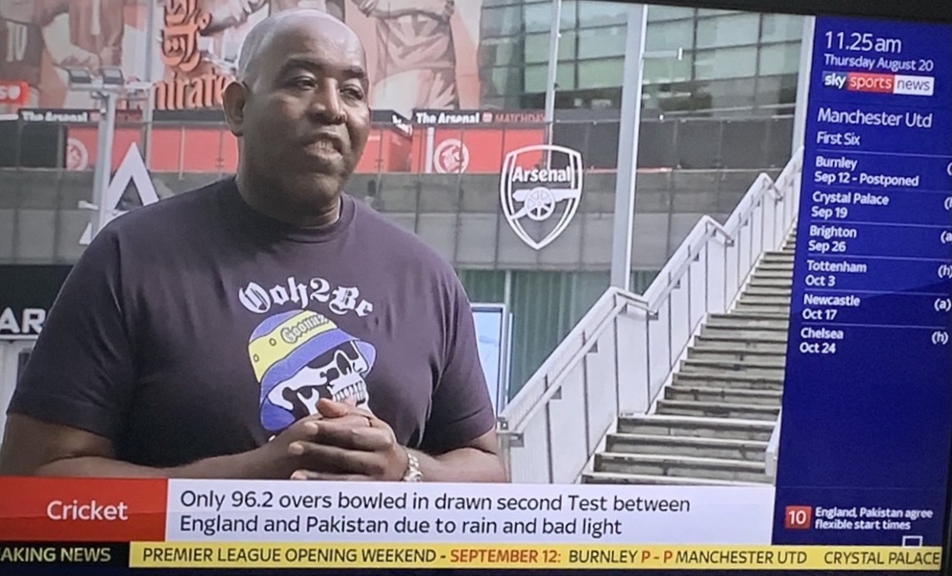
(Fig.2.)
This mimicking of content is one of many ways' television has adapted to the Web 2.0 fragmented audiences and “no guarantee of engaged audiences.”. The major method however is television adoption of user-generated content seen on YouTube and repurposing it on their channel, capitalising on its effectiveness and audience whilst also legitimising it to more traditional or different audiences. Often evident on Sky Sports News where professional journalists will interview people from fan channels (see fig.2 where AFTV personality Robbie Lyle is being interviewed). This allows television to gain an essence of personalisation like YouTube’s algorithm in broadcasting niche individuals from online to their wider audience. Whilst also reaffirming television’s role as cultural ‘gate-keeper’ portraying what they deem ‘newsworthy’ and reaching new markets. This form of influencer marketing by major broadcasters is an attempt to attract online fans of these influencers, to subscribe to Sky Sports’ content.

YouTube
Unlike television and its limited channels, the internets and YouTubes are boundless, however due to YouTube’s abundance in content it has had to implement algorithms to tailor its content to their fragmented audiences. This algorithmic process is an advancement of the aforementioned ‘narrow-casting.’ Through these different channels, like-minded people build communities which are then used as commodities for advertisers. However, YouTube’s ability to create limitless avenues for niche content is also distancing itself from having the ability of creating a “public sphere.”
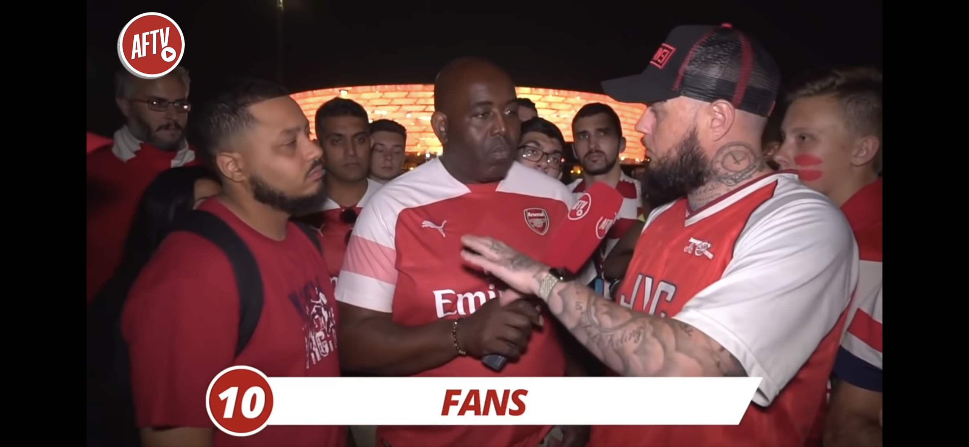
(Fig.3.)
Fan-produced media tends to feature heavily in biases that would negate it from television’s socially accepted guidelines of ‘good taste.’ Thus fan-generated content is often considered subversive content. Although it is obvious to see the influence of conglomerates like Sky Sports’ broadcasting techniques appropriated in these fan channels, (see fig.3) like the use of branding on the microphone, discussions of topics positioning parties against one another as seen in political debates, and the presence of a presenter to navigate the narrative. An example of remediation of 'sport-familiar terrain for viewers.’ To apply Hito Steyerl’s theory of the poor image “along with the increased privatisation of intellectual content, online marketing and commodification creates a demand from the public who cannot afford it.”
With further privatisation in sports broadcasting and the growing costs of subscription to view Premier League football in the UK and Ireland, could explain the rise in popularity of fan channels. It is no coincidence this has occurred alongside to the rise of ‘citizen journalists,’ and arguably both are identical in their methods of upheaval of mainstream media. Professional journalists’ core values of autonomy, objectivity and immediacy have led them to become detached from the society in which they report for, claiming neutrality and an unhealthy obsession for the ‘first scoop’. This depletion in quality only strengthens Bolter and Grusin’s argument that online media can challenge traditional media’s locus of cultural control.

However, there is an ever-growing audience for this opinionated and argumentative style of content, exemplary in the rapid rise of YouTube channels of fan produced content dedicated to respective teams like Arsenal Fan TV (Arsenal), with over one million subscribers. Fan TV accounts are representative of their respective teams fanbases, reporting on and debating on anything new regarding their club through fellow fans who bring with them their own qualities and ideologies, often encouraged to provide emotional and reactive content. For example, Troopz (a predominant personality on Arsenal Fan TV) and the majority of the Arsenal Fan TV (AFTV) cast are infamous for their ‘rants' and could arguably be described as dramatic characters. These ‘average-joe’ individuals would not be seen on any respected sports television broadcaster, due to their lack of credibility in the eyes of the television producer and viewer.

Although they appear more ‘real’ are more relatable to fans of that club due to the fact they are not perceived to be produced or scripted, based off their extremely visceral outbursts. AFTV will regularly interview Arsenal fans prior to a match and after, often live streamed on YouTube, gaining an essence of “immediacy” through its ‘live’ element. An obvious remediation of Sky Sports’ broadcasts. This live streaming also acts as a mode of surveillance which is what viewers deem as ‘reality.’ This technique was initially adopted by reality television shows like Big Brother and appropriated to online media forms such as AFTV’s live streams. These live streams are an example of “hypermediacy,” as they are a mix between television and online technology.

This is especially attractive to international fans, with most Premier League fans living abroad and stadia having capacities, these fan channels offer the most authentic ‘feel' in terms of that sense of belonging to a community and experiencing the match day event with like-minded individuals. These “imagined communities” communicate through online live streams prior to kick-off, during the game through “watch-alongs” and after the final whistle. These events, especially live streaming, cross-pollinates international borders creating a sense of “cultural proximity” and further establishing the theory of “translocality” experienced by the audiences of these channels.

Conclusion
“the spread of Internet technologies is highly uneven and serves to reinforce differences between developed and developing countries and segments of populations within coun- tries.” (Global Games: Culture, Political Economy and Sport in the Globalised World of the 21st Century p.1332)
Arsenal Fan TV’s remediation of Sky Sports’ broadcasting techniques like discussions consisting of a presenter and two ‘specialist pundits’, branded props and representation of reality through its forms of live streaming and use of ‘real’ people and locations has proved successful judging from their number of subscribers. Although, it arguably offers a much greater impact on the viewer in terms of immediacy, it still lacks the authority and social standing of television. For YouTube to gain ‘cultural control’ of the masses its channels must broaden their fragmented audiences in the hope of becoming more diverse. However, they will risk losing their initial niche fanbases by doing so. Television’s position as the ‘superstructure’ in the public sphere remains safe if they continue to adapt with technology. Along with their ability to capitalise on modern technologies and user-generated content, their social and cultural history through decades of reporting, has intrinsically positioned themselves as the authoritative voice in the ideologies of the consumer. Sky Sports’ purchasing of the television rights to broadcast the Premier League is the major factor in their dominance of viewership over their Fan TV counterparts. Should Project Big Picture be approved, and independent clubs will be capable in selling streams of their respective clubs oversees via online, this would ‘legitimise’ online television to the detriment of traditional television.

Bibliography
Andrejevic, Mark, Reality TV: The Work of Being Watched (Oxford: Rowman & Littlefield Publishers, Inc., 2003), p. 122 in, <https://www.academia.edu/4391470/Reality_TV_The_Work_of_Being_Watched_Critical_Media_Studies> [accessed 7 December 2020].

Barry, Peter, Begining Theory, 4th edn (Manchester : Manchester University Press, 2017), p.179.

Bolter, J D, and Richard A. Grusin. Remediation: Understanding New Media. (Cambridge, Mass: MIT Press, 1999), pp. 30-199.

Jean Burgess and Joshua Green, YouTube: Online Video and Participatory Culture, 2 edn (Cambridge: Polity Press, 2018), p.82.

Dennis Deninger. Sports on Television : The How and Why Behind What You See, (Taylor & Francis Group, 2012) pp.77-84. ProQuest Ebook Central, https://ebookcentral.proquest.com/lib/iadt-ebooks/detail.action?docID=1075181. [Accessed 5 December 2020]

Drok, Nico, Journalistic Roles, Values and Qualifications in the 21st century How European journalism educators view the future of a profession in transition (Zwolle: Uitgave, 2019), p. 8. in , <https://www.ejta.eu/sites/ejta.eu/files/2019%2004%2012%20DROK%20Report%20RVQ.pdf> [accessed 5 December 2020].,

Herman, Edward S., and Noam Chomsky, Manufacturing Consent: The Political Economy of the Mass Media(New York: Pantheon Books, 1988), pp.1-5 in, <http://torontoforumoncuba.weebly.com/uploads/5/1/8/5/5185218/manufacturing_consent_-_the_political_economy_of_the_mass_media.pdf> [accessed 5 December 2020].

Jenkins, Henry, Convergence Culture: Where Old and New Media Collide (New York: NYU Press, 2006), p. 362-363.
Koh, Adeline, "Imagined Communities, Social Media, and the Faculty." Academe 102, no. 3 (American Association of University Professors, 2016), p.20. Accessed December 1, 2020. http://www.jstor.org/stable/26407636.

Lotz, Amanda D. The Television Will Be Revolutionized. New York: New York
University Press, 2007.
Nauright, John, Third World Quarterly: “Global Games: Culture, Political Economy and Sport in the Globalised World of the 21st Century.” (Taylor & Francis, Ltd, 2004), pp. 1332. JSTOR, www.jstor.org/stable/3993813. Accessed 11 Dec. 2020.

Sutherland, Ben, 'Project Big Picture: What is it and how would it work?', BBC, , (2020), , in <https://www.bbc.com/sport/africa/54510898> [accessed 7 December 2020].
The Guardian, 'Timeline: a history of TV football rights', The Guardian, , (2003), , in <https://www.theguardian.com/media/2003/feb/25/broadcasting3> [accessed 1 December 2020].
Youtube, Arsenal Fan TV (2020) <https://www.youtube.com/channel/UCBTy8j2cPy6zw68godcE7MQ> [accessed 7 December 2020].

Amanda D. Lotz, The Television Will Be Revolutionized. (New York: New York University Press, 2007). p.42.
Herman, Edward S., and Noam Chomsky, Manufacturing Consent: The Political Economy of the Mass Media(New York: Pantheon Books, 1988), pp. 4-5 in, <http://torontoforumoncuba.weebly.com/uploads/5/1/8/5/5185218/manufacturing_consent_-_the_political_economy_of_the_mass_media.pdf> [accessed 5 December 2020].
The Guardian, 'Timeline: a history of TV football rights', The Guardian, , (2003), , in <https://www.theguardian.com/media/2003/feb/25/broadcasting3> [accessed 1 December 2020].
Dennis Deninger. Sports on Television : The How and Why Behind What You See, (Taylor & Francis Group, 2012) p.77. ProQuest Ebook Central, https://ebookcentral.proquest.com/lib/iadt-ebooks/detail.action?docID=1075181. [Accessed 5 December 2020]
Deninger, p.84.
Deninger, p.83.
Herman and Chomsky, p.1.
Peter Barry, Begining Theory, 4th edn (Manchester : Manchester University Press, 2017), p.179.
Bolter, J D, and Richard A. Grusin. Remediation: Understanding New Media. (Cambridge, Mass: MIT Press, 1999), p.45
Koh, p. 20.
Bolter and Grusin, p.199.
Nico Drok, Journalistic Roles, Values and Qualifications in the 21st century How European journalism educators view the future of a profession in transition(Zwolle: Uitgave, 2019), p. 8 in , <https://www.ejta.eu/sites/ejta.eu/files/2019%2004%2012%20DROK%20Report%20RVQ.pdf> [accessed 5 December 2020].,
Bolter and Grusin, p.60.
Bolter and Grusin, p.30.
Mark Andrejevic, Reality TV: The Work of Being Watched(Oxford: Rowman & Littlefield Publishers, Inc., 2003), p. 122 in , <https://www.academia.edu/4391470/Reality_TV_The_Work_of_Being_Watched_Critical_Media_Studies> [accessed 7 December 2020].
Bolter and Grusin, p. 31.
YouTube, Arsenal Fan TV (2020) <https://www.youtube.com/channel/UCBTy8j2cPy6zw68godcE7MQ> [accessed 7 December 2020].
Ben Sutherland, 'Project Big Picture: What is it and how would it work?', BBC, , (2020), , in <https://www.bbc.com/sport/africa/54510898> [accessed 7 December 2020].
John, Nauright. Third World Quarterly:“Global Games: Culture, Political Economy and Sport in the Globalised World of the 21st Century.” (Taylor & Francis, Ltd, 2004), pp. 1332. JSTOR, www.jstor.org/stable/3993813. Accessed 11 Dec. 2020.
Adeline Koh. "Imagined Communities, Social Media, and the Faculty." Academe 102, no. 3 (American Association of University Professors, 2016), p.20. Accessed December 1, 2020. http://www.jstor.org/stable/26407636.
Jean Burgess and Joshua Green, YouTube: Online Video and Participatory Culture, 2 edn (Cambridge: Polity Press, 2018), p.82.
Henry Jenkins, Convergence Culture: Where Old and New Media Collide (New York: NYU Press, 2006), p. 362-363.

