THE EFFECT OF COLOUR HARMONY ON USER EXPERIENCE AND PERCEIVED AESTHETICS

Ciara Little
Institute of Art and Design Technology
DL825 Applied Psychology
Marian McDonnell
April 2022

Declaration

I declare that this submission is my own work. Where I have read, consulted, and used the work of others I have acknowledged this in the text.

Signed: Ciara Little
Date: 08/04/2022

Word Count: 4,946

Acknowledgements
I’d like to take this opportunity to thank Marian McDonnell for all her advice, guidance and help throughout this process. Her excellence, knowledge, patience and positive, understanding attitude really helped me to accomplish this thesis and I fully appreciate every message, meeting and email that we exchanged. I would like to thank Dr Christine Horn for her continuous help with my statistics. Her time and knowledge were generously given and I couldn’t have completed it without her help. I would like to thank my participants, without whom I wouldn’t have been able to collect the results and insight. I’d like to acknowledge the patience and care my family and friends have had for me throughout this year in preparation for my final year project. I was also lucky to have a lovely college year group and have felt their support throughout the process. To all staff of IADT, this experience was made by your kindness, compassion, and empathy and I will always value it highly.

Contents
Abstract 7
1. Literature Review 8
1.1. Visual Design and User Perception 8
1.2. UX and Visual Aesthetics 9
1.3. Colour Perception and UX 10
1.4. Colour Harmony 11
1.5. The Present Study 12
2. Method 14
2.1 Design 14
2.2 Participants 14
2.3. Materials 14
2.4. Pilot Study 16
2.5. Procedure 16
3. Results 17
3.1. Overview 17
3.2 Analysis 1 17
Descriptive Statistics 17
Assumptions 18
Inferential Statistics 20
3.3. Analysis 2 21
Descriptive Statistics 21
Assumptions 22
Inferential Statistics 25
4. Discussion 27
4.1. Overview 27
4.2. Theoretical and Practical Implications 28
4.3. Strengths and Limitations 28
4.4. Future Research 28
4.5. Conclusion 29
5. References 30
6. Appendices 36
6.1. Appendix A. Types of Colour Harmony 36
6.2. Appendix B. Group Pro Harmonious and Disharmonious Version 37
6.3. Appendix C – Microsoft Form 38
6.4. Appendix D – Questionnaires 44
6.5. Appendix E – Analysis 1 Output 46
6.6. Appendix F – Analysis 2 Output 48

Table of Tables
1 – UX and Aesthetics Descriptive Statistics | 16
2 - UX and Aesthetics Differences between Colour Harmony | 20
3 – UX Subscales Descriptive Statistics | 22
4 - UX Subscales Mean Differences between Colour Harmony | 25

Table of Figures
1 - Linearity Scatterplot for Harmonious Condition | 17
2 - Linearity Scatterplot for Disharmonious Condition | 19
3 - Boxplot of Harmonious Condition. | 19
4 - Boxplot of Disharmonious Condition. | 20
5 - Mean Scores of User Experience and Perceived Aesthetics for Colour Harmony | 21

Abstract
There are several aspects of design that are crucial for creating a positive user experience (UX) in mobile apps. One of the most important aspects is that of colour and its relationship with the imagery and flow of the application. Certain colours look better together than others, determined by a type of colour theory called colour harmony. The present study investigated the effects of colour harmony on user experience and perceived aesthetics in the context of a mobile application. Particular examination of the 4 different elements of user experience; Hedonic Quality Identification, Hedonic Quality Stimulation, Pragmatic Quality and Attractiveness was examined. Having viewed one of two versions (harmonious colour, disharmonious colour) of the same mobile app, 54 participants rated their experience. Results demonstrated a significant difference in the dependent variable scores. However, the disharmonious version of the app surprisingly scored higher in user experience and perceived aesthetics was surprisingly the more liked of the two, scoring higher in both UX and perceived aesthetics. Additionally, the only element within user experience that was affected was Hedonic Quality Identification. Given this result, further research is proposed into the types of colour harmony to affect these variables and investigating eye tracking as a form of measurement.

Literature Review

Visual Design and User Perception
The visual design of an online environment significantly affects a user’s perception (Sánchez-Franco et al., 2013). Within the field of visual aesthetics, researchers investigate how first impressions are created and what they depend on (Tuch et al., 2012). One’s first impression of a design can be identified as the visceral level in Norman’s Emotional Design Model (2004). As it is involuntary, the visceral response can create difficulty in identifying why something is perceived as visually appealing, as it is an automated response that cannot be controlled.

Perceptions are formed through top-down (concept-driven) and bottom-up (stimulus-driven) processing (Grondin, 2016; Tan, 2018). According to Lindgaard et al. (2006), users can perceive visual appeal within 50 milliseconds. Visual appeal is an experience that is dependent on the user and may alternate throughout the interaction with a mobile app or website (Alharoon, 2020). Miniukovich and De Angeli (2014) examined the relationship between the first impression and subsequent evaluation of web pages. The results supported Lindgaard’s (2006) reporting that participants’ perception altered very little between 50 milliseconds and 4 seconds, demonstrating the importance of the observers’ initial perceptions, reiterating that fast-paced process of a first impression is propelled by appearance and matters most, according to Norman (2013). Douneva et al. (2015) observed the influence of website design on first impressions, aesthetic evaluations, and memory performance. The results demonstrated that high colour saturation was the least preferred between those large images and an image/ text balance.

Mobile technology is a fast-growing field that continuously connects with our work and day-to-day interactions (Jayatilleke et al., 2018). Since its inception, design research on mobile apps and websites has continuously coincided with technology development. Despite this research, what precisely influences user preference in certain mobile apps remains unclear (Bhandari et al., 2018). An example of historical research, where certain design principles were identified, is dated at 1891, where Jackson identified repetition, variety, contrast, radiation, and symmetry as fundamental principles to consider in design (as cited in Kimball, 2013). Currently, however, there are five design principles in user experience (UX), according to the Norman Nielsen Group; scale, visual hierarchy, balance, contrast, and Gestalt. Identifying these principles in detail is essential when considering the design of mobile apps, especially with the user in mind. However, a user is more likely to tolerate usability and UX issues when an interface is visually appealing (Lindgaard, 2007). It is suggested by research that the halo effect could be responsible for this. Tractinsky et al. (2000) propose that due to visual beauty being the most outstanding and apparent characteristic that is noticed, it is one of the first to be perceived by a user, thus influencing the perception of the interface in later interactions. Despite the usability being low, due to the interface having an aesthetic layout, the user associates that with a satisfying experience overall (Tractinsky et al., 2000).

UX and Visual Aesthetics
UX is defined as the effects felt, by a user, as a result of interaction and usage context of a system, device, or product, including the influence of usability, usefulness and emotional impact, and savouring the memory after the interaction (Hartson & Pyla, 2013). Sharp et al., (2019) identify UX as a vital part of interaction design and declare that it can be achieved while considering satisfaction, enjoyment, fun, entertainment, helpfulness, motivation, aesthetic pleasure, support of creativity, reward, and emotional fulfilment. The goals of UX are to analyse and develop the quality of the users’ experience, i.e., to be aesthetically pleasing (Sharp et al., 2019). In addition, researchers have identified several factors influencing UX, specifically when designing mobile apps and websites. For example, Hogan (2014) identifies influencing factors of UX as accessibility, information architecture, usability, and aesthetics.

The importance of aesthetics has been acknowledged since the time of Plato and Aristotle (Pappas, 2020). The current emphasis in technology development and media, such as mobile apps, incorporates beauty through visual aesthetics. Creators and users consider aesthetics when designing and viewing such media, particularly concerning the ease and enjoyment of use. Research has found that the nature of beauty is not goal-oriented but self-oriented, whereas goodness relates to both (Hassenzahl, 2004). When designing online interfaces, although it is essential to consider the opinions of others, it is not necessary to design something that satisfies everyone involved (Garrett, 2010). Graphic design involves developing the visual communication of information, using elements such as colour, images, typography, and layout (Van Duyne et al., 2007).

Although it is crucial to have a visually appealing mobile app, it should not be the designer’s primary focus. UX is best when there is a balance between visual appeal and ease of use (Sharp et al., 2019). Mahlke (2006) conducted a study involving MP3 player skins and observed that users preferred a skin with reasonably low usability but high aesthetics over another that scored higher on usability but scored lower on aesthetics.

Colour Perception and UX
The perception of colour occurs when photoreceptors in the retina, consisting of three cone-opponent mechanisms; red-green, blue-yellow and black-white (luminance), receive light (Mullen et al., 2005; Johnson 2014). Colours are distinguished most efficiently when a strong signal occurs on one of these three channels while a neutral signal on the other two, i.e. red, green, yellow, blue, black and white (Johnson 2014). Some people may only identify colour as a factor when considering the creative arts, but colour can also psychologically impact emotion, attitude, and interest (Bakshi & Gilbert, 2015). As a result, this affects user behaviours and attitudes, influencing their learning (Kimmons, 2020). According to Kimmons, among UX and LX (learning experience) designers, colour is generally approached in an exchange between “technical prescription and intuitive preference”. Kimmons (2020) suggests that the four guiding considerations concerning colour use are contrast, attention, meaning and harmony.

Colour is an essential aspect of design, but little is known as to why individuals prefer specific colours over others. Research has shown contrasting results regarding preferred colour in digital design. For example, Bonnardel et al. (2011) carried out two studies involving colour in web design; the first study investigated web homepage colours and the preference of designers and users. Results showed that participants regarded blue and orange as the most appealing colours for both users and designers, which the authors argue could be explained by the emotional association with these colours. In the second study, three colours (blue, orange, and grey) were used, and the results demonstrated that colour was a determining factor in how users interacted with the website. Users found the grey site less appealing than the other two and less time was spent on the blue site than on the orange one. This suggested that the participants may have felt more affinity with this site, explaining the length of time and its appeal.

Additionally, Skulmowski et al. (2016) carried out a study involving the effects of colour saturation on visual appeal. Unlike other research, results showed that saturation caused adverse effects on visual appeal, trustworthiness, and usability, depending on the domain. These results identified that the research available could not be generalised to the perception of websites (Skulmowski et al., 2016). Given that the type of domain made a significant difference, this suggests that the effects may also be evident with the introduction of a different type of interface. Oyibo and Vassileva (2020) observed how the layout of information and colour temperature of a website for mobile devices influence essential user experience (UX) and six design attributes (perceived aesthetics, perceived enjoyment, perceived ease of use, perceived usefulness, and intention to use). Colour temperature involves whether a colour has warm (orange) or cool (blue) undertones (Feisner, 2006, as cited in Attiah & A. Alawad, 2021). The researchers observed that both information layout and colour temperature significantly influence perceived aesthetics, perceived enjoyment, perceived usefulness, and intention to use. Oyibo and Vassileva (2020) also reported that cooler colour temperatures (blue and green) positively influences perceived effectiveness and intention to use.

Colour Harmony
Colour harmony is achieved when the juxtaposition of colours produces a satisfying unity or balance (Paterson, 2004; as cited by Weingerl & Javorsek, 2018). There are six basic hue templates of colour harmony based on their positions on the colour wheel (Weingerl & Javorsek, 2018; See Appendix A), These hue templates include monochromatic (colours with similar or equal hue), analogous (colours next to each other with similar hues), triadic (three colour hues separated by 120 degrees on the colour wheel), complementary, (colours on opposite sides of the colour wheel) split-complementary (three colours, with two being either side of the complement of the third on the colour wheel) and tetradic (double complementary scheme, two complementary pairs lying opposite each other on the colour wheel; Weingerl & Javorsek, 2018).

In research, authors have used the terms “harmony” and “preference” interchangeably, resulting in contradiction and confusion in existing literature (Schloss & Palmer, 2010). There is limited research on the relationship between colour harmony and its effects on user experience related to mobile apps. Schloss and Palmer (2010) carried out a study and reported that colours most similar in hue were rated with higher colour preference and harmony. However, no overall increase was observed in preference or harmony ratings for complementary hues. Additionally, Seckler et al. (2015) observed the link between objective design factors and different facets of subjective aesthetic perception. The results showed that websites of high symmetry, low complexity, blue hue, medium brightness or medium and high saturation received the highest overall aesthetics ratings.

Venni and Betrancourt (2020) studied the impact of website colour harmony on four dependent variables; usability, aesthetics, user experience, and memory. They used the AttrakDiff2 questionnaire (Hassenzahl et al., 2003), which divides user experience into four elements, two of which focus on hedonism (related to, characterized by, or considered in terms of pleasant, or unpleasant, sensations). Hedonic Quality Identification (communication of human identity and personality), Hedonic Quality Stimulation (the need for personal development, to improve personal skills and knowledge), Pragmatic Quality (traditional task-related usability aspects, i.e. efficiency, effectiveness and learnability) and Attractiveness are the subscales in question. The researchers reported that disharmonious colours received a lower pragmatic score, caused a distraction for visual attention, but led to higher memory recall scores. They also observed that harmonious colours did not affect navigation or perceived usability, perception of aesthetics, hedonic qualities, and user experience.

The Present Study
There is a lack of research regarding the relationship between colour and user experience in the context of mobile applications. Although there is research on the effects of colour on user experience and aesthetics in websites, limited results are available, specifically focusing on mobile applications. With this and previous research in mind, the present study will investigate the effects of mobile app colour harmony on user experience and perceived aesthetics.

The research questions presented are as follows:
RQ1: Are perceived aesthetics and user experience affected by colour harmony?
RQ2: Does colour harmony affect aspects of user experience differently?
RQ3: Which elements of user experience are affected by colour harmony?

The hypotheses presented are as follows:
H1: There will be a significant difference for app users on their perceived aesthetics scores based on the app’s colour harmony.
H2: There will be a significant difference for app users on their user experience based on the app’s colour harmony.
H3: There will be a significant difference for app users on Hedonic Quality Identification scores based on the app’s colour harmony.
H4: There will be a significant difference for app users on Hedonic Quality Stimulation scores based on the app’s colour harmony.
H5: There will be a significant difference for app users on Pragmatic Quality scores based on the app’s colour harmony.
H6: There will be a significant difference for app users on Attractiveness scores based on the app’s colour harmony.

Method

2.1 Design
The present study employs a between-groups, quasi-experimental design. The independent variable is colour harmony (k=2, harmonious vs disharmonious) and user experience and perceived aesthetics are the dependent variables. According to Charness et al. (2012), advantages of employing a between-groups design include statistical power. This means that the design’s internal validity does not depend on the sample being randomly assigned to conditions, the statistical power can be substantially boosted, and they coincide more naturally with theoretical mindsets.

2.2 Participants
A total of 73 participants were recruited for the present study. However, after removing missing data and those who did not pass the Ishihara (1987) colour test (See Appendix C), 54 participants (16 male, 38 female) were included in the analysis. Participants were gathered using convenience snowball sampling and aged between 20 and 59 years old (M = 25.33, SD= 8.95). The participants declared themselves to have average or higher mobile app proficiency (average = 29.3%, above average = 34.5%, excellent = 36.2%). Most participants claimed to spend 4+ hours daily using mobile apps (58.6%), with only 1.7% spending less than one hour. The current study was approved by the Department of Technology and Psychology Ethics Committee (DTPEC), and all participants were treated according to ethical standards of the Psychological Society of Ireland.

2.3. Materials
The stimulus material consisted of two colour versions of the same mobile app (See Appendix B). This app, named GroupPro, was previously designed by the researcher for the 3rd year Applied Psychology Group IT Project module. This app was created to allow for a single collaborative app that contains all the necessary functions for group work, saving space in the user’s device and making creating a group project easier. The app design contains features like document creation, accessible communication, progress tracking and task checklists. The colour palette of the harmonious condition was chosen to support the “complementary” hue template of colour harmony (Weingerl & Javorsek, 2018). The disharmonious palette was identified by choosing a palette that avoided these types by adjusting each colour's hue (Nemcsics, 2007). Each colour version of the app was edited using Affinity Designer (Version 1.10.4). See appendix B for screenshots of both conditions.
All materials were provided to the participants in a Microsoft Form (See Appendix C). The results were kept on a password-protected computer, according to the IADT GDPR procedure, which states that IADT owns the data collected and the thesis supervisor is responsible for storage and deletion. The Ishihara (1978) colour test was used to establish the participants' colour vision and determine if they would distinguish between the colours adequately. The Microsoft Form also included an information sheet, consent form and debrief (See Appendix C). The information sheet contained the reasons for the study, the benefits of taking part, how the participants' data would be collected and anonymised, and information on how to withdraw from the study. It also included contact details for the researcher and supervisor. In addition, the consent form contained statements declaring the participants' willingness to participate in the study and indicated their awareness that their participation was voluntary. Two scales were used to measure perceived aesthetics and user experience (See Appendix D). Finally, the debrief included a statement thanking the participants for taking part in the study and reassuring them of their ability to withdraw if they so wished.
Two separate scales were used in data collection (See Appendix D). The VisAWI-s questionnaire (α = .88; Moshagen & Thielsch, 2010) measured aesthetics, characterised by high objectivity, reliability and validity, and economic applicability and assesses the general factor of aesthetics (Thielsch & Mochagen, 2013; 2015). This is the short version of the 7-point Likert scale of visual aesthetics of websites inventory, The AttrakDiff2 questionnaire (α = .92; Hassenzahl et al., 2003) determined the user experience. This consists of 28, 7-point bipolar items that represent opposites. The questionnaire is split into four subscales each containing 7 items; Hedonic Quality Identification subscale (HQI; α = .84), Hedonic Quality Stimulation (HQS; α = .76), Pragmatic Quality (PQ; α = .641) and Attractiveness (ATT; α = .92).

2.4. Pilot Study
A pilot study was conducted (n=6) to outline any problems which may have negatively affected the study. Problems identified by the test participants were rectified prior to the final data collection. This pilot study allowed the researcher to ensure that the questions and instructions provided were easily understandable. Additionally, minor problems were detected and rectified. This included rephrasing some of the instructions to appear clearer as they were initially misleading to the participants. Furthermore, in the Ishihara Test (1987) to detect colour blindness as an exclusion criterion the researcher underlined the instruction of typing “none” if there was no number evident. The wording of the task description was also rectified to make it clear that the participants were to observe the app while carrying out the task.

2.5. Procedure
The participants were provided with two links to the present study and were asked to select one of their choosing. When they clicked their desired link, they were directed to one of two Microsoft Forms (either the Harmonious or Disharmonious condition). The participants were welcomed and invited to take part in the study on the form. The participants read the information sheet, which notified them of all the necessary details according to DTPEC. They were then directed to a virtual consent form within the Microsoft Form, where they agreed to take part. In addition, each participant was asked a series of demographic questions such as age, gender and mobile app use habits. The participants were then asked to participate in the shortened Ishihara Colour Test to test for possible colour blindness (Ishihara, 1987). As research has demonstrated, online colour blindness tests effectively test for colour blindness (Van Staden et al., 2018). Next, the form presented the participants with a task requesting that after “Following the below link, log in (you are not required to create an account), explore the app and find the most recent message in the Group IT project folder.”, followed by a link and an explicit instruction to return to the Microsoft Form once the task was complete. Having returned to the Microsoft Form, the participants filled out the VisAWI-s and AttrakDiff questionnaires to establish perceived aesthetics and user experience. Once the participants filled out both questionnaires, they were debriefed and thanked for participating in the study.

Results

Overview
Participants were randomly assigned to one of two mobile app conditions and their experiences were reported using Vis-AWIs (Moshagen & Thielsch, 2010) and AttrakDiff2 (Hassenzahl et al., 2003) questionnaires. The AttrakDiff2 questionnaire was reverse coded to match that of the Vis-AWIs (1 = negative score, 7 = positive score). Two Hotelling’s T² MANOVAs (multivariate analyses of variance) were conducted, on Version 27 of IBM SPSS, to measure if there was a significant difference for user experience and perceived aesthetics based on the version of app (harmonious vs. disharmonious) they experienced. Initial outliers were identified and removed so as not to distort the statistical analysis.

3.2 Analysis 1

Descriptive Statistics
The first analysis was carried out using the AttrakDiff2 questionnaire as a whole variable. 54 participants were included in the analysis. Table 1 contains descriptive statistics for the dependent variables (user experience and perceived aesthetics) disaggregated by the independent variable (harmonious, disharmonious).

Table 1
UX and Aesthetics Descriptive Statistics (N = 54)
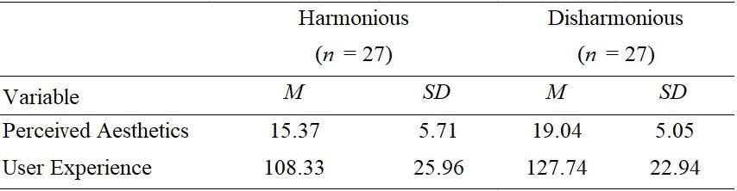

Assumptions
Preliminary tests were conducted to establish test assumptions (See Appendix E). There was a linear relationship between perceived aesthetics and user experience in each colour condition, as assessed by scatterplot (See Figure 1 & 2). There was no evidence of multicollinearity, as assessed by Pearson correlation (|r| < 0.9). Mahalanobis distance was used to assess multivariate outliers; the critical value of 13.82 was not surpassed (max. value = 7.79), thus the assumption was not violated. Boxplots were assessed determining that there was a univariate outlier in the data (Figures 3 & 4). The data was normally distributed, as assessed by Shapiro-Wilk test (p > .05). There was homogeneity of variance-covariance matrices, as assessed by Box's test, M = 1.13, F (3, 486720) = .356, p = .785).

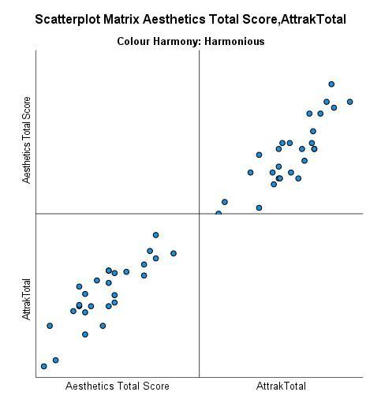

Figure 1. Linearity Scatterplot for Harmonious Condition This figure displays linearity of the dependent variables in the harmonious condition.
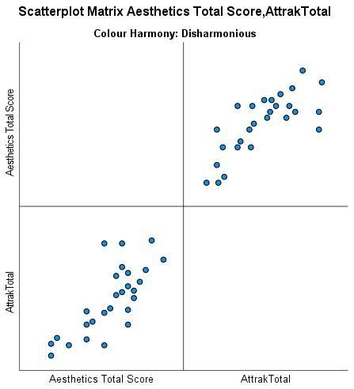
Figure 2. Linearity Scatterplot for Disharmonious Condition This figure displays linearity of the dependant variables in the harmonious condition.
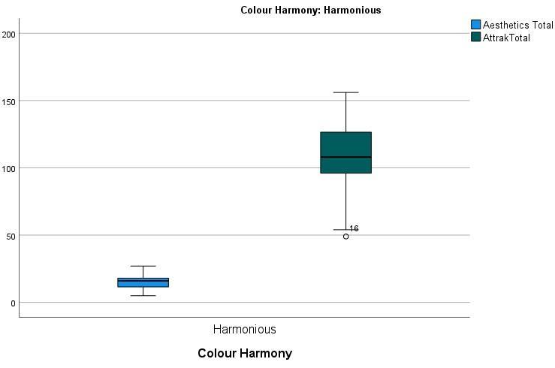
Figure 3. Boxplot of Harmonious Condition. This figure demonstrates the univariate outlier present in the data of the harmonious condition.
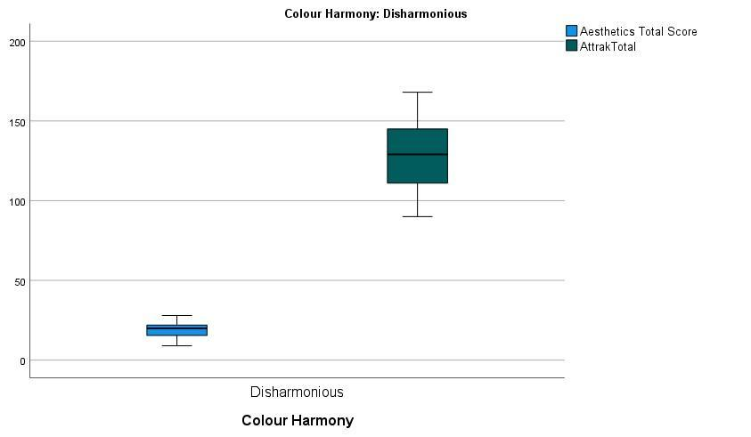
Figure 4. Boxplot of Disharmonious Condition. This figure demonstrates that there are no univariate outliers present in the data of the disharmonious condition.

Inferential Statistics
The Hotelling’s T² MANOVA yielded that there was a statistically significant difference between the disharmonious and harmonious groups on the combined dependent variables, user experience and perceived aesthetics, Wilks' Λ = .859; F (2, 51) = 4.18, p =.02; partial η2 = .141 (See Appendix E). Following this statistically significant result, an independent t-test, using a Bonferroni adjusted α level of .025 (.05/2) with a simultaneous 97.5% confidence level was used for each variable. Table 2 displays mean differences between the dependant variables. The mean scores for the disharmonious condition scored higher in each dependant variable.
Table 2
UX and Aesthetics Differences between Colour Harmony 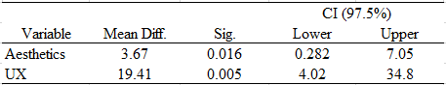

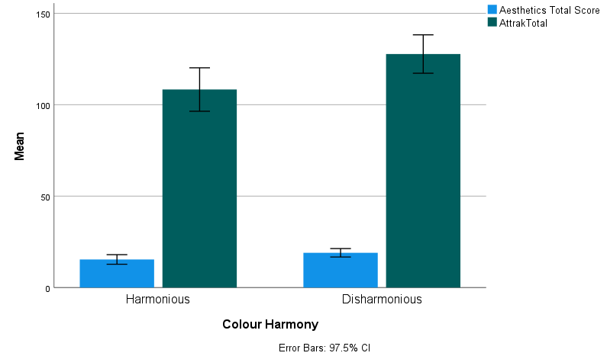
Figure 5 Mean Scores of User Experience and Perceived Aesthetics for Colour Harmony

The results (See Appendix E) show that there was a statistically significant difference in perceived aesthetic scores between the harmonious and disharmonious conditions, p = .016, therefore H1 is accepted. Additionally, there was a statistically significant difference in user experience between the participants in the harmonious and disharmonious conditions, p = .005, therefore H2 is accepted.

Analysis 2

Descriptive Statistics
A second Hotelling’s T² test was conducted to investigate the significant difference within the user experience variable. The AttrakDiff2 questionnaire subscales (Hedonic Quality Identification (HQI), Hedonic Quality Stimulation (HQS), Pragmatic Quality (PQ) and Attractiveness (ATT) ) were the dependant variables. The independant variable was colour harmony (harmonious and disharmonious). 54 participants were included in the analysis. Table 3 contains descriptive statistics for HQI, HQS, PQ and ATT disaggregated by the independant variable (harmonious, disharmonious).
Table 3.
UX Subscales Descriptive Statistics (N = 54)
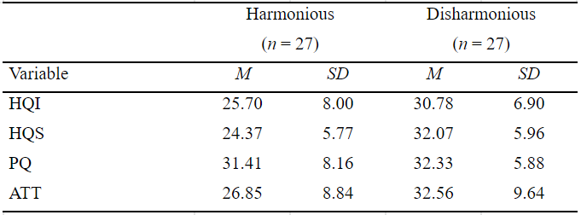

Assumptions
Preliminary tests were carried out to assess assumptions (See Appendix F). There was a linear relationship between user experience subscales in each colour condition, as assessed by scatterplot (Figures 6 & 7). There was no evidence of multicollinearity, as assessed by Pearson correlation (|r| < 0.9). Mahalanobis distance was used to assess multivariate outliers; the critical value of 18.47 was not surpassed (max. value = 11.30), thus the assumption was not violated. Boxplots were assessed determining that there were no univariate outliers in the data (See Figure 8 & 9). All dependant variables were normally distributed, as assessed by Shapiro-Wilk's test (p > .05), except PQ scores in the harmonious condition (p = .005). However, due to Hotelling’s T² MANOVA being a reasonably robust analysis, violations of normality can be tolerated when the sample size has at least 20 in each cell (Tabachnick & Fidell, 2019). There was homogeneity of variance-covariance matrices, as assessed by Box's test, M = 13.003, F (10, 12927.490) = 1.192, p = .291.

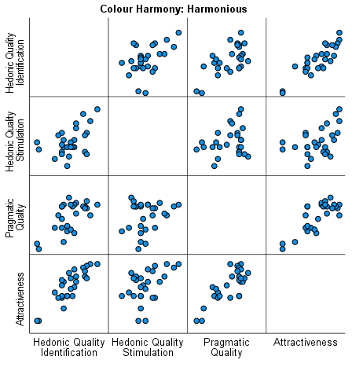

Figure 6. Linearity Scatterplot for Harmonious Condition This figure displays linearity of the dependant variables in the harmonious condition.

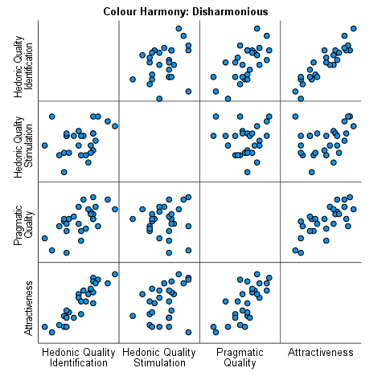

Figure 7. Linearity Scatterplot for Disharmonious Condition This figure displays linearity of the dependant variables in the disharmonious condition.
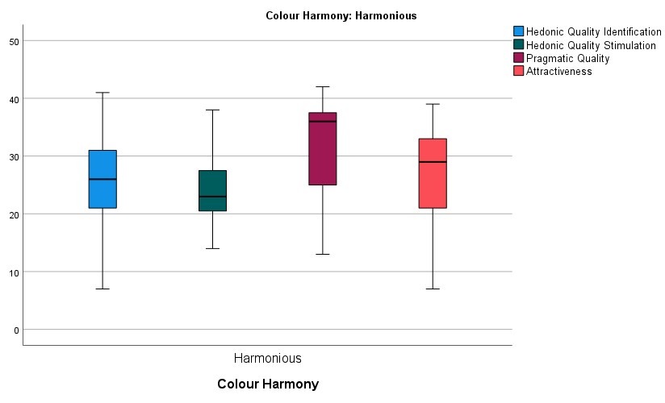
Figure 8. Boxplot of Harmonious Condition. This figure demonstrates no univariate outliers present in the data of the harmonious condition.
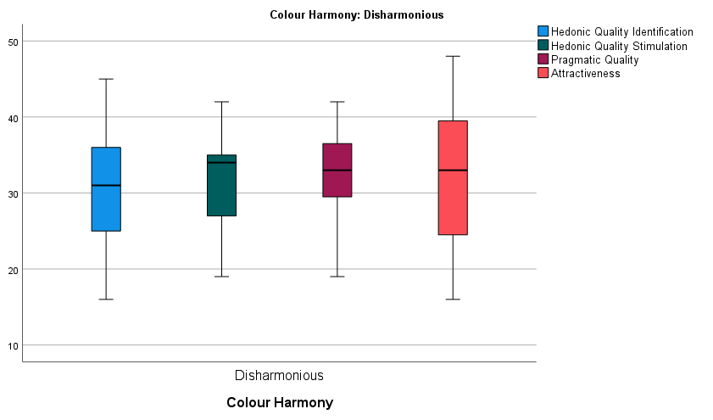
Figure 9. Boxplot of Disharmonious Condition. This figure demonstrates no univariate outliers present in the data of the disharmonious condition.

Inferential Statistics
The second Hotellings T² yielded that there was a statistically significant difference between the colour conditions on the combined dependant variables; Wilks' Λ = .681, F (4, 49) = 5.74, p < .001; partial η² = .319 (See Appendix F). Following this statistically significant result, an independent t-test, using Bonferroni adjusted α level of .01 (.05/5) with a simultaneous 99% confidence level was used for each subscale. Table 4 displays mean differences between the dependant variables. The mean scores for the disharmonious condition scored higher in each dependant variable.

Table 4
UX Subscales Mean Differences between Colour Harmony
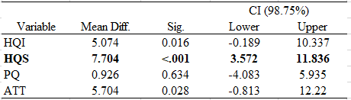

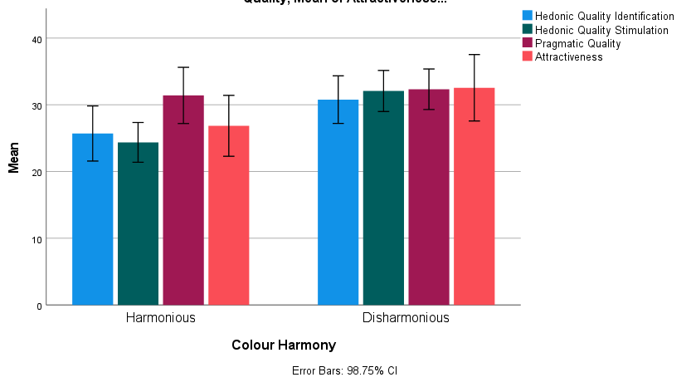
Figure 10. Clustered Bar Chart of Mean Scores for Dependent Variables in each condition
The results presented (See Appendix F) show that there was a significant difference for HQS (see Table 4). All other differences were not significant, thus H4 is the only hypothesis accepted in this analysis.

Discussion

4.1. Overview
The current study set out to analyse the effects of colour harmony on user experience and perceived aesthetics. The visual manipulation of colour harmony was sufficient to impact the dependant variables, in line with H1 and H2. There was difference in perceived aesthetics and user experience based on the colour harmony condition experienced by the participant, coinciding with the halo effect theory (Tractinsky et al., 2000). However, with further analysis of the subscales of the AttrakDiff2 questionnaire, the results demonstrated that the significant difference in user experience was for the Hedonic Quality Stimulation element only. The results indicated that colour harmony influences how the user experienced the app and if they thought it was visually appealing.

A surprise to the researcher was that the participants enjoyed the appearance of the disharmonious colours more than the harmonious colours. Research has shown that websites of blue hue or medium brightness received the highest overall aesthetics ratings (Seckler et al., 2015). Other researchers reported that disharmonious colour received a lower score in pragmatic quality (Venni & Bétrancourt, 2020), unlike the current study’s mean higher pragmatic scores in disharmonious colour. Venni and Bétrancourt (2020) reported that colour harmony did not affect the other 3 aspects of UX (HQI, HQS and ATT), unlike the current study which reported a significant difference in user experience was for the Hedonic Quality Stimulation. Where theories of colour and emotion suggest that attractiveness enhance learning and attention (Venni & Betrancourt, 2020), the findings of the current study suggest otherwise. An explanation for the higher score for the disharmonious condition is suggested by arousal theory (Sung & Mayer, 2012). Despite the visual elements of the app being less attractive, arousal theory suggests that disharmonious colour will still raise the arousal levels of the user (Sung & Mayer, 2012). Another explanation could be that the vibrancy of the disharmonious colours drew the attention of the participants (Tractinsky et al., 2000), thus making them observe the app more. Eyetracking data analyses in Venni and Betrancourt’s (2020) study suggested that disharmonious colours constitute a more visible irrelevant graphic element than harmonious colours as it attracted more eye fixations, but without influencing task performance.

4.2. Theoretical and Practical Implications
The implications of the current study suggest that colour harmony is a significant aspect of user experience of mobile apps. App designers should be especially diligent when it comes to the choice of colour and colour palette while designing apps, as they can affect the way the user perceives the app. Whether the choice of colour be harmonious or disharmonious, the user will notice it when considering using the app again. There is a lack of research on the incorporation of disharmonious colour in web and app design. The results of the current study have demonstrated that there is a place for colour disharmony in the design of interfaces and in UX research. The current study’s results have highlighted that interface users may find disharmony in colour more exciting and interesting to look at. Attention can be drawn to the idea that as technology develops, maybe so do the users’ opinions of visual aesthetics and what qualifies as an aesthetically pleasing interface. Furthermore, it can be pointed out that the results have displayed the need for more colour harmony research to be undertaken in the UX industry and strengthens the findings that colour influences the impressions and experience of the user (Oyibo & Vassileva, 2020).

Strengths and Limitations
The current study provides a new insight into the relationship between colour harmony, aesthetics and UX. A strength of the current study was that both groups had the same size sample, giving a good representation of the data. Additionally, employing a between groups design avoided the participants from being influenced by more than one condition. Finally, the sample was collected from a wide demographic of ages and places e.g., social media, providing a larger representation of the population than if they were recruited from one location i.e. the college campus.
Limitations of the study include a small sample. There was a limited amount of people over the age of 40 (9.5%). Furthermore, the complexity of the task was relatively low, limiting the users to exposure to the app and preventing them from experiencing a more in-depth interaction.

Future Research
A suggestion for future research is to use a larger more diverse sample size. A larger range of age and general demographic would be more representative of the population. Future research could particularly focus on an older age group, who would be less native to technology. Another suggestion would be to focus on gender as an independent variable and investigate if that affects the results. This would be particularly useful information for interfaces that are targeted at gender-specific audiences. Additionally, future research may benefit from the investigation of the different colour harmony types and their effect on the user experience. Researchers may find a statistical significance in observing the effects of accessible colour palettes for those with visual impairments or colour blindness. Finally, the current study used a student designed low fidelity prototype. Designing a fully functioning high-fidelity prototype or using an already existing mobile app for participants to test may improve the quality of feedback and would broaden the reach of research in UX design.

Conclusion
The current study identified that colour harmony influences users’ perceived aesthetics and user experience. While hedonic aspects were influenced, there was no specific effect for pragmatic and attractive aspects of UX. Research into the harmony of colours is evidently important and should be expanded. As technology becomes ever more pervasive, so will the demand for interfaces that are equally as usable as they are aesthetic, and the development of this research will influence interface development and user experience

References
Alharoon, D., & Gillan, D. J. (2020). The Relation of the Perceptions of Aesthetics and Usability. Proceedings of the Human Factors and Ergonomics Society Annual Meeting, 64(1), 1876–1880. https://doi.org/10.1177/1071181320641452
Attiah, D., & A. Alawad, A. (2021). Saudi Arabia’s Colourful Culture: Exploring Colour in Saudi Heritage Homes’ Al-Majlis Rooms. Humanities and Management Sciences - Scientific Journal of King Faisal University, 1–8. https://doi.org/10.37575/h/art/210054
American Psychological Association (2021). Apa.org. https://www.apa.org/topics/ethics#
Bhandari, U., Chang, K., & Neben, T. (2019). Understanding the impact of perceived visual aesthetics on user evaluations: An emotional perspective. Information & Management, 56(1), 85-93.
Bonnardel, N., Piolat, A., & Le Bigot, L. (2011). The impact of colour on Website appeal and users’ cognitive processes. Displays, 32(2), 69–80. https://doi.org/10.1016/j.displa.2010.12.002
Carey, E. (2010). Navigating the process of ethical approval : a methodological note. 193.1.102.107. http://193.1.102.107/handle/10344/1079
Carey, E. (2020). Aligning with the flow of control: A grounded theory study of choice and autonomy in decision-making practices of people with intellectual disabilities. International Journal of Qualitative Studies on Health and Well-Being, 16(1), 1857053. https://doi.org/10.1080/17482631.2020.1857053
Charness, G., Gneezy, U., & Kuhn, M. A. (2012). Experimental methods: Between-subject and within-subject design. Journal of Economic Behavior & Organization, 81(1), 1–8. https://doi.org/10.1016/j.jebo.2011.08.009
Douneva, M., Jaron, R., & Thielsch, M. T. (2015). Effects of Different Website Designs on First Impressions, Aesthetic Judgements and Memory Performance after Short Presentation. Interacting with Computers, 28(4), 552–567. https://doi.org/10.1093/iwc/iwv033
E., B. O., & Odji, E. (2018). Emotion and colour perception: A psychoanalytical theory of graphic design in consumer of goods. Journal of Fine and Studio Art, 7(1), 1–11. https://doi.org/10.5897/jfsa2017.0050
Garrett, J. J. (2010). The elements of user experience: user-centered design for the web and beyond. Pearson Education.
Gordon, K. (2020). 5 principles of visual design in UX. Nielsen Norman group website. Retrieved from: https://www.nngroup.com/articles/principles-visual-design/
Hassenzahl, M., Burmester, M., & Koller, F. (2003). AttrakDiff: A questionnaire to measure perceived hedonic and pragmatic quality. In Mensch & computer 2003 (pp. 187-196). Vieweg + Teubner Verlag.
Hobbs, N. (1948). The development of a code of ethical standards for psychology. American Psychologist, 3(3), 80–84. https://doi.org/10.1037/h0060281
Hogan, L. C. (2014). Designing for Performance: Weighing Aesthetics and Speed. " O'Reilly Media, Inc.".
International Organization for Standardization (2019), Ergonomics of human-system interaction - Part 210: Human centred design for interactive systems. Beuth, Berlin
Ishihara, S. (1987). Test for colour-blindness. Tokyo, Japan: Kanehara.
Jayatilleke, B. G., Ranawaka, G. R., Wijesekera, C., & Kumarasinha, M. C. (2018). Development of mobile application through design-based research. Asian Association of Open Universities Journal.
Johnson, J. (2014). Designing with the mind in mind: Simple guide to understanding user interface design rules. Morgan Kaufmann Publishers/Elsevier.
Kimball, M. A. (2013). Visual Design Principles: An Empirical Study of Design Lore. Journal of Technical Writing and Communication, 43(1), 3–41. https://doi.org/10.2190/tw.43.1.b
Kimmons, R. (2020). Color theory in experience design. In M. Schmidt, A. A. Tawfik, I. Jahnke, & Y. Earnshaw (Eds.), Learner and user exper ience research (pp. 106-126). EdTech Books. https://edtechbooks.org/ux
Laerd Statistics (2017). Hotelling's T² using SPSS Statistics. Statistical tutorials and software guides. Retrieved from https://statistics.laerd.com/
Law, E., Roto, V., Vermeeren, A. P. O. S., Kort, J., & Hassenzahl, M. (2008). Towards a shared definition of user experience. Proceeding of the Twenty-Sixth Annual CHI Conference Extended Abstracts on Human Factors in Computing Systems - CHI ’08. https://doi.org/10.1145/1358628.1358693
Lindgaard, G. (2007). Aesthetics, visual appeal, usability and user satisfaction: what do the user's eyes tell the user's brain?. Australian Journal of Emerging Technologies & Society, 5(1).
Lindgaard, G., Fernandes, G., Dudek, C., & Brown, J. (2006). Attention web designers: You have 50 milliseconds to make a good first impression! Behaviour & Information Technology, 25(2), 115–126. https://doi.org/10.1080/01449290500330448
Miniukovich, A., & De Angeli, A. (2014). Visual impressions of mobile app interfaces. Proceedings of the 8th Nordic Conference on Human-Computer Interaction: Fun, Fast, Foundational. https://doi.org/10.1145/2639189.2641219
Moran, K. (2017). The Aesthetic-Usability Effect. Nielsen Norman Group. https://www.nngroup.com/articles/aesthetic-usability-effect/
Moshagen, M., & Thielsch, M. (2013). A short version of the visual aesthetics of websites inventory. Behaviour & Information Technology, 32(12), 1305–1311. https://doi.org/10.1080/0144929x.2012.694910
Moshagen, M., & Thielsch, M. (2015). VisAWI manual (visual aesthetics of websites inventory) and the short form visawi-s (short visual aesthetics of websites inventory). Perception of Websites. https://doi.org/10.13140/RG.2.1.3985.6169
Moshagen, M., & Thielsch, M. T. (2010). Facets of visual aesthetics. International Journal of Human-Computer Studies, 68(10), 689–709. https://doi.org/10.1016/j.ijhcs.2010.05.006
Nemcsics, A. (2007). Experimental determination of laws of color harmony. Part 1: Harmony content of different scales with similar hue. Color Research & Application, 32(6), 477–488. https://doi.org/10.1002/col.20357
Norman, D. A. (2004). Emotional design: Why we love (or hate) everyday things. Basic Civitas Books.
Norman, D. A. (2013). The Design of Everyday Things. Mit Press.
Oyibo, K., & Vassileva, J. (2020). The Effect of Layout and Colour Temperature on the Perception of Tourism Websites for Mobile Devices. Multimodal Technologies and Interaction, 4(1), 8. https://doi.org/10.3390/mti4010008
Palmer, S. E., & Schloss, K. B. (2010). An ecological valence theory of human color preference. Proceedings of the National Academy of Sciences, 107(19), 8877–8882. https://doi.org/10.1073/pnas.0906172107
Pappas, N. (2020). Plato’s Aesthetics. Plato.stanford.edu. Edward N. Zalta (ed.) Retrieved from: https://plato.stanford.edu/archives/fall2020/entries/plato-aesthetics/
Parekh, R. (2017). What Is Intellectual Disability? Psychiatry.org. https://www.psychiatry.org/patients-families/intellectual-disability/what-is-intellectual-disability
Preece, J., Rogers, Y., & Sharp, H. (2002). Interaction design: beyond human-computer interaction. Wiley.
Sánchez-Franco, M. J., Villarejo-Ramos, Á. F., Peral-Peral, B., Buitrago-Esquinas, E. M., & Roldán, J. L. (2013). Users’ Perception of Visual Design and the Usefulness of A Web-based Educational Tool. Procedia - Social and Behavioral Sciences, 93, 1916–1921. https://doi.org/10.1016/j.sbspro.2013.10.140
Schloss, K. B., & Palmer, S. E. (2010). Aesthetic response to color combinations: preference, harmony, and similarity. Attention, Perception, & Psychophysics, 73(2), 551–571. https://doi.org/10.3758/s13414-010-0027-0
Seckler, M., Opwis, K., & Tuch, A. N. (2015). Linking objective design factors with subjective aesthetics: An experimental study on how structure and color of websites affect the facets of users’ visual aesthetic perception. Computers in Human Behavior, 49, 375–389. https://doi.org/10.1016/j.chb.2015.02.056
Skulmowski, A., Augustin, Y., Pradel, S., Nebel, S., Schneider, S., & Rey, G. D. (2016). The negative impact of saturation on website trustworthiness and appeal: A temporal model of aesthetic website perception. Computers in Human Behavior, 61, 386–393. https://doi.org/10.1016/j.chb.2016.03.054
Sung, E., & Mayer, R. E. (2012). When graphics improve liking but not learning from online lessons. Computers in Human Behavior, 28(5), 1618–1625. https://doi.org/10.1016/j.chb.2012.03.026
Tabachnick, B. G., & Fidell, L. S. (2019). Using multivariate statistics. Boston Pearson. http://www.ru.ac.bd/wp-content/uploads/sites/25/2019/03/401_04_Fidell_Using-multivariate-statisticsFF.pdf
Tan, E. S. (2018). A psychology of the film. Palgrave Communications, 4(1). https://doi.org/10.1057/s41599-018-0111-y
Tan, S.-L., Spackman, M. P., & Wakefield, E. M. (2017). The Effects of Diegetic and Nondiegetic Music on Viewers’ Interpretations of a Film Scene. Music Perception: An Interdisciplinary Journal, 34(5), 605–623. https://doi.org/10.1525/mp.2017.34.5.605

Tractinsky, N., Katz, A. S., & Ikar, D. (2000). What is beautiful is usable. Interacting with Computers, 13(2), 127–145. https://doi.org/10.1016/s0953-5438(00)00031-x
Tuch, A. N., Presslaber, E. E., Stöcklin, M., Opwis, K., & Bargas-Avila, J. A. (2012). The role of visual complexity and prototypicality regarding first impression of websites: Working towards understanding aesthetic judgments. International Journal of Human-Computer Studies, 70(11), 794–811. https://doi.org/10.1016/j.ijhcs.2012.06.003
Van Duyne, D. K., Landay, J. A., & Hong, J. I. (2007). The design of sites: Patterns for creating winning web sites. Prentice Hall Professional.
Van Staden, D., Noor Mahomed, F., Govender, S., Lengisi, L., Singh, B., & Aboobaker, O. (2018). Comparing the validity of an online Ishihara colour vision test to the traditional Ishihara handbook in a South African university population. African Vision and Eye Health, 77(1). https://doi.org/10.4102/aveh.v77i1.370
Venni, J., & Bétrancourt, M. (2020). Aesthetics in Hypermedia: Impact of Colour Harmony on Implicit Memory and User Experience. Companion Publication of the 2020 International Conference on Multimodal Interaction. https://doi.org/10.1145/3395035.3425324
Weingerl, P., & Javorsek, D. (2018). Theory of Colour Harmony and Its Application. Tehnicki Vjesnik - Technical Gazette, 25(4). https://doi.org/10.17559/tv-20170316092852

Appendices

6.1. Appendix A. Types of Colour Harmony

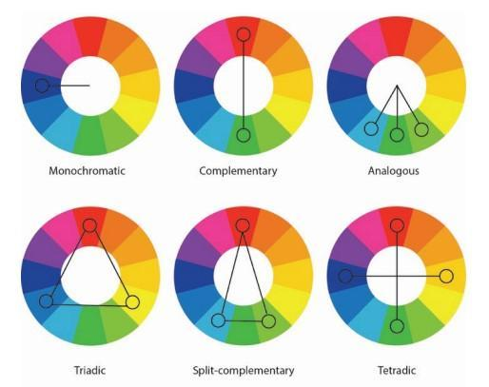

6.2. Appendix B. Group Pro Harmonious and Disharmonious Version
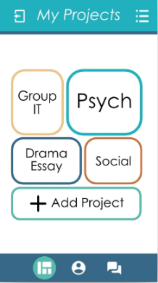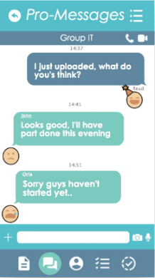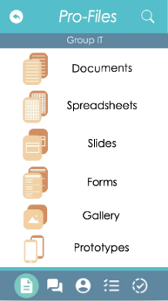
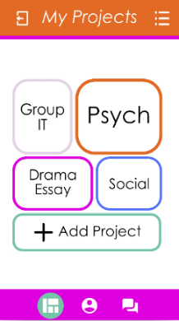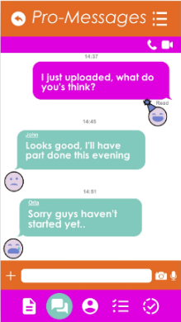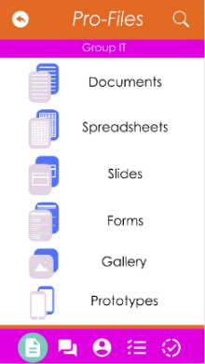
6.3. Appendix C – Microsoft Form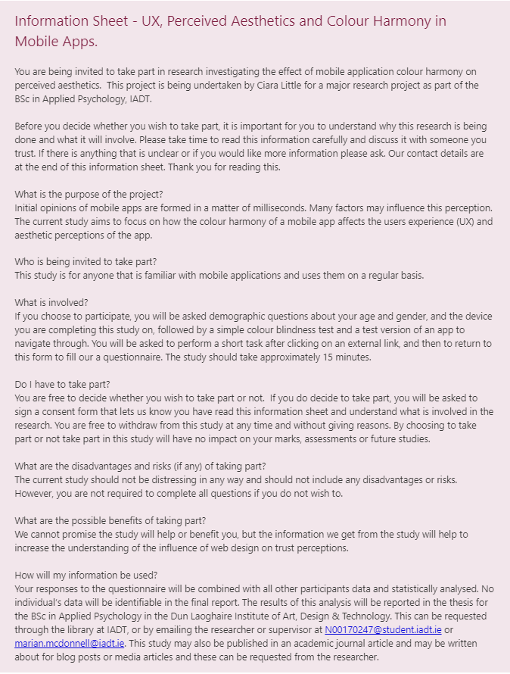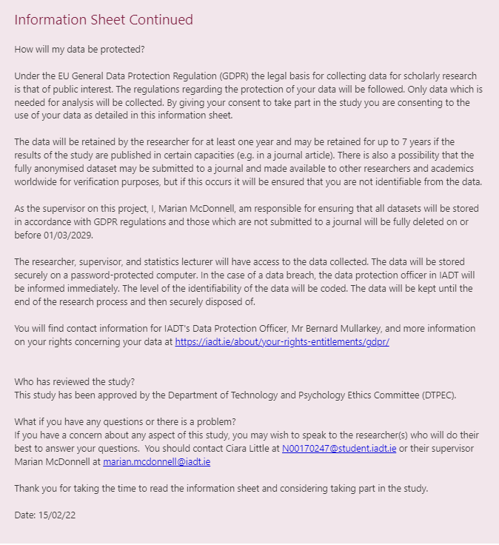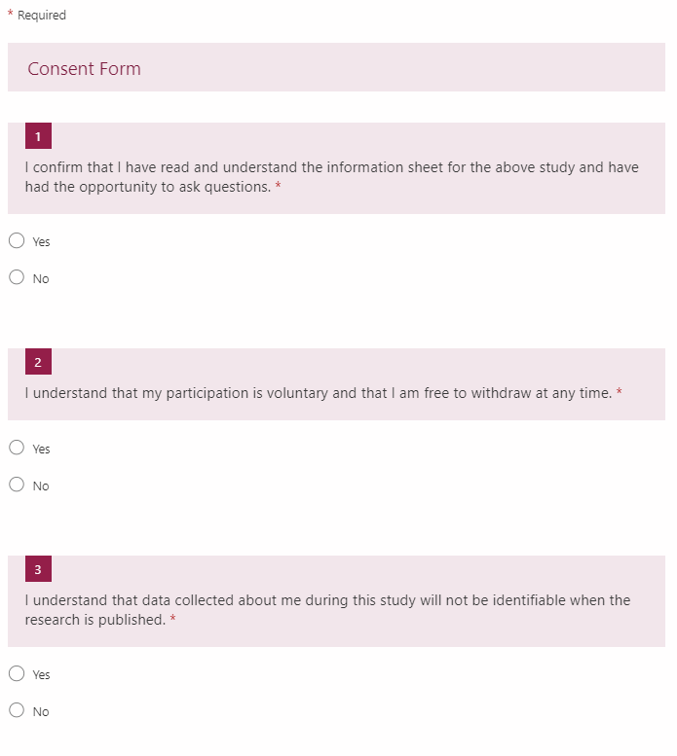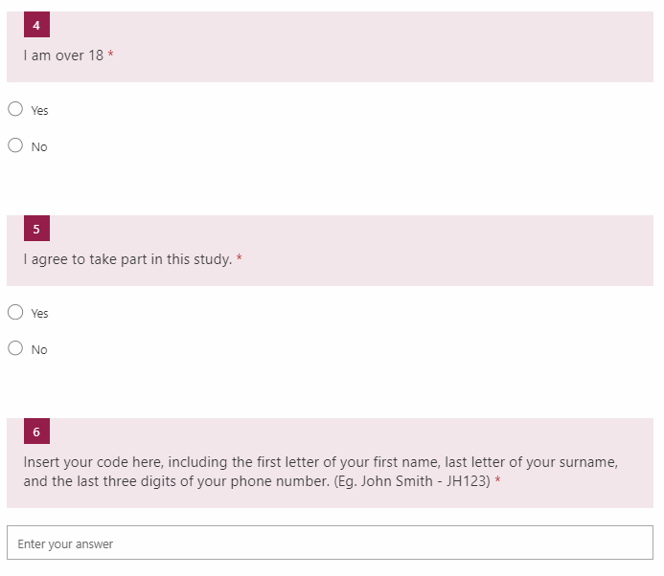
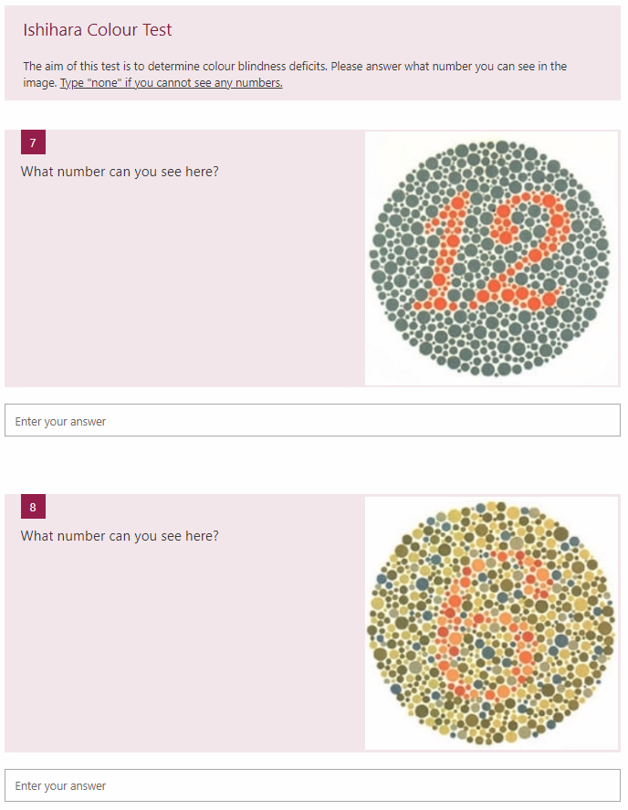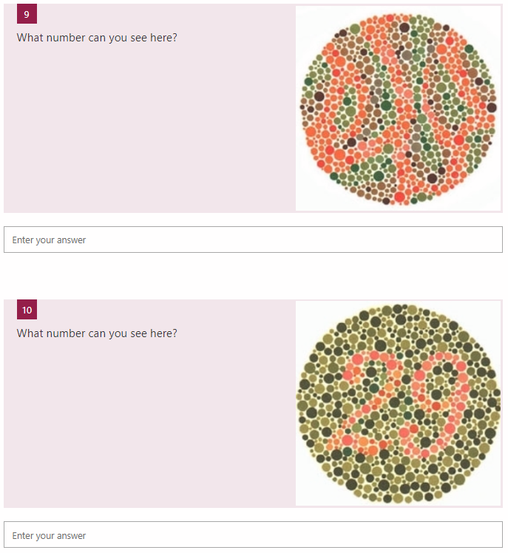
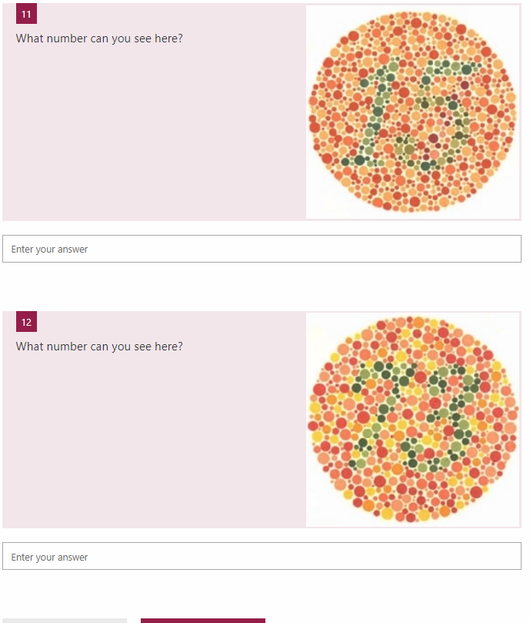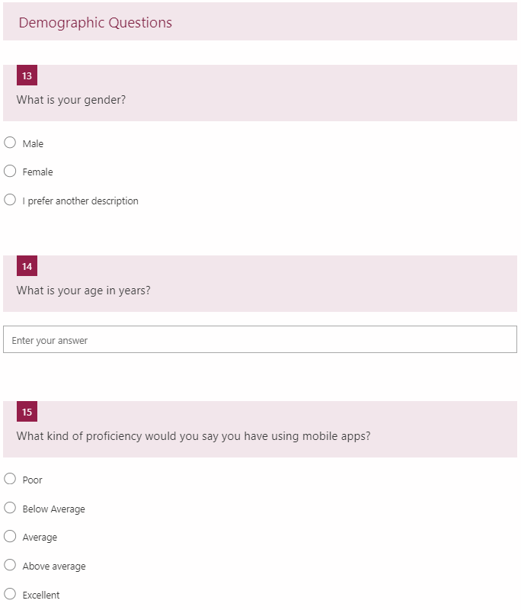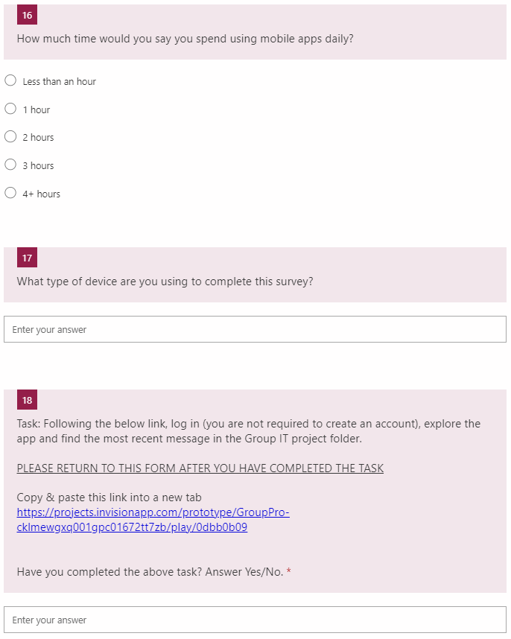

6.4. Appendix D – Questionnaires
AttrakDiff2 Questionnaire
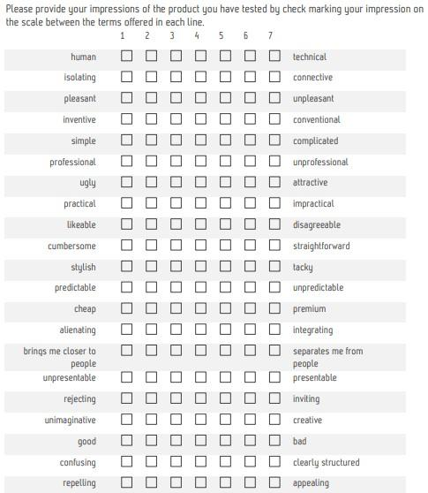
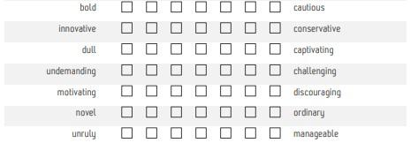

Vis-AWIs Questionnaire

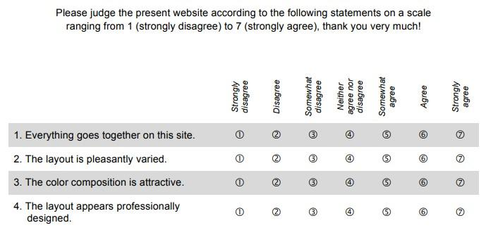

6.5. Appendix E – Analysis 1 Output
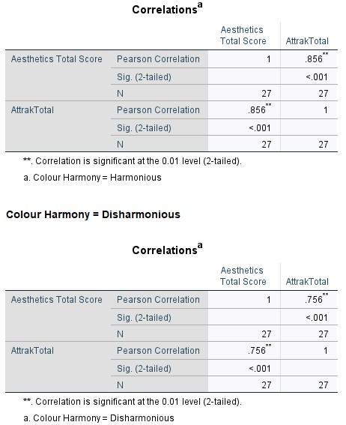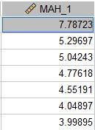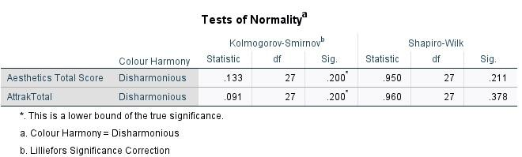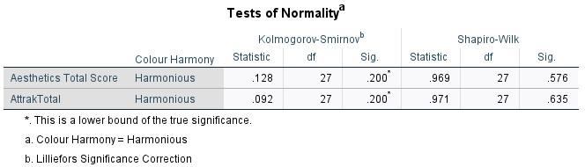
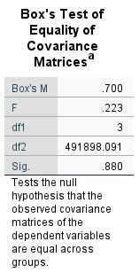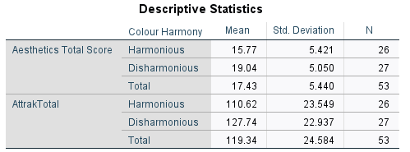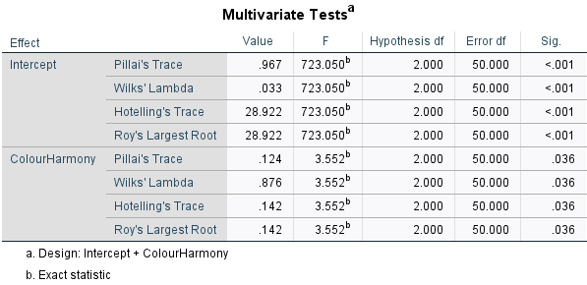
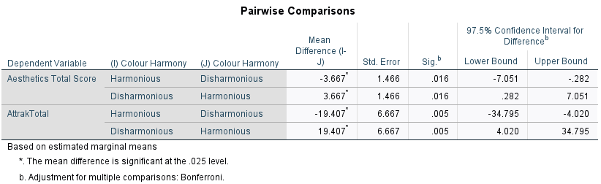

6.6. Appendix F – Analysis 2 Output
