Covoid
A thesis exploring how open data could improve our response to Covid
Tom Farrelly – N00160498 – Year 4 2021-22
Supervisors: John Montayne | Mohammed Cherbatji

Abstract

The goal of this project was to build a system that would assist flyers who were concerned about Covid in returning to their normal flight schedule. This platform was designed to inform users about travel needs, local constraints, and to visually portray Covid-related data.
According to studies, a huge number of respondents found it difficult to find out what was expected of them while traveling to a new country, such as tests, vaccines, and documentation. This was compounded by the fact that it was difficult to understand how successfully a country was responding to the spread of cases and what restrictions were in place.
This application's goal is to inform users on current case patterns while also offering enough information for them to think about when making trip arrangements.
The steps in constructing this system were researched to identify the requirements needed to meet the applications’ user desires, designing the application to meet these requirements, and implementing these designs and functional requirements.
Testing was performed both during and after implementation. According to the results of the testing, the majority of the functionality that was required was straightforward to identify, and the navigation was pretty intuitive. There should be some design modifications made to the search for travel requirements and local restrictions. Some labelling adjustments will also be required to make the application as user-friendly as possible.
Further development into integrating features from other products to integrate into the application, as well as enhancements in processing speeds and security, could be carried out.

Acknowledgements
Throughout the development of this project, I have recaived a great deal of aid and support.
I would like to begin by personally thanking my project manager, John Montayne, for his knowledge and ongoing proactive observations, which were incredibly helpful in devising the project's research, design, implementation, and management throughout its duration. Mohammed Cherbatji, my other supervisor, also delivered the advanced JavaScript course, which I found both engaging and instructive in terms of problem-solving and grasping the fundamentals of JavaScript inside MERN stack development.
I am extremely appreciative of all the lectures I had the opportunity of attending this year. The skills and information I have learned this year have been important to my development not only as a programmer but also as a future tech industry professional.
In addition, I would like to thank IADT and all the on- and off-campus employees who structured this year and provided me with future employment options and invaluable life skills. I am particularly appreciative for the provision of education and collaboration resources throughout the pandemic-affected year, when the typical schedule and procedures had to be adjusted. The ongoing effort in communication, management, and education has greatly aided me in finishing this project effectively.

The incorporation of material without formal and proper acknowledgement (even with no deliberate intent to cheat) can constitute plagiarism.
If you have received significant help with a solution from one or more colleagues, you should document this in your submitted work and if you have any doubt as to what level of discussion/collaboration is acceptable, you should consult your lecturer or the Course Director.
WARNING: Take care when discarding program listings lest they be copied by someone else, which may well bring you under suspicion. Do not to leave copies of your own files on a hard disk where they can be accessed by other. Be aware that removable media, used to transfer work, may also be removed and/or copied by others if left unattended.
Plagiarism is considered to be an act of fraudulence and an offence against Institute discipline.
Alleged plagiarism will be investigated and dealt with appropriately by the Institute. Please refer to the Institute Handbook for further details of penalties.
The following is an extract from the B.Sc. in Creative Computing (Hons) course handbook. Please read carefully and sign the declaration below
Collusion may be defined as more than one person working on an individual assessment. This would include jointly developed solutions as well as one individual giving a solution to another who then makes some changes and hands it up as their own work.
DECLARATION:
I am aware of the Institute’s policy on plagiarism and certify that this thesis is my own work.
Student : TOM FARRELLY
Signed Tom Farrelly

Failure to complete and submit this form may lead to an investigation into your work.

Abstract 1
Acknowledgements 2
1 Research 9
1.1 What Is Open Data 9
1.2 Who Uses Open Data and What Are the Benefits? 10
1.2.1 Government 10
1.2.2 Healthcare 11
1.2.3 Tourism 12
1.3 Challenges to Open Data 12
1.4 Conclusion 13
2 Requirements 15
2.1 Introduction 15
2.2 Similar Applications 15
2.2.1 Bing Covid-19 Tracker 15
2.2.2 Our World in Data 18
2.2.3 Vaccovid 21
2.3 Survey 25
2.4 Personas 28
2.5 Functional Requirements 30
2.6 Non-functional Requirements 30
2.7 Use CASE Diagram 31
2.8 Feasibility 32
2.8.1 D3.js 32
2.8.2 React.js 32
2.8.3 Node.js 34
2.8.4 Express.js 35
2.8.5 MongoDB 36
2.8.6 APIs 38
3 Design 40
3.1 Introduction 40
3.2 Application Design 40
3.2.1 Technologies 40
3.2.2 Design Pattern 45
3.2.3 Application Architecture 47
3.2.4 Database Design 48
3.2.5 Process Design 49
3.2.6 User Interface Design 52
3.2.7 Conclusion 59
4 Implementation 60
4.1 Development Environment Setup 60
4.2 SCRUM Methodology 60
4.3 System Architecture 62
4.4 Back-End 62
4.4.1 MongoDB 62
4.4.2 Server 65
4.4.3 Routes 66
4.4.4 Authentication 67
4.4.5 Controller 69
4.4.6 DAO 70
4.5 Front-End 72
4.5.1 Axios 72
4.5.2 React Components 74
4.5.3 Charts 75
4.5.4 Conditional Rendering 77
4.5.5 Forms 78
4.5.6 Authorization 83
4.5.7 Router 84
5 Testing 87
5.1 Functional Testing 87
5.1.1 Navigation 88
5.1.2 Forms 89
5.1.3 Discussion of Functional Testing Results 90
5.2 User Testing 90
5.3 Introduction 90
5.4 Tasks 91
5.5 Demographic 92
5.6 Type of Test 92
5.7 Data Summary 92
5.8 Design Changes 93
5.9 Conclusion 94
6 Conclusion 95
6.1 Views on the Project 95
6.1.1 Limitations 95
6.1.2 Learning Outcomes 96
6.2 Future Work 97
6.2.1 Maps 97
6.2.2 Trip Planner 97
6.2.3 Vaccines and Variants 97
6.3 Final Thoughts 97
7 Bibliography 100
Figure 1. Covid-19 Bing logo 15
Figure 2. Bing Covid map 16
Figure 3. Bing covid timeseries chart displaying covid cases over time 16
Figure 4. Bing line, bar and area charts dislaying vaccinations 16
Figure 5. Worlwide data 17
Figure 6. Linear scale 17
Figure 7. News 18
Figure 8. Linear scale timeseries 19
Figure 9. Heat Map 20
Figure 10. Heat Map 20
Figure 11. Regional covid statistics 21
Figure 12. Worldwide data 22
Figure 13. Country table 22
Figure 14. Country data 23
Figure 15. Vaccine table 24
Figure 16. Vaccine data 24
Figure 17. Results from surevey asking users how many times they have flown 25
Figure 18. Response from why they had not travelled 26
Figure 19. Results from asking what mode of transport was used 26
Figure 20. Results from asking to rate the ease in which it was to find covid related travel data 26
Figure 21. Results from asking what information was most important to display 27
Figure 22. Use Case 31
Figure 23. React DOM venn diagram handling 32
Figure 24. function component 33
Figure 25. class component 33
Figure 26. Application architecture diagram 47
Figure 27. Database ERD 48
Figure 28. Class Diagram 49
Figure 29. User flow chart 50
Figure 30. Global data page 52
Figure 31. Country Stats 53
Figure 32. Country Restrictions 53
Figure 33. Login screen 54
Figure 34. Registration 54
Figure 35. Global data 55
Figure 36. Travel requirements screen 55
Figure 37. Local restrictions 56
Figure 38. Scrum sprint diagram 61
Figure 39. Trello board 61
Figure 40. env file 63
Figure 41. Index.js file 63
Figure 42. Server provisioning 64
Figure 43. index.js file 64
Figure 44. Server.js imports 65
figure 45. Index.js 66
Figure 46. Travel Router 67
Figure 47. User object 68
Figure 48. Session object 68
Figure 49. Passowrd hashing 68
Figure 50. Users controller register 69
Figure 51. Travel controller 70
Figure 52. Departure and arrival requirements function within the travel DAO 71
Figure 53. End of function 72
Figure 54. Axios GET request 73
Figure 55. Function component 74
Figure 56. Timeseries chart 75
Figure 57. c3 time series chart code 76
Figure 58. data parse function 76
Figure 59. GET request response sent to parser 77
Figure 60. Registration Form 78
Figure 61. Registration input fields 79
Figure 62. Form submission 80
Figure 63. Dropdown function 81
Figure 64. Dropdown select 81
Figure 65. handleChange function 82
Figure 66. Dropdown submit 82
Figure 67.JWT AUTHORIZATION IN THE TRAVEL CONTROLLER 83
Figure 68. User authentication for route access 83
Figure 69.Protected routes 84
Figure 70. React Router 85
Figure 71. Navbar Material UI components 85
Figure 72. Pages Constant 86
Figure 73. Pages mapping 86
Figure 74. Navigation bar dropdown 94

Research
How Open Data can improve our Response to Covid
“By bringing companies, research institutions, non-profits and governments together, we extract meaningful insights and address important societal changes both social and economic”
Microsoft

What Is Open Data
The Open Knowledge Foundation defines "open data" as information that can be freely accessed, reused, and transferred. It describes the massive datasets that governments and corporations make available for free examination by anybody, for any purpose. In addition, it has been acknowledged as a crucial resource for governments, businesses, and civic society (Open Data in Ireland, 2019). Open data is characterized by access and availability, when data is made available in its entirety and at a reasonable cost. Reusability and redistribution entails that the data must be offered under terms that facilitate recycling and circulation, as well as the intermixing of other datasets. There should be no discrimination towards endeavours or individuals or groups (Open Knowledge Foundation, What is Open Data?, 2022).
Open data projects are fast becoming a pivotal role in economic and social development, pushing progress in areas like healthcare, education, banking, travel, climate change and technological innovation. A growing list of private companies, whose businesses have become reliant on private data, are also coming to recognise the potential competitive and social benefits of opening that data up ( Schalkwyk, F.V. et al., 2017 ).
The positive impacts of open data are wide-ranging and cover political, social and economic spheres. These can range from improving transparency and efficiency of government, potential for business innovation and a vast array of social, personal and medical benefits (Open Data in Ireland, 2019). There has always been a great suspense around open data and where it can strengthen citizen engagement and yield new innovative business, (Huijboom, N. 2011) but it has only been in the past decade with modern advancements in technology, like mobiles, web based libraries and cloud computing, that we have been able to harvest and apply these findings from open data. These advancements in collecting, processing and preserving data have resulted in an expansion of information, accumulating from a variety of sources. Some of these open data sources include databases from academic institutions, open access journals, scientific results from experiments governments, research institutions and companies (Deka, M. & Buragohain, D., 2021).

Who Uses Open Data and What Are the Benefits?

Government
The Publications Office of the European Union states that, open (government) data refers to the information collected, produced or paid for by the public bodies which is also referred to as public sector information. Around the world, in both developed and developing countries, at the national and local levels, governments have created or are planning open data programmes and portals ( Schalkwyk, F.V. et al., 2017 ).
Governments collect or generate a lot of data for their own purposes or from their own operations. This data is predominantly comes from the public service which comprises from a diverse range of government departments, offices and agencies, who deliver a wide range of services across all areas of society and business. These organisations produce large quantities of valuable data. This wide range of data is collected from their departments, then compile that data into anonymized datasets, finally releasing those datasets to the public as open data. (Open Data in Ireland, 2019) The objective of open government data projects is to facilitate co-operation among public administration, industry and citizens. From this governments hope to strengthen transparency, democracy, public participation and collaborative work to be of benefit to their society (Maestre, G. P., 2021).
Some of the benefits of open data are varied and reach from improved efficiency of public administrations, economic growth within the private sector to wider social welfare (data.europa.eu., 2016). The publications office of the EU site that open data can “enhance performance and contribute to improving the efficiency of public services. Greater efficiency in processes and delivery of public services can be achieved thanks to cross-sector sharing of data, which can for example provide an overview of unnecessary spending.” They highlight that the economy can benefit from a more innate access to data, thus supplying to the development of innovative services and the construction of new business models. From this, the European Commission has estimated that the economic gains from opening government data could amount to €40 billion a year. This has created the opportunity for a growing number of small enterprises to tap into the potentials of open data (Ahmadi Zeleti et al., 2016).
Outside of economics, the potential for governments to enact responsive policies and make useful tools for the public has been seen across the globe, especially due to the Covid pandemic. Most countries collect data and provide daily reports on the virus spread, the number of infected, recovered, and deceased persons for comparisons to other countries (Rahkmawati, N. A., 2021). In Indonesia the government provides a website which displays a distributed map of Covid cases across the country to allow for citizens to have readily accessible information enabling them to make informed decisions when leaving their home or travelling elsewhere in the country (Website Resmi Penanganan COVID-19, 2021). Tools like these can be of great benefit when keeping case numbers low, enabling them to be of huge service to both the public and healthcare sectors.

Healthcare
The healthcare industry historically has generated vast amounts of data, from record keeping, compliance & regulatory requirements, and patient care (Raghupathi & Raghupathi, 2014). With healthcare being rapidly digitized there is an abundance of data, coming from electronic patient records as well as real time geo located health data gathered from personal wearable devices. Researching this data provides major opportunities for improving health systems as well as individual care (Kostkova et al., 2016).
From this data there is an exponential increase of its application within technology. Take for example in Cécilias 2020 study of medical data governance, it highlights an algorithm created by a team at MIT that is capable of identifying apparently healthy breast tissue in the precise area where cancer would develop four years later through the use of x-rays and open data, to build the algorithm. Opening up medical data, sharing and linking vast healthcare datasets enables for enriched data on symptoms, diseases, diagnosis, treatments, and prescriptions offering the potential for improvements in care for individuals and populations (Kostkova et al., 2016).
It is not only in using advanced AI algorithms or a highly accurate diagnosis that open data is applicable toward the healthcare system, due to Covid there has been a rapid change on public view toward health data. Covid has highlighted that it is essential to be able to model and understand the spread of infectious diseases. (Hunter et al)., highlight that using open data driven agent based model to simulate outbreaks will help identify spreading factors and help prepare for pandemic scenarios relating to specific diseases. Through iterations of institutions and governments allowing their data to be used openly, there are constant developments in combating the pandemic.
Covid, has completely changed the way in which society interacts with health data. It has become an enormous and dominating focus for both public and media interest and now guides a significant proportion of research effort. Both traditional and social media is dominated by daily updates on new figures, visualizations, and discussion (González-Padilla & Tortolero-Blanco, 2020).

Tourism
The growth of data online and services from the Web have made open data become more and more emerging as an indispensable tool of traveling for the tourist industry (Cao et al., 2011). For tourism destinations there are significant possibilities in utilizing open data for development of cultural sights, transportation, marketing and environment (Lampi, 2016).
There is a plethora of tourism apps where users can book and review accommodation like Airbnb, Booking.com Trip Advisor etc. Governments in China and South Korea are also heavily investing into initiatives mostly focused on building the technological infrastructure that supports tourism (Gretzel et al., 2015).
There has been advancements in tourism tools for cities where collaboration between web data and open data from a public institution resulted in a mobile tourism application that works as a tour guide. This app also allows other tour guides add new information about the cultural heritage for some sites (Fermoso et al., 2015). In Lo Duca’s 2019 study on Tourpedia, a website about tourism, which is built using open data provided by government agencies containing over 70,000 accommodation’s in France, Spain and Italy, they have a different goal. The aim of Tourpedia is to unify the multiple open data sources it makes use of to provide a single website to access information regarding tourism. These tools can provide a fundamental and innate way to travel around any given destination and provide great returns for the tourist industry.
Contrarily, the pandemic has resulted in numerous socio-cultural, economic and psychological impacts on various tourism stakeholders (Sigala, 2020). Despite the fact that the tourism industry has been greatly affected by the pandemic it is also provides for a transformational opportunity to reform the mindset toward tourism as crises also accelerate technology, innovation and change (Sigala, 2020).

Challenges to Open Data
With all the possibilities and benefits from open data, there does come some challenges that are faced in regards to privacy and storage limitations.
Ownership of personal data is a key issue faced when dealing with open data, Floridi (2014) stated it as “is a battle between fostering human rights and improving human welfare”. In the example of healthcare, a balance must be struck between an individual’s desire for privacy and their want for reliable evidence to drive healthcare, which may sometimes be in conflict (Kostkova et al., 2016). It is very understandable why most patients wouldn’t want their personal data out in the open. So in moving forward with open data, there must be adherence to data protection and anonymization. Yet this can also prove to be a challenge, as almost all data that is open sourced is de-identified when it is being used but there is a limit where the principles of data protection should not apply to data rendered anonymous in such a way that the data subject is no longer identifiable (Floridi, 2014). The main concern would be if this data ended up in the hand of hackers or scammers it could prove to have detrimental effects on the person whose data was utilized and re-identified.
What should be acknowledged is the fact that there are both friendly and hostile users of open data and that secure infrastructure will need to be in place to ensure that the use of open data is done in a safe manor respective of one’s privacy (Floridi, 2014).
Some institutes can receive over ten terabytes of data daily, this invokes the challenge of how to store such huge amounts of data. There is certain data, like climate data, that is extremely factor sensitive and cannot be deleted as it can’t be replicated (Eggleton & Winfield, 2020). Filling up on storage can prove to be massive challenge due to cost, access, space and software.
There are cost effective storage methods around this like using tape, which is used for large volume datasets that act as a secondary backup (Eggleton & Winfield, 2020).

Conclusion
In conclusion, open data is information that can be freely used, reused and redistributed. It is used around the world by various entities from governments to small time local tourism start-ups. In each area open data has the power to be a powerful tool in helping drive business innovation and a vast array of social, personal and medical benefits.
Within governance, open data help improve the efficiency of public services, help grow the economy and make responsive policies. As more government’s help fund open data initiatives the tools that are being developed for them now will increase in strength and become more applicable to the common user. For this to work the data must be easy to read and understand and not allow for biased or incomplete data to be included.
Healthcare provides one of the most exciting and possibly influential changes in how we approach our health. Utilizing AI algorithms that are made up of open data could ensure an exceptionally accurate diagnosis and further studies into disease spread can supply us with needed information on pandemics that have not yet happened. As previously stated, the data relating to healthcare is arguably one of the most sensitive and thus should be highly secure.
Finally in tourism, there are an amplitude of new innovative tools to help be our guide around a foreign destination. Although the tourism sector has been devasted in comparison to previous years, there is now a great opportunity to re imagine the space of where technological innovations along with open data, could revitalise this sector.
The challenges that we currently face with open data should definitely not be over looked. There is great risk when handling sensitive personal information that it does not get into the wrong hands and that the data is stored correctly with ample security and storage.
Currently, we are still a distance away with today’s technology being limited in storage and data structure, from harnessing the full potential of open data. That being said, the possibility in which it can be achieved is quite plausible in the future.

Requirements

Introduction
The objective of the requirements phase is to enable developers to determine the capabilities of the application. It is crucial to understand what the users want the program to perform, as opposed to the developer choosing what is necessary.

Similar Applications

Bing Covid-19 Tracker
Figure 1. Covid-19 Bing logo
When first viewing Bings Covid tracker website, you are greeted with a map of the world with ellipses over each country, that when hovered over give you a small snippet of data pertaining to the country. This makes for a very intuitive way of getting a glimpse of how a country, or region, is performing in relation to Covid and makes for a nice backdrop while utilising the multiple features, as shown below.
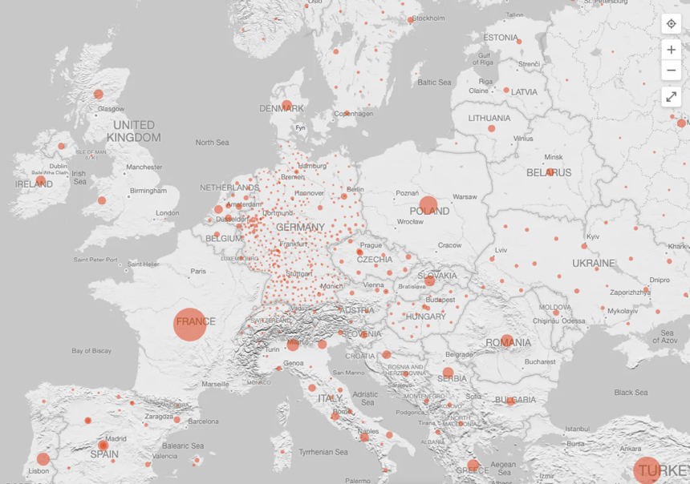
Figure 2. Bing Covid map
Bing offers both global and regional statistics and graphs relating to Covid. These statistics include, total and fatal cases, both fully vaccinated and received one dose stats relating to vaccination and shows daily spread trends for cases both new and fatal. These graphs are interactive, allowing the user to hover over each column, representing a day, and find the statistics related to that specific period. Having both daily and cumulative spread trend graphs side by side really helps the user attain a comparative analysis of the risk of spread and fatality of Covid.
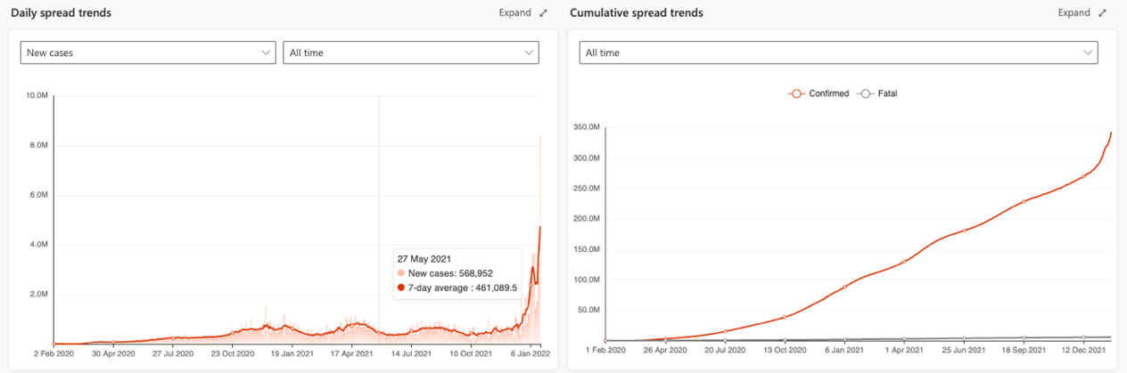
Figure 3. Bing covid timeseries chart displaying covid cases over time
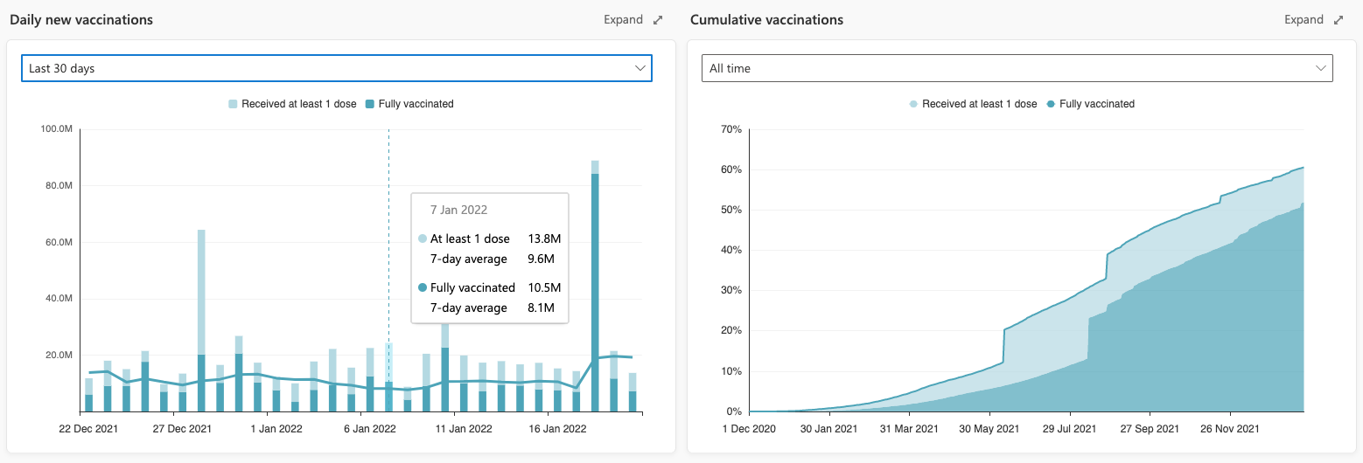
Figure 4. Bing line, bar and area charts dislaying vaccinations
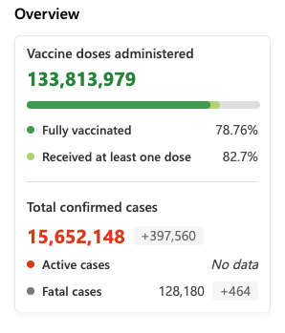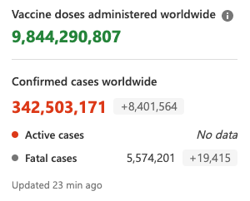
Figure 5. Worlwide data
When inspecting cases on a global scale, Bing provide a table with the top 5 regions with the most cases. This gives the user a decent perception to grasp how Covid is performing on a global scale.
This website also has the capability to display graphs that can compare by region. This ability can provide very useful information and indicate to users how their region is performing.
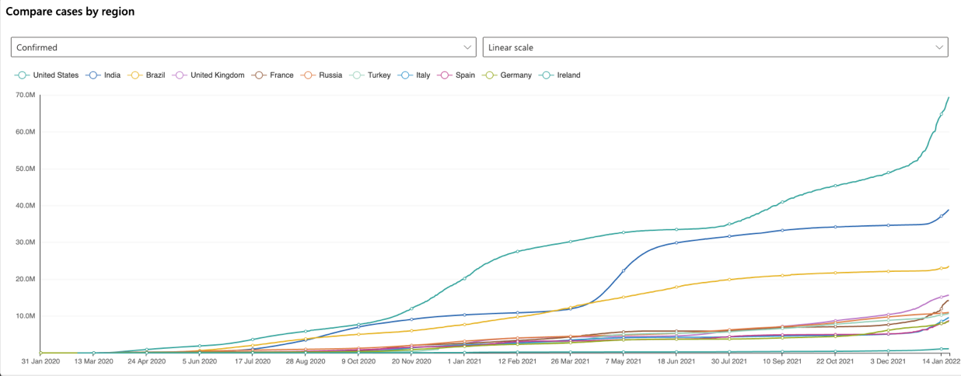
Figure 6. Linear scale
Along with covid statistics the website also provides country based news and videos that relate to Covid. With providing this news insight it allows users to get a on the ground perception of how the country is handling Covid, something that can be overlooked and hard to get a feel of when just digesting stats and graphs.
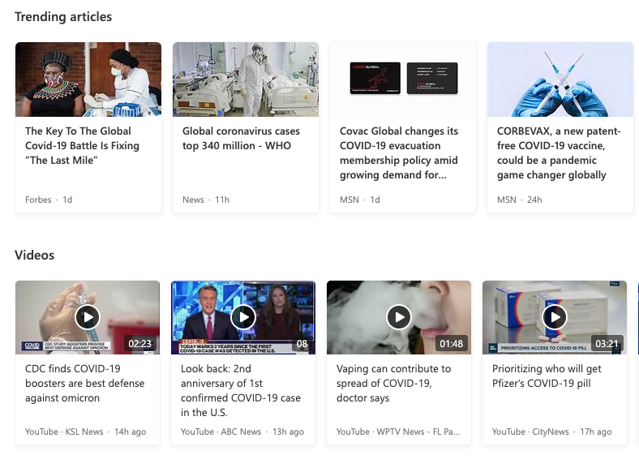
Figure 7. News
I’d identify this platform as a primary competitor, as it follows a similar ethos that I want to provide to my users with using this platform to help users make informed decisions when they are considering travelling abroad.

Our World in Data
Next is Our World in Data’s Covid website whose goal is to make the knowledge on the big problems, like global warming and the pandemic, accessible and understandable. They are a trusted source for multiple news media like the BBC, CNBC and The New York Times to name a few. Their work is also commonly used as teaching material in schools and universities namely Harvard, MIT and Cambridge among others.
Their graphs pose a very in depth analysis of Covid, in which they have numerous metrics and different intervals to select from to help users visualise and understand how Covid is developing. While using their graphs there is the ability to add numerous countries to compare and also provide timeline functionality to show how Covid developed in the selected countries in the past year. This, to me, is a key feature as it can provide fundamental insights to users who are trying to digest these graphs and gives good representation of the course the selected countries have taken.
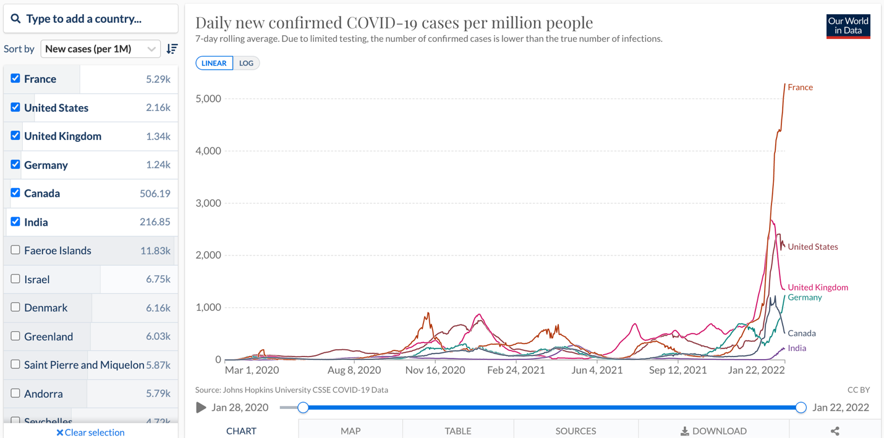
Figure 8. Linear scale timeseries
These graphs also contain multiple tabs that allow the user to see this data displayed in either a table or map format. The map tab provides a heat map of the globe and has the option to select a specific continent.
Differences in the population size between different countries are often large so it is insightful to compare the number of confirmed cases per million people. It is important to keep in mind that in countries that do very little testing, the actual number of cases can be much higher than the number of confirmed cases shown here.
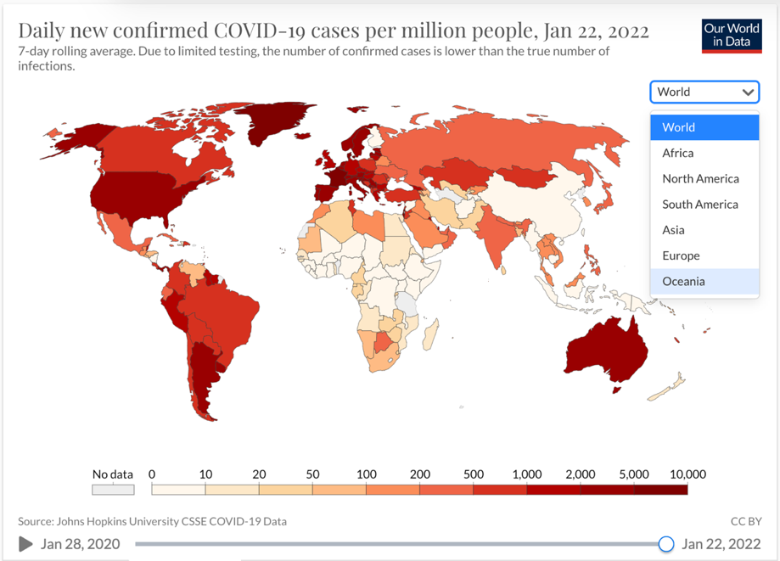
Figure 9. Heat Map
Since reporting can vary significantly from day to day, irrespectively of any actual variation of cases, it can be helpful to look at changes from week to week. This provides a slightly clearer picture of where the pandemic is developing by either accelerating, slowing, or reducing.
The maps shown below provide figures on weekly and biweekly confirmed cases, one set shows the number of confirmed cases per million people in the previous seven days (the weekly or biweekly cumulative total), the other set shows the growth rate over these periods.
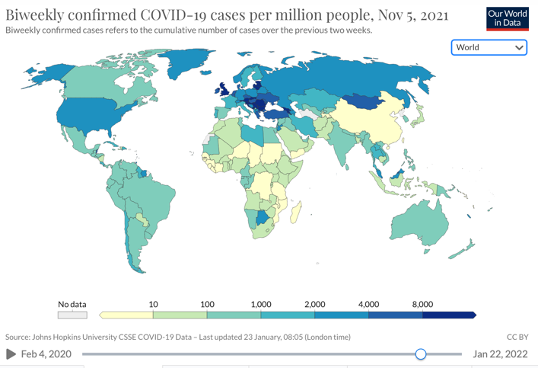
Figure 10. Heat Map
Having both sets beside each other does allow the user to get a sense of how the pandemic is developing but simply looking at the cumulative total or daily number of confirmed cases does not allow the user to understand or compare the speed at which these figures are rising.
From this they have developed a table that shows how long it has taken for the number of confirmed cases to double in each country for which we have data. The table also shows both the cumulative total and daily new number of confirmed cases, and how those numbers have changed over the last 14 days.
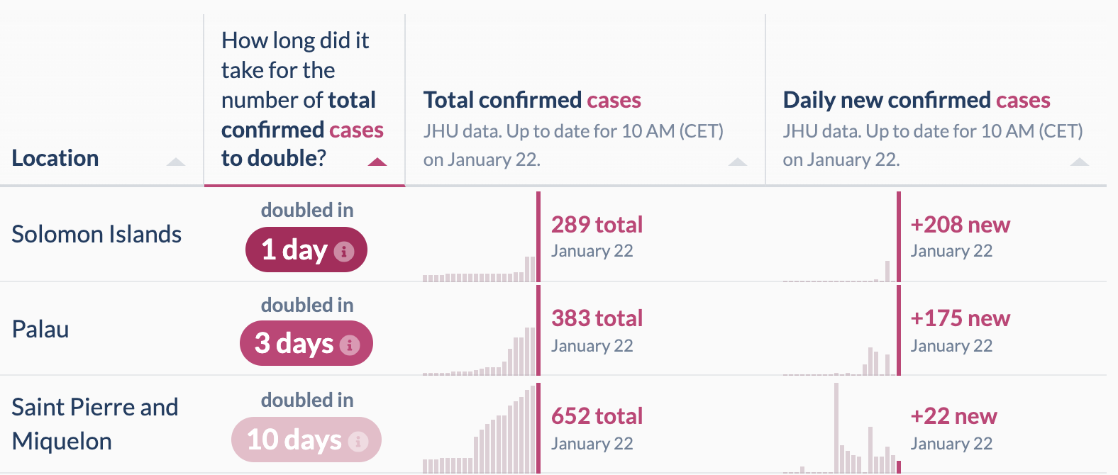
Figure 11. Regional covid statistics
This is a pivotal feature, as it allows the user to really comprehend and make sense of the data that is being displayed.
This website is an extensive analysis on Covid development and includes multiple graphs and tools to digest and track Covid’s development around the world.

Vaccovid
This website is a comprehensive, up-to-date vaccination tracker, Covid tracker, and treatment tracker created to inform users throughout the world about the current coronavirus epidemic.
As soon as you enter the website, you are presented with a summary of worldwide Covid-related statistics.
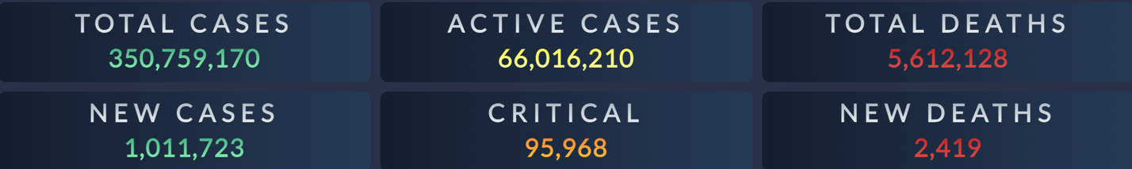
Figure 12. Worldwide data
Observable data are segregated into several columns in each table: Total cases, New Case, Active Cases, Serious or Critical Cases, Total Deaths, New Deaths, Total Tests, and Total Recovered. In order to make the statistics of coronavirus cases more accessible, they also provide four additional measurements: Infection risk, Case fatality rate (CFR), Test percentage, and Recovery percentage.
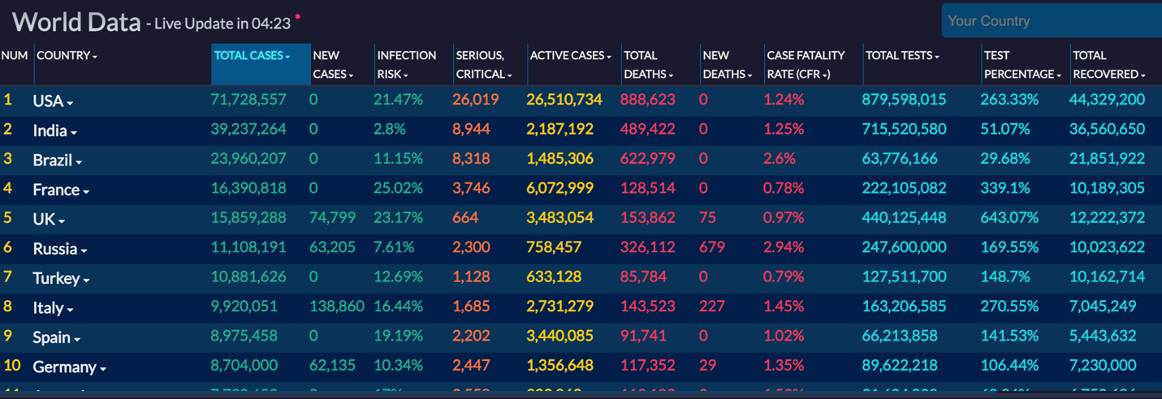
Figure 13. Country table
In addition, you can see the data tracked from the past six months on visual charts in order to realize the trends on Total and New cases or deaths of each country, over time. You can also compare each country's data with the average world status.
When clicking a specific country on the table you are shown even more in depth statistics also including graphs and charts to represent the data
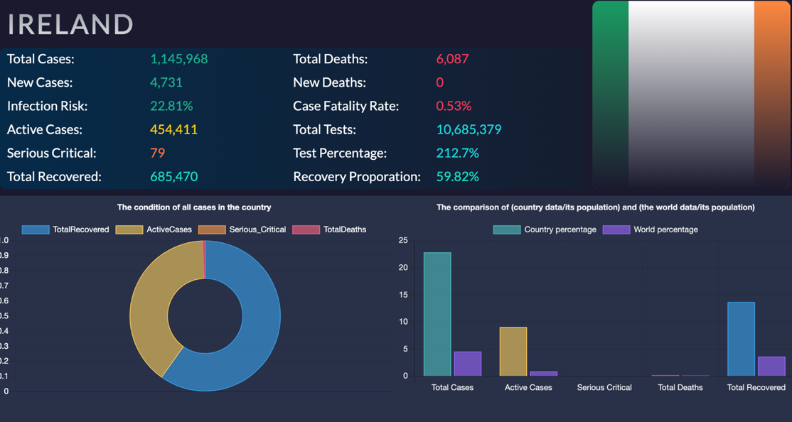
Figure 14. Country data
In addition to providing information on Covid cases, they also give vaccine and treatment information. They compiled information on more than 230 vaccines in development and offer the following details on each vaccine:
- The stage in its development
- The description of vaccine product
- Following steps that the company should take for getting into the next phase
- FDA approval in order to show that which vaccine has the eligibility to get into the market for public use
- The Last time that the producing company revealed their results
- Specific links to the results of each vaccine progress
The vaccines are organized according to the phase in it development and production platform. They have also specified links to the vaccines that are more likely to reach phase 4 and get FDA approval.
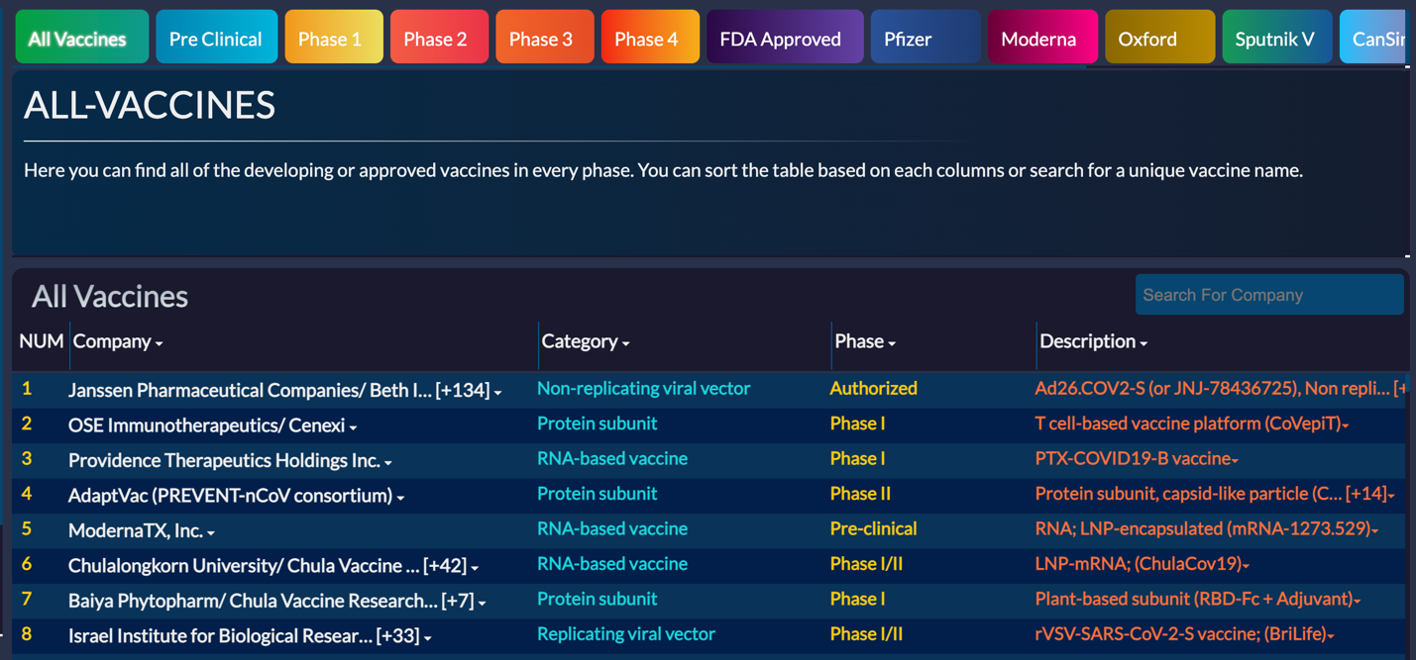
Figure 15. Vaccine table
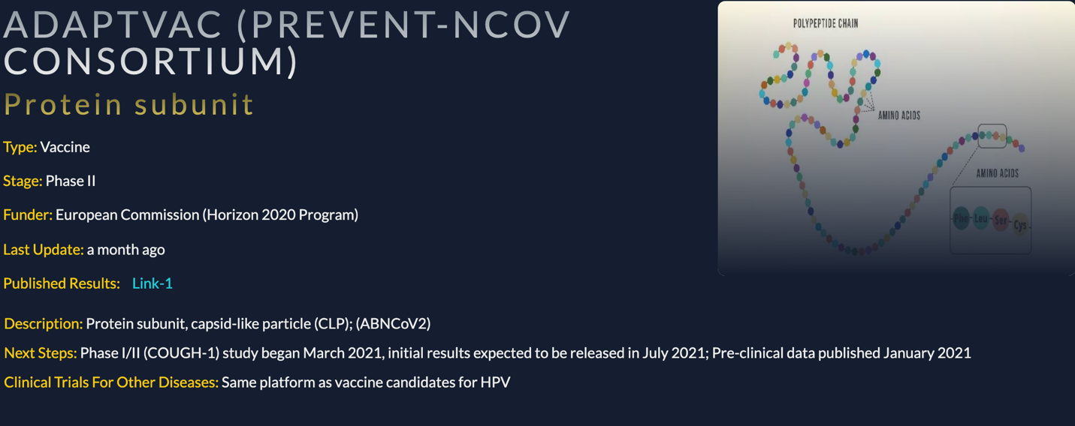
Figure 16. Vaccine data
Similar to the vaccine tracker they also provide a treatment tracker, providing the user with links to the most frequently used medications which are currently utilized to treat Covid cases and have more potential than other treatments to get FDA approval.
Among the trackers they have included a news page where gather the most relevant coronavirus news from more than 20 broadcasting services with reliable sources for coronavirus news and update them every 5 hours.
These insights are very in depth and may not be the most applicable to the everyday person. When taking into consideration my application, I will be wary to include as much information so I do not confuse or disorient the users.

Survey
For conducting my survey I created a questionnaire that accommodates to my user base. I conducted this questionnaire to help better understand my user’s needs and what functionality I should implement in my application to cater to them.
When asked if they had travelled since the start of the pandemic the results showed that 93% of users surveyed had left the country at least once over that time. From further questioning I found that the majority of about 33.3% had left the country 3 times and that 11.1% had gone over 6 times. These results highlight that a large portion of people are travelling outside of Ireland and would need to be aware of the Covid development in whichever country they are travelling to.
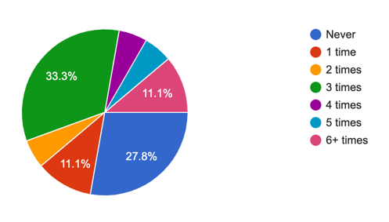
Figure 17. Results from surevey asking users how many times they have flown
With only 22.2% of users not leaving Ireland since the pandemic started, they sited that their anxiety from catching covid was the main factor in them not travelling. Dealing with anxiety is a lot more difficult during a pandemic and although my web application by no means will help people get rid of their anxiety, I believe that providing as much information as possible in relation to Covid could help some alleviate their anxiety.
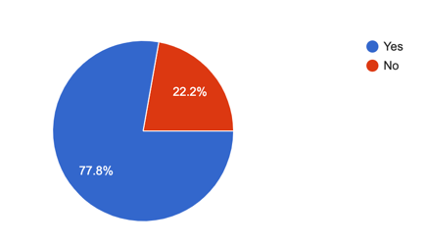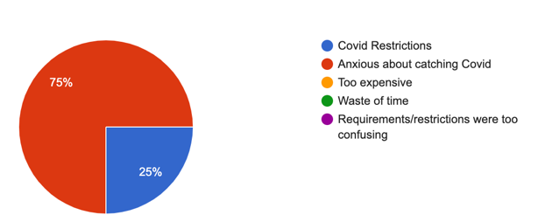
Figure 18. Response from why they had not travelled
When posed the question of what mode of transport was taken by them, the overwhelming leader was an airplane with 64.3% of respondents using that mode of transport. Trains were a second by some distance at 14.3%. These findings show that when developing my application I should pay keen attention to restrictions and requirements specific to air and rail travel, making it an easier process for users to know what they will need.
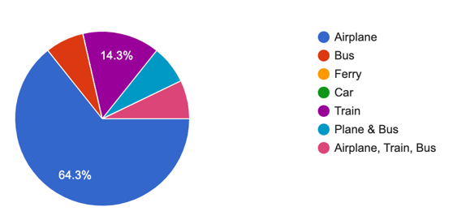
Figure 19. Results from asking what mode of transport was used
When asked what information they needed when traveling, the response was in favour of tests and vaccine certificates. In addition, when asked to rate how difficult it was for them to obtain these requirements, 60% rated them between 6 and 10, with 10 being extremely difficult. This information emphasizes the importance of displaying the restrictions and requirements for each country to and from which the user wishes to travel.
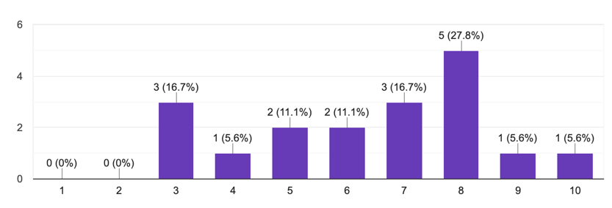
Figure 20. Results from asking to rate the ease in which it was to find covid related travel data
After being asked what information would be of benefit to know before they travelled abroad most responded with being able to know what restrictions are in place in regards to travel and hospitality. A key finding from these results was that a lot of people would like to know the price and location of tests, both antigen and PCR. Including this information on my application could heighten the user engagement and help guide users to make better and more informed travel plans.
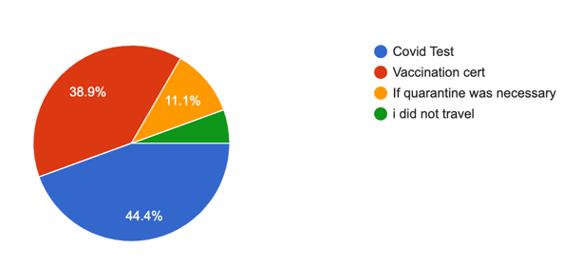
Figure 21. Results from asking what information was most important to display
Finally, when people were asked what apps they used when travelling abroad the overwhelming majority was Google Maps, as to be expected, and the second most common was Skyscanner which is used to find cheap flights. Including an API for each of these could prove to be very constructive for users as they could gauge flight prices to their selected destination while also witnessing how that country is performing in relation to the pandemic.
The information I gathered from this survey has greatly aided my understanding of my users and helped me determine which areas I should prioritize. I also know that this application will help users on their travels and will fill a gap in the current market.

Personas
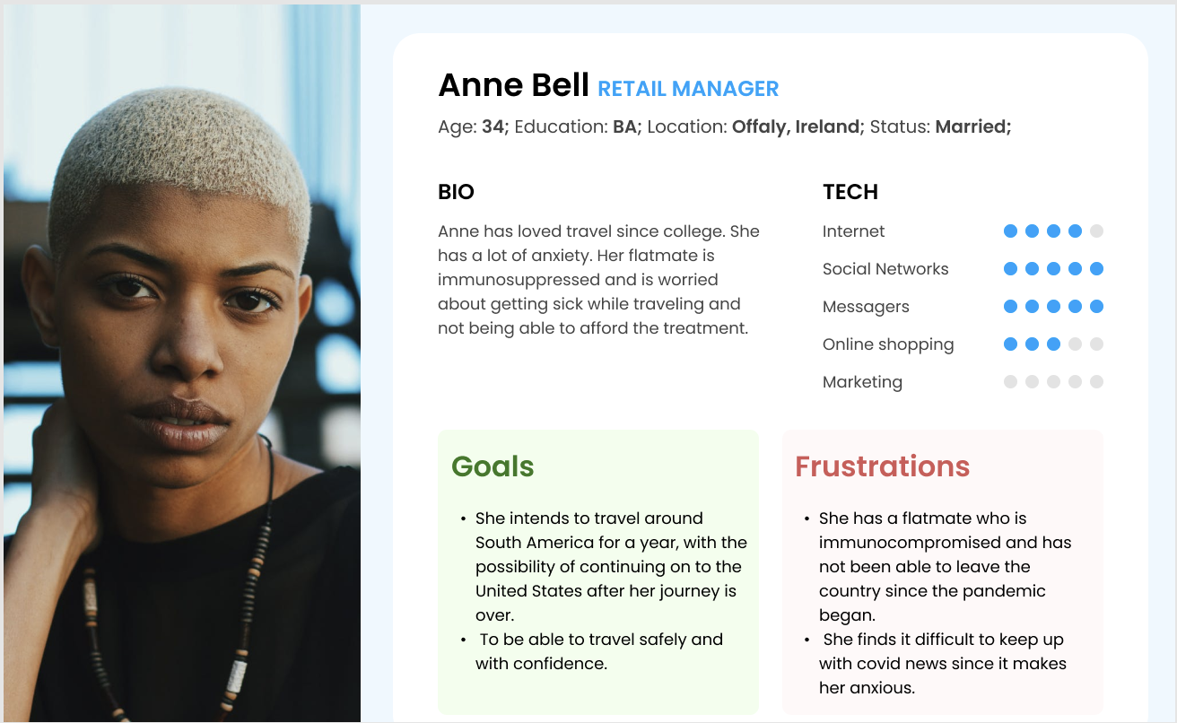

Functional Requirements
The conditions that relate to the technical functionality of the system for the web application are known as functional requirements. The way users interact with the web application is defined by these conditions.
The following are the most important aspects of this online application for users:
- To use the web application's services, a user must be able to login or create an account.
- Be presented with Covid-related information on a global scale, such as death, cases, and immunization rate, on the homepage. The ability to compare Covid related statistics based on country or region.
- Interact with graphs and add more countries for comparative analysis.
- Filter graphs and statistics based on daily, monthly, yearly and all time.
- View the entry requirements and restrictions in place in each country or region.
- Be able to read news articles relating to covid in each selected country or region.
- Be able to compare cases and vaccines rates with data relating to the economy of a country, like GDP.
- Show pricing and locations of Covid tests.
The most important features of this web application for the admin are;
- Must be able to maintain the web application.
- Have the ability to update the application.
- Ensure functionality and app responsiveness .
- Ensure that data being outputted from the APIs is reliable and in real time.
- CRUD for users.
Create notifications for users regarding the web application.

Non-functional Requirements
Non-functional requirements define the criteria to judge the operation of the web application. Rather than specific behaviours these are conditions which define how the application is supposed to be.
The non-functional requirements for this application are;
Usability – The appearance of the UI and how people interact with it.
Scalability – Can the application handle large volume of users and datasets with the prospect of them growing in size.
Capacity – How much storage will be needed.
Performance – How long will each page take to load.
Supportability – Can the application run on different browsers and can it run on different devices like a computer or a mobile device.
Security – Security of content, users and encryption.
Availability – Downtime of the application.
Manageability – The ease with which the administrators can monitor the system.

Use CASE Diagram
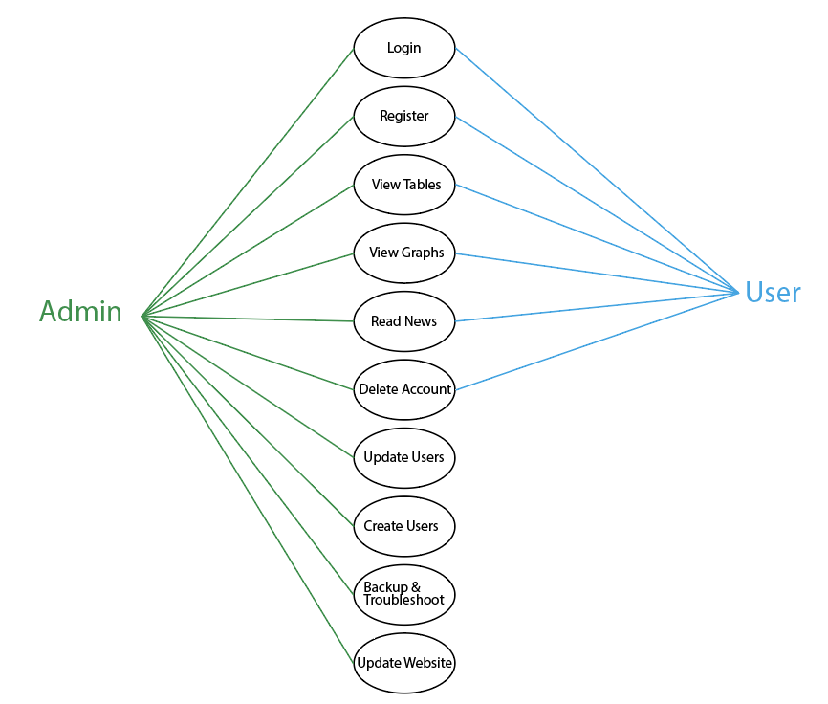
Figure 22. Use Case

Feasibility
There are various technologies that I aim to employ for my web application in order to accomplish the functionality and features that I have mentioned. To make my application operate and meet the expectations of my users, I will employ a variety of software and APIs. D3.js, React.js, Node.js, Express, and a series of APIs using real-time, country-based data related to Covid-19 will be the technologies I will be utilizing.

D3.js
D3.js is a JavaScript toolkit that enables the creation of dynamic, interactive data visualizations utilizing HTML, CSS, and SVG. It links data to the DOM and its elements, enabling data-driven manipulation of visualizations. D3.js and React are frequently employed in tandem to generate dynamic data visualizations. Using shapes, lines, and colourful graphs, data visualization facilitates the clear and effective communication of data. It supports huge datasets and dynamic behaviours, allowing you to encourage user involvement through the use of animations.
Due to the fact that both React and D3 manipulate the DOM, conflicts may emerge. This may be circumvented by employing D3 code as components. React can handle the majority of DOM actions, such as saving data and sending it to components, however D3 is preferable for data visualization and computations. As seen by the Venn diagram below.
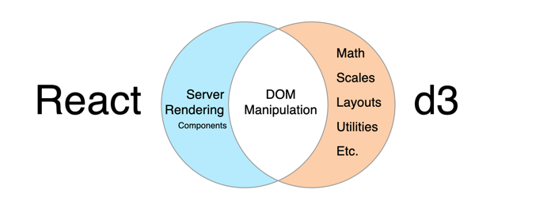
Figure 23. React DOM venn diagram handling

React.js
React.js is a free JavaScript frontend framework that allows you to create complex user interfaces and UI components. It is a declarative framework for front-end web development that allows you to construct interactive user interfaces for websites. It allows developers to create reusable user interface components such as navigation bars, menus, pop up modals, buttons, and tables. It also helps with development organization and the delivery of increasingly complicated features. To understand and use React effectively, developers must be familiar with the basic elements that make it a strong framework: components, virtual DOM, JSX, and so on.

Components
A web application contains numerous user interface (UI) elements. The majority of these components will be duplicated and will have the same or similar characteristics. If developers just use plain languages with no libraries or frameworks, the development team will face difficulties controlling the DOM or maintaining the system. As a result, React splits UI elements into discrete reusable blocks of code to make things easier for developers. These separate parts are referred to as components. They encompass the representations and functionality of all related UI elements. Properties are assigned to components, which can then be declared as JavaScript functions or inherited React Component classes. Each component is a JavaScript function that returns a piece of code representing a web page section. They are typically thought of as functional components, but they may also be used as class components by calling the render() method, which returns the component's JSX. Class components can keep track of their current state. This data is referred to as state, and it is kept in a JavaScript object. The term "state" refers to a method of altering the user interface in response to events. When a user touches a button, the status and UI are both updated. State handlers must handle these events. When a component is modified, these functions are called. The event object is passed to the function as an argument and can be used if desired.
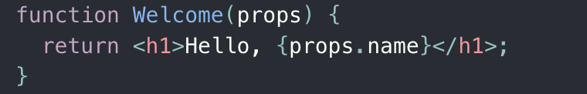
Figure 24. function component
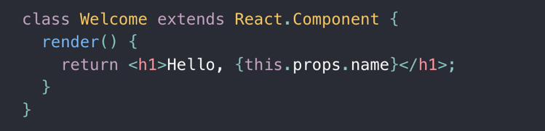
Figure 25. class component

Jsx
JavaScript XML (JSX) is an HTML-like extension to the JavaScript language syntax. Although React does not require the use of JSX, it is a preferred addition to React since it allows for the explicit separation of component and non-component code and makes use of developers' existing HTML knowledge.
JSX provides a more HTML-like interface for working with Reacts functions. Although JSX appears to be quite similar to standard HTML on the surface, it compiles to JavaScript and so gives the benefits of script code such as loops and other functions, making the components even more concise and flexible. The sections of JSX that use ordinary JavaScript are separated by curly brackets.

Node.js
Node.js is a web application framework designed to improve the performance and scalability of online-based applications and services. It provides a dependable solution to a variety of common web-development issues. This is because Node conducts single-threaded, non-blocking, asynchronous programming, which saves a substantial amount of memory and improves overall application performance by increasing responsiveness.
Node.js' event-driven architecture, which allows program code to be executed asynchronously, is a significant benefit of the framework. A server's most common functions include responding to requests, storing data in a database, reading files from a hard drive, and creating connections with other network components. In programming languages like C and Java, I/O operations are performed synchronously. This implies that tasks are performed one at a time, and the focus turns to the next task once the previous one is effectively completed. Asynchronous I/O is used by Node, which enables read and write operations to be directed straight to the operating system or a database, respectively. This enables a large number of I/O jobs to be executed in parallel without generating any delays. In some cases, the efficiency of NodeJS and JavaScript-based apps can benefit from this, particularly when it comes to lowering latency. NodeJS also contains tools and functions like NPM and "require," which help developers manage third-party libraries like MongoDB and Express, allowing them to work more quickly and efficiently. Node is also extremely configurable with NPM, which allows Node users to install packages from open-source blocks of code that are tailored to their specific needs. These utilities facilitate the loading of pre-installed node modules into applications.
Node compiles and executes JavaScript code inside a VM, allowing JavaScript code to be run on the server side. This makes JavaScript a viable alternative to other server-side languages such as PHP, ASP, or Java, and most importantly, it allows JavaScript to be used at all stages of the web stack–server, transport format (JSON), and client.
By executing JavaScript code outside of a web browser, Node.js allows users to create network apps that are both speedy and scalable. It employs a non-blocking I/O architecture, which makes it lightweight and efficient while also being appropriate for data-intensive real-time applications that run on a number of various devices. JavaScript is more easily translated to machine language, and as a result, the code runs faster.
Node was intended to boost web application speed and scalability. It provides a good solution to many common web-development challenges. Node conducts single-threaded, non-blocking, asynchronous programming, which is incredibly memory efficient and improves total application speed by enhancing responsiveness.

Express.js
Express is a web application framework written in Node.js that provides a simple API for constructing webpages, web applications, and back ends. It includes tools for creating handlers for requests using a variety of HTTP verbs and originating from a number of URL paths (routes). Because it is a non-opinionated framework, it has substantially fewer constraints on the best way to connect components to achieve a goal, or even which components should be used. It also adds handy utilities to Node HTTP objects, making dynamic HTTP objects easier to show on the client side.
Express is a Node.js online application framework with a simple API for building webpages, web apps, and back ends. It provides tools for writing handlers for requests with various HTTP verbs at various URL paths (routes). It is a non-opinionated framework, which means it has considerably fewer constraints on how you glue components together to achieve a purpose, or even what components should be employed. It also adds useful utilities to Node HTTP objects and makes dynamic HTTP objects easier to render.
Express improves the functionality of web, mobile, and API programs. Many libraries have been created to make Node server-side development easier. The express library, which is offered for free, is by far the most popular developed library for this purpose. Third-party middleware must be installed in order to extend the functionality of the express application and add new features as needed. In the Express framework, middleware is executed from top to bottom during the request-response cycle. Each middleware maintains access to the request and response objects, as well as a next function that is passed from one middleware to the next during the request and response. The middleware accepts the request, executes the code within it, updates the request and response objects, and then invokes the next function, that triggers the middleware in the queue behind it, and so on. An express application can use application-level middleware, router-level middleware, error-handling middleware, built-in middleware, and third-party middleware. When building application-level middleware, the app.use and app.method functions are used, where'method' refers to an HTTP action that the application is currently performing. The router-level middleware connects it to a specific instance of the express router. Objects that contain error-handling middleware are surrounded by the object and receive four arguments: the error object, the request object, the response object, and the next object.

MongoDB
MongoDB is an open-source NoSQL database that is highly scalable, trustworthy, and free. MongoDB has a reputation for being a versatile, adaptable database, and it is used as the backend data storage for many high-profile companies and organizations, including Forbes, Facebook, Google, IBM, Twitter, and many others.
MongoDB is a non-relational database system. The two most common database types are SQL (relational) and NoSQL (non-relational). Relational databases hold data in columns and rows. Companies such as Microsoft SQL Server, Oracle, and MySQL use relational database management systems (RDBMS).
In contrast, NoSQL databases hold schema-less, unstructured data in a large number of collections and nodes. Non-relational databases do not require fixed table schemas. NoSQL databases can scale horizontally but only support a limited amount of join queries.
When documents are retrieved in JSON format, they are more readable by humans. The JSON format can be nested for storing complex data objects. With a dynamic structure, adding and removing fields is simple. Because the developers have complete control over the schema, they may fine-tune and reformat it as the software matures.
Furthermore, the BSON format enables for faster data digestion while also significantly improving indexing and searching performance. There are text, partial, geographic, decimal, and other indexing methods accessible.
There are a number reasons why MongoDB is becoming increasingly popular. They are as follows:
- Flexibility: MongoDB is expressive and versatile because it employs documents that can include sub-documents in complicated hierarchies. MongoDB can map objects from any computer language, making it simple to develop and maintain.
- Flexible Query Model: The user may choose index particular sections of each document or query based on regular expressions, ranges, or attribute values, and each object can have as many attributes as the application layer requires.
- Native Aggregation: Users may extract and alter data from the database using native aggregation. The data can be exported to other data sources or put into a new format.
- Schema-less model: Applications are given the authority and duty to interpret various attributes present in documents in a collection.
- Load Balancing and Scalability: It is built to scale, both vertically and horizontally. Using the technique of sharding, an architect can achieve both write and read scalability. Data balancing occurs automatically and transparently to the user by the shard balancer.
Collections make up the entirety of the database. Since MongoDB is schemaless, documents in one collection do not have to be identical. Using key-value pairs, all data is saved as BSON documents. On the backend, MongoDB converts JSON data to a binary representation called as BSON. Layered data is also supported by MongoDB. As a result, data retrieval is reasonably quick.
As there are no tables in a MongoDB database, it is straightforward to deal with. Data is saved in BSON or extended JSON key-value pairs. A unique key is defined and a value is assigned to it. These values are recorded as documents and then saved in a collection.
More kinds of data, such as Boolean, text, double, integer, object, finery data, JavaScript, array, and so on, are supported for storage in the BSON format.
Although there are many pros to using MongoDB there are some drawback such as;
- MongoDB does not support joins in the same way that a relational database does. However, joining functionality may be used by manually scripting it. However, it may slow down execution and have an impact on performance.
- For each value pair, MongoDB saves the key name. There is also data redundancy owing to the lack of join functionality. As a result, RAM is being used inefficiently.
- You can have a document that is no larger than 16MB in size.
- Nesting documents for more than 100 layers is not possible.

APIs

Disease.sh
The Disease.sh API delivers the most recent and past COVID-19 statistics and news by country or state. It provides the most recent coronavirus news for the entire world or for your chosen country or state. This free COVID-19 stats and News API enables users to send a web-based query and obtain information regarding global and regional coronavirus data, such as the most recent news, numbers, historical values, and geo-breakdowns. It offers a number of endpoints that can be executed through the web and are well suited for React development. This API will be essential for displaying local and regional covid statistics.

Covid-19 data API
Provides information about Coronavirus disease, from several sources like John Hopkins CSSE, CDC and WHO. All sources are verified, and collection of information that is not confirmed by official authorities is avoided. It has 6 servers around the world and is considered one of the fastest APIs related to Covid as it is updated every 15 minutes.
This API will be critical for retrieving information regarding the statistical display of Covid related data.

News API
Simple, easy to use REST API that returns JSON search results for current and historic news articles published by over 80,000 worldwide sources. Gets JSON results with HTTP GET requests, or has the option to also use one of the SDKs available. Allows for filtering of news through publishers, titles, keywords and phrases. It has the ability to retrieve news within a specific period or up to the minute news. This API has the capacity of being able to translate each article into one of 14 languages from 55 countries.
This API will be an integral element for this web application as it allows the application to offer relevant and timely Covid news to the users, allowing them to make informed decisions and gauge how a country is performing relative to Covid.

EU Covid-19 Travel
An API based on data from the European Open Data Portal for retrieving data on Covid incidence rates and travel restrictions/requirements for travelling. The API provides three endpoints for retrieving country specific data and also provides the possibility to sort and filter the end points by risk level (Green: Low, Orange: Mid, Red: High) using query parameters. This API is updated weekly to reflect current data.

Covid-19 and Travel Safety API
Provides travel safety data from leading risk intelligence providers, to keep users safe at every step of the journey. Use the Travel Restrictions API to guide travelers through where they can go and what they need to do to get there. Provides COVID-19 caseload statistics, entry and exit requirements, and local guidelines in both their destination and their origin.
Use the Safe Place API to find categorized risk levels with neighborhood-level granularity. Can help users compare neighborhoods before booking, plan safer itineraries, or assess the risk level of their location in real-time.

Design

Introduction
This chapter explains the application's design. The goal of the project's design phase is to allow developers to arrive at a design for the application that fits the criteria for the application as specified in the Requirements chapter.
The design of an application is divided into two sections:
- Application Design
User Interface Design.

Application Design
The program design refers to the design required to make the task of programming and coding of the application more straightforward.

Technologies

React JS
I will be building this application using React JS, which is an open-source frontend JavaScript library. React allows for the building of intricate user interfaces and interactive elements. It is an efficient, progressive and multifaceted tool that allows for the creation of dynamic interfaces while developing single page or mobile applications. This library allows for users to engage with the interface without having to refresh the page during interactions like filling out a form, adding an item to a basket, geolocation and so on.
With it being the most popular JavaScript library, it has amassed an enormous following of developers who form new solutions and tools regularly. This vast following gives access to a large community of developers who provide their expertise on forums such as StackOverflow and Reactiflux. Reactiflux is an online community exclusively made for React Developers. There are over 110k members who are involved in helping decipher and share React related problems.
Along with its broad user support, using the React library to build the front end of my application will allow for a more standardized format. Through its use of components, JSX, Virtual DOM and its ease of debugging and testing will allow for better structuring while also allowing me to construct a fast and dynamic web application.
React allows for the making of a broad collection of UI components, which act like functions, that can be used for creating personalized and interactive elements. They accept inputs called props (which stand for properties) and return React elements specifying what should appear on the screen. Components are capable of maintaining their state by themselves and can be imported onto any page meaning that they are reusable.
These components can be used as primary JavaScript functions or as class components. They implement a render method that takes input data and returns what to display. While also taking input data, a component can maintain internal state data. When a component’s state changes, the rendered markup will be updated by re-invoking the render function. When React sees an element representing a user-defined component, it passes JSX attributes and children to this component as a single props object.
When using React, instead of using regular JavaScript, react code is written using JSX which is a XML/HTML like syntax extension of regular JavaScript and is used to create React elements by allowing XML/HTML like content to coexist alongside JavaScript/React code. JSX is described as a “template language” with the “full power of JavaScript,” according to its developers DeNA. With JSX instead of putting JavaScript into HTML as before, JSX allows for the placement of HTML into JavaScript.
Using JSX while developing in React isn’t a necessity, but it does make the creating of React applications an easier process by allowing me to define the UI in HTML. Apart from the importance of JSX visual aids when working with JavaScript UI, using JSX allows React to display more relative error messages and warnings for a simpler debugging process. If the HTML is flawed or missing a parent element, JSX will give a more specific error to fix it right away. JSX, as well as the Virtual DOM, increases the performance and efficiency of React applications.
DOM stands for ‘Document Object Model’, it is a structured representation of the HTML elements. The DOM is represented as a tree data structure. It is very useful as it allows developers to modify content through JavaScript, also it being in a structured format helps a lot as I can choose specific targets and all the code becomes much easier to work with. The DOM acts as an interface that represents HTML and XML code into trees. A web browser generates a DOM-like model to render output, treating each element of the HTML code as a node in the DOM tree.
Each time there is a change of state in the application, the DOM gets updated to represent that change in the UI. When the DOM gets updated, the updated element and its children must be rendered again to update the UI. Since each time there is a component update, the DOM and UI components need to also be updated. Updating the DOM not only involves changing the content, it also involves recalculating the CSS and changing the layouts which involve complex algorithms, leading to a lot of time and power consumption which affects the applications performance.
React uses Virtual DOM exists which is like a lightweight virtual representation of the real DOM. For every object that exists in the real DOM, there is an object for that in the Virtual DOM. The main difference being, it does not have the ability to directly change the alter of the document. The manipulation of the DOM is slow, but manipulating Virtual DOM is quick as nothing gets drawn on the screen. So each time there is a change in the state of an application, the Virtual DOM gets updated first instead of the real DOM.
React maintains two Virtual DOMs at any given time. One consists of the updated Virtual DOM and one which is just the pre-update version of this updated Virtual DOM. It then compares the pre-update version with the updated Virtual DOM and determines what exactly has changed in the DOM. This process of DOM comparison is known as ‘diffing’. This saves a lot of time, making the application fast and responsive.

D3 JS
D3.js is a JavaScript data visualisation library, used for manipulating documents based on data. D3 makes use of HTML, SVG and CSS to construct graphs showcasing data which can be any shape or colour, and can be interacted with and animated. D3’s emphasis on web standards allows for full capabilities within modern browsers without being tied to an exclusive framework, combining powerful visualization components and a data-driven approach to DOM manipulation. D3 works with data and web pages by first loading the data which it then binds to elements. Then transforms the data to a visual output and transitions elements based on triggered events.
D3 is written in JavaScript, it uses a functional style which allows for code reusability and the adding of specific functions, similar to React. D3 can also be run on a Node server to generate images that would be far too complex to render in a browser. This is extremely useful for a live web based graphical data experience, like geo locating graphs that may have thousands of dots on it. D3 allows for pre-rendering images of the maps in D3-Node and displaying them in HTML.
D3 will allow me to create engaging visuals with charts that move and transform in front of the users eyes. Not only is the result interesting, it’s also a way of presenting data so that it’s easier for my users to process.

Node.js
Node.js is an open-source, cross-platform, back-end, JavaScript runtime environment that executes JavaScript code outside a web browser that allows users to build fast and scalable network applications. It utilizes an event-driven, non-blocking I/O model that makes it lightweight, efficient, and excellent for data-intensive real-time applications that run across shared devices. Node is quite robust, using Node.js allows me to organize full stack JavaScript development ensuring the speed and performance of the application.
Node is great for real time applications, like messaging or live data, as it can ensure great speed and performance. As Node is fast and powerful, it is capable of handling large data flows. Secondly, Node can easily integrate with IoT protocols (like web sockets). Node is also well suited for data streaming with built in modules supporting data streaming and allowing for the creation of both readable and writable data streams.
Although Node really thrives with real-time applications, it’s also quite a native fit for exposing the data from object DBs (like MongoDB). JSON stored data allows Node to function without too much data conversion. With Node.js, JSON objects can be exposed with a REST API for the client to consume. Furthermore, there is no need to worry about converting between JSON and data formats when reading or writing from a database (like MongoDB). This helps avoiding the need for multiple conversions by using a consistent data serialization format across the server, client and database.

MongoDB
MongoDB is a document based, distributed database that uses JSON like documents. It is a highly popular with developers for creating scalable applications with evolving data schemas. Being a document database, MongoDB makes it easier for developers to store structured or unstructured data. From using a JSON-like format to store documents, it directly maps to native objects in most programming languages which alludes from having to think about data normalization.
MongoDB is also able to handle high volumes of data and is fully scalable to accommodate large data loads from using scale-out architecture. When bringing together multiple data sources, the flexibility of the document model can construct a single unified view that allows me to integrate large amounts of diverse data.

Express
Express.js is a free and open-source web application framework for Node.js. It is used for designing and building web applications quickly and easily. Web applications are web apps that you can run on a web browser. Since Express.js only requires JavaScript, it becomes easier for programmers and developers to build web applications and API without any effort.
The JavaScript library of Express.js helps the programmers to build efficient and fast web apps. Express.js enhances the functionality of the node.js. In fact, if you don’t use Express.js, then you have to do a lot of complex programming to build an efficient API. It has made programming in node.js effortless and has given many additional features.
With the help of Express.js, I can easily build different kinds of web applications in a short period of time. Express.js provides a simple routing for requests made by clients. It also provides a middleware that is responsible for making decisions to give the correct responses for the requests made by the client.

MUI
MUI, originally known as Material UI, is a Google open source front end component styling framework designed for React apps to facilitate rapid UI development. MUI provides a strong, flexible, and accessible library of high-quality components, allowing me to create my own design system and front-end for my React application. This is very useful when working under time limitations and not having enough time to build each component from the ground up.
MUI will help me convey a consistent design ethos because it matches with Google's Material Design, giving users a familiar feel while interacting with my application. MUI emphasizes this by offering access to Material Icons, allowing for a consistent set that will match my design. With the library being routinely updated and thoroughly documented, there is substantial support for bugs and issues. This is due to its large user base, which provides external help and examples on websites such as StackOverflow, Github, and MUI Treasury, an ecosystem of MUI components.

Disease.sh
The Disease.sh API provides the latest and historic COVID-19 stats and news information per country or state. It offers the latest coronavirus news for the globe or your selected country or state. This free COVID-19 stats and News API allows me to send a web based query and retrieve details about global and regional coronavirus data, including latest news, numbers, historic values, and geo-breakdowns. It provides several endpoints that can be executed over the web and can be well incorporated for React development. This API will be a key feature when displaying local and regional stats related to covid.

COVID-19 data
The Covid-19 Data API provides reliable statistics about Coronavirus which are updated every 15 minutes. It will assist me in building my real-time Coronavirus tracker application by providing global and local level Covid cases and deaths. The API server collects data from several reliable sources and has six servers worldwide, providing near real-time statistics about Coronavirus. This API will assist my dashboard by having functionalities like, daily reports and the listing of all countries being affected by Covid. The API has a free plan which allows fetching total and country wise statistics of 50k requests per month, which is more than enough for my application.

Covid-19 News API
This is a JSON API to find all news mentioning COVID-19 and its synonyms. You can filter news by topic, language, country, website and time period. It provides 10 requests per minute which will enable my application to provide up to date news regarding countries news updates about Covid. Having the ability to provide the latest news about Covid within a country will be a vital feature for my application as it will help users attain an on the ground feel rather than just interpreting statistics.

Design Pattern
I plan to use an MVC design pattern for my application. MVC stands for Model View Controller. It is mostly utilized by Node developers, although it is also used by C#, Ruby, and PHP framework users. The MVC design divides the application and its development into three interconnected components. The benefit of this is that it allows you to concentrate on a specific aspect of the program, such as how data is displayed to and received from the user. It aids in the effective recycling of code and the development of the application's back end. Although the project structure may change from an ideal MVC structure, the application's essential software flow remains the same.
Model: A model shows the structure of data, as well as the format and constraints under which it is stored. It stores the application's data. It is used to obtain all required data from a database, after which the data is provided to a view, which is subsequently rendered on the requested page.
View: The view is what the user sees. A view asks information from the model in order to deliver the output to the user. A user may also be permitted to make changes to the data displayed to him or her. They are made up of static and dynamic pages that are rendered or supplied to the user when they make a request for them.
The Controller is the component of the program that manages user interaction. It manages the user's requests and then prompts the relevant response, which is displayed to the viewer. The user typically interacts with the View, which generates the necessary request, which is processed by a controller. As a response, the controller renders the relevant view using the model data.
This method of structuring my app is beneficial as it separates everything into logical divisions. It helps to organize my code, making it less fragile and easier to debug.
Along with the MVC design pattern, I will be utilizing a variety of APIs for my application, which will function as REST APIs. REST is an abbreviation for Representation State Transfer, and API is an abbreviation for Application Programm Interface. A REST API is an architectural approach for an application program interface (API) that employs HTTP requests (GET, POST, PUT, and DELETE) to execute common CRUD database activities such as accessing and using data. They provide a flexible way to access online services without requiring huge processing power. The flexibility and adaptability of REST APIs in an application are important advantages.
An API's data can be given to a client in nearly any format, including JSON, HTML, Python, PHP, and so on. JSON is widely used because it is easily understood by both humans and machines.
Request headers and parameters are also required in REST API requests since they provide critical identification information such as metadata, authorizations, URIs, caching, cookies, and more. REST APIs are adaptable, with multiple calls returning diverse data formats and structural modifications with proper hypermedia implementation. It enables users to communicate with clients and servers that are hosted on numerous servers.

Application Architecture
This application's architecture is divided into three sections, each of which is crucial to the system's functionality. The web app is the first of these, and it regulates how users interact with the application. This section will mostly communicate with the back end through an API. The back end will also interact with other systems in order to provide the user with the necessary quantity of information, as well as query the database for any stored data. An overview of the application's architecture is provided below.
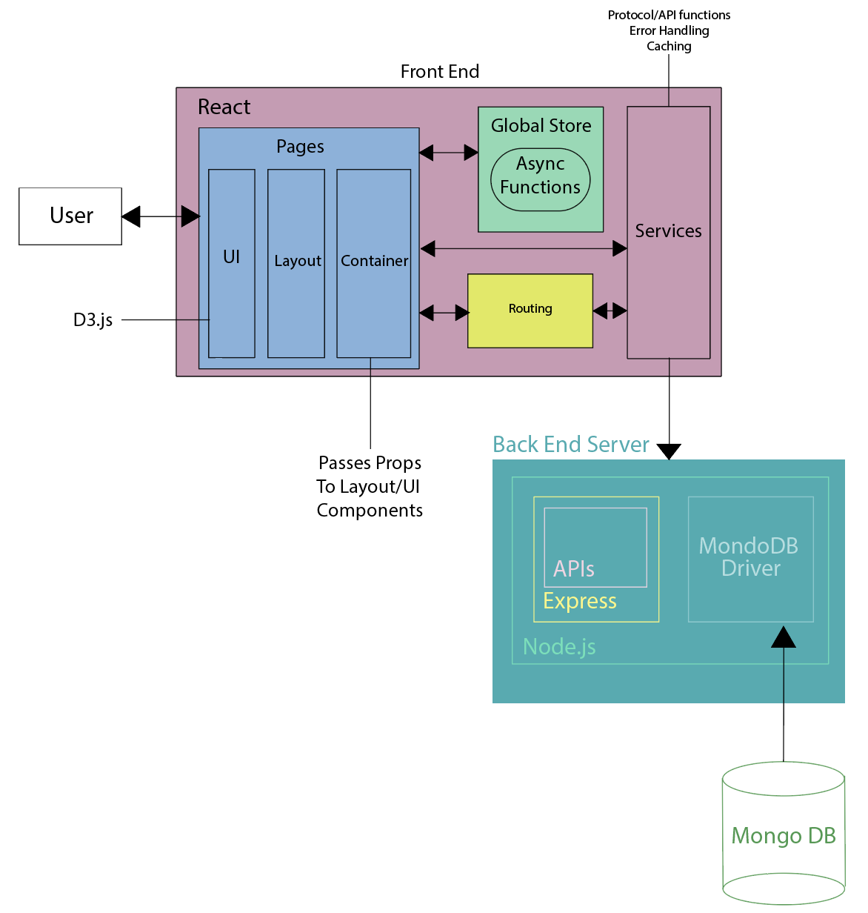
Figure 26. Application architecture diagram

Database Design
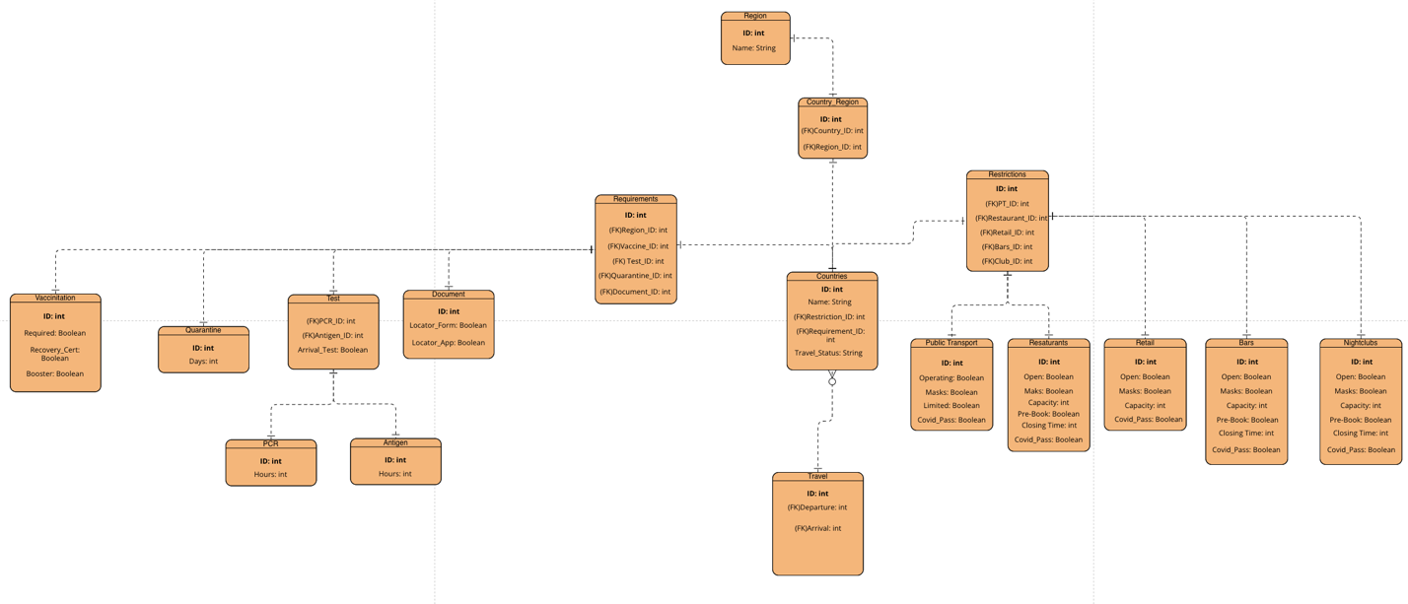
Figure 27. Database ERD

Process Design

Class Diagram
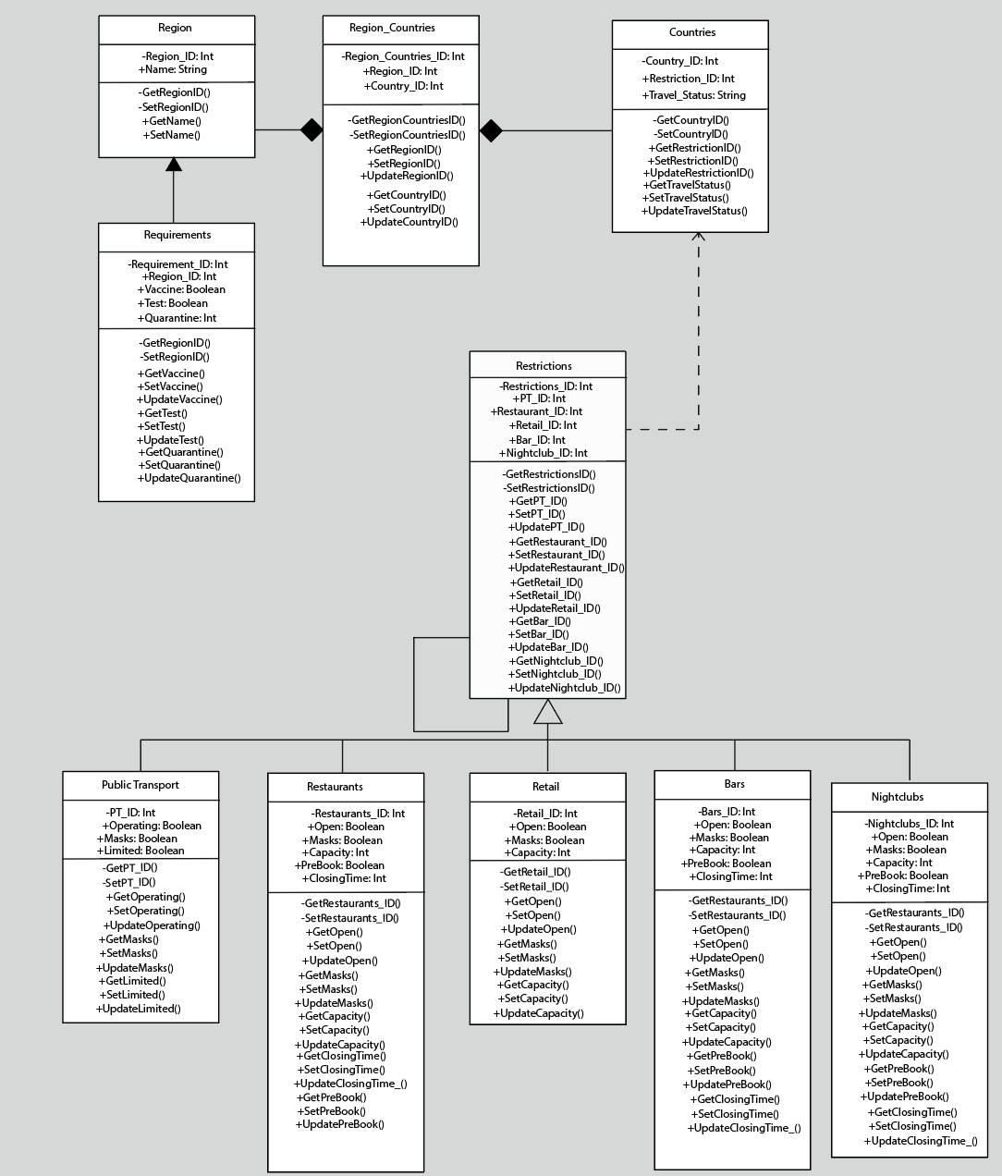
Figure 28. Class Diagram

Flow Chart
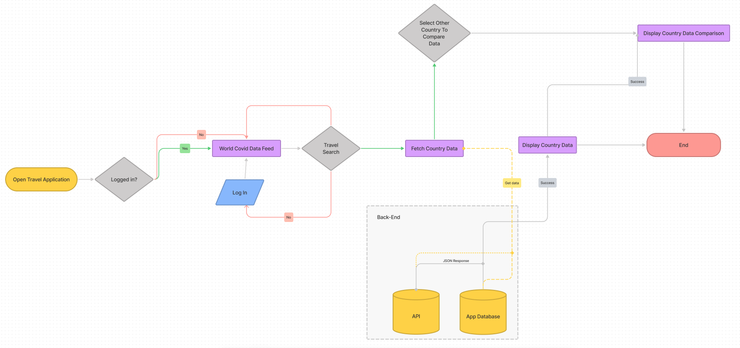
Figure 29. User flow chart

Pseudocode
Since this application will serve as a dashboard for both global and regional Covid statistics, the usage of graphs and charts is essential for the display of this data. D3.js will be utilized for this, including its pie charts, scatterplots, and histograms, among other features. My application will also show the local and regional regulations established by governments for international My application will also show the local and regional regulations established by governments for international travel.
D3.js offers a pie() method for creating pie charts, which generates an svg that is then displayed using React. I'll use an API as the dataset and submit a server-side Axios request, which will return an array with each item representing a pie chart group. Each item is a two-property object. They offer the name of the group as well as its value. For instance, active cases (name) and the associated number (value). Each group's start and end angles are computed using the pie() function. By default, this method requires a number array as an input. As a result, I'll show it how to discover the value to utilize in the dataset by utilizing an assesor function to retrieve and set values. I'll create a string that may be provided as the d property in a path, defining the consecutive coordinates of the places over which the path must travel. To accommodate this approach, D3 has an arc() function.
A scatterplot depicts the relationship between two numerical variables. This will be used to show the rate of cases and/or vaccine inoculation over time. This information will be supplied through an API, which will provide an array of objects to my program. Each object must have at least two attributes that provide values for the x and y axes; this will be accomplished with the scaleLinear() method. It will also provide data point-specific attributes. I'll set the graph's size and margins before appending the svg object to the page's body. The dataset is then parsed using the d3.csv() tool. Finally, I'll be adding points to the svg by attaching circles to it.
A histogram is a precise graphical depiction of a numeric variable's distribution. It only accepts numeric variables as input. The variable is divided into numerous bins, and the height of the bar represents the number of observations per bin. In my application, I will first set the size and margins of the graph to construct an svg area to describe the chart dimensions and margins before generating a histogram. Second, I'll attach the svg object to the page's body using the d3.select() function and the matching height and width properties. After retrieving the data using the d3.csv() function, I can scale and render the X and Y axes with the scaleLinear() method. I can then configure the histogram settings and apply the histogram() method to the data to retrieve the bins. Finally, I'll use.append("rect") to attach the bar rectangles to the svg element.
I'll be querying my Mongo database, which I built, to display the trip needs and local constraints. This database will include travel regulations specific to an area, such as the EU or Asia, including information on whether a vaccine or test is necessary, whether a quarantine is enforced for visitors arriving in the country, and how long that quarantine period lasts. This structure will have a table that contains all regions and will pass a foreign key to the requirements table, which will contain information on vaccines, testing, and quarantine for that region. A pivot table named country region will be used to assign each country to a region.
On the other hand, there will be limits specific to each nation. This limits table will be made up of foreign keys from tables containing information about the country's public transportation, restaurant, retail, and nightlife restrictions, all of which have a one-to-one link. A foreign key will be provided into the Countries database to identify each nation and any limitations that may be in effect.
This database will serve as a travel guide for people who want to visit a given nation or region, providing them with the most up-to-date requirements and limitations. To obtain data for display, I will use lookup querys to search this database. When a user enters a country to which they wish to go or inquire, a query is sent to the database, which matches the inputted value to of the country and then locates its matching Country ID in the Travel table. Access to the travel requirements for that region is made possible by linking the Country ID to the Travel ID in the database. Similarly, to display specific countries' local restrictions, the query will include a parameter identifying the Restricitions ID inside the Countries table, allowing access to the Restrictions table, which contains foreign keys for each restriction variable. These queries will yield a JSON-like answer comprising arrays within an object, which will be processed and displayed by React on the application's front end to present this information to the user.

User Interface Design

Wireframe Version 1
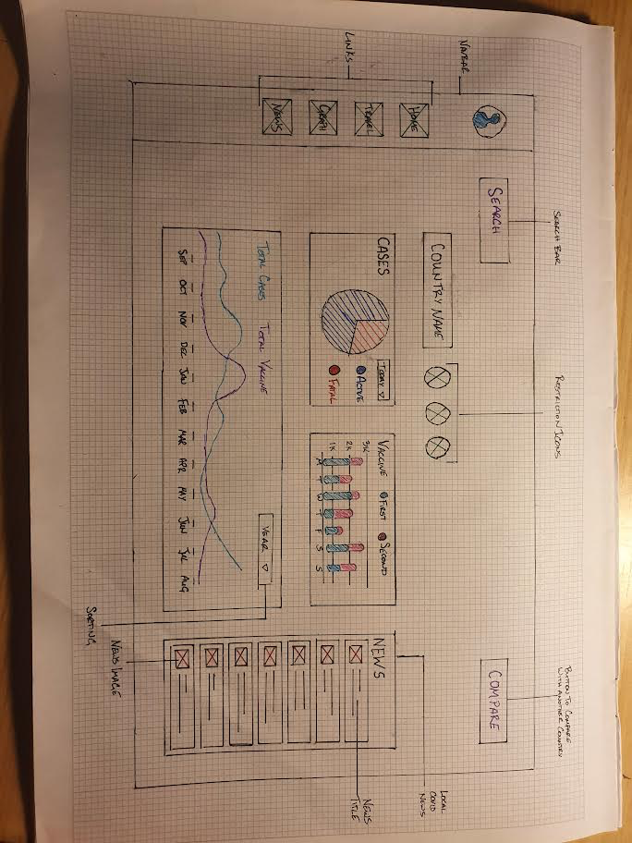
Figure 30. Global data page
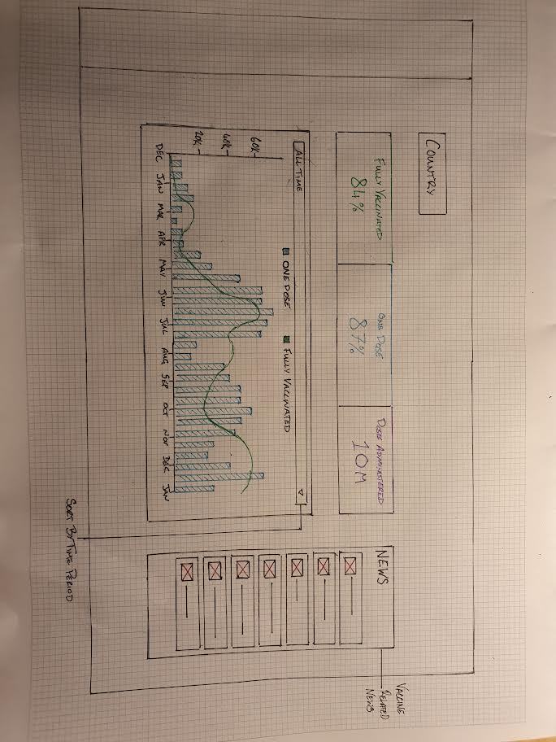
Figure 31. Country Stats
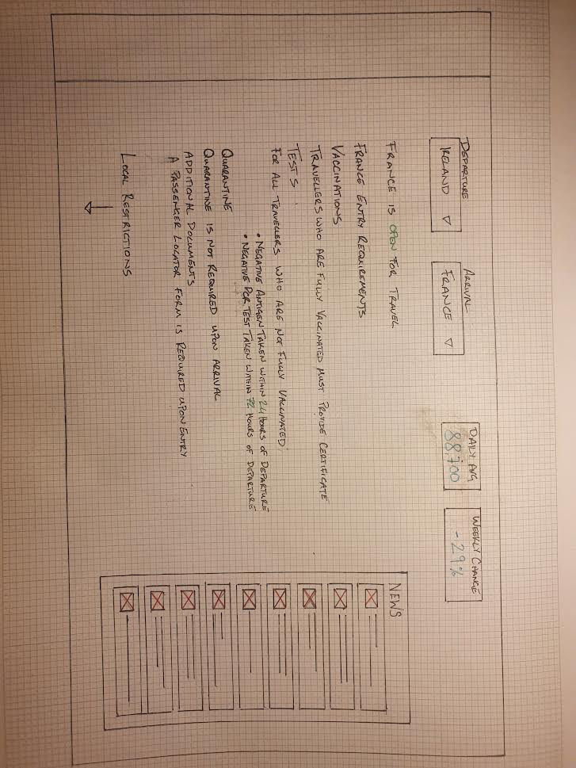
Figure 32. Country Restrictions

Version 2
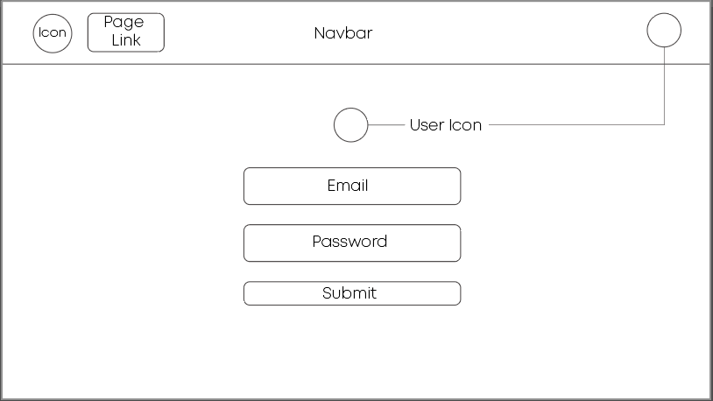
Figure 33. Login screen
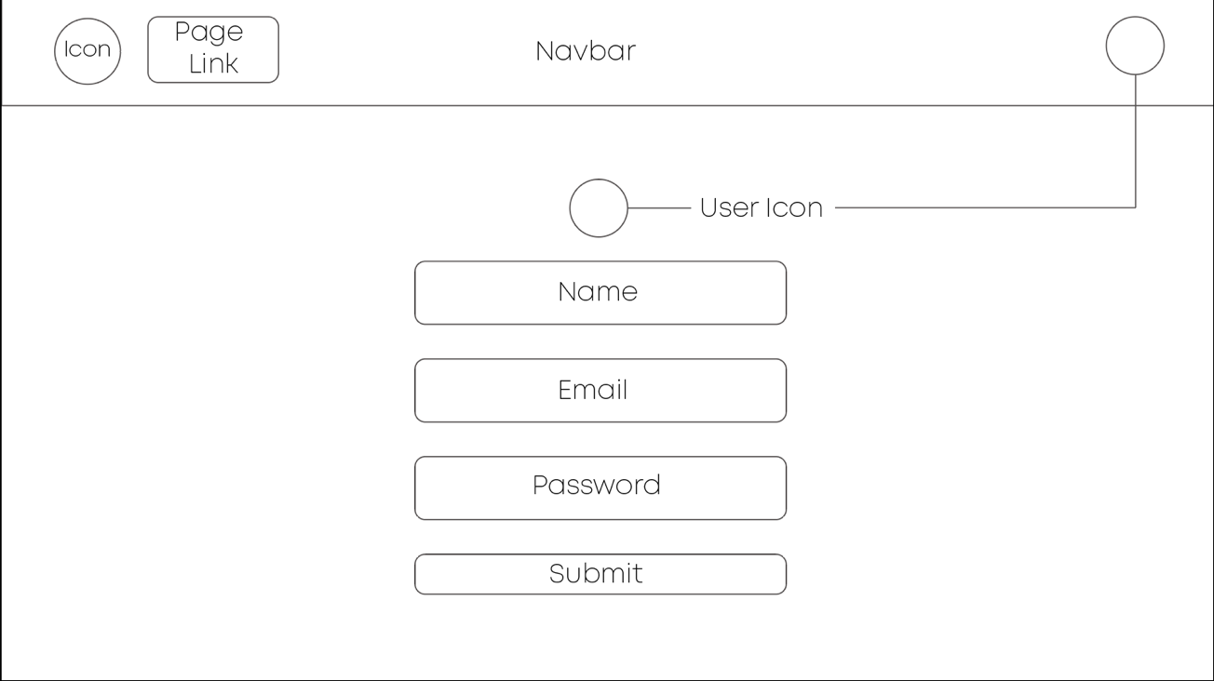
Figure 34. Registration
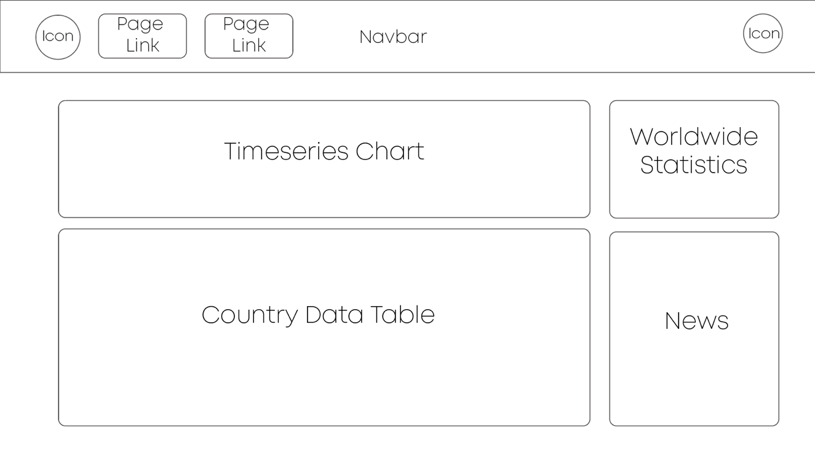
Figure 35. Global data

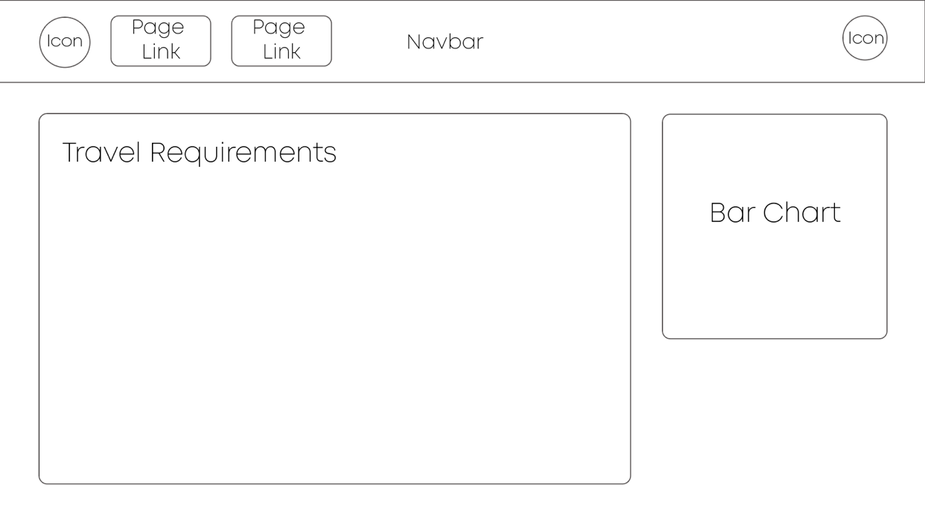
Figure 36. Travel requirements screen

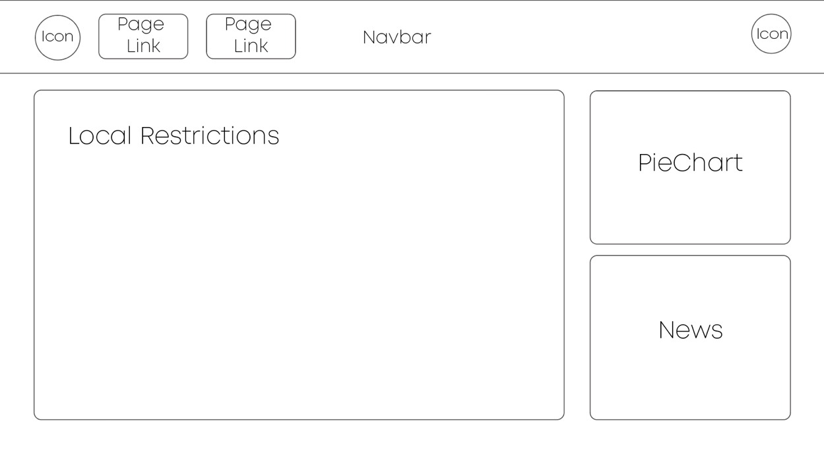
Figure 37. Local restrictions

Style Guide
The style guide of a website is acts as a graphic charter for the design. It contains the style of different types of HTML elements such as titles, paragraphs, lists, buttons, as well as all generic elements such as colours and fonts used. It enables a uniform approach in the construction of the website. It helps limit the management of exceptions and is quite useful during the development of the website. The guide offers better transparency over the look and feel of the website elements.

Colour Palette
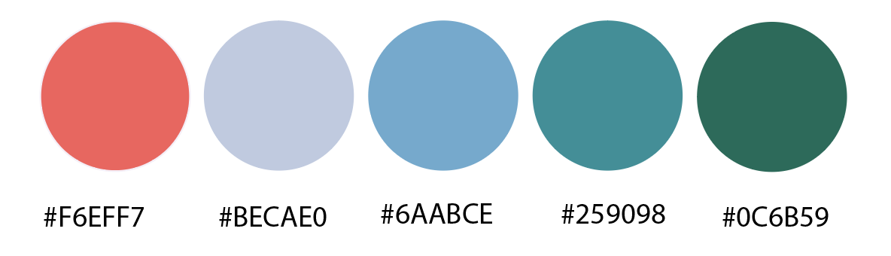
After researching on how a colour scheme can affect the representation of a website, I have chosen the scheme above as my primary and secondary colours. The scheme consists of a light colour, a dark colour, main brand colour and two highlight colours. The main colour is in the centre of the scheme and will have a key impact on the overall look.
From continuous research in the field of data visualisation the use of colour to highlight and showcase data is of great importance when being displayed to the user. This, along with having Covid statistics, encouraged me to choose a relatively light palette as to ensure an ease of mind user experience. This palette was chosen to help users not get anxious about viewing cases or fatalities when considering their travel plans, but instead to help the user make informed decisions for their travel.
The background of the application will be dark, which will help enhance the vibrancy of the colours and in turn will assist in the digestion of graphical data for the user. The first colour on the palette will be used when displaying data related to fatalities. It is quite a light shade of pink and was chosen with the psychology of the user in mind as to not make them anxious or scared when viewing this data. The second colour, an opaque blue, will apply to the accent colours which can be used to bring attention to design elements by contrasting with the rest of the palette. The main brand colour, located in the centre as a light blue, will be applied liberally to the design as its main identity. The last two colours will be utilized when dealing with data related to vaccines and current cases respectively.

Typography
The typography of an application is of equal importance as the colour palette. It confirms the uniform branding ethos that the application is trying to portray. As for my application I have chosen the Montserrat font for my headings, which was designed by Google specifically for online use. This font portrays a formal yet soft feeling that will grab the attention of users while also ensuring a calmness when using the application. Moreover, I chose the Courier New Font, a typewriter font, for the body and paragraphs of the application. I selected this font for its clear and classical display, it has an eloquent display that aides in the portrayal of covid data and will bring a more official ethos to my application.

Conclusion
My application is designed to broadcast relative Covid and Vaccine data both globally and locally. It is aimed at travellers who wish to journey outside their country and aide them in making informed decisions before taking these trips. When handling and broadcasting this data comes certain requirements. One of these is to attain accurate representation of this data for users.
In this design chapter I have laid out my design in which I developed the layout of the application through a rigorous developmental process. I started by planning out the ERD making sure all the information that will be needed to store in order for me to showcase local restrictions and travel requirements on a country or regional basis. I then designed the class diagram to highlight how the data will relate to each other with methods included to show functionality.
After, I started to design the wireframes to see how my application should look and how the user will be able to navigate through it. While designing the wireframes I was made to really analyse how the user will interact with the application which allows me to have a clearer picture when it came to moving forward into the implementation of the application. It also helped me when it came to finding the right colour palette and typography in the application. I was able to focus on what information I want to display and how I should broadcast it.

Implementation
This chapter goes through how specific components of the application were implemented as they were envisioned. The previous chapter discussed the system's design, but this chapter goes into detail on how each section was implemented in accordance with SCRUM methodology, the proposed design and what aspects had to be adjusted or amended as a result of implementation and new information.

Development Environment Setup
It's often essential to select the appropriate tools and environment for any work. Combining these tools and environments improves job efficiency, enhances productivity, and saves significant time. Choosing a comfy stack is also critical to achieving success and streamlining the development process. The program was created fully on a MacBook Pro 2018 running macOS BigSur 11.5.2. Additionally, many third-party tools and software were employed to facilitate the development process and ensure the desired outcome.
For this project, Visual Studio Coding was utilized as the code editor. VS Code is a Microsoft-led open-source project that was originally launched in 2015. Since then, it has grown in popularity among developers as one of the most popular code editors. VS Code is an excellent package that covers everything from setup to debugging a NodeJS web application to cloud deployment.

SCRUM Methodology
Scrum is a framework that assists developers in working on iterative and incremental procedures during complicated projects using the scientific method of empiricism, a philosophy that argues that information is obtained solely or mostly from sensory experience. A product is broken down into a number of steps, or iterations, which create a sprint, which helps break down large projects into a series of modest goals to be fulfilled at the conclusion of each sprint.
This project's implementation planning included a total of seven sprints. Each sprint took place over a two-week period. Each sprint would consist of a series of items to be completed, and at the start of each week, the developers show what has been completed or broadcast in difficulty completing a task, which would then be talked out in a collaborative process to find a solution and move forward, helping to ensure developers are on track and able to continue into the next sprint.
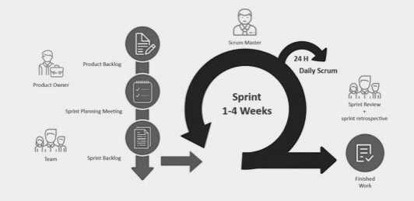
Figure 38. Scrum sprint diagram
The figure above depicts the process that occurs with each sprint. Trello was used to assist arrange the project tasks into individual cards that are stored in boards reflecting the areas being worked on, inside each sprint the task was organized into smaller phases. An extract from my Trello board follows.
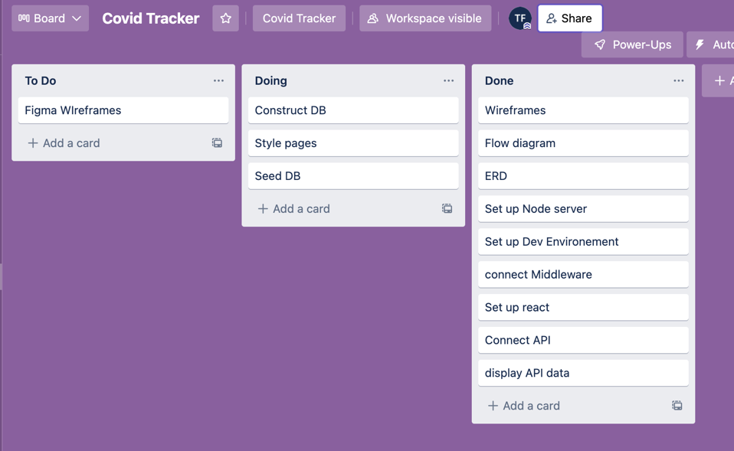
Figure 39. Trello board
Trello allows developers to keep track of progress and completed projects, as well as highlight crucial areas to work on next.
Using the scrum methodology with Trello to manage and finish tasks was extremely beneficial in terms of quality, transparency, and flexibility. With this procedure relying on continual and open communication between developers and project managers, it is possible to maintain a standard of quality as regular inspections of the application occur as it develops. Encouraging active participation from all parties enables openness throughout in terms of development and application state, which helps to ensure that expectations are managed successfully. Scrum embraces and expects change as precise requirements emerge and evolve during the development of the application, allowing for flexibility. This enables project managers to make required trade-off judgments if a job has an impact on or will have an impact on other sections of the application.
Overall, this methodology is quite valuable when working on large-scale projects and will be used in the future.

System Architecture
The first part to be constructed was the web application. It took the most time to accomplish. This needed to be made up of React and Axios at first in order to serve as a foundation for the construction of the basic components that would be built on top of it. This was achieved by using freeCodeCamp's "Learn the MERN Stack" course, which offered an overview of how to set up and install the software.

Back-End
For the backend, Express was utilized to process web requests. Express was chosen since it is a lightweight Node.js web application framework. It includes sophisticated models for URL routing (matching an incoming URL with a server function) and HTTP request and response processing.
It can connect to the Express.js functions that run the application by sending XML HTTP Requests or GETs or POSTs from the React.js front-end. These methods, in turn, enable MongoDB's Node.js drivers to access and update data in the MongoDB database, either via callbacks or Promises, which acts as a wrapper for a value that may or may not be known at the time the object is instantiated. It also integrates well with MongoDB, providing an excellent developer experience.
After that, Nodemon was used which is a command-line utility that enables the execution of several commands within the terminal. This is a useful tool for concurrently executing the front end and back end of a project. If any modifications are made to the server.js file, they are automatically reflected in the server.js file, and the server is restarted with the most recent output shown on the browser.

MongoDB
The first feature to be created in the back-end was the database to store all relevant data so it can be retrieved and displayed on the front end of the application.
With the database structure already in place, the first step was to specify how it will be maintained within MongoDB. As MongoDB, does not impose a schema by default, the plan of action was to transform the database into a REST API so that it could communicate with the front end with ease. This was accomplished by initially utilizing the cloud database service MongoDB Atlas.
The free tier was chosen for this project, with a cluster hosted on an Amazon Web Services (AWS) server in Ireland. This ensured that the database connection could be simply integrated and controlled during the final deployment.
The dotenv package, which was loaded using npm, was used to load environment variables given in the .env file when the script was run. The image below illustrates the environment variables that were utilized, which included the name of the database collection, the port number, a database key, and a URI string. The URI string specifies the user, password, and host address of the MongoDB database, as well as the database and additional connection parameters.
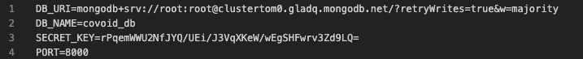
Figure 40. env file
Once the .env file has been created, its contents can be used as environment variables. This was accomplished by including it in the index.js file with the Mongo Client package, which is a Node module that enables the manipulation, construction, and connection to a Mongo database.
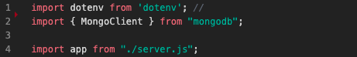
Figure 41. Index.js file
After importing the environment variables from the.env file, they may be assigned to local variables through the global variable process.env, which is injected by Node at runtime for the application to utilize and describes the state of the system environment in which the program starts. This is referred to as server provisioning and is demonstrated in the figure below from lines 12 to 18, where the environment variables are loaded on line 12, the port number and URI are declared on lines 15 and 16, and the database's URI is passed to the MongoClient class to establish a connection with the database.
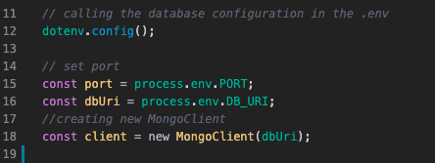
Figure 42. Server provisioning
With that, a try and catch statement is formed with several await functions that wait for the promise to settle and return its result. On line 24, the connect method is used with the "client" argument stated in the previous picture to establish a connection to the server, followed by four other await methods, from lines 26 to 29, that inject data into the database from the corresponding DAOs. The listen Express function is used to bind and listen for connections on the provided host and port. It accepts a port parameter and outputs a console log of the port number on which it is operating, if the preceding promises have been fulfilled. This is followed by a catch statement to handle any errors that may arise, with an err argument followed by a stack parameter for displaying the stack trace during an error call-back. This statement is ended with an exit method on line 38, which is used to terminate the concurrently running process with an exit code in Node, which is supplied the argument 1 to terminate the process with a failure rather than 0 to terminate the process without any failure.
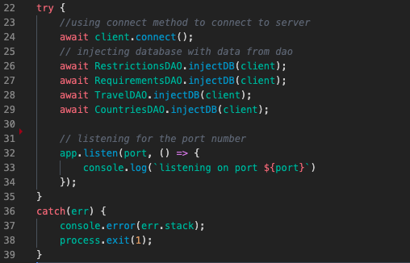
Figure 43. index.js file

Server
For any MERN stack application, the server is a dominant component that must be implemented in order for the back-end to compile JavaScript code.
A package.json file is produced once Node is initialized and several key questions about the project's description and developer information are answered. Rather than relying on the HTTP core modules to create the server, this approach uses the Express.js framework and existing npm packages.
Following that, the server is configured in the server.js file in the application's backend, where it is invoked by importing express and cors, a browser protocol that permits restricted access to resources located outside of a specific domain, as seen in the picture below on lines 1 and 2. This is followed by importing the router objects that were exported from their respective router files in order to be used in conjunction with Express's use() function, which adds a new layer to the Express middleware stack, which is then executed in order.
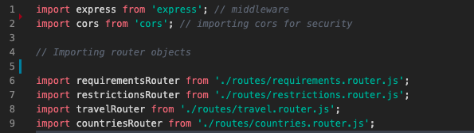
Figure 44. Server.js imports
This is followed by loading the Express module into its own variable, allowing it to be used elsewhere in the script, as seen in the figure below from lines 17 to 25. On line 17, the express.json method is used to parse incoming JSON requests and save the results in the req.body variable. This is continued on line 18 by using the urlencoded Express function with the extended argument set to true, which enables processing of inbound requests with urlencoded payloads and access to the req.body. Following that, on line 19, CORS is enabled to make the server available to other domains by allowing the server to reply to preflight requests, which are requests submitted to the server prior to the actual request being delivered.
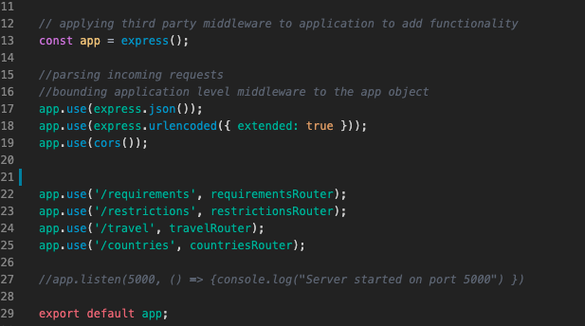
figure 45. Index.js
From lines 22 to 25, the use function is used by giving a path argument that instructs Express to only run the specified middleware and imported router objects when it gets a request for a URL that begins with the given path. Express employs the use method to gather together URLs that are same across several URLs. This implies that when the route is defined it will not have to prefix its cluster, since Express will automatically do so. This is demonstrated in figure 45, which shows the creation of a group for the route "/travel". Routes built in the travel controller can then define URLs such as "/:id" that Express will translate as "travel/:id" and use the travel controller's apiGetTravel method, as seen in figure 46 in the next section.

Routes
Routing is the process by which an application determines how to reply to a client request for a certain endpoint, which is represented by a URI (or path) and a specific HTTP request method (GET, POST, etc.). Each route may have one or more handler functions that are called once the route is matched (Express Routing, 2017). This is initiated in the router.js file by importing the Router object from Express and the controller from the scripts respective controller. A route takes an HTTP request and forwards it to the relevant controller. A route is designed to handle requests that originate from a certain URL and include a specified request type. This is seen in the preceding image, where a function processes a post request to "/travel-requirements."
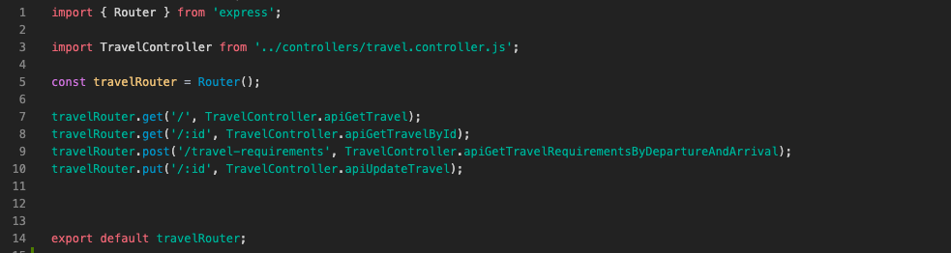
Figure 46. Travel Router
The router object is then allocated to a local variable on line 5 for usage throughout the script, which adds router level middleware that affects only that router and not the entire application. This is then used in conjunction with the respective HTTP methods and their paths in lines 7 to 10. This enables the application to listen for requests that match the provided route and method, and to invoke the supplied call-back function when one is detected. These call-back functions originate from the respective controllers that contain the function that is executed when the router calls them.

Insomnia
While implementing the routes, Insomnia was used extensively in doing integration testing to make sure the routes were working as should. Insomnia is a cross-platform desktop system that makes communicating with and building HTTP-based APIs easier. Insomnia blends a user-friendly interface with complex features such as authentication helpers, code creation, and local variables that are updated with each endpoint call. Insomnia allowed for immediate feedback when testing the route of the back-end of the application, as it provided for swift and seamless integration testing before having to construct a front-end of the application.

Authentication
Authentication is the process of verifying the identity of a user who is accessing the application. Users can verify themselves to the server with the login form. The most common method for verifying the authenticity of a user in web applications is via the login form. All the authentication in this app is handled by JSON Web Tokens (JWT). A JWT is an open standard that enables the safe exchange of data between parties in the form of a JSON object. Due to the fact that this data is digitally signed, it may be verified and trusted making it possible to verify the integrity of the statements contained inside, whereas encrypted tokens hide them.
In this application, there are routes that are dedicated to authenticating users, in order to allow them have authorization to execute the protected route calls in the front-end of the application. Authentication is accomplished using a registered username and password combination, which enables users to obtain a JsonWebToken that grants access to the remainder of the application. This information is encrypted and stored in the database. Each time a user logs in with their credentials, a JWT is returned and stored in the database's session document as seen in figure 48.
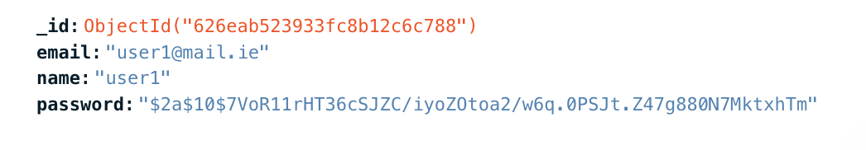
Figure 47. User object
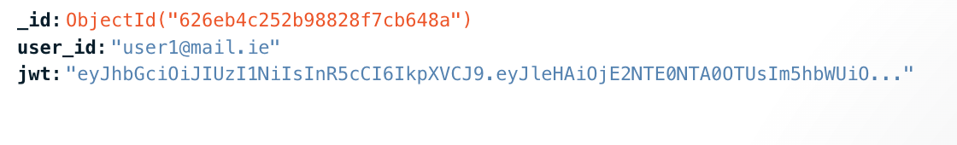
Figure 48. Session object
Following the user's registration, a hash string similar to the one displayed as the password value in Figure 47, is created based on the user's password using Bcrypt's hashing algorithm as a security measure to prevent passwords from being kept in plain form. By adopting a one-way hashing approach, the service is able to handle the genuine passwords at no point other than the HTTP request between the client and server during registration and login, which is secured through SSL. The hashed password is maintained alongside the email address in order to link the two upon login. If the password matches the hashed password saved on the server, the user is granted a new JsonWebToken through a secret string code kept on the server as a Node.js environment variable. As seen in figure 48, this JWT is associated with the user within the databases’ sessions document. The token is then saved in the browser's local storage until the user logs out, where the session is then deleted. This eliminates the need for the user to log in each time they intend to access the service. Although JWT is not the most secure method of authentication due to the possibility of the tokens being forged by a skilled attacker, it is more than enough given the absence of non-sensitive data in this application. This is demonstrated below in figures 49 and 50.
Figure 49. Passowrd hashing
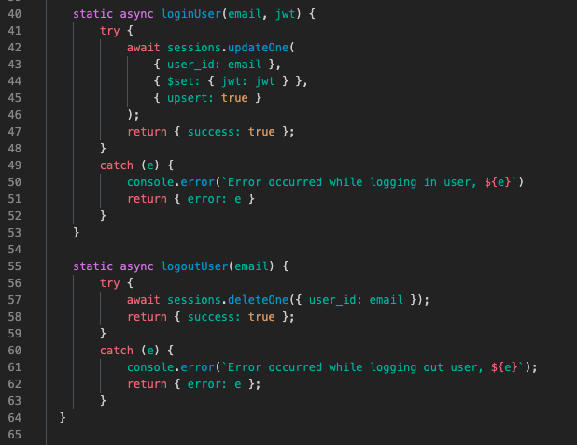
Figure 50. Users controller register

Controller
Controllers are the files that describe what happens within routes and contain all of the API's functionalities. It functions as a piece of software that controls or regulates the transfer of data across two entities.
The sample below, figure 51, from the travel controller illustrates how a request for departure and arrival requirements for a country of travel are handled. It is a static async method that accepts two arguments, a request and a response, and determines how data is transmitted to the corresponding DAO.
Generally, static methods are used to develop utility functions. They are not invoked on the instance of the class, rather, they are made to invoke the class directly. These are straightforward function calls that may be used to obtain information about the application, trigger certain events, and so on. When a function is preceded by the term async, the function returns a promise, which is an object representing the completion or failure of the async operation.
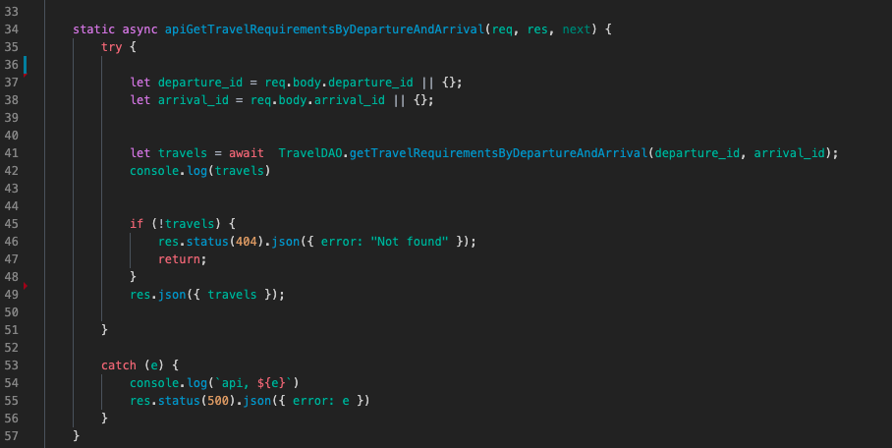
Figure 51. Travel controller
In Figure 51, a try and catch statement is implemented within the function. On lines 37 and 38 of the try function, two variables, departure id and arrival id, are declared and set to the values included in the request body supplied by the application's front-end. This is followed by the declaration of the variable travels and its assignment to an await function, which instructs the function to wait until the promise is resolved before providing its result, which sends the two previously specified parameters to the relevant function in the respective DAO. This is followed by an if statement that indicates that if there are no travels, the page will return a 404 error with a statement showing "Not found". If there are travels, the item travels will be returned. This method concludes with a catch that handles any issues by reporting them to the console with the server error code 500.

DAO
Data Access Objects, in this instance acts as a model and is a data access layer that establishes a connection between the services and the database in the application. The objective of the DAO is to abstract and encapsulate all data access and to provide an interface for data to be displayed on the front-end of the application.
The below is an extract from the travel DAO cooperates with the function in the previous section from the travel controller. It is passed the two parameters of departure_id and arrival_id, in which an aggregation pipeline is constructed, matching the parameters with their corresponding values within the database. The aggregation pipeline, a multi-stage pipeline that transforms the documents into aggregated results. It acts as a collection of operations that process, transform, and return data. In a pipeline, subsequent operations are informed by the outcome of the prior operation (MongoDB Aggregation Pipeline, 2022).
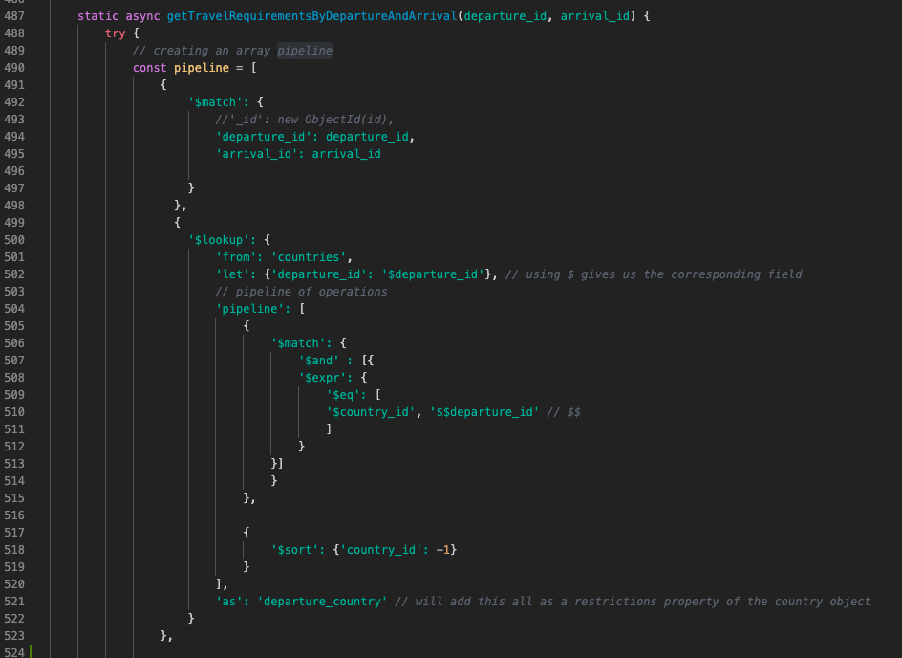
Figure 52. Departure and arrival requirements function within the travel DAO
The pipeline is constructed within a try method in which the first stage is $match which filters the documents in order to forward to the next pipeline stage only those that satisfy the stated condition. In this instance the $match stage matches the two arguments passed into the function with their corresponding values in the database.
This step is followed by the $lookup, which performs a left outer join on an unsharded collection contained inside the same database in order to process documents included within the "joined" collection. This stage creates a new array field holding the matched documents from the "joined" collection. The $from operator specifies the database collection with which to conduct the join in the preceding example, which is "countries." This is followed by the pipeline of operations, which is initiated by the $match stage and contains $expr, which enables the construction of query expressions that compare fields from the same document in a $match stage, as well as the use of the $eq operator, which can make use of an index on the "from" collection referenced in a $lookup stage, as indicated on line 500. This then enables the travel collection's departure_id to be compared to the countries collection's country_id. Then, using the $sort stage, which sorts the input documents and returns them in sorted order to the pipeline, change it to -1 to sort them in ascending order. The $as stage completes this pipeline by allowing for the name of the outputted array of objects. This method is repeated for each required item in the array.
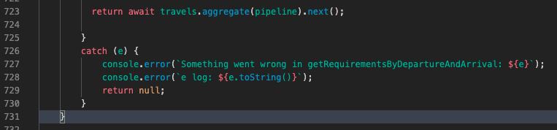
Figure 53. End of function
This try method concludes by providing a promise that awaits the completion of the pipeline's aggregation, at which point it is delivered to the next passing route, or middleware, by the express argument next ().
A catch method is included at the conclusion of the function to handle any errors that may arise. The error object is supplied into the method that logs it to the console and converts it from an object to a string so it can be read for debugging purposes.

Front-End
For the front-end of the application React was utilized to construct the web application. This needed to be made up of React while utilizing Axios at first in order to serve as a foundation for the construction of the basic components that would be built on top of it. This was achieved by using freeCodeCamp's "Learn the MERN Stack" course, which offered an overview of how to set up and install the software.

Axios
Axios is a promise-based HTTP client written in node.js and accessed via the browser. It possesses isomorphism (meaning that the same codebase may run in the browser and nodejs). On the server side, it makes use of the native node.js http module, and on the client (browser) side, it makes use of XMLHttpRequests (Axios Docs, 2022).
In addition to supporting the construction of XMLHttpRequests from the browser, axios also enables the construction of http requests from node.js, allowing for the access and retrieval of database objects from the server. Axios is incredibly clear and straightforward in compared to other HTTP request choices. jQuery and AJAX both serve the same function, however with a React project, React manages everything in its own virtual DOM, eliminating the need for jQuery. Axios is capable of changing request and response data, it is particularly helpful for dealing with JSON data, as it does it automatically.
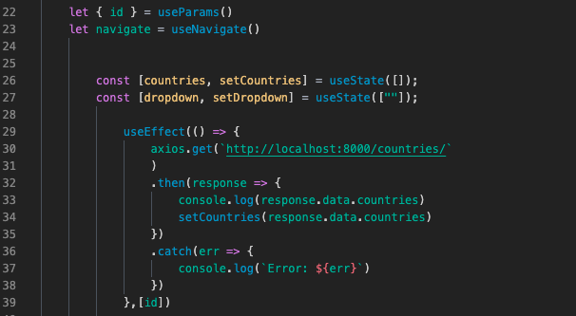
Figure 54. Axios GET request
Above, in figure 54, an Axios GET request is triggered in a useEffect which is a React Hook, that runs for every render of the component, unless specified to only render if a dependency is changed, such as the id as shown in the above image on line 39. It allows for the performing of side effects within components, these side effects include fetching data, directly updating the DOM and timers. In the above function, when/if the promise returned by the get request resolves, the resolution value is used to set the state of the component by utilizing the Hook useState. This enables state to be added to function components. Utilizing useState within a function component creates a single instance of state for that component. Each state object has a single value, which may be an object, an array, or a boolean. In this instance, useState takes the initial value of an empty array as an argument as it expects to receive an array from the get request response.

React Components
As stated before in the Requirements chapter, components are a fundamental principle of React. They are often self-contained and include reusable code blocks of code. While this helps avoid creating duplicate code, it also simplifies the debugging process by requiring only one component file to be verified and updated across all files that utilize the same code. In React, components deliver a chunk of JSX code that specifies what should be shown on the screen.
Function components are primarily used in React over class components, thanks to version 16.8, with the introduction of hooks allows for function components to become functional by managing the internal component state, the ability to avoid code duplication and providing a way of building much lighter components.
In React, a functional component is defined as a JavaScript function that returns JSX. These functions receive any number of parameters (often referred to as "props") and return React elements defining what should display on the screen. As is the case with vanilla JavaScript, these components can also be expressed as arrow functions, as seen below in figure 55.
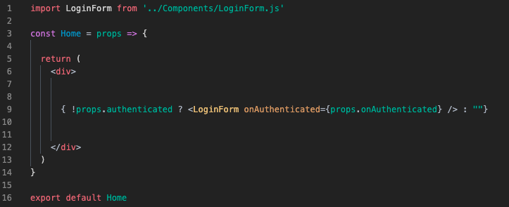
Figure 55. Function component
When React encounters an element that represents a user-defined component, it passes the component's JSX properties and children as a single object. This is referred to as "props". Props are similar to function arguments in JavaScript and attributes in HTML and are used to transfer data between React components in a React application. Functions can also be passed as props, this is displayed the in the above image where props is passed into the component with the attribute function of authenticated where it is utilized within an if statement to check if a user is not authenticated, if they are then the login component will be rendered.
While components can be written in a single file, many are created in two files: one as a container and one as a component of that container, as shown in figure 55 where the Home component acts as a container for the LoginForm component. The reason for this is that when a component's complexity increases, the file can get rather lengthy and cluttered, since there may be several custom methods in addition to a complicated render function. To simplify and organize things, the container is responsible for taking data from the state and any needed methods and providing it to the component. After, the component is in charge of formatting and presenting the data on the screen.

Charts
Data visualization has long been a significant element of software engineering, particularly frontend development. Handling big quantities of data in a visual style aids in providing a summary of previously hidden trends in the data, presenting insights that can assist users in understanding how the most recent data is being analysed to decide travel decisions. As a result, it is vital to evaluate what is being expressed and select the appropriate graphics to convey that information in an understandable manner.
This application deals with vast amounts of data that needs to be expressed in a comprehensive manner. For this, the C3.js framework was used. It is a D3-based reusable chart library, as explained in the design chapter. In this application, these charts were built as components that were imported into various pages throughout the application and shown with Covid-related data.
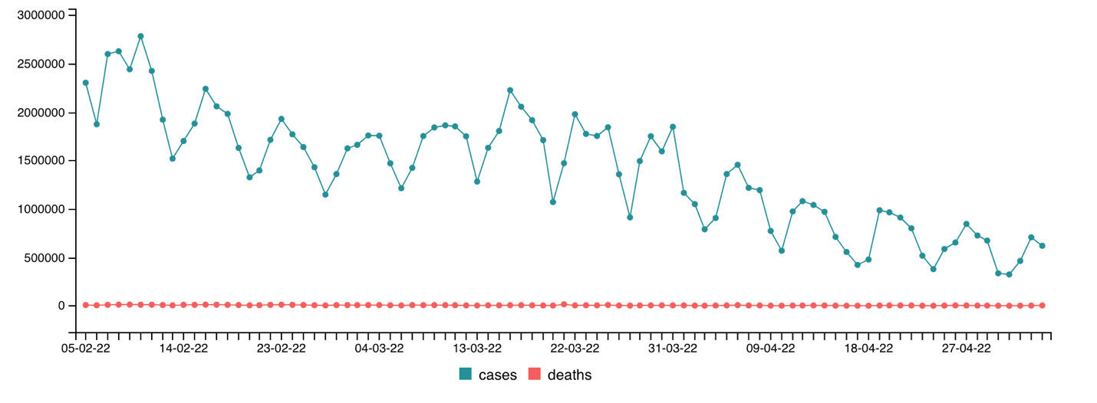
Figure 56. Timeseries chart
By executing generate with the parameter object, C3 constructs a chart, and an element containing the chart will insert into the element supplied as a selector in that argument as bindto. The data element is then passed, which contains data on the x axis data format and type. Following that, the keys element is used to specify the key for the x values in the data; while this element is often optional in C3 charts, it is essential in this case due to the fact that the chart is a timeseries chart as specified in the axis element.
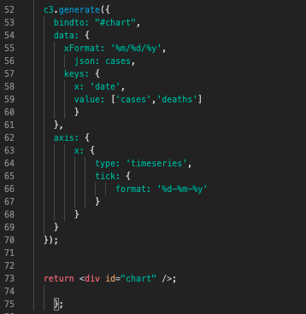
Figure 57. c3 time series chart code
To ensure that this data is taken and displayed appropriately by a C3 chart, it must first be parsed. To do this, a function was created to modify the data. This function takes three inputs, one of which is the data obtained from the API response, and the other two of which are references to the cases and death data variables, each of which is assigned a variable name. Within the function, a for loop is formed with a nested if statement that runs through the data and concatenates the value for each date object in the cases and deaths array by subtracting it from the previous day's value. This is because the numbers given by the API are iterative and hence would not function in a time series because they would continue to incline, creating a false narrative about what the data actually indicated. Following that, these values are assigned variable names and pushed into the empty infoGraph array.
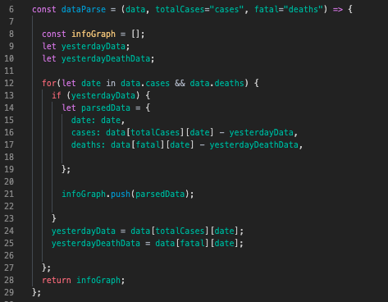
Figure 58. data parse function
Once the parser function is constructed correctly, it is used in a useEffect. This useEffect sends an Axios GET request and sets the cases object state to the function's returned value in the response. This allows for the chart to read and display this data appropriately.
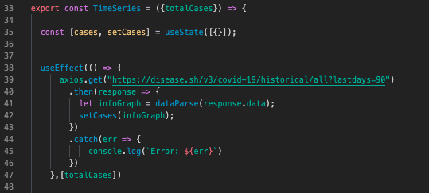
Figure 59. GET request response sent to parser

Conditional Rendering
Reacts conditional rendering operates in the same way that JavaScript's conditions do. It creates items expressing the current state using JavaScript operators such as if and the conditional operator, and then lets React adapt the UI to match them. This is done because different components that encapsulate behaviour can be constructed in React. The application can then render only part of these depending on its current state. This can be accomplished by the use of an if-else statement, conditional operators, and the logical operator &&.

Forms
Forms are an integral part of React-based web apps. They let users to enter and submit data directly into components ranging from login screens to checkout pages. Because the majority of React apps are single page applications (SPAs), or web applications that load a single page and dynamically display fresh data, the information entered in the form will not be delivered immediately to the server. Alternatively, it will collect form data on the client side and communicate or display it using additional JSX.
React forms provide a unique challenge since they may either delegate control to the browser and gather data via React change events, or they can utilize React to completely manage the element by setting and updating the input value directly. Because React does not set the value in the first approach, it is referred to as an uncontrolled component. The second technique is referred to as a controlled component due to the fact that React is constantly updating the input.

Registration & Login
The registration and login forms act as controlled components in this application, as HTML input fields natively maintain their own state, but with the introduction of React hooks such as useState, allowing for state management of the input fields by declaring an initial state value, as seen on line 29 in figure 60. These then become controlled by passing a value attribute to the input field, as seen in figure 61.
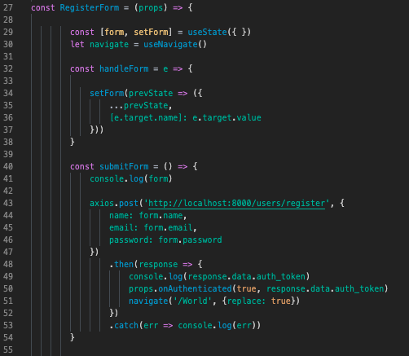
Figure 60. Registration Form
The form event is handled in figure 60 by invoking the prevState parameter in the setForm callback method, which is referred to as an event handler. This is done in order to increase efficiency. Due to the fact that React may combine many setState calls into a single update, referred to as "batching" and since state changes are asynchronous, their values cannot be relied upon for determining the next state. This is resolved by using setState with a second parameter that takes a function rather than an object. That function will accept the previous state as its first argument and props as its second argument at the time the update is run.
In Figure 60, the argument ...prevState is passed to setForm. The tree dots accompanying prevState indicate the spread syntax used to deconstruct and inherit the variables of the form state objects, in this case; name, email, and password. When handleForm is used as a callback function, the second parameter assigns the class name of the DOM element that caused the event to the value of the event, allowing the form handler to set the right value to the relevant state attribute.
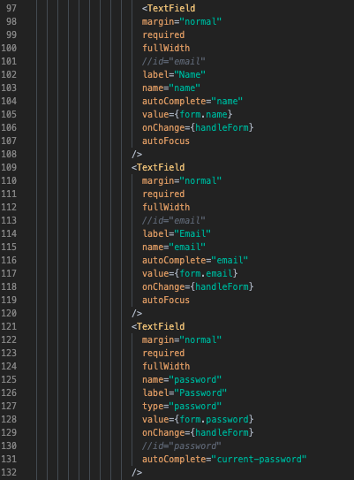
Figure 61. Registration input fields
These event handlers are invoked in figure 61's textfield components. Each component's value is allocated as an attribute to the form state object, that then transmits its current value to the handleForm function through the onChange event handler, which enables access to the target input's value within handleForm.
As soon as the form has finished processing the various input values, it is submitted by utilizing the onClick event handler, which executes an action when a button is pressed; in this case, the action is the submitForm function, which can be seen in figure 60. This function sends an Axios POST request to the route "/users/register" with the form attributes included in the body of the request; the response's authorization is then logged in the console and authenticated using the onAuthenticated callback function, which then navigates the user to the "/World" page and replaces the /register route in the history stack so the user doesn't return to the register page when clicking the back button after registering.
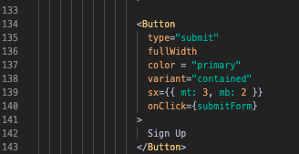
Figure 62. Form submission

Dropdown
To view the travel requirements between two countries, users must complete a dropdown form that includes a departure and arrival country. This requires retrieving a list of countries from the database and displaying them in the dropdown form, as well as selecting and submitting these countries via the dropdown form.
As illustrated in Figure 63, the initial state of the useState hooks is set to an empty array on line 26. Line 30 sends an Axios GET request to the "/countries" route, where the return data, an array of countries, is assigned to the countries state object. At the conclusion of the useEffect, a catch method is used to handle errors, and the dependency of an an id object is supplied, which causes the use effect to occur each time the id changes. The id object is set to the react-router-dom package's useParams React Hook, which enables access to the current route's arguments, in this instance the id parameter.
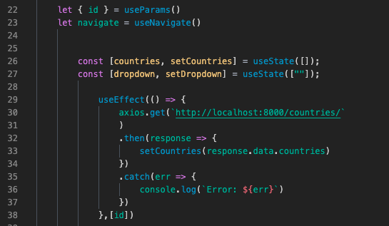
Figure 63. Dropdown function
Once the array of countries is set to the countries state object, the country names may be mapped to the MenuItem component as JSX and presented as a list within the Select component, as illustrated on line 89 in figure 64 below. The value of the MenuItem is set to the country id property of the countries state object, and the object id is used as a key to indicate which items have changed. This is true for the country option choices for both arrival and departure.
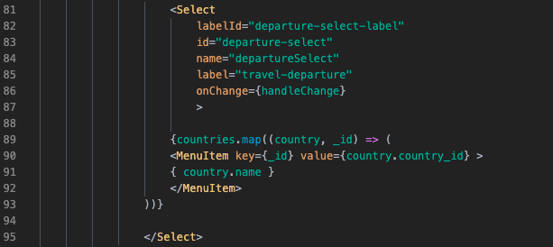
Figure 64. Dropdown select
As seen in Figure 63, on line 27, another useState hook is invoked using an empty string contained within an array. This is configured to accept the country's name, which is a string, and manage it in the handleChange method, shown in Figure 65. This enables the dropdown's visual input to display the selected country's name, similar to figure 61 in the previous section.
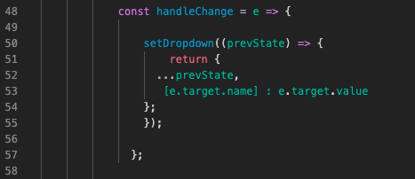
Figure 65. handleChange function
After selecting both the departure and destination countries, the form is submitted using the onClick hook, which invokes the callback function submitDropwn, as seen in Figure 66. This function returns an Axios POST request with a body containing the two country attributes for departure and arrival, and an Authorization header containing the Bearer token, which will be discussed further in the next section. The user is then routed to the requirements page through the response object's id value. This is accomplished by the use of template literals, which enable string interpolation, a process similar to concatenating a string.
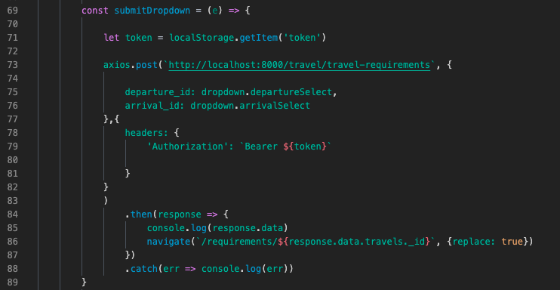
Figure 66. Dropdown submit

React Dev Tools
While building the forms, to make sure that the component tree structure and state management was being implemented correctly. It's a browser plugin that added a set of React-specific inspection tools to help the with development pf the application. This plugin was vital for stage-management in the course of developing components such as the dropdown menu.

Authorization
As shown in the previous section in figure 66, some API calls from the client-side requesting permission to access a protected route must have an Authorization header with a token attached, which gives the data of the user that makes the request, and checks if they have permission to execute. This is accomplished through the usage of JWTs, in which a request is made to obtain the authorization header and then the token is sliced to obtain the "Bearer" and the token to be decoded in the user constant. Once this authentication process is complete the user will be able to execute the query, as seen below in figure 67.
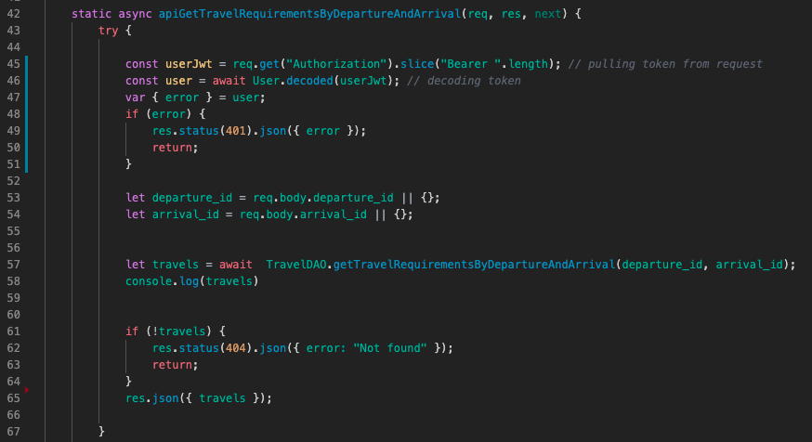
Figure 67.JWT AUTHORIZATION IN THE TRAVEL CONTROLLER
Bearer authentication (alternatively referred to as token authentication) is a type of HTTP authentication that utilizes security tokens known as bearer tokens. The bearer token is a small security token that enables access to a protected resource for the "bearer”. The bearer token is a long, opaque string that the server typically generates in response to a login request. When sending requests to protected resources, the client must include this token in the Authorization header as demonstrated in figure 68.
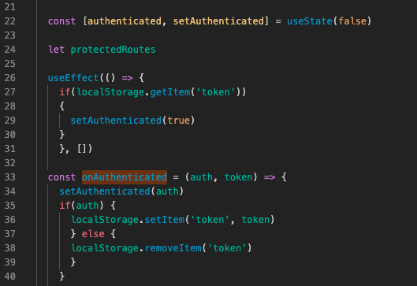
Figure 68. User authentication for route access
The process of authenticating and authorizing a user to access specific routes is governed in the App.js file, which contains the application's routes. As shown in figure 68, the useState hooks are initialized as false, indicating that the user is not authorized. A useEffect is constructed to run once after the first render, and it comprises an if statement that fetches the token from local storage and changes the authenticated state value to true if the token is present. Following that, a constant is created to determine whether the user is authorized; if they are, the token is stored in local storage; if they are not, the token is removed. Following this, an additional if statement is created to hold the protected routes. The if statement specifies that the protected routes be presented if the user is authenticated, as illustrated in figure 69 below. These protected routes are then imported into the React Router which will be discussed in the next section.
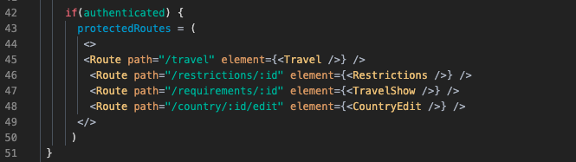
Figure 69.Protected routes

Router
Routers assist in the creation and navigation of many URLs inside a web application. They enable the user to navigate between the app's components while maintaining user state, and they can give unique URLs for each component to make them more reusable. By utilizing Routers, developers can improve the user experience by streamlining site navigation.
React Router is one of the most widely used React routing frameworks. The library is composed of intuitive components that facilitate the development of an application's declarative routing system. Allowing developers to specify which components have a specific route. Declarative routing can generate intuitive, human-readable routes, which simplifies application architecture management. React Router is aims at not only to mapping a URL to a function or component, it is also providing a complete user interface that corresponds to the URL.
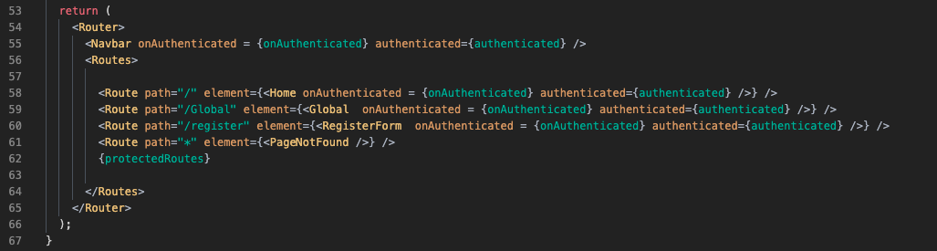
Figure 70. React Router
As illustrated in Figure 35, the React Router is initialized using the Router component, which builds a base router that serves as a parent component for all other components. Anything not contained within this component will be rendered on each page. The Navbar component is then inserted into the Router component to provide intuitive application navigation. The next component is the Routes component, which defines the nested routes in each Route component. The Route component validates the current URL and displays the component that corresponds to it. Finally the protected routes are passed in as JSX.

Navbar
The navigation bar in this application is composed of components imported from Material UI. The top App bar displays material and activities associated with the currently displayed screen. It is used to brand, navigate, and perform tasks. Container is a fundamental Material-UI component that horizontally centers content and handles the layout of its children. It serves as a container for the ToolBar component, which configures the children's settings to be horizontally aligned. The Toolbar component simply applies the CSS by vertically centring and padding the component. As is seen in figure 71.
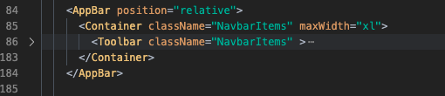
Figure 71. Navbar Material UI components
The NavBar offers links to the application's pages. These links are stored in an array that is assigned to a constant, allowing for the mapping of the pages shown in figures 72 and 73. Some of these links are secured for authorized users and hence cannot be seen by an unauthenticated user. This is accomplished through the use of a method known as conditional rendering. The conditional operator is used to create an if statement that invokes the onAuthenitcated function to determine whether the user is authenticated; if true, both links are displayed; if false, just one is displayed.
Figure 72. Pages Constant
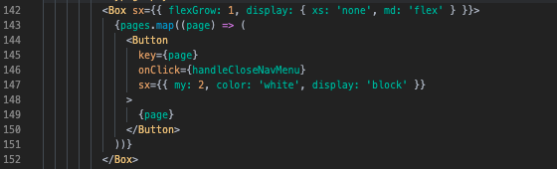
Figure 73. Pages mapping

Testing
Functional testing is a form of software testing in which the system is tested to ensure that it meets the functional requirements. The app is assessed by determining whether the actual output for a given input matches the predicted outcome. The testing should be based on the app's requirements. The findings of functional testing can reveal whether or not a piece of software is functional and operational, but not whether or not the software is simple to use.
User testing is a technique used in the interface design process to validate a product, feature, or prototype with actual users. The most typical reason for performing usability testing is to assist the design team in identifying inefficiencies in a user interface that is being developed to solve before it is designed or deployed. Early detection of problems saves money in the long term. Assignments are typically assigned to users, who are expected to accomplish tasks to the best of their abilities while observers wait, listen, and take notes. Organizing user instruction comprises creating a survey schedule, conducting interviews with testers, conducting the study, and analysing the data to generate conclusions and recommendations. Jest was intended to be used to provide for testing of the various components of the application, but due to time constraints to was not feasible to implement.

Functional Testing
This section outlines the functional tests performed on the app. These functional tests are classified as follows:
- Navigation
- Forms
Functional testing typically employs a Black Box Testing technique, which indicates that the tester is uninterested in the internal logic of the system being tested. The only thing the tester cares about is if the actual output matches the intended output.

Navigation
Test No | Description of test case | Input | Expected Output | Actual Output | Status
1 | Login | The login link takes you to a login page. | The user should be able to access the login page. | The user can see the login page. | Passed
2 | Register | The login link takes you to a register page. | The user should be able to access the login page. | The user can see the register form | Passed
3 | Home Page/ View Global Data | Does the Global link take you to a page with global covid data? | The user should be able to access the Global | The user is able to view the home page displaying their events | Passed
4 | Submit Travel Dropdown | Does the dropdown submit redirect to the page where all the travel requirements are displayed | The user should be able to land on the page displaying travel requirements | The user is able to see the requirements page which display all the travel requirements | Passed
5 | View Restrictions | Does the country name link redirect users to the page where they can view restrictions | The user should be able to land on the restrictions page | The user is able to the restrictions page | Passed
7 | Logout | Does the logout link log the user out of the account | The user should be logged out of his account when clicking on the logout link | The user gets logged out when they click on the log out link | Passed

Forms
Test No | Description of test case | Is the validation taking place | When validation happens does the database interaction happen | Does formatting occur | Is the query routing to the right view | Status
1 | Register Form | Yes | Yes | Yes | Yes | Passed
2 | Login Form | Yes | Yes | Yes | Yes | Passed
3 | Travel Form | Yes | Yes | Yes | Yes | Passed
4 | Register Form | Yes | Yes | Yes | Yes | Passed

Discussion of Functional Testing Results
The application's functional testing produced a satisfying outcome. The project's required functionalities work on both the client and server sides of the application. The navigation works as expected, with links redirecting to the correct pages. If the procedures are not completed successfully, the forms are evaluated and prepared properly to generate errors. The practical testing method assisted in determining which stage the application was in, and everything operated as intended in this situation.

User Testing

Introduction
The goal of this project is to create an online platform that allows users to read, evaluate, and stay current on Covid developments around the world. This platform aims to visually and comprehensively convey data to users in order to aid them in making travel arrangements.
During Covid, the tourism industry was one of the hardest hit businesses in the world. The consequences of which are still being felt throughout the sector today. Previous flight passengers are now much more cautious when it comes to travel; some are concerned about rising case trends, while others are dissatisfied with ever-changing travel requirements between countries. Whatever the reason, more and more customers have become disenchanted with the proposal of travel and are hesitant to return.
The purpose of this platform is to make holiday planning easier for consumers by providing an easy-to-use data visualization and presentation. While allowing the customer to feel entirely up to date and educated in order to alleviate their nervousness or prospects of obtaining a break.

Tasks
For the usability tests, three tasks were compiled for users to complete. These tasks were wrote for the user to get a good grasp and feel for the application and for them to get a complete scope of functionality.
The tasks the participants were asked to carry out to carry out were;
Search for Travel Requirements
Create an account (email: user@mail.com | pw: secret) and Search for Travel Requirements between Ireland and Spain.
- Locate the travel form and input the two countries mentioned.
- Find out what test requirements are requested upon arrival.
- Find out the local restrictions regarding restaurants in the country of arrival.
Data Analysis
- After the finding the local restrictions, from the charts describe you’re understanding of what is happening in the arrival country.
- Does this correlate with the news headlines?
- Navigate back to the home page and log out.

Conditional Rendering
- Once logged out, return to the global page and try then navigate to the travel page.
- Log back in and repeat the process as tasked before.

Demographic
The "kind" of participant who would be appropriate for this application's usability testing is anyone between the ages of 18 and 55 who is concerned about traveling during Covid or other diseases. Their age will be a factor in terms of functioning in the appliction; the application may also be appealing to individuals who do not intend to travel but want to stay up to date on current Covid trends throughout the world. Although this is the optimum demographic in terms of user base, individuals from other demographics are welcome to share different perspectives on the application.

Type of Test
For this usability test, an ease-of-use evaluation was undertaken to determine how simple and intuitive the application makes the viewing of travel-related data, news, and information, as well as local constraints, for users who intend to travel. The desired outcome was to guarantee that the application's operations, features, and overall purpose align with its vision outlined in the design chapter, by monitoring how actual users interact with it. This technique enables verifying the application by identifying what works and what doesn't using hard data to determine what adjustments or upgrades are required.

Data Summary
In reviewing the data from the usability tests and surveys, the responses from both participants were mostly positive, with comments complementing the layout and design of the application, with both participants feeling that the majority of the functionality that was needed was easy to find and found the navigation, for the most part, to be quite intuitive.
Some participants failed to find the trip form, which caused some issues along the route. During the testing of the travel process, one participant became confused when attempting to locate the precise countries for arrival and departure. The second participant was concerned by the labelling of the travel requirements since they believed there should be icons accompanying them to help convey what was being communicated. When engaging with the travel form, one of the participants stated that the travel dropdown should be situated in the navigation bar rather than on the page since it hampered the navigation and travel process.
The basic structure and layout of the application were found to be of decent quality, but an emphasis on labelling and rebuilding the travel process will be required for this application to be successful in a real world scenario.

Design Changes
After reviewing the data collected from the surveys based on the results of each participant's user test, alterations to the application were recommended. These changes were; the labelling around certain features, like the travel requirements or local restrictions, and the travel process should be more condensed with an intuitive design flow that encourages the usability on the application.
When displaying travel requirements or restrictions in the application, using words to convey ideas is the most direct method however, readers may get bored or lose concentration if there is too much text, causing them to ignore the message entirely. Adding icons to explain this information might be an even more successful as not only do they provide diversity to the section, but they also provide a visual interpretation of the subject. This makes it much simpler for the user to associate the symbol with the notion and comprehend the given characteristics or functionalities.
The Travel process provided some key issues to be focused on. These issues included navigation of the travel dropdown and clear labelling of location. Both participants highlighted that when submitting the travel form, the form had taken up the majority of the screen and made it hard to see information and navigate to the previous screen. They felt this hindered the navigational experience of the application. In response to this finding, the travel form was located to appear in a dropdown in the navigation bar accompanied by an icon representing the functionality as displayed below.
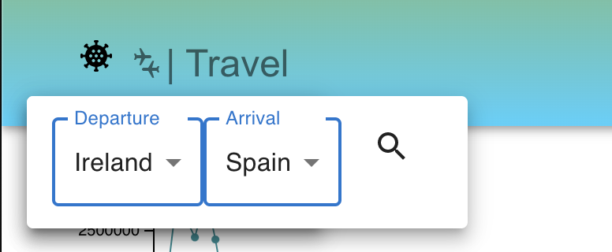
Figure 74. Navigation bar dropdown
These changes will improve the navigation, overall user experience and could help push the application to be better equipped for a real world environment.

Conclusion
Before the application's debut, this procedure proved to be quite beneficial for testing and adapting it to the user base. Planning out tasks for participants prior to testing allowed for an analysis of the application's navigation, since it was necessary to ensure that all functionality was displayed and everything was appropriately labelled. By having participants talk aloud during testing, it was much easier to comprehend the issues that regular users may encounter, as it was instantly clear where they were coming from in terms of design changes.
Loop11 would not be used to conduct another usability test as there were issues with the account and downloading the test recordings. Unfortunately, when the videos were downloaded, only the introduction was recorded for both participants with the rest of the video rendering unplayable was; in retrospect, it would have been wise to create a screen recording as a backup to the Loop11 recordings in order to avoid such complications. A greater emphasis would have been made on recruiting participants who were worried about receiving Covid while traveling, as they would have provided more insightful feedback not only for technical usability but also for real-world applicability, particularly in terms of highlighting key features or what information they would typically look for first when booking a flight.
In general, this procedure was quite beneficial to the application and be aware of how the user may interact with the application. The website will benefit from the participants' clear, concise, and helpful feedback moving forward. When completing these tests, it became evident that the website's usability and navigation could be vastly improved by implementing the necessary design modifications.

Conclusion
This chapter summarises how the project went, the views on the project, strengths, limitations, work could be implemented in future developments and what was learnt as a result. It concludes with a discussion on the research objective in determining how the use of open data and a MERN stack application could help resolve the travel industries response to Covid.

Views on the Project
Overall this was a great learning experience in MERN stack development and data visualisation. In retrospect, the product that was outlined in the requirements chapter was quite ambitious, as some of these requirements were not met. With constant adaptation and changes to the plan that was originally set out, it is a bit disappointing that these were not completed to the applications full capacity. However, this should not be seen as a failure, instead pointing to the way in which issues faced were overcome and adapted to suit modifications and finding alternate solutions to the problems faced.

Limitations
Some of the applications limitations lie in its performance in regard to in-depth, customizable graphs showcasing data from Covid statistics. With the original intention of building these charts using the D3 framework, to allow for intriguing data visualizations that would engage the user by allowing them to update the graphs displaying a wider diversity of data. Unfortunately with time constraints, this was not feasible as the time to learn, develop and implement D3 charts would have been too long. D3.js's intricacy and adaptability make it a time consuming framework to grasp for many users. D3 is perhaps the most flexible chart library for JavaScript, but this flexibility results in increasing complexity. Although D3 was not possible in this project, instead the C3 framework was used, which is built on D3. C3 is a D3 based reusable library that enables the integration of charts in a much simpler manner than that of D3. This simplicity of implementation does however, limit the design and capabilities of the charts, limiting them to be quite static in response to user interaction.
Initially the application was to cover the multifaceted subject of Covid, including statistics on vaccine developments, inoculation rates and in depth analysis on varying strains that had arisen in various countries. This would take extensive research into each topic and further research into reliable resources of this information. Although these components would have been a positive addition to the application, it was again not possible with the amount of time left to complete the application.
An admin side of the application was also intended on being implemented over the course of this project. The admin was to be able have full CRUD capabilities over the back-end of the application by being able to update data in the database and manage users accounts. However, this side of the application also fell short due to the time parameters in place.

Learning Outcomes
This project was a big learning process. With limited knowledge in data visualization and some small experience in MERN stack development. I was able to create a full MERN stack web application that was taken through rigorous research, design, implementation and testing stages. As data visualization is not a part of this course, I had to research extensively on the topic in order to ensure that information that was presented is consistent with the other information that was being displayed. Accompanying this, was the need to understand when and why to use certain graphs or charts and what each of their strengths would be.
Another big factor of learning was time management. Developing a schedule that includes understanding that there may be missed goals from time to time, but caters toward leaving room after to go over correct these mishaps would be of great benefit. Not only would this allow for work to get done in an efficient manner but it would also then create a list of functionality that was over looked that could be revised with the remaining allocated time. This could also be of benefit to the developer who is working in that schedule, who could feel at ease knowing that there is time amend previous issues.
Overall this project proved to be challenging, but proved to be an invaluable learning experience. I was able to apply my knowledge of UI design along with learning about statistical analysis and graphical chart representation to create a well-designed and functional application that at its rudimentary level accomplished its goal. Combining the multiple skills that I have acquired over the course of my time in third level education, I developed a responsive and scalable product that could be used in real life scenarios to better users travel experience.

Future Work
Although this application completed its development cycle for the most part, there are some features and existing functionality that could be added to or built upon.

Maps
In future iterations of this application it would be of benefit to include a World map view of statistical Covid data. This could be done by the use of either a heatmap which would show the spread of cases and variants or through an interactive one where by the user clicking on various countries would display in depth Covid stats and news that pertain to that country. This could push forward a whole new UI experience, allowing for a much more intuitive design and navigational flow through the application.

Trip Planner
As this application was built to aide customers of the travel industry return to their previous habits of vacating outside of the country, integrating a trip planner side to the application would allow users to keep track of all the necessary components of flying. This could include an API that can track available flights and lead users to book flights if their assessment of how the country is responding to Covid is positive to facilitate and accelerate decision making.

Vaccines and Variants
Including a synopsis of recent strains that had been found, accompanied by current vaccines being developed, highlighting what stage they each are would greatly befit this applications usability in terms of depth. Allowing users to keep track of these developments could help them even further their understanding of how not only Covid is developing but also the medical response to it.

Final Thoughts
The topic that the thesis project aimed to address was the relative difficulty of obtaining and discovering important information about Covid and what could be needed to know before traveling. The thesis attempted to address this issue by developing a full stack web application that uses the vast resources of open data coupled with the strength of JavaScript under the MERN stack, and that stores content in a database that is fetched when required into a web application containing search capabilities in the form of a dropdown menu that allow users to find those parts of the information that are relevant to the user. Finally, this device was developed to help both nervous passengers who are hesitant to return to air travels and, as a result, the travel industry.
The thesis also attempted to investigate the main technologies employed in the development of the web application. Each technology consumed a lot of time to thoroughly research and develop the concept. The key ideas and primary benefits of adopting the stack are extensively explored, followed by a detailed discussion of the design, implementation, and testing process.
For this application's study, an examination of other apps that competed in the same intended market as this application was performed. These applications included Bing's Covid tracker, Our World in Data, and Vaccovid. This research was carried on by performing surveys and interviews, collecting data, and modeling personas based on the information gathered. Creating personas provided a better understanding of the needs that this application should address in order to serve the possible user base.
Following research and data assessment, design decisions were taken in order to represent the users' preferences in the modelling of this application. Figma was used extensively to prototype and build wireframes. This method entailed a number of rounds in which wireframes were created and compared to how the application should perform on a functional level. It was evident in the initial iteration of this process that navigation and convenience of use were disregarded, with too many pages that the user had to navigate through to execute simple activities. After discussing the initial iteration with my project manager, adjustments were made and the wireframes were changed to improve the navigation, incorporate a more eye-catching style, and increase the application's functionality.
Following the completion of the research and design for the application, a plan for implementing functionality and producing the product was developed. The product developed was an application for presenting Covid data from all around the world and assisting users in making trip arrangements based on their data analysis. Users were able to register in the web app by establishing an account and login in with their system credentials. There were protected routes, so only registered users could access the application's trip portion.
The Global data page is accessible to non-logged-in users. This user, however, is limited from accessing the travel side of the program to check travel needs or local restrictions. The application's frontend was built with React. React Hooks, the most recent React feature, was also introduced, and the application was made responsive using Axios.
Despite the fact that the project met a number of obstacles that resulted in restrictions in overall functionality. The finished solution was successful in that it readily resolves the initial problems and provides a pleasant user experience. On a programming level, the implementation of the various solutions caused challenges throughout development owing to a lack of knowledge in areas of data visualization and poor time management skills, but they were solved via a process of learning and reworking elements multiple times. Future development is extremely likely as additional data is expected to be incorporated into the service, however thanks to the service's robust architecture offered by the frameworks, new kinds of data and user functionalities can be effectively integrated in future developments.

Bibliography
Atenas, J., Bonina, C., & Belbis, J. (2021). What is Open Data. Retrieved from Researchgate: https:///www.researchgate.net/publication/356879602_What_is_open_data
COMMUNICATION FROM THE COMMISSION TO THE EUROPEAN PARLIAMENT, THE COUNCIL, THE EUROPEAN ECONOMIC AND SOCIAL COMMITTEE AND THE COMMITTEE OF THE REGIONSAn EU Strategy to harness the potential of offshore renewable energy for a climate neutral future. (n.d.). Retrieved from https://ec.europa.eu/energy/sites/ener/files/offshore_renewable_energy_strategy.pdf
Darnault, C. (2020). Medical Data Governance: From individual protection to a collective data resource.
Huijboom, N., & Tijs , d. V. (2011). Open data: an international comparison of strategies.
Lampi, M. (2016). Juho Pesonen Centre for Tourism Studies, University of Eastern Finland. Retrieved from Utilizing open data in tourism. .
Penenganan, R. (2021). COVID-19. Retrieved from Coivdis19.go.id: https://covid19.go.id/peta-sebaran
Policy-information. (2019, February 19). Retrieved from Gov.ie: https://www.gov.ie/en/policy-information/8587b0-open-data/
Rahkmawati, N. A., Akbar, A., Adhilaksono, B., Baharuddin, F., & Hidayat, R. (2021). Indonesia COVID-19 cases report using Linked Open Data.
Schalkwyk, F. V., & Verhulst, S. (2017). The state of open data and open data research . Retrieved from Research gate: https://www.researchgate.net/publication/323771872_The_state_of_open_data_and_open_data_research
Ahmadi Zeleti, F., Ojo, A., & Curry, E. (2016). Exploring the economic value of open government data. Government Information Quarterly, 33(3), 535–551. https://doi.org/10.1016/j.giq.2016.01.008
Bostock, M. (n.d.). D3.js—Data-Driven Documents. Retrieved May 8, 2022, from https://d3js.org/
Buragohain, D., & Deka, M. (2021). AN OVERVIEW OF OPEN DATA AND ROLE OF LIS PROFESSIONALS IN OPEN DATA ECOSYSTEM. https://www.researchgate.net/publication/353168987_AN_OVERVIEW_OF_OPEN_DATA_AND_ROLE_OF_LIS_PROFESSIONALS_IN_OPEN_DATA_ECOSYSTEM
Components and Props – React. (n.d.). Retrieved May 8, 2022, from https://reactjs.org/docs/components-and-props.html
Coronavirus Dashboard. (n.d.). Retrieved May 8, 2022, from https://ncov2019.live/
El valor de los datos abiertos de gobierno: Un enfoque desde la evaluación de calidad | Revista de Investigación, Desarrollo e Innovación. (n.d.). Retrieved May 8, 2022, from https://revistas.uptc.edu.co/index.php/investigacion_duitama/article/view/13348
Express routing. (n.d.). Retrieved May 8, 2022, from https://expressjs.com/en/guide/routing.html
Fermoso, A. M., Mateos, M., Beato, M. E., & Berjón, R. (2015). Open linked data and mobile devices as e-tourism tools. A practical approach to collaborative e-learning. Computers in Human Behavior, 51, 618–626. https://doi.org/10.1016/j.chb.2015.02.032
Find Vaccine centers. (n.d.). Retrieved May 8, 2022, from https://www.bing.com/covid?ref=share
Floridi, L. (2014). Open Data, Data Protection, and Group Privacy. Philosophy & Technology, 27(1), 1–3. https://doi.org/10.1007/s13347-014-0157-8
Forms – React. (n.d.). Retrieved May 8, 2022, from https://reactjs.org/docs/forms.html
Getting Started | Axios Docs. (n.d.). Retrieved May 8, 2022, from https://axios-http.com/docs/intro
González-Padilla, D. A., & Tortolero-Blanco, L. (2020). Social media influence in the COVID-19 Pandemic. International Braz j Urol, 46, 120–124. https://doi.org/10.1590/S1677-5538.IBJU.2020.S121
JSX In Depth – React. (n.d.). Retrieved May 8, 2022, from https://reactjs.org/docs/jsx-in-depth.html
Kostkova, P., Brewer, H., de Lusignan, S., Fottrell, E., Goldacre, B., Hart, G., Koczan, P., Knight, P., Marsolier, C., McKendry, R. A., Ross, E., Sasse, A., Sullivan, R., Chaytor, S., Stevenson, O., Velho, R., & Tooke, J. (2016). Who Owns the Data? Open Data for Healthcare. Frontiers in Public Health, 4. https://www.frontiersin.org/article/10.3389/fpubh.2016.00007
Lo Duca, A., & Marchetti, A. (2019). Open data for tourism: The case of Tourpedia. Journal of Hospitality and Tourism Technology, 10(3), 351–368. https://doi.org/10.1108/JHTT-07-2017-0042
Maestre-Gongora, G., Rangel-Carrillo, A., & Osorio-Sanabria, M. (2021). The value of open data government: A quality assessment approach. Revista de Investigación, Desarrollo e Innovación, 11(3), 507–518. https://doi.org/10.19053/20278306.v11.n3.2021.13348
Open Data Challenges in Climate Science. (n.d.). Retrieved May 8, 2022, from https://datascience.codata.org/articles/10.5334/dsj-2020-052/
Raghupathi, W., & Raghupathi, V. (2014). Big data analytics in healthcare: Promise and potential. Health Information Science and Systems, 2(1), 3. https://doi.org/10.1186/2047-2501-2-3
Sigala, M. (2020). Tourism and COVID-19: Impacts and implications for advancing and resetting industry and research. Journal of Business Research, 117, 312–321. https://doi.org/10.1016/j.jbusres.2020.06.015
What is Open Data? (2022). Open Data Handbook. https://opendatahandbook.org/guide/en/what-is-open-data/
What is open data | data.europa.eu. (n.d.). Retrieved May 8, 2022, from https://data.europa.eu/en/trening/what-open-data
C3.js | D3-based reusable chart library. (n.d.). Retrieved May 8, 2022, from https://c3js.org/reference.html
Link to Github: https://github.com/tomfarrelly/YR4-MajProj.git
Link to Pre-test Survey: https://forms.gle/YeKPzQKvwVJqUtCr5
Link to Post-test Survey: https://forms.gle/yN7a1NJvaQiFvFRx6

