3D Level Design for Quadruped Characters

Tara Kelly-Brophy
N00161637

Report submitted in partial fulfilment of the requirements for the BSc (Hons) in Creative Computing at the Institute of Art, Design and Technology (IADT).
The incorporation of material without formal and proper acknowledgement (even with no deliberate intent to cheat) can constitute plagiarism.
If you have received significant help with a solution from one or more colleagues, you should document this in your submitted work and if you have any doubt as to what level of discussion/collaboration is acceptable, you should consult your lecturer or the Course Director.
WARNING: Take care when discarding program listings lest they be copied by someone else, which may well bring you under suspicion. Do not to leave copies of your own files on a hard disk where they can be accessed by other. Be aware that removable media, used to transfer work, may also be removed and/or copied by others if left unattended.
Plagiarism is considered to be an act of fraudulence and an offence against Institute discipline.
Alleged plagiarism will be investigated and dealt with appropriately by the Institute. Please refer to the Institute Handbook for further details of penalties.
The following is an extract from the B.Sc. in Computing (Hons) course handbook. Please read carefully and sign the declaration below.
Collusion may be defined as more than one person working on an individual assessment. This would include jointly developed solutions as well as one individual giving a solution to another who then makes some changes and hands it up as their own work.
DECLARATION:
I am aware of the Institute’s policy on plagiarism and certify that this thesis is my own work.
Student : Tara Kelly-Brophy
Signed
Tara Kelly-Brophy

Failure to complete and submit this form may lead to an investigation into your work.

Acknowledgements

I would like to thank my project supervisor, Timm Jeschawitz, for his help on this project, as well as all my lecturers on the Year 4 Creative Computing program. I would also like to thank my friends and family for their unwavering support.

Abstract

The aim of this project was to research and test various aspects of level design for quadrupeds in 3D platformers. Existing games were analysed, a survey was carried out, and a simple test level was created. From this research, it was found that certain design and gameplay aspects are important when creating levels specifically for quadruped characters. By creating and playing the test level, elements essential to level design for quadrupeds were established and presented in a tangible manner.

Contents

Acknowledgements 3
Abstract 4
Contents 5
1. Introduction 8
2. Requirements & Feasibility 9
2.1. Introduction 9
2.2. Requirements Analysis 9
2.2.1. Existing Applications 9
Spyro the Dragon (original series & Spyro Reignited Trilogy) 9
Jak & Daxter: The Precursor Legacy 11
Nytro 12
Zera: Myths Awaken 13
Summary of Findings 15
2.2.2. User Profile 15
Survey 15
Persona 16
2.3. Requirement Modelling 16
2.3.1. Functional Requirements 17
Use Case diagram 17
3.3.2. Non-Functional Requirements 18
3.4. System Model and System Requirements 19
3.5. Feasibility Study 20
3.6. Project Plan 20
3.7. Test Plan 20
3.8. Chapter Summary 21
3. Research 22
3.1. Introduction 22
3.2. Key Elements of a 3D Platformer Game 22
3.2.1. Characters 23
3.2.2. Game World & Levels 23
3.2.3. Collectibles 24
3.3. Key Elements of an Action-Adventure Game (compared to a 3D Platformer) 25
3.3.1. Character Controls 25
3.3.2. World Design & Mechanics 26
3.4. Conclusion 26
4. Design 27
4.1. Introduction 27
4.2. Program Design 27
4.2.2. Technologies 27
4.2.3. Structure of Unity 27
4.2.4. Design Patterns 28
4.2.5. Process design 28
4.3. User interface design 30
4.3.1. Wireframe 30
4.3.2. Style guide 32
4.3.3. Environment 34
4.4. Chapter Summary 36
5. Implementation 37
5.3. Implementation Steps 37
5.4. Implementation Problems 42
5.4.1. Animation 42
5.5. Chapter Summary 42
6. Testing 43
6.1. Unit Testing 43
6.2. User Testing 44
6.3. Chapter Summary 44
7. Discussion 46
8. Conclusion 47
References 48
Appendices 49
Appendix 1: Other relevant Material 49
Survey Answers (Requirements) 49

Introduction

This project focuses on level design for 3D platformer games, specifically those in which the player controls a quadruped such as an animal or other non-humanoid creature. It explores various aspects of level design in 3D platformer games, particularly those unique to quadrupeds. This topic was examined through analysing existing games of this genre, and creating a playable test level based on this research.

The Requirements chapter focuses on analysing existing 3D platformers, several of which also feature quadruped player characters. It also details the type of user the application is targeted towards, and outlines other key requirements such as a system model and feasibility study.

The Research chapter explains the background research that was undertaken for this project. It analyses key aspects of 3D platformer games, and the features that set them apart from other game genres. Most importantly, it describes aspects of these games specific to quadrupeds, which is the main topic of this project as a whole.

The Design chapter explores the design of the technology used to create the test level (Unity), and the design elements of the application itself in terms of the user interface and game environment.

The Implementation chapter describes how various features of the level were created in Unity, and outlines how they were added to the level. It also discusses problems that arose during the implementation process, and how those problems were solved.

The Testing chapter explains the both the unit tests and the user testing that was carried out on this game level. It shows the results of the tests, and discusses whether various elements of gameplay worked as intended.

Finally, the Discussion chapter reflects on the project as a whole, as well as exploring possible features that could be added and future applications of the project.

Requirements & Feasibility

Introduction

For this project, a third-person 3D platformer level will be developed in Unity. This project will explore level design in video games, with a focus on designing levels for quadruped characters. The player will be able to interact with multiple elements in the level, such as collectibles. This topic was decided upon as 3D platformer games have always been of interest. This project creates an opportunity to explore the basics of 3D platformer design.

Requirements Analysis

Existing Applications

Spyro the Dragon (original series & Spyro Reignited Trilogy)

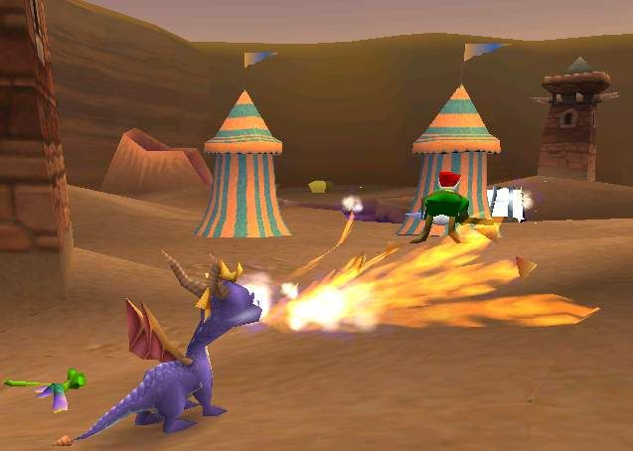
Figure 1. A screenshot from Spyro the Dragon (PS1)

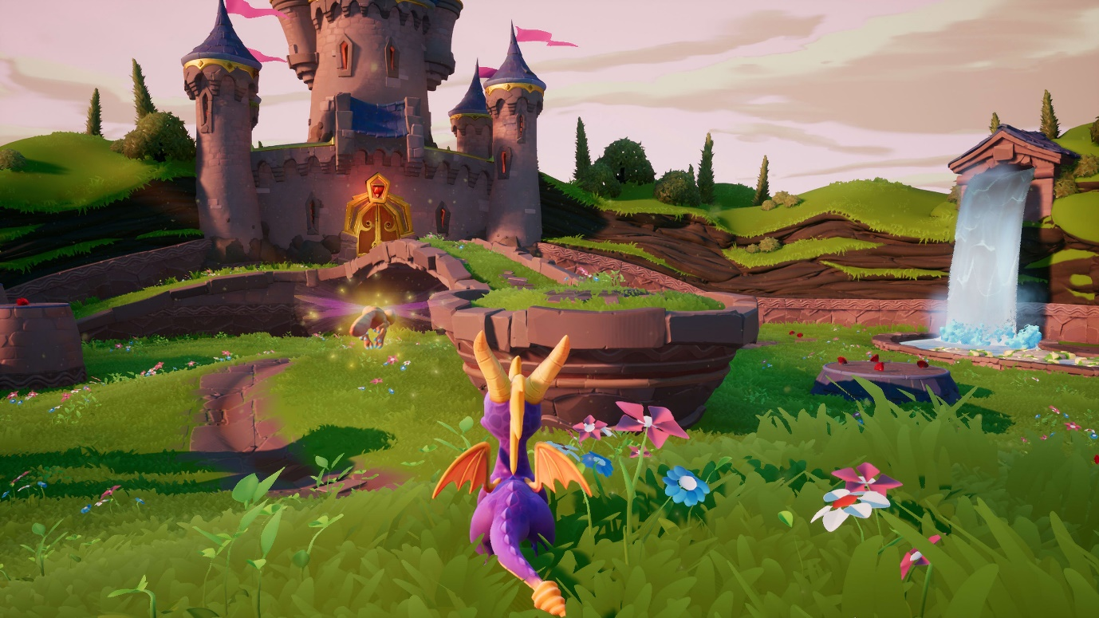
Figure 2. A screenshot from Spyro Reignited Trilogy (PS4)

Description: Spyro the Dragon is a game franchise which was created by Insomniac Games in 1998. It is now currently owned by Activision. The series has had many games, the most recent of which was Spyro Reignited Trilogy in 2018, developed by Activision and Toys For Bob (see Figure 2). This game is a remake of the first three games: Spyro the Dragon, Spyro 2: Ripto’s Rage and Spyro: Year of the Dragon, all developed by Insomniac Games and published by Sony Computer Entertainment.

Advantages:
- Eye-catching, colourful graphics, especially in the case of Spyro Reignited Trilogy
- A memorable, likeable protagonist
- Good level design, with levels that are mostly open and non-linear
- A variety of platforming and interaction moves – Spyro can breathe fire, charge, glide and roll in addition to standard running and jumping
- Excellent soundtrack

Disadvantages:
- Some challenge missions in in the original and Reignited Trilogy are more difficult than others, and some can be frustrating.

Jak & Daxter: The Precursor Legacy

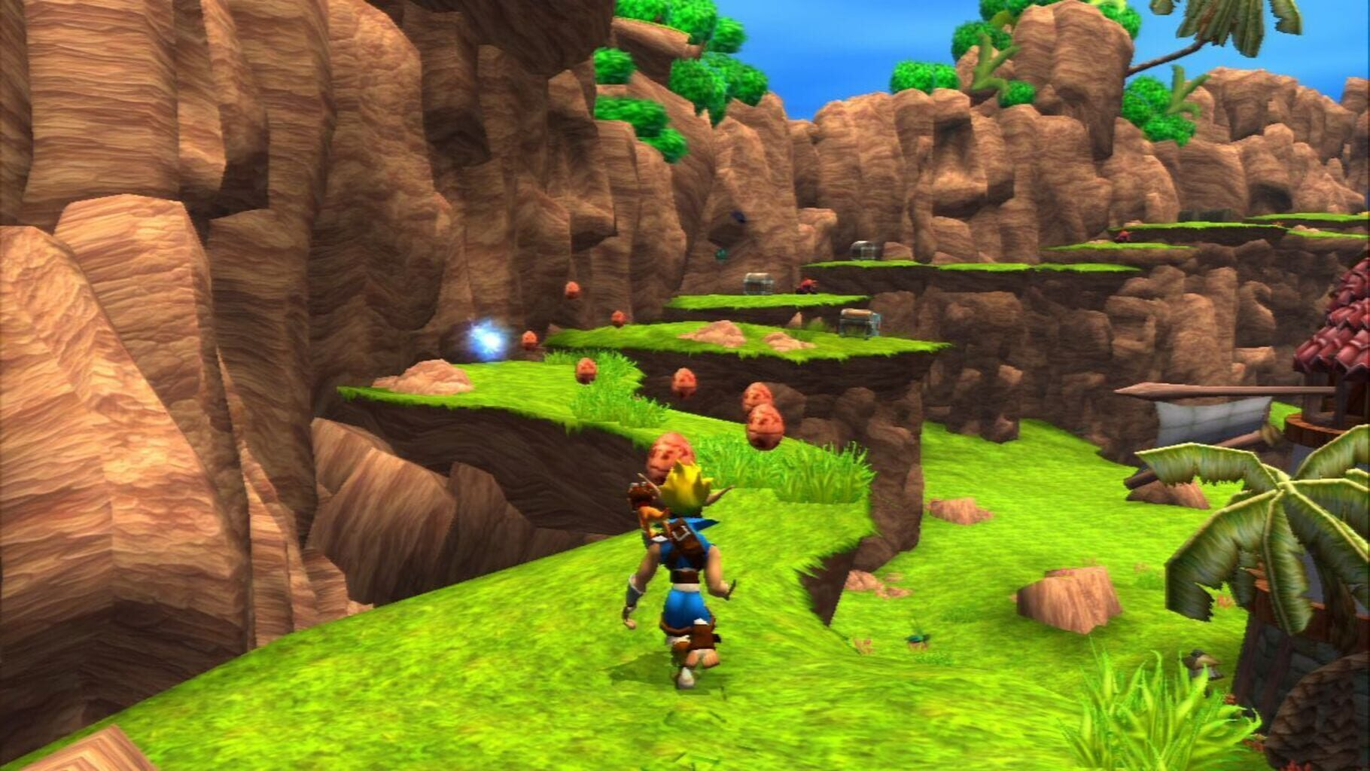
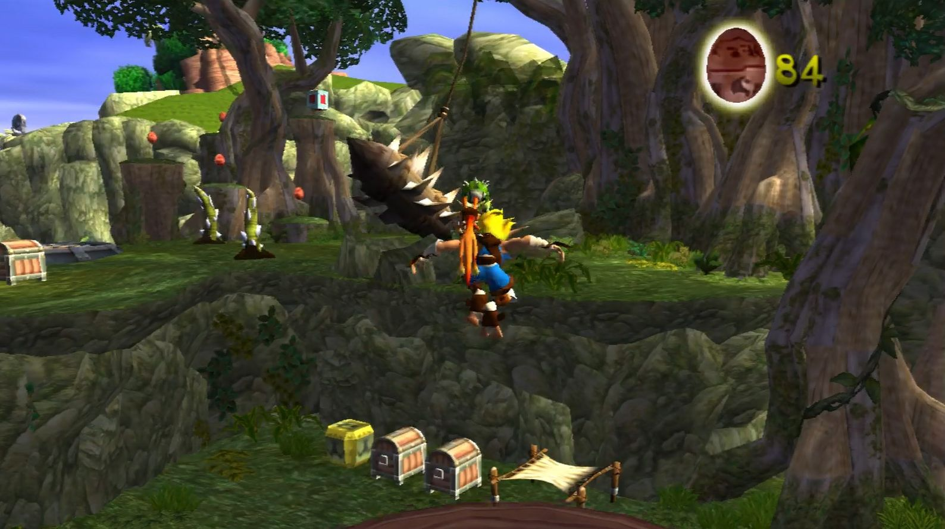
Figure 3. Screenshots from Jak & Daxter: The Precursor Legacy (PS2)

Description: Jak & Daxter: The Precursor Legacy is the first game in the Jak series developed by Naughty Dog in 2001 and published by Sony Computer Entertainment. In this game, the player controls Jak as he sets out to turn his companion, Daxter, human again after he is transformed into a small furry creature.

Advantages:
- A wide variety of large, colourful levels in an open world
- Plenty of fun and interesting challenge missions
- Excellent level design
- Excellent soundtrack

Disadvantages:
- Like many 3D platformers, some challenge missions and later levels can be difficult
- Main character is not a quadruped.

Nytro

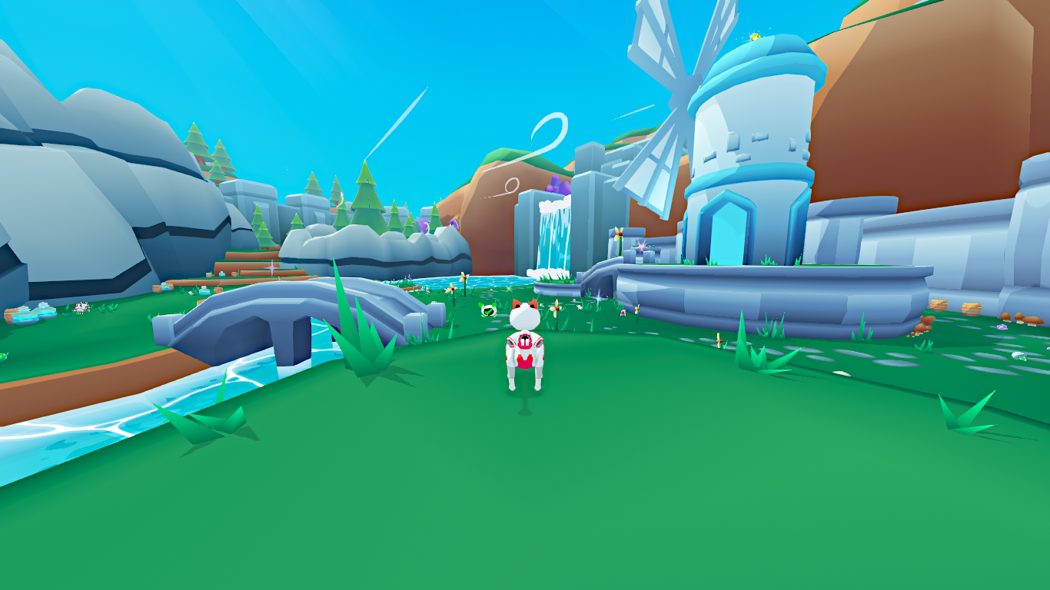
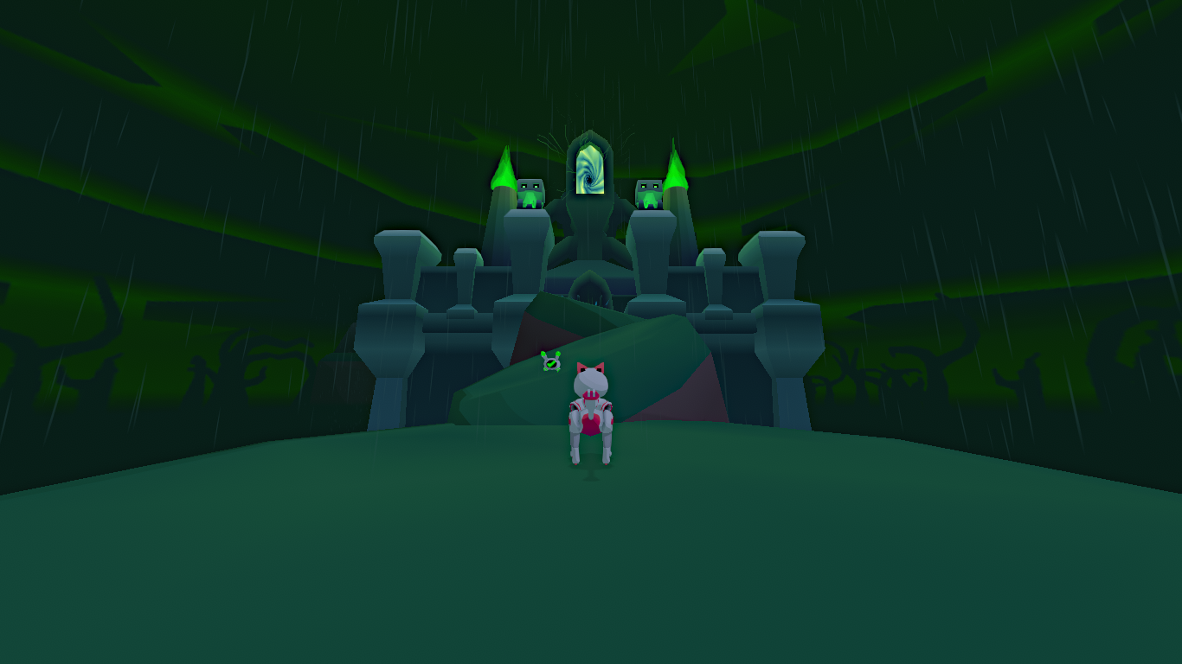
Figure 4. Screenshots from Nytro, an indie game by user OhiraKyou on itch.io

Description: Nytro is an independent (indie) game available on itch.io, made by the user OhiraKyou. It is a platformer inspired by the Spyro series, with similar gameplay mechanics and level design. Currently there is only a demo available for PC, Mac and Linux download.

Advantages:
- Unique, low-poly art style
- Familiar gameplay for long time Spyro players, with a few small differences
- Plays well on PC with a QWERTY keyboard, but can also be played with a gamepad

Disadvantages:
- Takes perhaps too much inspiration from Spyro, without doing many new things
- Keyboard controls can sometimes make platforming difficult
- The game is only a demo and may never be completed.

Zera: Myths Awaken

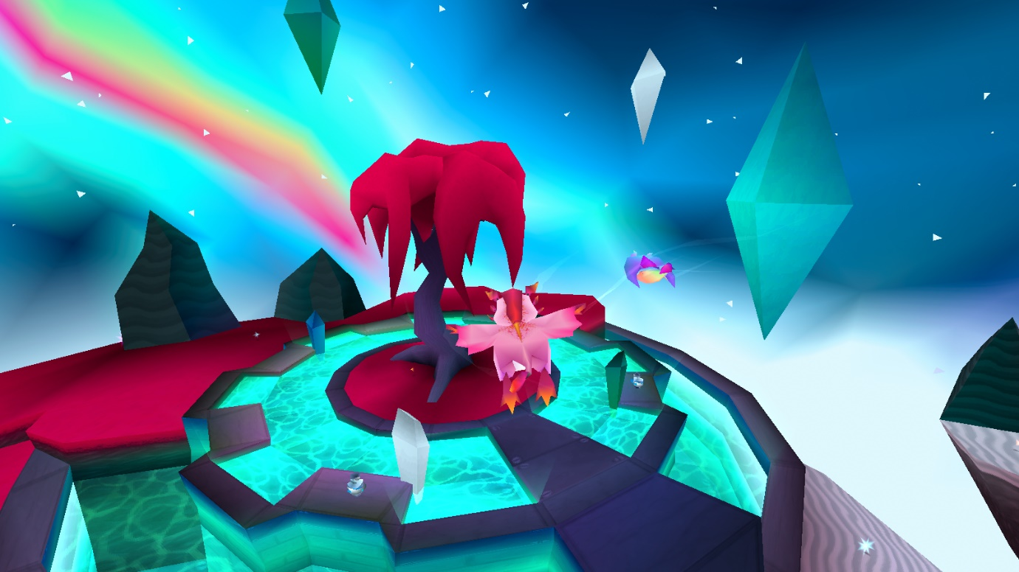
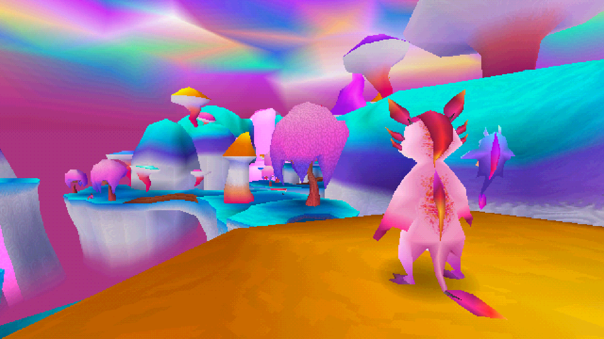
Figure 5. Screenshots from Zera: Myths Awaken, an indie game by user Cyreides on itch.io

Description: Zera: Myths Awaken is an indie game available on itch.io, made by the user Cyreides. Like Nytro, it is heavily inspired by Spyro, with an art style reminiscent of PS1 graphics. The game is constantly being updated by the creator.

Advantages:
- Familiar gameplay for long time Spyro players, with some unique features as well
- Plays well on PC with a QWERTY keyboard
- Graphic style emulates PS1 graphics, which adds a further nostalgic touch to the game
- Excellent, unique soundtrack, which is completely different from the style of the game that inspired it

Disadvantages:
- Level design could be improved in some areas
- Sections of some levels are quite difficult.
- Main character is only quadrupedal when performing certain actions, otherwise she is bipedal.

Summary of Findings

From analysing these existing applications, it is clear that they contain many aspects that can be used for this project. Spyro the Dragon and Nytro, for example, both contain playable quadruped characters, so their level design naturally reflects this. The same applies to Zera: Myths Awaken to an extent, but as mentioned in the section above, the main character in this game is not entirely quadrupedal in nature. Jak & Daxter, while it is a 3D platformer, does not feature a quadruped as a protagonist, and is therefore the least useful example for this project specifically. The game contains many examples of good level design, but unlike the application being developed for this project, the level design is not specific to quadruped characters. From examining these applications, a foundation for this project’s test level can now be built.

User Profile

The target audience for the game I am developing is gamers between the ages of 18 and 30, who would have grown up playing 3D platformer games on the original PlayStation, Nintendo 64 and PlayStation 2. 3D platformers as a genre are usually child-friendly, but they were much more common in the late 1990s and early 2000s so my game will be targeted towards the people who were children then.

Survey

As part of the requirements research, a questionnaire/survey was carried out using Google Forms. Screenshots of the results in full are shown in Appendix A (page 43).

The results showed that the participants were aged between 20-26 years old, with an outlier of 34. They mostly play games on PC, followed by PlayStation, mobile and Nintendo Switch. As expected, the types of game participants played most when growing up were 2D and 3D platformers. 3D platformers are still frequently played by the participants according to the results, but they are tied with adventure games, RPGs and simulators. The three game series participants were most familiar with were Super Mario, Crash Bandicoot and Spyro. Good level design was considered the most important aspect of a 3D platformer, followed by a memorable protagonist and exploration. Answers from the written questions are recorded in the screenshots in Appendix A. Character and level design were topics that recurred frequently in the answers above, so these will be taken into consideration while developing this game.

Persona

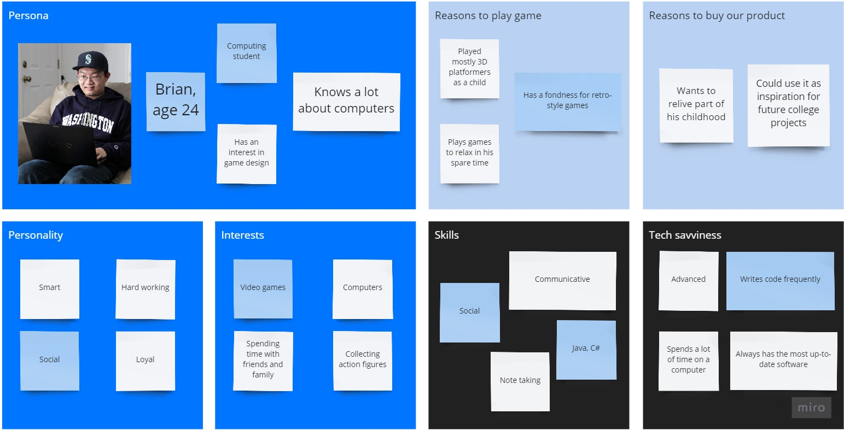
https://miro.com/welcomeonboard/mMpeiQua7cfb7UYSXzOgwhlsseUgQacm0pJZPA9ISZZzCiAcHR7RQdsU1AOruC5j

Requirement Modelling

Functional Requirements

- The game should allow the player to control and move the quadruped character around the level.
- The quadruped must be animated correctly based on the controller functionality used.
- The user should be able to interact with various objects in the level.

Use Case diagram

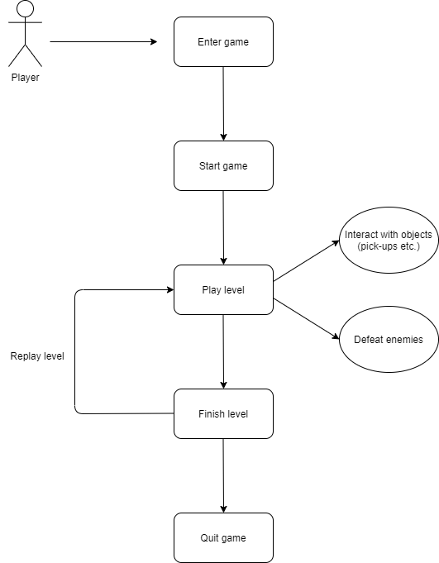
Figure 6. Use case diagram

Non-Functional Requirements

- The game should be easy for the player to pick up and learn in terms of controls. 3D platformers are generally easy to learn for experienced players, but it must be accessible to those unfamiliar with the genre as well.
- Hardware should probably also be taken into consideration, as more powerful PCs will be able to run the application better.
- The game’s graphics should be appealing to the target user of the application.
- The game should feel satisfying to play, without problems or frustration.

System Model and System Requirements

Unity was chosen to create this project as it is an intuitive, user-friendly development environment for making 3D games and applications, including platformers. The game being developed for this project is not an online game, so the system model below solely focuses on Unity and the game scenes contained in the project.

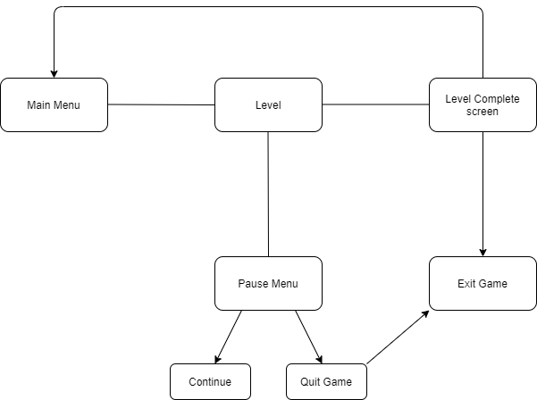
Figure 7. System model diagram

Feasibility Study

As with any project, there are several obstacles to be overcome during this project’s development. These are listed and explained below.

The first issue is time management. It may be difficult to balance this project with other college assignments, especially in the implementation phase. To overcome this, a good strategy would be to set aside specific times during the day or week to carry out project work.

Another issue is code bugs. Bugs and errors can easily arise during development of any game project. To resolve this, bugs will be noted during development and solutions will be researched online through programming forums and Unity forums.

Project Plan

1. Research and analysis: Research into already existing 3D platformer games, survey, requirements document
2. Outline design: Basic gameplay storyboard, user interface design, level and environment design
3. Detailed design: Code design, class diagram, sequence diagrams, design document.
4. Implementation: Implementation of level design and gameplay, integration of
assets in Unity.
5. Testing: Unit testing, integration testing, system testing, and test plan.
6. Final documentation.

Test Plan

Testing of this project will be carried out in multiple phases: unit testing, integration testing, regression testing, system testing and user testing.

- Unit testing will be carried out during the later stages of the game being developed. This allows continuous testing for any potential errors and prevents them where possible.
- Integration testing will also be undertaken while the project is in development. Integration testing will ensure all project assets interact properly and work well with one another.
- Regression testing is also necessary while working on this project, as new features will be added along the way. This is an essential step to ensure that the game runs as intended at every step.
- System testing will occur when the Unity project is completed. This will test how the game works as a whole.
- User testing will be carried out on the finished application to ensure it has met the requirements of the target audience.

Chapter Summary

This chapter has established the requirements needed to create this project. These requirements will be taken into consideration during the implementation phase, when the playable prototype is built.

Research

Introduction

This literature review focuses on answering the question: What elements differentiate 3D platformers from third-person action-adventure games? Many video games are third person, yet 3D platformers contain their own distinct characteristics and features that other genres may not. This literature review seeks to examine the features of gameplay and level design that set this genre apart from others.

3D platformers have existed since the 1980s, but it was not until the 1990s that the genre became popular and entered the mainstream. The earliest “true” 3D platformer was Alpha Waves, published in 1990 by Infogrames (Atari SA) for the Atari ST and Amiga consoles as well as PC. Nintendo’s Super Mario 64 was released in 1996, setting a new standard for future 3D platformer games. Throughout the 1990s, many other popular 3D platformers emerged, such as Naughty Dog’s Crash Bandicoot, Rare’s Banjo-Kazooie, and Insomniac Games’ Spyro the Dragon. The popularity of 3D platformers began to decline in the early 2000s, but several notable franchises were still developed at this time. Naughty Dog and Insomniac Games continued the trend with Jak & Daxter and Ratchet & Clank respectively. However, both franchises displayed a shift away from traditional platforming, with weapons and action-oriented gameplay added to the formula. Although the genre is not as popular today, 3D platformers still have a niche following and continue to be made.

One genre that 3D platformers are often compared to is action-adventure games. This genre includes game franchises such as The Legend of Zelda. Although 3D platformers share similarities with action-adventure games, there are some key differences between the two genres. These differences will be examined in this literature review.

The sections of this research chapter are as follows:
- Key elements of 3D platformer games
- Key elements of action-adventure games, compared to 3D platformers
- Conclusion

Key Elements of a 3D Platformer Game

Characters

The first important aspect of any 3D platformer is the character design, especially the design of the protagonist. 3D platformers typically have a stylised, “cartoony” appearance, which appeals to a wide variety of demographics. Main characters appear in promotional art and cover art, so they are the first thing a potential player will notice about the game. According to Steve Mayles, a character artist for Yooka-Laylee, “Appeal also comes from the overall shape and stand-out features, and how the character is posed/animated” (Playtonic Games team, 2015).

Character movement is also fundamentally important in a 3D platform game. At its core, the 3D platformer genre mainly focuses on two character abilities: moving (usually running) and jumping. Additional mechanics may include climbing, hitting, crawling, or abilities from other game genres such as shooters (Gustafsson & Andersson Gidlund, 2014). Gameplay must feel good first and foremost, before adding the final polish to make it look good. This is according to Chris Sutherland, project director on Yooka-Laylee - “just moving something around with the controller should feel fun and engaging” (Playtonic Games team, 2015). Also of note in the 3D platformer genre is the “double jump” ability. Although this is physically impossible in the real world, it is included in many platformers. There is usually no explanation provided in-game for why the main character can jump twice (Faber, 2020), it is merely a useful core ability that the genre utilises very well.

Game World & Levels

A very important element of 3D platform games is their worlds and levels. These are the spaces in which the player moves, jumps, and explores. There are many important aspects of good level design, some of which are outlined below.

When designing a level for a 3D platformer, or any game, the first thing that must be decided upon is its purpose. Some levels have purposes such as teaching the player a game mechanic, or advancing the game’s story (Aaltonen, 2018). Equally as important as the purpose is the theme of a level. Deciding on a level’s theme helps to define what design elements should be included in that level. For example, a forest level should contain plenty of trees, and a volcanic level should contain lava (Aaltonen, 2018).

It is not enough for a level to have a theme; the appearance of the level must be established as well. This can be done through gathering reference images, creating mood boards, or drawing concept art.

The goal of a level is also important. This usually varies between genres, and even between games in the same genre. For example, Super Mario 64 and Spyro the Dragon are both 3D platformers, but their level goals are both different. In Super Mario 64, the goal of each level is to collect a power star, while in Spyro the Dragon, the goal in each level is to find and rescue all the dragons in that level and collect all the level’s treasure. Both game’s goals are similar, but still differ from one another.

Metric constraints must also be considered in level and world design. This takes into account the player character’s abilities, and what they should and should not be able to do in a level. An example of this is ensuring the player cannot jump high or far enough to reach unintended areas of a level (Aaltonen, 2018).

The test level developed for this project will focus on aspects of level design created specifically for quadruped characters. Quadrupeds, such as Spyro in the Spyro the Dragon franchise, possess their own unique abilities and limitations compared to humanoid characters. For example, quadruped characters cannot pick up items or use handheld tools, as they do not have arms. Because of this limitation, many are also unable to use ladders and other similar means of accessing high areas. One way to solve this is to allow the quadruped to pick up and hold items using their mouth, as well as using moving platforms or wind tunnels to access higher areas. Both of these solutions allow quadruped characters to perform the same actions as humanoids, but using methods better suited to their abilities and limitations. These limitations also require objects like switches to be at an accessible level to quadrupeds, usually ground level. Such objects include pressure pads, usually used for unlocking new areas when the quadruped steps on them, or jump pads, which can be used as an alternative to wind tunnels or ladders as a means of accessing high areas.

The level created for this project will be a test level, and thus act as a demonstration of quadruped-specific level design elements similar to the ones mentioned above. Many video games include test levels, or tutorials, at the start of the game to teach the player about the game’s controls and other important gameplay elements. A good example of this is the first level, “Geyser Rock”, in Jak & Daxter: The Precursor Legacy. This is a small, basic level set on its own island, in which the player learns about the game’s controls, collectibles, and power-ups. In this way, the level serves as an important guide to the main gameplay while still being part of the main game.

Collectibles

Collectible trinkets are a staple of the 3D platformer genre, with many platformers containing them in one form or another. As such, many 3D platformers are informally referred to as “collect-a-thons”, such as the Spyro franchise and Banjo-Kazooie.

The appearance and visual appeal of collectibles is very important. Collectibles in any platformer must be visually distinctive enough that the player can easily see them to pick them up. In many cases, this is done through animating the collectibles so they rotate in place, as seen in the Spyro franchise and Jak & Daxter. Collectibles are usually shiny or bright in colour, helping them to stand out from the environment of the game.

According to Mark Stevenson, technical artist of Yooka-Laylee, collectibles are “an incredible versatile and useful design tool”, as well as being a currency or a means of completing the game (Playtonic Games team, 2015). They can help guide the player through a level: by placing collectibles in certain locations of a level, the player knows that they must go to those locations. Trails of collectibles can also be used to help the player navigate a level, and they can also be placed in difficult locations to allow the player to test their platforming skills.

It is clear that there are many distinctive elements of character and level design associated with 3D platformers. In the next section, action-adventure games, and their differences to 3D platformers, will be examined.

Key Elements of an Action-Adventure Game (compared to a 3D Platformer)

In this section, several key elements of action-adventure games will be discussed and compared to 3D platformers, from my personal observations.

Character Controls

In 3D platformer games, moving and jumping are the two basic controls. Therefore, there is always a button or key input associated with the jump ability, for example the X button on a PlayStation controller or the Space key on a PC keyboard. In most action-adventure games, such as the The Legend of Zelda franchise by Nintendo, the player does not press a button or key to make the player character jump; they jump automatically off ledges, or pull themselves up on a ledge if it is a little too high. As jumping is not a core mechanic of action-adventure games, there does not have to be a dedicated input for it.

World Design & Mechanics

Another difference between 3D platformers and action-adventure games is that action-adventure games tend to have a more open world, while most platformers are fairly linear in nature. 3D platformers usually focus on overcoming obstacles in levels using the player’s basic abilities. Levels in 3D platformers are also very distinct from one another. In action-adventure games, the focus is more on exploring than running and jumping, and the game world is usually larger, more open, and may or may not include separate levels. In addition to this, many action-adventure games have more of an emphasis on combat, while most 3D platformers do not (enemies are usually defeated with one hit). Enemies in action-adventure games require more skill and effort to defeat.

Conclusion

This chapter has examined and discussed several design elements that define a game as a 3D platformer. From the findings in this chapter, it has been established that character design, controls, level design and collectibles are all important in making a 3D platformer. It has also discussed some differences between 3D platformers and action-adventure games. While both genres are primarily third person, it is clear that they differ in some respects such as character controls and world design.

This chapter will be useful in shaping the project in development. The findings on character controls, level design and collectibles will be of particular interest during the design and implementation phases of the overall research project. It is now clearer which features should and should not be implemented in the final project.

Design

Introduction

This chapter describes the design of the application. The purpose of the design phase of the project is to allow the developers to arrive at a design for the application, so that the application meets the requirements set out in the Requirements chapter.

The design of this application is divided into:
- Program Design
- User Interface Design.

The application for this project is to explore 3D level design, and how the resulting game mechanics work with a quadrupedal player character.

Program Design

The program design refers to the design required to make programming and coding of the application more straightforward.

Technologies

The technologies being used to create this application are:
- Unity 2019.4
- Visual Studio Code

These technologies were chosen because Unity is a widely supported and intuitive program for developing 3D games and prototypes. Visual Studio Code was chosen as the script editor for the game’s code, as it supports C# for Unity and is generally very easy to use.

Another possible technology which could have been used was Unreal Engine. This technology was not suitable due to my lack of experience in using it. It is also more suited to high-end game development than a college-level project.

Structure of Unity

Below is a screenshot of a Unity project folder structure, taken from an early prototype of this project.

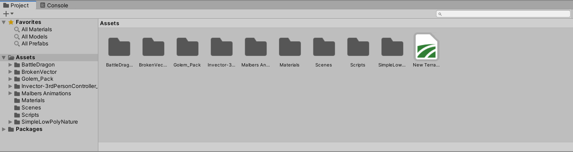
There is a file for the terrain object in the game scene, as well as folders for materials, C# scripts and game scenes. Asset packs imported from the Unity Asset Store also have their own folders.

Design Patterns

Unity has many game design patterns, one of which is the Update() method. This is widely used within Unity. The idea behind this method is that the game scene contains various different objects, whose behaviours need to be updated with each frame. For this to work, every object needs an Update() method. With each frame, the game will update each object.

Process design

- User Flow chart:

Figure 8. User Flow diagram

- Level Flow chart:

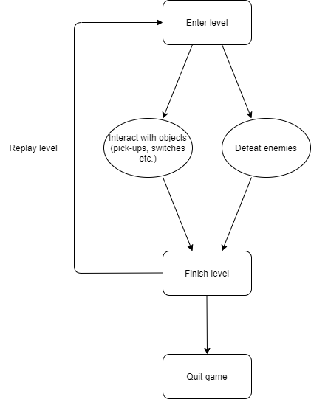
Figure 9. Level Flow diagram

User interface design

This section describes how the user interface (UI) is designed.

Wireframe

The wireframes below show the layout of the main game screens.

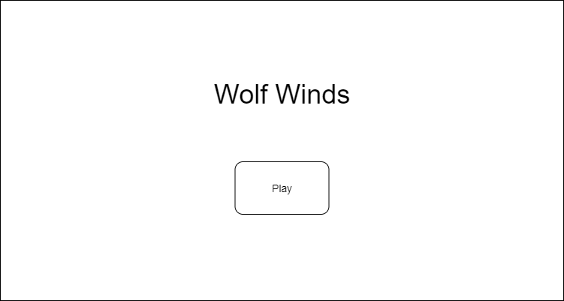
Figure 10. Example Start Screen wireframe

Figure 11. Example Main screen wireframe

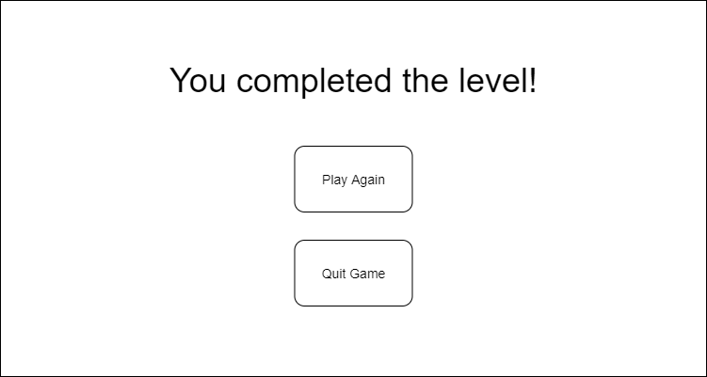
Figure 12. Example Level Complete screen wireframe

Style guide

The main colours used in the UI for this project are inspired by nature and the theme of the game. To convey this to the user, various shades of brown and green will be used.

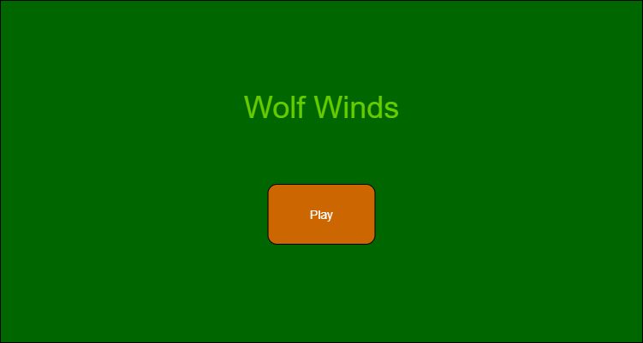
Figure 13. Example menu layout, showing possible colour scheme
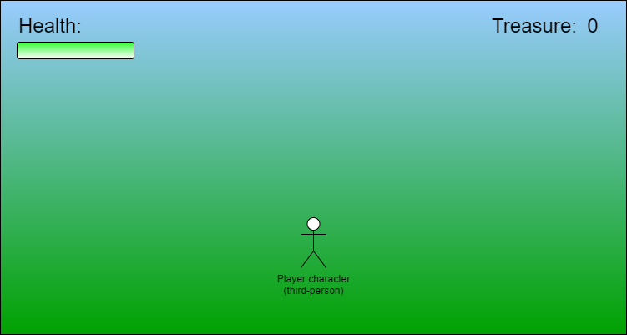
Figure 14. Example level screen, showing possible colour scheme

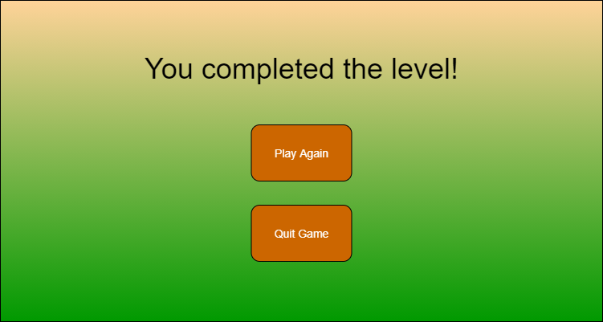
Figure 15. Example "Level Complete" screen, showing possible colour scheme

Various fonts were explored for the UI of the game. These fonts are listed below.

Anudaw

Good Dog

Good Dog (Plain)

Moria

Wilderness

Roster

My Leaf

Vecna

El Katana

This font will be used in the final game level for UI elements, such as help text to guide the player through the various parts of the level. The font chosen from the ones listed above will most likely be used alongside a basic font for legibility purposes.

Environment

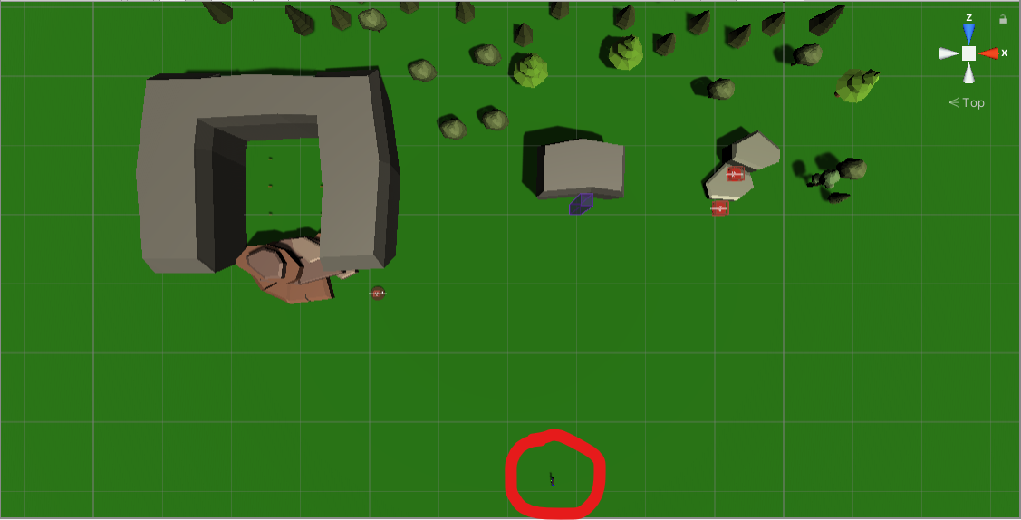
Figure 16. Top-down view of the test level created for this project

The layout of the test level can be seen in the figure shown above. The start position of the player character is marked with a red circle. The three “test stations” in the level can also be seen in this screenshot. These are shown in more detail in the figures below.

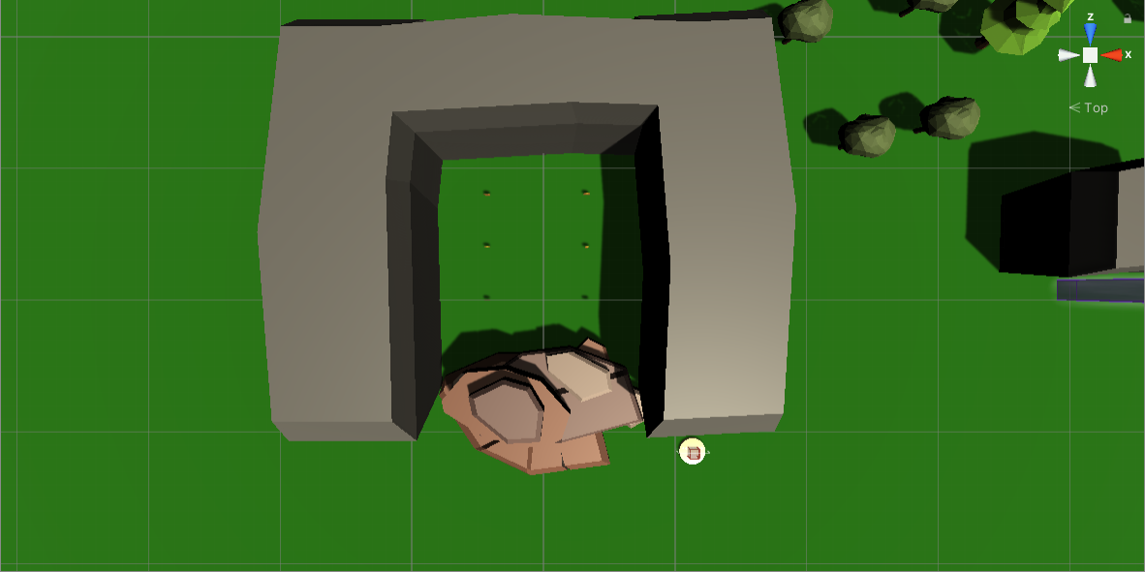
Figure 17. Test station with pressure pad and collectibles

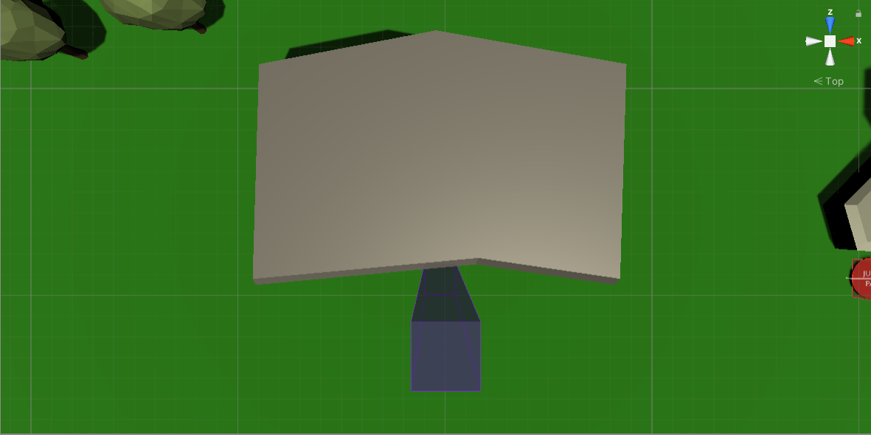
Figure 18. Test station with wind tunnel

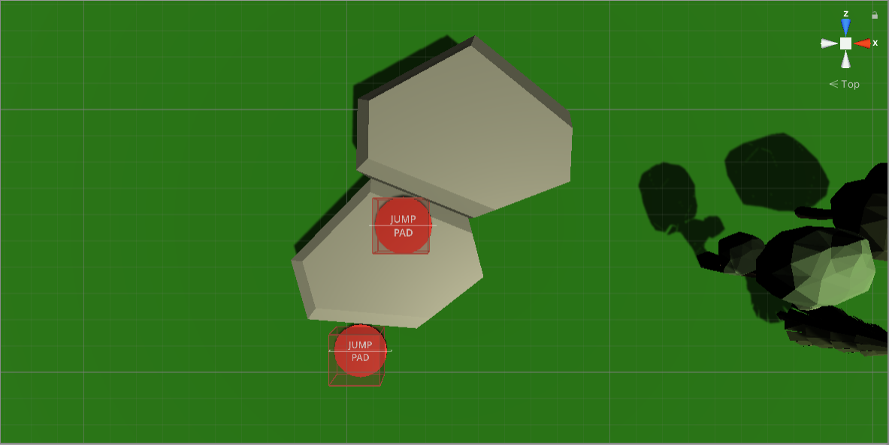
Figure 19. Test station with jump pads

Chapter Summary

This chapter has laid out the most important design aspects for the application being developed in this project. These design aspects will be considered while developing the game during the implementation phase.

Implementation

Trello was used to track what needed to be done during this phase of the project. The Trello board used can be seen below.

https://trello.com/b/fDpjrFju/year-4-project
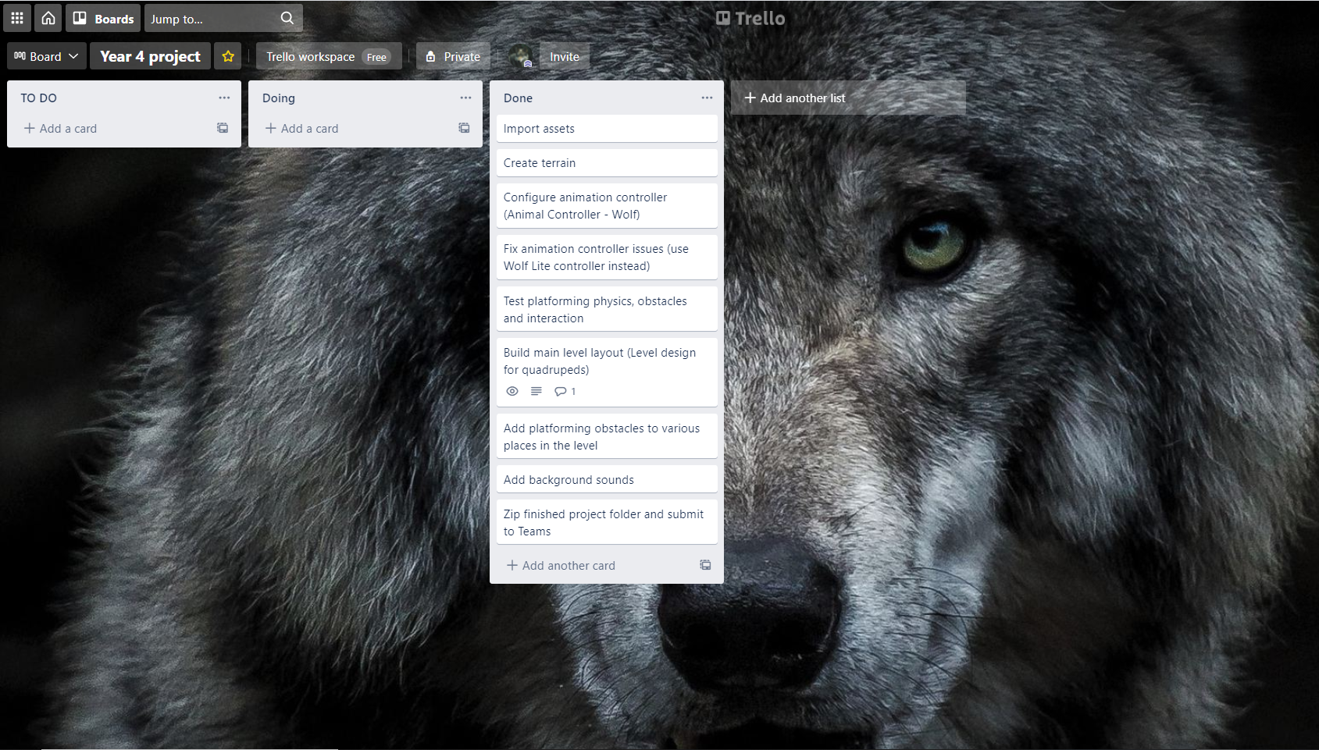
Figure 20. Trello board for this project

As can be seen above, this board contains a list of features that were implemented in the final project. These implementation steps are discussed in more detail below.

Implementation Steps

The first step in this implementation phase was to set up the basics inside the Unity editor. These included importing the necessary assets into the game scene and creating the terrain for the playable level.

For the player character, the “Poly Art: Wolf” asset, created by Malbers Animations on the Unity Asset Store, was used.
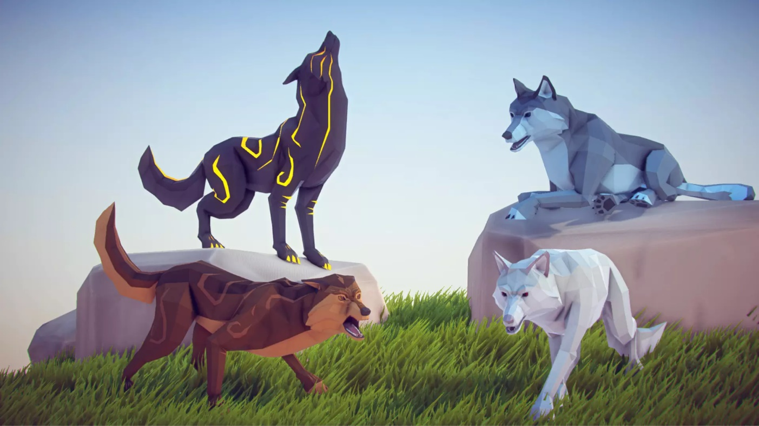
Figure 21. Poly Art: Wolf by Malbers Animations

Figure 22. Poly Art: Wolf asset in Unity

The next step was to animate the wolf model so the player could move around. This was done using the “Animal Controller” asset from the Unity Asset Store, also by Malbers Animations. The animations were controlled using the animator component in the Unity editor.

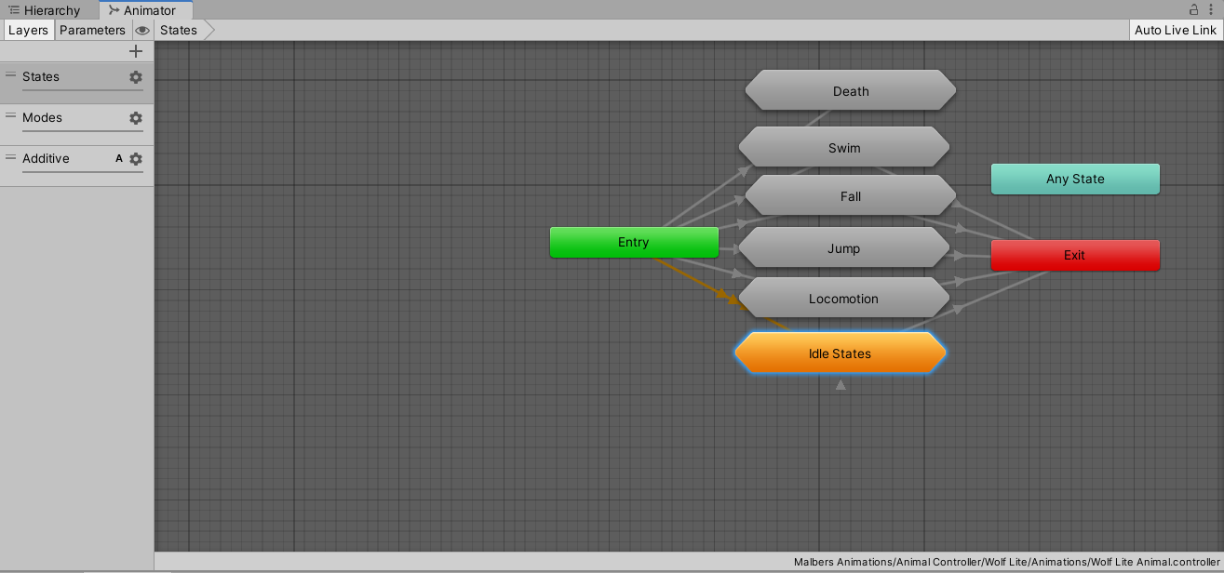
Figure 23. The Animator window within Unity

The “Animal Controller” asset also contained various level design elements which would come in useful for this project. Among these were collectible coins (with pickup sound), pressure pads, jump pads and a wind tunnel.

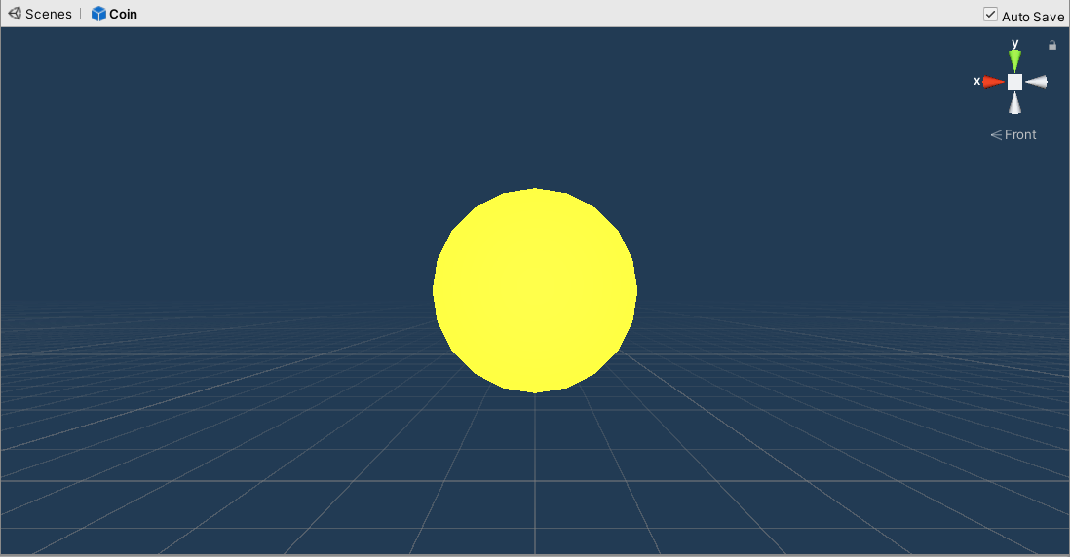
Figure 24. Collectable coin item

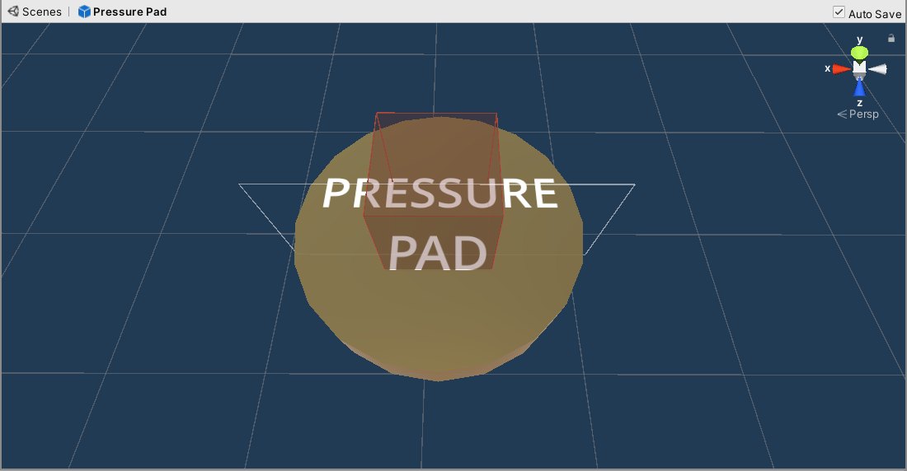
Figure 25. Pressure pad

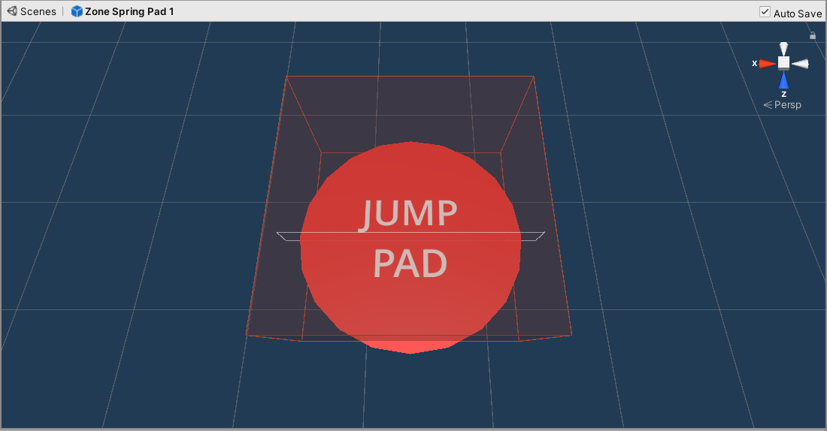
Figure 26. Jump pad

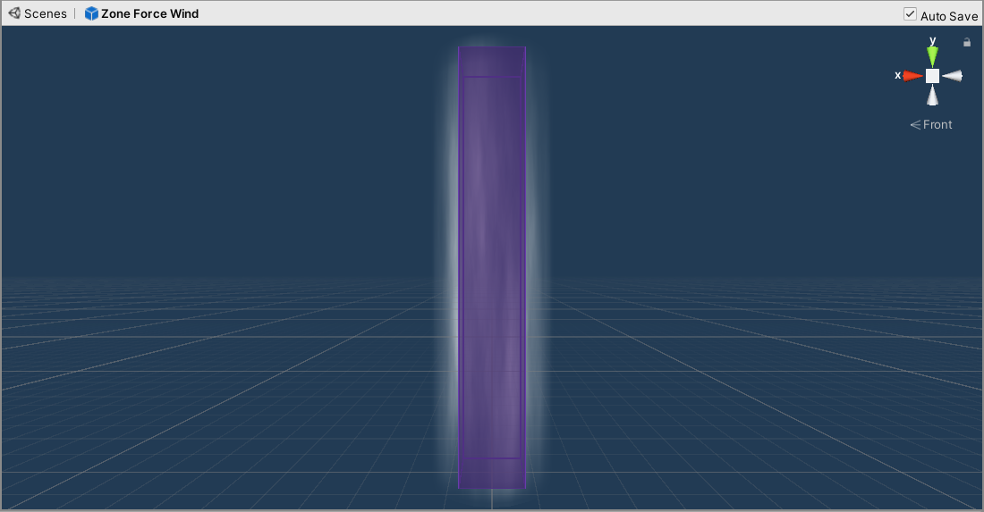
Figure 27. Wind tunnel, used to access high areas

The next, and most important step was to build the actual game level itself. The level was designed to test some of the various platforming elements of a quadrupedal character. The assets used above were combined with rocks and platforms of various sizes to demonstrate their uses in gameplay.

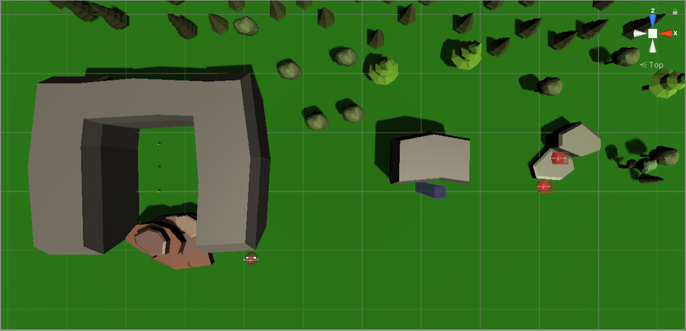
Figure 28. Top-down screenshot of "test" level layout in Unity

The last detail to be added was background sounds. Although this step was not necessary to the game’s functionality, it adds a degree of immersion to the environment of the level.

Implementation Problems

Animation

One problem faced while developing this project was animating the wolf character. It was not pre-animated, and animations had to be applied to it using a user-made controller and a set of tutorials by the asset creator, Malbers Animations. Initial attempts at animating the wolf did not produce successful results, with some animations creating bugs or appearing unnatural. This problem was solved by using the pre-made controller for the Wolf Lite asset included with the Animal Controller pack. This controller contains the animations essential to 3D platformers, such as locomotion (running), jumping and an idle state.

Chapter Summary

This chapter has outlined the various steps of the implementation process. The level designed in this stage of the project can now be tested.

Testing

Unit testing and user testing were both used for this project. Summaries of these tests can be seen in the sections below.

Unit Testing

Unit testing was used to determine whether the various elements of the level functioned as intended. The results of these unit tests are summarized below.

- Controls & Animation:
  - The quadruped player character moved in each direction as intended when the W, A, S and D keys were pressed.
  - It jumped when the spacebar was pressed.
  - Some colliders on objects in the level caused the quadruped to “get stuck” in a certain position and be unable to move, prompting a restart of the application.
  - Some optional animations could be added.
- Pressure pad:
  - Worked as intended when moved over carefully.
  - Quadruped sometimes got “stuck” on the edge of the pressure pad’s collider, or was launched sideways due to a bug.
  - Worked as intended sometimes, not always.
  - Needs to be fixed/refined.
- Collectibles:
  - Worked as intended, when walked up to they disappeared and the pickup sound effect played.
- Wind tunnel:
  - Worked as intended, quadruped was carried upwards.
- Jump pads:
  - Worked as intended, caused quadruped to bounce onto the higher platforms.

As can be seen from these unit testing results, most features of the level performed their intended purpose without any problems. However, the quadruped’s animation and the pressure pad’s colliders still contain bugs that must be fixed.

Also of note is that in an earlier version of the test level, there was a pickup item (ball) on the ground that the quadruped could pick up in its mouth. This was eventually left out of the level due to bugs and implementation problems. One problem was that the quadruped would pick up the ball automatically, but it was unable to put it down again. This feature was also partially left out due to time constraints. The bug could have been fixed had there been more time to implement the feature properly.

User Testing

Because this application is a test level and not a full game, user testing was fairly limited. One user test was carried out, the results of which are summarized below.

- Controls & Animation:
  - The quadruped player character moved in each direction as intended when the W, A, S and D keys were pressed.
  - It jumped when the spacebar was pressed.
  - Some colliders on objects in the level caused the quadruped to “get stuck” in a certain position and be unable to move, prompting a restart of the application.
  - A “restart” button was suggested as a fix for this issue.
- Pressure pad:
  - Worked as intended when moved over carefully.
- Collectibles:
  - Worked as intended, when walked up to they disappeared and the pickup sound effect played.
  - Different types of collectible were suggested, such as a larger coin with more value than the standard coins.
- Wind tunnel:
  - Did not always work as intended, caused quadruped to be launched into the air.
- Jump pads:
  - Worked as intended, caused quadruped to bounce onto the higher platforms.

As can be seen from the user testing results, several features were suggested to improve the test level or fix problems. These included a restart button when the quadruped gets stuck, and multiple different types of collectible as well as the standard coins. A wind tunnel bug was also documented, which did not occur during unit testing. These features were all noted.

Chapter Summary
This chapter has discussed the various tests that were carried out on the finished test level. Most features worked as intended. However, it is clear that there are still areas which must be improved on, and bugs that must be fixed.

Discussion

I believe this project fulfilled the basic objective it set out to achieve. However, had there been more time to work on it, further game features could have been added. Features that could have been included are enemies and a player health gauge (represented by a health bar in the user interface). Other useful features could include a pickup item (as mentioned in the previous section), as well as a restart button.

I believe this project fulfils the research and requirements laid out in earlier chapters. The test level that was developed clearly includes elements of level design unique to 3D platformers, specifically those featuring quadrupeds. I feel I could have added more interactivity to the level, as mentioned above. However, the basics of my project aim have been achieved regardless.

I feel this project could be used to show others how quadruped gameplay differs to that of a humanoid character. In this way, it fulfils its purpose in explaining the differences between both types of gameplay.

Conclusion

I believe this project fulfils the goal defined in the requirements and research phases. Various aspects of level design for quadrupeds were explored, tested, and laid out in their most basic form.

If I were to undertake this project again, I would add more interactive elements to the game level, such as enemies and a greater variety of collectible items. I think that, with gameplay elements such as these added, the test level could be expanded to a complete level, and possibly a small-scale game of its own. If this project were to become a full game, working with a small team would be a future possibility. This in turn would help me improve my teamwork skills.

Throughout the course of this project I learned valuable skills, such as using the Animator component in Unity to animate the wolf character (or quadruped). This skill could easily be applied to anything I make in Unity in the future, with various different assets. This is a valuable skill that will definitely be of use in future game projects.

To develop my skills further, I would probably create assets myself instead of using pre-existing assets from the Unity Asset Store. This would certainly be a challenge, but it is a logical next step after learning how to animate in Unity. Programs such as Blender could be used for this purpose.

In conclusion, I am pleased with how this project turned out, even if I could have done more with it. The topic of the project in particular was definitely interesting to research, and I would gladly research similar topics again.

References

Aaltonen, T. (2018). Toni Aaltonen 3D platformer level design Bachelor of business ad- ministration Data processing. https://www.theseus.fi/bitstream/handle/10024/157130/Aaltonen_Toni.pdf?sequence=1

Alpha Waves. (1990). Video game, Infogrames Entertainment S.A., Data East, Atari SA.

Banjo-Kazooie. (1998). Video game, Nintendo.

Crash Bandicoot. (1996). Video game, Sony Computer Entertainment.

Faber, T. (2020, October 20). Why platform games such as Crash Bandicoot are as popular as ever. @FinancialTimes; Financial Times. https://www.ft.com/content/5ddd3c7a-929d-4fd2-ab8f-32942e2e6460

Filippidis, K. (2018, May 8). Every 3D Platformer Ever Made. Gameranx. https://gameranx.com/features/id/139851/article/every-3d-platformer-ever-made/

Gustafsson, A., & Andersson Gidlund, T. (2014). An Analysis of Platform Game Design Implementation Categories and Complexity Measurements. https://www.diva-portal.org/smash/get/diva2:728079/FULLTEXT01.pdf

Jak & Daxter: The Precursor Legacy. (2001). Video game, Sony Computer Entertainment.

Nytro. (2017). Video game demo, OhiraKyou. Retrieved from https://ohirakyou.itch.io

Playtonic Games team. (2015). 6 musts for a perfect platformer, from the Yooka-Laylee team. Gamasutra.com. https://www.gamasutra.com/view/news/243310/6_musts_for_a_perfect_platformer_from_the_YookaLaylee_team.php

Ratchet & Clank. (2002). Video game, Sony Computer Entertainment.

Spyro 2: Ripto’s Rage! (1999). Video game, Sony Computer Entertainment.

Spyro Reignited Trilogy. (2018). Video game, Activision. Retrieved from https://www.spyrothedragon.com

Spyro the Dragon. (1998). Video game, Sony Computer Entertainment.

Spyro: Year of the Dragon. (2000). Video game, Sony Computer Entertainment.

Super Mario 64. (1996). Video game, Nintendo.

The Legend of Zelda. (1986). Video game franchise, Nintendo. Retrieved from https://www.zelda.com

Yooka-Laylee. (2017). Video game, Team17. Retrieved from https://www.playtonicgames.com

Zera: Myths Awaken. (2019). Video game, Cyreides. Retrieved from https://cyreides.itch.io

Appendices

Appendix 1: Other relevant Material

Survey Answers (Requirements)

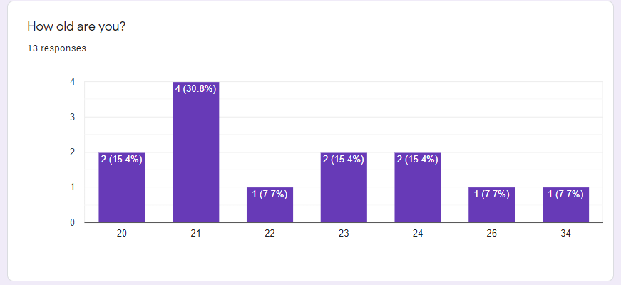
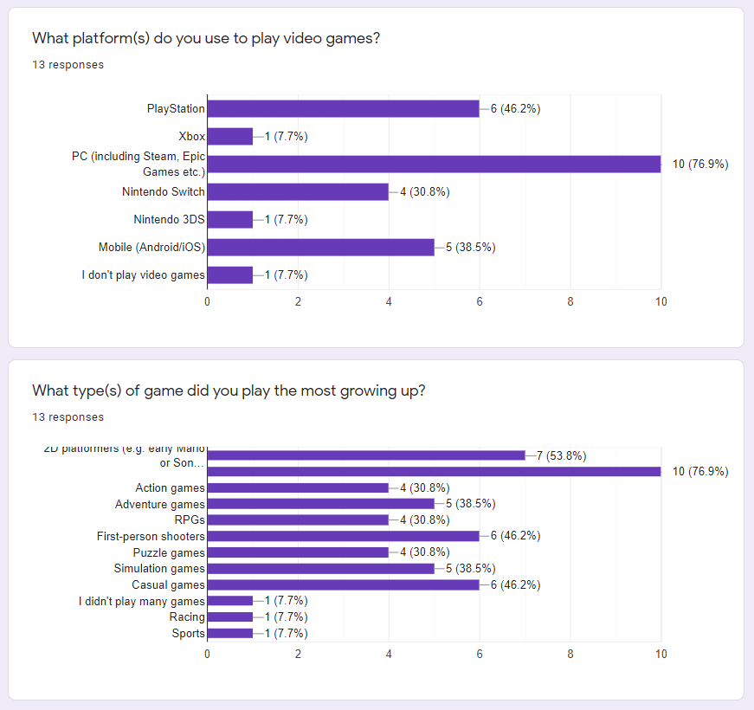
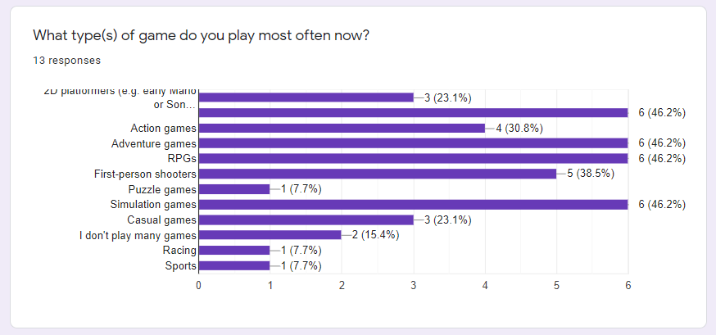
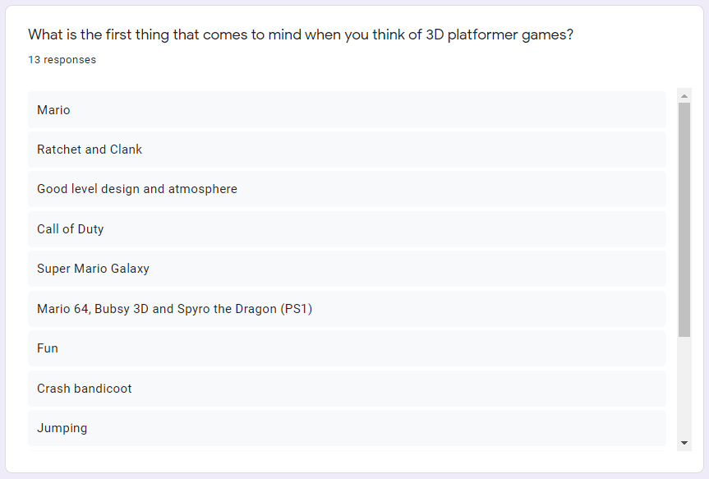
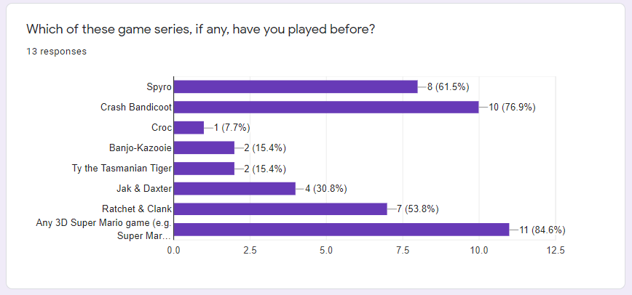
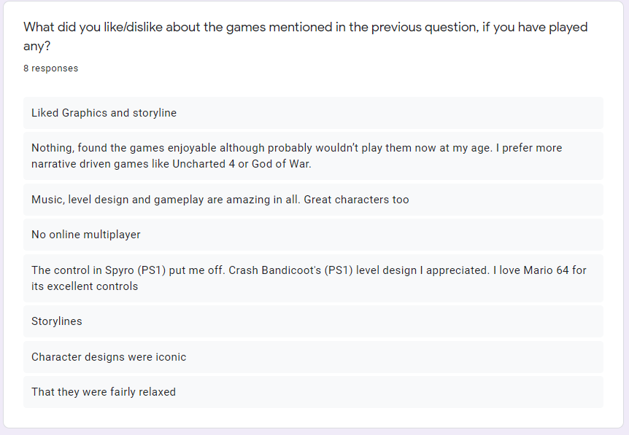
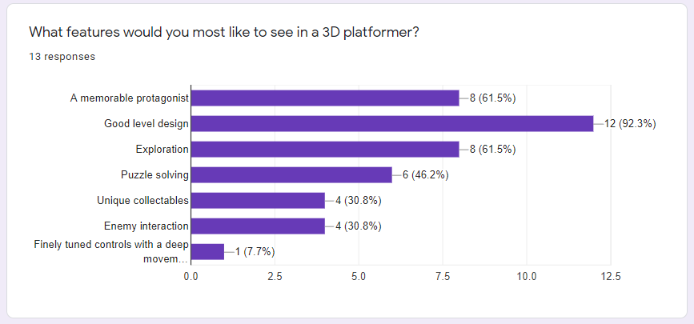
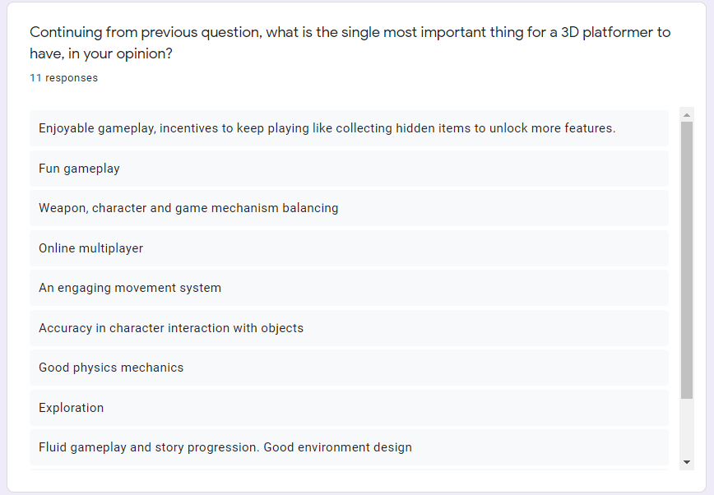
Figure 29. Survey answers from the Requirements chapter

