The Institute of Art, Design and Technology, Dun Laoghaire
Faculty of Film, Arts and Creative Technologies.

The Detached Observer:
Representation of Urbanistic, Cultural & Communal Essence in Documentary Photography.

By
Jake Hoffman

Supervisor: Dr. Justin Carville

Submitted to the Department of Film & Media in Candidacy for the Bachelor of Arts Honours Degree in Photography, 2023.
Declaration of Originality
This dissertation is submitted by the undersigned to the Institute of Art Design & Technology, Dun Laoghaire in partial fulfilment of the examination for the BA (Hons) in Photography. It is entirely the author’s own work except where noted and has not been submitted for an award from this or any other educational institution.

Signed: Jake Hoffman

Jake Hoffman
Student Number: N00193311

Abstract
With social and political agendas, a continued theme within the field of representation is that of urban youth culture. Though capturing the symptoms of raw urban life and the complex constructs of identity itself in a vulnerable fashion. The methodology and style of image-making is derived from a rapport and emotional obligation guided by social responsibility, that further humanises a vastly obscure lifestyle in a nuanced manner. Invariably, the subject matter addresses the systematic problematics of social and societal limitations, which only adds to the pendulum and complexities of those at the centre of the narrative.

When representation is personified by that of the detached observer, it can weave emotive and informative narratives in the ethos of the lifestyle and traits of the multi-layered essences of distinct cultural and communal groups. As the photographic medium evolved so to did the ethical and moral reasonings of the documentary practice. It is within this rubric that the cultural and communal affiliation of the photographer became a non-necessity in modes of representation. Guided by a moral philosophy and creative process of non-intrusion, the capacity for authenticity and visceral immersion became a defining characteristic of the practice. The urbanistic qualities of youth culture were portrayed through dedicated engagement, disciplined practice, and a rare measure of human awareness, through an analysis of lifestyle, social affiliation, and their harmonious structures. With the dramatic nature of the imagery often reflecting this trajectory. Reflecting perseverance and devotion, the practice is further illuminated through the production of the photographic publication, which evolved into a space for didactic collaboration, where stories were told on the subject’s accord and the photographic medium was utilised as a mode to challenge generalisations.

Acknowledgements
I would like to express my sincere gratitude to Dr. Justin Carville, Aoife Herrity, and Adrian Reilly for their profound support, inspiration and tolerance during the four academic years in which they shaped such a significant part of my photographic outlook. Through this, I wish to extend my sincere gratitude to Martin Healy, Kate Nolan, Mark Curran, and David Farrell of the BA (Hons) in Photography program at Dun Laoghaire Institute of Art, Design, and Technology for their knowledge, guidance and support of my progression within the photographic practice

Contents

Abstract 3

Acknowledgements 4

List of Illustrations 6

Introduction 7

Chapter One 12

Chapter Two 25

Chapter Three 43

Conclusion 59

Bibliography 65

List of Illustrations
Chapter One
Fig. 1. Jim Goldberg. I’m Dave, from the series - Raised By Wolves, 1995.
Fig. 2. Jim Goldberg, Slamming Alcohol, from the series - Raised By Wolves, 1995.

Chapter Two
Fig. 1. Ross McDonnell. Cover, from the series - Joyrider, 2021.
Fig. 2. Ross McDonnell. Interior Layout 1, from the series - Joyrider, 2021.
Fig. 3. Ross McDonnell. Interior Layout 2, from the series - Joyrider, 2021.
Fig. 4. Ross McDonnell. Trainers and Tracksuit Trousers, from the series - Joyrider, 2021.
Fig. 5. Ross McDonnell. Untitled, from the series - Joyrider, 2021.
Fig. 6. Ross McDonnell. Untitled, from the series - Joyrider, 2021.

Chapter Three
Fig. 1. Bruce Gilden, Untitled, from the series - Palermo Gilden, 2020.
Fig. 2. Boogie, Untitled, from the series - It’s All Good, 2006.
Fig. 3. Bruce Gilden, Jessica, from the series - Only God Can Judge Me, 2018.
Fig. 4. Boogie, Untitled, from the series - It’s All Good, 2006.

Introduction

The traditional conventions of the documentary form is that of the photographer as impartial and the work produced as objective. The attempt to understand work as both objective and subjective has often devalued the debate of photographic work within the field of documentary. Once viewed as an objective-based system and practice, documentary was frequently distinguished by a constant desire for assurance and investigation. Following the progression of the photographic and visual cultures of the image, came modernised use and context. Where critical questions formed and social investigations furthered, its characteristics progressed and its essence evolved further from its original utopian status. The photograph became authentic less by the nature of the image and more by the structure of social and professional practice, which prompted “a tendency to push beyond the purely visual narrative and seek innovation in the documentary form”.

Within the realm of documentary practice, there are problematic forms of representation. While it could be argued that subject matter centred around taboo societal concerns such as imperative drug use or prostitution may objectify those on the periphery, when the theories of subjectivity and positionality are applied to such a practice, a fundamental understanding of the modes of representation are made explicit. When the camera is utilised with ethical and moral reasoning, it has the capacity to capture communal and cultural essences and make them accessible to a wider audience. However, within the domain of representation lies the pluralistic principles of the ‘inside’ and ‘outside’ witness.

The ideologies of the inside perspective within the realm of representation can be characterised as - intimate, trusting, empathic, engaged and participatory, with the practice of Nan Goldin in ‘The Ballad of Sexual Dependency’ reflecting such symptoms. Goldin augments and cements the role of the ‘insider’ as Solomon-Godeau notes - “the people in her photographs regard her camera as part of her… the camera does not distance… but creates clarity and emotional connection’’. Though many assess the work undertaken in a reductive manner owing to its social and societal setting, Goldin implemented a diaristic approach to the subject matter as a means to represent an indelible visual record of her life and the community in which she had personal involvement. Achieved through a unique aesthetic of vernacular modernism, in doing so, the work created an ostensibly realistic and intimate relationship between the artist and subject, with the photographic reflecting the truth of its era.

Comparatively, within the constructs of the documentary practice, the concept of the outside witness or detached observer within the realm of representation is perpetuated by Simone Weil, who notes - “Attachment is the great fabricator of illusions; reality can be obtained only by someone who is detached”. A recurring theme in photographic representation, the circumstances of its creative process is that of critical distance; a participant, yet impartial witness. An outside perspective with close perimeters, observing from a particular and specific position as situations unfold and events transpire. Searching for environmental context or established introspective understanding in order to formulate a subjective comprehension of urbanistic cultural and communal essence. Vigilantly deconstructing and attaching understanding, meaning and interpretation with a critical eye. Obscuring the problematic connotations of developmental and societal functions, in order to project the essence and essential elements of community and culture, through a devoid of bias and by elucidating the underlying principles which underpin the complexities of the human condition.

The subjective position of the detached observer has often been indicative of the problematic principles of voyeurism, tourism and exploitation, but has also wielded insightful and emotive effects within the realm of representation. Notably, when a modus of representation is undertaken in extensive documentation of marginalised cultural and communal groups. The visual and contextual constructs of the subject matter must emote ethical and moral reasoning, and be void of ambiguity. A recurring theme within this field is that of urban youth culture, where the photographer was granted admission to a world typically closed to the detached observer and hegemonic societies. Which has often concluded with a comprehensive and credible depiction of the topic under investigation. This extensive practice is further illuminated by the production of the documentary-guided photographic publication.

This dissertation is concerned with the practice of detached observation in documentary photography and the various forms of representation with regard to its capacity to exhibit the cultural and communal essences of the urbanistic lifestyles. With an analysis of Jim Goldberg’s ‘Raised By Wolves’, chapter one initiates the theoretical framework that will shape the structure of the dissertation. Through a theoretical analysis of sociological and phenomenological frame working, the theories of subjectivity and positionality will be applied to the documentary photography practice. Through the use of relevant photographic imagery, a discussion will be developed to further narrate and explore the framework. While the theme of urban youth culture will be introduced as a perimeter in which the theoretical framework will work within, motivating the discussion in a direction that will bring the photographic work analysed to the forefront. In turn, allowing for a greater understanding of the material under examination and how the artist used their positionality and subjectivity as a catalyst for creative expression. In chapter two, through an evaluation of Ross McDonnell’s ‘Joyrider’, the contextualisation of the image is implemented and applied to the concept of the photographic publication as a means of furthering the possibilities of the documentary form. Set against the urban backdrop, this section examines the intrinsic value of youth culture and group identity in the face of urban regeneration, demonstrating the photographic medium’s capacity with regard to the representation and preservation of cultural and communal memorialisations. This practice is then investigated in chapter three through the lens of the ethical and moral reasonings of the photographer as means of attaining the desired image in the documentation and representation of two distinct cultures both under marginalisation owing to lifestyle and societal setting. This is achieved through an argumentative analysis of the comparative and contrasting practices of Bruce Gilden’s in ‘Only God Can Judge Me’ and Boogie’s ‘It’s All Good’. The development of this analysis within the aforementioned framework will help to inform the central thesis of this dissertation; identifying the role and technique of the detached observer, through their positionality within the practice as an effective means to engage critically with subjective representation.

Chapter One

Embedded within the themes of urban youth culture lies the oeuvre of photographer - Jim Goldberg. Published in 1995, ‘Raised By Wolves’ was a decade-long, in-depth collaboration between subject and artist that depicted the lives of a community of oppressed, affectionate, and anguished characters. This seminal body of work followed the formative practice of Goldberg as he integrated himself into a community of adolescent runaways in the state of California. Goldberg established and built relationships that would later form the basis of ‘Raised by Wolves’. A mixed media publication that integrated diverse photographic imagery with handwritten accounts, testimonials, transcripts, drawings, and diary entries. Using this platform, the subjects would often address their descent into positions of marginality, introspection, transgressive behaviour, and requisite drug use. Through a dichotomy of image and text, Goldberg incorporated the subjects’ writings and annotations into his presentation to provide visibility and a voice to those belittled by mainstream society and obscured from public awareness. In contrast to compelling portraiture, accounts are provided from the position of at-risk adolescents, where their personalities, stories, and aspirations are equally considered and illustrated through a subjective narrative. This subsequently restores a sense of autonomy through astute representation and subject matter.

‘Raised By Wolves’ became one of the most influential albeit elusive publications of its era; an experimental yet innovative monograph that redefined commonly held notions of documentary work and later prompted the expansion of the documentary form. The characters were real, with the photographs, text and ephemera of the publication being expressions of personal experience. A story of abandonment, abuse, and survival, with a narrative reflecting symptoms of affection and affliction - “a heartbreaking novel with pictures”. Goldberg implemented an array of mixed media efforts into the work by projecting their voice, identity, and personal belongings into the visual material, in turn further humanising those often cast into caricature. Goldberg’s oeuvre can be recognised as a momentous piece of material within the realm of documentary, a conscious contribution to the medium that acknowledges the systemic complexities of social and societal limitations.

Within the constructs of the photographic act, the abstractions of subjectivity allow the photographer to imprint their personal disposition, tastes and opinions into their subject matter, often influenced by experience and cultural background. This allows for their own interpretation of the reality they wish to depict. The theory of positionality in photography coincides with the artist’s social (identity, difference) and political (socio-political) frameworks, in turn informing their approach, motive and subject matter. While both are integral characteristics of the medium in regard to the practice of documentary, it is fundamental that an understanding of how each photographer’s practice acknowledges these theories within their work, rationalising and re-conceptualising their subject matter and further contextualising it for the viewer. For instance, when looking at documentary photographers that depict communities and/or cultures of which they were not a part of, one must examine how they portray and depict the topic and/or issues at hand. With subject matter such as this, inclusion is not a requirement, as detached observation can be expressive and informative. The unique standpoint as an outsider may allow for an authentic depiction of those represented and poignant to those observing, in turn producing work which encompassed patience and an investment of time. This can be made explicit when analysing the narrative and subject matter the photographer wishes to address through their practice.

A preliminary discussion of sociology in documentary photography, the literature that will support the concept of subjectivity, and how it will be integrated into the theoretical framework must be established prior to an analysis of the photographic imagery. Sociology and documentary photography are concerned with the development, structure and functioning of societal factors, or in simplistic terms; people and place, with the former prescribed as science and the latter as art. However, sociology, in terms of the photographic medium, is influenced by the study of social semiotics, similar to the concept of subjectivity, as our cultural and ethical background and experiences can motivate connotative meaning. Douglas Harper notes - “the photograph is constructed by the maker and the viewer, both of whom carry their social positions and interests to the photographic act”. It is here that the abstractions of subjectivity within the medium are brought to the foreground, as the concept allows the documentarian to demonstrate how the world is perceived through their unique perspective. In turn, allowing the observer to develop their own interpretation of the work as both bring their own social positions to the photographic act. In contrast, Sociologist Howard S. Becker questions and addresses the role of the medium - “What is documentary ‘supposed to do’?… it’s supposed to dig deep… be ‘concerned’ about society, play an active role in social change, be socially responsible, worry about its effects on the society in which its work is distributed”. A socio-political approach must be taken when engaging in subject matter that can be perceived as problematic, the documentarians’ ethical reasoning, as well as their social and political issues, must be addressed. Within this realm, lies the application of subjectivity, as from here the artist will have the capacity to prompt social issues and motivate change. The ideologies of sociology provide the photographer with the theoretical framework to understand, influence, and produce work, while subjectivity allows for the personalised manner in which they present and relay the issues they seek to address. With this fundamental understanding, it’s evident that sociology and documentary photography are integral to one another, they must coincide within the lens and coexist within the frame.
Semiotician Roland Barthes adhered to the notion - “the press photograph is a message… formed by a source of emission, a channel of transmission and a point of reception”. Through this statement, Barthes breaks the process of production into three parties - those who commission, composite and connote meaning. What differs press from documentary within the realm of photography - the former can be delineated as non-partisan, while the latter grants creative outlet, or alternatively; subjectivity. It is those who construct the image and those who observe, bestow connotative meaning. Stating that - “The emission and the reception of the message both lie within the field of sociology: it is a matter of studying human groups, of defining motives and attitudes, and of trying to link the behaviour of these groups to the social totality of which they are a part”. Barthes viewed that the production and interpretation of the image belong to the disciplines of sociology and played a fundamental role in understanding one’s motivations and attitudes within a social group, in turn connecting their actions to the larger social system in which they exist.

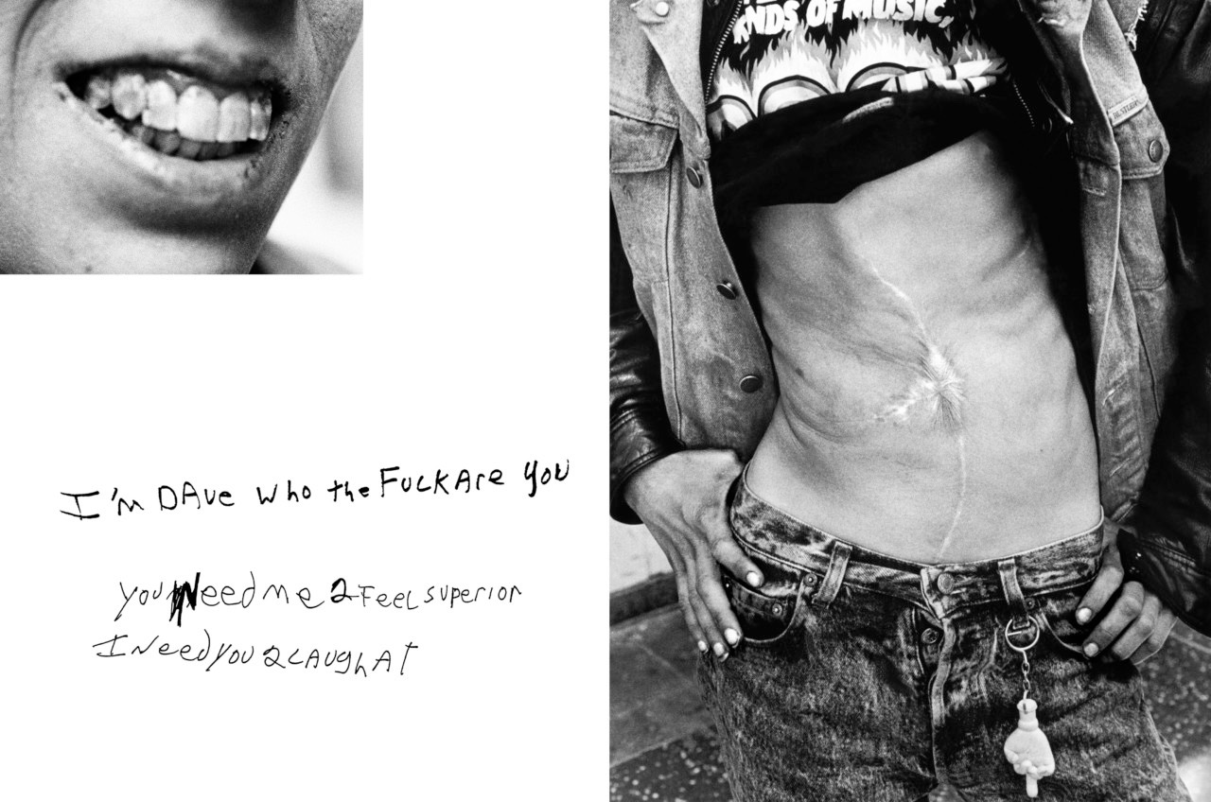
Fig. 1. Jim Goldberg. I’m Dave, from the series - Raised By Wolves, 1995.

With the sociological context in which the photographic is to be informed and analysed, now implemented, it can be applied to the photographic work of ‘Raised By Wolves’. As stated, the role of semiotics is crucial to the theory of sociology and integral to the artist’s subjective outlet, in light of this, a discussion regarding the connotation of the image (Fig. 1.) must first be addressed. The diptych photograph titled - ‘I’m Dave’, serves as a preface to the character of ‘Tweaky Dave’, the charismatic, yet troubled deuteragonist of the story. Divided into three compositional elements, the photographic illustrates the subject as withered and faceless, a deeply scarred, frail young man, dressed in worn denim. The image provides a vivid insight into the character’s personal struggles and social circumstances (income, healthcare access). Comparatively, the vilified handwritten text further demonstrates the characters’ educational status (numbers in place of letters) and admission of social belonging. The comparative ideologies of perception with regard to the contrasting lifestyles of the affluent and the destitute, further emphasise the generalisations the photographer wished to challenge. In contrast to the apathetic and egocentric ethos of California was the empathy and compassion of Goldberg.

The use of handwritten annotations throughout the photographic publication is evocative of Charles Sanders Peirce’s semiotics with regard to the index - “the presentative characteristics of the sign are contiguous with the object and it thereby establishes its correlation with that object primarily by that means”. As through the accounts, transcripts and so forth, Goldberg has since preserved the voices and memorialised the ideologies of his subjects, with their human condition and common flaws upheld. Writings that may have been maligned and distorted under the treatment of another photographer. The photograph responds to Becker’s statement - “influenced by the photographer’s exposure to social science, provide… text, sometimes in the words of the people involved”, that alludes to the methods implemented by the photographer in order to grant the unheard with a ‘voice’. The diptych photographic is comparable to David Bate’s remark of - “Telling a story with pictures”. As the artist employed the subjects’ own handwritten narratives to convey their character, inclinations and to extend the experiences of the subject matter. Consequently, furthering our comprehension of their collected traumas and misfortunes. While the duty of documentary is to honestly inform and educate the public. Portrayed through the artist’s social standpoint, photography's role is to challenge generalisations, by motivating the viewer to question, rather than to judge.

Goldberg allowed the subjects to speak on their own accord, with accounts often relaying the experiences of behavioural and emotional dysregulation. However, it has been suspected that many of the testimonies were only partially correct or total fabrications disclosed by fallible narrators. It is this latent allowance of fictitious admittance that permits subjective inclusion. Goldberg’s humanistic approach to subjective expression was not photojournalism, but instead a fusion of fact and fiction - “a work of fiction that’s completely true”. Goldberg presented ‘Raised By Wolves’ as didactic at first, but owing to subjectivity, it evolved. While the traditional conception of documentary is that the photographer is impartial and the work produced is objective. ‘Raised By Wolves’ was produced in the documentary format, yet the creative freedom and liberties of subjectivity were adapted in order to communicate a creative vision. The work produced are photographs of an alternate and subjective reality, experienced by the subjects and curated by Goldberg. While the importance of documentary lies in its authentic, accurate and honest ability to highlight significant and relevant happenings. When the concept of subjectivity is implemented, matters can be addressed through a canvas of artistic expression.
Having established the role of sociology and subjectivity within the theoretical framework, a discussion of the theory of phenomenology within the photographic medium, the literature that will support the topic of positionality, and how it will be applied to the theoretical framework will now be introduced and implemented. As stated, documentary is objectively concerned with people and place, depicted through the subjective prism of the photographer and the subject matter they address. Similar to sociology, phenomenology is an innate trope of documentary. Its ideology is concerned with the artist’s conscious structures, as seen through the perspective of the observer. To coincide with this, positionality in photography is linked to the social and political context of the artist and their approach, motive, and motif in subject matter. However, phenomenology, with regard to the photographic medium, is influenced by our own interpretation of the image and ethical values when photographing. Similar to positionality, it is influenced by our perceptions, social position and the experiences that shaped them. This construct is further reinforced when applied to the aforementioned practice of photographers who document communities and cultures to which they were not part of, and how said documentation culminated in an authentic and informative body of work.

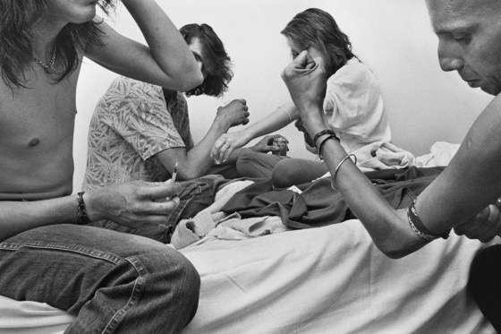
Fig. 2. Jim Goldberg, Slamming Alcohol, from the series - Raised By Wolves, 1995.

Sociologist, Chris Jenks’ notes - “my concerns are with the ‘seen’ or ‘witnessed’ character of… urban space”, an apprehension that is applicable to the method of practice and motives of Goldberg. The idea of positionality within the medium is similar to that of the flaneur, a participative, yet detached observer; an individual that is simultaneously ‘part of’ and ‘apart from’ the crowd, functioning by comprehending, engaging with, and depicting systems of representation -“The flaneur moves through space and among the people with a viscosity that both enables and privileges vision”. In Edward Relph’s phenomenological account of how places are experienced, he proposes the concept of insideness and outsideness, describing the former - “to be inside a place is to belong to it and to identify with it, and the more profoundly inside you are stronger is this identity with the place” and the latter - “from the outside you look upon a place as a traveller might look upon a town from a distance…”. The dualism theorised can be differentiated as “one that is fundamental in our experiences of lived space and one that provides the essence of place”. This outlook on the dualistic positions of place and experience can be applied to the concept of positionality within the photographic realm, and the treatment of documentary within the medium.

Visual artists who evoke the essence of place, experience and positionality must observe, study and analyse through the lens of phenomenological frame working. With the theory of phenomenology and the concept of positionality heavily associated with one’s social position and ethical values when photographing, it is critical to discuss the role of semiotics within the medium; in particular; the denotation. The essential elements that comprise the overall composition of the image (Fig. 2.) will be identified using the denoted. In turn, furthering one’s understanding of the photographer’s positionality at the time of photographic manifestation. Titled - ‘Slamming Alcohol’, the image portrays three men and a woman, divided amongst the four corners of a motel bed, wearing provisional tourniquets as they prepare to inject an unknown substance. In actuality, following the announcement of a pregnancy, the collective commemorate such an occasion with a dose of rum. When contextualised for the viewer, the photographic emotes a sense of togetherness, experienced between the subjects. With the imagery referenced, reflecting the manner in which they celebrate such revelations. Through the positionality of the photographer, Goldberg offers an unadulterated glimpse into the subjects’ humanity, where the conviviality and gravity of communal existence are given similar treatment.

When speaking on ‘Raised By Wolves’, Goldberg states that - “I have great privilege of being both witness and storyteller. Intimacy, trust and intuition guide my work”. Positioned not only as the curator and photographer of the publication, but as friend and detached observer, Goldberg was intrinsic to the scenes of composition. Whilst referring to the flaneur, Jenks’ states - “An observer… who is everywhere in possession of his incognito”. Evidenced through ‘Slamming Alcohol’, the characters and the photographer were equally present within the scene, as Goldberg documented the personal and private circumstances of a foreign lifestyle; be it drug use for recreational purposes or out of necessity. The image is the product of a communal tourist, the detached observer, yet as integral to the narrative as any other participant. Although bearing witness to their transgressions as they occurred, as a documentary photographer, Goldberg was morally and ethically obligated to acknowledge their benevolence, self-destructive behaviour, and their relational dynamics.

One may interpret Relph’s meaning of outsideness as applicable to the practice of Goldberg. In actuality, it’s the subcategories of behavioural and empathic insideness that are utilised through a modus of cinema vérité, with the former - “engaging in the activities of the culture while remaining a dispassionate observer” and the latter - “involving emotional as well as behavioural participation”. They are both pertinent to the subject matter, as through the extensive documentation of Goldberg came a collaborative process between subject and artist, prompted by intimate moments shared, patience, and an investment of time. The ‘behind closed doors’ depictions are presented through the photographer’s positionality, where the scars of self-abuse, track marks, and drug-induced psoriasis of the stories’ protagonists, deuteragonists and supporting characters are given equal attention. It is Relph’s statement that - “photographers… compress identity into one small feature which somehow captures the essence of a place”, which when reinterpreted can be applied to Goldberg’s practice within the photographic realm. As it acknowledges the aforementioned explanation of cultural and communal inclusion as a non-necessity, just as the flaneur will depict the incidental characteristics that capture the essence of the community they are representing, in turn exposing the viewer to an otherworldly manner of existence, different from their own.

Chapter Two

Both wildly different and eerily similar to ‘Raised by Wolves’, is Ross McDonnell’s ‘Joyrider’. Commencing in 2005 and spanning 6 years, McDonnell worked closely with and documented the marginalised youth of Ballymun, a notorious housing commission four miles north of Dublin’s city centre. Upon the series’ inception, Ballymun was synonymous with neglectful planning, drug distribution, gang violence and a byword for urban deprivation. The documentation would later form the basis of ‘Joyrider’, McDonnell’s oeuvre followed a set of “kids… willing to dive into a world of drugs and guns, kids without any fear of prison, of fatherhood, of violence”. Not only the eponym of which the publication was named but the ritual of its residential youth. The publication depicted ‘The Block’ and its criminal youth, as they partook in a somewhat unorthodox ‘rite of passage’ which involved stealing a car, evading legal pursuit, and finally torching the vehicle beyond recognition. While McDonnell documented a young generation during a highly publicised urban renewal project, ‘Joyrider’ depicted them as they attempted to reclaim the space around them, asserting their place and identity in the face of urban regeneration. The work is ultimately a coming-of-age story with a narrative rooted in Ballymun and “set against the backdrop of a housing estate”, where young men transitioned from teenagers engaged in acts of social disorder once fuelled by a mixture of boredom and necessity, into the increasingly dangerous world of drug distribution, with the imagery reflecting this trajectory.

The discussion of photographic work within the realm of documentary has often become maligned by the endeavour to comprehend work both objectively and subjectively. Beheld as a context-based system, documentary is often characterised by a continuous need for reassurance and inquiry. Although concerned with legibility over ambiguity, its virtue is invariably tied to its contextuality. However, the contextualisation of the image, similar to positionality, is derived from our perceptions, social relations, and the experiences that shape them. Ansel Adams adhered to the notion that a “photograph is usually looked at - seldom looked into”, when re-contextualised for the discussion's purpose - “photography is… contextually determined and connotative”. Meaning is not intrinsic but instead - “constructed through discursive and institutional conventions in the field of representation”.

Context is not requisite in documentary, although the “knowledge of context can… add richness to our understanding”. Additional context may distort how the audience perceive. The comprehension of the process behind the work augments it, illustrating more than ‘just’ the release of a shutter occurred, but an understanding of the intricacies behind the artistic and creative process. Akin to subjectivity, context is often influenced by one’s cultural and ethical background - “The meaning of a photograph… is inevitably subject to cultural definition… to define and engage critically something we might call the ‘photographic discourse’. A discourse can be defined as an arena of information exchange… a system of relations between parties engaged in communicative activity”. While the image is thought to have a simplistic meaning devoid of any cultural connotations, the photographic discourse is a system in which culture uses images for varied representational purposes. There are ideological restrictions in interpretation, meaning is developed through the act of subjective interpretation as a comprehension of that reality.

While the purpose of handwritten narrations in the aforementioned - ‘Raised By Wolves’ was effectively utilised in order to convey the personalities, stories and aspirations of its characters. Allan Sekula seemingly sought to critique the use of text within the photographic realm as a mode of contextual communication - “These artists… bracket their photographs with language, using texts to anchor, contradict, reinforce, subvert… or go beyond the meanings offered by the images… often located within an extended narrative structure”. Sekula argues that text can be utilised to discredit the photographic conceptual frameworks of narrative. Instead, context should be presented in a thorough and nuanced manner through a combination of diverse forms of imagery, where legibility is concise and the numerous discourses appear to reinforce and expand one another. The context of the photographic is pertinent to position and purpose. This must be conveyed without a convoluted justification to the observer. These techniques, to varying degrees, are based on the realisation that “meaning cannot be derived from a single image, but rather from a complex interaction of images”. It is this outlook on interpretation in documentary photography that can be applied to the context of the photo-book, where content, pacing, sequencing and overall presentation, influence cognitive meaning.

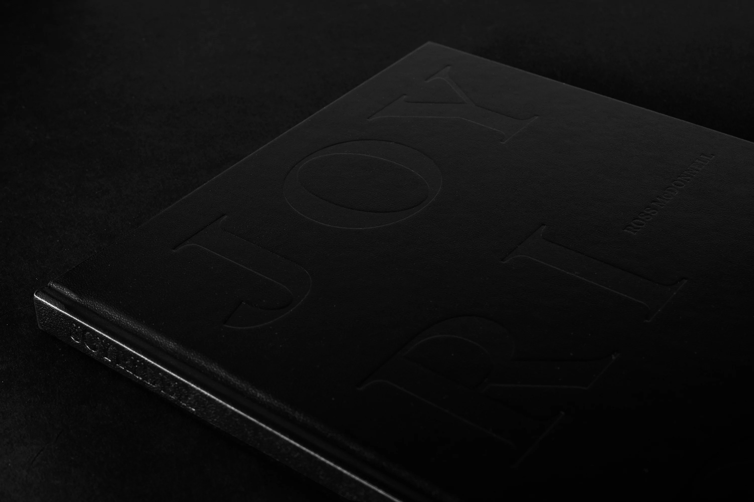
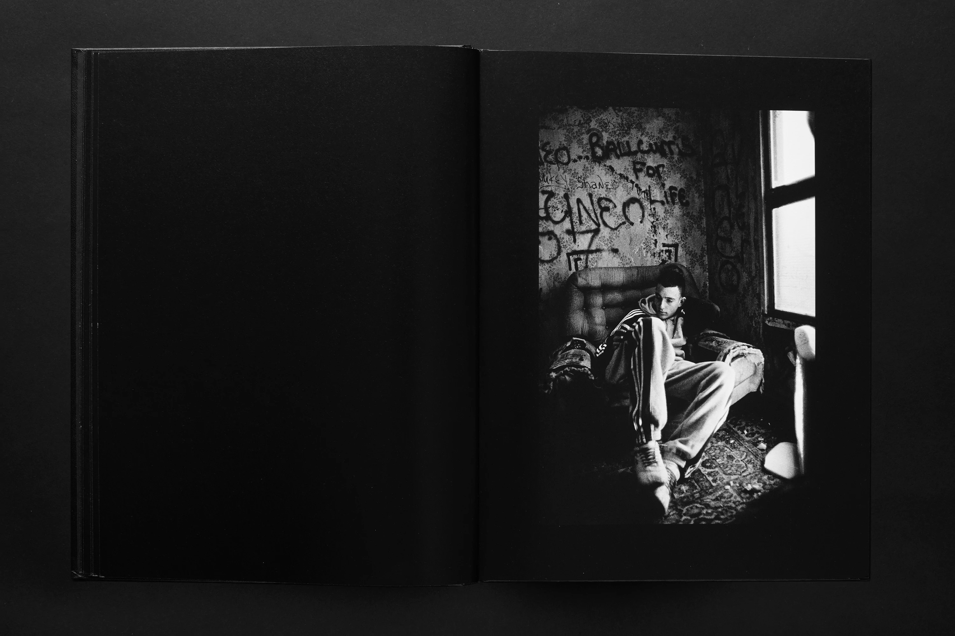
Fig. 1. Ross McDonnell. Cover, from the series - Joyrider, 2021.
Fig. 2. Ross McDonnell. Interior Layout 1, from the series - Joyrider, 2021.

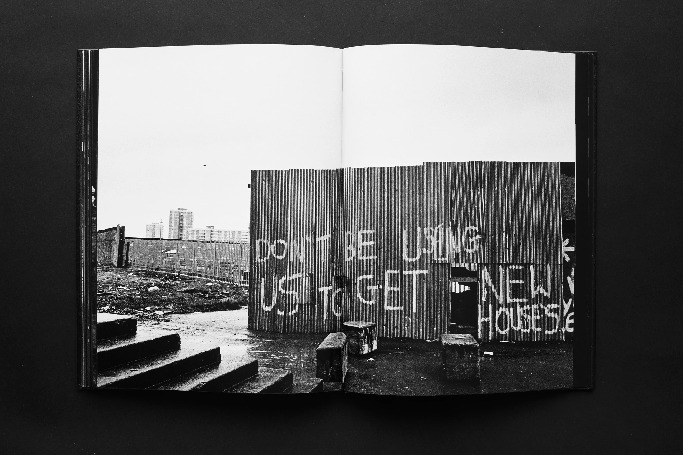
Fig. 2. Ross McDonnell. Interior Layout 2, from the series - Joyrider, 2021.

Aligning with Sekula’s critique, with no introductory or concluding essay, ‘Joyrider’ is without text or manifesto, photography is the only vehicle for meaning within the publication. Published in 2021, the hardback leather-bound photo book consists of 112 pages and 61 monochromatic images. With only the faintest hint of an embossed title (Fig. 1.) - “the black leather cover is a homage to Honda Civic dashboards…”. Shades of black are dominant throughout the publication - “it’s immersive, enveloping, cinematic, and at times oppressive” that punctuate compositions. The photo book utilises a variance of aesthetics and styles in presentation, with images displayed as single (Fig. 2.) or double page spreads (Fig. 3.), some with borders, others full bleed. The contrast between imagery and black space creates tension and drama. By avoiding repetition, it keeps the viewer engaged with the material throughout. The black borders and space provide a graphic and impactful style, separating it from the traditional format of photo-book design. The use of black space motivates a sense of energy and storytelling, presented in a manner reminiscent of a storyboard or contact sheet. Its inclusion is thematic, given the high contrast and dramatic nature of the imagery. Through the narrative, the body of work relies on sequencing to impart a sense of pacing and mood to the viewer. ‘Joyrider’ leaves little room for interpretation, visually communicating the unrelenting experience of chaotic nights, the sequence of events which led to them, and the colourless scenes of its aftermath. It is these outlandish frequencies, somewhat normalised within a context, that further our comprehension of the collective lifestyle.

Perspective is dependent on the background and culture of the interpreter. This furthers our understanding of the image and how it acts as a signifier of urban youth culture. Addressing the numerous forms of interpretation the photographic can evoke, Barthes states - “the object is polysemous… it readily offers itself to several readings of meaning… there are almost always several readings possible and this is not only between one reader and the next, but also, sometimes, within one and the same reader”. When reinterpreted for documentary purposes, the statement suggests the notion that the image can lend itself to multiple connotative meanings. Sekula’s statement furthers this ideology - “I should not have to argue that photographic meaning is relatively indeterminate; the same picture can convey a variety of messages under differing presentational circumstances”. Meaning is derived through taste and subjective observance. Interest prompts the connoted. For example, with an analysis of the image in question (Fig. 4.), one may disregard the thematic tones or subject matter of ‘Joyrider’; instead observe with the discourse of a fashion historian, where interest is evoked out of the meaning of attire and/or its era, rather than the compositional elements that construct the image.

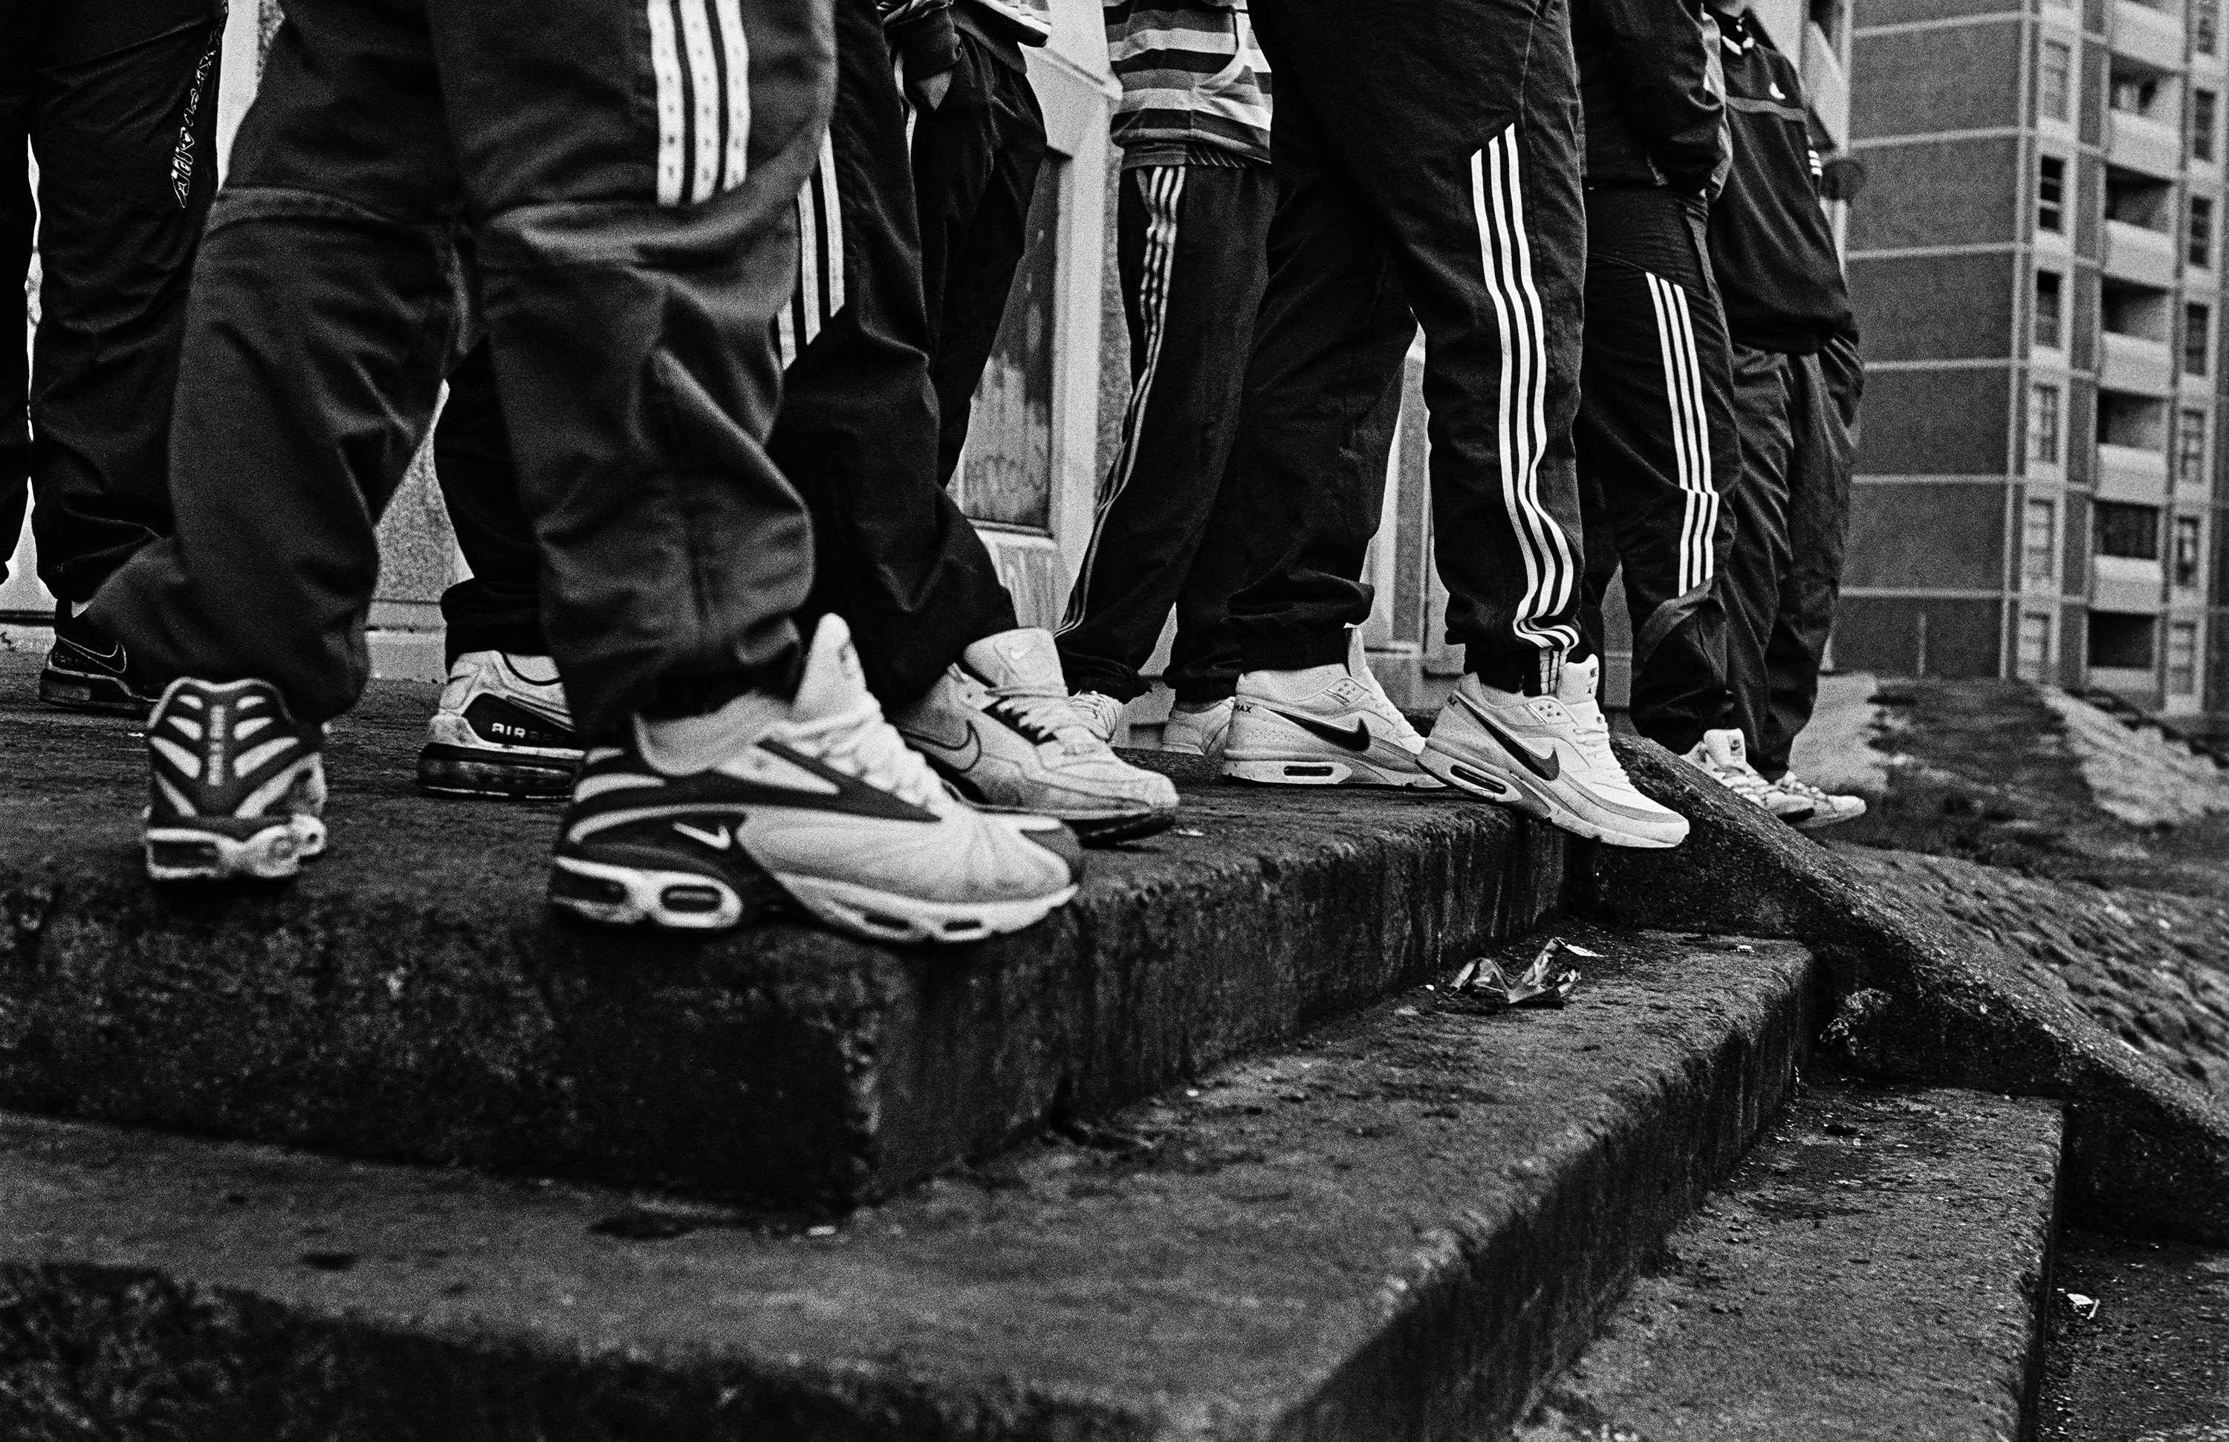
Fig. 4. Ross McDonnell. Trainers and Tracksuit Trousers, from the series - Joyrider, 2021.

Synonymous with ‘Joyrider’, the compositional spectacle of ‘Trainers and Tracksuit Trousers’ (Fig. 4.) foregrounds the intrinsic value of youth culture, illustrated through a sense of inclusion and escapism, and a desire for acceptance and distraction. While some may perceive the image as a caricature in accordance with Ballymun’s reputation, it symbolises the pressures of survival in the face of urban regeneration led to a clear sense of group spirit, where streetwear is portrayed as uniform - an identity shared. The image is reminiscent of Frank Barry’s statement - “abnegation of individualism”, as the subjects reject their depiction as individuals, and embrace instead a collective identity. Though many relate the attire with the problematic social issues the work addresses, photography is used not to romanticise or glamourise a lifestyle, but rather to relay shared values as a source of strength. Barthes notes - “from a phenomenological viewpoint, in the photograph, the power of authentication exceeds the power of representation”. With such subject matter, photography can portray identity as a threat and photographs can be used in a derogatory manner. However, photography's purpose here is to document rather than to glorify and is ethically obligated to authenticate. In doing so, the subjects were portrayed as definitively authentic, with McDonnell offering insight into a cultural and communal lifestyle, social affiliation, and their harmonious nature.

The use of style among the subjects can be categorised as a form of aestheticised resistance. This is often a characteristic of marginalised groups and liminal identities. As Stanley Cohen has highlighted with reference to the abject aesthetics found within certain subcultures - “Two dominant themes are suggested: first that style - whatever else it is - is essentially a type of resistance to subordination; secondly, that the form taken by this resistance is somehow symbolic or magical”. This portrayal reinforces the generalisations that not all conditions of youth culture depicted are associated with negative connotations, with this image exemplifying the camaraderie and togetherness found within a tight-knit community, regardless of common grounds. Although, speaking on playwright Dermot Bolger’s work which centres on Ballymun, when reinterpreted, Malone’s statement is applicable to the photographers positionality. While issues of representation are often problematic, McDonnell was “conscious of his status as an outside artist taking on the responsibility of speaking on behalf of a community to which he had no ancestral link”. McDonnell ostensibly practiced behavioural insideness, a theory that can be applied to the concept of communal inclusion as a non-necessity, as detached observation can, too, be diligent and emotive, depicting the incidental characteristics that capture the essence of its subject matter. Here, urban youth culture is distinguished through a sense of belonging, stoicism, and hyperbole, where emotional energy, gesture and character are given similar treatment, and the subjects hedonism and adversity coexist.

Phenomenological philosopher Maurice Merleau-Ponty claimed - “phenomenology is the study of essences; and according to it, all problems amount to finding definitions of essences”. The essence referenced is a philosophical term used to designate the quality and/or qualities that define an object or products core characteristics in order to maintain identity. However, when re-contextualised, the essence can be applied to the definition of urbanism suggested by Emily Talen as a - "human settlement that is guided by principles of diversity, connectivity, mix, equity and the importance of public space”. When reframed within the context of the thematic issues presented in ‘Joyrider’, wherein the fundamental characteristics of urbanism are inadequate, the idiosyncrasies of an environment may prompt transgressive or antisocial behaviour in its adolescent populace.

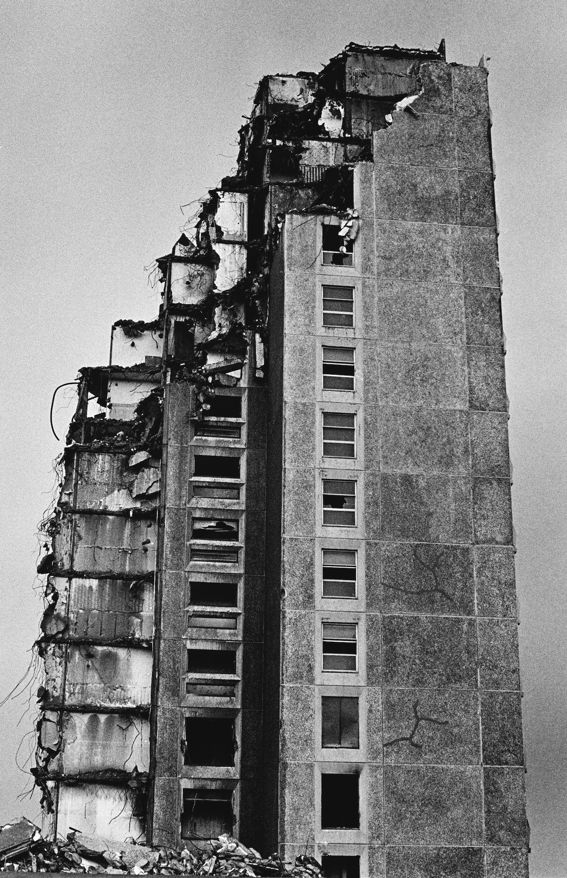
Fig. 5. Ross McDonnell. Untitled, from the series - Joyrider, 2021.
McDonnell stated - “it was a failure from… inception. Despite utopian vision, the lack of planning and infrastructure rendered the area underdeveloped. Ballymun became an iconic symbol of Dublin’s underclass…”. Here, the urban issues ‘Joyrider’ addresses are brought to focus, when a community are met with inadequate living conditions and no immediate facilities, with the photograph (Fig. 5.) acting as an emblem to Ballymun’s residents and a memorial to broken promises. Describing Ballymun as “a place 15 storeys high and a million stories deep”, the image acts as a microcosm to the problems that plagued the estate; a lack of services, social amenities, and recreational facilities, once promised, yet never materialised. While Ellen Rowley states - “crime might be mitigated through design and architecture”, it can be argued that when a community is not met with adequate services or facilities, anti-social behaviour can be anticipated, provoked by society and stimulated out of boredom. The issues of urbanism lie here; state failure, a once ambitious large-scale modern housing scheme transformed into an impoverished urban estate with widespread social problems, colloquially known as a ‘ghetto’. Rowley argued - “the association of temporary housing with ghettoisation and the notion that Ireland was not industrial enough to justify experimental housing meant that these methods were sidelined in favour of traditional systems”, that tie in heavily with this construct.

The urban backdrop adopted throughout the publication is a perpetual looming presence, never truly out of frame, an enduring reminder of the larger economic and social realities they represent. The buildings are ominously geometric - derelict, stained and falling to decline, illuminated by oppressive tones and seething fires. The photograph illustrates impoverished structures and the detritus of the everyday, neglected by the state and marginalised by the greater public, infrastructures that dualistically played a role as an anarchic playground and humble abode. When vast social problems and decrepit structure construct the compositional elements of an environment, it can allude to unpredictable developments in its inhabitants, reminiscent of psycho-geography - the effect of location on the emotions and behaviour of the individual. While McDonnell employed the surrounding infrastructure as a backdrop, it could appear he was concerned with the aesthetics of abandoned and dilapidated architecture, taking the decline of the built environment as a subject.

Since erased and replaced, Ballymun, as McDonnell captured it, exists only in memories imprinted and published, images to be reflected upon, interpreted and framed with meaning, sparking conversation on the role of photography; its ability to preserve what no longer exists, and how it may be implemented in developing discussions in future urban renewal schemes. Sekula often sought to critique the limited forms of documentary and its “tendency to promote voyeuristic, fetishising and exoticising traits through a form of othering”. Recognised as one of the great virtues of the practice, representation has served as the framework wherein some of the genres more problematic representations occurred. Taking the role of the detached observer in many instances has portrayed a certain contempt for the lifestyle and traits of those photographed - “they become the ‘other’, exotic creatures, objects of contemplation”. Martha Rosler seemingly supported this notion by suggesting the ‘parachute photographer’ - “who would go somewhere, take pictures… and get the hell out”. In contrast, McDonnell’s practice was driven by humanising those subjected to stereotypes on the grounds of environmental reputation, the work acknowledges a critical understanding of the world and the medium’s ability to amass evidence. While it could be argued that McDonnell rehearsed the role of the flaneur - a participant, yet detached observer, it is evident that he positioned himself as a friend and witness throughout his extensive in-depth collaboration with the marginalised youth of ‘Joyrider’. Although Rosler believed - “documentary is a little like horror movies, putting a face on fear and transforming threat into fantasy, into imagery”, when reinterpreted, this can be applied to the humanistic motivations of the publication, as ‘Joyrider’ sought to challenge the generalisations of Ballymun by introducing us to a way of life we otherwise wouldn’t relate to.

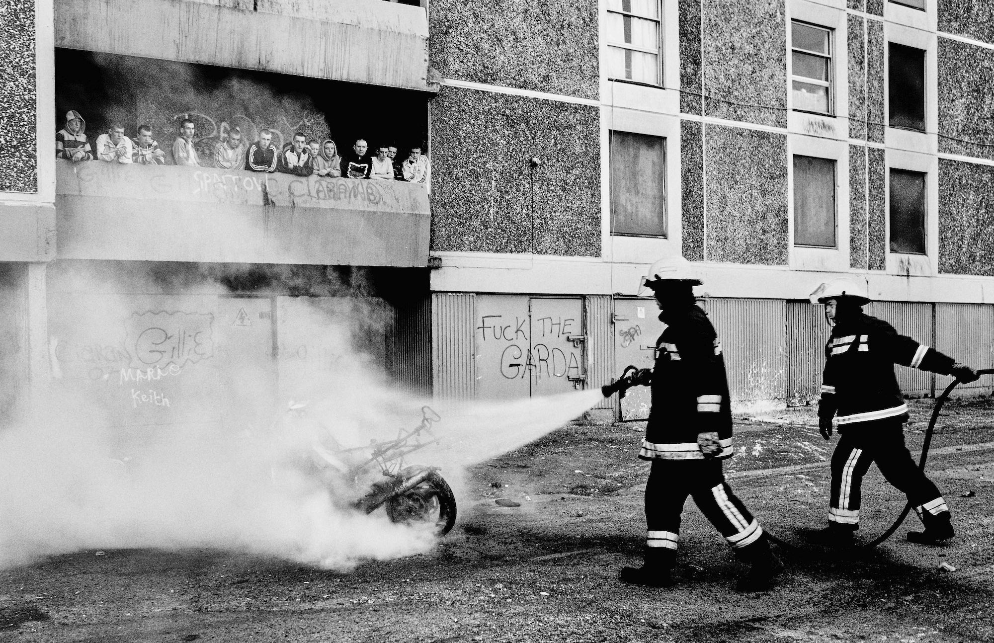
Fig. 6. Ross McDonnell. Untitled, from the series - Joyrider, 2021.

Like that of any documentary photographer that spent extended periods of time with marginalised communities and cultures, McDonnell was embedded. Using the medium to guide the viewer into a world typically closed to outsiders, with the photographic capturing the collective illicit behaviours and the more nuanced human complexities. As a documentarian, he observed the residential youth of ‘The Block’ reclaim vacant flats and stairwells, reclamation that would later define the photographer’s time in Ballymun. Although the only fate that seemed certain was that of the surrounding structures in the face of urban regeneration, the photograph became a space for collaboration, seemingly celebratory, where stories were told on the subject’s accord. Here, Pierre Bourdieu’s statement can be applied to the compositional context of the image (Fig. 6.) - “Taste is first and foremost distaste, disgust and visceral intolerance of the taste of others.”, as it highlights the collective experience amongst those with problematic commonalities. Here, the photograph portrays the surreal experiences and circumstances that frequently reemerge throughout the publication, the aftermath of which the eponym was named, as those at the centre of its narrative witness the latest act of ‘recreation’.

Frank Barry states - “exposure to modern culture promotes an increased desire for excitement, for a fast-paced life, for the car chase and the amphetamine rush”. This ties in with the thematic tones of ‘Joyrider’, as the residential youth engaged in acts of social disorder prompted by dissatisfaction and a desire for excitement; a common interest. While Louis Wirth defines urbanism as a “way of life”, McDonnell acknowledges the cause of the decline in the housing commission - “very quickly… things unravelled… they weren't provided amenities… bus routes… shopping or leisure facilities”. When the essence of urbanism fails, the disorderly conduct that relieves the subjects and causes harm to the greater community flourish and a ‘lack’ of distraction fuels interest elsewhere. Documentary was not utilised as a mode to glorify a lifestyle, but to authenticate the normalities of a community on the fringe of society.

Chapter Three

When representation is characterised by that of the detached observer, it can weave expressive and informative narratives. However, the fundamental concerns within representation must be formally addressed. The cultural and contextual constructs in which work is produced are as integral as the work itself. Consequently, if the customs and compliance of those portrayed are attentively acknowledged, the incidental characteristics of representation may be meticulously endorsed. Without the boundaries of consent, representation, and subsequently those represented, become liable for problematic interpretations, objectification and biased narratives. Susan Sontag notes that in such afflictions - “certain forms of photographic depiction were especially complicit with processes of objectification that precluded either empathy or identification”. The calamities of subject matter often act as a productive source of narration within the field of representation. Though recognised as a key attribute within the realm of documentary, it has also acted as the context wherein problematic depictions have occurred. An occurrence typically procured through the redaction of the photographer's ethical and moral reasoning. However, in photography, ethical and moral boundaries are subjective, contextual and versatile - a comprehension of disparities is solicited by cultural background, experience and value.

The role of the detached observer is prompted by positionality, subjectivity and moral philosophy, in turn motivating “the individual… his uniqueness, his responsibility, and his capacity to choose”, as they craft delicate forms of representation. Intrinsically, unwarranted representation is commonplace within the practice of documentary-inspired methodologies. Though the photographic act accommodates to the qualities of ambiguity and subjectivity, the perimeters and moral frameworks of the medium can incite ethically contentious behaviours on the grounds of autonomy and well-being. Increasingly ambiguous, such ideologies are liable to the equivocal ethical and moral definitions within the practice.

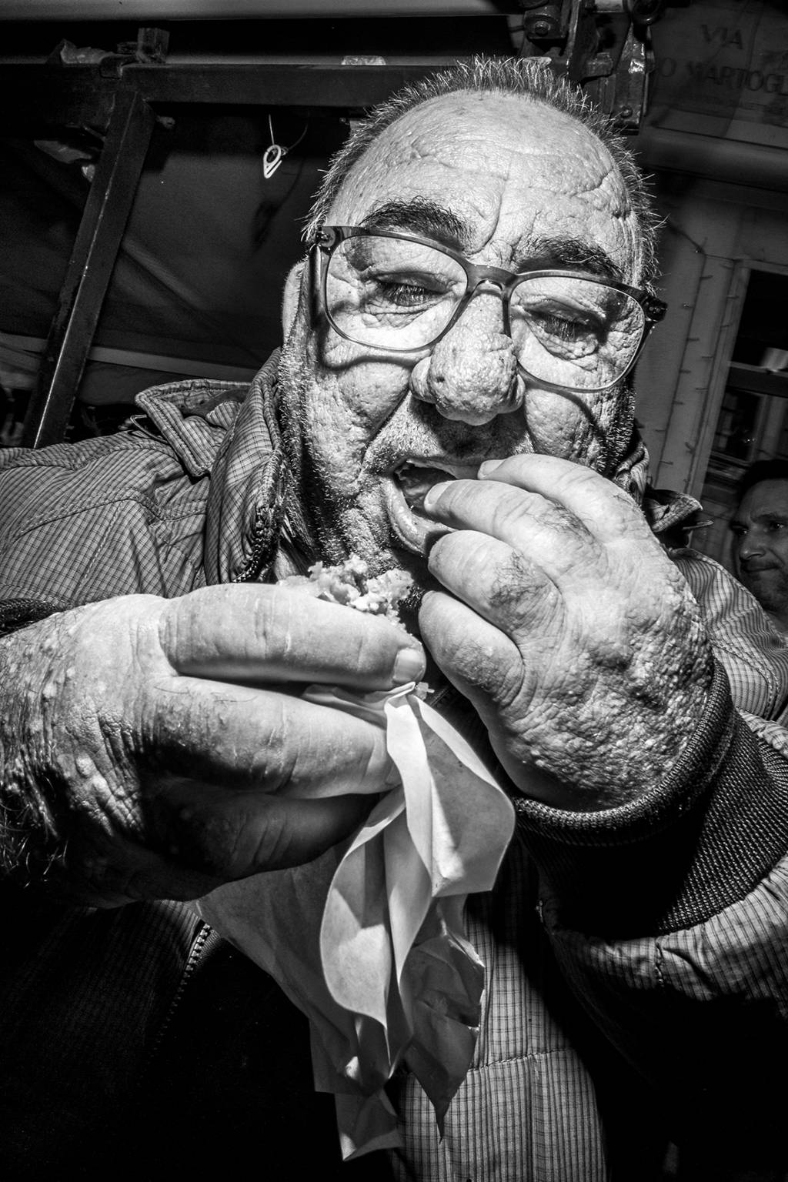
Fig. 1. Bruce Gilden, Untitled, from the series - Palermo Gilden, 2020.
It is within this rubric that the practices of controversial albeit renowned New York native and street photographer - Bruce Gilden. Defined by a signature approach to street portraiture characterised as aggressive, abrasive and confrontational, utilising a camera, handheld “flash in one hand and jumping at people”. In the hands of Gilden - “The camera is a kind of passport that annihilates moral boundaries and social inhibitions, freeing the photographer from any responsibility toward the people photographed”. The camera becomes a permit for unethical, obnoxious behaviour and the photographs produced convey such entitlement, as this detached approach objectifies and subsequently attempts to prevent the viewer from having any empathy with the subject.

While the candidness of Gilden’s work may capture elements of the human condition in its most raw and vulnerable form, some consider the technique utilised as an ambush on the subject and one’s personal space. The images produced do not portray the emotions of anger, embarrassment and frustration that typically manifest afterward. Though a single face can derive symptoms of expression, emotion, and detail when under the photographic treatment of Gilden, every conceivable conscious imperfection (Fig. 1.) is illuminated. Positioning the camera to achieve a strikingly candid expression such as shock or alarm may allow Gilden to promote his sought-after artistic values. His compositions are aesthetically striking due to timing and proximity to the unsuspecting, yet it is this modus that renders his practice ethically contentious. The photographer’s closeup work is intrusive, his practice seemingly seeks to dehumanise the sporadic subject and reinforce whichever unforgiving stereotype he wishes to prescribe. The images are caricatures that often cast superficial representations of those on the fringe of society. This is not photojournalism, but rather conceptual documentary stripped of context and depicted through the emphatically impersonal experience of the involuntary. Through the unique ideologies of subjectivity and positionality, Gilden’s photographic work is curated with an eye for the grotesque, where the erratic and normalities of the everyday coexist.

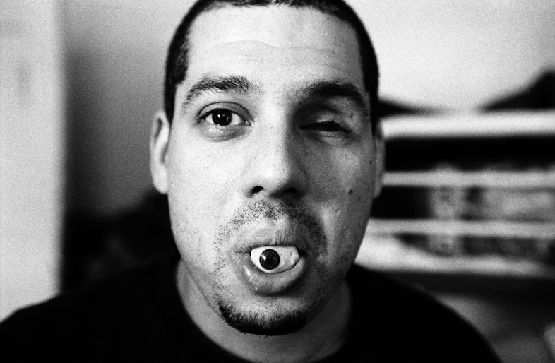
Fig. 2. Boogie, Untitled, from the series - It’s All Good, 2006.

In contrast to the problematic practice of Gilden is Serbian-born, New York-based Vladimir Milivojevich, also known as Boogie. An accomplished documentarian of urban street culture, Boogie’s disarmingly honest practice grants rare access into some of the most alienated syndicates of culture and community, seemingly “bound by the nexus of violence, poverty and crime”. While some may perceive his work as a depiction of juvenile delinquency, Boogie captures the raw symptoms of urban life (Fig. 2.), with his oeuvre suggesting what lies beneath the surface of bravado reveals the complex constructions of identity itself. Immortalising the inhumanity of metropolitan reality and set against the backdrop of America’s most disadvantaged neighbourhoods. Both violence and rebellion are prevalent, but so too “are intimate moments of heightened human emotion”, and a sense of belonging that contrasts deeply with the isolation that the socially estranged often experience, be it self-inflicted or culturally constructed.

The issue of unrest, prevalent within his work, resonates with a social and political agenda. Conveyed through a black and white austere aesthetic that further emphasises the fundamental tropes of morality, it speaks volumes on community and culture. As an outsider, Boogie has persuaded seasoned criminals and versed addicts to further incriminate themselves by posing for photographs in impoverished and unfamiliar settings. While his positionality would seemingly be an obstacle in an exclusive, secluded environment. His practice offers an eyewitness discourse, transcending the notion of the detached observer. The narrative and subject matter traditionally undertaken by the photographer are undoubtedly linked to an ability to be accepted by those under marginalisation. As throughout his tenure, Boogie has honed an inimitable skill of winning the trust of the criminally rehearsed, socially alienated and societally marginalised.

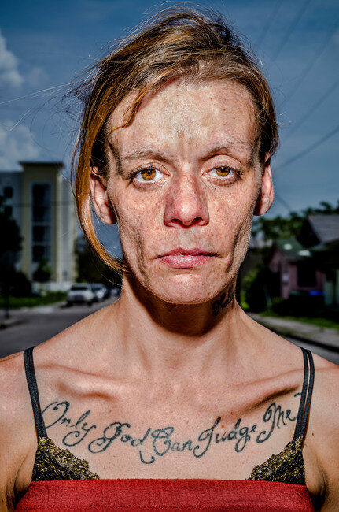
Fig. 3. Bruce Gilden, Jessica, from the series - Only God Can Judge Me, 2018.
Gilden has noted a fascination with the duality and double lives of the individuals he photographs, an attraction that compelled and guided one of his more recent works. Set in Miami and published in 2018, the problematic yet insightful publication ‘Only God Can Judge Me’, follows the transgressions of its subjects, whose addiction and requisite drug use incite sex work. Similar to Goldberg’s ‘Raised By Wolves’, the work utilises a juxtaposition of image and text to further extend the experiences of the subject matter and impart contextual discourse to the viewer. Though at close proximity, and despite a rehearsed and repetitive practice, the body of work goes against the conventional methods of Gilden, as the work undertaken was a consensual and collaborative process between subject and artist. However, the portraits that form the basis of the publication fall into the category typically linked with Gilden’s portfolio of the absurd.

With similar treatment to previous cases of representation - the blemishes, bad teeth and lacerations are rendered by near proximity and an unremitting illumination - “where social realism meets an altogether more provocative approach characterised by bold colours and the white-light flash of a relentlessly prowling camera”, with an image (Fig. 3.) entitled ‘Jessica’, reflecting such symptoms. As she solemnly gazes upon the lens, the harsh contrast highlights every pore and wrinkle, the drug-induced psoriasis and botched exertion of cosmetics further accentuate the transcript scribed across her torso, in which the collection is eponymously named. In an ironic twist, despite permission and cooperation from the subjects of the monograph, the outcome is in many ways, even more, oppressive and demeaning.

Gilden expressed through an introductory excerpt within the publication, how the subject matter relates closely to him on a personal and societal level - “In all of these women, I see my own mother - ravaged by pharmaceutical drugs, alcohol and her lifestyle”. Though claiming to exercise engagement through the perspective of a disillusioned detached observer, the callous objectification casts an inquisitive and unsympathetic demeanour toward those photographed and a collective, if unsolicited lifestyle. John Tagg’s argument that “the portrait is… a sign whose purpose is both the description of an individual and the inscription of social identity”. When re-contextualised can be applied to the diptych format utilised in presentation. The accounts and testimonials of the publication convey surreal stories of the sex trade and the problematic conditions commonly linked with it, in a concise and succinct manner. Yet by comparison, the photographic medium, whilst under the treatment of Gilden, “is unable to do anything but show superficial appearances”. When the principles of representation and proximity harmonise in order to produce the desired image, the photographer sacrifices the subject's welfare in favour of aesthetic worth and, by doing so, “we must question the naturalness of portraiture”. The portraits that form the publication are women whose likenesses embellish the state of disenfranchisement and marginalisation. Though the work may have derived out of a rapport and an emotional obligation guided by social responsibility, the outcome, in an attempt to humanise those portrayed, became a catalyst for objectification, seemingly bound by a mixture of anxiety and raw intimacy that borders on the voyeuristic.

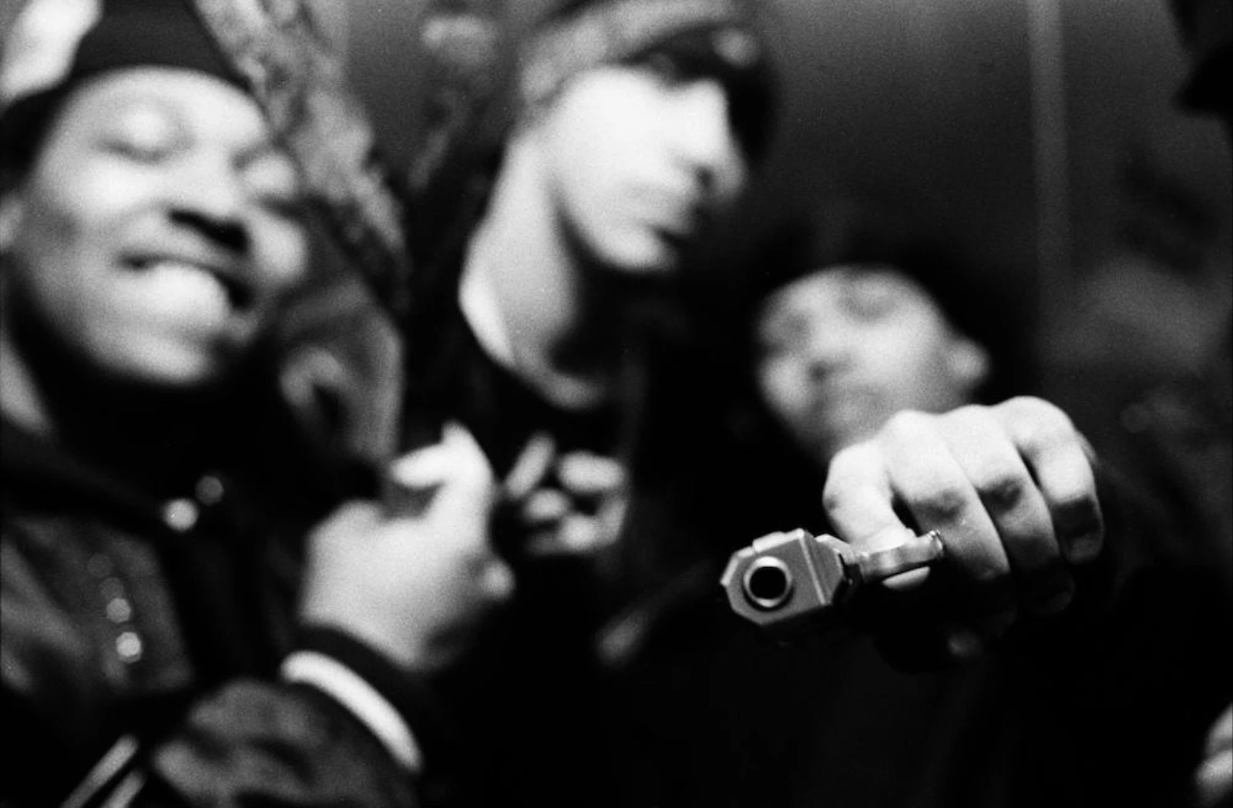
Fig. 4. Boogie, Untitled, from the series - It’s All Good, 2006.

Raw and uncompromising, reminiscent of the setting and subject, Boogie’s depiction of New York’s underbelly in ‘It’s All Good’ garnered notoriety and brought his practice into the public discourse. Published in 2006 as his debut monograph and set against the climacteric turn of the millennium, the publication catalogues three of the state’s infamous neighbourhoods in Bushwick, Bedford-Stuyvesant and Queensbridge, and offers a graphic exposure to an omnipresent underworld and its inhabitants. Though the work portrays problematic societal factors - “woman shooting up in her bathroom, a gangster pointing a loaded gun at the camera lens and addicts sprawled on the streets”, it’s marked by a mood of pessimism, fatalism and menace. The monochromatic, noir-esque aesthetic perfectly expresses the feeling of despair that defined an era of racial tension, rampant gangland misconduct and widespread drug addiction. In an untitled image (Fig. 4.) synonymous with the body of work, the artificial lighting of the composition projects a high contrast and shallow depth of field, distorted and drowned out, obscuring ego and exhibiting identity. The image humanises an imperative lifestyle, by subverting the portraiture one would expect from a photograph of ‘gangsters’ - informally posed and smiling. The mannerisms in which an individual presents themselves for the camera reveal as much about the subject as that of the candid image, an emotive connection is formed through a projected persona that is continuously performing a cultural identity. In turn, promoting an incentive to explore an equally potent influence of the narrative; reputation.

Reputation plays a central role throughout the publication, in each frame we are met with eye contact, facial expression, gesture, posture, the use of objects and body language, through nonverbal forms of commutation; emotion is universal. Despite the compositional elements that form the foreground of the image, there is a lurking sense of vulnerability, a feeling of intimacy is created by the close proximity between the subjects. Boogie’s depiction employs the perfect visual backdrop to a collective of antiheroes. Weapon in hand, the image encapsulates the hardened and stoic representations that many within such a culture aspire toward. In the shadows of the ‘American Dream’, attributable to a lifestyle immersed in violence and poverty, the image conveys a sense of transience, where the shadows cast faint echoes of a penurious environment; a place few dare to enter, a space few dare to leave. The photographer’s philosophy of representation is one of non-intrusion. At hand, yet out of frame, Boogie feels as present as the subjects themselves, loitering on the fringe of composition, creating an alluring suggestion of another photograph happening beyond the frame. Just shy of invasive, Boogie utilised a hybrid style in which the documentary form and an empathic rapport correspond. Together, they provide a useful study of risk and reward in visual representations.

The subjects of ‘Only God Can Judge Me’ and ‘It’s All Good’ are societal outcasts portrayed through the positionality of the ‘outsider’, not in any way connected with the culture other than through the photographic act. Though the concept of the detached observer in the form of representation is often linked with the negative connotations of objectification, alienation and touristic qualities, this suggests the false notion that - “the viewer is not presented with an informed impression and ultimately takes an interpretation that is not accurate”. Art critic Abigail Solomon-Godeau explores the idea that the detached observer can yield powerful insight - “certainly there is truth in its evocation of the lonely crowd, the anomie and nightmare that lay behind the official representations…”. As the photographer who “immerses themselves in the environment of another cultural or social denomination is the one who stands to provide an accurate representation”. Consequently, similar issues are at stake. Though Gilden and Boogie photographed the complex and multi-layered members of two distinct cultures, both were often vilified owing to a particular lifestyle. Similarly, both photographers grant the subject the opportunity to speak on their own accord within their respective works. Recounting the challenges of a troubled lifestyle in the boroughs and presented in their own words and interspersed throughout ‘It’s All Good’, lie intense testimonials from the subjects of the publication, notably, Kasino, a three-star general in The East Coast Bloods. Yet, it’s the demeanour of imagery that prompts problems in the ethos of marginalised representation - “each of these images belongs to a distinct moment; each owes its qualities to particular conditions of production and its meaning to conventions…”. In the rehearsals of the photographic act lies the juxtaposed conditions of unwavering loyalty and sporadic participation. Within the pathos of representation, both photographers implemented their own subjective forms of positionality, with Boogies applicable to the aforementioned practices of the flaneur and empathic insideness, whilst Gilden assumes the role of the socially alienated - a disconnection to those in which he has an affinity.

Under the photographic treatment of Gilden, falls shockingly tone-deaf representations where empathy is obstructed by visual distractions, a parody of the celebrated Henri Cartier-Bresson’s with - “the indecisive moment”. This in turn illustrates the degree of arrogance that informs his methodology and style of image-making, which has little to do with people or place. The outward simplicity of his work underlines and undermines the depth of the subject matter. Comparatively, as a documentarian, Boogie’s practice is prompted by exploiting a ‘weakness’ to his advantage - “the gangsters came to me, not the other way around, we talked… they liked me - perhaps it was my accent… I don’t sound like anyone they would hate”. The dichotomy of image and text demonstrate that, as far as Gilden’s concerned, their lives are not to be understood, but rather commodified, objectified and vilified - “when you come to a region often misrepresented or only represented in a certain light, and use people as props”.

Not only essential to the subject matter, but essential to the authenticity of the world Boogie wished to capture, the notion of authenticity and visceral immersion will likely remain the single most defining characteristics of his oeuvre; to identify that which makes the subject significant and real, to craft characters and stories not only around reputation, but who they are. Boogie sought to explore the culture through the medium and, as authentically as possible, he illustrated the urbanistic qualities of those on the peripheral through immersive engagement, disciplined practice, and a rare measure of human awareness. Imagery of community and environment, dealers and users, weapons and wealth are distinguished by a cultural perspective and reinforced by the photographic medium; a narrative prompted by people, not characters. The subjects have little to no say in their prospects, in turn prompting a life of crime portrayed in a complex manner where persona and alter ego collide in a uniquely vulnerable way. Although one of the most populated cities globally, at times the images seem set against a remote, desolate landscape. With regard to the audience, particularly those of a more privileged background, the imagery is dramatic and otherworldly, immersed in a community and culture very different from the one often taken for granted. Vastly complex and nuanced, the photographer is in a way creating rather than representing, yet interpretation is left to the viewer.

Conclusion

Through the use of credible photographic imagery, this dissertation has offered an opportunity to unearth the role of the detached observer within the documentary practice and examine it under sociological and phenomenological frameworks, through an analysis of the theories of subjectivity and positionality. The theme of urban youth culture was introduced as a perimeter for the social and political theoretical frameworks to work within, as a mode to bring the photographic work under consideration to the foreground, contributing to an improved understanding of the material under evaluation and how said theories were utilised as a precursor for creative expression. With the theories, ideologies and terminologies introduced infrequent in the theoretical writings of documentary photography, sociology and phenomenology, the objective was to attain literature without specified limitations and reinterpret said readings, and apply them to photographic to progress the discussion.

Through the examinations of ‘Raised By Wolves’, ‘Joyrider’ and ‘It’s All Good’, it is overt that their neutral aesthetic as detached observer acted as a forerunner for subjective positionality within the documentary practice. Said, subjectivity and positionality prompted cognitive meaning with regard to the social and political frameworks, which in turn, informed the approach, motives and subject matter of their respective publications. Although the intrinsic value of documentary photography resides in its capacity to emphasise significant events in a real, truthful and honest manner. Issues can be portrayed through a canvas of artistic expression when the concept of subjectivity is incorporated into the practice.

Narratives which address the challenges and trials of their protagonists have become a constructive source of narration in documentary photography. Though recognised as one of the great virtues of the practice, it has also served as the framework wherein some of the genres more problematic representations occur. The ideologies and utilisation of positionality and subjectivity undertook by Jim Goldberg, Ross McDonnell and Boogie render their work an outlier to the practice’s typically problematic representations. While the social-political frameworks and stylistic conventions of their practice are effective, the emotional engagements in their respective narratives cast melancholic and empathetic representations in the throes of urban youth culture. It is through this, the photographers produced photographic publications which are indebted to the greater documentary practice, and also anomalous to it.

The images referenced relay the re-emerging thematic issues of their respective publications, with narratives rooted in urban youth culture; time and perspective revealed a tale of introspection, along with the larger context of marginalisation and surrounding crisis’. The subjects and settings of each publication were depicted as specific to time and place, representing a cadre of youthful exuberance in an era of societal redaction. Their premise illustrates a foggy transition of when childhood concluded and adulthood commenced. Beneath the bravado, the photographers captured scenes of momentary reflection and fleeting disillusion. Where drug activity is framed as eager entrepreneurialism, vagrancy as recreation and acts of arson as a ‘rite of passage’. With subject matter and content like that of ‘Raised By Wolves’, ’Joyrider’ and ‘It’s All Good’, documentary practice and the photographic publication further “the possibilities of the form and the development of visual narrations that subvert traditional viewing habits”.

Through the photographic, the oeuvres of Goldberg, McDonnell, and Boogie offer a critique that address the systemic complexities of social negligence and societal inadequacy through the lens of cultural and communal essences, through those often subjected to marginalisation by the mainstream population. Further isolated owning to social setting and belonging. Their mastery of the photographic medium and its capacity to represent the stoic conditions of existence resonates with us, depicting the thematics as expressive to those observing and authentic to those represented. The narrative's insightful connections provide dramatic portrayals of urban youth culture and the strife of adolescence, be it self-inflicted or socially constructed.

Goldberg, McDonnell and Boogie’s positionality is an emotional proxy for understanding community and culture. The organic environmental stories come to life, turning the lens on individuals, communities, values and vulnerability. In doing so, the photographers were able to tease out stories of hardship, with a deep and alluring emotional honesty that most photographers can only imitate. In a collaborative process, the works brought together distinct cultures and perspectives, work that is experienced differently, yet together within the same visual sphere. Constructing a rapport between subject and viewer, we are looking as an equal, looking at others for aspects of ourselves mirrored in their personality and culture. Any emphasis on authenticity in documentary places enormous pressure on the photographer and the representation of any given community. What truly sets ‘Raised By Wolves’, ‘Joyrider’ and ‘It’s All Good’ apart from similar works that struggle to tackle themes of ambiguity, survival and personal activism, is how they choose to fold the issues into a broader narrative, where the environment is treated less as an obstacle than a catalyst.

Often portrayed as problematic, the negative connotations frequently linked with marginalised communities and cultures are often inaccurate; while mindful of the repetitiveness of the detached portrayal of those under marginalisation. Before tackling subject matter that may be conceived as problematic, the photographer must acknowledge and give thought to their moral and ethical justifications. In practice, there is no convoluted requirement for rationalisation. Photography demands patience, effort, and an investment of time. Documentary photography is about people and place rather than the photographer. Photography in general is the artist's subjective expression of the
experience, not a representation of it. It is utilised as a mode to tell the stories of the everyday experience, and photographs can immortalise such moments and provide greater insight into the cultural and communal lifestyles of the unknown. The documentation of the publications’ analyses further humanise the negative connotations often linked with the marginalised and offer insight into a world typically closed to mainstream society. Such collectives are not a minority of society to be managed or transformed. Evidentially, the role of detached observer seemingly aspires toward an empathetic connection with the subjects at the centre of their narrative, by suppressing any desire to judge.

To draw this distortion to a close and with a final sentiment to carry forward - when we see a passing stranger for a brief moment, we know nothing of their lives or who they are, any commentary we wish to make is determined by our own preconceived ideologies; we are constrained by the lens of our own experience. When approaching people, the initial personality typically ascribed to them is, more often than not, wrong. It's not until conversations begin that expectations may be defied. Ultimately, we all must establish our own boundaries of demarcation between what we deem ethical and unethical, moral and immoral. It is crucial to be sincere with oneself and recognise our motivations. Cultural inclusion is not an ethical requirement for one's subject matter, detached observation can be demonstrated ethically. Honest ethics and integrity are vital to any photographer within the practice of documentary photography. The detached observer should aspire toward a bond of trust, as the relationships built will allow for intimate representations of the cultural and communal essences. Environment and identity are perhaps the most essential aspects of human existence, with the photographic an effective medium for bridging the cultural, linguistic, and experiential barriers.

Bibliography.
Andrews, Rosie, Strange Creatures (Indiana: Author House, 2014)

Barrett, Terry, Criticising Photographs: An Introduction to Understanding Images (London: Routledge, 1990)

Barthes, Roland, Image-Music-Text, London (New York: Fontana Press, 1977)

Barthes, Roland, The Semiotic Challenge (California: University of California Press, 1995)

Barry, Frank, Between Tradition and Modernity: Cultural Values and The Problems of Irish Society (Cork: Cork University Press, 1987)

Bate, David, Photography: The Key Concepts (London: Bloomsbury Publishing, 2009)

Bourdieu, Pierre, Distinction: A Social Critique of The Judgement of Taste (London: Routledge, 2010)

Cohen, Stanley, Folk Devils and Moral Panics (New York: Routledge, 2002)

Gaiger, Jason, Wood, Paul, Art of The Twentieth Century: A Reader (Connecticut: Yale University Press, 2003)

George, Vic, Wilding, Paul, Ideology and Social Welfare (London: Routledge, 1985)

Goldberg, Vicki, Photography in Print: Writings from 1816 to the Present (New Mexico: University of New Mexico, 1988)

Jakób Liszka, James, A General Introduction to the Semiotic of Charles Sanders Peirce (Indiana: Indiana University Press, 1996)

Jenks, Chris, Visual Culture, (London: Routledge, 1995)

La Grange, Ashley, Basic Critical Theory for Photographers (Massachusetts: Focal Press, 2005)

Lee, David, Newby, Howard, The Problem of Sociology: An Introduction to the Discipline (London: Routledge, 1983)

Piha, Elaine A, What on Earth Are We Doing Here?: Exploring the Case for Human Suffering (Indiana: Balboa Press, 2011)

Prosser, Jon, Image Based Research: A Sourcebook for Qualitative Researchers (London: Falmer Press, 1998)

Rabate, Jean-Michel, Writing the Image After Roland Barthes (Pennsylvania: University of Pennsylvania Press, 1997)

Relph, Edward, Place and Placelessness (London: Pion Publishing, 1976)

Rosler, Martha, Decoys and Disruptions: Selected Writings, 1975-2001 (Massachusetts: MIT Publishing, 2006)

Rowley, Ellen, Housing, Architecture and the Edge Condition: Dublin is building, 1935 - 1975 (London: Routledge, 2018)

Sekula, Allan, Photography Against the Grain: Essays and Photo Works 1973-1983 (London:Mack, 1984)

Solomon-Godeau, Abigail, Photography after Photography: Gender, Genre, History (North Carolina: Duke University Press, 2017)

Sontag, Susan, On Photography (London: Penguin Books, 1979)

Tagg, John, The Burdens of Representation: Essays on Photographies and Histories (London: Palgrave Macmillan, 1988)

Blake, Chloe, Photography & The Importance of Context, Medium, May 29, 2019https://medium.com/@Kingkiwi/photography-and-the-importance-of-context-852bf4d73952 (Accessed November 16, 2022)

Cacouris, Christina, Bruce Gilden: “It Doesn’t Have to Be Perfect, It’s Organised Chaos”, Blind Magazine, April 14th, 2021.
https://www.blind-magazine.com/stories/bruce-gilden-it-doesnt-have-to-be-perfect-its-organized-chaos/ (Accessed January 6, 2023)

Chowdhury, Rashedur, Misrepresentation of Marginalised Groups: A Critique of Epistemic Neocolonialism, Journal of Business Ethics, September 5, 2022.
https://link.springer.com/article/10.1007/s10551-022-05229-4 (Accessed January 9, 2023)

Coop, Elizabeth, Unflinching photos of Brooklyn’s gangsters and addicts, Dazed, September 23, 2016.
https://www.dazeddigital.com/photography/article/33000/1/boogie-unflinching-photos-of-brooklyns-gangsters-and-junkies (Accessed December 18, 2022)

Fromm, Karen, Context matters: Image and Text In The Works of Allan Sekula and Martha Rosler, Photocaptionist, July 13, 2021.
https://photocaptionist.com/context-matters-image-text-works-allan-sekula-martha-rosler/ (Accessed November 15, 2022)

Gilden, Bruce, Only God Can Judge Me, Magnum Photos, June 15, 2017.
https://www.magnumphotos.com/arts-culture/society-arts-culture/bruce-gilden-only-god-can-judge-me/ (Accessed January 6, 2023)

Goldberg, Jim, A Completely True Work Of Fiction: Jim Goldberg’s Raised By Wolves, Magnum Photos, May 05, 2018.
https://www.magnumphotos.com/arts-culture/art/jim-goldberg-raised-by-wolves/ (Accessed October 18, 2022).

Helly, Eimear, Ballymun: Dublin’s Dream and Disaster, Planet Geography, April 30, 2020.
https://planetgeogblog.wordpress.com/2020/04/30/ballymun-dublins-dream-and-disaster/ (Accessed November 27, 2022)

It’s All Good - 10th Anniversary Edition, Powerhouse Books, December 6, 2016.
https://powerhousebooks.com/books/it-s-all-good-10th-anniversary-edition/ (Accessed December 18, 2022)

Knoblauch, Loring, Ross McDonnell’s Joyrider, Collector Daily, March 9, 2022.
https://collectordaily.com/ross-mcdonnell-joyrider/ (Accessed November 04, 2022)

Malone, Niamh, “Oh Jesus, I can’t take this”: Playing Witness to the Dramatisation of Ballymun’s Urban Regeneration Project, Dublin, 2004-2008, Breac, July 10 2014.
https://breac.nd.edu/articles/oh-jesus-i-cant-take-this-playing-witness-to-the-dramatization-of-ballymuns-urban-regeneration-project-dublin-2004-2008/ (Accessed November 11, 2022)

Murphy, Dylan, Ross McDonnell To Publish First Photography Book ‘Joyrider’, District Magazine, October 7, 2021.
https://districtmagazine.ie/news/ross-mcdonnell-to-publish-first-photography-book-joyrider/ (Accessed October 29, 2022)

O’Hagen, Sean, A latter-day freak show? Bruce Gilden's extreme portraits are relentlessly cruel, The Guardian, August 19, 2015.
https://www.theguardian.com/artanddesign/2015/aug/19/bruce-gilden-face-street-portraits-photographs-book (Accessed December 9, 2022)

O’Hagen, Sean, Photographer David Moore's dingy, deteriorating Derby is the real deal, The Guardian, April 10, 2013.
https://www.theguardian.com/artanddesign/2013/apr/10/photographer-david-moore-real-world (Accessed December 13, 2022)

Richard, Paul, Finding Beauty In Desperation: Jim Goldberg’s Raised By Wolves, The Washington Post, September 18, 1995.
https://www.washingtonpost.com/archive/lifestyle/1995/09/18/finding-beauty-in-desperation/0752b92b-481b-484f-9d80-dbf80278619c/ (Accessed October 12, 2022)

Robinson, Mark, Joyrider By Ross McDonnell, The 189, June 19, 2010.
https://the189.com/photography/joyrider-by-ross-mcdonnell/ (Accessed November 04, 2022)

Voronov, George, Joyrider Documents Growing Up In Ireland’s Most Notorious Housing Project, District Magazine, November 11, 2021.
https://districtmagazine.ie/art-and-design/joyrider-documents-growing-up-in-irelands-most-notorious-housing-project/ (Accessed November 02, 2022)
Woodall, Rebecca, Abigail Solomon-Godeau - Inside/Out, Rebecca Woodall Photography, January 27, 2015.
https://rebeccawoodallphotography.wordpress.com/2015/01/27/abigail-solomon-godeau-insideout/ (Accessed January 6, 2023)

Woodall, Rebecca, Tactile digital ethnography: Researching mobile media through the hand, Rebecca Woodall Photography, April 20, 2016.
https://rebeccawoodallphotography.wordpress.com/tag/researchpaper/ (Accessed January 15, 2023)

Context matters: Image and Text in the Works of Allan Sekula and Martha Rosler, Karen Fromm, Photocaptionist.
Abigail Solomon-Godeau, Photography after Photography: Gender, Genre, History, page 53.
Elaine A. Piha, What on Earth Are We Doing Here?: Exploring the Case for Human Suffering, page 30.
Finding Beauty In Desperation: Jim Goldberg’s Raised By Wolves, Paul Richard, The Washington Post.
Jon Prosser, Image Based Research: A Sourcebook for Qualitative Researchers, page 27.
Jon Prosser, Image Based Research: A Sourcebook for Qualitative Researchers, page 76.
Roland Barthes, Image-Music-Text, page 15.
Roland Barthes, Image-Music-Text, page 15.
James Jakób Liszka, A General Introduction to the Semiotic of Charles Sanders Peirce, page 117.
Jon Prosser, Image Based Research: A Sourcebook for Qualitative Researchers, page 78.
David Bate, Photography: The Key Concepts, page 45.
A Completely True Work of Fiction: Jim Goldberg’s Raised By Wolves, Jim Goldberg, Magnum Photos.
Chris Jenks, Visual Culture, page 146.
Edward Relph, Place and Placelessness, page 49.
Edward Relph, Place and Placelessness, page 49.
Edward Relph, Place and Placelessness, page 49.
A Completely True Work of Fiction: Jim Goldberg’s Raised By Wolves, Jim Goldberg, Magnum Photos.
Chris Jenks, Visual Culture, page 146.
Edward Relph, Place and Placelessness, page 50.
Edward Relph, Place and Placelessness, page 50.
Edward Relph, Place and Placelessness, page 48.
Ballymun: Dublin’s Dream and Disaster, Eimear Helly, Planet Geography. Ballymun has long been a controversial topic in development, wounded by planning and utopian urban regeneration. While a demolition project was developed, facing uncertainties, the area has since been redeemed by new forms of urban policy. The modernist ideals went into decline and soon the vision had lapsed into a dystopian nightmare. As social housing declined, followed by the withdrawal of a Bank of Ireland branch, outmigration and the heroin epidemic. Third Way Urban Policy was introduced as a coalition between local community groups and Ballymun Regeneration Limited, focused on forms of governance based on accountability, flexibility and civil society in contemporary housing, education, health, social and urban policy. Planning by residents and community groups brought forward ideas that would be used for a newly regenerated and gentrified urban area. Yet, amidst signs of success, Ballymun failed in economic regeneration, building of new social housing and local amenities.
Joyrider By Ross McDonnell, Mark Robinson, The 189.
Ross McDonnell To Publish First Photography Book ‘Joyrider’, Dylan Murphy, District Magazine.
Rosie Andrews, Strange Creatures, page 24.
Photography & The Importance of Context, Chloe Blake, Medium.
Context matters: Image and Text in the Works of Allan Sekula and Martha Rosler, Karen Fromm, Photocaptionist.
Terry Barrett, Criticising Photographs: An Introduction to Understanding Images, page 23.
Vicki Goldberg, Photography in Print: Writings from 1816 to the Present, page 452.
Allan Sekula, Photography Against the Grain: Essays and Photo Works 1973-1983, page 60.
Context matters: Image and Text in the Works of Allan Sekula and Martha Rosler, Karen Fromm, Photocaptionist.
Ross McDonnell To Publish First Photography Book ‘Joyrider’, Dylan Murphy, District Magazine.
Ross McDonnell’s Joyrider, Loring Knoblauch, Collector Daily.
Roland Barthes, The Semiotic Challenge, page 188.
Jason Gaiger, Paul Wood, Art of The Twentieth Century: A Reader, page 140.
Frank Barry, Between Tradition and Modernity: Cultural Values and The Problems of Irish Society, page 25.
Jean-Michel Rabate, Writing the Image After Roland Barthes, page 41.
Stanley Cohen, Folk Devils and Moral Panics, page iiv.
“Oh Jesus, I can’t take this”: Playing Witness to the Dramatisation of Ballymun’s Urban Regeneration Project, Dublin, 2004-2008, Niamh Malone, Breac.
Ross McDonnell To Publish First Photography Book ‘Joyrider’, Dylan Murphy, District Magazine.
“Oh Jesus, I can’t take this”: Playing Witness to the Dramatisation of Ballymun’s Urban Regeneration Project, Dublin, 2004-2008, Niamh Malone, Breac.
Ellen Rowley, Housing, Architecture and the Edge Condition: Dublin is building, 1935 - 1975, page 235.
Ellen Rowley, Housing, Architecture and the Edge Condition: Dublin is building, 1935 - 1975, page 248.
Context matters: Image and Text in the Works of Allan Sekula and Martha Rosler, Karen Fromm, Photocaptionist.
Jason Gaiger, Paul Wood, Art of The Twentieth Century: A Reader, page 142.
Martha Rosler, Decoys and Disruptions: Selected Writings, 1975-2001, page 251.
Martha Rosler, Decoys and Disruptions: Selected Writings, 1975-2001, page 179.
Pierre Bourdieu, Distinction: A Social Critique of The Judgement of Taste, page 56.
Frank Barry, Between Tradition and Modernity: Cultural Values and The Problems of Irish Society, page 27.
David Lee, Howard Newby, The Problem of Sociology: An Introduction to the Discipline, page 32.
Joyrider Documents Growing Up In Ireland’s Most Notorious Housing Project, George Voronov, District Magazine.
Abigail Solomon-Godeau, Photography after Photography: Gender, Genre, History, page 49.
Paul Wilding, Vic George, Ideology and Social Welfare, page 22.
A latter-day freak show? Bruce Gilden's extreme portraits are relentlessly cruel, Sean O’Hagen, The Guardian.
Susan Sontag, On Photography, page 41.
Unflinching photos of Brooklyn’s gangsters and addicts, Elizabeth Coop, Dazed.
Unflinching photos of Brooklyn’s gangsters and addicts, Elizabeth Coop, Dazed.
Photographer David Moore's dingy, deteriorating Derby is the real deal, Sean O’Hagen, The Guardian.
Only God Can Judge Me, Bruce Gilden, Magnum Photos.
John Tagg, The Burdens of Representation: Essays on Photographies and Histories, page 37.
Ashley La Grange, Basic Critical Theory for Photographers, page 126.
John Tagg, The Burdens of Representation: Essays on Photographies and Histories, page 35.
Unflinching photos of Brooklyn’s gangsters and addicts, Elizabeth Coop, Dazed.
Tactile digital ethnography: Researching mobile media through the hand, Rebecca Woodall, Rebecca Woodall Photography.
Abigail Solomon-Godeau, Photography after Photography: Gender, Genre, History, page 60.
Abigail Solomon-Godeau - Inside/Out, Rebecca Woodall, Rebecca Woodall Photography.
It’s All Good - 10th Anniversary Edition, Powerhouse Books. “…initiations happen every day. You hear about them on the news, but you don’t know it was an initiation. You hear about somebody getting shot somewhere in New York, and nobody knows why that person got shot; nine times out of ten it was a gang initiation. I am a three-star general in the Bloods, so I know what’s going on. The majority of crime in New York City is ’cause of gangs; drugs, killings, stabbings, robberies… are all ’cause of gangs.”
John Tagg, The Burdens of Representation: Essays on Photographies and Histories, page 35.
Bruce Gilden: “It Doesn’t Have to Be Perfect, It’s Organised Chaos”, Christina Cacouris, Blind Magazine.
Unflinching photos of Brooklyn’s gangsters and addicts, Elizabeth Coop, Dazed.
Misrepresentation of Marginalised Groups: A Critique of Epistemic Neocolonialism, Rashedur Chowdhury, Journal of Business Ethics.
Context matters: Image and Text in the Works of Allan Sekula and Martha Rosler, Karen Fromm, Photocaptionist.

