The Relationship Between Self-Esteem, Extraversion, and Life Satisfaction in Undergraduate Students.

Rebecca Montague
N00190248
Research Supervisor:
Dr Irene Connolly

Dissertation submitted as a requirement for the degree of BSc (Hons) in Applied Psychology, Dun Laoghaire Institute of Art, Design & Technology
2023

Declaration

I declare that this submission is my own work. Where I have read, consulted, and used the work of others, I have acknowledged this in the text.

Word Count: 4,965

Student Signature: Rebecca Montague

Date: 20/03/2023

Acknowledgements
Firstly, I would like to thank my research supervisor, Dr Irene Connolly, for her continued support and reassurance throughout the year. Her guidance and assistance throughout this process has been extremely valuable and greatly appreciated.
Also, I would like to thank Dr Christine Horn for the exceptional guidance throughout the statistical analysis of this research and for her patience and dedication whilst helping me carry out a multiple regression for the first time. I would also like to acknowledge the work of Major Research Project programme co-ordinator Dr John Greaney and Ms Sinead Meade as programme chair. I would like to thank all my lecturers for allowing me to collect participants during their lectures.
Thank you to my family and friends who have supported and encouraged me throughout this process, when I felt I could not achieve this. I would also like to thank my fellow classmates in Applied Psychology, who have always made me feel welcome and special, and have stuck by each other through two tough years of online studies during the pandemic.
Finally, I would especially like to thank Darren O’Malley, my fellow classmate and dear friend, for his never-ending support and countless hours of proofreading throughout my four years at IADT. My time at IADT would not have been the same without you.
I would also like to thank everyone who took the time out of their day to participate in my study, I am incredibly grateful.

Contents
Contents iv
Abstract 1
Introduction 2
1.1 Extraversion 2
1.2 Subjective Well-Being 2
1.3 Life Satisfaction 3
1.4 Self-Esteem 4
1.5 Self-Esteem and Life Satisfaction 5
1.6 Extraversion and Life Satisfaction 5
1.7 Self-esteem, Extraversion and Life Satisfaction 6
1.8 Present Study 7
1.9 Research Question and Hypotheses 7
Method 8
2.1 Design 8
2.2 Participants 8
2.3 Ethics 9
2.4 Materials 9
2.4.1 Satisfaction with Life Scale 9
2.4.2 Rosenberg’s Self-Esteem Scale 10
2.4.3 Big Five Personality Inventory-Extraversion Subscale 10
2.5 Pilot Study 11
2.6 Procedure 11
Results 12
3.1 Overview of Results 12
3.2 Descriptive Statistics 12
3.3 Inferential Statistics 12
3.3.1 Assumptions 13
3.3.2 Multiple Regression 15
3.4 Summary of results 16
Discussion 17
4.1 Overview of Findings 17
4.2 Strengths and Limitations of the present study 18
4.3 Theoretical Implications 19
4.4 Practical Implications 19
4.5 Future research 20
4.6 Conclusion 20
References 21
Appendices 25
Appendix A: Ethical Approval Email 25
Appendix B: Life Satisfaction Scale 26
Appendix C: Rosenberg Self-Esteem Scale 27
Appendix D: Big Five Personality Questionnaire 29
Appendix E: Participant Code and Demographic Questions Form 30
Appendix F: Information Sheet 31
Appendix G: Consent Form 34
Appendix H: Debrief Form 35
Appendix I: SPSS Output 37
Appendix J: Descriptive Statistics 39
Appendix K: Reliability Analysis – Satisfaction with Life 41
Appendix L: Reliability Analysis – Self-Esteem 42
Appendix M: Reliability Analysis – Extraversion 44
Appendix N: Multiple Regression Output 45
Appendix O: Scatterplot of Standardised Residuals 48
Appendix P: P-Plot of Regression Residuals 48
Appendix Q: 3-D Scatterplot of the relationship between self-esteem, extraversion, and life satisfaction 49
Appendix R: G Power Output 50
Appendix S: Dissemination Plan 51

List of Tables and Figures

Table 1 – Descriptive Statistics 12
Table 2 – Pearson Correlations 14
Table 3 – Regression Coefficients 15

Figure 1 – Gender Distribution 8
Figure 2 – Histogram Plot of Normality 13
Figure 3 – 3-D Scatterplot 15

List of Abbreviations
RSES – Rosenberg’s Self-Esteem Scale
SWLS – Satisfaction with Life Scale
BFI – Big Five Personality Inventory
SWB – Subjective Well-Being
PSI – The Psychological Society of Ireland
BPS – The British Psychological Society

Abstract
Previous research has suggested that there is a relationship between extraversion, self-esteem, and life satisfaction. The concepts of extraversion and subjective well-being (SWB) are often reported as strongly correlated in previous research. The present study investigated whether there was a relationship between extraversion, self-esteem, and a specific facet of SWB (life satisfaction). Participants included multiple genders within the age range of 18-44 years. One hundred and twenty undergraduate students took part in an online survey. Participants were asked several demographic questions such as age, gender and whether they were undergraduate students. Reliable scales such as Rosenberg’s Self-Esteem Scale (Rosenberg, 1965), Satisfaction with Life Scale (Diener, Emmons, Larsen & Griffin, 1985) and the Big Five Inventory Extraversion subscale (John & Srivastava, 1999) were used in the present study. The present study reported a significant linear relationship between extraversion, self-esteem, and life satisfaction. The results of the present study contradicted previous studies that suggested a strong positive correlation between extraversion and life satisfaction. However, the present study did have similarities to previous research suggesting a relationship between self-esteem and life satisfaction.

Introduction
Extraversion has long been reported to be predictive of life satisfaction both concurrently and longitudinally, an influential study pioneering this research was conducted by Costa & McCrae (1980). Previous research has also reported that self-esteem has been predictive of life satisfaction (Szcześniak et al., 2021).

1.1 Extraversion
Extraversion is one of the dimensions of the Five-Factor model of personality. It is characterised by an individual's interest and behaviours to the outside world of people and things instead of the subjective experience (American Psychological Association, n.d.). Extraversion is measured on a continuum of behaviours ranging from extremely introverted to extremely extroverted. It is multi-faceted, including labels such as sociability, activity, excitement-seeking, outgoingness, and the tendency to experience positive emotions. Extraverts appear to be happier and have higher levels of well-being due to higher social skills and the likeliness to experience more positive emotions (Schimmack et al., 2004). Costa and McCrae (1992) produced the now widely accepted Five Factor Model of personality, the model includes five dimensions of personality: Extraversion, Neuroticism, Agreeableness, Openness to Experience and Conscientiousness. The present study will focus on the extraversion dimension of this theory. Costa and McCrae also published The Big Five personality inventory, which measures these five dimensions of personality. This test is now one of the most widely used and well-researched personality questionnaires. Schimmack et al. (2004) reported SWB as being linked to extraversion, they suggest this is due to extraverts having more pleasant experiences, which are associated with high SWB. Schimmack et al. (2004) focused on examining the cognitive component of SWB (Life satisfaction). The present study also focuses on the cognitive component of SWB and whether there is a relationship between extraversion and life satisfaction, as Schimmack et al. suggest.

1.2 Subjective Well-Being
DeNeve and Cooper (1998) report that SWB examines how people experience their lives positively. DeNeve and Cooper (1998) conducted a meta-analysis which investigated different personality constructs as mediators of SWB. DeNeve and Cooper (1998) reported a correlation between all personality variables and SWB, they stated that previous researchers believed higher levels of extraversion influences individuals to increased positive affect, however, their results pointed towards a more broadened view. They summarised positive affect as not tied to extraversion but instead stems from a connection to others, which extraverts usually pertain more. The meta-analyses aimed to examine how important personality is to SWB in comparison to other indicators of SWB. Diener (1984) defines SWB into three categories: external criteria such as virtue or holiness, life satisfaction, and third positive affect. Life satisfaction is explained by Diener (1984) as “what leads people to evaluate their lives in positive terms” (p. 543). Positive affect is described as a person experiencing pleasant emotional experiences during their life. SWB measures positive factors, not just the absence of negative factors, which most mental health measures examine.
Li et al. (2015) conducted a cross-sectional study on Chinese university students (N=542), investigating the effects of self-esteem and gender on the relationship between extraversion and SWB. The study aimed to gather data on extraversion and well-being outside of Western culture. Li et al. (2015) reported that the data showed SWB was strongly associated with self-esteem and extraversion, which supports previous research in the area. Bivariate analyses were conducted to investigate the relationship between extraversion, self-esteem and SWB, both variables were positively correlated to SWB. A hierarchical regression analysis confirmed the researcher’s hypothesis that extraversion did significantly predict SWB. Results suggested that self-esteem moderates the link between extraversion and SWB. Participants with high levels of extraversion were reported to have greater SWB regardless of if they scored low or high self-esteem than those with low levels of extraversion.

1.3 Life Satisfaction
Steel et al. (2008) conducted a meta-analysis to investigate the relationship between personality traits and SWB. Life satisfaction, happiness and job satisfaction were included under the category of SWB. The results showed a substantial relationship between personality traits and SWB. The researchers stated that previous research suggests that more extroverted individuals have more fulfilling interactions with others, which may lead to greater levels of happiness. The article lacks future research suggestions and limitations of the meta-analysis. The researchers strengthened the findings of a meta-analysis by DeNeve and Cooper (1998), this study is relevant to the current topic under investigation as it examines how personality traits can affect SWB, which measures life satisfaction. Meta-analyses such as Steel et al. (2008) may overestimate the importance of personality traits in SWB, as the questionnaires use self-reporting scales.

1.4 Self-Esteem
Self-esteem is defined as the extent individuals accept or approve of themselves or value themselves (McLeod, 2008, as cited in Varanarasama et al., 2019). Szcześniak et al. (2021) state that self-esteem is a complex construct which is relatively stable throughout life and increases in early adulthood. Tan et al. (2016) conducted a study on Malaysian university students (N=311) investigating the mediating role of self-esteem and social support on extraversion and happiness. Previous research supports the statement made by Tan et al. that happiness is strongly correlated with high extraversion. Individuals with high self-esteem are often described as having high autonomy, dominance and power, these characteristics conceptually overlap with those of extraversion. This further suggests that self-esteem may mediate the relationship between extraversion and life satisfaction. The study by Tan et al. replicates previous findings that extraversion predicts self-esteem.
Varanarasama et al. (2019) conducted a study which investigated the relationship between personality and self-esteem among Malaysian university students (N=515). Varanarasama et al. reported that higher levels of extraversion in individuals significantly predicted self-esteem. Similarly, Zeigler-Hill et al. (2015) conducted a series of studies to investigate the relationship between self-esteem and the Big Five Personality traits in university students in China, the United States and Israel. The results echoed that of Varanarasama et al., and Zeigler-Hill et al., which reported that increased self-esteem was positively associated with extraversion. Niazi and Mehmood (2017) conducted a study on 240 university students investigating personality traits as a predictor of self-esteem using hierarchal regression analysis. Niazi and Mehmood (2017) reported a significant positive correlation between extraversion and self-esteem. However, this study does not measure other psychological and social factors which may influence self-esteem.

1.5 Self-Esteem and Life Satisfaction
Szcześniak and Timoszyk-Tomczak (2020) also reported that in some cultures, self-esteem can depend on factors such as the quality of interpersonal relationships, inclusion/rejection, and success/failure in achieving goals. However, in other cultures, self-esteem appears to depend on satisfaction in various aspects of life. Previous research in this area positively links self-esteem as a mediator of life satisfaction (Joshanloo & Afshari, 2011; Szcześniak & Timoszyk-Tomczak, 2020). Szcześniak et al. (2021) conducted a mediation analysis and reported that life satisfaction positively relates to self-esteem, supporting past literature in the area. A meta-analysis conducted by Kurnaz et al. (2020) examined the relationship between self-esteem and life satisfaction, the studies were analysed by investigating publication bias, homogeneity of test results and combined effect sizes. Kurnaz et al. (2020) reviewed over 70 studies and reported that there was a moderate relationship between life satisfaction and self-esteem, they also reported individuals with high self-esteem had more satisfaction with life than individuals with low self-esteem. Effect size analyses indicated a positive, moderate effect between life satisfaction and self-esteem. Kurnaz et al. also reported that other variables such as gender, age, internet usage, social status and health conditions play an important mediating role between life satisfaction and self-esteem. Multiple studies in the meta-analyses reported self-esteem as a mediating role in achieving an individual’s desired life satisfaction.

1.6 Extraversion and Life Satisfaction
A cross-cultural study by Kim et al. (2018) examined the relationship between extraversion and life satisfaction in college students. They concluded that the findings provide evidence to suggest the relationship between extraversion and life satisfaction differs culturally, a significant positive association was found between life satisfaction and extraversion in North American samples but was not as significant in other cultures. Multiple studies were conducted within the Kim et al. (2018) paper, study one consisted of first-year psychology students (N=1,460) in a university in Canada. Participants completed a questionnaire containing scales on personality traits and life satisfaction. Results found that there was a moderate to strong correlation between extraversion and life satisfaction. A regression analysis was used to test whether the relationship remained significant, it slightly decreased but remained significant. Kim et al. (2018) recognised the limitation of a North American sample of study one, they state that it is possible that extraversion is a strong predictor for young adults' life satisfaction. Study two confirmed the researcher’s hypothesis that extraversion predicted higher life satisfaction in the United States.
In a German sample (study three) (N=18,683), extraversion did predict life satisfaction, however, the effect size was significantly weaker than in studies conducted in North America (Kim et al., 2018). These results are similar to those reported by Steel et al. (2008). Similar findings were reported in study four which consisted of a British sample (N=13,443), the regression model was significant. However, similar to the German sample, the effect size was smaller than the North American sample. As stated above, people with higher levels of extraversion have increased social relationships and quality of relationships, which can lead to greater levels of happiness and fulfilment. This fulfilment and pleasure are more important in individualistic countries which have more emphasis on materialistic values, this may suggest one reason why extraversion may be an indicator of life satisfaction in western samples (Kim et al., 2018). This suggests that extraversion and life satisfaction may be mediated by culture, but the evidence in research does not have consistent results.

1.7 Self-esteem, Extraversion and Life Satisfaction
A study conducted by Joshanloo and Afshari (2011) conducted a study in an Iranian university (N=235) investigating the relationship between the Big Five Personality traits, self-esteem, and life satisfaction. They hypothesised that personality traits and self-esteem would significantly predict life satisfaction. Results were consistent with previous studies (DeNeve & Cooper, 1998), a bivariate correlational analysis found that extraversion was significantly correlated with life satisfaction. A regression analysis also found that extraversion significantly predicted life satisfaction. They also reported self-esteem to be strongly correlated with life satisfaction.

1.8 Present Study
The present study focuses on life satisfaction instead of SWB, as SWB includes the presence or absence of positive and negative affect, positive affect has an overlap with extraversion as a facet of extraversion includes positive affect. To exclude this conceptual overlap, the present study focuses on life satisfaction as an indicator of well-being. Previous research has had continuous findings about well-being and life satisfaction in collectivistic and individualistic countries, in individualistic countries the link between extraversion and life satisfaction appears to be stronger (Kim et al., 2018). The present study aims to investigate whether there is a relationship between extraversion, self-esteem and life satisfaction.

1.9 Research Question and Hypotheses
RQ1: Is there a significant relationship between extraversion, self-esteem, and life satisfaction? ​
Hypotheses:
H1: There will be a significant linear relationship between extraversion, self-esteem, and life satisfaction.
H1a: There will be a strong, positive linear relationship between extraversion and life satisfaction.
H1b: There will be a strong, positive linear relationship between self-esteem and life satisfaction.

Method

2.1 Design
The present study employed a quantitative, cross-sectional, and correlational design which analysed the relationship between one target variable and two-factor variables using multiple regression analysis. The target variable investigated was life satisfaction. The two-factor variables were extraversion and self-esteem. The methodology used was an online survey.

2.2 Participants
The participants were a sample of Irish undergraduate students (N=120) who were recruited using convenience and snowball sampling via the distribution of an online survey on social media. There were 92 females, 25 males, two non-binary individuals, and one individual who opted to not report their gender. Their ages ranged from 18 to 44 years. Thirty-seven participants were excluded due to various reasons such as failure to complete, wrong age, and not being an undergraduate student. One hundred and eighty-eight people viewed the study, however, 157 took part, therefore there was an 83.5% response rate.
Figure 1
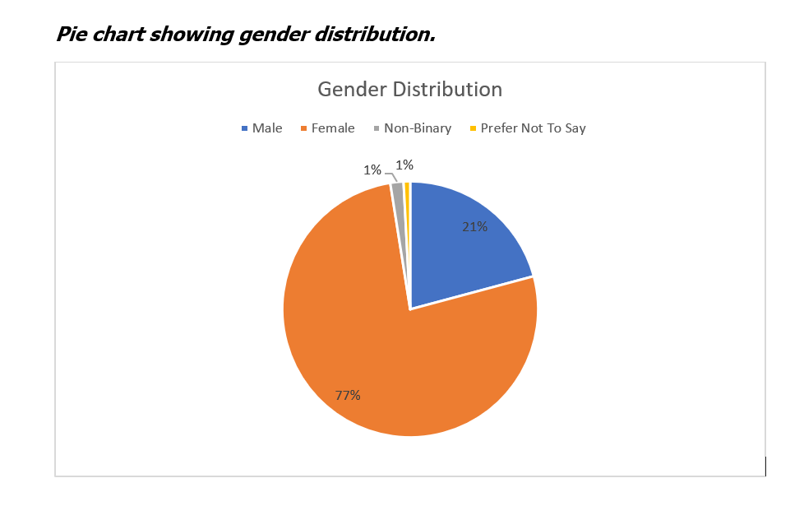

2.3 Ethics
The present study was approved by the Department of Technology and Psychology Ethics Committee (DTPEC) of IADT (see Appendix A), it was also in accordance with the Psychological Society of Ireland (PSI) ethical principles (PSI, 2019). The present study also adhered to the BPS ethics guidelines for internet-mediated research (BPS, 2021). The data was anonymised with unique identification codes created by the participants.

2.4 Materials
The materials used for the present study consisted of three scales that were used in the online survey. These were the Satisfaction with Life Scale (Diener, Emmons, Larsen & Griffin, 1985) (see Appendix B), Rosenberg’s Self-Esteem scale (Rosenberg, 1965) (see Appendix C) and the Big Five Personality Inventory (John & Srivastava, 1999) - extraversion subscale (see Appendix D). The online survey also asked demographic questions (age, gender and whether the individual was an undergraduate student) (see appendix E).
Each participant received an information sheet (see Appendix F) containing the aim of the study, what they will be asked to do, how their data will be stored and the date to which they can withdraw their data. This was followed by an informed consent form (see Appendix G) and a debrief at the end of the study. A debrief form (see Appendix H) provided participants with the researcher’s and supervisor’s contact details, withdrawing data information, data protection and support services. Consent was asked at the beginning and end of the survey. Qualtrics was used for the online survey.

2.4.1 Satisfaction with Life Scale (Diener, Emmons, Larsen & Griffin, 1985)
The SWLS measures cognitive judgments of an individual’s satisfaction with life. It is a short five-item 7-point Likert scale ranging from strongly agree (7) to strongly disagree (1). Scores range from 5-35 (extremely dissatisfied to extremely satisfied). Previous studies have reported a high Cronbach’s alpha ranging from .85 to .87 (Diener et al., 1985; Pavot et al., 1991). The present study conducted a high Cronbach’s alpha of (.88) (see Appendix L). An example of a question included is “In most ways my life is close to ideal.” Multiple studies have reported the SWLS as internally consistent and has moderate temporal stability (Pavot & Diener, 1993). The moderate temporal stability of the SWLS supports research that reports life satisfaction may be consistent over time. The SWLS shows construct validity in previous research as it has been negatively correlated with distress and positively correlated with extraversion (Pavot & Diener, 1993). These correlations have been replicated with self-report and non-self-report measures providing validity for the SWLS.

2.4.2 Rosenberg’s Self-Esteem Scale (Rosenberg, 1965)
The RSES measures self-worth by measuring positive and negative feelings about the individual self. It is a ten-item 4-point Likert scale ranging from strongly agree (4) to strongly disagree (1). Questions 2,5,6,8 and 9 are reverse scored. Scores range from 10 to 40 with higher scores indicating higher self-esteem. An example of a question included is “On the whole, I am satisfied with myself.” The RSES has reported a previous high Cronbach’s alpha of .86 (Rosenberg, 1965). The present study conducted a high Cronbach’s alpha of (.83) (see Appendix M). The RSES has been widely used as a self-report measure of self-esteem in recent decades. It has demonstrated good predictive and construct validity using known groups (Rosenberg, 1965). Due to the non-intrusive nature of the questions, it was used in the present study to ensure the participant’s safety and well-being.

2.4.3 Big Five Personality Inventory (John & Srivastava, 1999)-Extraversion Subscale
The Big Five Personality Inventory (BFI) is a 44-item scale that was used for the present study. Specifically, the extraversion subscale was used which has eight questions, such as "Is talkative". It uses a Likert scale ranging from Disagree strongly (1) to Agree strongly (5), the extraversion subscale was used to avoid participant fatigue during the survey and to keep the questions that are asked relevant to the research question. The BFI has Cronbach’s alpha of (.83) for the whole BFI scale and a Cronbach’s alpha of (.86) for the extraversion subscale (John et al., 2008). The present study reported a Cronbach alpha of (.85) for the extraversion subscale (see Appendix N). The BFI is a widely used personality questionnaire, especially for college students (John et al., 2008). Previous research has shown that the BFI has substantial convergent and discriminant validity (John et al., 2008).

2.5 Pilot Study
After ethical approval was received, a pilot test (n=3) was conducted to ensure everything was clear in the online survey, any feedback or improvements was reviewed, and alterations were made as needed. Examples of feedback were changing the wording of the extraversion scale instructions as it came across as confusing. To keep the pilot study as representative of the actual study as possible, participants met the inclusion criteria of the survey (over 18 years old and undergraduate students). The survey took approximately five minutes to complete.

2.6 Procedure
Participants were invited to voluntarily take part in the study through social media or word of mouth. Participants used either a QR code or a link to access the survey. Data was collected using Qualtrics. The participant was directed towards the information sheet when the link was clicked. After reading the information sheet, participants were invited to read the consent form and proceed with the study if they agreed. Each participant was asked to create a unique identification code in case they wanted to withdraw their data from the study. Participants were then directed towards demographic questions such as age, gender and whether they were undergraduate students. The scales followed starting with the RSES, followed by the SWLS and then the BFI-extraversion subscale. All questions were optional except for the consent to ensure the participant’s well-being and any incomplete surveys were excluded afterwards. Participants were then given a debriefing document to read, which included thanking the participants for taking part, and gave further resources and contact information of the researcher. Participants were asked to tick a final consent box to ensure they wanted their data included. Withdrawal information and the date to which the data could be withdrawn were also provided.

Results

3.1 Overview of Results
The factor variables of the present study were:
- Self-Esteem
- Extraversion
The target variable for the present study was life satisfaction. Version 28 of IBM SPSS statistics software was used to conduct the statistics for the present study (see Appendix I for SPSS output).

3.2 Descriptive Statistics
Table 1 illustrates the means, standard deviations, and n-values for participants within each group: life satisfaction, self-esteem, and extraversion.

Table 1
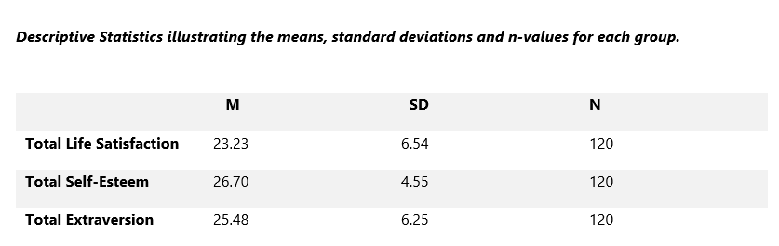

3.3 Inferential Statistics
A multiple linear regression analysis in the standard model was conducted to investigate the relationship between extraversion, self-esteem, and life satisfaction. A prior power analysis was conducted using G power version 3.1.9.7 software (Faul et al., 2007), this was used to investigate the minimum number of participants required to achieve a 95% power for detecting a medium effect, at a significance value of α = .05, which was reported as N=107 for a standard linear multiple regression. Thus, the obtained sample size of N = 120 is adequate to test the present study hypotheses (see Appendix S for G-power output).

3.3.1 Assumptions
To ensure the assumptions of the test were met, the variables underwent preliminary analysis, according to Pallant (2016). Standard residuals were analysed to identify any outliers indicating the data contained no outliers (Std. Residual Min=-2.80, Std. Residual Max=2.91). Outliers were also checked using Mahalanobis distance, no cases exceeded the critical value of 13.82. Tests to investigate whether the assumption of collinearity indicated that multicollinearity was not a concern (Tolerance=.901). The data met the assumption of independence of residuals (Durbin-Watson=1.861). The histogram of standardised residuals (See Figure 2) indicates that the data is relatively normally distributed, as did the P-Plot of the standardised residuals (see Appendix Q), which showed that the data points were close to the line but not entirely on the line.
Figure 2

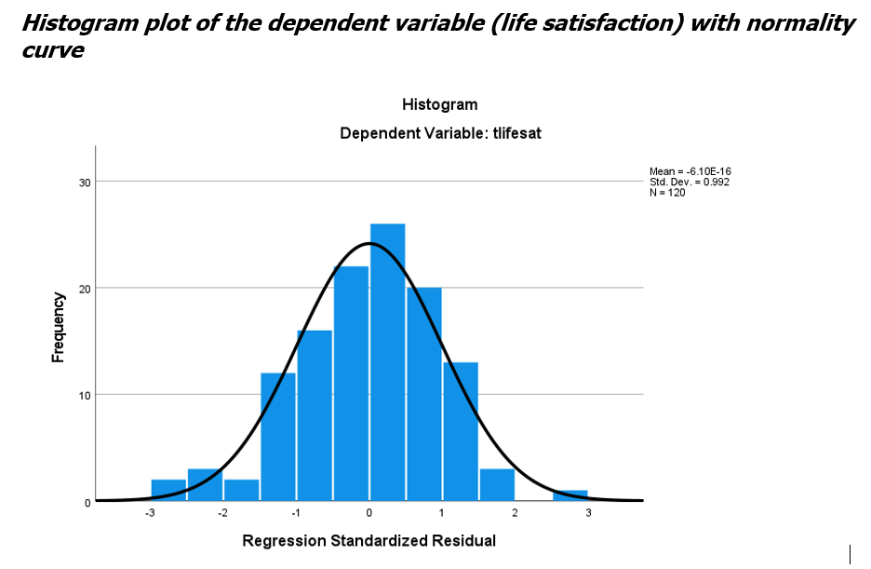

There were no Cook’s Distance values identified over 1 (Cook’s Distance Maximum=.12), suggesting no major problems. The scatterplot of standardised residuals (see Appendix P) indicated that the data met the assumption of linearity. The assumption of sample size was also met (Tabachnick & Fidell, 2007) suggest a formula for calculating sample size for a multiple regression N> 50 + 8m (m= the number of independent variables), in the present study m= 2, therefore N>66.

Bivariate Pearson Correlations were conducted between all variables displayed in Table 2. There was a weak positive linear correlation between extraversion and self-esteem. There was a weak positive linear correlation between extraversion and life satisfaction. There was also a strong positive linear correlation between self-esteem and life satisfaction. See Figure 3 for a 3-D visualisation of the bivariate correlations.
Table 2
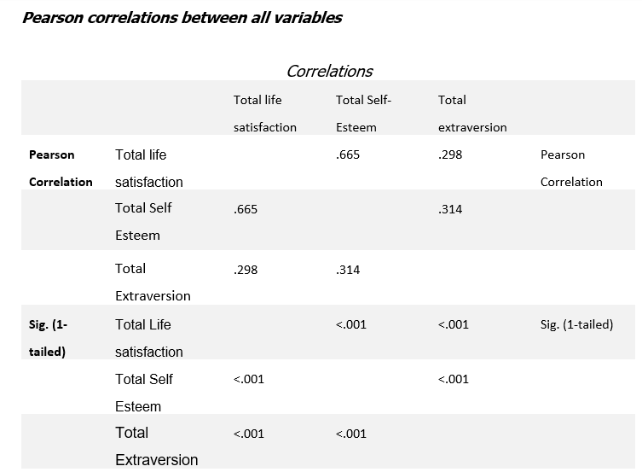

Figure 3
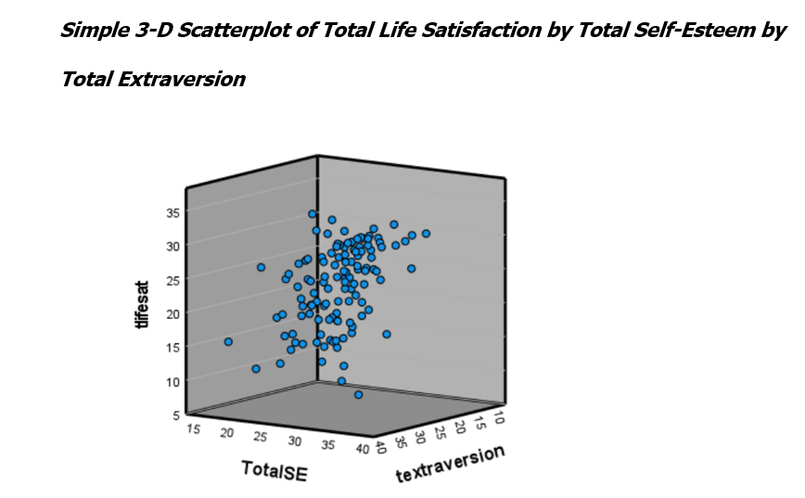

3.3.2 Multiple Regression
The multiple regression model using the enter method for the present study was reported as statistically significant F (2,117) =48.01, p<.001, which accounted for approximately 45% of the variance of life satisfaction, R²=.451 (see Appendix O for SPSS model summary output). The analysis showed (see Table 3) that self-esteem level did significantly predict life satisfaction (β=.634, t (2,117) =8.78, p<.001). However, the analysis also showed that extraversion level did not significantly predict life satisfaction (β=.99, t (2,117) =1.37, p=.175).
Table 3
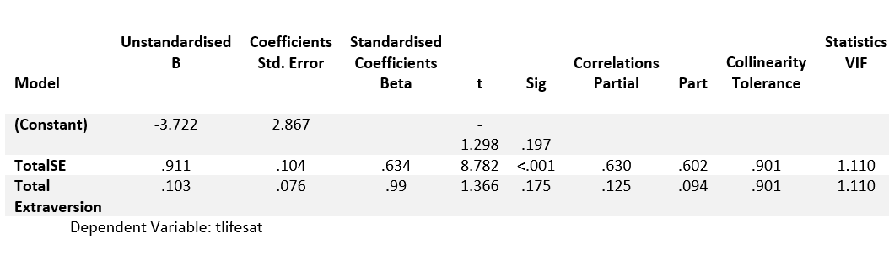

3.4 Summary of results
H1 stated that there will be a significant linear relationship between extraversion, self-esteem, and life satisfaction. This hypothesis was supported. The model was reported as statistically significant F (2,117) =48.01, p<.001, R²=.451.
H1a stated there will be a strong, positive, linear significant relationship between students’ extraversion and life satisfaction. A Person correlation reported there was a significant weak positive correlation between extraversion and life satisfaction of .298 p<.001. Therefore, H1a is not supported.
H1b stated that there will be a strong, positive, linear significant relationship between self-esteem and life satisfaction. There was a strong positive linear correlation of .665 p<.001 (See Table 2). Therefore, H1b is supported.
The results of the present study will be discussed in more detail in the next section.

Discussion

4.1 Overview of Findings
The purpose of this study was to add to the current research on whether life satisfaction is related to self-esteem and extraversion. Previous research has focused on exploring the relationship between extraversion and SWB, this study hopes to narrow this view to one facet of SWB (life satisfaction). The present study aimed to investigate whether there is a significant relationship between extraversion, self-esteem, and life satisfaction.

Both hypotheses 1 and 1b were statistically significant, 45% of the variance in life satisfaction was accounted for by self-esteem and extraversion, part correlation values indicated that self-esteem explained 60% of the variance in life satisfaction. While self-esteem could be described as a predictor of life satisfaction, causation is not implied, only correlation.

The present study supported the work of numerous previous research papers such as (Li et al., 2015; Varanarasama et al., 2019; Zeigler-Hill et al., 2015) who reported self-esteem was positively associated with extraversion. However, in the present study, this association was weak. Joshanloo and Afshari (2011) had similar findings to that of the present study, both studies conducted a regression analysis that reported self-esteem and extraversion did have a significant relationship with life satisfaction. Self-esteem was found to be the strongest correlator of life satisfaction, which was also found in the present study. Joshanloo and Afshari used the BFI scale, SWLS, and the RSES which were all also used in the present study.
The present study contradicted the work of Tan et al. (2016) who reported that there was a strong relationship between self-esteem and extraversion. Both the present study and the study by Tan et al. employed a survey design and both used the RSES and the BFI extraversion subscale. However, Tan et al. results differed from the present study, the researchers reported extraversion as a significant predictor of self-esteem. Tan et al also reported that extraversion facilitated happiness through self-esteem. This is not mirrored in the present study accounting for life satisfaction rather than happiness.
The present study somewhat supported the work of Li et al. (2015), both the present study and Li et al. (2015) reported significant weak correlations between extraversion and self-esteem. Both studies used the RSES to measure participants self-esteem, and both used a multiple regression analysis. Li et al. also reported a significant positive correlation between self-esteem and SWB. This also supports the present study as a strong positive correlation was found between self-esteem and life satisfaction. As stated above, the present study uses life satisfaction which is reported as a facet of SWB rather than SWB as a whole. The researchers also reported higher levels of extraversion and self-esteem were associated with greater SWB, this is consistent with the findings in the present study, higher extraversion and self-esteem were associated with greater life satisfaction. However, they also reported that extraversion significantly predicted SWB, which was not supported in the present study. Further in contrast to the present study, the meta-analysis conducted by Steel et al. (2008) reported that extraversion did significantly predict life satisfaction. The present study discovered that extraversion did not significantly predict life satisfaction. However, the present study found that there was a significant relationship between self-esteem and life satisfaction.

4.2 Strengths and Limitations of the present study
A key strength of the present study was the exploration of a new sample in the literature. Previous research has mostly been conducted on this topic in the United States, Asia, and Germany (Kim et al., 2018). The present study adds an Irish undergraduate student sample to the existing literature. Another strength of the present study is the scales that were used have reliability and validity, all three scales which were used have been used worldwide and have high Cronbach alphas (α>.80). In addition, there is little research using the exact combination of scales used in the present study (Rosenberg’s Self-Esteem Scale, Satisfaction with Life Sale, and the Big Five Inventory-extraversion subscale). Another strength of the study is the large age range of participants 18-44 years, as it gives more information on young adults and mature adults in third-level education.
Although there are a number of strengths to the research project, there are also a number of limitations. The generalisability of the present study may be limited due to a small sample size (N=120). Generalisability to a general population may also be limited due to unequal numbers of participants in gender groups. 77% of participants were female, 21% male and 2% identified as others (Non-binary, prefer not to say). This limitation may be due to women being more likely to participate in surveys than men (Becker, 2022). Another limitation is the method used to recruit participants. Participants were recruited using social media and may have been known to the researcher, potentially introducing social desirability bias which may limit the reliability of results (Meriac & Gorman, 2017).

4.3 Theoretical Implications
This research contributes to the theoretical knowledge of self-esteem, personality traits and SWB, additionally, it incorporates an Irish sample which has not been conducted before. Life satisfaction and extraversion are rarely investigated together, the present study adds to the limited research on this topic (Kim et al., 2018). This research also adds to the theoretical knowledge of internet mediated research, research in previous years have been conducted in person (Hewson, 2014).

4.4 Practical Implications
The present study could benefit third-level education institutions’ support systems for students. Third-level institutions should try to improve students’ self-esteem to increase their life satisfaction. On-campus counsellors, cognitive behavioural therapy workshops and mindfulness workshops could do this. The Higher Education Authority of Ireland implemented the National Student Mental Health and Suicide Prevention Framework (Fox et al., 2020), this programme aims to address the issues of student mental health and suicide prevention after the Covid-19 pandemic. The implementation guide describes numerous ways to build knowledge and skills about mental health, such as training on mental health literacy and suicide prevention for both students and staff. The programme states it is important that the steps for help and support are known to everyone. Establishing support throughout higher education is also vital, such as transition supports for students entering higher education and leaving higher education. Creating campus communities is also recommended to foster the development of well-being, purpose and belonging. This can be initiated by a zero tolerance to bullying and harassment policy and encouraging social events with smaller groups on campus.

4.5 Future research
Future research could investigate whether self-esteem moderates the link between extraversion and life satisfaction, as Li et al. (2015) suggest. Future research may include SWB as an additional variable to investigate whether there is a relationship between extraversion and SWB, as previous research suggests. The present study recruited participants from one college in Ireland, future research may employ a national survey using all third levels in Ireland. A longitudinal study would also be beneficial to analyse whether students’ self-esteem and life satisfaction improve after an initiative such as the one suggested above.

4.6 Conclusion
The present study aimed to add to the previous literature on the topic of the relationship between extraversion, self-esteem, and life satisfaction. The results supported the findings of (Joshanloo & Afshari, 2011; Li et al., 2015; Varanarasama et al., 2019) whilst contradicting the findings of Tan et al. (2016). The present study also contradicted some findings of (Kim et al., 2018). A multiple regression analysis established that there is a significant relationship between self-esteem, extraversion, and life satisfaction, however, extraversion does not seem to significantly predict greater life satisfaction. Findings indicated that self-esteem was more correlated to life satisfaction than extraversion. Future research in this area could include a more randomised sample to reduce the possibility of social desirability bias. The implications of this study could be of interest to third-level education institutions interested in improving student’s life satisfaction and well-being.

References
American Psychological Association. (n.d.). Extraversion. APA Dictionary of Psychology. Retrieved November 18, 2022, from https://dictionary.apa.org/extraversion.
Becker, R. (2022). Gender and Survey Participation. An Event History Analysis of the Gender Effects of Survey Participation in a Probability-based Multi-wave Panel Study with a Sequential Mixed-mode Design. Methods, data analyses (MDA), 16(1), 3-32. https://doi.org/10.12758/mda.2021.08
The British Psychological Society (BPS). (2021). Ethics guidelines for internet-mediated research. https://doi.org/10.53841/bpsrep.2021.rep155
Costa, P. T., & McCrae, R. R. (1980). Influence of extraversion and neuroticism on subjective well-being: happy and unhappy people. Journal of personality and social psychology, 38(4), 668–678. https://doi.org/10.1037//0022-3514.38.4.668
Costa, P. T., & McCrae, R. R. (1992). Normal personality assessment in clinical practice: The neo personality inventory. Psychological Assessment, 4(1), 5–13. https://doi.org/10.1037/1040-3590.4.1.5
DeNeve, K. M., & Cooper, H. (1998). The happy personality: A meta-analysis of 137 personality traits and subjective well-being. Psychological Bulletin, 124(2), 197–229. https://doi.org/10.1037/0033-2909.124.2.197
Diener, E. (1984). Subjective Well-Being. Psychological Bulletin. 95 (3), 542-575.
Diener, E., Emmons, R. A., Larsen, R. J., & Griffin, S. (1985). The Satisfaction With Life Scale. Journal of Personality Assessment, 49(1), 71-75. https://doi.org/10.1207/s15327752jpa4901_13
Faul, F., Erdfelder, E., Lang, A.-G., & Buchner, A. (2007). G*Power 3: A flexible statistical power analysis program for the social, behavioral, and biomedical sciences. Behavior Research Methods, 39, 175–191. https://doi.org/10.3758/BF03193146
Fox, T., Byrne, D., & Surdey, J. (2020). National Student Mental Health and Suicide Prevention Framework. Higher Education Authority. https://hea.ie/assets/uploads/2020/10/HEA-NSMHS-Framework.pdf
Hewson, C. (2014). Methods: Conducting research on the internet – a new era. The British Psychological Society (BPS). Retrieved from: https://www.bps.org.uk/psychologist/methods-conducting-research-internet-new-era.
John, O. P., Naumann, L., & Soto, C. (2008). Paradigm shift to the integrative Big Five taxonomy.
John, O. P., & Srivastava, S. (1999). The Big Five Trait taxonomy: History, measurement, and theoretical perspectives. In L. A. Pervin & O. P. John, Handbook of personality: Theory and research (pp. 102–138). Guilford Press.
Joshanloo, M., & Afshari, S. (2011). Big Five personality traits and self-esteem as predictors of life satisfaction in Iranian Muslim university students. Journal of Happiness Studies: An Interdisciplinary Forum on Subjective Well-Being, 12(1), 105–113. https://doi.org/10.1007/s10902-009-9177-y
Kim, H., Schimmack, U., Oishi, S., & Tsutsui, Y. (2018). Extraversion and life satisfaction: Across-cultural examination of student and nationally representative samples. Journal of Personality,86, 604-618. https://doi.org/10.1111/jopy.12339
Kurnaz, M. F., Teke, E., & Günaydın, H. A. (2020). Relationship between self-esteem and life satisfaction: A meta-analysis study. Research on Education and Psychology (REP), 4(2), 236-253.
Li, Y., Lan, J., & Ju, C. (2015). Self-esteem, gender, and the relationship between extraversion and subjective well-being. Social Behavior and Personality: An International Journal, 43(8), 1243–1254. https://doi.org/10.2224/sbp.2015.43.8.1243
Meriac, J. P., & Gorman, C. A. (2017). Work ethic and work outcomes in an expanded criterion domain. Journal of Business and Psychology, 32(3), 273-282. https://doi.org/10.1007/s10869-016-9460-y
Niazi, S., & Mehmood, B. (2017). Personality Traits as Predictor of Self-esteem of University Students: Moderating Role of Openness to Experience. Journal of Behavioural Sciences. 27.(2). 102-119.
Pallant, J. (2016). Spss survival manual: A step by step guide to data analysis using spss. McGraw-Hill Education.
Pavot, W., & Diener, E. (1993). Review of the Satisfaction With Life Scale. Psychological Assessment, 5(2), 164–172. https://doi.org/10.1037/1040-3590.5.2.164
Pavot, W., Diener, E., Colvin, C. R., & Sandvik, E. (1991). Further validation of the Satisfaction with Life Scale: Evidence for the cross-method convergence of well-being measures. Journal of Personality Assessment, 57(1), 149–161. https://doi.org/10.1207/s15327752jpa5701_17
The Psychological Society of Ireland (PSI). (2019). Code of Professional Ethics. https://www.psychologicalsociety.ie/source/Code%20of%20Professional%20Ethics%20(Oct%202019).pdf
Rosenberg, M. (1965). Rosenberg Self-Esteem Scale (RSES). APA PsycTests. https://doi.org/10.1037/t01038-000
Schimmack, U., Oishi, S., Furr, R. M., & Funder, D. C. (2004). Personality and Life Satisfaction: A Facet-Level Analysis. Personality and Social Psychology Bulletin, 30(8), 1062–1075. https://doi.org/10.1177/0146167204264292
Steel, P., Schmidt, J., & Shultz, J. (2008). Refining the relationship between personality and subjective well-being. Psychological bulletin, 134(1), 138–161. https://doi.org/10.1037/0033-2909.134.1.138
Szcześniak, M., Mazur, P., Rodzeń, W., & Szpunar, K. (2021). Influence of Life Satisfaction on Self-Esteem Among Young Adults: The Mediating Role of Self-Presentation. Psychology and Research Behavior Management 14, 1473-1482. https://doi.org/10.2147/PRBM.S322788
Szcześniak, M., & Timoszyk-Tomczak, C. (2020). Religious Struggle and Life Satisfaction Among Adult Christians: Self-esteem as a Mediator. Journal of Religion and Health, 59, 2833–2856. https://doi.org/10.1007/s10943-020-01082-9
Tabachnick, B. G., & Fidell, L. S. (2007). Using multivariate statistics (5th ed.). Allyn & Bacon/Pearson Education.
Tan, C.-S., Krishnan, S. A. P., & Lee, Q.-W. (2016). The role of self-esteem and social support in the relationship between extraversion and happiness: A serial mediation model. Current Psychology, 36(3), 556–564. https://doi.org/10.1007/s12144-016-9444-0
Varanarasama, E. A. P., Singh, A. K., & Muthu, K. A. P. (2019). The relationship between personality and self-esteem towards university students in Malaysia. Proceedings of the 4th ASEAN Conference on Psychology, Counselling, and Humanities (ACPCH 2018), 304, 410-414. https://doi.org/10.2991/acpch-18.2019.97
Zeigler-Hill, V., Holden, C. J., Enjaian, B., Southard, A. C., Besser, A., Li, H., & Zhang, Q. (2015). Self-esteem instability and personality: the connections between feelings of self-worth and the big five dimensions of personality. Personality & social psychology bulletin, 41(2), 183–198. https://doi.org/10.1177/0146167214559719

Appendices

Appendix A: Ethical Approval Email
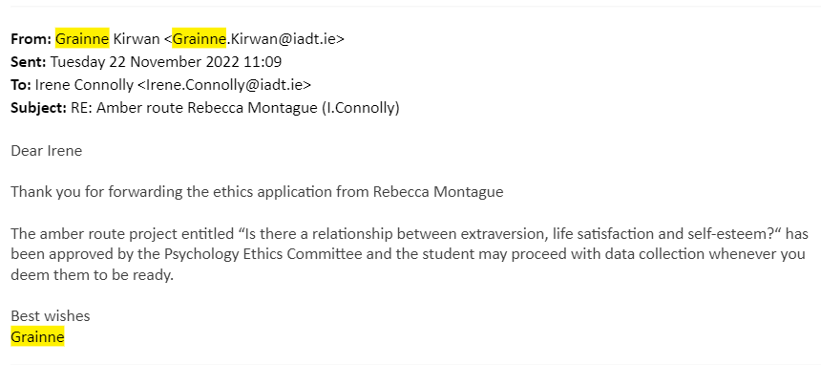

Appendix B: Life Satisfaction Scale

Below are five statements that you may agree or disagree with. Using the 1-7 scale below, indicate your agreement with each item by placing the appropriate number on the line preceding that item. Please be open and honest in your responding.
- Strongly Disagree
- Disagree
- Slightly Disagree
- Neither agree nor disagree
- Slightly Agree
- Agree
- Strongly Agree

_____ In most ways my life is close to my ideal.
_____ The conditions of my life are excellent.
_____ I am satisfied with my life.
_____ So far, I have gotten the important things I want in life.
_____ If I could live my life over, I would change almost nothing.
Scoring:
Values range from 5-35
5-9 Extremely dissatisfied
10-14 Dissatisfied
15-19 Slightly Dissatisfied
20 Neutral
21-25 Slightly Satisfied
26-30 Satisfied
31-35 extremely Satisfied.

Appendix C: Rosenberg Self-Esteem Scale

Instructions: Below is a list of statements dealing with your general feelings about yourself. Please indicate how strongly you agree or disagree with each statement.

- On the whole, I am satisfied with myself.
Strongly Agree ___ Agree___ Disagree___ Strongly Disagree___
- At times I think I am no good at all.
Strongly Agree ___ Agree___ Disagree___ Strongly Disagree___
- I feel that I have a number of good qualities.
Strongly Agree ___ Agree___ Disagree___ Strongly Disagree___
- I am able to do things as well as most other people.
Strongly Agree ___ Agree___ Disagree___ Strongly Disagree___
- I feel I do not have much to be proud of.
Strongly Agree ___ Agree___ Disagree___ Strongly Disagree___
- I certainly feel useless at times.
Strongly Agree ___ Agree___ Disagree___ Strongly Disagree___
- I feel that I'm a person of worth.
Strongly Agree ___ Agree___ Disagree___ Strongly Disagree__
- I wish I could have more respect for myself.
Strongly Agree ___ Agree___ Disagree___ Strongly Disagree___
- All in all, I am inclined to think that I am a failure
Strongly Agree ___ Agree___ Disagree___ Strongly Disagree___
- I take a positive attitude toward myself
Strongly Agree ___ Agree___ Disagree___ Strongly Disagree___

Scoring:
- Strongly Disagree
- Disagree
- Agree
- Strongly Agree
Questions 2,5,6,8,9 are reversed scored.

Appendix D: Big Five Personality Questionnaire

Here are a number of characteristics that may or may not apply to you. Please indicate next to each statement the extent to which you agree or disagree with that statement.

- Disagree Strongly
- Disagree a little
- Neither agree nor disagree
- Agree a little
- Agree Strongly

___Is talkative.
___Is reserved.
___Is full of energy.
___Generates a lot of enthusiasm.
___Tends to be quiet.
___Has an assertive personality.
___Is sometimes shy, inhibited.
___Is outgoing, sociable.

Scoring: Questions 2,5, 7 are reversed scored

Appendix E: Participant Code and Demographic Questions Form

- Please provide us with an anonymised code which we can use to identify your data if you later wish to have it removed from our dataset. Please do so by answering the following two questions.
  - What are the second letters of your first and last name? (For example, if your name is Jane Smith, these letters would be ‘AM’) and what are the last three digits of your telephone number?

_________
- Gender: I identify as:
  - Male
  - Female
  - Non-Binary
  - I prefer not to say
  - Other_____

- Age: I am
  - Under 18 years __
  - 18-24 years __
  - 25-34 years __
  - 35-44 years __
  - 45-54 years __
  - 55-64 years __
  - 65-74 years __
  - 75 years or older __
  - I prefer not to say __

- Are you an undergraduate student?
___ No, I am not
___ Yes, I am

Appendix F: Information Sheet

Title of project: The relationship between self-esteem, extraversion, and life satisfaction in undergraduate students.
You are being invited to take part in the research A correlational study of the relationship between self-esteem, extraversion, and life satisfaction. This project is being undertaken by Rebecca Montague for our major research project as part of the BSc (Hons) in Applied Psychology, IADT.

Before you decide whether you wish to take part, it is important for you to understand why this research is being done and what it will involve. Please take time to read this information carefully and discuss it with someone you trust. If there is anything that is unclear or if you would like more information please ask, our contact details are at the end of this information sheet. Thank you for reading this.
What is the purpose of the project?
The purpose of this study is to add to the current research on whether extraversion (our outgoingness) is related to our self-esteem and life satisfaction. Previous research has focused on exploring the relationship between extraversion and subjective well-being, this study hopes to narrow this view to one facet of subjective well-being (life satisfaction).
Why are you being invited to take part?
You are being invited to participate in this study because you are an undergraduate student over the age of 18 in Ireland.
What is involved?
Participants will be asked to sign a consent form if they wish to take part in the study. Participants will then be asked demographic questions such as “What age are you.,” followed by three short scales. The first is on self-esteem which is a 10-item scale. The second is on satisfaction with life which is a five-item scale and lastly a personality subscale consisting of seven questions. A debriefing form will then be provided. This will take approximately 4-5 minutes.

Do I have to take part?
You are free to decide whether you wish to take part or not. If you do decide to take part, you will be asked to sign a consent form that lets us know you have read this information sheet and understand what is involved in the research. You are free to withdraw from this study at any time and without giving reasons. Whether you decide to take part in this study or not, there will be no impact on your marks, assessments, or future studies.
What are the disadvantages and risks (if any) of taking part?
This research should not cause any harm to participants. However, contact details for the researcher and support agencies are provided at the end of the survey if any questionnaires cause discomfort. The participant may choose if they want to not answer any question throughout the survey.
What are the possible benefits of taking part?
By taking part in this study, you will be assisting a fourth year Applied Psychology student to complete their major research project.
How will my information be used?
The data collected will be analysed through statistical analysis and will be safely discarded within 7 years. Your responses to the questionnaire will be combined with all other participants data and statistically analysed. No individual’s data will be identifiable in the final report. The results of this analysis will be reported in the thesis for the BSc (Hons) in Applied Psychology in the Dun Laoghaire Institute of Art, Design & Technology. This can be requested through the library at IADT, or by emailing the researcher at N00190248@iadt.ie This study may also be published in an academic journal article and may be written about for blog posts or media articles and these can be requested from the researcher.

How will my data be protected?
Under the EU General Data Protection Regulation (GDPR) the legal basis for collecting data for scholarly research is that of public interest. The regulations regarding the protection of your data will be followed. Only data which is needed for analysis will be collected. By giving your consent to take part in the study you are consenting to the use of your data as detailed in this information sheet. The data will be retained by the researcher for at least one year and may be retained for up to 7 years if the results of the study are published in certain capacities (e.g., in a journal article). There is also a possibility that the fully anonymised dataset may be submitted to a journal and made available to other researchers and academics worldwide for verification purposes, but if this occurs it will be ensured that you are not identifiable from the data. As the supervisor on this project, I, Dr Irene Connolly irene.connolly@iadt.ie, am responsible for ensuring that all datasets will be stored in accordance with GDPR regulations and those which are not submitted to a journal will be fully deleted on or before date 7 years from data collection. You will find contact information for IADT's Data Protection Officer, Mr Bernard Mullarkey, and more information on your rights concerning your data at https://iadt.ie/about/your-rights-entitlements/gdpr/
Who has reviewed the study?
This study has been approved by the IADT Psychology Ethics Committee.

What if you have any questions or there is a problem?
If you have a concern about any aspect of this study, you may wish to speak to the researcher(s) who will do their best to answer your questions. You should contact Rebecca Montague at N00190248@iadt.ie or their supervisor irene.connolly@iadt.ie
Thank you.
Thank you for taking the time to read this information sheet.
Date
11/01/2023

Appendix G: Consent Form
Title of Project:
The relationship between self-esteem, extraversion, and life satisfaction in undergraduate students.
Name of Researcher/s: Rebecca Montague
Please Click box.
1 | I confirm that I have read and understand the information sheet for the above study and have had the opportunity to ask questions.  Yes □  No □
2 | I understand that my participation is voluntary and that I am free to withdraw at any time.  Yes □  No □
3 | I understand that data collected about me during this study will not be identifiable when the research is published.  Yes □  No □
4 | I am over 18.  Yes □  No □

Appendix H: Debrief Form

If you still consent to submit your data to this study, please click the following box:
Yes, I consent to my responses being used __
No. I do not consent__

Title of Project: The relationship between self-esteem, extraversion, and life satisfaction in undergraduate students.
Name of Researcher: Rebecca Montague
Thank you very much for taking part in this research study.
This study is designed to investigate the relationship between self-esteem, extraversion, and life satisfaction.

Withdrawal information
If you have any questions about this study, or if you would like to withdraw your data from the study, please contact the researcher or supervisor at N00190248@iadt.ie and Irene.Connolly@iadt.ie In your email let them know your unique ID code (second letters of their name and last 3 digits of phone number). If you submit a request for data removal, all data collected from you will be securely deleted. You will be able to remove your data from the study until 28/2/2023 when the data will be combined and analysed. Data removal will not be possible after that date. Please keep a copy of this information in case you wish to remove your data after leaving this screen.
Data Protection
Your data will be treated according to GDPR regulations. You will find contact information for IADT's Data Protection Officer, Mr Bernard Mullarkey, and more information on your rights concerning your data at https://iadt.ie/about/your-rights-entitlements/gdpr/
Support resources
If you have been affected by the content of this study in any way, the organisations below may be of assistance.
Aware
www.aware.ie or phone 1800 80 48 48
Pieta House
www.pietahouse.ie or phone 1800 247 247

Thank you again for taking the time to participate in this research.
If you have any questions about this study, please contact the researcher or supervisor at
Rebecca Montague
N00190248@iadt.ie

Dr Irene Connolly
Irene.connolly@iadt.ie

Appendix I: SPSS Output

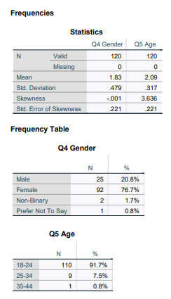

Pie Chart
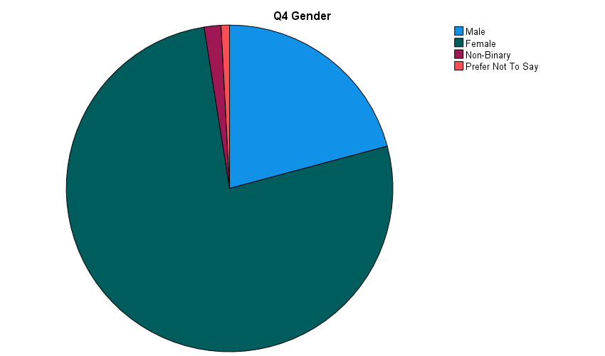

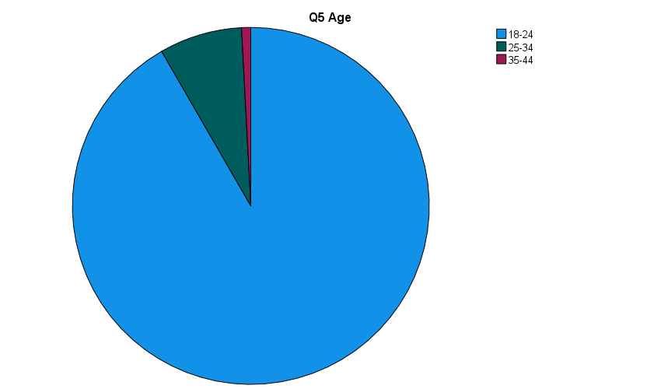

Appendix J: Descriptive Statistics

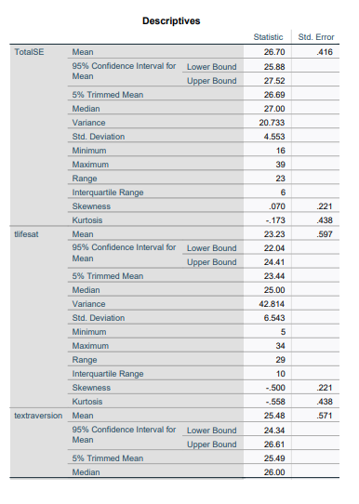
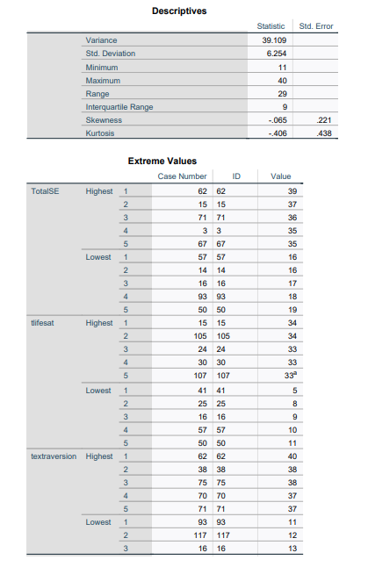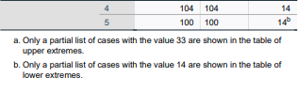

Appendix K: Reliability Analysis – Satisfaction with Life

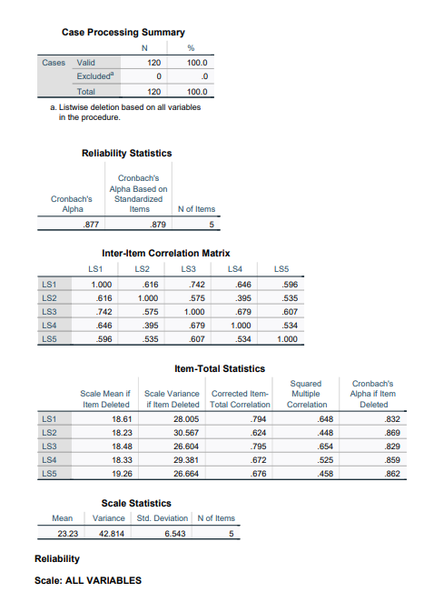

Appendix L: Reliability Analysis – Self-Esteem

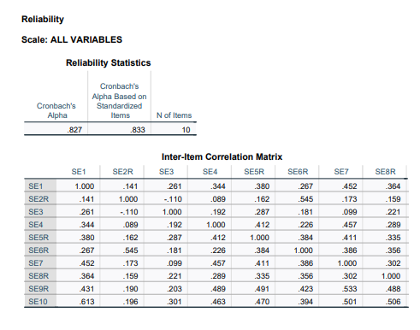
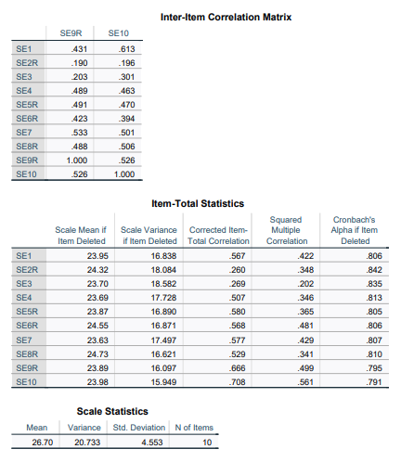

Appendix M: Reliability Analysis – Extraversion

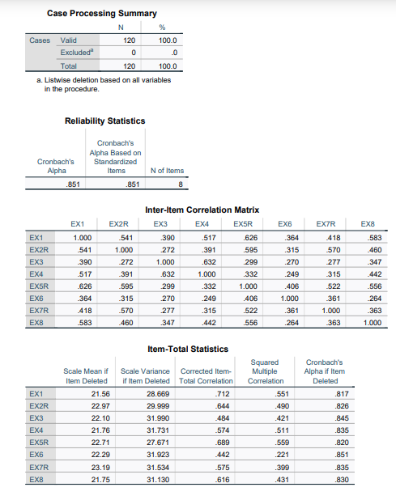

Appendix N: Multiple Regression Output

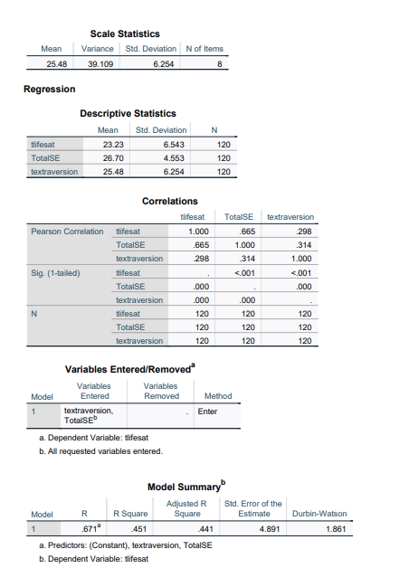
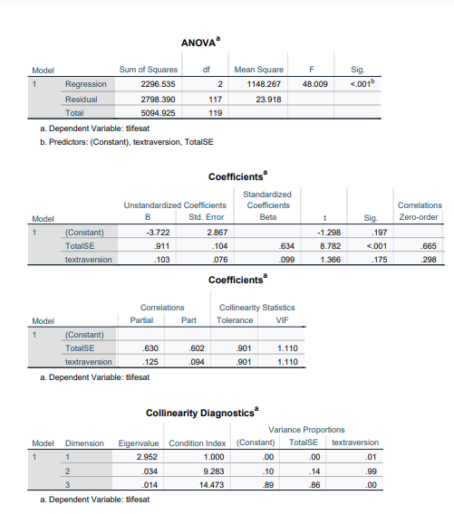

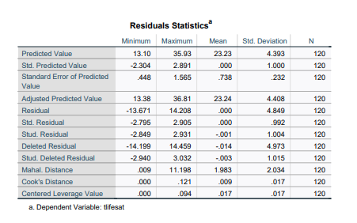

Charts

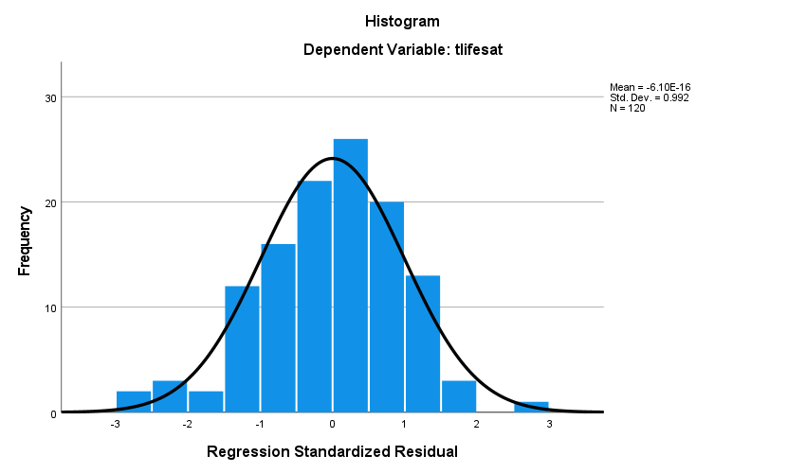

Appendix O: Scatterplot of Standardised Residuals

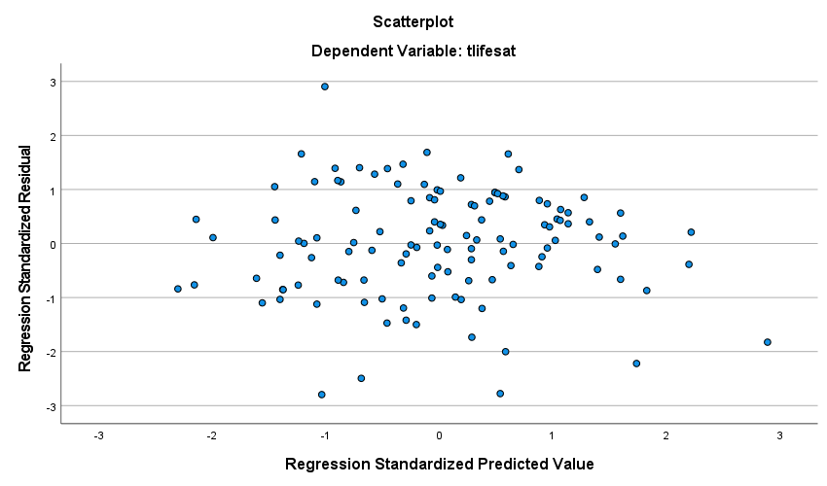

Appendix P: P-Plot of Regression Residuals
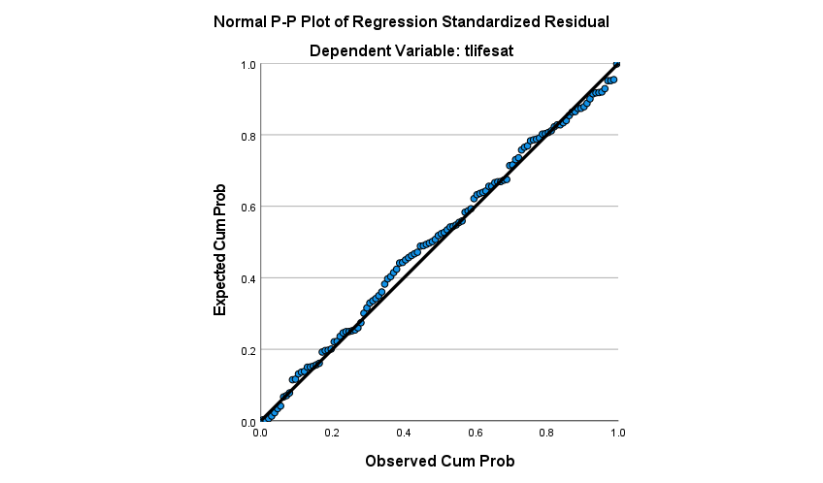

Appendix Q: 3-D Scatterplot of the relationship between self-esteem, extraversion, and life satisfaction

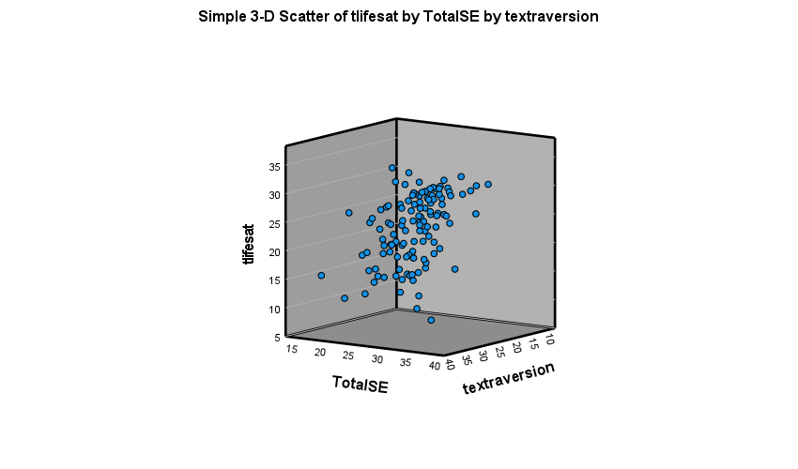

Appendix R: G Power Output

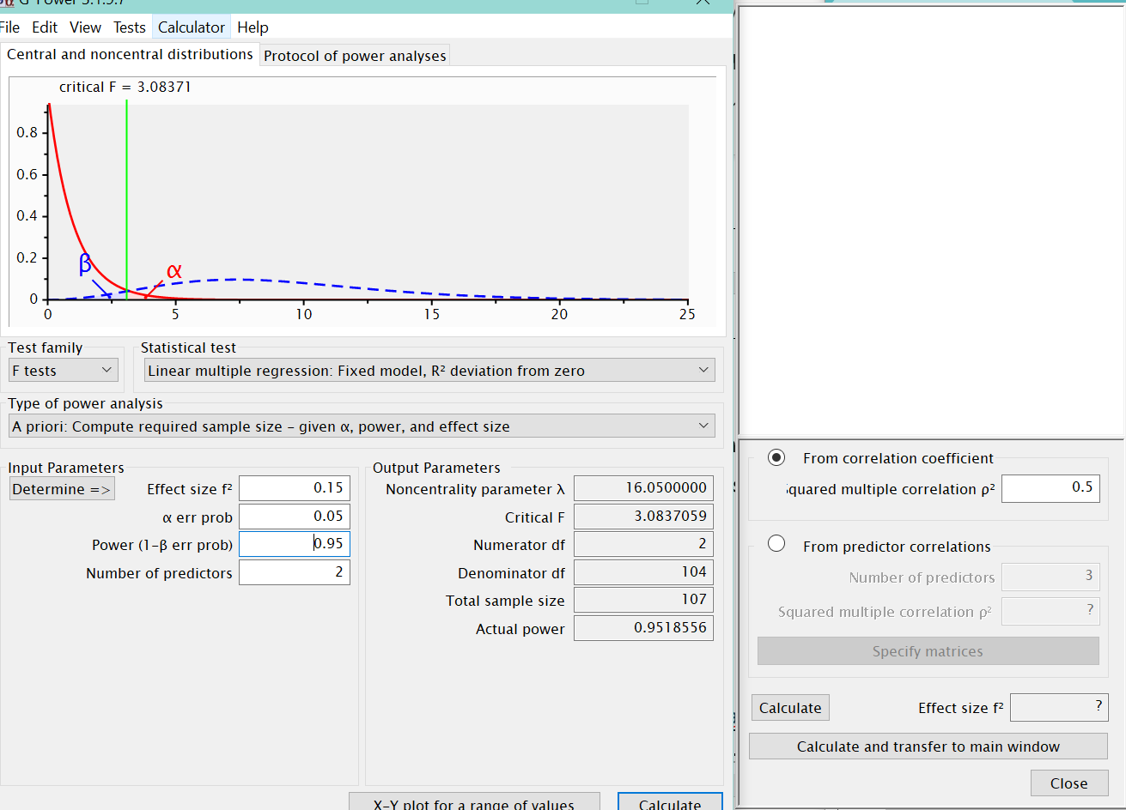

Appendix S: Dissemination Plan
Method: IADT On-Show Graduate Exhibitions
Name:
Rebecca Montague
Rebecca.montague35@gmail.com
LinkedIn
Supervisor’s Name:
Irene Connolly
Possible Profile Image:

Project Title:
The relationship between self-esteem, extraversion, and life satisfaction in undergraduate students.
Personal Bio:
My name is Rebecca Montague, I am a soon to be graduate of Applied Psychology (BSc hons) in IADT specialising in the practice path. Throughout my years at IADT, I have found my main interests are Educational/Developmental Psychology and forensic psychology. My studies have allowed me to volunteer with organisations such as Foróige and Barretstown. My next goal is to further increase my volunteer experience before I make a final decision on a postgraduate degree.
Project Overview (150 words max)
Previous research has suggested there is a relationship between extraversion, self-esteem, and life satisfaction. The present study aimed investigate whether there was a relationship between extraversion, self-esteem, and life satisfaction in undergraduate students. This was achieved by researching previous findings on the topic and conducting an online survey using three scales. The data was collected and statistically analysed; the findings were then discussed with reference to previous research. Any implications of the study was further discussed along with suggestions for future research.
Project Description (250 words max)
The present study is titled “The relationship between self-esteem, extraversion, and life satisfaction in undergraduate students”. The study aimed to add to the previous literature on the topic of extraversion, self-esteem, and life satisfaction. Previous research has suggested there is a relationship between extraversion, self-esteem, and life satisfaction. The concepts of extraversion and subjective well-being (SWB) are often reported as strongly correlated in previous research. There were 92 (77%) females, 25 (21%) males, two (1%) non-binary individuals, and one (1%) individual who reported prefer not to say, within the age range of 18-44 years (N=120). Thirty-seven participants were excluded due to various reasons such as failure to complete, wrong age, and not being an undergraduate student. The study employed a quantitative, cross-sectional, and correlational design, which was administered using an online survey. The target variable of the study was life satisfaction, the two factor variables were extraversion and self-esteem. Reliable scales such as Rosenberg’s Self-Esteem Scale (Rosenberg, 1965), Satisfaction with Life Scale (Diener, Emmons, Larsen & Griffin, 1985) and the Big Five Inventory Extraversion subscale (John & Srivastava, 1999) were used in the present study.
Project Findings (250 words max)
A multiple linear regression analysis was conducted to investigate the relationship between the factor variables, i.e. extraversion, self-esteem and the predictor target variable, which was life satisfaction. The results of the study suggest that there is a significant relationship between self-esteem, extraversion, and life satisfaction, however, extraversion does not seem to significantly predict greater life satisfaction. Overall, self-esteem seemed to be more closely linked to life satisfaction than extraversion. While self-esteem could be described as a predictor of life satisfaction, causation is not implied, only correlation. Bivariate Pearson Correlations were conducted between all variables and discovered there was a weak positive linear correlation between extraversion and self-esteem. There was a weak positive linear correlation between extraversion and life satisfaction. There was also a strong positive linear correlation between self-esteem and life satisfaction.
A key strength of the present study was the exploration of a new sample in the literature. Previous research has mostly been conducted on this topic in the United States, Asia, and Germany (Kim et al., 2018). The present study adds an Irish undergraduate student sample to the existing literature. This research contributes to the theoretical knowledge of self-esteem, personality traits and SWB, additionally, it incorporates an Irish sample which has not been conducted before. Life satisfaction and extraversion are rarely investigated together, the present study adds to the limited research on this topic (Kim et al., 2018). This research also adds to the theoretical knowledge of internet mediated research, research in previous years have been conducted in person (Hewson, 2014).
Possible Pictures to Use:
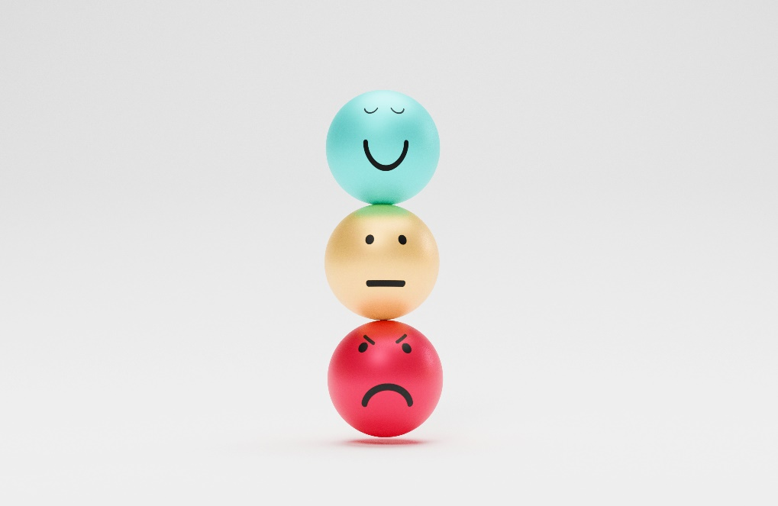
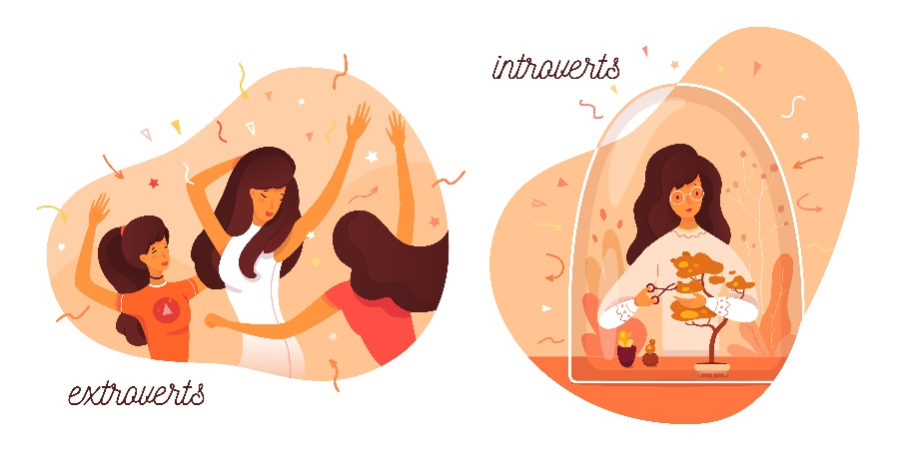
Pictures from FreePik.com

