______________________________________________________________________________

“Investigating the relationship between Empathy, Gratitude & Prosocial Behaviour.”

______________________________________________________________________________

Sophie Kathryn

N00190598

Research Supervisor: Hannah Barton

Dissertation submitted as a requirement for the degree of BSc (Hons) in Applied Psychology, Dún Laoghaire Institute of Art, Design, & Technology, 2023.

Declaration

I declare that this submission is my own work. Where I have read, consulted, and used the work of others I have acknowledged this in the text.

Signed: Sophie Kathryn

Date: 30/03/2023

Word Count: 4518

Acknowledgements

I would like to thank my supervisor Hannah Barton for her help and guidance throughout this project, it is extremely appreciated - her teachings of social psychology is what first spiked my interest in this area.
Thank you to Sinead Meade, John Greaney, Dr Gráinne Kirwan, Dr Christine Horn and the other IADT and Applied Psychology staff for their continuous support, understanding, patience, and help - especially in this final year of study. Your work never goes unnoticed and your kindness has always been much appreciated.
I would also like to thank the Research & Evaluation team in Jigsaw - they never fail to provide endless support and learning opportunities which have been incredibly helpful in my journey thus far as a researcher.
Thank you to all participants who took time to contribute to this study.
Thank you to my friends, family, and partner, Rory, who have been there for every chat and hug needed to get me through this year despite their own stress.
Finally, thank you to my fellow classmates of 2023’s Applied Psychology. The connections and fun shared together got us through the majority of our college years affected by the COVID-19 pandemic. I don’t think another group of people could have bonded as well as we did. A special thanks to Alan, Cillian, Ciarán, and the gang for the love, support, jokes, and coffee breaks that got us through four years - especially in our final year. You all mean so much to me.

Ní neart go cur le chéile.

Table of Contents
Page
Abstract ……………………………………………………………………….………………… 1
- Introduction ………………………………………………………….…………………. 2
1.1 Empathy ……………………………………………………………………... 2
1.2 Gratitude …………………………………………………………………... 2-3
1.3 Empathy & Gratitude ………………………………………………………... 3
1.4 Prosocial Behaviour & Benefits ……………...……………………………… 4
1.5 Prosocial Behaviour & Empathy ………………………………………….. 5-6
1.6 Prosocial Behaviour & Gratitude ……………………………………………. 6
1.7 Prosocial Behaviour, Empathy, & Gratitude ……...………………………… 7
1.8 Current Study ……………………………………………………………… 7-8
- Method ……………………………………………………………..…………………… 9
2.1 Design …………………………………………………………….…………. 9
2.2 Participants ……………………………….…………………………………. 9
2.3 Materials ………………………………………………………………...…. 10
2.4 Pilot Study ……………………………………………..……………………11
2.5 Procedure ……………………………………………………………………11
2.6 Ethical Considerations ………………………………………………..……..11
- Results ………………………………………………………………………………….12
3.1 Overview …………………………………………………………………... 12
3.2 Descriptive Statistics ………………………………………………………. 12
3.3 Inferential Statistics …………………………………………………….. 12-15
- Discussion ………………………………………………………………………….….. 16
4.1 Overview of Findings ……………………………………………………… 16
4.2 Theoretical Implications …………………………………………………… 17
4.3 Practical Implications ……………………………………………………… 17
4.4 Strengths & Limitations of Current Study ……….………………………… 18
4.5 Future Research ……………………………...………………………… 18- 19
4.6 Conclusion …………………………………………………………………. 19
- Reference List ……………………………………………………………...…….. 20 - 23
- Appendices ………………………………………………………………………....….. 24
6.1 Appendix A- Information Sheet ………………..………………………. 24-27
6.2 Appendix B - Consent Sheet ……………………………………………….. 28
6.3 Appendix C - Demographic Questions …………….………………………. 29
6.4 Appendix D - Confirmation of Consent ……………………………………. 30
6.5 Appendix E – Debrief …...……………………………………………… 31-32
6.6 Appendix F - Toronto Empathy Scale (measure 1) ….…………………. 33-34
6.7 Appendix G - Reliability Analysis for measure 1 …………..………….. 35-36
6.8 Appendix H- GQ-6 Scale (measure 2) ……………………..……………… 37
6.9 Appendix I - Reliability Analysis for measure 2 ………………………….. 38
6.10 Appendix J - Prosocial Behaviour Scale for Adults (measure 3) ..………. 39
6.11 Appendix K - Reliability Analysis for measure 3 ……..……………… 40-41
6.12 Appendix L - Anonymised Code Creation ………………….……………. 42
6.13 Appendix M - Ethical Approval from IADT Psychology
Ethics Committee ………………………………….………. 43
6.14 Appendix N - SPSS Output of Predictor Variable Correlations ………….. 44
6.15 Appendix O - SPSS Output of normal p-plot of regression
standardised residual ………………………………………. 45
6.16 Appendix P - SPSS Output of Tolerance values ………………………….. 46
6.17 Appendix Q - SPSS Output showing Mahalanobis
Distances for Normality ……………..…………………….. 47
6.18 Appendix R - SPSS Output showing Model Summary
& Multiple regression analysis ……………………………. 48

Abstract

The current study aimed to examine the relationship between empathy, gratitude, and prosocial behaviour levels. 280 adults participated in an online survey (via Qualtrics) shared through social media platforms. Participants answered questions from the Toronto Empathy Scale (Spreng et al., 2009), GQ-6 (McCullough et al., 2002), and the Prosocial Scale for Adults (Caprara et al., 2005). A multiple linear regression was conducted where a significant model emerged. Empathy and gratitude were found to be both strong predictors of prosocial behaviour levels. The current study corroborates the findings of the empathy-altruism hypothesis (Batson, 2011) and other studies finding close relationships between empathy, gratitude, and prosocial behaviour (Emmons & McCullough, 2003; Kamas & Preston, 2021; Kim et al., 2018; Pang et al., 2022). These findings help communities to understand the importance of the variables at hand and suggest encouragement of greater levels of prosocial behaviour - mediated by empathy and gratitude. The present study did not account for the relationship of the variables to various demographic groups such as cross-cultural studies, gender/sex, employment and education type - future researchers. Future researchers may consider the implementation of these observations.

Introduction
Research on empathy, gratitude, and prosocial behaviour has quite often been restricted,
failing to adequately consider interactions between all variables, instead focusing on limited comparisons (Decety & Cowell, 2014; Kamas & Preston, 2021; Kim et al., 2018; Lambert et al., 2009; Rodriguez et al., 2021). Only a little research has been conducted on the relationship between empathy, gratitude, and prosocial behaviour.

Many studies (Brown et al., 2012; Okun & Kim, 2016; Raposa et al., 2016) have made the community aware of the positive effects of prosocial behaviour, but what influences this behaviour? This study aims to answer the question; do empathy and gratitude levels affect how prosocial we are?

Literature Review

1.1 Empathy
There is often are difficulties within the field in defining and studying the concept of
empathy. Cuff et al. (2014) found 43 varying conceptual definitions of empathy across the literature. The APA Dictionary (n.d.) defines empathy as understanding, derived from your personal experiences, towards someone else’s feelings and perceptions. To experience empathy, Fletcher-Watson and Bird (2020) argue that we must; notice someone’s emotions, correctly interpret their emotions, feel similarly to how they feel, and respond to that feeling. It is found that women often experience greater levels of empathy (Hoffman, 1977; Kamas & Preston, 2021).

1.2 Gratitude
Lambert et al. (2009) suggest a definition of generalised gratitude where gratitude is an
emotion from an appreciation of something of value and meaning to oneself. People may be grateful for relationships or an act someone has performed. Lambert et al. (2009) suggest that many types of gratitude exist, such as personal and transpersonal gratefulness. A considerable amount of literature has been published on gratitude - in 2015 alone, 111 research studies on gratitude were published in the PsycINFO database (Allen, 2018).

Gratitude journaling is a common and popular intervention used to enhance
feelings of gratitude and has been shown to improve well-being, anxiety, and stress (Emmons & McCullough, 2003; Flinchbaugh et al., 2012). Emmons and McCullough (2003) conducted three studies where each experimental study had a gratitude condition. The participants performed self-guided gratitude exercises, which improved subjective well-being over time. The researchers found that participants in almost all gratitude conditions showed emotional, interpersonal, and physical benefits. Gratitude conditions in this study were not always advantageous over other conditions, and the researchers did not consider other factors, such as gender. The researchers also explored empathy and prosocial behaviour, which the present study will explore in further detail.

1.3 Empathy & Gratitude
Kim et al. (2018) studied over 200 students using self-report measures and found that
higher levels of gratitude resulted in greater compassionate love through feelings of empathy. They also found that cognitive empathy best-mediated gratitude. Although this study gives excellent insights into the positive relationship between empathy and gratitude, the population studied was mainly wealthy, white, Christian Americans in a religious-affiliated university; this demographic does not represent a diverse population.

Lasota et al. (2020) also found a positive relationship between gratitude and empathy.
Lasota et al. (2020) found that resilience, empathy, and gender were significant predictors of gratitude, and affective empathy directly influenced gratitude. The researchers encourage future research to account for more comprehensive demographic information (such as gender and age), which the present study will record. McCullough et al. (2002) found grateful disposition was positively correlated with empathetic concern, showing a positive link between gratitude and empathy. McCullough et al. (2002) suggested that future researchers consider the role of gratitude in reciprocity, which the present study aims to explore through prosocial behaviour.

1.4 Prosocial Behaviour & Benefits
Prosocial behaviour often coincides with altruism, but prosocial behaviour covers a
broader range of actions to benefit others, whereas altruism is a subsection of prosocial behaviour. Prosocial behaviour is a significant area of interest within social psychology.

Prosocial behaviour and altruism have been the subject of many classic studies, such as the Bystander Effect - where people are often less likely to provide help to someone in need if other people are present, which often contributes to the diffusion of responsibility (Darley & Latané, 1968). Although Philpot et al. (2020) found through studying public surveillance cameras that bystanders were likely to help someone in need 9 out of 10 times, perhaps this narrative of bystanders being unhelpful has changed.

Factors found to be influencing motivations behind prosocial behaviour have been
explored in several studies. People often forgo a cost-benefit analysis when partaking in prosocial behaviour, considering factors such as time, energy and money before helping someone else (Dovidio et al., 2006).

Prosocial behaviour can have many benefits, including boosting mood and relieving
stress (Raposa et al., 2016). Post (2011) presented a literature review analysing all relevant papers regarding how helping others improves well-being. Post found that prosocial behaviour is a coping mechanism that can improve well-being, loneliness, stress levels, and sleep, and even help those who have chronic health conditions or are grieving. A study conducted by Brown et al. (2012) with 2500 students found that participants gained improved self-esteem, self-efficacy, and social connectedness after volunteering, which enhanced their well-being.

Okun & Kim (2016) explored pleasure versus pressure-based prosocial motivations and
found that the frequency of volunteering and prosocial motivation interacted and improved participants’ purpose in life. Some studies previously mentioned (Brown et al., 2012; Okun & Kim, 2016) explore prosocial behaviour concerning solely volunteering, and the samples focus on undergraduate students - the present study aims to explore prosocial behaviour in a broader sense and have a more comprehensive sample group.
1.5 Prosocial Behaviour & Empathy
Prosocial behaviour is often thought to be stimulated by empathy processes (Decety &
Cowell, 2014). The empathy-altruism model (Batson, 2011) is central to empathy and prosocial behaviour. Batson (2011) proposed that people try to imagine how a victim feels; they experience empathetic concern, which raises an altruistic motivation in which people feel the urge to help someone in need. Zaki (2014) suggests there are varying phenomena that motivate individuals to engage and avoid empathy; those involved with empathetic behaviour often do so due to social desirability.

Ipsos MRBI and Volunteer Ireland (2020) found that before the pandemic, less than 43%
participants had volunteered regularly, but 75% of the Irish population partook in prosocial behaviour during the pandemic through varying means. Cnaan et al. (2010) studied 4000 student volunteers across five countries and their motivations at the frequency intervals of regular, occasional, and non-volunteers. It was found that the most common form of volunteering amongst students was occasional, and they mainly volunteer in roles which also benefit other young people. This shows a link to empathy being a driver of prosocial behaviour especially involving similar or in-groups due to group identification. The present study aims to explore the factors affecting prosocial behaviour levels as prosocial acts are essential to communities and continue to rise.

Rodriguez et al. (2021) conducted a cross-cultural analysis exploring empathy and
prosocial behaviour, finding empathy acted as a strong predictor and mediator of prosocial behaviour in Argentinian and Spanish students. A cross-cultural study of this kind should continue to be explored across other countries and not just limited to students.

In Kamas and Preston’s (2021) study, they found that more empathetic participants acted
more prosocial. They also found women had higher levels of empathy and partook in prosocial behaviour more frequently - but men with similar empathic concern levels to women had similar frequent prosocial behaviour levels. This study utilised an experimental design which is helpful but similar to other studies (Kim et al., 2018; Rodriguez et al., 2021); only students were examined. People who regularly engage in prosocial behaviours can often experience the phenomenon of “compassion fatigue”, where those who help others experience physical,
emotional, and psychological stress after prolonged periods of helping those in need (Post, 2011). People should be aware of compassion fatigue and partake in self-care activities to avoid it.

1.6 Prosocial Behaviour & Gratitude
Many studies (Emmons & McCullough, 2003; Lambert et al., 2009; Tian et al., 2015;
Yang et al., 2021) have found that gratitude and prosocial behaviour have significant and interactive effects on each other. Pang et al. (2022) found that gratitude can motivate college students to partake in prosocial behaviour; similarly, Lambert et al. (2009) stated that gratitude is a feature of reciprocal altruism.

Tian et al. (2015) found that prosocial behaviour had a mediating effect on gratitude in
primary school children - with gratitude improving subjective well-being and showing young male participants benefitting more greatly from gratitude in their personal well-being. It was found that gratitude and prosocial behaviour played significant roles in social relationships for children and young adults. Llenares et al. (2020) studied how volunteerism affected gratitude and resilience in students. They found volunteerism supported students’ well-being and how often students volunteered enhanced their resilience and gratitude.

Yang et al. (2021) conducted a longitudinal study and found that self-compassion
enhances gratitude and, in turn, promotes prosocial behaviour. This three-year longitudinal study produced rich insights into the various elements, such as self-compassion, that promote gratitude and prosocial behaviour in adolescents. Emmons and McCullough (2003) have shown three studies exploring the effects of gratitude and subjective well-being in everyday life. They found prosocial motivation was a consequence of their gratitude condition - suggesting more significant levels of gratitude heightened prosocial motivation. The current study aims to explore this relationship further, as well as to account for empathy.

1.7 Prosocial Behaviour, Empathy & Gratitude
Lasota et al. (2020) stated that prosociality is a character of gratitude rooted in empathy.
Similarly, McCullough et al. (2002) showed that prosocial behaviour was embedded in gratitude, and as previously stated, these characteristics are ingrained in empathy. McCullough et al. (2002) suggest that the disposition toward gratitude significantly correlates with empathy, an inherently prosocial tendency.

Emmons and McCullough’s (2003) second study inquired about prosocial behaviours.
Furthermore, it was found that those partaking in the gratitude condition were more likely to offer emotional support to others and help others with problems. These findings suggest empathy may play a role in this emotionally driven prosocial behaviour. Puri et al. (2019) found that gratitude and empathy significantly affect prosocial behaviour in young adults. This study was conducted through scale questionnaires and explored family types as a predictor, although this did not show significant results and only studied young adults.

Recent empirical research by Pang et al. (2022) explored the varying types of empathy
and their effects on prosocial behaviour mediated by gratitude. It was found that those with high empathetic concern positively correlated with prosocial behaviour. This study’s sample only accounted for Chinese university students.

1.8 Current Study
Close ties have been shown between the variables in pairs (Emmons & McCullough,
2003; Kamas & Preston, 2021; Lasota et al., 2020), as previously discussed. Upon examining the research available, there have been few empirical investigations (Kamas & Preston, 2021; Pang et al., 2022; Puri et al., 2019) into studies which compare the specific relationships between empathy, gratitude, and prosocial behaviour levels. The present study aims to investigate this gap in the literature. Having discussed the roles and literature regarding the variables, this current study proposes to assess the relationship between empathy and gratitude on prosocial behaviour levels.

RQ: Is there a relationship between empathy, gratitude, and prosocial behaviour levels?

H1: There will be a significant linear relationship between empathy and gratitude on
prosocial behaviour

H2: There will be a significant relationship between empathy and prosocial behaviour.

H3: There will be a significant relationship between gratitude and prosocial behaviour.

Method
2.1 Design
A quantitative correlational design has been utilised in this study, investigating the
relationship between empathy, gratitude, and prosocial behaviour without the control or manipulation of the variables. The independent or predictor variables evaluated in the present study are empathy and gratitude, with the dependent or target variable being prosocial behaviour. This study was conducted using an online survey via Qualtrics.

2.2 Participants
This study adopted voluntary response sampling. The survey was posted online through
various social media platforms throughout January and February 2023. A total of 280 participants were involved in this study. The range of participant ages was 18-75. Participants self-described their gender identity and distribution, as shown in Figure 1 below.

Figure 1: Distribution of participants’ gender.
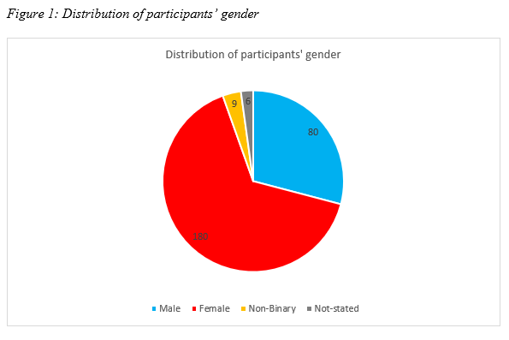

2.3 Materials
Participants were shown an information sheet (See Appendix A), communicating
the aims, requirements, and how their data would be used for this research. A consent sheet (See Appendix B) stated that participation was voluntary and anonymous. Participants could withdraw at any time until February 7th 2023, and asked to confirm participants were over 18. Demographic questions asked participants to select their age range and enter their gender identification (See Appendix C). The participants were then instructed to complete each of the three measures mentioned below. After completion, participants were asked again for the confirmation of their consent (See Appendix D) and then appropriately debriefed (See Appendix E). No questions were required to be answered, and only those indicating consent at both the beginning and end were used.

Measure of empathy: The Toronto Empathy Scale (see Appendix F), produced by
Spreng et al. (2009) is a self-report scale comprising 16 items on a 0 to 4 Likert scale. 0= Never, 1= Rarely, 2= Sometimes, 3= Often, 4= Always. Cronbach’s α has been calculated at .81
(See Appendix G).

Measure of gratitude: The Gratitude Questionnaire Six-Item Form (GQ-6) (see Appendix
H), developed by McCullough et al. (2002), is a self-report of 6 items on a 1 to 7 Likert scale. 1= strongly disagree, 2= disagree, 3= slightly disagree, 4= neutral, 5= slightly agree, 6= agree, 7= strongly agree. Two of the questions are reverse-scored. The GQ-6 has good internal reliability, with Cronbach’s alphas being .79. (See Appendix I).

Measure of prosocial behaviour: This Prosocial Scale for Adults (PSA) (see Appendix J)
was developed by Caprara et al. (2005). This self-report scale consists of 16 items on a 1 to 5 Likert scale, where 1= never/almost never true, 2= occasionally true, 3= sometimes true, 4= often true, and 5= almost always/always true. Cronbach’s α has been established at .91 (See Appendix K).

2.4 Pilot study
A pilot study was conducted prior to the experiment (n=7). Participant feedback indicated
the time it took to complete the survey (approximately 7 minutes), found the survey easy to navigate and faced no significant issues. No changes were made to the materials utilised.

2.5 Procedure
The online survey presented participants with an information sheet and consent
form. Participants were then asked to create an anonymised code (see Appendix L) and begin answering the questions. Participants were asked to provide information about their age and gender and then complete the formal measures previously mentioned. Once the measures were completed, the participants were asked to re-confirm their consent, debriefed, and thanked for their participation.

2.6 Ethical considerations
This research study obtained ethical approval from the Department of Technology &
Psychology in IADT (see Appendix M) remained in line with the code of Professional Ethics outlined by the Psychological Society of Ireland (2019). Participants created an anonymised code to keep their answers unidentifiable, allowing them to contact the researchers to have their data removed using their 5-digit code. As previously mentioned, informed consent was obtained, and participants were appropriately debriefed. As the study was conducted through the use of online surveys, researchers followed guidelines by the British Psychological Society (2021) for internet-mediated research - including concerns for data privacy and protection.

Results
3.1 Overview
The factor variables of the present study were empathy and gratitude. The target variable
for the present study was prosocial behaviour. Using SPSS IBM version 28, a standard multiple linear regression was conducted.

3.2 Descriptive Statistics
The data used to conduct the standard multiple linear regression of the current study
is outlined in Table 1 below. Four participants were eliminated from the original data (N=280) as outliers. In total, 276 participants were included in the analysis. The N value, mean, and standard deviation for each scale variable are presented below.
Table 1: Descriptive Statistics
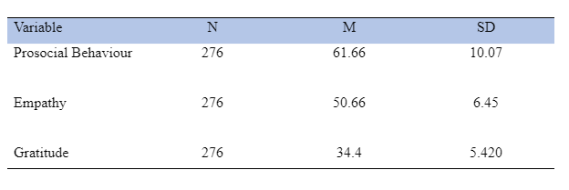
3.3 Inferential Statistics
3.3.1 Assumptions
Preliminary analyses were conducted to ensure the assumptions of this test were met, no
violation of singularity, normality, linearity, multicollinearity, and homoscedasticity was found. The assumption of singularity was met as there were no strong correlations between the predictor variables (see Appendix N for SPSS output). Partial regression plots assessed the linearity (See Appendix O) and a plot of standardised residuals against the predicted values (See Figure 2 below). The assumption of independence of residuals was met, illustrated by a Durbin-Watson statistic of 2.03. All tolerance values are above .7, concluding no evidence of multicollinearity (see Appendix P for SPSS output). The assumption of normality is met as the Mahalanobis distances range from .011 to 12.52 (See Appendix Q).

Figure 2: Histogram displaying normal distribution for target variable.
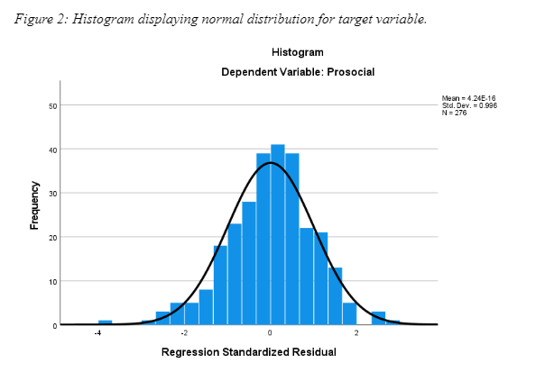
3.3.2 Multiple Regression
Using the enter method, a significant model emerged: F (2, 273) =136.55, p<.001,
R2 = .500, R²Adjusted = .496). (See Appendix R for SPSS output). Table 2 below provides information for the predictor variables entered into the model. The strongest predictor of prosocial behaviour levels was empathy levels (β=.638, t (2,273) =12.736, p=<.001). Gratitude was also a strong predictor of prosocial behaviour levels (β= 119, t (2,273) =2.373, p=.018).

Table 2: The standardised and unstandardized regression coefficients for predictor variables entered into the model.
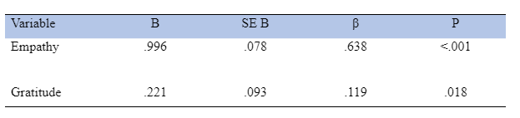

3.3.3 Summary of results:
The primary hypothesis stated that there would be a significant linear relationship
between empathy and gratitude in prosocial behaviour. Hypothesis 1 was supported as empathy and gratitude significantly contributed to the regression model F (2, 273) =136.55, p<.001, R2 = .500, R²Adjusted = .496).

The second hypothesis stated that there would be a significant relationship between
empathy and prosocial behaviour. There was a strong positive linear correlation of .700, p<.001. Therefore, H2 is supported. Figure 4 below shows a scatterplot representation of the correlation between empathy and prosocial behaviour levels.

Figure 3: Scatterplot showing correlation between empathy and prosocial behaviour levels.
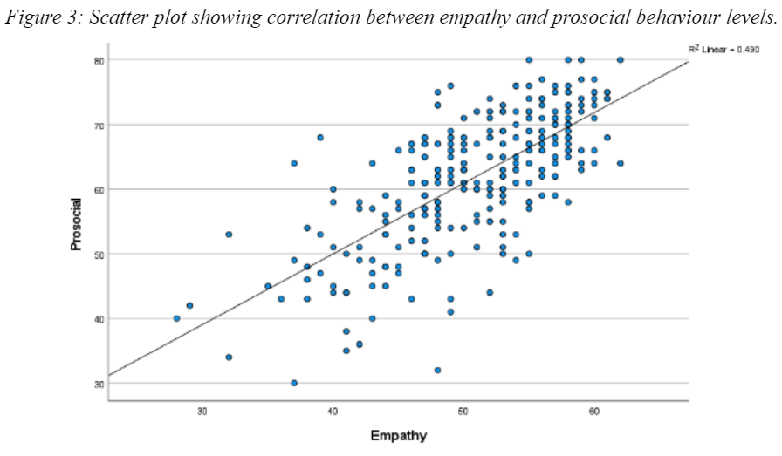

The third hypothesis stated that there would be a significant relationship between gratitude
and prosocial behaviour. There was a moderate correlation of .451, with a significant p-value of <.001; therefore, H3 is supported. Figure 5 below shows a scatterplot representation of the correlation between gratitude and prosocial behaviour levels.

Figure 4: Scatterplot showing correlation between gratitude and prosocial behaviour levels.

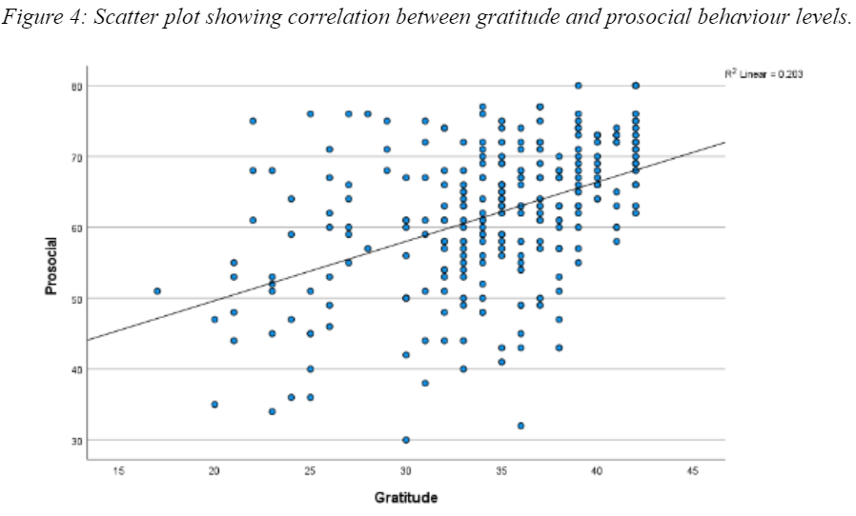
Discussion
4.1 Overview
The purpose of the current research study was to investigate the relationship between
empathy, gratitude, and prosocial behaviour. The contribution of this study has been to confirm significant relationships found between empathy and gratitude on prosocial behaviour levels. These findings broadly support the work of other studies (Kim et al., 2018; Puri et al., 2019; Rodriguez et al., 2021) in linking empathy and gratitude with prosocial behaviour.

Hypothesis 1 states there will be a significant linear relationship between empathy and
gratitude in prosocial behaviour. Hypothesis 1 was found to be accurate as empathy and gratitude did show a significant correlation to prosocial behaviour levels.
This supports the findings of Pang et al. (2022), as gratitude and empathy were essential
mediators in the effect of prosocial behaviour. Similarly, the present study corroborates the ideas of Kim et al. (2018), who suggested that gratitude and empathy correlate to prosocial behaviours as mediated by compassion.

Hypothesis 2 states that there would be a significant relationship between empathy and
prosocial behaviour. Hypothesis 2 was shown to be true. The findings of this investigation complement those of earlier studies linking empathy with prosocial behaviour. This study supports evidence from previous observations (Kamas & Preston, 2021; Pang et al., 2022; Rodriguez et al., 2021), where participants who reported higher levels of empathy were found to produce greater levels of prosocial behaviour. It is suggested that prosocial behaviour is aroused or motivated by empathy (Cnaan et al., 2010; Decety & Cowell, 2014).

Hypothesis 3 states there will be a significant relationship between gratitude and
prosocial behaviour. Hypothesis 3 was found to be accurate as higher levels of gratitude did show a significant correlation to higher levels of prosocial behaviour. This supports the findings of Emmons and McCullough (2003), where it was found that higher levels of gratitude showed higher prosocial behaviour motivation. Findings are also consistent with the research by Lambert et al. (2009), which found that gratitude mediates reciprocal altruism.

4.2 Theoretical implications
The present study contributes to the developing literature regarding the studied variables.
These combinations of findings between empathy and prosocial behaviour provide some support for the conceptual premise of the empathy-altruism hypothesis, as proposed by Batson (2011). Higher levels of empathy, or empathetic concern, correlated with higher levels of prosocial behaviour, which is related to altruistic motivation. Batson (2011) describes altruistic or prosocial activities across many cases and species. This information can be used to develop targeted interventions to promote greater levels and frequency of empathy and prosocial behaviour, as discussed further in the following section.

4.3 Practical Implications
The findings of this study have several practical implications. The present study can
help people recognise the importance of empathy, gratitude, and prosocial behaviour. High prosocial behaviour and empathy levels can help improve connection to like-groups (Cnaan et al., 2010). Prosocial behaviour has been shown to significantly affect gratitude and resilience, which should continue to be promoted as this can improve well-being (Llenares et al., 2020). Acting prosocially can improve social connectedness within communities (Brown et al., 2012), an essential element in many areas of life. Social connections have been found to be linked to happiness and a source of overall well-being (Helliwell et al., 2018). Communities should focus on encouraging more significant levels of social capital to improve societal function through prosocial behaviour, empathy, and gratitude.

As the findings state, higher levels of empathy and gratitude can cause greater prosocial
behaviour. Post (2011) suggests that compassion fatigue should be avoided by people who are prone to overexert themselves through empathetic altruism. It is important to replenish well-being in order to continue to act prosocially in our communities by helping others. To avoid burnout, self-care should be taught and encouraged in schools and the workplace. Compassion fatigue can be avoided by balancing time between helping behaviours and time to the self, and some people may also find spiritual actions may also help replenish (Post, 2011). Well-being can be improved or restored by any means, but as previously stated by Emmons and McCullough (2003), self-guided gratitude exercises can improve well-being.
4.4 Strengths and Limitations
The present study explores the specific correlation between empathy, gratitude, and
prosocial behaviour, which has yet to be explored extensively in previous literature and research. The present study used self-report measures with high levels of internal consistency. Kreitchmann et al. (2019) stated that self-report measures could sometimes lead to participants providing more socially desirable results. This could have led to some participants’ reporting higher levels of empathy, gratitude, or prosocial behaviour than what is actually experienced.

A comprehensive demographic group of many ages and genders were examined in the
present study as per the suggestion of previously cited research (Lasota et al., 2020; Kamas & Preston, 2021; Kim et al., 2018; Tian et al., 2015). Although, the present study did not consider further details such as education level, occupation, religion, etc., which may have altered the outcome of the results (Kim et al., 2018). As previously discussed, people from different groups might produce higher levels of empathy, gratitude or prosocial behaviour towards other groups (Cnaan et al., 2010; Kamas & Preston, 2021; Rodriguez et al., 2021) - for example, religious people being more frequently charitable or people acting more prosocially towards like-groups.

4.5 Future research
Future research should consider implementing experiment-based research to establish
differences between prosocial motivations and prosocial actions. Cnaan et al. (2010) found that young people often have varying motivations for partaking in prosocial behaviour - such as altruistic or ego-driven motivations. There have also been studies with varying results regarding the Bystander Effect (Darley & Latané, 1968; Philpot et al., 2020) or people engaging in prosocial behaviour only due to social desirability (Zaki et al., 2014), so an experimental design might provide richer results.

As previously mentioned, often self-report surveys are answered in ways that may not
reflect a participant’s true feelings or actions (Kreitchmann et al., 2019). Using self-report scales and observer reports (surveys filled in by a relative, partner, or close friend of the participant), similar to Emmons and McCullough (2003), could be considered a research design by future researchers. Observer reports can help eliminate any internal biases or social desirability participants may feel.

Future research in this area might consider accounting for variables such as gender,
education level, or religion concerning empathy, gratitude, and prosocial behaviour. Women generally have higher levels of empathy (Hoffman, 1977; Kamas & Preston, 2022), so including gender as a variable could produce varying correlational results. Exploring various aspects of empathy, such as cognitive or affective empathy, may also be beneficial to study (Pang et al., 2022). Cnaan et al. (2010) found that young people most commonly partook in volunteer roles that benefitted other young people, so further research considering prosocial behaviour biases between like-groups could also be considered.

4.6 Conclusion
The present study set out to explore if there was a relationship between empathy,
gratitude, and prosocial behaviour levels. Multiple regression analysis revealed that higher levels of empathy and gratitude significantly correlate to higher levels of prosocial behaviour. The findings support those of other previous research (Emmons & McCullough, 2003; Kim et al., 2018; Pang et al., 2022). The study aids to contribute to a previous gap in the literature regarding the specific relationship between the three variables with a diverse and moderate size sample. More information on gender (Kamas & Preston, 2021; Kim et al., 2018; Tian et al., 2015), types of empathy (Pang et al., 2022), types of gratitude (Lambert et al., 2009) or experimental conditions could help to establish a greater degree of insight on this matter for future researchers. Communities should focus on encouraging more significant levels of social connectedness to improve societal function through prosocial behaviour, empathy, and gratitude.

5. References

Allen, S. (2018). The Science of Gratitude. Conshohocken, PA: John Templeton Foundation.
Retrieved from: https://thesnipermind.com/images/Studies-PDF-Format/GGSC-JTF_White_Paper-Gratitude-FINAL.pdf
American Psychological Association. (n.d.). Empathy. In APA Dictionary of Psychology.
Retrieved November 20 2022, from https://dictionary.apa.org/empathy
Batson, C. D. (2011). Altruism in Humans. Oxford University Press, USA.
British Psychological Society. (2021). Ethics Guidelines for Internet Mediated Research.
Brown, K. M., Hoye, R., & Nicholson, M. (2012) Self-Esteem, Self-Efficacy, and Social
Connectedness as Mediators of the Relationship Between Volunteering and Well-Being, Journal of Social Service Research, 38:4, 468-483, DOI: 10.1080/01488376.2012.687706
Caprara, G. V., Steca, P., Zelli, A., & Capanna, C. (2005). A new scale for measuring adults'
prosocialness. European Journal of Psychological Assessment, 21(2), 77-89. DOI 10.1027/1015-5759.21.2.77
Cnaan, R. A., Smith, K. A., Holmes, K., Haski-Leventhal, D., Handy, F., & Brudney, J. L.
(2010). Motivations and Benefits of Student Volunteering: Comparing Regular, Occasional, and Non-Volunteers in Five Countries. Canadian Journal of Nonprofit and Social Economy Research, 1(1), 65-81. https://doi.org/10.22230/cjnser.2010v1n1a2
Cuff, B. M. P., Brown, S. J., Taylor, L., & Howat, D. J. (2014). Empathy: A Review of the
Concept. Emotion Review, 8(2), 144–153. doi:10.1177/1754073914558466
Darley, J. M., & Latané, B. (1968). "Bystander intervention in emergencies: Diffusion of
responsibility". Journal of Personality and Social Psychology. 8 (4, Pt.1): 377–383. doi:10.1037/h0025589
Decety, J., & Cowell, J. M. (2014). The complex relation between morality and empathy. Trends
in Cognitive Sciences, 18(7), 337-339. https://doi.org/10.1016/j.tics.2014.04.008
Dovidio, J.F., Piliavin, J.A., Schroeder, D.A., & Penner, L.A. (2006). The Social Psychology of
Prosocial Behaviour (1st ed.). Psychology Press. https://doi.org/10.4324/9781315085241
Emmons, R. A., & McCullough, M. E. (2003). Counting blessings versus burdens: an
experimental investigation of gratitude and subjective well-being in daily life. Journal of Personality and Social Psychology, 84(2), 377. DOI: 10.1037/0022-3514.84.2.377
Fletcher-Watson, S., & Bird, G. (2020). Autism and empathy: What are the real links? Autism,
24(1), 3-6. https://doi.org/10.1177/1362361319883506
Flinchbaugh, C. L., Moore, E. W. G., Chang, Y. K., & May, D. R. (2012). Student Well-Being
Interventions: The Effects of Stress Management Techniques and Gratitude Journaling in the Management Education Classroom. Journal of Management Education, 36(2), 191–219. https://doi.org/10.1177/1052562911430062
Helliwell, J. F., Aknin, L. B., Shiplett, H., Huang, H., & Wang, S. (2018). Social capital and
prosocial behavior as sources of well-being. In E. Diener, S. Oishi, & L. Tay (Eds.), Handbook of well-being. Salt Lake City, UT: DEF Publishers. DOI: nobascholar.com
Hoffman, M. L. (1977). Sex differences in empathy and related behaviors. Psychological
Bulletin, 84(4), 712. https://doi.org/10.1037/0033-2909.84.4.712
Ipsos MRBI & Volunteer Ireland. (2020). IMPACT OF COVID-19 ON VOLUNTEER
PARTICIPATION IN IRELAND. Volunteer Ireland OmniPoll Research. 20-071440. Retrieved from: https://www.volunteer.ie/wp-content/uploads/2022/04/20-071440-Volunteer-Ireland-Omnipoll-Research-FINAL-23rd-Oct-2020.pdf
Kamas, L., & Preston, A. (2021). Empathy, gender, and prosocial behaviour. Journal of
Behavioural and Experimental Economics, 92, 101654. https://doi.org/10.1016/j.socec.2020.101654
Kim, G. Y., Wang, D., & Hill, P. (2018). An investigation into the multifaceted relationship
between gratitude, empathy, and compassion. Journal of Positive Psychology and Wellbeing, 2(1), 23-44. Retrieved from: https://journalppw.com/index.php/jpsp/article/view/56
Kreitchmann, R. S., Abad, F. J., Ponsoda, V., Nieto, M. D., & Morillo, D. (2019). Controlling for
response biases in self-report scales: Forced-choice vs. psychometric modelling of Likert items. Frontiers in Psychology, 10, 2309. https://doi.org/10.3389/fpsyg.2019.02309
Lambert, N. M., Graham, S. M., & Fincham, F. D. (2009). A prototype analysis of gratitude:
Varieties of gratitude experiences. Personality and Social Psychology Bulletin, 35(9), 1193-1207. https://doi.org/10.1177/0146167209338071

Lasota, A., Tomaszek, K., & Bosacki, S. (2020). How to become more grateful? The mediating
role of resilience between empathy and gratitude. Current Psychology: A Journal for Diverse Perspectives on Diverse Psychological Issues, 41(10), 6848–6857. https://doi.org/10.1007/s12144-020-01178-1
Llenares, I., Sario, J. A, Bialba, D, & Dela Cruz, M.J, (2020) Volunteerism influences on student
resilience and gratitude, Journal of Psychology in Africa, 30:3, 211-216, DOI: 10.1080/14330237.2020.1777031
McCullough, M. E., Emmons, R. A., & Tsang, J. (2002). The grateful disposition: A conceptual
and empirical topography. Journal of Personality and Social Psychology, 82, 112-127. https://doi.org/10.1037/0022-3514.82.1.112
Okun, M. A., & Kim, G. Y. (2016). The interplay of frequency of volunteering and prosocial
motivation on purpose in life in emerging adults. Journal of Social Psychology, 156(3), 328–333. https://doi.org/10.1080/00224545.2015.1080657
Pang, Y., Song, C., & Ma, C. (2022). Effect of different types of empathy on prosocial
behaviour: Gratitude as mediator. Frontiers in Psychology, 13. doi: 10.3389/fpsyg.2022.768827
Philpot, R., Liebst, L. S., Levine, M., Bernasco, W., & Lindegaard, M. R. (2020). Would I be
helped? Cross-national CCTV footage shows that intervention is the norm in public conflicts. The American psychologist, 75(1), 66–75. https://doi.org/10.1037/amp0000469
Post, S. G. (2011). It’s good to be good: 2011 fifth annual scientific report on health, happiness
and helping others. International Journal of Person-Centred Medicine, 1, 4. https://doi.org/10.5750/ijpcm.v1i4.154
Psychological Society of Ireland. (2019). Professional Code of Ethics.
Puri, A., Mohan, K., & Panday, N. (2019). Empathy and gratitude as indicators of pro-social
behaviour among adolescents. IAHRW International Journal of Social Sciences Review, 7(5-III), 1594-1599. Retrieved from: https://search.proquest.com/openview/7132c92215b9ef7baab588a9e5cfb305/1?pq-origsite=gscholar&cbl=5347679
Raposa, E. B., Laws, H. B., & Ansell, E. B. (2016). Prosocial behaviour mitigates the negative
effects of stress in everyday life. Clinical Psychological Science, 4(4), 691–698. https://doi.org/10.1177/2167702615611073
Rodriguez, L. M., Martí-Vilar, M., Reig, J. E., Mesurado, B. (2021). Empathy as a predictor of
prosocial behaviour and the perceived seriousness of delinquent acts: a cross-cultural comparison of Argentina and Spain. Ethics Behaviour. 31, 91–101. Doi: 10.1080/10508422.2019.1705159
Spreng, R. N., McKinnon, M. C., Mar, R. A., & Levine, B. (2009). The Toronto Empathy
Questionnaire: scale development and initial validation of a factor-analytic solution to multiple empathy measures. Journal of Personality Assessment, 91(1), 62–71. doi: 10.1080/00223890802484381
Tian, L., Du, M., & Huebner, E. S. (2015). The effect of gratitude on elementary school students’
subjective well-being in schools: The mediating role of prosocial behaviour. Social Indicators Research, 122(3), 887-904. DOI:10.1007/s11205-014-0712-9
Yang, Y., Kong, X., Guo, Z., & Kou, Y. (2021). Can self-compassion promote gratitude and
prosocial behaviour in adolescents? A 3-year longitudinal study from China. Mindfulness, 12(6), 1377-1386. https://doi.org/10.1007/s12671-021-01605-9
Zaki, J. (2014). Empathy: A motivated account. Psychological Bulletin, 140(6), 1608–1647.
https://doi.org/10.1037/a0037679

6. Appendices
6.1 Appendix A - Information Sheet

Title of project: “The relationship between Empathy & Gratitude on Prosocial Behaviour levels.”

You are invited to take part in the research investigation into the relationship between Empathy and Gratitude levels on Prosocial Behaviour.
This project is being undertaken by Sophie Kathryn, under the supervision of Hannah Barton, for a major research project as part of the BSc (Hons) in Applied Psychology, IADT.

Before you decide whether you wish to take part, it is important for you to understand why this research is being done and what it will involve. Please take time to read this information carefully and discuss it with someone you trust. If there is anything that is unclear or if you would like more information please ask, our contact details are at the end of this information sheet.

What is the purpose of the project?
Empathy and gratitude may be concepts that many people are familiar with in everyday life. Prosocial Behaviours are a broad range of actions that benefit others – which some people link to Empathy and Gratitude. This research study aims to understand how Empathy and Gratitude levels have a possible effect on Prosocial Behaviour.

Why are you being invited to take part?
This study is for any persons over the age of 18 interested in taking part.

What is involved?
If you choose to participate, you will be asked demographic questions about your age and gender, followed by three questionnaires.
After the demographic questions, three subsequent sections will ask you to rate your experiences regarding certain statements on Likert scales (example: never, rarely sometimes, often, always). The first section will show statements regarding Empathy, the second section will show statements regarding Gratitude, and the third section will show statements regarding Prosocial Behaviour.
The study will take approximately 10 minutes.

Do I have to take part?
You are free to decide whether you wish to take part or not. If you do decide to take part, you will be asked to sign a consent form that lets us know you have read this information sheet and understand what is involved in the research. You are free to withdraw from this study at any time and without giving reasons.

What are the disadvantages and risks (if any) of taking part?
The questionnaire will be asking questions regarding Empathy, Gratitude, and Prosocial Behaviour and there is a possibility that there might be questions that make you uncomfortable. You may decide not to answer these questions if you do not wish to.

What are the possible benefits of taking part?
We cannot promise the study will help you, but the information we get from the study will help to increase the understanding of Empathy and Gratitude’s role in Prosocial Behaviour.

How will my information be used?
Your responses to the questionnaire will be combined with all other participants' data and statistically analysed under an anonymised code. No individual’s data will be identifiable in the final report. The results of this analysis will be reported in the thesis for the BSc (Hons) in Applied Psychology at the Dun Laoghaire Institute of Art, Design & Technology.
The thesis can be requested through the library at IADT by emailing infolib@iadt.ie or by emailing the researcher or supervisor at N00190598@student.iadt.ie or Hannah.barton@iadt.ie once all data collection and analysis has been completed, submitted, and approved.
This study may also be published in an academic journal article and may be written about for blog posts or media articles, and these can be requested from the researcher.

How will my data be protected?
Your confidentiality will be safeguarded during and after the study through the use of creating an anonymised code to identify your data if you choose to proceed with this study.
Under the EU General Data Protection Regulation (GDPR) the legal basis for collecting data for scholarly research is that of public interest. The regulations regarding the protection of your data will be followed. Only data which is needed for analysis will be collected. By giving your consent to take part in the study you are consenting to the use of your data as detailed in this information sheet.
The data will be retained by the researcher for at least one year, and may be retained for up to 7 years if the results of the study are published in certain capacities (e.g., in a journal article). There is also a possibility that the fully anonymised dataset may be submitted to a journal and made available to other researchers and academics worldwide for verification purposes, but if this occurs it will be ensured that you are not identifiable from the data.

As the supervisor on this project, I, Hannah Barton, am responsible for ensuring that all datasets will be stored in accordance with GDPR regulations and those which are not submitted to a journal will be fully deleted on or before date 7 years from data collection.
Those who will have access to the data of this study will be the primary researcher, Sophie Kathryn, the supervisor, Hannah Barton, and the IADT statistics lecturer and tutor, Dr. Christine Horn. The data will be unlinked-anonymous and stored securely on password protected computers and accounts only accessible by researchers mentioned above.

In the case of a data breach, the Data Protection Officer in IADT will be informed immediately. You will find contact information for IADT's Data Protection Officer, Mr. Bernard Mullarkey, and more information on your rights concerning your data at https://iadt.ie/about/your-rights-entitlements/gdpr/

Who has reviewed the study?
This study has been approved by the IADT Psychology Ethics Committee and supervised by Hannah Barton.

What if you have any questions or there is a problem?
If you have a concern about any aspect of this study, you may wish to speak to the researcher who will do their best to answer your questions.
You should contact Sophie Kathryn (N00190598@student.iadt.ie) or their supervisor Hannah Barton (Hannah.Barton@iadt.ie) should you have any queries or problems.
Thank you for taking the time to read this information sheet and agreeing to take part in the study.

● I have read this information sheet.

Appendices
6.2 Appendix B - Consent Sheet

Title of Project: The relationship between Empathy & Gratitude on Prosocial Behaviour levels.
Name of Researcher: Sophie Kathryn

Consent Form:

● I confirm that I have read and understand the information sheet for the above study and have had the opportunity to ask questions.

● I understand that my participation is voluntary and that I am free to withdraw at any time.

● I understand that data collected about me during this study will not be identifiable when the research is published.

● I am over 18. I agree to take part in this study.

Appendices
6.3 Appendix C - Demographic Questions

Age:
I am…
● 18-24
● 25-34
● 35-44
● 45-54
● 55-64
● 65-74
● 75 years or older
● I prefer not to say.

Gender:
I identify as…
● [Text box]
● I prefer not to say.

Appendices
6.4 Appendix D - Confirmation of Consent

CONFIRMATION OF CONSENT FOR DATA USE:

Having completed the questionnaire:
● I consent to the researchers using my answers for their research.
● I wish to have my answers removed from the research.

Appendices
6.5 Appendix E - Debrief

Title of Project: The relationship between Empathy & Gratitude on Prosocial Behaviour levels.
Name of Researcher: Sophie Kathryn

Thank you very much for taking part in this research study.

Empathy and gratitude may be concepts that many people are familiar with in everyday life. Prosocial Behaviours are a broad range of actions that benefit others – which some people link to Empathy and Gratitude.
The questionnaire you have taken part in will help with understanding how Empathy and Gratitude levels have a possible effect on Prosocial Behaviour.

Withdrawal information:
If you have any questions about this study, or if you would like to withdraw your data from the study, please contact the researcher or supervisor at N00190598@student.iadt.ie or Hannah.Barton@iadt.ie
In your email let them know your unique ID code where you combined the second letters of your first and last name and the last three digits of your telephone number.
If you submit a request for data removal, all data collected from you will be securely deleted. You will be able to remove your data from the study until February 7th, 2022, when the data will be combined and analysed. Data removal will not be possible after that date. Please keep a copy of this information in case you wish to remove your data after leaving this screen.

Data protection:
Your data will be treated according to GDPR regulations. You will find contact information for IADT's Data Protection Officer, Mr Bernard Mullarkey, and more information on your rights concerning your data at https://iadt.ie/about/your-rights-entitlements/gdpr/
Support resources
If you have been affected by the content of this study in any way, the organisations below may be of assistance.

SAMARITANS are available 24/7 for free support by phone 116 123 or Email: jo@samaritans.ie

AWARE are operating their free-phone support line, email supportmail@aware.ie and online Life Skills programme. 1800 804 848 (7 days a week from 10 AM – 10 PM).

CRISIS TEXT LINE New free 24/7 anonymous text support in a crisis. Text MU to 50808 to chat with a trained volunteer at any time.

Appendices
6.6 Appendix F - Toronto Empathy Scale (measure 1)

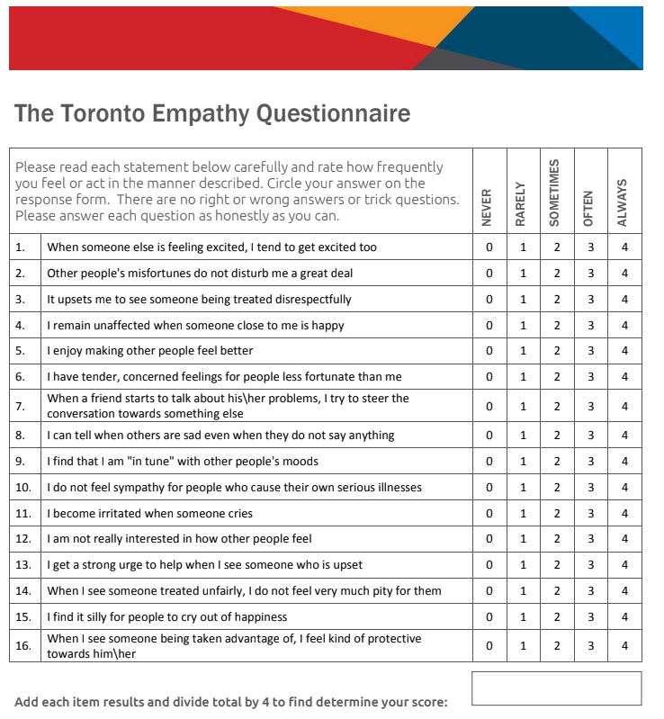

Higher scores indicate high levels of self-reported empathy while scores
below 45 are indicative of below average empathy levels.
Scoring: Item responses are scored according to the following scale for positively worded Items 1, 3, 5, 6, 8, 9, 13, 16. Never = 0; Rarely = 1; Sometimes = 2; Often = 3; Always = 4. The following negatively worded items are reverse scored: 2, 4, 7, 10, 11, 12, 14, 15. Scores are summed to derive total for the Toronto Empathy Questionnaire, which can range from 0 to 64. Males’ general score for this measure ranges from 43.46 to 44.45, while females tend to score within the range of 44.62 to 48.93. Gender differences, as measured by this questionnaire are reported as being moderate.
Spreng, R. N., McKinnon, M. C., Mar, R. A., & Levine, B. (2009). “The Toronto Empathy Questionnaire.” Journal of Personality Assessment, 91(1), 62-71.

Appendices

6.7 Appendix G - Reliability Analysis for measure 1

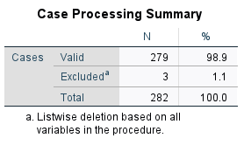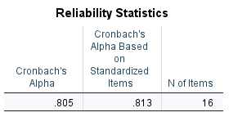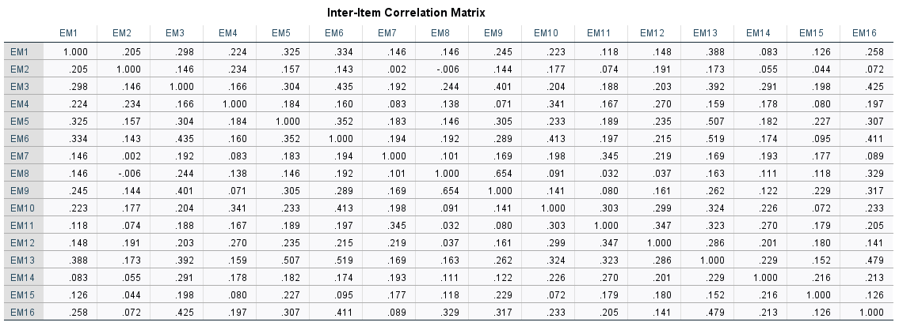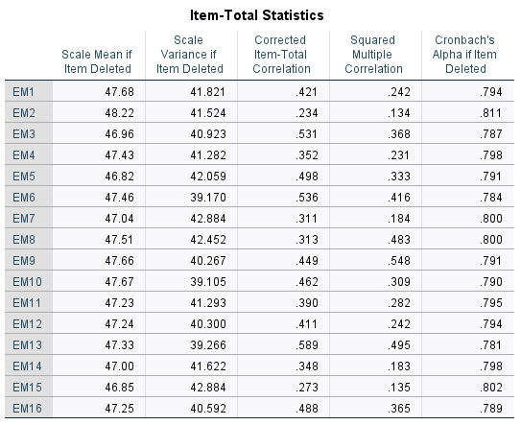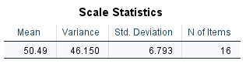

Appendices
6.8 Appendix H - GQ-6 Scale (measure 2)

The Gratitude Questionnaire – Six Item Form (GQ-6)
The Gratitude Questionnaire-Six-Item Form (GQ-6) is a six-item self-report questionnaire
designed to assess individual differences in the proneness to experience gratitude in daily life.
McCullough, M. E., Emmons, R. A., & Tsang, J. (2002). The grateful disposition: A conceptual
and empirical topography. Journal of Personality and Social Psychology, 82, 112-127.
Instructions: Using the scale below as a guide, write a number beside each statement to indicate
how much you agree with it.
1 = strongly disagree
2 = disagree
3 = slightly disagree
4 = neutral
5 = slightly agree
6 = agree
7 = strongly agree
____1. I have so much in life to be thankful for.
____2. If I had to list everything that I felt grateful for, it would be a very long list.
____3. When I look at the world, I don’t see much to be grateful for.
____4. I am grateful to a wide variety of people.
____5. As I get older I find myself more able to appreciate the people, events, and situations that
have been part of my life history.
____6. Long amounts of time can go by before I feel grateful to something or someone.
Scoring: Compute a mean across the item ratings; items 3 and 6 are reverse-scored.

Appendices
Appendix I - Reliability Analysis for measure 2

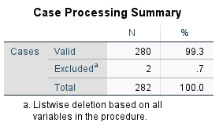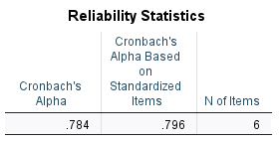
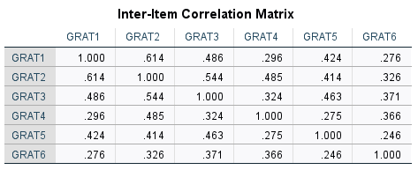
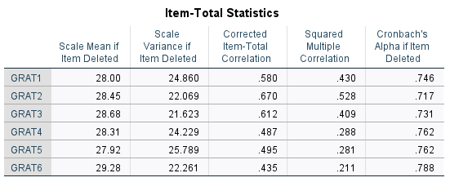
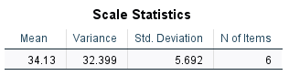

Appendices
6.10 Appendix J - Prosocial Behaviour Scale for Adults (measure 3)

“The following statements describe a large number of common situations.
There are no ‘right’ or ‘wrong’ answers; the best answer is the immediate, spontaneous one. Read carefully each phrase and mark the answer that reflects your first reaction.”

1. I am pleased to help my friends/colleagues in their activities
2. I share the things that I have with my friends
3. I try to help others
4. I am available for volunteer activities to help those who are in need
5. I am emphatic with those who are in need
6. I help immediately those who are in need
7. I do what I can to help others avoid getting into trouble
8. I intensely feel what others feel
9. I am willing to make my knowledge and abilities available to others
10. I try to console those who are sad
11. I easily lend money or other things
12. I easily put myself in the shoes of those who are in discomfort
13. I try to be close to and take care of those who are in need
14. I easily share with friends any good opportunity that comes to me
15. I spend time with those friends who feel lonely
16. I immediately sense my friends’ discomfort even when it is not directly communicated to me.

Never/almost never true (coded as 1)
Occasionally true (coded as 2)
Sometimes true (coded as 3)
Often true (coded as 4)
Almost always/always true (coded as 5).

Appendices
6.11 Appendix K - Reliability Analysis for measure 3

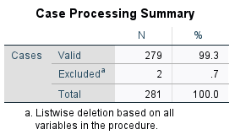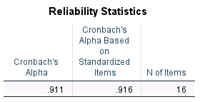

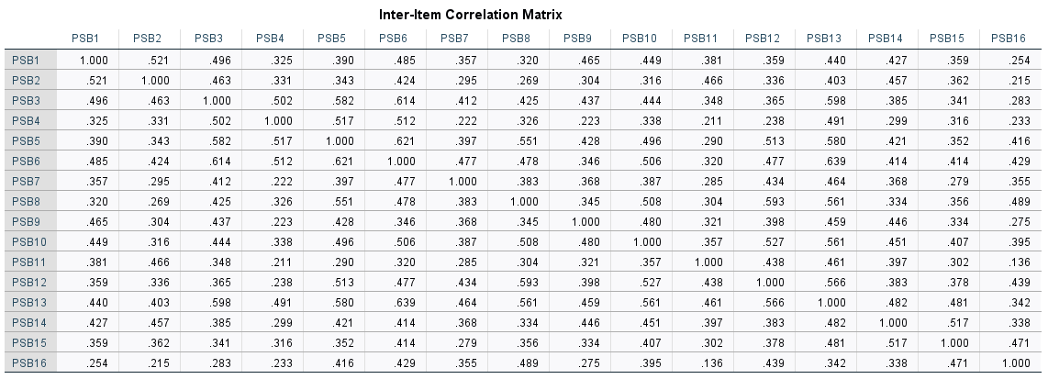
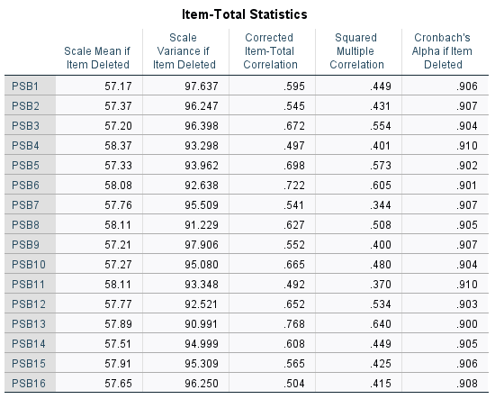
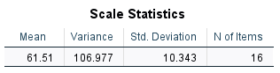

Appendices
6.12 Appendix L - Anonymised Code Creation

Please provide us with an anonymised code which we can use to identify your data if you later wish to have it removed from our dataset.
Please do so by answering the following two questions and combining them to create a 5-digit code.

1. What are the second letters of your first and last name?
2. What are the last three digits of your telephone number?

(For example, if your name is Jane Smith, these letters would be ‘AM’,
and if your number is 080 123 4567, these numbers would be '567',
Therefore, this example code would be 'AM567')

● [Text Box]

Appendices
6.13 Appendix M - Ethical Approval from IADT Psychology Ethics Committee

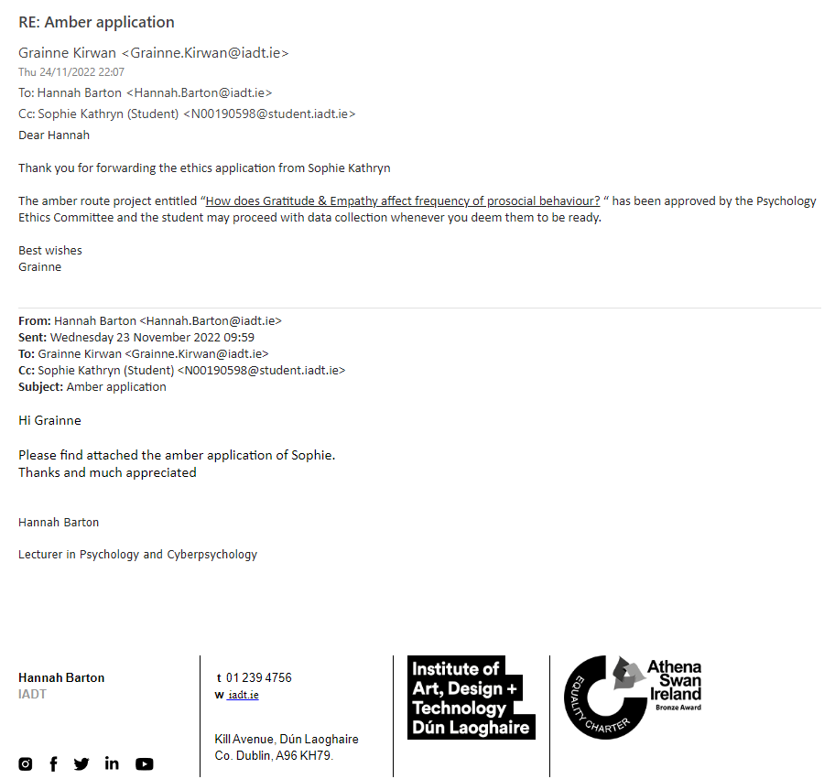

Appendices
6.14 Appendix N - SPSS Output of Predictor Variable Correlations

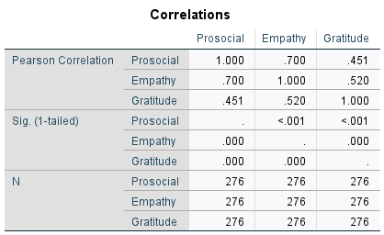

Appendices
6.15 Appendix O - SPSS Output of normal p-plot of regression standardised residual.

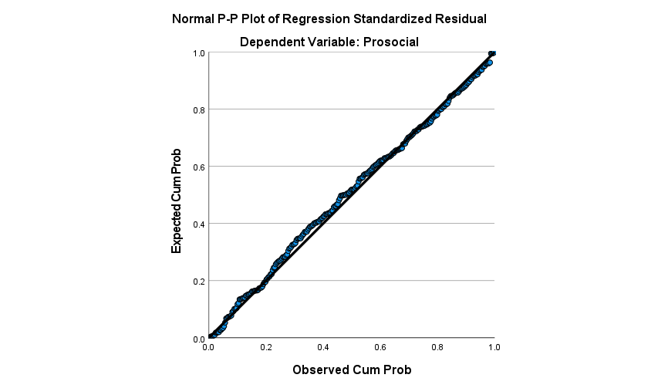

Appendices
6.16 Appendix P - SPSS Output of Tolerance values (for no multicollinearity)

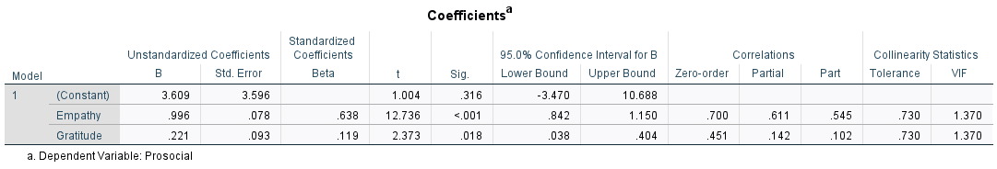

Appendices
6.17 Appendix Q - SPSS Output showing Mahalanobis Distances for Normality

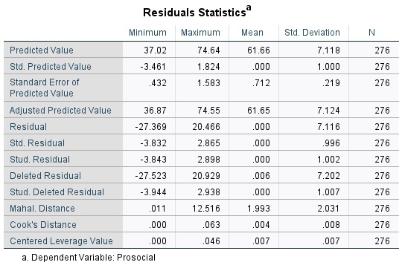

Appendices
6.18 Appendix R - SPSS Output showing Model Summary & Multiple regression analysis.

