“The Forgotten Man”:
An Investigation into the Lived Experiences of
the Fathers of Children with Autism

Lorna Corcoran
N00193411

Research Supervisor:
Dr. Nicola Fox Hamilton

Dissertation submitted as a requirement for the degree of Bachelor Of Science (Honours) in Applied Psychology, Dun Laoghaire Institute of Art Design and Technology, 2023

Declaration

I declare that this submission is my own work. Where I have read, consulted, and used the work of others, I have acknowledged this in the text.

Word Count: 5328 words

Signed:
Lorna Corcoran

Date: 29th March 2023

Acknowledgements

This is the ideal opportunity to thank my research supervisor, Nicola Fox Hamilton, for the wonderful support, great insight and endless patience that she has shown to me. I would like to thank John Greaney for his kindness and care of his students. Thank you to Sinead Meade for her encouragement, and Grainne Kirwan and Christine Horn for the attention to detail in their work. All the academic staff of the Department of Psychology have been both supportive and professional, and enthusiastic in imparting knowledge to their students. My classmates have been a source of knowledge, support and fun, for which thank you all.
Thank you to my parents, Eithne and Eamonn, for fostering curiosity and wonder in me from the beginning. To my children, thank you Eoin for the statistics help, Emer for the neuroscience help and Grainne for the emotional support. Finally and most importantly, I could not have even started on the road to this thesis without the home advantage of my husband Gabriel. Thank you for the endless support and cups of tea, and particularly your belief in me, which made it all possible.
Table of Contents
Page
Number
1. Abstract 1
2. Introduction 2
2.1 Definition 2
2.2 Family Stress 3
2.3. Parental Stress 3
2.4. Cultural and Social Differences 4
2.5 Differences between mothers and fathers 5
2.6 Sources of Support 5
2.7 Key Study 6
2.8 Why study online fora? 6
2.9 Present study 7
3. Method 8
3.1 Design 8
3.2 Ethics 8
3.3 Procedure 8
3.4 Reflexive Thematic Analysis process 9
4. Results 11
4.1. Statistics 11
4.2. Themes and Sub-Themes 11
4.2.1 Theme: Children’s Issues 12
4.2.2. Theme: Family and Home 13
4.2.3 Theme: Obstacles to Progress 14
4.2.4 Online Approaches to Finding Help 15
4.2.5 Theme: Positive Aspects of the Father/Child Relationship 17
4.2.6 Fathers’ Negative Emotions 18
5. Discussion 20
5.1 Parental Stress 20
5.2 Family Relationships 20
5.3 Unexpected Codes 21
5.4 Unexpected Omissions 21
5.5 Strengths and Limitations 21
5.6 Suggestions for Future Research 22
5.7 Conclusion 22
6. References 23
7. Appendices 26
7.1 Appendix A: Original posts from which data was extracted 26
7.2 Appendix B: Data showing initial coding and table of codes 50
7.3 Appendix C: Table of Finalised Themes, Sub-Themes and Codes 70
7.4 Appendix D: Themes, Sub-Themes and Codes 72
7.5. Dissemination Element 80
- Abstract
Despite their importance to rearing a child with Autistic Spectrum Disorder (ASD), fathers are often overlooked in research and their voices not heard. Current research increasingly includes fathers as well as mothers. Fathers reported similar reactions to their child’s diagnosis and problems as mothers, however the sources of stress can be different. Most prior research with fathers involved fathers who were connected to services. In order to explore experiences of those who may not be connected to services, the current study used Reddit.com which is an anonymous forum. The first 5 suitable posts from six ASD-related sub-Reddits were selected, giving a total of 30 posts. A reflexive thematic analysis on these posts was carried out. Results were largely as expected from prior research. Themes of negative emotions, positive emotions and obstacles to progress were seen. Online approaches to finding help included seeking support and seeking resources. Many children involved were not diagnosed. Unexpected themes included the joy and love in the father / child relationship. The children discussed in the data were younger than expected, and the male to female ratio was higher than expected. Results supported the need for father-only interventions and father-to-father communication and mentoring.

- Introduction

“The Forgotten Man” is a term coined by Eisenberg in his 1957 work “The Fathers of Autistic Children”(p. 715). Then and now, one-half of the parenting team of autistic children is often under-represented, neglected and ignored. Fathers have an important part to play in the raising of all children, with paternal involvement improving children’s mental health, academic, social and cognitive outcomes (Cabrera et al., 2000). This can be particularly important in the case of autistic children, where needs may be excessive for just one person. The incidence of autism is approximately 1 in 100 worldwide (WHO, 2022). The increasing rate of incidence is generally attributed to more precise and earlier diagnosis and higher awareness. This literature review looks at what has been found in existing research about stress in the families of autistic children, and the differences between mothers and fathers in this respect. It also looks at sources of support, and cultural differences in how autism is treated in a family. This research aims to expand the knowledge of a fathers role in a family with a child with autism.

  - Definition

Autistic spectrum disorder (ASD) is a neurodevelopmental disorder which is defined by deficits in social communication, restricted interests, and repetitive behaviours(Hodges et al., 2020). Asperger's Syndrome is now classified as Level 1 Autism, meaning that the person requires support. Levels 2 and 3 require substantial or very substantial support respectively. (A.P.A., 2022). The term Asperger’s is still widely used by non-professionals. The ratio of males to females diagnosed with ASD was until recently around 4:1, however more nuanced diagnosis of females has decreased this to about 2:1 (Carpenter et al., 2019). Often diagnosed in early childhood, parents of children with ASD are of necessity very involved in their care and education. Children with ASD are often slow to learn speech and toilet training. Sensory issues can cause difficulty with dressing and eating. Sleeping difficulties are common, while emotional self regulation is often poor leading to meltdowns. Services needed may include speech and language therapy, occupational therapy, behavioural therapy, and specialised medical care. Parents typically become involved in the navigation of services for their children, and family support and involvement is critical to positive outcomes of treatment and therapies (Azeem et al., 2016).

  - Family Stress

A diagnosis of ASD can have an impact on the whole family. A 2015 study discovered that non-ASD siblings of ASD children were more likely to be diagnosed with Generalised Anxiety Disorder or Major Depressive Disorder, than those without an ASD sibling. (Bitsika et al., 2015). This appears to be as a result of the non-ASD children having less access to parental time, and frustration and anger at the challenges brought by their ASD sibling. It may be that families under stress need training not only in raising a child with ASD but also in communicating effectively in order to help that child’s siblings(Haukeland et al., 2022).

  - Parental Stress

The often near-constant struggle for resources and treatment for their children is a major source of stress for parents (Davis & Carter, 2008). This can sometimes lead to conflict between parents and service providers (May et al., 2022). When combined with the difficulties faced by children with ASD, together with their often challenging behaviour, parents often struggle to find support for themselves, particularly if this has financial cost implications (Shepherd et al., 2020). This may be particularly true of fathers, who sometimes feel that they themselves should be the source of support to their partner and child, without needing support themselves (Shave & Lashewicz, 2016). This can often lead fathers to not seek help when it is needed.

Increases in parental stress can have a negative impact on the quality of the care that the child receives. This can lead to feelings of parental guilt, increasing stress, and a negative cycle is then perpetuated (Shepherd et al., 2020). Parents of an ASD child also have less satisfaction and more conflict in their parent-couple relationship than those who do not have a child with ASD (Putney et al., 2021)

A study found that parents of ASD children appear to have a lower than normal level of cortisol on awakening. This blunting of the cortisol response is indicative of greater health risks, and is often as a result of ongoing stress, including being a marker of people with post traumatic stress disorder. This would indicate that as well as psychological stress, parents of ASD children are at greater risk of negative health events. (Foody et al., 2015). For fathers, the challenging behavior of the child has a direct negative effect on their feelings of adequacy as a care-giver (Rudelli et al., 2021). The presence of a father in an ASD home, however, can mediate severe depression in mothers (Machado Junior et al., 2014). This may be because of financial support, social support, or the extra help a father gives with the child. Maternal stress appears to come from the child’s skills in self regulation, i.e. sleeping, emotional regulation, while paternal stress appears to stem from the child’s externalised behaviour (Grebe et al., 2022).

2.4 Cultural and Social Differences

The parents of children with autism have less favourable perceptions of their child’s strengths than the parents of neurotypical children(Larose et al., 2021). This may be because many children with ASD show strength in numbers and letters, logos and plumbing, and electronics, whereas neurotypical children have strengths in playing with friends, reading books and role-playing,which are seen as more “normal”.

Parental perception of the impact of ASD can vary according to culture and social conditions. McLeod and Sabatino carried out research in this area in 2019. This showed that Hispanic parents appear to suffer more distress at their child’s diagnosis than do white parents. This may be a result of Latina mothers having responsibility for the care of other family members as well as the child, but this was not accounted for in the research. Children of more educated parents were less likely to have co-morbid conditions, while children in higher-income families were more likely to have higher functioning ASD. This may be due to differences in access to effective therapy due to cost, but this is unclear. In India, lack of access to the internet can often mean that parents have little understanding of ASD and its implications for their child. Furthermore, fathers in Indian culture have the role of upholding rules and maintaining discipline, making it difficult for fathers there to develop a close relationship with their child with ASD (Gupta, 2020). In Hong Kong, access to information on ASD usually comes from other parents, and there is very little post-diagnosis follow-up. In traditional Chinese culture, a child with a disability is often hidden from the extended family (Tait et al., 2016). These differences show that while clinical information on ASD remains the same worldwide, culture can have a considerable impact on how the ASD child, their diagnosis and their treatment are seen by their families and the wider society.

2.5 Differences between mothers and fathers

Much of the current research on ASD families primarily reflects the experiences and concerns of mothers rather than fathers. A 2015 study included 425 mothers but only 160 fathers(DePape & Lindsay, 2015). A 2016 study on the experience of fathers of children with ASD recommended that further qualitative study in this area be carried out (Cheuk & Lashewicz, 2015).
There are multiple reasons why fathers may not be the primary contact for a child using ASD services. These may include the child’s mother taking the lead in accessing services; the child not living with the father; father’s work commitments not allowing time for accessing services; feelings of shame; language barriers, and undoubtedly many other reasons. However, even when fathers actively seek to be involved in their child’s care and treatment, they often feel ignored and excluded (Brown et al., 2021). One reason for this may be that, in Western cultures, the majority of related professional roles such as social workers, pre-school teachers and school-based speech and language therapists are female, and may feel more comfortable working with mothers (American Speech-Language-Hearing Association 2018; Bureau of Labor Statistics, U.S. Department of Labor, 2016–2018, cited in Rankin et al., 2019).
Mothers and fathers may also differ in how they cope with the challenges of raising a child with ASD. Fathers appear to be less likely than mothers to admit to struggling, or having emotional difficulties. It has been said that “the mothers cry to someone, the fathers cry alone” (McGrath & Chesler, 2004 as cited in Cheuk & Lashewicz, 2015). Mothers report more, and better, coping skills than fathers (Grebe et al., 2022).

2.6 Sources of Support

Support for fathers can come in many forms. Financial, informational and emotional support may all be needed at different times. For example, in some areas, diagnosis can be an expensive process, in which case financial support may be needed. Informational support is particularly relevant when the child is first diagnosed, while emotional support is of best value at a time of crisis.
The sharing of information and experience can be a good form of support, particularly when this is with other fathers (Paynter et al., 2018). Mentoring of fathers whose child has a new diagnosis, by more experienced fathers, may be particularly helpful (Shave & Lashewicz, 2016). However autism is notoriously heterogenous and child specific (Anagnostou et al., 2014) which can lead to difficulty in sharing parental experiences. Many fathers feel that there is not enough social support for them (Rudelli et al., 2021).

2.7 Key Study

A key study in this area compared the stress levels of mothers and fathers, in some cases where they were co-parenting the same child (Grebe et al., 2022). Twenty seven dyads of parents, and a total of 361 participants were recruited to the study. Within the co-parenting dyads, mothers had significantly more self-reported stress than fathers (64.3 compared to 50) but also scored higher for family-based support (70.4 compared to 44.4) and higher positive coping scores (51.9 compared to 29.6). These findings illustrate that fathers often have different perceptions about their children with autism, and the support offered, compared with mothers. Fathers also seem to use different coping skills than the mothers of their children.

However this study does not give the full picture. Participants were recruited through an autism research network (Simons Simplex Collection@Interactive Autism Network), which meant that parents who were not in contact with autism services were less likely to participate. Also, the overwhelming majority of participants were white (84.9%). They were mostly well educated, in that more than 75% had a bachelor's degree or higher, and the majority were higher income families, more than 57% had an income greater than $80K per annum. This study did not have information about families who were outside of services, lower income families, racial minority families or less educated families. There is a need to look at the experiences of those who may not have access to services.

2.8 Why study online fora?

In prior studies, participants are often recruited through their pre-existing connections with ASD services. Gentles et al. carried out research in 2019 on ASD services, for which participant recruitment took place through autism advocacy services. A similar 2015 study by Han et al. recruited participants at an autism-related conference. It would be useful to ascertain the experience of fathers who may not be linked in to ASD services. Such fathers are perhaps more likely to use online, anonymous forums to access information about how best to help, understand or simply cope with their child. The use of social media can be an effective form of support for ASD parents, as it is usually cost free, and can be accessed at a time and place that suits the user (Shepherd et al., 2020). Online support groups are helpful as they create a perception of community while also reaching a wide audience (Chuang & Yang, 2012). A 2019 study of Facebook groups related to autism found that 60% of the groups were created as mutual support for the users, the majority of whom were parents of children or young adults with ASD (Abel et al., 2019).

Judgement is often made of online revelations of parental difficulties. Parents may be harshly treated if they reveal problems in handling their child’s behaviour, whether or not the child has a neurodivergence (Ammari et al., 2019). For this reason a forum such as Reddit.com is often used as a way to vent frustrations or seek help, as anonymity can be preserved. This makes the Reddit.com fora an ideal source of data for this research.

2.9 Present study

Having looked at the current literature, it appears that while the situation is improving, fathers are still often overlooked in autism research. Those fathers who are included are often connected to autism services. To explore the experiences of fathers who may not be thus connected, an anonymous online forum is ideal.

The research question is: What are the lived experiences of the fathers of children with autism who seek support online through Reddit?

3. Methods
3.1 Design
A descriptive, inductive, reflexive qualitative design was chosen for this study. Reflexive thematic analysis, as described by Braun and Clark (2021) is an evolved method of thematic analysis, where the researcher’s reflections on their own position and possible bias is recognised as part of the research process. This brings a rich depth of description, as instead of ignoring or compensating for the researcher’s own values and beliefs, account is taken of these and they become an integral part of the research.

3.2 Ethics
This study was submitted to the IADT Psychology Ethics Committee as a green route application and was approved. The forum used is accessible to the public without use of a password, and there is no contact with the participants.

3.3 Procedure
The research was carried out on posts online by the fathers of children with ASD, to explore their experiences..
A number of online fora were examined for suitability. However any forum used had the requirement of accessibility without login or identification. For this reason Reddit.com was chosen as it is possible to view posts anonymously. A number of communities (r/) on Reddit were inspected for suitability. These include r/Autistic Spectrum Disorder, r/Autism, r/Autism Parenting, r/Autism Translated, r/aspergers, r/aspergirls.
A search was carried out on each of the above communities, for the words “Father”, “Dad”, “Daddy”, “Papa” and “old man”. The term “father” includes trans men, adoptive fathers, step fathers and any others who consider themselves to be a father. The initial post selection was the first posts on each forum recorded on 16 January 2023 at 11.50 a.m.
Of the posts then seen, each one was examined for meaning, in order to ascertain that the post was regarding experiences as a father, rather than experiences about a father. All of the posts were gathered together in a single document, and numbered for organisational purposes. There were a total of 30 posts, with an average post length of 237. Screenshots of the posts were taken together with the text (Appendix A).

3.4 Reflexive Thematic Analysis process
Phase One: Data Familiarisation: The first phase of analysis was familiarisation with the text. For this purpose, the posts were read several times over the course of one week. This was to ensure familiarity with the content of the posts prior to any further, formal analysis. Following this initial immersion, the researcher wrote a reflection on their initial impressions of the texts.
Phase Two: Coding: Following this, the coding phase began. Each piece of text was identified as to whether or not it was of importance, and if so, what an appropriate code for it would be. For example, a piece of text that said “My child will not eat and it makes me mad” could be coded as both Eating Difficulties and Father’s Anger. Coding was carried out by assigning to each code either a highlight colour or a text colour within the document. Where the meaning was implicit or latent, without a particular word carrying meaning, a few spaces were highlighted in the relevant colour at the start of the post. A table of colours and codes was used to keep track of these. Codes were reviewed throughout the whole process. An example of the initial coded data is seen in Appendix B.
Phase Three: Generating Initial Themes: A note was made of candidate themes as they occurred in the text. Shared meaning across the text was identified.
Phase Four: Developing and Reviewing Themes: The candidate themes were assessed in light of the data. Some were split, while others coalesced. The themes and sub-themes were reviewed in light of the research question, to ensure that they had relevance.
Phase Five: Refining, Defining and Naming Themes: The themes were further reviewed and refined. Each theme and sub-theme was given a meaningful label.
Throughout all of this process, the codes, themes and sub-themes were reviewed and revised as meaning was made from the data. Some codes, themes and sub-themes were eliminated altogether, while occasionally new sub-themes or codes were created, for example the “Celebration” code in the theme Online Approach to Finding Help was only added in the final refinement of Themes. At the stage at which it was felt that all possible meaning had been taken from the data, the themes and sub-themes were finalised.
A table was then created of the themes, sub themes and codes. This finalised table can be seen in Appendix C.
Phase Six: Writing Up Throughout the process, writing was carried out both in reflection on the data, and in starting the process of report writing. The researcher reflected on their own situation in relation to the data, and their reactions to the data. This reflexive analysis of the data is more nuanced than analysis where the researcher tries to be completely impartial.
A word cloud was also created of the data, in order to make a visual representation of the content of the text.
Most of the posts used in this research have been paraphrased. This is in order to avoid the possibility of an original post being identified through a search engine. However some original phrases have been kept from the posts, in order to maintain the integrity of the data.

4. Results
4.1 Statistics

A brief analysis was carried out regarding ages and genders of the children concerned. While these were not clear in every case, where stated, there were 28 children, 85% of them were males. This data set showed a male to female ratio of 6:1 instead of the expected 2:1 (Carpenter et al., 2019) . Average age was 4.5 years, with the youngest child being 2 years and the oldest child 11 years. There were 30 posts of an average length of 237 words. The shortest post was 33 words long with the longest post being 753 words.

A word cloud was created in to visualise the text, in order to assist the researcher in familiarisation with the data, and is seen below.
Figure 1
Word Cloud visualisation of Data
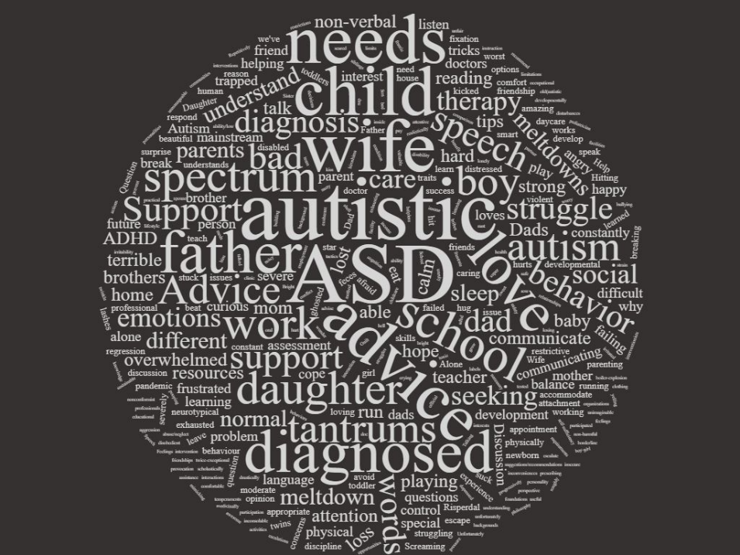

4.2 Themes and Sub-Themes

Most of the posts used in this research have been paraphrased. This is in order to avoid the possibility of an original post being identified through a search engine. However some text has been preserved in order to maintain the integrity of the data. There were 6 major themes found in the data, with some sub themes. Taken together, these illustrate some but not all aspects of life with a child with autism.
4.2.1 Theme: Children’s Issues

Figure 2.
Components of Theme: Children’s Issues
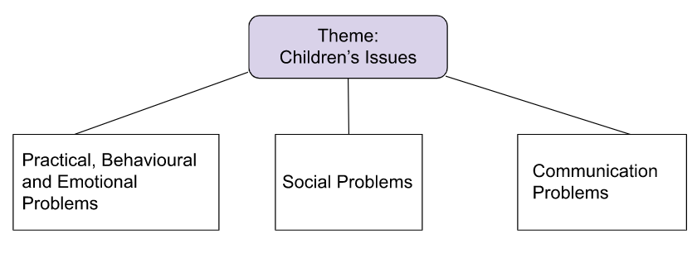
The first theme is Children’s Issues. These are the difficulties faced by the child, which often prompt the father to post online in the first place. These are broken down into sub-themes of the type of issue the child has, as these are dealt with in different ways by fathers. This research is about the fathers, not the children themselves, therefore it is not appropriate at this time to look too closely at the problems of the children, except for inasmuch as they affect the fathers.
Figure 3.
What the fathers say: Children’s Difficulties
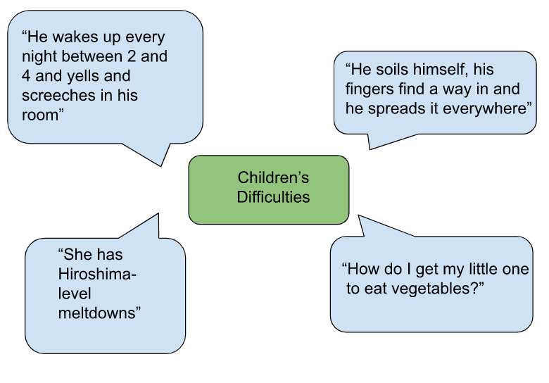
4.2.2 Theme: Family and Home

Figure 4.
Components of Theme: Family and Home
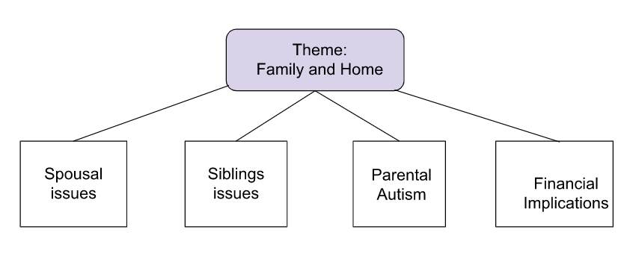

It is quite common that a child’s diagnosis is followed by a diagnosis of a parent or sibling. The mechanism would appear to be that in learning about ASD in a child, the parent recognises the same traits in themselves. Sometimes it can be the other way around as illustrated here:
“I realised that I am probably autistic. I am going through assessment, but I started noticing things about my daughter”.

Spousal issues can refer to a wife, partner or significant other. One wife has a disability which means that she is less able to care for their autistic child. Another wife feels that there is no problem with the child, while the child’s fathers feels that ASD is likely. When both parents are in full time work, this can cause difficulty with child care arrangements, especially where there are behavioural problems. More than one child referenced had been excluded from daycare.
Siblings may feel neglected, or suffer because of the challenges of their autistic sibling. Fathers are concerned that their non-autistic children get enough attention.
Work and finance can have a big impact on any family. Issues such as not having enough money for equipment needed for a child with ASD, and finding funding for therapies, are not as prominent as expected but they are present nonetheless.

Figure 5.
What the fathers say: Family and Home
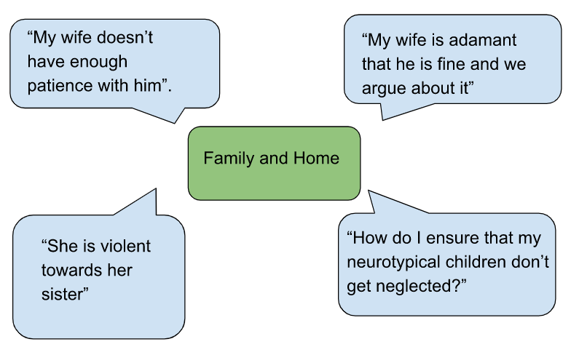

4.2.3 Theme: Obstacles to Progress

Figure 6.
Components of Theme: Obstacles to Progress
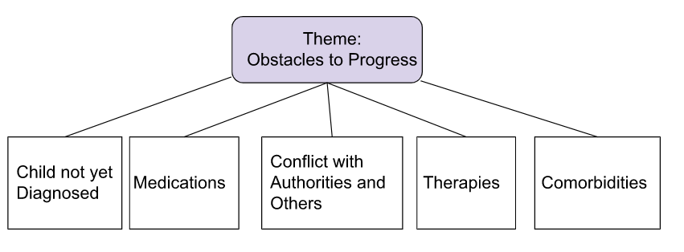
Most parents want to do everything that they can to help their child. However there is not always a straightforward path to doing this. Many of the children discussed are not diagnosed. A diagnosis may be necessary in order for a family to access services, educational accommodations and therapies. In some areas therapy is easily available, whereas in others, parents have to fight for everything. Even when therapies are available, they do not alway have the desired outcome. One father states
“Speech and Language therapy made no difference to him”.

There may be more than one condition present, as ASD is often comorbid with ADHD, anxiety, and depression. Several of the children in the data set have either diagnosed or suspected ADHD as well as ASD, while one child has severe depression. Suicidal ideation is also seen, sometimes in quite young children. Medications are used, particularly in the USA, to treat irritability associated with ASD. While not very prevalent in the data, for some, medication can be source of conflict.

Figure 7.
What the fathers say: Obstacles to Progress
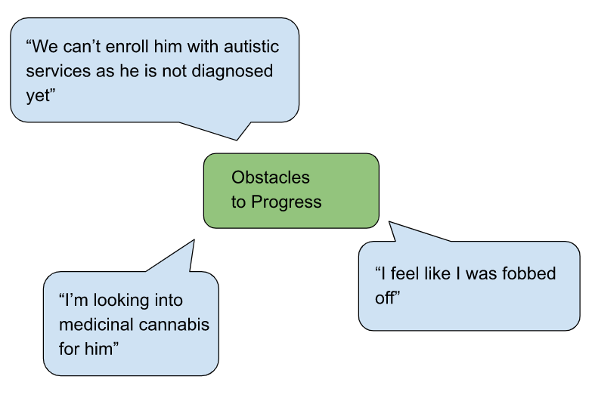

4.2.4 Theme: Online approach to finding help
Figure 8.
Components of Theme: Online Approach to Finding Help
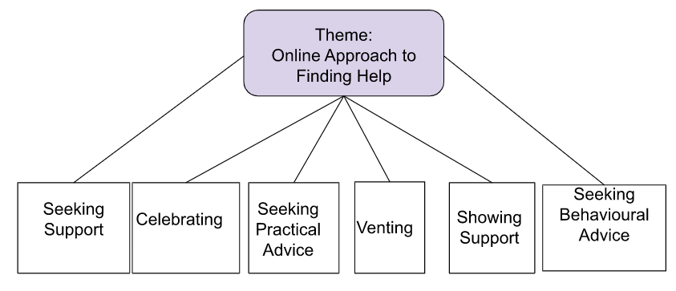

It would appear from the data that usually something happens that triggers a father’s decision to post on an online forum. This might be a diagnosis, or a particularly bad meltdown, or sometimes just the realisation that help is needed.

Raising a child with ASD can sometimes feel very lonely. Support seeking is often seen as a latent meaning without being specifically mentioned. It may be that fathers are looking for support, without being consciously aware that that is what they are doing. Quite often, all that is needed is to vent. While the word “venting” was not often used, it appears that many posts act as a catharsis for fathers; a way to “get things off their chest” without consequence

Advice from others on how best to navigate services or handle situations is a common theme in the data. One dad discusses “... my quest to accommodate and help my son” which illustrates this theme well. A less expected thread is one of celebration; sharing with other fathers a step in progress, as other dads can best appreciate it. A child saying “Daddy, today was a perfect day” is a celebration for the dad who posted it, but also a glimmer of hope for those going through a rough patch.

Figure 9.
What the fathers say: Online Approach to Finding Help
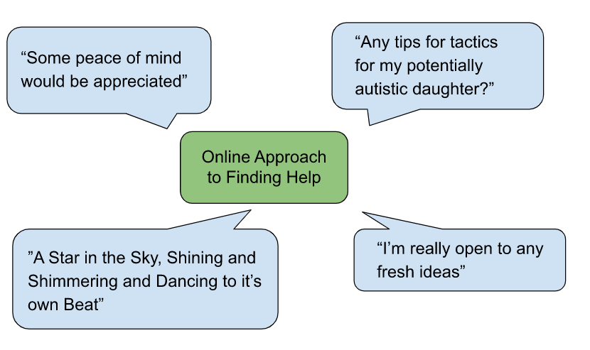

4.2.5 Theme: Positive aspects of father/child relationship

Figure 10.
Components of Theme: Positive Aspects of Father/Child Relationship
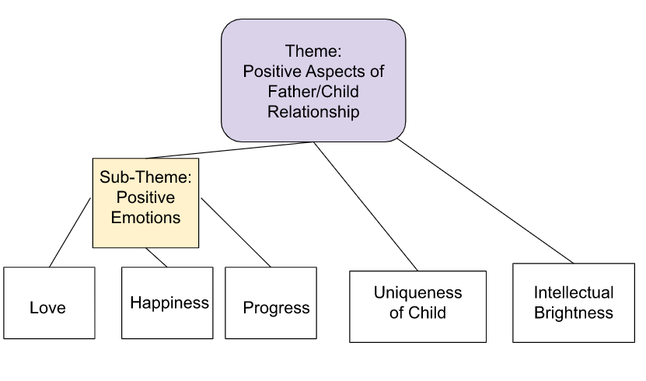

The positive aspects of having children with autism are often overlooked. The strongest emotion that emanates from the data is love. Love is something that is not often found in scientific research, nonetheless it is what keeps these men attached to their children, despite the difficulties. In the words of one dad:
“I love my kids. They are probably the only reason I keep on working and don’t just live in a van by the river”.
The fathers seem to really appreciate even tiny steps made by their children, and this is seen throughout the data.
It is a common mistake to regard all those with autism as being a savant. While this is not true, autism does not preclude a high level of cognition and this is often recognised while the child is quite young.

Figure 11.
What the fathers say: Positive Aspects of Father/Child Relationship

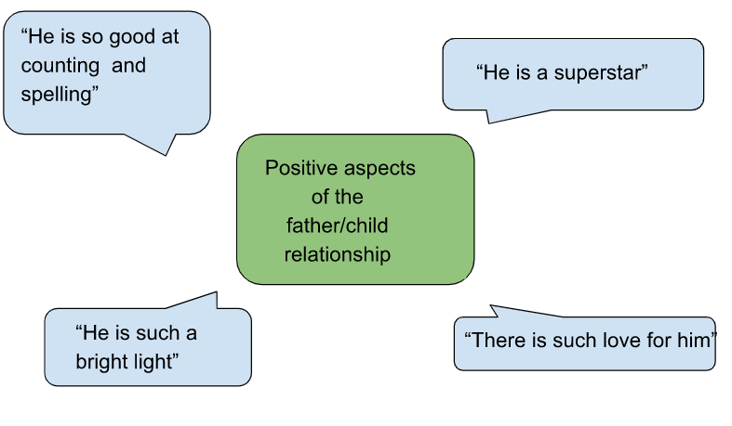
4.2.6 Theme: Fathers’ negative emotions
Figure 12.
Components of Theme: Fathers’ Negative Emotions
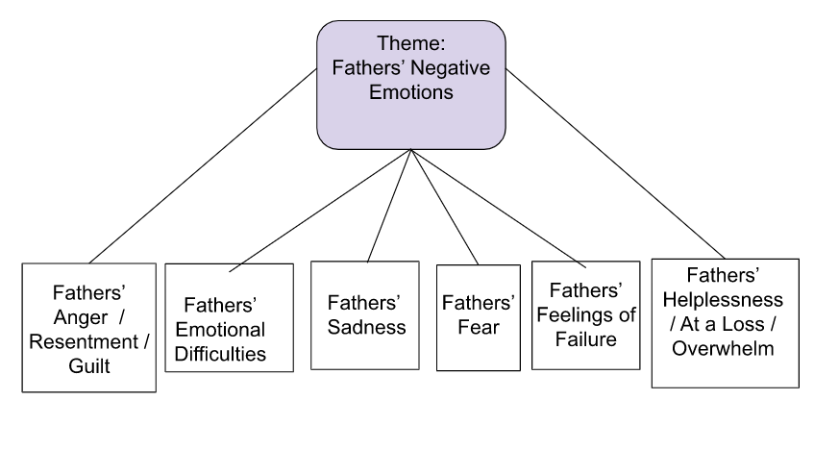
For many fathers, the reason for posting in the first place is due to a negative emotion. These can be very complex. Negative and positive emotions are often mixed together, for example happiness at a child’s progress can be mingled with sadness that it took so long. These negative emotions are seen throughout the data. Often the initial reading of a post does not demonstrate a negative emotion, however more careful reading can often show negative emotions “between the lines” of the posts. The challenges of raising a child with ASD can exacerbate pre-existing emotional difficulties. Anger and resentment are illustrated with phrases such as “I lost my cool”. Feeling of being overwhelmed and at a loss, seen with phrases such as “I cannot cope”, “I have no idea” and “I feel lost” give evidence to the immense difficulty felt by the fathers. Cultural expectations that fathers should provide answers to problems can lead to the use of words such as “failure” and “inadequate” when fathers self-describe.

Figure 13.
What the fathers say: Fathers’ Negative Emotions
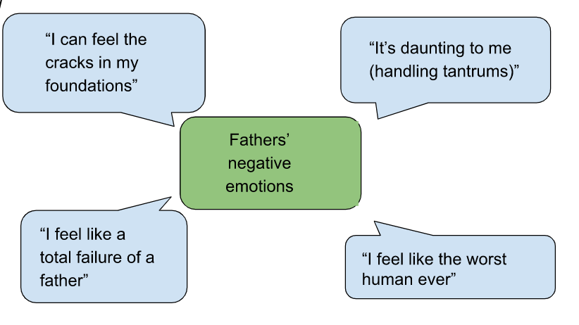

5. Discussion

The fathers whose posts have been examined show “tender involvement along with fierce protectiveness” (Lashewicz et al. 2016 cited in May et al., 2022). They clearly love their children, and many are fighting for services and help for them.

5.1 Parental stress

Prior studies have found that there are many stressors for parents of children with ASD (Shepherd et al., 2020) (DePape & Lindsay, 2015). Extracts from the data support these findings. The sources of stress appear to remain the same; the difficulty of coping with the child’s challenges, navigating services, maintaining a good relationship with spouse and other children. However it would appear that for fathers, there are additional stresses. These are maintaining their own mental health, and maintaining financial provision. This may be because fathers have poorer coping skills than mothers, as suggested in prior research (Grebe et al., 2022). Another additional stressor seen in the data appears to be the conflict between being a carer and more traditional masculine roles such as being the breadwinner, as seen by Shave & Lashewicz (2016).

5.2 Family relationships

Where spouses are mentioned, it is often in a conflict situation regarding care or diagnosis of the child. This has been seen in the literature, (e.g. Putney et al., 2021) and is expected. Previous studies found that siblings of those with ASD and other chronic conditions often suffer with depression and anxiety (Bitsika et al., 2015, Haukeland et al., 2022). These studies were typically where the non-ASD child was aged 8+. However having an ASD child as an older sibling seems, from the data, to possibly have a negative impact on the younger child. Little work has been carried out on this, or the impact on parents of having an ASD child as an older sibling.

5.3 Unexpected codes

The data illustrates feelings happiness as fathers, love for their children, and joy at the progress of their children. This theme of the positive aspects of the father child relationship is rarely seen in previous research, although (Cheuk & Lashewicz, 2015) discuss the appreciation that these fathers have for their child’s development, and a sense of gratitude for their child’s capabilities and personalities. There were less daughters mentioned than expected, despite the increase in diagnosis of females with ASD. This data set showed a female to male ratio of 1:6 instead of the expected 1:2.

5. 4 Unexpected data omissions

This data set did not include some areas which were expected. This does not mean that these aspects are not experienced by the fathers, simply that they were not mentioned in the sample. These include shutdowns (as opposed to meltdowns), stimming and sensory processing difficulties. It was also surprising that the children concerned were so young. The oldest child, where age was identified, was around 11. It was expected that the fathers of older children would be present in the data set, particularly as puberty can often be a time of disruption and challenges for children with ASD, and therefore also for their parents. Further, there was no mention of stigma or social isolation due to having a child with ASD, as seen by Tait et al. (2016). Social support, for example from extended family and friends, was seen in prior work such as that by Rudelli et al. (2021), but was not mentioned in this data set.

5.5 Strengths and Limitations

The non invasive method used to collect data can be equivocal. The anonymous nature of posting on Reddit.com allows participants to be truthful without consideration of the feelings of others. However this very anonymity can also allow “trolling”, where someone can post contentious material simply to enjoy the reaction. As a website such as Reddit.com may attract a particular demographic of user, it may limit the type of data available. However as multiple fora on the website were used, it gives a broader view of experience. It also does not show the view of fathers who, for language, literacy, or technology reasons, do not have access to fora such as Reddit.com. This research fills a gap in the literature, as it allows expression from an otherwise under-represented group who may not respond to surveys. This form of data collection has a strong ethical element, as there is no contact with the participants.

5.6 Suggestions for Future Research

There are many suggestions for future research which are highlighted by this research. Sibling research appears to be rare in this area. The impact on siblings of a child with ASD,particularly younger siblings, needs further research. Impact on parents of a child with ASD where one or more siblings are present is also worthy of further study. Impact on a parent with ASD of having a child with ASD, and vice versa, may also uncover data which might change the approach of medical professionals.

5.7 Conclusion

This research has found that the fathers of children with ASD are struggling practically, emotionally and financially, while balancing the needs of their ASD child, their other children, their spouses and themselves. Despite this they have a deep love for their children, and appear determined to do everything they can to help them. The mental health of these fathers is suffering. Their unique perceptions and strengths are valuable in the raising of a child with ASD, and this should be better recognised in the provision of services for parents and their children. Mental health supports for parents of children with ASD should perhaps have “Father only” services with Father-to-Father mentoring and communication.
The Forgotten Man should be remembered in his own right, and for the sake of his children.

6. References

American Psychiatric Association. (2022). Diagnostic and statistical manual of mental disorders (5th ed., text rev.). https://doi.org/10.1176/appi.books.9780890425787
American Speech-Language-Hearing Association 2018; Bureau of Labor Statistics, U.S. Department of Labor, 2016–2018, cited in
Abel, S., Machin, T., & Brownlow, C. (2019). Support, socialise and advocate: An exploration of the stated purposes of Facebook autism groups. Research in Autism Spectrum Disorders, 61, 10–21. https://doi.org/10.1016/j.rasd.2019.01.009
Ammari, T., Schoenebeck, S., & Romero, D. (2019). Self-declared Throwaway Accounts on Reddit: How Platform Affordances and Shared Norms enable Parenting Disclosure and Support. Proceedings of the ACM on Human-Computer Interaction, 3(CSCW), 1–30. https://doi.org/10.1145/3359237
Anagnostou E., Zwaigenbaum L., Szatmari P., Fombonne E., Fernandez B.A., Woodbury-Smith M., Brian J., Bryson S., Smith I.M., Drmic I., Buchanan J.A., Roberts W., Scherer S.W., (2014). Autism spectrum disorder: advances in evidence-based practice. Canadian Medical Association Journal, 2014. Apr 15;186(7):509-19. doi: 10.1503/cmaj.121756. Epub 2014 Jan 13. PMID: 24418986; PMCID: PMC3986314.
Azeem, M. W., Imran, N., & Khawaja, I. S. (2016). Autism Spectrum Disorder: An Update. Psychiatric Annals, 46(1), 58–62. https://doi.org/10.3928/00485713-20151202-01
Bitsika, V., Sharpley, C. F., & Mailli, R. (2015). The influence of gender, age, Psychological resilience and family interaction factors upon anxiety and depression in non-autism spectrum disorder siblings of children with an autism spectrum disorder. British Journal of Guidance & Counselling, 43(2), 216–228. https://doi.org/10.1080/03069885.2014.950944
Braun, V. & Clarke, V. (2022). Thematic Analysis: A Practical Guide. Sage Publications
Brown, M., Marsh, L., & McCann, E. (2021). Experiences of fathers regarding the diagnosis of their child with autism spectrum disorder: A narrative review of the international research. Journal of Clinical Nursing, 30(19–20), 2758–2768. https://doi.org/10.1111/jocn.15781
Cabrera, N., Tamis-LeMonda, C. S., Bradley, R. H., Hofferth, S., & Lamb, M. E. (2000). Fatherhood in the Twenty-First Century. Child Development, 71(1), 127–136. https://doi.org/10.1111/1467-8624.00126
Carpenter, B., Happé, F., & Egerton, J. (2019). Girls and Autism: Educational, Family and Personal Perspectives. Routledge.
Cheuk, S., & Lashewicz, B. (2015). How are they doing? Listening as fathers of children with autism spectrum disorder compare themselves to fathers of children who are typically developing. Autism : The International Journal of Research and Practice, 20. https://doi.org/10.1177/1362361315584464
Chuang, K. Y., & Yang, C. C. (2012). Interaction Patterns of Nurturant Support Exchanged in Online Health Social Networking. Journal of Medical Internet Research, 14(3), e54. https://doi.org/10.2196/jmir.1824
Davis, N. O., & Carter, A. S. (2008). Parenting Stress in Mothers and Fathers of Toddlers with Autism Spectrum Disorders: Associations with Child Characteristics. Journal of Autism and Developmental Disorders, 38(7), 1278–1291. https://doi.org/10.1007/s10803-007-0512-z
DePape, A.-M., & Lindsay, S. (2015). Parents’ experiences of caring for a child with autism spectrum disorder. Qualitative Health Research, 25, 569–583. https://doi.org/10.1177/1049732314552455
Eisenberg, L. (1957). The fathers of autistic children. American Journal of Orthopsychiatry, 27(4), 715–724. https://doi.org/10.1111/j.1939-0025.1957.tb05539.x
Foody, C., James, J., & Leader, G. (2015). Parenting Stress, Salivary Biomarkers, and Ambulatory Blood Pressure: A Comparison Between Mothers and Fathers of Children with Autism Spectrum Disorders. Journal of Autism & Developmental Disorders, 45(4), 1084–1095. https://doi.org/10.1007/s10803-014-2263-y
Grebe, S. C., Mire, S. S., Kim, H., & Keller-Margulis, M. A. (2022). Comparing Fathers’ and Mothers’ Perspectives About Their Child’s Autism Spectrum Disorder. Journal of Autism & Developmental Disorders, 52(4), 1841–1854. https://doi.org/10.1007/s10803-021-05077-7
Gupta, Y. (2020). Narratives of Indian Parents of Children Diagnosed with Autism Spectrum Disorder. PsyArXiv. https://doi.org/10.31234/osf.io/cq3fj
Haukeland, Y. B., Fjermestad, K. W., Mossige, S., & Vatne, T. M. (2022). Parent-child communication about emotions during SIBS: A joint intervention for siblings and parents of children with chronic disorders. Nordic Psychology, 74(3), 205–221. https://doi.org/10.1080/19012276.2021.1986850
Hodges, H., Fealko, C., & Soares, N. (2020). Autism spectrum disorder: Definition, epidemiology, causes, and clinical evaluation. Translational Pediatrics, 9(Suppl 1), S55–S65. https://doi.org/10.21037/tp.2019.09.09
Larose, V., Sotelo, K., Mottron, L., & Jacques, C. (2021). Initial development of a questionnaire about parents’ perspectives on the strengths and interests of autistic preschoolers. Canadian Journal of Behavioural Science / Revue Canadienne Des Sciences Du Comportement, 53(4), 530–535. https://doi.org/10.1037/cbs0000268
Machado Junior, S. B., Celestino, M. I. O., Serra, J. P. C., Caron, J., & Pondé, M. P. (2014). Risk and protective factors for symptoms of anxiety and depression in parents of children with autism spectrum disorder. Developmental Neurorehabilitation, 1–8. https://doi.org/10.3109/17518423.2014.925519
May, C. D., St George, J. M., & Lane, S. (2022). Fathers Raising Children on the Autism Spectrum: Lower Stress and Higher Self-Efficacy Following SMS (Text2dads) Intervention. Journal of Autism & Developmental Disorders, 52(1), 306–315. https://doi.org/10.1007/s10803-021-04925-w
Paynter, J., Davies, M., & Beamish, W. (2018). Recognising the “forgotten man”: Fathers’ experiences in caring for a young child with autism spectrum disorder. Journal of Intellectual & Developmental Disability, 43(1), 112–124. https://doi.org/10.3109/13668250.2017.1293235
Putney, J. M., Greenlee, J. L., & Hartley, S. L. (2021). Use and Benefit of Dyadic Coping for Couple Relationship Satisfaction in Parents of Children with Autism. Family Process, 60(4), 1331–1346. https://doi.org/10.1111/famp.12617
Rankin, J. A., Paisley, C. A., Tomeny, T. S., & Eldred, S. W. (2019). Fathers of Youth with Autism Spectrum Disorder: A Systematic Review of the Impact of Fathers’ Involvement on Youth, Families, and Intervention. Clinical Child & Family Psychology Review, 22(4), 458–477. https://doi.org/10.1007/s10567-019-00294-0
Rudelli, N., Straccia, C., & Petitpierre, G. (2021). Fathers of children with autism spectrum disorder: Their perceptions of paternal role a predictor of caregiving satisfaction, self-efficacy and burden. Research in Autism Spectrum Disorders, 83, 101744. https://doi.org/10.1016/j.rasd.2021.101744
Shave, K., & Lashewicz, B. (2016). Support Needs of Fathers of Children with ASD: Individual, Family, Community and Ideological Influences. Journal of Applied Research in Intellectual Disabilities, 29(6), 495–507. https://doi.org/10.1111/jar.12204
Shepherd, D., Goedeke, S., Landon, J., & Meads, J. (2020). The Types and Functions of Social Supports Used by Parents Caring for a Child With Autism Spectrum Disorder. Journal of Autism and Developmental Disorders, 50(4), 1337–1352. https://doi.org/10.1007/s10803-019-04359-5
Tait, K., Fung, F., Hu, A., Sweller, N., & Wang, W. (2016). Understanding Hong Kong Chinese Families’ Experiences of an Autism/ASD Diagnosis. Journal of Autism & Developmental Disorders, 46(4), 1164–1183. https://doi.org/10.1007/s10803-015-2650-z
World Health Organisation (2022, November). Autism. https://www.who.int/news-room/fact-sheets/detail/autism-spectrum-disorders

7. APPENDICES
7.1 Appendix A: Original posts from which data was extracted
Most of the posts have both the text of the post, and a screenshot of the actual post. However some were missed and then could not be found again.
1

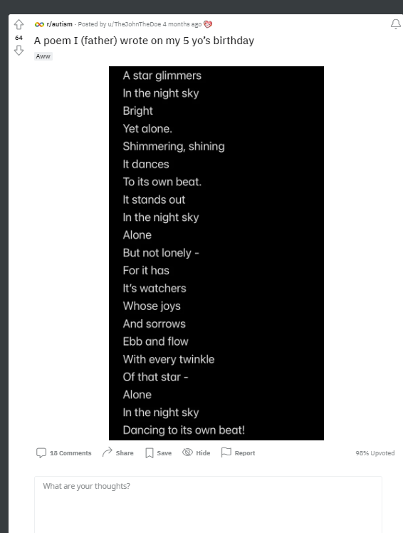

A star glimmers in the night sky
Bright yet Alone
Shimmering, shining, it dances to its own beat.
It stands out in the night sky alone
But not lonely - for it has its watchers
Whose joys and sorrows ebb and flow
With every twinkle of that star -
Alone in the night sky
Dancing to its own beat!

12
2
•Posted by
u/EnemiesAllAround
3 months ago
father of an autistic child- please help
Advice
Hi everyone,
I'm a father to a 5 year old autistic boy. He is my whole world and I want to support him as best as I can. I'm already a member of various support communities on here which really help me in my approaches to helping him, but I'd like some advice from not only other parents, but autistic people themselves.
Some background on my son. He's completely non verbal, not toilet trained and has been through speech and language therapy etc to no avail and has been discharged. He doesnt respond well to pecs and when he does its because he's only learned the process to follow and doesn't actually get the point behind the cards. (E.g. he knows he has to give me a card, but doesn't know which one and doesnt correlate any pictures on them to a specificbitem.he may give me one for a car when he wants juice )
I kept pushing him with the cards for some time but he became distressed and everytime I stuck them on boards on the wall, he would rip them off and throw them away. So I gave it a rest for a while. His primary method of communicating is leading you to things with his hand, and when you don't understand or try and explain you can't/ won't do something he has a meltdown because you can't explain why to him so all he sees is you saying no.
I struggle to keep his attention on anything I'm trying to teach him, and he won't give attention to anything he isn't interested in, regardless of bribes or me trying to make it exciting. I've tried adapting teaching to what he is interested in but unfortunately I had no success there either.
He loves lights, cause and effect sensory play and multiples of things in different colours. Though most of his time is spent doing the same thing daily. Looking through coloured shapes at light, and watching the same TV show every day.
Now, he's started school. Yes mainstream school. He was not given an alternate pathway despite us having reports from his diagnosis, speech and language, nursery, a 12 week pre assessment centre etc. All stating he would benefit and needs the support.
School has been trying to support as best they can and provided a 1-1 support teacher, but realistically their approaches aren't sustainable long term. For example the head teacher and one other is the only person allowed to change his nappy due to disclosure requirements and I don't see them doing this long term as he gets older.
Also, the homework primary 1 is giving out is things like counting numbers in order, spelling, putting letters together to make sounds. He's just not there yet and doesn't show any interest or speak. I feel the gap between his class and him will only get larger as time goes on. Leaving him behind and us wasting valuable time for early intervention if we haven't already missed it.
Now I did escalate his placement issues and was told by the board who decide what child goes where to try out mainstream and if it doesn't work they can move him 6 months down the line. They said being amongst neurotypical children may help him develop. I agreed and now wish I hadn't.
I'm starting to feel like I was fobbed off a bit and that we are now wasting precious time where he could be learning life skills as opposed to essentially playing every day at school; I say playing because they allow him to do so to avoid any behaviour escalations. I just feel that learning to talk, to go to the bathroom, to communicate somehow, learn about safety etc is more important for him at the moment and that a special needs school would be far more appropriate.
I have a few questions.
- Are there any autistic adults here who learned to speak later in life that remember being this young? What would have helped you most ?
- What can I do besides be loving and caring to support him and help him develop when he shows no signs of interest in doing so?
- Is mainstream a waste of time? Should I push for the alternate placement 100%?
- Any strategies for me to communicate with him?
- Anything else you can think of that may help us. Anything at all will help!
- What resources are available that you know of?
10 Comments
Share
Save
Hide
Report
89% Upvoted

r/autism
•Posted by
u/dezzrokk
3 months ago

3
Father of child on spectrum with question for people on the spectrum.
Question
First, I want to apologize if this post doesn't meet guidelines. Mods you can delete if it violates.
However, my son, 5yo, was diagnosed with "high functioning" autism in the spring. It wasn't really a surprise to my wife and I because there were countless social queues, sarcasm, pronoun usage etc that he just didn't get or even care to understand. He is, from what I have come to understand, on a fairly common place on the spectrum where most people who aren't evaluated are just considered different, nonconformist, etc but can still excel scholastically and kind of keep up socially.
My question deals with how he perceives or feels love. There are numerous times when he has tantrums where his emotions are so strong and violent and I'm wondering if he will feel positive emotions equally as strong. Also, as he grows, will his attachment to us as his parents change into a love of understanding and appreciation or will it remain as one of simple comfort attachment?
I realize everyone is different but I'm so curious about what he feels when I hug and kiss him or tell him I love him (which he always replies with I love you back). He has always been free with physical displays of affection but never initiates physical displays unless he wants a cuddle when he isnt feeling well or to be held to go to sleep.
I appreciate any feedback. Even critiques. I just want my son to be happy and comfortable when navigating the world.
8 Comments
Share
Save
Hide
Report
80% Upvoted

r/autism
•Posted by
u/DadOfTwoBoys1791
2 months ago

4
Single father of two boys full time
Help
Hey there guys! First post here, but I am looking for advise and positivity in my quest to accommodate and help my 4 year old(autistic) son. I currently have to keep him in full body suits/footed sleepers, for his love of playing in his feces... I have had so many nervous breakdowns, and feel absolutely terrible for getting so overwhelmed with it. Discipline DOES NOT WORK. Calm and collective DOES NOT WORK. Repetitively explaining that we do not do it DOES NOT WORK. He is nonverbal and high strung. He has meltdowns over it and not being able to play in it causes him to act out. I for the life of me cannot remedy the situation, and I absolutely HATE feces being all over everything. Even with restrictive clothing, he figures out how to get through it no matter what I do. We have dealt with MRSA and staff infections constantly.. Even when he doesn't soil hisself, his fingers find their way to the spot and he spreads it on toys, walls, floors, beds, etc... I haven't been able to acquire employment, or make much for income outside of providing care for my son.. So I do not have much capital to purchase more restrictive equipment for him.. I have completely changed my lifestyle to more accommodate him, and I have gone through emotions I did not know were possible.. Any help, advice, or even a piece of mind would be greatly appreciated... I hate the thought of a group home, and he will absolutely not be placed into a state facility or foster home. I have exhausted all of my options, but doing this alone is the biggest struggle ever.. Thank you guys for reading...
0 Comments
Share
Save
Hide
Report
100% Upvoted

r/autism
•Posted by
u/Orangeaddict1
20 days ago

5
Give dad some advice please.
Questionspoiler
Any pointers that I can use to be the best dad possible? My youngest is 6yo and on the spectrum. Guess I was wondering if you could give a parent advice about raising a child with autism what would it be? Thanks I’m advance.
r/autism
•Posted by
u/TheEmotionsPanda
2 months ago
6
Just a dad trying to help
Question
Hey everyone, I am a single dad of 2 kids. my son who is 6 years old lost his mother at the age of 2 and has severe ADHD as well as trauma. He is on a waitlist currently to get tested for autism. They believe he is on the spectrum somewhere. I left my ex wife about 2 years ago due to I found out she was abusing my son while I was at work. after all of that I created this character and book for kids to help them express and track their emotions. Its called The Emotions Panda and it is on amazon but, it's main intent is to help kids. if you or you know someone who has any type of disability or just struggles in general have them check it out. how do I help people with this book without "promoting" it? I just want to help as many people as I can with it and get it out there.
10 Comments
Share
Save
Hide
Report
33% Upvoted

7
r/daddit
•Posted by
u/Proper-Skill7062
1 month ago
My Daughter (2.5 years old) was recently diagnosed with moderate form of Autism and constantly throws tantrums.
Support
I'm sorry, I am not trying to sound like a bad father but her tantrums frustrate me so much. I get really irritated and sometimes I have to leave the room because I don't wanna spank or hurt my child. Every little thing sets my daughter off and she gets mad at the smallest things.
I'm reading stories of other parents with autistic children and how they struggle with their kids meltdowns as well.
I don't know if the tantrums would get worse with time or she will always have them but I really can't handle them. It's daunting to me to learn that it is possible she might do this even in the future. I can't handle this. I love her so much and it hurts me to see her so mad but I really can't handle tantrums for the rest of her life.
I feel like a terrible human and even worse father, but I feel stuck.

8
r/daddit
•Posted by
u/Proper-Skill7062
2 months ago
My Daughter (2 Years Old) was just diagnosed with autism.
Support
I'm trying to cope with this and I am spiraling down right now. Just wanted to reach out. My apologies for not writing a lengthy description I am just still just trying to cope.

14
r/daddit
•Posted by
u/icelugger86
4 months ago
9
Dads that have children with autism, how do you balance that child’s needs with the needs of their siblings?
Advice Request
How can I make sure my neurotypical children don’t feel neglected?
1

3
10
r/daddit
•Posted by
u/DrapedInVelvet
9 months ago
My son (3 yo) just got diagnosed with Autism.
Support
So I'm a first time dad with twins. My wife works a lot (sometimes 100+ Hours a week) and I have a full time job as well. We have a nanny, mostly because my son gets kicked out of daycare within a week (2x so far), and once they realize he's going to be a problem, they don't want to deal with it.
I'm not going to lie, raising them has been hard. When my wife works weekends, I get the kids by myself all weekend, often without a break if she's working a 24 hour shift. We've finally gotten some childcare help on the weekends, but at times it feels like its 'work, watch the kids, back to work'. I can often go 2-3 weeks without a break when the kids are awake. My daughter is fairly advanced, already reading her sight words and starting to sound out words. My son has a speech delay and is always busy. Just non stop, run run run all day it seems. On days I have them I will strap them in the car and drive around for an hour just to get a break from the constant motion. Any park we go to, my son will always run and try to escape, even if its enclosed. My poor daughter has been bit, pushed, and punched by him more times than we can count, and trying to find an effective way to discipline him in a way he understands is difficult. We've noticed that our daughter has figured out he gets away with a lot, so she is starting to push limits as well.
He isn't a severe case (he is actually very social and seems to be smart and curious, even if its just in being an escape artist in a new way). I'm just exhausted and don't know what is next. Give me some autism diagnoses success stories.
4 Comments
Share
Save
Hide
Report
81% Upvoted
11
r/daddit
•Posted by

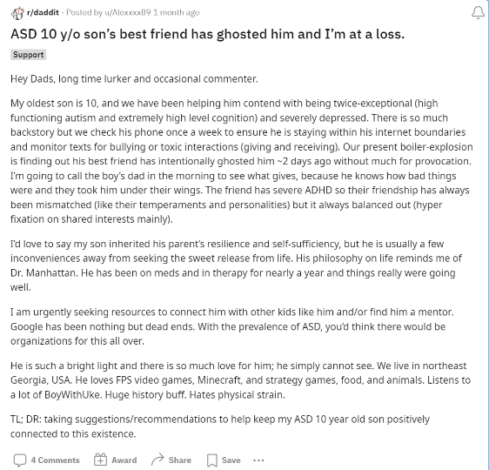
u/Alexxxx89
23 days ago
ASD 10 y/o son’s best friend has ghosted him and I’m at a loss.
Support
Hey Dads, long time lurker and occasional commenter.
My oldest son is 10, and we have been helping him contend with being twice-exceptional (high functioning autism and extremely high level cognition) and severely depressed. There is so much backstory but we check his phone once a week to ensure he is staying within his internet boundaries and monitor texts for bullying or toxic interactions (giving and receiving). Our present boiler-explosion is finding out his best friend has intentionally ghosted him ~2 days ago without much for provocation. I’m going to call the boy’s dad in the morning to see what gives, because he knows how bad things were and they took him under their wings. The friend has severe ADHD so their friendship has always been mismatched (like their temperaments and personalities) but it always balanced out (hyper fixation on shared interests mainly).
I’d love to say my son inherited his parent’s resilience and self-sufficiency, but he is usually a few inconveniences away from seeking the sweet release from life. His philosophy on life reminds me of Dr. Manhattan. He has been on meds and in therapy for nearly a year and things really were going well.
I am urgently seeking resources to connect him with other kids like him and/or find him a mentor. Google has been nothing but dead ends. With the prevalence of ASD, you’d think there would be organizations for this all over.
He is such a bright light and there is so much love for him; he simply cannot see. We live in northeast Georgia, USA. He loves FPS video games, Minecraft, and strategy games, food, and animals. Listens to a lot of BoyWithUke. Huge history buff. Hates physical strain.
TL; DR: taking suggestions/recommendations to help keep my ASD 10 year old son positively connected to this existence.
============================

12
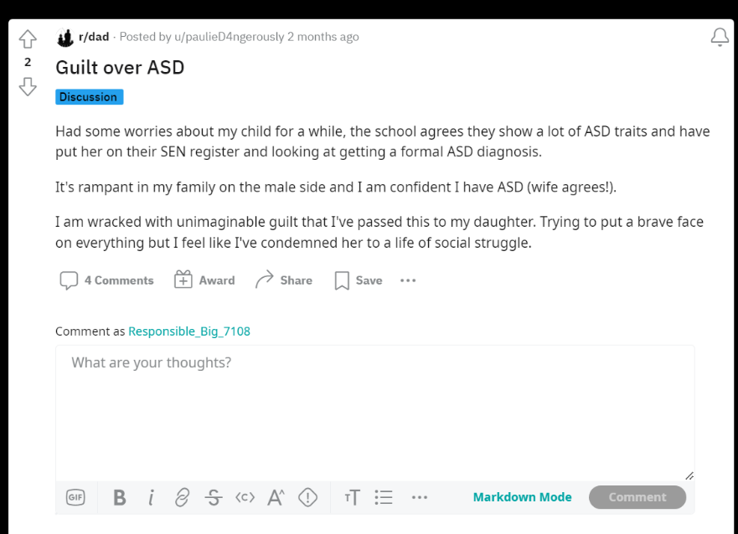

Guilt over ASD
Discussion
Had some worries about my child for a while, the school agrees they show a lot of ASD traits and have put her on their SEN register and looking at getting a formal ASD diagnosis.
It's rampant in my family on the male side and I am confident I have ASD (wife agrees!).
I am wracked with unimaginable guilt that I've passed this to my daughter. Trying to put a brave face on everything but I feel like I've condemned her to a life of social struggle.
4 Comments
Award
Share
Save

13

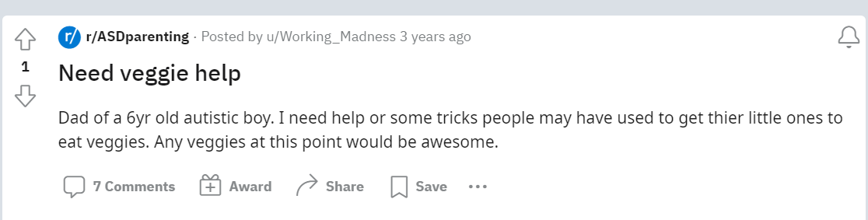

Need veggie help

Dad of a 6yr old autistic boy. I need help or some tricks people may have used to get thier little ones to eat veggies. Any veggies at this point would be awesome.

14
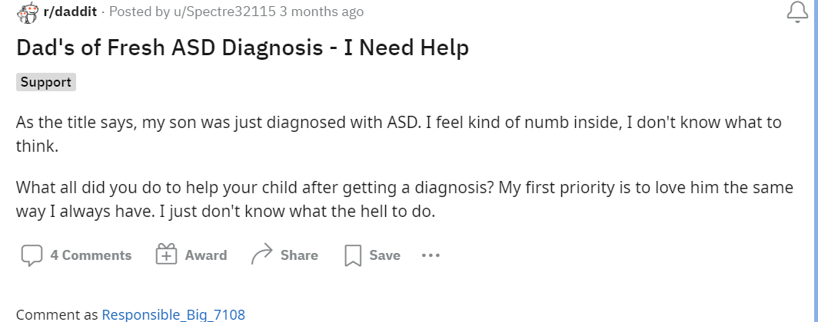
Dad's of Fresh ASD Diagnosis - I Need Help
Support
As the title says, my son was just diagnosed with ASD. I feel kind of numb inside, I don't know what to think.
What all did you do to help your child after getting a diagnosis? My first priority is to love him the same way I always have. I just don't know what the hell to do.

15

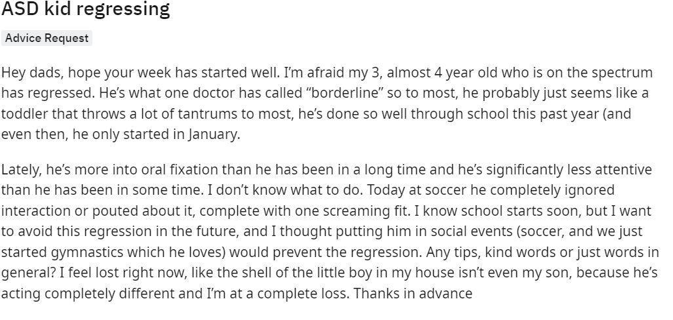

ASD kid regressing
Advice Request
Hey dads, hope your week has started well. I’m afraid my 3, almost 4 year old who is on the spectrum has regressed. He’s what one doctor has called “borderline” so to most, he probably just seems like a toddler that throws a lot of tantrums to most, he’s done so well through school this past year (and even then, he only started in January.
Lately, he’s more into oral fixation than he has been in a long time and he’s significantly less attentive than he has been in some time. I don’t know what to do. Today at soccer he completely ignored interaction or pouted about it, complete with one screaming fit. I know school starts soon, but I want to avoid this regression in the future, and I thought putting him in social events (soccer, and we just started gymnastics which he loves) would prevent the regression. Any tips, kind words or just words in general? I feel lost right now, like the shell of the little boy in my house isn’t even my son, because he’s acting completely different and I’m at a complete loss. Thanks in advance

16

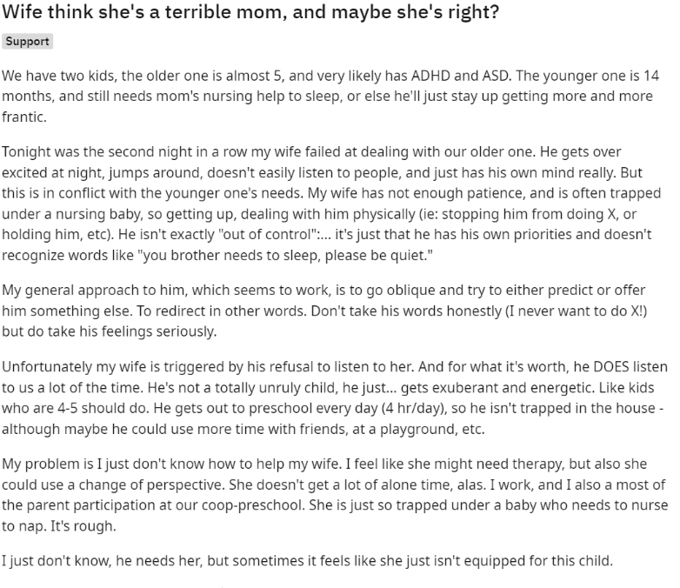

Wife think she's a terrible mom, and maybe she's right?
Support
We have two kids, the older one is almost 5, and very likely has ADHD and ASD. The younger one is 14 months, and still needs mom's nursing help to sleep, or else he'll just stay up getting more and more frantic.
Tonight was the second night in a row my wife failed at dealing with our older one. He gets over excited at night, jumps around, doesn't easily listen to people, and just has his own mind really. But this is in conflict with the younger one's needs. My wife has not enough patience, and is often trapped under a nursing baby, so getting up, dealing with him physically (ie: stopping him from doing X, or holding him, etc). He isn't exactly "out of control":... it's just that he has his own priorities and doesn't recognize words like "you brother needs to sleep, please be quiet."
My general approach to him, which seems to work, is to go oblique and try to either predict or offer him something else. To redirect in other words. Don't take his words honestly (I never want to do X!) but do take his feelings seriously.
Unfortunately my wife is triggered by his refusal to listen to her. And for what it's worth, he DOES listen to us a lot of the time. He's not a totally unruly child, he just... gets exuberant and energetic. Like kids who are 4-5 should do. He gets out to preschool every day (4 hr/day), so he isn't trapped in the house - although maybe he could use more time with friends, at a playground, etc.
My problem is I just don't know how to help my wife. I feel like she might need therapy, but also she could use a change of perspective. She doesn't get a lot of alone time, alas. I work, and I also a most of the parent participation at our coop-preschool. She is just so trapped under a baby who needs to nurse to nap. It's rough.
I just don't know, he needs her, but sometimes it feels like she just isn't equipped for this child.

17

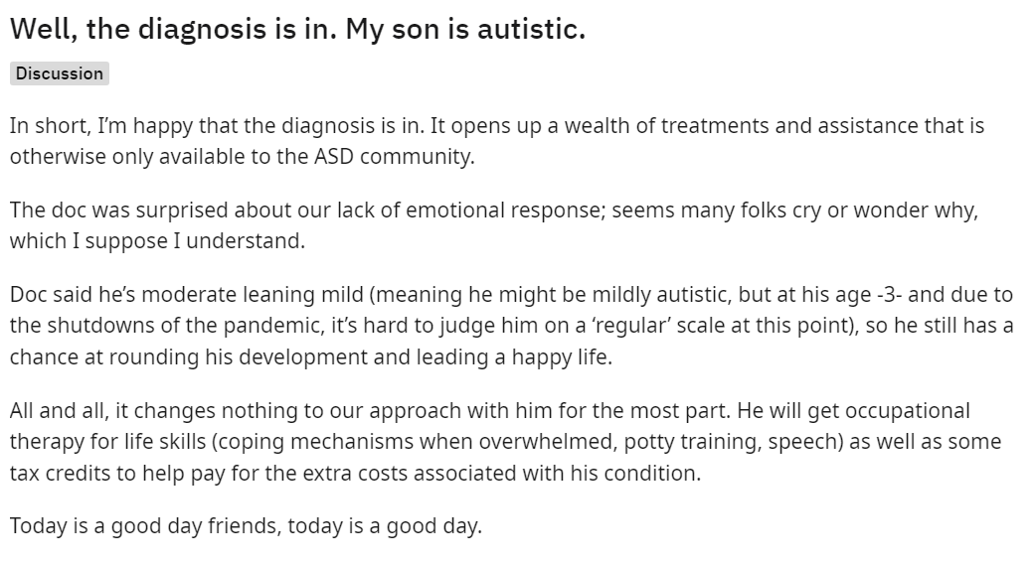
Well, the diagnosis is in. My son is autistic.
Discussion
In short, I’m happy that the diagnosis is in. It opens up a wealth of treatments and assistance that is otherwise only available to the ASD community.
The doc was surprised about our lack of emotional response; seems many folks cry or wonder why, which I suppose I understand.
Doc said he’s moderate leaning mild (meaning he might be mildly autistic, but at his age -3- and due to the shutdowns of the pandemic, it’s hard to judge him on a ‘regular’ scale at this point), so he still has a chance at rounding his development and leading a happy life.
All and all, it changes nothing to our approach with him for the most part. He will get occupational therapy for life skills (coping mechanisms when overwhelmed, potty training, speech) as well as some tax credits to help pay for the extra costs associated with his condition.
Today is a good day friends, today is a good day.

18

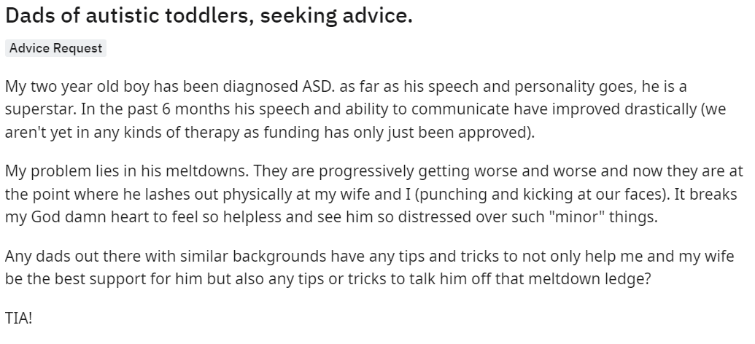
Dads of autistic toddlers, seeking advice.
Advice Request
My two year old boy has been diagnosed ASD. as far as his speech and personality goes, he is a superstar. In the past 6 months his speech and ability to communicate have improved drastically (we aren't yet in any kinds of therapy as funding has only just been approved).
My problem lies in his meltdowns. They are progressively getting worse and worse and now they are at the point where he lashes out physically at my wife and I (punching and kicking at our faces). It breaks my God damn heart to feel so helpless and see him so distressed over such "minor" things.
Any dads out there with similar backgrounds have any tips and tricks to not only help me and my wife be the best support for him but also any tips or tricks to talk him off that meltdown ledge?
TIA!

19
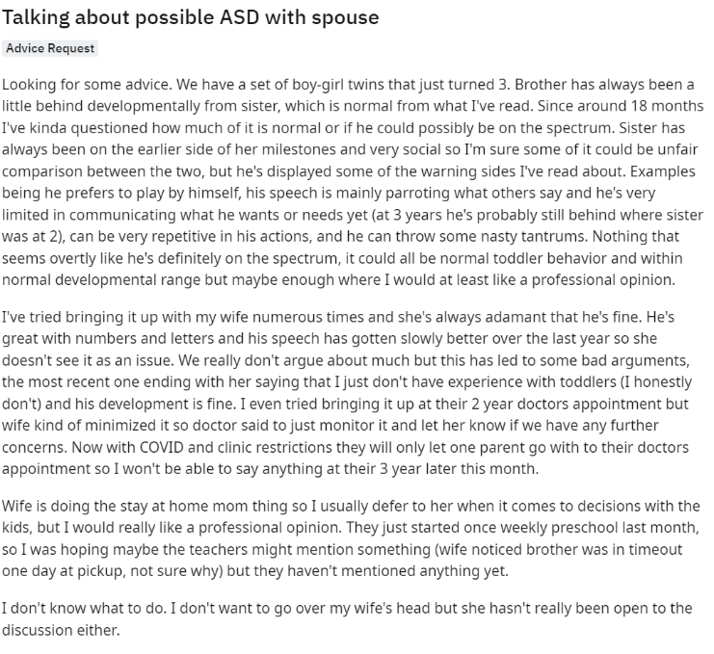
Talking about possible ASD with spouse
Advice Request
Looking for some advice. We have a set of boy-girl twins that just turned 3. Brother has always been a little behind developmentally from sister, which is normal from what I've read. Since around 18 months I've kinda questioned how much of it is normal or if he could possibly be on the spectrum. Sister has always been on the earlier side of her milestones and very social so I'm sure some of it could be unfair comparison between the two, but he's displayed some of the warning sides I've read about. Examples being he prefers to play by himself, his speech is mainly parroting what others say and he's very limited in communicating what he wants or needs yet (at 3 years he's probably still behind where sister was at 2), can be very repetitive in his actions, and he can throw some nasty tantrums. Nothing that seems overtly like he's definitely on the spectrum, it could all be normal toddler behavior and within normal developmental range but maybe enough where I would at least like a professional opinion.
I've tried bringing it up with my wife numerous times and she's always adamant that he's fine. He's great with numbers and letters and his speech has gotten slowly better over the last year so she doesn't see it as an issue. We really don't argue about much but this has led to some bad arguments, the most recent one ending with her saying that I just don't have experience with toddlers (I honestly don't) and his development is fine. I even tried bringing it up at their 2 year doctors appointment but wife kind of minimized it so doctor said to just monitor it and let her know if we have any further concerns. Now with COVID and clinic restrictions they will only let one parent go with to their doctors appointment so I won't be able to say anything at their 3 year later this month.
Wife is doing the stay at home mom thing so I usually defer to her when it comes to decisions with the kids, but I would really like a professional opinion. They just started once weekly preschool last month, so I was hoping maybe the teachers might mention something (wife noticed brother was in timeout one day at pickup, not sure why) but they haven't mentioned anything yet.
I don't know what to do. I don't want to go over my wife's head but she hasn't really been open to the discussion either.

20
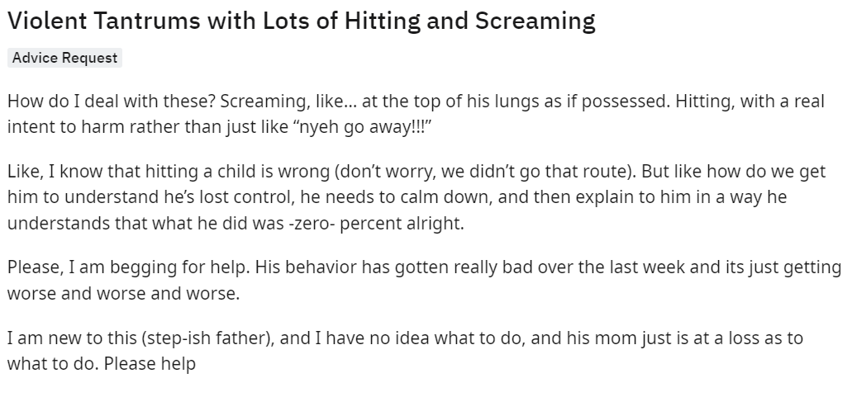
Violent Tantrums with Lots of Hitting and Screaming
Advice Request
How do I deal with these? Screaming, like… at the top of his lungs as if possessed. Hitting, with a real intent to harm rather than just like “nyeh go away!!!”
Like, I know that hitting a child is wrong (don’t worry, we didn’t go that route). But like how do we get him to understand he’s lost control, he needs to calm down, and then explain to him in a way he understands that what he did was -zero- percent alright.
Please, I am begging for help. His behavior has gotten really bad over the last week and its just getting worse and worse and worse.
I am new to this (step-ish father), and I have no idea what to do, and his mom just is at a loss as to what to do. Please help

21
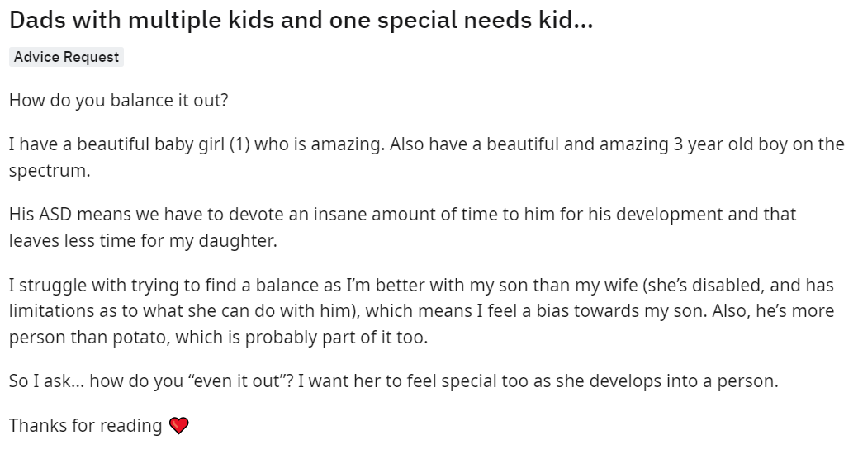
Dads with multiple kids and one special needs kid…
Advice Request
How do you balance it out?
I have a beautiful baby girl (1) who is amazing. Also have a beautiful and amazing 3 year old boy on the spectrum.
His ASD means we have to devote an insane amount of time to him for his development and that leaves less time for my daughter.
I struggle with trying to find a balance as I’m better with my son than my wife (she’s disabled, and has limitations as to what she can do with him), which means I feel a bias towards my son. Also, he’s more person than potato, which is probably part of it too.
So I ask… how do you “even it out”? I want her to feel special too as she develops into a person.
Thanks for reading ❤️

22

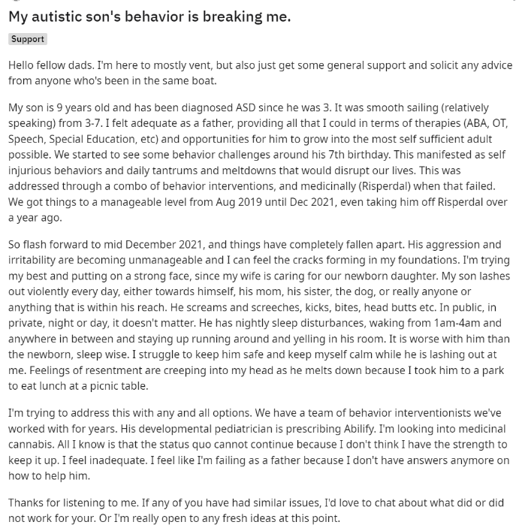
My autistic son's behavior is breaking me.
Support
Hello fellow dads. I'm here to mostly vent, but also just get some general support and solicit any advice from anyone who's been in the same boat.
My son is 9 years old and has been diagnosed ASD since he was 3. It was smooth sailing (relatively speaking) from 3-7. I felt adequate as a father, providing all that I could in terms of therapies (ABA, OT, Speech, Special Education, etc) and opportunities for him to grow into the most self sufficient adult possible. We started to see some behavior challenges around his 7th birthday. This manifested as self injurious behaviors and daily tantrums and meltdowns that would disrupt our lives. This was addressed through a combo of behavior interventions, and medicinally (Risperdal) when that failed. We got things to a manageable level from Aug 2019 until Dec 2021, even taking him off Risperdal over a year ago.
So flash forward to mid December 2021, and things have completely fallen apart. His aggression and irritability are becoming unmanageable and I can feel the cracks forming in my foundations. I'm trying my best and putting on a strong face, since my wife is caring for our newborn daughter. My son lashes out violently every day, either towards himself, his mom, his sister, the dog, or really anyone or anything that is within his reach. He screams and screeches, kicks, bites, head butts etc. In public, in private, night or day, it doesn't matter. He has nightly sleep disturbances, waking from 1am-4am and anywhere in between and staying up running around and yelling in his room. It is worse with him than the newborn, sleep wise. I struggle to keep him safe and keep myself calm while he is lashing out at me. Feelings of resentment are creeping into my head as he melts down because I took him to a park to eat lunch at a picnic table.
I'm trying to address this with any and all options. We have a team of behavior interventionists we've worked with for years. His developmental pediatrician is prescribing Abilify. I'm looking into medicinal cannabis. All I know is that the status quo cannot continue because I don't think I have the strength to keep it up. I feel inadequate. I feel like I'm failing as a father because I don't have answers anymore on how to help him.
Thanks for listening to me. If any of you have had similar issues, I'd love to chat about what did or did not work for your. Or I'm really open to any fresh ideas at this point.
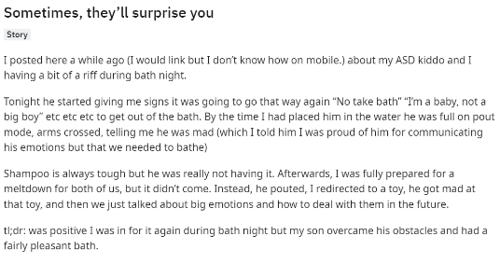

23
Sometimes, they’ll surprise you
Story
I posted here a while ago (I would link but I don’t know how on mobile.) about my ASD kiddo and I having a bit of a riff during bath night.
Tonight he started giving me signs it was going to go that way again “No take bath” “I’m a baby, not a big boy” etc etc etc to get out of the bath. By the time I had placed him in the water he was full on pout mode, arms crossed, telling me he was mad (which I told him I was proud of him for communicating his emotions but that we needed to bathe)
Shampoo is always tough but he was really not having it. Afterwards, I was fully prepared for a meltdown for both of us, but it didn’t come. Instead, he pouted, I redirected to a toy, he got mad at that toy, and then we just talked about big emotions and how to deal with them in the future.
tl;dr: was positive I was in for it again during bath night but my son overcame his obstacles and had a fairly pleasant bath.

24
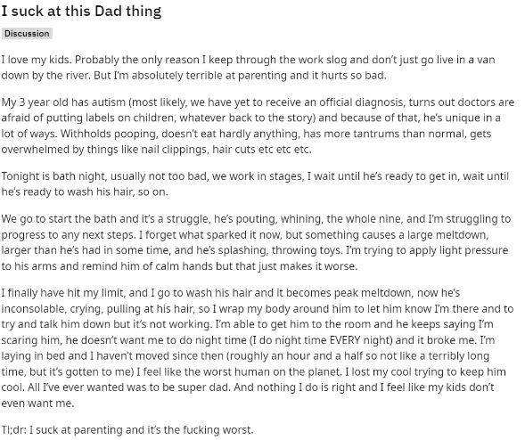

I suck at this Dad thing
Discussion
I love my kids. Probably the only reason I keep through the work slog and don’t just go live in a van down by the river. But I’m absolutely terrible at parenting and it hurts so bad.
My 3 year old has autism (most likely, we have yet to receive an official diagnosis, turns out doctors are afraid of putting labels on children, whatever back to the story) and because of that, he’s unique in a lot of ways. Withholds pooping, doesn’t eat hardly anything, has more tantrums than normal, gets overwhelmed by things like nail clippings, hair cuts etc etc etc.
Tonight is bath night, usually not too bad, we work in stages, I wait until he’s ready to get in, wait until he’s ready to wash his hair, so on.
We go to start the bath and it’s a struggle, he’s pouting, whining, the whole nine, and I’m struggling to progress to any next steps. I forget what sparked it now, but something causes a large meltdown, larger than he’s had in some time, and he’s splashing, throwing toys. I’m trying to apply light pressure to his arms and remind him of calm hands but that just makes it worse.
I finally have hit my limit, and I go to wash his hair and it becomes peak meltdown, now he’s inconsolable, crying, pulling at his hair, so I wrap my body around him to let him know I’m there and to try and talk him down but it’s not working. I’m able to get him to the room and he keeps saying I’m scaring him, he doesn’t want me to do night time (I do night time EVERY night) and it broke me. I’m laying in bed and I haven’t moved since then (roughly an hour and a half so not like a terribly long time, but it’s gotten to me) I feel like the worst human on the planet. I lost my cool trying to keep him cool. All I’ve ever wanted was to be super dad. And nothing I do is right and I feel like my kids don’t even want me.
Tl;dr: I suck at parenting and it’s the fucking worst.

25
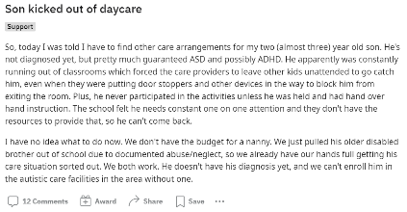

Son kicked out of daycare
Support
So, today I was told I have to find other care arrangements for my two (almost three) year old son. He's not diagnosed yet, but pretty much guaranteed ASD and possibly ADHD. He apparently was constantly running out of classrooms which forced the care providers to leave other kids unattended to go catch him, even when they were putting door stoppers and other devices in the way to block him from exiting the room. Plus, he never participated in the activities unless he was held and had hand over hand instruction. The school felt he needs constant one on one attention and they don't have the resources to provide that, so he can't come back.
I have no idea what to do now. We don't have the budget for a nanny. We just pulled his older disabled brother out of school due to documented abuse/neglect, so we already have our hands full getting his care situation sorted out. We both work. He doesn't have his diagnosis yet, and we can't enroll him in the autistic care facilities in the area without one.

26

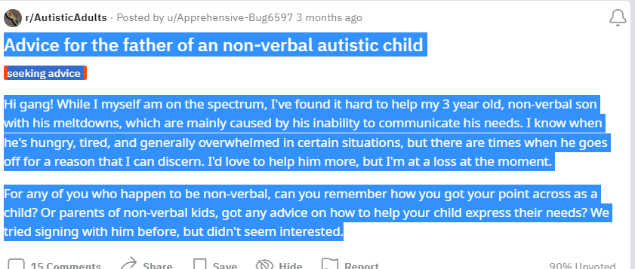

Advice for the father of an non-verbal autistic child
seeking advice
Hi gang! While I myself am on the spectrum, I've found it hard to help my 3 year old, non-verbal son with his meltdowns, which are mainly caused by his inability to communicate his needs. I know when he's hungry, tired, and generally overwhelmed in certain situations, but there are times when he goes off for a reason that I can discern. I'd love to help him more, but I'm at a loss at the moment.
For any of you who happen to be non-verbal, can you remember how you got your point across as a child? Or parents of non-verbal kids, got any advice on how to help your child express their needs? We tried signing with him before, but didn't seem interested.

27
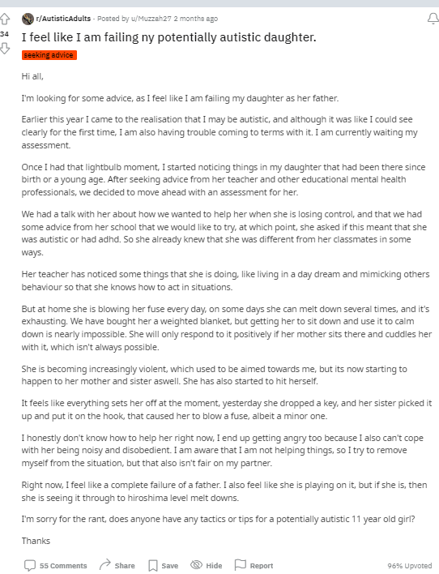
I feel like I am failing ny potentially autistic daughter.
seeking advice
Hi all,
I'm looking for some advice, as I feel like I am failing my daughter as her father.
Earlier this year I came to the realisation that I may be autistic, and although it was like I could see clearly for the first time, I am also having trouble coming to terms with it. I am currently waiting my assessment.
Once I had that lightbulb moment, I started noticing things in my daughter that had been there since birth or a young age. After seeking advice from her teacher and other educational mental health professionals, we decided to move ahead with an assessment for her.
We had a talk with her about how we wanted to help her when she is losing control, and that we had some advice from her school that we would like to try, at which point, she asked if this meant that she was autistic or had adhd. So she already knew that she was different from her classmates in some ways.
Her teacher has noticed some things that she is doing, like living in a day dream and mimicking others behaviour so that she knows how to act in situations.
But at home she is blowing her fuse every day, on some days she can melt down several times, and it's exhausting. We have bought her a weighted blanket, but getting her to sit down and use it to calm down is nearly impossible. She will only respond to it positively if her mother sits there and cuddles her with it, which isn't always possible.
She is becoming increasingly violent, which used to be aimed towards me, but its now starting to happen to her mother and sister aswell. She has also started to hit herself.
It feels like everything sets her off at the moment, yesterday she dropped a key, and her sister picked it up and put it on the hook, that caused her to blow a fuse, albeit a minor one.
I honestly don't know how to help her right now, I end up getting angry too because I also can't cope with her being noisy and disobedient. I am aware that I am not helping things, so I try to remove myself from the situation, but that also isn't fair on my partner.
Right now, I feel like a complete failure of a father. I also feel like she is playing on it, but if she is, then she is seeing it through to hiroshima level melt downs.
I'm sorry for the rant, does anyone have any tactics or tips for a potentially autistic 11 year old girl?
Thanks

Father of child on spectrum with question for people on the spectrum.
Question
First, I want to apologize if this post doesn't meet guidelines. Mods you can delete if it violates.
However, my son, 5yo, was diagnosed with "high functioning" autism in the spring. It wasn't really a surprise to my wife and I because there were countless social queues, sarcasm, pronoun usage etc that he just didn't get or even care to understand. He is, from what I have come to understand, on a fairly common place on the spectrum where most people who aren't evaluated are just considered different, nonconformist, etc but can still excel scholastically and kind of keep up socially.
My question deals with how he perceives or feels love. There are numerous times when he has tantrums where his emotions are so strong and violent and I'm wondering if he will feel positive emotions equally as strong. Also, as he grows, will his attachment to us as his parents change into a love of understanding and appreciation or will it remain as one of simple comfort attachment?
I realize everyone is different but I'm so curious about what he feels when I hug and kiss him or tell him I love him (which he always replies with I love you back). He has always been free with physical displays of affection but never initiates physical displays unless he wants a cuddle when he isnt feeling well or to be held to go to sleep.
I appreciate any feedback. Even critiques. I just want my son to be happy and comfortable when navigating the world.
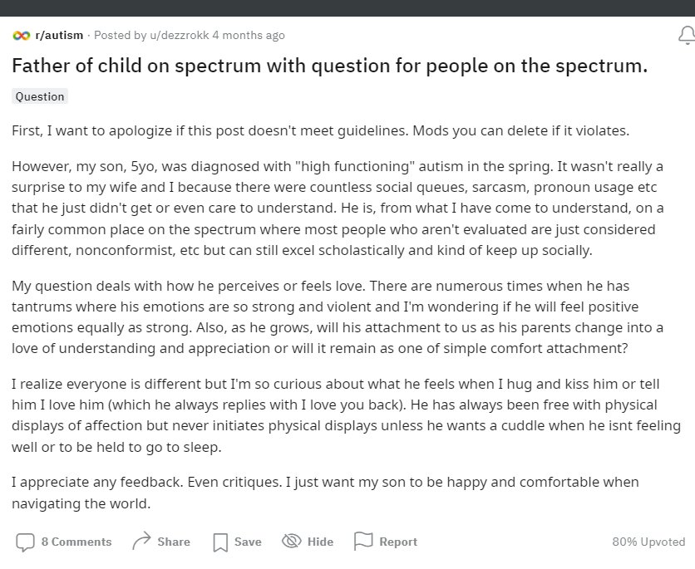

Father who wants advice
Advice
Hello. I’m insecure about what I’m writing, I hope it was done right this time. I’ve been a lurker for a little while since my second son was diagnosed with autism. Since then, my third son was diagnosed with it as well. My fourth son was born about a year ago, not diagnosed but is in therapy, unknown. I love all of my boys, there is NOTHING that will ever change that. My 4 year old that was diagnosed as severely autistic is so smart at his age. So many things I’ve tried to teach him, he quickly took to. Counting and spelling; he does so well. Social situations are difficult, I think especially because he was growing during the pandemic. I’ve many questions really, but only found the courage recently with a worrying behavior. My 4 year old (Ray) has 2 younger brothers, again 2 and 1 years old. Ray has been loving, curious, jealous, and angry with them sometimes. He has been frustrated more often lately. My main concern: When he seems frustrated or angry, sometimes he will “hug” or “hold” his brothers, sometimes around the waist but recently around the neck. My 1 year old is what concerns me most; he enjoys the attention but could do little to stop it if Ray’s “hugs” were to tighten. I’m thankful he’s showing an interest in his brothers, but this is when he’s upset. These neck “hugs” when he’s frustrated scare me, if he squeezed too hard it could be bad. But I feel bad trying to verbally discipline him, since he could be going to his brothers for comfort or other non-harmful reasons, I’m just scared he’ll squeeze too tight without realizing. I actually have more questions, but this is the most pressing. Is he just hugging when he’s mad? Could it get worse later on and cause choking? Thank you all for your time.
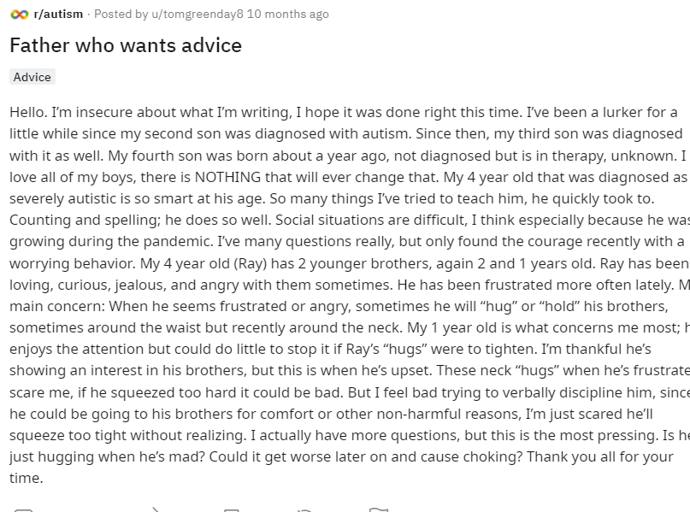

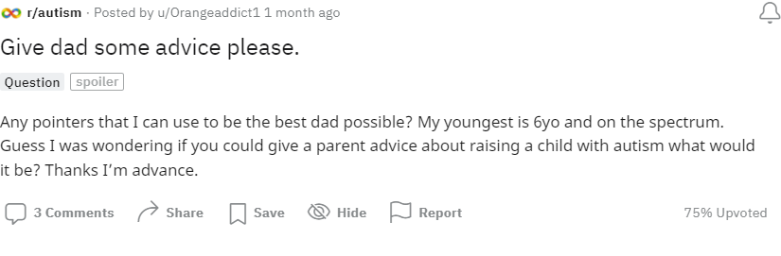

30

17
r/aspergers
•Posted by
u/Lubalin
10 months ago
Advice for father of Aspergers 5 year old boy
Hello, I hope this post is appropriate. I'm the father of a recently diagnosed autistic 5 year old boy, with strong aspergers traits (I hope I am using the right language here, please correct me if necessary, I am learning as I go).
He falls broadly into the highly academic ability/low social awareness category (again, please correct verbiage and terminology, I'll get there) which was fine until recently, but I'm finding that as other kids are making tight relationships and building friendship groups, my little boy is getting left behind. It's getting to the point where he himself is noticing and I'm struggling to help him negotiate the territory. His birthday is coming up, and I'm dreading the discussion about party's and inviting people, and whether anyone would actually show up (an issue we've not had to deal with thus far thanks to covid).
I'm not autistic myself (to my knowledge), but did find school and friendships very difficult at that age, so I don't feel like I can offer any useful advice (not that he'd take it if I did).
Is there anywhere anyone could recommend for me to find resources to help guide him? Or does anyone have any first hand experience they can bring to bear to reassure us as parents, or give us practical guidance? It's absolutely breaking my heart watching other kids give him side-eye when he's excitedly telling them about something he's enjoyed, and then turning their backs on him.
2
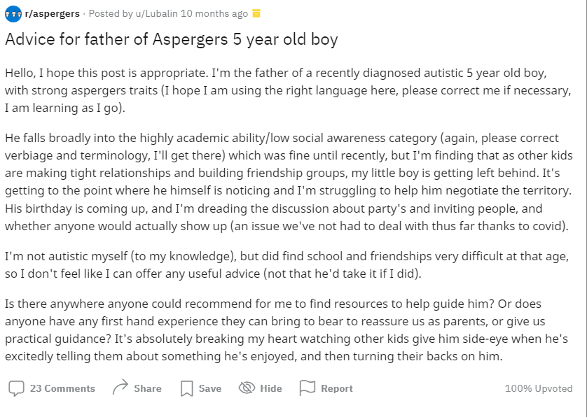

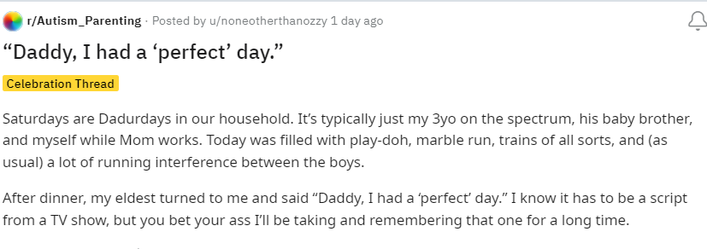

“Daddy, I had a ‘perfect’ day.”
Celebration Thread
Saturdays are Dadurdays in our household. It’s typically just my 3yo on the spectrum, his baby brother, and myself while Mom works. Today was filled with play-doh, marble run, trains of all sorts, and (as usual) a lot of running interference between the boys.
After dinner, my eldest turned to me and said “Daddy, I had a ‘perfect’ day.” I know it has to be a script from a TV show, but you bet your ass I’ll be taking and remembering that one for a long time.

7.2 Appendix B: Data showing initial coding and table of codes

Unique
Fathers Feelings of failure
Child: Behavioural problems | Physical violence  Meltdowns / Tantrums  Self injury / \  Sleep issues
Child: Practical problems | Not toilet trained  Food issues
Child: Social Problems | Social difficulties
Child: Communication problems | Communication issues  Non Verbal
Child: Emotional problems | suicidal ideation
Love
Intellectual attainment/Brightness
Showing support
Parental Autism
Fathers Emotional difficulties
Fathers Helplessness/ at a loss/Overwhelm
Spousal issues
Financial Implications
Comorbidity
Happiness
Siblings issues
Progress
Effect of Pandemic
Fathers Feelings of guilt
Fathers Sadness
Fathers Anger/Resentment
Medication
Therapies
Fear
Seeking Support
Seeking behavioural advice
Seeking practical advice
Venting

Celebrating
Resource seeking
Conflict with authorities or others
Not yet diagnosed

A poem I (father) wrote on my 5 year olds birthday

A star glimmers in the night sky
Bright yet Alone
Shimmering, shining, it dances to its own beat.
It stands out in the night sky alone
But not lonely - for it has its watchers
Whose joys and sorrows ebb and flow
With every twinkle of that star -
Alone in the night sky
Dancing to its own beat!
father of an autistic child- please help
Hi everyone,
I'm a father to a 5 year old autistic boy. He is my whole world and I want to support him as best as I can. I'm already a member of various support communities on here which really help me in my approaches to helping him, but I'd like some advice from not only other parents, but autistic people themselves.
Some background on my son. He's completely non verbal, not toilet trained and has been through speech and language therapy etc to no avail and has been discharged. He doesnt respond well to pecs and when he does its because he's only learned the process to follow and doesn't actually get the point behind the cards. (E.g. he knows he has to give me a card, but doesn't know which one and doesnt correlate any pictures on them to a specificbitem.he may give me one for a car when he wants juice )
I kept pushing him with the cards for some time but he became distressed and everytime I stuck them on boards on the wall, he would rip them off and throw them away. So I gave it a rest for a while. His primary method of communicating is leading you to things with his hand, and when you don't understand or try and explain you can't/ won't do something he has a meltdown because you can't explain why to him so all he sees is you saying no.
I struggle to keep his attention on anything I'm trying to teach him, and he won't give attention to anything he isn't interested in, regardless of bribes or me trying to make it exciting. I've tried adapting teaching to what he is interested in but unfortunately I had no success there either.
He loves lights, cause and effect sensory play and multiples of things in different colours. Though most of his time is spent doing the same thing daily. Looking through coloured shapes at light, and watching the same TV show every day.
Now, he's started school. Yes mainstream school. He was not given an alternate pathway despite us having reports from his diagnosis, speech and language, nursery, a 12 week pre assessment centre etc. All stating he would benefit and needs the support.
School has been trying to support as best they can and provided a 1-1 support teacher, but realistically their approaches aren't sustainable long term. For example the head teacher and one other is the only person allowed to change his nappy due to disclosure requirements and I don't see them doing this long term as he gets older.
Also, the homework primary 1 is giving out is things like counting numbers in order, spelling, putting letters together to make sounds. He's just not there yet and doesn't show any interest or speak. I feel the gap between his class and him will only get larger as time goes on. Leaving him behind and us wasting valuable time for early intervention if we haven't already missed it.
Now I did escalate his placement issues and was told by the board who decide what child goes where to try out mainstream and if it doesn't work they can move him 6 months down the line. They said being amongst neurotypical children may help him develop. I agreed and now wish I hadn't.
I'm starting to feel like I was fobbed off a bit and that we are now wasting precious time where he could be learning life skills as opposed to essentially playing every day at school; I say playing because they allow him to do so to avoid any behaviour escalations. I just feel that learning to talk, to go to the bathroom, to communicate somehow, learn about safety etc is more important for him at the moment and that a special needs school would be far more appropriate.
I have a few questions.
- Are there any autistic adults here who learned to speak later in life that remember being this young? What would have helped you most ?
- What can I do besides be loving and caring to support him and help him develop when he shows no signs of interest in doing so?
- Is mainstream a waste of time? Should I push for the alternate placement 100%?
- Any strategies for me to communicate with him?
- Anything else you can think of that may help us. Anything at all will help!
- What resources are available that you know of?
Father of child on spectrum with question for people on the spectrum.
Question
First, I want to apologize if this post doesn't meet guidelines. Mods you can delete if it violates.
However, my son, 5yo, was diagnosed with "high functioning" autism in the spring. It wasn't really a surprise to my wife and I because there were countless social queues, sarcasm, pronoun usage etc that he just didn't get or even care to understand. He is, from what I have come to understand, on a fairly common place on the spectrum where most people who aren't evaluated are just considered different, nonconformist, etc but can still excel scholastically and kind of keep up socially.
My question deals with how he perceives or feels love. There are numerous times when he has tantrums where his emotions are so strong and violent and I'm wondering if he will feel positive emotions equally as strong. Also, as he grows, will his attachment to us as his parents change into a love of understanding and appreciation or will it remain as one of simple comfort attachment?
I realize everyone is different but I'm so curious about what he feels when I hug and kiss him or tell him I love him (which he always replies with I love you back). He has always been free with physical displays of affection but never initiates physical displays unless he wants a cuddle when he isnt feeling well or to be held to go to sleep.
I appreciate any feedback. Even critiques. I just want my son to be happy and comfortable when navigating the world.
Single father of two boys full time
Help
Hey there guys! First post here, but I am looking for advise and positivity in my quest to accommodate and help my 4 year old(autistic) son. I currently have to keep him in full body suits/footed sleepers, for his love of playing in his feces... I have had so many nervous breakdowns, and feel absolutely terrible for getting so overwhelmed with it. Discipline DOES NOT WORK. Calm and collective DOES NOT WORK. Repetitively explaining that we do not do it DOES NOT WORK. He is nonverbal and high strung. He has meltdowns over it and not being able to play in it causes him to act out. I for the life of me cannot remedy the situation, and I absolutely HATE feces being all over everything. Even with restrictive clothing, he figures out how to get through it no matter what I do. We have dealt with MRSA and staff infections constantly.. Even when he doesn't soil hisself, his fingers find their way to the spot and he spreads it on toys, walls, floors, beds, etc... I haven't been able to acquire employment, or make much for income outside of providing care for my son.. So I do not have much capital to purchase more restrictive equipment for him.. I have completely changed my lifestyle to more accommodate him, and I have gone through emotions I did not know were possible.. Any help, advice, or even a piece of mind would be greatly appreciated... I hate the thought of a group home, and he will absolutely not be placed into a state facility or foster home. I have exhausted all of my options, but doing this alone is the biggest struggle ever.. Thank you guys for reading…
Give dad some advice please.
Questionspoiler
Any pointers that I can use to be the best dad possible? My youngest is 6yo and on the spectrum. Guess I was wondering if you could give a parent advice about raising a child with autism what would it be? Thanks I’m advance.
Just a dad trying to help
Question
Hey everyone, I am a single dad of 2 kids. my son who is 6 years old lost his mother at the age of 2 and has severe ADHD as well as trauma. He is on a waitlist currently to get tested for autism. They believe he is on the spectrum somewhere. I left my ex wife about 2 years ago due to I found out she was abusing my son while I was at work. after all of that I created this character and book for kids to help them express and track their emotions. Its called The Emotions Panda and it is on amazon but, it's main intent is to help kids. if you or you know someone who has any type of disability or just struggles in general have them check it out. how do I help people with this book without "promoting" it? I just want to help as many people as I can with it and get it out there.

My Daughter (2.5 years old) was recently diagnosed with moderate form of Autism and constantly throws tantrums.
Support
I'm sorry, I am not trying to sound like a bad father but her tantrums frustrate me so much. I get really irritated and sometimes I have to leave the room because I don't wanna spank or hurt my child. Every little thing sets my daughter off and she gets mad at the smallest things.
I'm reading stories of other parents with autistic children and how they struggle with their kids meltdowns as well.
I don't know if the tantrums would get worse with time or she will always have them but I really can't handle them. It's daunting to me to learn that it is possible she might do this even in the future. I can't handle this. I love her so much and it hurts me to see her so mad but I really can't handle tantrums for the rest of her life.
I feel like a terrible human and even worse father, but I feel stuck.
My Daughter (2 Years Old) was just diagnosed with autism.
Support
I'm trying to cope with this and I am spiraling down right now. Just wanted to reach out. My apologies for not writing a lengthy description I am just still just trying to cope.
Dads that have children with autism, how do you balance that child’s needs with the needs of their siblings?
Advice Request
How can I make sure my neurotypical children don’t feel neglected?
My son (3 yo) just got diagnosed with Autism.
Support
So I'm a first time dad with twins. My wife works a lot (sometimes 100+ Hours a week) and I have a full time job as well. We have a nanny, mostly because my son gets kicked out of daycare within a week (2x so far), and once they realize he's going to be a problem, they don't want to deal with it.
I'm not going to lie, raising them has been hard. When my wife works weekends, I get the kids by myself all weekend, often without a break if she's working a 24 hour shift. We've finally gotten some childcare help on the weekends, but at times it feels like its 'work, watch the kids, back to work'. I can often go 2-3 weeks without a break when the kids are awake. My daughter is fairly advanced, already reading her sight words and starting to sound out words. My son has a speech delay and is always busy. Just non stop, run run run all day it seems. On days I have them I will strap them in the car and drive around for an hour just to get a break from the constant motion. Any park we go to, my son will always run and try to escape, even if its enclosed. My poor daughter has been bit, pushed, and punched by him more times than we can count, and trying to find an effective way to discipline him in a way he understands is difficult. We've noticed that our daughter has figured out he gets away with a lot, so she is starting to push limits as well.
He isn't a severe case (he is actually very social and seems to be smart and curious, even if its just in being an escape artist in a new way). I'm just exhausted and don't know what is next. Give me some autism diagnoses success stories.
ASD 10 y/o son’s best friend has ghosted him and I’m at a loss.
Support
Hey Dads, long time lurker and occasional commenter.
My oldest son is 10, and we have been helping him contend with being twice-exceptional (high functioning autism and extremely high level cognition) and severely depressed. There is so much backstory but we check his phone once a week to ensure he is staying within his internet boundaries and monitor texts for bullying or toxic interactions (giving and receiving). Our present boiler-explosion is finding out his best friend has intentionally ghosted him ~2 days ago without much for provocation. I’m going to call the boy’s dad in the morning to see what gives, because he knows how bad things were and they took him under their wings. The friend has severe ADHD so their friendship has always been mismatched (like their temperaments and personalities) but it always balanced out (hyper fixation on shared interests mainly).
I’d love to say my son inherited his parent’s resilience and self-sufficiency, but he is usually a few inconveniences away from seeking the sweet release from life. His philosophy on life reminds me of Dr. Manhattan. He has been on meds and in therapy for nearly a year and things really were going well.
I am urgently seeking resources to connect him with other kids like him and/or find him a mentor. Google has been nothing but dead ends. With the prevalence of ASD, you’d think there would be organizations for this all over.
He is such a bright light and there is so much love for him; he simply cannot see. We live in northeast Georgia, USA. He loves FPS video games, Minecraft, and strategy games, food, and animals. Listens to a lot of BoyWithUke. Huge history buff. Hates physical strain.
TL; DR: taking suggestions/recommendations to help keep my ASD 10 year old son positively connected to this existence.
Guilt over ASD
Discussion
Had some worries about my child for a while, the school agrees they show a lot of ASD traits and have put her on their SEN register and looking at getting a formal ASD diagnosis.
It's rampant in my family on the male side and I am confident I have ASD (wife agrees!).
I am wracked with unimaginable guilt that I've passed this to my daughter. Trying to put a brave face on everything but I feel like I've condemned her to a life of social struggle.
Need veggie help

Dad of a 6yr old autistic boy. I need help or some tricks people may have used to get thier little ones to eat veggies. Any veggies at this point would be awesome
Dad's of Fresh ASD Diagnosis - I Need Help
Support
As the title says, my son was just diagnosed with ASD. I feel kind of numb inside, I don't know what to think.
What all did you do to help your child after getting a diagnosis? My first priority is to love him the same way I always have. I just don't know what the hell to do.
ASD kid regressing
Advice Request
Hey dads, hope your week has started well. I’m afraid my 3, almost 4 year old who is on the spectrum has regressed. He’s what one doctor has called “borderline” so to most, he probably just seems like a toddler that throws a lot of tantrums to most, he’s done so well through school this past year (and even then, he only started in January.
Lately, he’s more into oral fixation than he has been in a long time and he’s significantly less attentive than he has been in some time. I don’t know what to do. Today at soccer he completely ignored interaction or pouted about it, complete with one screaming fit. I know school starts soon, but I want to avoid this regression in the future, and I thought putting him in social events (soccer, and we just started gymnastics which he loves) would prevent the regression. Any tips, kind words or just words in general? I feel lost right now, like the shell of the little boy in my house isn’t even my son, because he’s acting completely different and I’m at a complete loss. Thanks in advance

Wife think she's a terrible mom, and maybe she's right?
Support
We have two kids, the older one is almost 5, and very likely has ADHD and ASD. The younger one is 14 months, and still needs mom's nursing help to sleep, or else he'll just stay up getting more and more frantic.
Tonight was the second night in a row my wife failed at dealing with our older one. He gets over excited at night, jumps around, doesn't easily listen to people, and just has his own mind really. But this is in conflict with the younger one's needs. My wife has not enough patience, and is often trapped under a nursing baby, so getting up, dealing with him physically (ie: stopping him from doing X, or holding him, etc). He isn't exactly "out of control":... it's just that he has his own priorities and doesn't recognize words like "you brother needs to sleep, please be quiet."
My general approach to him, which seems to work, is to go oblique and try to either predict or offer him something else. To redirect in other words. Don't take his words honestly (I never want to do X!) but do take his feelings seriously.
Unfortunately my wife is triggered by his refusal to listen to her. And for what it's worth, he DOES listen to us a lot of the time. He's not a totally unruly child, he just... gets exuberant and energetic. Like kids who are 4-5 should do. He gets out to preschool every day (4 hr/day), so he isn't trapped in the house - although maybe he could use more time with friends, at a playground, etc.
My problem is I just don't know how to help my wife. I feel like she might need therapy, but also she could use a change of perspective. She doesn't get a lot of alone time, alas. I work, and I also a most of the parent participation at our coop-preschool. She is just so trapped under a baby who needs to nurse to nap. It's rough.
I just don't know, he needs her, but sometimes it feels like she just isn't equipped for this child.
Well, the diagnosis is in. My son is autistic.
Discussion
In short, I’m happy that the diagnosis is in. It opens up a wealth of treatments and assistance that is otherwise only available to the ASD community.
The doc was surprised about our lack of emotional response; seems many folks cry or wonder why, which I suppose I understand.
Doc said he’s moderate leaning mild (meaning he might be mildly autistic, but at his age -3- and due to the shutdowns of the pandemic, it’s hard to judge him on a ‘regular’ scale at this point), so he still has a chance at rounding his development and leading a happy life.
All and all, it changes nothing to our approach with him for the most part. He will get occupational therapy for life skills (coping mechanisms when overwhelmed, potty training, speech) as well as some tax credits to help pay for the extra costs associated with his condition.
Today is a good day friends, today is a good day.
Dads of autistic toddlers, seeking advice.
Advice Request
My two year old boy has been diagnosed ASD. as far as his speech and personality goes, he is a superstar. In the past 6 months his speech and ability to communicate have improved drastically (we aren't yet in any kinds of therapy as funding has only just been approved).
My problem lies in his meltdowns. They are progressively getting worse and worse and now they are at the point where he lashes out physically at my wife and I (punching and kicking at our faces). It breaks my God damn heart to feel so helpless and see him so distressed over such "minor" things.
Any dads out there with similar backgrounds have any tips and tricks to not only help me and my wife be the best support for him but also any tips or tricks to talk him off that meltdown ledge?
TIA!
Talking about possible ASD with spouse
Advice Request
Looking for some advice. We have a set of boy-girl twins that just turned 3. Brother has always been a little behind developmentally from sister, which is normal from what I've read. Since around 18 months I've kinda questioned how much of it is normal or if he could possibly be on the spectrum. Sister has always been on the earlier side of her milestones and very social so I'm sure some of it could be unfair comparison between the two, but he's displayed some of the warning sides I've read about. Examples being he prefers to play by himself, his speech is mainly parroting what others say and he's very limited in communicating what he wants or needs yet (at 3 years he's probably still behind where sister was at 2), can be very repetitive in his actions, and he can throw some nasty tantrums. Nothing that seems overtly like he's definitely on the spectrum, it could all be normal toddler behavior and within normal developmental range but maybe enough where I would at least like a professional opinion.
I've tried bringing it up with my wife numerous times and she's always adamant that he's fine. He's great with numbers and letters and his speech has gotten slowly better over the last year so she doesn't see it as an issue. We really don't argue about much but this has led to some bad arguments, the most recent one ending with her saying that I just don't have experience with toddlers (I honestly don't) and his development is fine. I even tried bringing it up at their 2 year doctors appointment but wife kind of minimized it so doctor said to just monitor it and let her know if we have any further concerns. Now with COVID and clinic restrictions they will only let one parent go with to their doctors appointment so I won't be able to say anything at their 3 year later this month.
Wife is doing the stay at home mom thing so I usually defer to her when it comes to decisions with the kids, but I would really like a professional opinion. They just started once weekly preschool last month, so I was hoping maybe the teachers might mention something (wife noticed brother was in timeout one day at pickup, not sure why) but they haven't mentioned anything yet.
I don't know what to do. I don't want to go over my wife's head but she hasn't really been open to the discussion either.
Violent Tantrums with Lots of Hitting and Screaming
Advice Request
How do I deal with these? Screaming, like… at the top of his lungs as if possessed. Hitting, with a real intent to harm rather than just like “nyeh go away!!!”
Like, I know that hitting a child is wrong (don’t worry, we didn’t go that route). But like how do we get him to understand he’s lost control, he needs to calm down, and then explain to him in a way he understands that what he did was -zero- percent alright.
Please, I am begging for help. His behavior has gotten really bad over the last week and its just getting worse and worse and worse.
I am new to this (step-ish father), and I have no idea what to do, and his mom just is at a loss as to what to do. Please help
Dads with multiple kids and one special needs kid…
Advice Request
How do you balance it out?
I have a beautiful baby girl (1) who is amazing. Also have a beautiful and amazing 3 year old boy on the spectrum.
His ASD means we have to devote an insane amount of time to him for his development and that leaves less time for my daughter.
I struggle with trying to find a balance as I’m better with my son than my wife (she’s disabled, and has limitations as to what she can do with him), which means I feel a bias towards my son. Also, he’s more person than potato, which is probably part of it too.
So I ask… how do you “even it out”? I want her to feel special too as she develops into a person.
Thanks for reading ❤️
My autistic son's behavior is breaking me.
Support
Hello fellow dads. I'm here to mostly vent, but also just get some general support and solicit any advice from anyone who's been in the same boat.
My son is 9 years old and has been diagnosed ASD since he was 3. It was smooth sailing (relatively speaking) from 3-7. I felt adequate as a father, providing all that I could in terms of therapies (ABA, OT, Speech, Special Education, etc) and opportunities for him to grow into the most self sufficient adult possible. We started to see some behavior challenges around his 7th birthday. This manifested as self injurious behaviors and daily tantrums and meltdowns that would disrupt our lives. This was addressed through a combo of behavior interventions, and medicinally (Risperdal) when that failed. We got things to a manageable level from Aug 2019 until Dec 2021, even taking him off Risperdal over a year ago.
So flash forward to mid December 2021, and things have completely fallen apart. His aggression and irritability are becoming unmanageable and I can feel the cracks forming in my foundations. I'm trying my best and putting on a strong face, since my wife is caring for our newborn daughter. My son lashes out violently every day, either towards himself, his mom, his sister, the dog, or really anyone or anything that is within his reach. He screams and screeches, kicks, bites, head butts etc. In public, in private, night or day, it doesn't matter. He has nightly sleep disturbances, waking from 1am-4am and anywhere in between and staying up running around and yelling in his room. It is worse with him than the newborn, sleep wise. I struggle to keep him safe and keep myself calm while he is lashing out at me. Feelings of resentment are creeping into my head as he melts down because I took him to a park to eat lunch at a picnic table.
I'm trying to address this with any and all options. We have a team of behavior interventionists we've worked with for years. His developmental pediatrician is prescribing Abilify. I'm looking into medicinal cannabis. All I know is that the status quo cannot continue because I don't think I have the strength to keep it up. I feel inadequate. I feel like I'm failing as a father because I don't have answers anymore on how to help him.
Thanks for listening to me. If any of you have had similar issues, I'd love to chat about what did or did not work for your. Or I'm really open to any fresh ideas at this point.
I suck at this Dad thing
Discussion
I love my kids. Probably the only reason I keep through the work slog and don’t just go live in a van down by the river. But I’m absolutely terrible at parenting and it hurts so bad.
My 3 year old has autism (most likely, we have yet to receive an official diagnosis, turns out doctors are afraid of putting labels on children, whatever back to the story) and because of that, he’s unique in a lot of ways. Withholds pooping, doesn’t eat hardly anything, has more tantrums than normal, gets overwhelmed by things like nail clippings, hair cuts etc etc etc.
Tonight is bath night, usually not too bad, we work in stages, I wait until he’s ready to get in, wait until he’s ready to wash his hair, so on.
We go to start the bath and it’s a struggle, he’s pouting, whining, the whole nine, and I’m struggling to progress to any next steps. I forget what sparked it now, but something causes a large meltdown, larger than he’s had in some time, and he’s splashing, throwing toys. I’m trying to apply light pressure to his arms and remind him of calm hands but that just makes it worse.
I finally have hit my limit, and I go to wash his hair and it becomes peak meltdown, now he’s inconsolable, crying, pulling at his hair, so I wrap my body around him to let him know I’m there and to try and talk him down but it’s not working. I’m able to get him to the room and he keeps saying I’m scaring him, he doesn’t want me to do night time (I do night time EVERY night) and it broke me. I’m laying in bed and I haven’t moved since then (roughly an hour and a half so not like a terribly long time, but it’s gotten to me) I feel like the worst human on the planet. I lost my cool trying to keep him cool. All I’ve ever wanted was to be super dad. And nothing I do is right and I feel like my kids don’t even want me.
Tl;dr: I suck at parenting and it’s the fucking worst.
Sometimes, they’ll surprise you
Story
I posted here a while ago (I would link but I don’t know how on mobile.) about my ASD kiddo and I having a bit of a riff during bath night.
Tonight he started giving me signs it was going to go that way again “No take bath” “I’m a baby, not a big boy” etc etc etc to get out of the bath. By the time I had placed him in the water he was full on pout mode, arms crossed, telling me he was mad (which I told him I was proud of him for communicating his emotions but that we needed to bathe)
Shampoo is always tough but he was really not having it. Afterwards, I was fully prepared for a meltdown for both of us, but it didn’t come. Instead, he pouted, I redirected to a toy, he got mad at that toy, and then we just talked about big emotions and how to deal with them in the future.
tl;dr: was positive I was in for it again during bath night but my son overcame his obstacles and had a fairly pleasant bath.

Son kicked out of daycare
Support
So, today I was told I have to find other care arrangements for my two (almost three) year old son. He's not diagnosed yet, but pretty much guaranteed ASD and possibly ADHD. He apparently was constantly running out of classrooms which forced the care providers to leave other kids unattended to go catch him, even when they were putting door stoppers and other devices in the way to block him from exiting the room. Plus, he never participated in the activities unless he was held and had hand over hand instruction. The school felt he needs constant one on one attention and they don't have the resources to provide that, so he can't come back.
I have no idea what to do now. We don't have the budget for a nanny. We just pulled his older disabled brother out of school due to documented abuse/neglect, so we already have our hands full getting his care situation sorted out. We both work. He doesn't have his diagnosis yet, and we can't enroll him in the autistic care facilities in the area without one.
Advice for the father of an non-verbal autistic child
seeking advice
Hi gang! While I myself am on the spectrum, I've found it hard to help my 3 year old, non-verbal son with his meltdowns, which are mainly caused by his inability to communicate his needs. I know when he's hungry, tired, and generally overwhelmed in certain situations, but there are times when he goes off for a reason that I can discern. I'd love to help him more, but I'm at a loss at the moment.
For any of you who happen to be non-verbal, can you remember how you got your point across as a child? Or parents of non-verbal kids, got any advice on how to help your child express their needs? We tried signing with him before, but didn't seem interested.

I feel like I am failing ny potentially autistic daughter.
seeking advice
Hi all,
I'm looking for some advice, as I feel like I am failing my daughter as her father.
Earlier this year I came to the realisation that I may be autistic, and although it was like I could see clearly for the first time, I am also having trouble coming to terms with it. I am currently waiting my assessment.
Once I had that lightbulb moment, I started noticing things in my daughter that had been there since birth or a young age. After seeking advice from her teacher and other educational mental health professionals, we decided to move ahead with an assessment for her.
We had a talk with her about how we wanted to help her when she is losing control, and that we had some advice from her school that we would like to try, at which point, she asked if this meant that she was autistic or had adhd. So she already knew that she was different from her classmates in some ways.
Her teacher has noticed some things that she is doing, like living in a day dream and mimicking others behaviour so that she knows how to act in situations.
But at home she is blowing her fuse every day, on some days she can melt down several times, and it's exhausting. We have bought her a weighted blanket, but getting her to sit down and use it to calm down is nearly impossible. She will only respond to it positively if her mother sits there and cuddles her with it, which isn't always possible.
She is becoming increasingly violent, which used to be aimed towards me, but its now starting to happen to her mother and sister aswell. She has also started to hit herself.
It feels like everything sets her off at the moment, yesterday she dropped a key, and her sister picked it up and put it on the hook, that caused her to blow a fuse, albeit a minor one.
I honestly don't know how to help her right now, I end up getting angry too because I also can't cope with her being noisy and disobedient. I am aware that I am not helping things, so I try to remove myself from the situation, but that also isn't fair on my partner.
Right now, I feel like a complete failure of a father. I also feel like she is playing on it, but if she is, then she is seeing it through to hiroshima level melt downs.
I'm sorry for the rant, does anyone have any tactics or tips for a potentially autistic 11 year old girl?
Thanks
Father who wants advice
Advice
Hello. I’m insecure about what I’m writing, I hope it was done right this time. I’ve been a lurker for a little while since my second son was diagnosed with autism. Since then, my third son was diagnosed with it as well. My fourth son was born about a year ago, not diagnosed but is in therapy, unknown. I love all of my boys, there is NOTHING that will ever change that. My 4 year old vch n that was diagnosed as severely autistic is so smart at his age. So many things I’ve tried to teach him, he quickly took to. Counting and spelling; he does so well. Social situations are difficult, I think especially because he was growing during the pandemic. I’ve many questions really, but only found the courage recently with a worrying behavior. My 4 year old (Ray) has 2 younger brothers, again 2 and 1 years old. Ray has been loving, curious, jealous, and angry with them sometimes. He has been frustrated more often lately. My main concern: When he seems frustrated or angry, sometimes he will “hug” or “hold” his brothers, sometimes around the waist but recently around the neck. My 1 year old is what concerns me most; he enjoys the attention but could do little to stop it if Ray’s “hugs” were to tighten. I’m thankful he’s showing an interest in his brothers, but this is when he’s upset. These neck “hugs” when he’s frustrated scare me, if he squeezed too hard it could be bad. But I feel bad trying to verbally discipline him, since he could be going to his brothers for comfort or other non-harmful reasons, I’m just scared he’ll squeeze too tight without realizing. I actually have more questions, but this is the most pressing. Is he just hugging when he’s mad? Could it get worse later on and cause choking? Thank you all for your time.

Advice for father of Aspergers 5 year old boy
Hello, I hope this post is appropriate. I'm the father of a recently diagnosed autistic 5 year old boy, with strong aspergers traits (I hope I am using the right language here, please correct me if necessary, I am learning as I go).
He falls broadly into the highly academic ability/low social awareness category (again, please correct verbiage and terminology, I'll get there) which was fine until recently, but I'm finding that as other kids are making tight relationships and building friendship groups, my little boy is getting left behind. It's getting to the point where he himself is noticing and I'm struggling to help him negotiate the territory. His birthday is coming up, and I'm dreading the discussion about party's and inviting people, and whether anyone would actually show up (an issue we've not had to deal with thus far thanks to covid).
I'm not autistic myself (to my knowledge), but did find school and friendships very difficult at that age, so I don't feel like I can offer any useful advice (not that he'd take it if I did).
Is there anywhere anyone could recommend for me to find resources to help guide him? Or does anyone have any first hand experience they can bring to bear to reassure us as parents, or give us practical guidance? It's absolutely breaking my heart watching other kids give him side-eye when he's excitedly telling them about something he's enjoyed, and then turning their backs on him.

“Daddy, I had a ‘perfect’ day.”
Celebration Thread
Saturdays are Dadurdays in our household. It’s typically just my 3yo on the spectrum, his baby brother, and myself while Mom works. Today was filled with play-doh, marble run, trains of all sorts, and (as usual) a lot of running interference between the boys.
After dinner, my eldest turned to me and said “Daddy, I had a ‘perfect’ day.” I know it has to be a script from a TV show, but you bet your ass I’ll be taking and remembering that one for a long time.

7.3 Appendix C: Finalised Themes, Sub-Themes and Codes
Table 1
Finalised themes, sub-themes and codes
Themes | Sub Themes | Codes
Children’s issues | Practical,  Behavioural, Emotional problems | Child: Behavioural problems
 |  | Child: Practical problems
 |  | Child: Emotional problems
 | Social Problems | Effect of Pandemic
 |  | Child: Social Problems
 | Communication problems | Child: Communication problems
Family and Home |  | Financial Implications
 |  | Siblings issues
 |  | Spousal issues
 |  | Parental Autism
Obstacles to progress |  | Not yet diagnosed
 |  | Medication
 |  | Therapies
 |  | Comorbidity
 |  | Conflict with authorities or others
Online approach to finding help |  | Showing support
 |  | Seeking Support
 |  | Seeking behavioural advice
 |  | Seeking practical advice
 |  | Resource seeking
 |  | Venting
 |  | Celebrating
Positive aspects of father /child relationship | Positive emotions | Love
 |  | Happiness
 |  | Progress
 |  | Uniqueness of child
 |  | Intellectual Brightness
Fathers’ negative emotions |  | Fear
 |  | Fathers Emotional difficulties
 |  | Fathers Anger / Resentment / Guilt
 |  | Fathers Helplessness / at a loss / Overwhelm
 |  | Fathers Sadness
 |  | Fathers Feelings of failure

7.4 Appendix D

Themes, Sub-Themes and Codes

This is a further exploration of the themes and sub themes, with an explanation of codes, and several quotations.

Theme: Children’s Issues
The first theme is Children’s Issues. These are the difficulties faced by the child, which often prompt the father to post online in the first place. These are broken down into sub-themes.

Sub Theme: Behavioural, Practical and Emotional Problems
Behavioural problems account for the bulk of the posts seen here. Behavioural problems include problems with tantrums and meltdowns, physical violence, self harm and sleep issues.
“He has tantrums with such strong emotions”.
“Every little thing sets her off”.
“Screaming like he is possessed”
“He lashes out at me and his Mom”.
“He punches and kicks us”.
“She has started to harm herself”
“Sleep wise, he is worse than the newborn”

Practical problems are typically problems with eating and elimination. Food is often an issue for children with ASD, as sensory processing difficulties can cause food items to feel or look wrong.
“He eats practically nothing”
“How do I get my little one to eat vegetables?”

Some of the children are not toilet trained, and this can lead to significant difficulties both in the home and elsewhere. Data extracts illustrate this.
”I feel he should be learning how to use the bathroom”.
“The principal of the school and one other person are the only ones allowed to change his nappy”.

Emotional problems, while not seen that often, can be particularly distressing for parents. A child who says that they want to die is difficult to cope with.
“My son is deeply depressed”.
“He is a few inconveniences away from seeking release from life”
“He is highly strung”

Sub Theme: Social Problems
The sub-theme Social problems can affect children and adults of all ages. Many fathers discuss the fact that their child likes to play alone, cannot connect with their peers, or have difficulties with friendships. In some cases the pandemic has been an additional barrier to social development.
“There were countless social cues problems”
“My son’s friend has ghosted him”
“My son’s friends turn away when he is talking about something that he enjoys”.
“She knows that she is different from her classmates”

Sub Theme: Communication Problems
Communication Problems are a sub-theme that is quite widespread. Some children are non verbal (do not speak at all) or pre verbal (have some speech or make sounds imitating speech). Others, while verbal, have difficulty communicating their needs, particularly at times of stress. PECS is Picture Exchange Communication System which is a communication system for non verbal people.

“He has been through speech and language therapy but it didn’t help”
“He doesnt get the point behinds the PECS cards”
He just doesn’t get pronoun usage
“His speech is mainly parroting others”
“His meltdowns are because he cannot communicate his needs”

Theme: Family and Home

The theme Family and Home relates to other issues which affect fathers. It is quite common that a child’s diagnosis is followed by a diagnosis of a parent or sibling. The mechanism would appear to be that in learning about ASD in a child, the parent recognises the same traits in themselves. Sometimes it can be the other way around:

“I realised that I am probably autistic. I am going through assessment, but I started noticing things about my daughter”.
“I’m confident that I am autistic, and I have passed this on to my daughter”

Spousal issues can be complex. One wife has a disability which means that she is less able to care for their autistic child. Another wife feels that there is no problem with the child, while the child’s fathers feels that ASD is likely. When both parents are in full time work, this can cause difficulty with child care arrangements, especially where there are behavioural problems. More than one child referenced had been “kicked out” of daycare.

“My ex wife abused my son while I was at work”
“My wife is not patient enough”
“She is busy with the baby and cannot deal with (the child with ASD)”
“My wife is adamant that he is fine”
“She is not open to discussion about ASD”
“His mom is at a loss as to what to do”

Siblings issues
Where a child with ASD has siblings, this can often cause issues both for the child with ASD, for their siblings, and for their parents.
“How do I ensure that my neurotypical children don’t get neglected?”
“How do you balance the needs of your kids”
“She is violent towards her sister”
“He hugs his little brother for comfort but I’m afraid he will hug too hard and hurt him”
“Our daughter has figured out that (her brother) gets away with a lot and is pushing boundaries”
“He has been angry, curious, loving and jealous with his brothers”
Financial Implications
Work and finance can have a big impact on any family. Issues such as not having enough money for equipment needed for a child with ASD, and finding funding for therapies, are not as prominent as expected but they are present nonetheless.
“I don’t have the capital for what he needs”
“Now that he is diagnosed, we will get help to pay for what he needs”
“I cannot do extra work to pay for his needs”
Theme: Obstacles to Progress
Most parents want to do everything that they can to help their child. However there is not always a straightforward path to accessing services.

Not Yet Diagnosed
In some areas, a diagnosis is necessary in order to avail of services, while for some, the diagnosis is more a formality. In an older child, a diagnosis can help them to understand why they have difficulties.
“We talked to her about losing control and what to do, she asked did it mean that she has autism or ADHD”
“Our 3 year old most likely has autism, not yet diagnosed”
“We can’t enroll him with autistic services as he isnt diagnosed yet”

Medications

While there is no medication for ASD, there are medications that can be taken for anxiety and other conditions. While not seen in this data, conflict sometimes arises when professionals wish to medicate a child, but the parents would prefer not, and sometimes it is vice versa.

Abilify is a brand name for Aripiprazole, while Risperdal is a brand name for Risperidone. Both are used to treat irritability associated with ASD in children aged 6+, mostly in the USA.
There is not much mention of medication in the data. However both aripiprazole, risperidone and medicinal cannabis are mentioned.
“His paediatrician is prescribing Abilify”
“I’m looking into medicinal cannabis for him”

Therapies
The availability of therapies is often a struggle for parents. While some therapies are very effective, for some children they do not always work.

ABA is Applied Behavioural Analysis which uses positive consequences to reward desired behaviour. OT is occupational therapy.

“I provided therapies: Special education, ABA, speech, OT”
“We bought a weighted blanket for her but she doesnt use it unless her mom sits with her”
“He will get occupational therapy for life skills”
“We are not in any kind of therapy yet as funding hasnt started”
“He could be learning life skills”
“Speech and language therapy hasnt helped”

Comorbidity
ASD is often comorbid with other neurodivergencies such as ADHD. While it is known that anxiety is often a comorbidity with ASD, this is not always easily identified in young children, and can cause difficulty for both the child and their parents.
Depression in autism is quite common. Learning disabilities can often be diagnosed along with ASD. A difficulty that occurs is figuring out what part of a child’s behaviour or emotions are because of ASD, or is it simply the child’s personality. This difficulty is further compounded if a comorbidity is present.
“He has autism, high cognition, and is severely depressed”
“He very likely has ASD and ADHD
“Hes pretty much guaranteed to be ASD, and probably ADHD too”

Conflict with authorities and others
Therapies work well when both parent and authorities are in agreement about a child’s needs. However conflict in this area can lead to frustration and a feeling of time wasted.
“(Having the child in mainstream school) is wasting valuable time for early intervention”
“I feel like I was fobbed off”
“A special needs school would have been more appropriate for him”
“The doctor said to just monitor it”

Online approach to finding help
It would appear, from the data, that usually something happens that triggers a father’s decision to post on an online forum. This might be a diagnosis, or a particularly bad meltdown, or sometimes just the realisation that help is needed. Quite often, all that is needed is to vent. However fathers post online for different reasons which is explored here.

Showing support
A thread throughout these posts is fathers talking about what they are already doing to support their children. Physically, mentally, emotionally and financially, dads are helping their children as best they can. One dad wrote a book to help his child, and is offering it to help others.
“I just want to help as many people as I can with (the book)”
“I want to support him as best as I can”
“.. my quest to accommodate and help my son”
“I provided all that I could by way of therapy”

Seeking support
Support seeking is often seen as a latent meaning without being specifically mentioned. It may be that fathers are looking for support, without being consciously aware that that is what they are doing.

“Some peace of mind would be appreciated”
“Can I have some success stories about autism please”
“Any tips and tricks at all”
“I am begging for help”
“If you have had similar issues, I’d love to talk”
“What can I do”

Seeking Practical Advice
Linked to the sub theme Child’s practical problems, Dads often come online to find solutions to these. Sometimes the advice sought is very specific, while other times it is a more general request.
“(To autistic adults who were non verbal when younger) What would have helped you most?”
“Any pointers I can use to being the best dad possible?”
“Any advice on how to help your child communicate?”

Seeking behavioural advice
Linked to the sub theme Child’s behavioural problems, this is a very common thread.
“How do I talk him off that meltdown ledge?”
“I’m really open to fresh ideas”
“Any tips or tactics for a potentially autistic girl?”
“Can anyone give us practical guidance?”

Seeking resources
Resource here can mean therapies, online groups, or other sources of help.
“What resources are available that you know of?”
“I am seeking resources urgently to connect him to other kids”

Venting
Venting is a latent rather than semantic code. While the word “venting” was not often used, it appears that many posts act as a catharsis for fathers; a way to “get things off their chest” without consequence. This is common among the parents of children with special needs, and indeed for all parents. This sub-theme is very closely linked with “Fathers’ Helplessness” and “Fathers’ feelings of failure”.
“I’m mostly here to vent”
“I’m not going to lie, it’s rough”
“How do I deal with it”
“I just don’t know”.

Celebrating
An aspect of ASD that is not mentioned enough is that there can be great joy. An achievement which to others means little, can mean the world to the father of a child with ASD, such as giving the child a bath without a row erupting.
“(Diagnosis day) is a good day”
“Daddy today was a perfect day”
“A Star in the Sky, Shining and Shimmering and Dancing to it’s own beat”
“I was prepared for a meltdown that didn’t come”

Theme: Positive aspects of father/child relationship

The positive aspects of children with autism are often overlooked.

Love
The strongest emotion that emanates from the data is love. Love is something that is not often found in scientific research, nonetheless it is what keeps these men attached to their children, despite the difficulties. In the words of one dad: “I love my kids. They are probably the only reason I keep on working and don’t just live in a van by the river”.
“I love her so much”
“There is such love for him”
“My main priority is to love him”
“He is my whole world”

Happiness
Like any child, along with problems, life with a child with autism can bring much happiness. The children often have much happiness in their lives too.
“He loves coloured lights”
“I put him in gymnastics, which he loves”
“I’m happy that the diagnosis is done”
“He is a superstar”
“Sometimes they surprise you”
“Daddy I had a perfect day”
“I’m thankful he shows an interest in his brothers”

Progress
Progress can be difficult to see when the child and parent are living together. Sometimes progress can come in very small steps, but they are still going in the right direction and should be celebrated.
“He overcame his obstacles”
“I was proud of him”
“He had opportunities to grow”
“Things were at a manageable level”
“His speech has slowly improved”
“His ability to communicate has improved a lot”
“He does listen to us”

Uniqueness of child
“He is such a bright light”
“He is doubly exceptional (High cognition and autism)”
“Some people on the spectrum are seen as different or non conformist”
“Bright yet alone”

Academic brightness
It is a common mistake to regard all those with autism as being a savant. While this is not true, autism does not preclude a high level of cognition and this is often recognised while the child is quite youg.
“He has high academic ability”
“He has taken to so many things I have taught him”
“He is so smart”
“He has done so well in school”
“Counting and spelling he does so well”
Theme: Fathers’ negative emotions

For many fathers, the reason for posting in the first place is due to a negative emotion. These can be very complex. Negative and positive emotions are often mixed together.

Fear
While Fear is not heavily mentioned as a semantic code, it is very present as a latent code. Fear of the future looms large. One dad is faced with a child with suicidal ideation, while another is seeing opportunities for his son to “grow into as self sufficient an adult as possible” slipping away, due to his son’s recent behavioural problems.
“I’m dreading discussing a party with him”
“I’m scared (that he will hurt his brother)
“It’s daunting to me (handling tantrums)”

Fathers’ emotional difficulties
Fathers, like us all, can haveemotional difficulties prior to having a child with autism. Any such difficulties are only exacerbated by difficulties with their child, which would test any parent.
“I’m struggling to give him help”
“I feel like the worst human ever”
“My kids don’t even want me”
“I don’t think I have the strength”
“Trying to put a brave face on”
“I’ve gone through emotions I didn’t think were possible”
“I’ve had many nervous breakdowns”

Fathers anger / Resentment/ Guilt
Anger is not a very prevalent emotion seen in the data. This may be surprising, as anger is one of the steps to acceptance. However, not seeing anger in this data set, does not mean that it is not present, just not much discussed here.
“I lost my cool”
“Feelings of resentment are creeping in”
“I am wracked by guilt (about passing on ASD)”

Fathers’ Helplessness / at a loss / overwhelm
This is a very strong emotion in both a semantic and a latent interpretation of the data.
“I honestly don’t know how to help her”
“I can’t cope”
“I’m at a loss”
“The status quo cannot continue”
“I can feel the cracks in my foundations”
“His behaviour is breaking me”
“I have no idea what to do”
“I feel lost right now”
“I’m kind of numb”
“I can’t handle this (tantrums)”
“All my options are exhausted”

Fathers’ sadness
In many patriarchal societies, men still find it difficult to admit to the “softer” emotions such as sadness. However the fathers in this data set have no such difficulty.
“It absolutely breaks my heart to see other kids give him the side-eye”
“I’m having trouble coming to terms with it (a diagnosis of autism)”
“It broke me”
“It hurts so bad”

Fathers’ feelings of failure
In many societies, fathers are expected to be the provider both of material goods but also of answers to problems. When a problem cannot be solved, this can lead to feelings of failure on the part of the father:
“I feel like a total failure of a father”
“I suck at parenting”
“I am failing my daughter”
“I feel inadequate as a dad”

7.5. Dissemination Element
Work in Progress
The experiences of the Fathers of Children With Autism

What is Autism?
Autism is a developmental disorder which affects approximately 1 in 100 children. It can include difficulties in social communication, repetitive behaviours and stilted speech.

What was the Research?
The study looked at posts on Reddit.com from the fathers of autistic children. 30 posts were analysed for meaning.

What were the Findings?
The research found that fathers are struggling with emotional difficulties brought about by their child’s behaviour and difficulties. The love that they have for their children however is undiminished.

What does it Mean?
Fathers would benefit from father-specific support, including father-to-father mentoring

