New Media Studies

Faculty of Enterprise & Humanities | Department of Humanities & Arts Management

Final Year Project submitted in part fulfillment of
Bachelor of Arts (Honours) in New Media Studies

Student Name: Benedit Akemba

Student Number: N00201362

Project Title: A Seat at the Table: Black designers redefining fashion's landscape

Project Type: Blog

Declaration of Ownership: I declare that the attached work is entirely my own and that all sources have been acknowledged: I confirm □

Date: 24th April 2024

Final Year Project – Critical Essay

A Seat at the Table: Black designers redefining fashion's landscape

Colonialism is often thought of as a distant period in history, when looking at the structures and systems that the fashion industry was built on and continues to operate on, it’s clear that colonisation is deeply ingrained in the industry to this day. Fashion’s own history is embedded in a network of colonial institutions and practices; it has come to refer to newness and nowness, and a system of power and capitalist industry that was conceived in Europe and exported to the rest of the world through European imperialism and globalisation. To decolonise is to free from the dominating influence of a colonizing power especially: to identify, challenge, and revise or replace assumptions, ideas, values, and practices that reflect a colonizer's dominating influence; in most cases a Eurocentric dominating influence. Black designers, who are often side-lined in mainstream discourse, are at the forefront of this movement, defying traditional norms and reclaiming their cultural identity. It is a crucial step towards addressing the social and environmental issues caused by the fashion industry. In order to achieve decolonised fashion, it has to acknowledge and value the cultural heritage of marginalized communities, aswell as adopting a more sustainable, holistic approach towards production. Decolonizing fashion transcends mere representation; it demands a paradigm shift. It's about challenging the commercialism of culture, confronting exploitative labour practices, and focusing on ethical approaches to design and production. It's about using fashions transformative power as a tool for social change and liberation. At its core, it is a journey towards healing and liberation. It's about embracing the wisdom of ancestral traditions and creating new paths towards an equitable future. It's about making room for voices that have long been silenced.
An illustration of this is the works of Grace Wales Bonner. Defying conventional fashion norms, she has proven herself not only as a designer but also as a visionary storyteller, infusing every garment with intricate stories of identity, heritage, and resilience. Since graduating from Central Saint Martins in 2014, she has captivated the industry with her unique approach to cultural luxury. Her designs seamlessly blend her European heritage with an Afro-Atlantic spirit to craft garments that transcend mere fashion and become powerful tools of narrative expression. At the root of Wales Bonner's work lies a profound regard for Black culture and its multifaceted history. Her collections serve as an homage to Black luminaries such as the abolitionist Ethiopian leader Haile Selassie I, the Caribbean poet Derek Walcott, and the Harlem writer Langston Hughes. Wales Bonner's designs aim to connect the history of Black artists and intellectuals by celebrating their contributions to African, European, and American culture.
One of her most notable collections, Ebonics A/W 2015, illustrates her visionary approach. Inspired by the Harlem Renaissance, Ebonics is a symphony of blackness—a seamless blend of seventies decadence and early nineteenth-century representations. Inspiration is also drawn from Carl Van Vechten’s portraits of homosexuality entwine with the tones of Langston, the gentle elegance of synchronised lovers. Ebonics is a collection that deconstructs elements of formalwear with a rhythm interrupted by bejeweled visions of femininity. Deep tones of
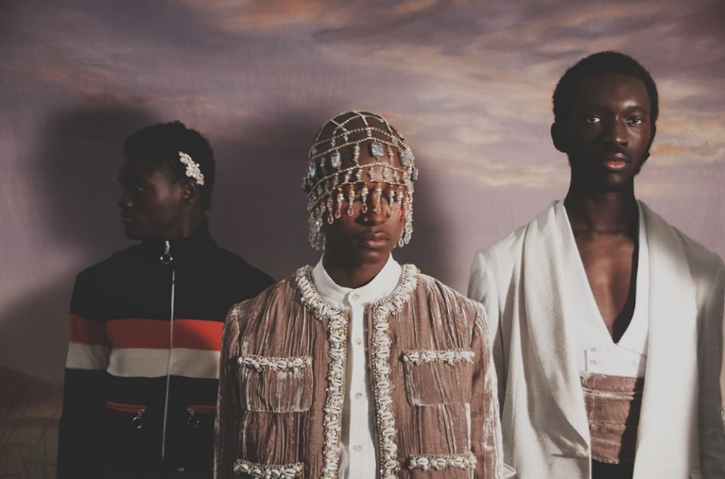
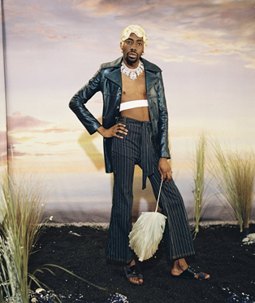
Figure 2: Ebonics A/W 2015
Figure 1: Ebonics A/W 2015
crushed velvet in mushroom, chocolate and indigo expand into luxurious flares with hand embroidered cowrie shells and crystals by Swarovski. Wales Bonner’s signature top stitched denim is refined in pinstripes, with an ivory raw silk cummerbund and cream rose pearls.
“I see my research practice as an artistic and spiritual practice because when I connect with it, I’m definitely connected to a form of energy that really guides me. It isn’t me doing something proactively; it’s intuitive and I’m moved to do it” – Grace Wales Bonner
Grace Wales Bonner's impact in the fashion industry is marked by her departure from trend-driven design to a deeper exploration of Black identity. She incorporates heritage and cultural significance narratives into her collections through diligent research and thorough curation. Each garment serves as an outlet for stories often marginalized, challenging traditional notions of luxury. Her devotion to inclusivity and cultural richness reshapes the fashion landscape, inspiring a more diverse and authentic industry.
Despite the abundance of talent within the black design community, mainstream fashion media often fails to adequately represent their work. According to a Zippia report, less than eight percent of fashion designers are Black, highlighting a glaring divide in an industry where white designers make up 60% of the workforce. In recent years, studies such as one carried out by Tameka N. Ellington at Kent State University in 2017, have shined a spotlight on these disparities. According to Ellington's research found that black designers were featured in only six out of twelve issues per year in media including Harper’s Bazaar and Vogue, with limited coverage and minimal advertising presence. Moreover, when featured, their work may be tokenized or reduced to niche categories, rather than celebrated as an essential part of the fashion landscape. The language used in fashion journalism may amplify these distinctions. Instead of celebrating the resilience and innovation of black designers, narratives tend to focus on their struggles and hardships, reinforcing stereotypes and diminishing their achievements. These inequalities extend beyond media coverage to opportunities for editorial features, runway presentations, and industry awards. Black designers face barriers to entry and recognition in the fashion community. This limits their ability to thrive and succeed on equal footing with their non-black peers.
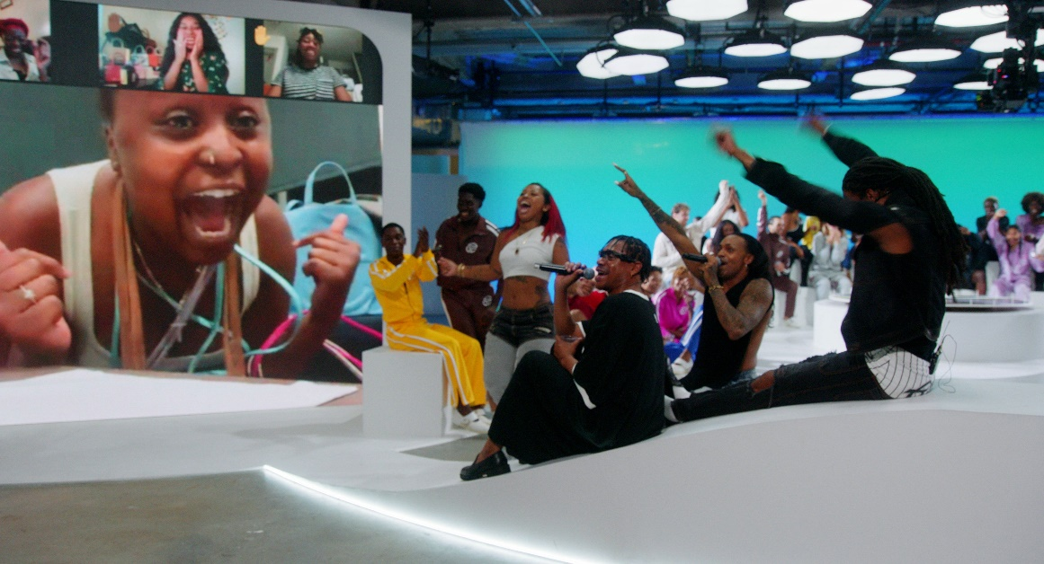
Telfar Clemens is a designer who has carved out his niche in the fashion industry. Born to Liberian parents in Queens in 1985, Clemens' upbringing formed his perspective on culture and community. Upon returning to the United States during the outbreak of the second Liberian civil war, Clemens found inspiration in fashion. This led him to establish his eponymous brand, Telfar, while attending Pace University. Since its launch, Telfar has challenged conventional concepts of luxury, as expressed by the timeless Telfar Shopping Bag, dubbed the "Bushwick Birkin." It combines the names of the once-industrial, now-hip Bushwick neighbourhood in Brooklyn and the notoriously Hermès Birkin handbags, which can cost up to six figures. This innovative development reflects Clemens' devotion to making high-end fashion accessible to a diverse audience. In 2017, Clemens' ground-breaking designs earned him the CFDA/Vogue Fashion Fund Award, further establishing his status in the industry. As Telfar shopping bags are constantly sold out, in 2020, a bag security program was created (BSP). This is a limited-time event where you can pre-order any color, size, and quantity of the bags. Clemens recently unveiled Telfar TV, a shopping channel offering brand-exclusive content and curated selections accessible via various platforms. It is a 24hr Live-Linear TV network in collaboration with the Ummah Chroma Collective. In addition to serving as a venue for the Telfar team to make announcements, and a way for fans to be a part of the team, you can upload videos of yourself and your Telfar items and may be eligible for a free bag in exchange for your contributions.

Figure 3: Telfar TV

If we can create an ecology between our business and the freedom of this channel, we will be able to develop programming on the scale of any other channel — without the corporate oversight/overseers — and because we sell bags and clothes and not human beings — we can allow artists to retain ownership of their work. Because our DRIP structure incentivizes a small but tight audience — we can give people real creative freedom. It’s not for you– it’s for everyone. It’s not for everyone, it’s for everyone. The world isn’t everything. Peace <3 – Telfar Clemens
Clemens' goal with Telfar TV is to democratize fashion by providing a unique shopping experience accessible to all. By leveraging social media and innovation, Clemens continues to break down barriers and redefine the fashion landscape.
His collections reinforce his belief that fashion should be inclusive, accessible, and reflective of the diverse world we live in. By embracing his mantra, “It’s not for you, it’s for everyone” and remaining true to his values, Clemens has cemented his position as a pioneer in the industry.
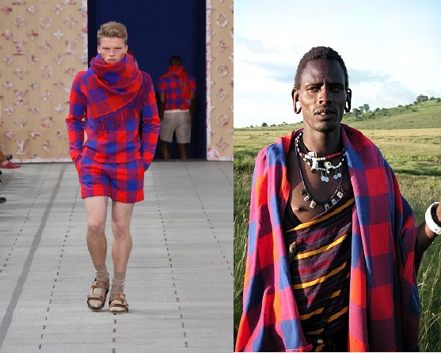
Luxury fashion thrives on exclusivity and creativity, constantly searching for new design elements to captivate audiences. However, this pursuit of the "new" has occasionally resulted in unethical practices, particularly when it comes to extensively taking from African tribal designs. African tribal designs hold deep cultural significance, as they are rooted in centuries of old traditions and represent the identity and heritage of the communities that create them. When luxury brands appropriate these designs without proper recognition or compensation, they strip away their cultural context, reducing them to mere trends. This falls into the act of cultural appropriation. It is the adoption, usually without acknowledgment, of cultural identity markers from subcultures or minority communities into mainstream culture by people with a relatively privileged status. Cultural appropriation reinforces negative stereotypes and perpetuates power imbalances in the industry. The Maasai of Kenya and Tanzania embody one of the most powerful images of tribes in Africa – but it’s an increasingly copied guise. Huge fashion brands around the world, for some time now, continue to exploit the Maasai’s iconic cultural brand in a bid to infuse a touch of exoticism to their products and increase sales.
Figure 4: Louis Vuitton and Massai

The most familiar example dates back to Louis Vuitton’s 2012 spring/summer men’s collection which featured hats, shirts and scarves inspired by the Maasai Shuka – a traditional African blanket cast in colourful shades of red and blue. Many of the Maasai live below the poverty line, but luxury brands continue to exploit their design heritage. They are not compensated for anything sold under these luxury brands' names, despite having helped them sell millions of dollars worldwide. Consumers play a crucial role in promoting change. By researching and seeking out brands committed to ethical sourcing and collaboration with African designers, advocates for more responsible practices. Educating oneself about the cultural significance of African design elements empowers informed purchasing decisions. It's important to recognise that African aesthetics are not monolithic. African designers are constantly innovating, reinterpreting traditional elements. Brands partnering with these designers gain access to a wealth of creativity while maintaining attribution and respect for cultural heritage.
South African designer, Thebe Magugu incorporates his heritage into his designs. Born and raised in South Africa in 1993, Magugu's early fashion career came with obstacles. After being rejected from Central Saint Martins, he enrolled at Stadio’s School of Fashion in Johannesburg. Following his graduation in 2016, he launched his own label. Thebe Magugu draws inspiration from his South African heritage. His designs incorporate African motifs, craft and silhouettes to create vibrant and celebratory looks that reflect the history, culture, and politics of the continent. His works investigates themes of storytelling, education, family and ancestry. One of his most significant collections “African Studies” is an introspective collection inspired by motifs & references from South African culture. From tailored blazers with graphic prints reminiscent of textbook illustrations to flowing dresses recalling the pages of a well-worn novel, each garment is a testament to the power of storytelling and the beauty of African heritage. Thebe Magugu stated that – “with this collection, I wanted to portray my Africa – not the Africa assumed through an auto-exotic gaze.”
The collection is a celebration of Africa's rich intellectual tradition and its impact on shaping global discourse. With attention to detail and innovative design techniques, Magugu elevates the mundane into the extraordinary, infusing each piece with layers of meaning and symbolism. Through his work, he strives to amplify the voices of underrepresented communities, paving the way for greater representation and empowerment within the industry. As the founder of his label, Thebe Magugu Studio, Magugu continues to push boundaries and set new standards for excellence in African fashion. With each collection, he invites us on a journey to experience the vibrant tapestry of African culture, celebrating its beauty, resilience, and boundless creativity.
Black designers are deconstructing the Eurocentric influence that continues to dominate fashion discourse with their visionary designs and commitment to inclusivity. Their work extends representation, it advocates for ethical production practices, cultural appreciation, and social justice. Grace Wales Bonner's exploration of Black identity and heritage in her collections demonstrates the transformative power of fashion as a narrative expression. Telfar Clemens' democratization of luxury through accessible designs and innovative platforms like Telfar TV challenges the boundaries of exclusivity and accessibility. Thebe Magugu's use of African motifs and storytelling in his designs celebrates the complexities of African culture while amplifying underrepresented voices.
However, despite the progress made by these designers, systemic barriers and inequalities remain within the industry. Mainstream fashion media often overlooks or tokenizes the work of Black designers, perpetuating stereotypes and reinforcing disparities of power. The path to success for Black creatives is beset with obstacles, disadvantages, setbacks, disappointment and compromise as a result of the well-documented systemic racism and unconscious bias in fashion industry institutions and businesses. Systemic racism governs every aspect of the industry, shaping opportunities and outcomes for Black designers. Institutionalized prejudice favour Eurocentric beauty standards, aesthetic preferences, and perspectives, marginalizing voices outside of the structure. As a result, Black designers must negotiate a landscape that consistently undervalues their contributions and overlooks their potential. Unconscious bias operates by influencing ways of thinking and perpetuating discrimination. Despite efforts to promote diversity and inclusion, prejudice continues to shape industry norms, restricting the advancement of Black designers and reinforcing existing power dynamics.
Furthermore, it's imperative for the fashion industry to implement a more inclusive and sustainable approach that values the contributions of Black designers and respects cultural heritage. By centering diverse voices, the fashion landscape can promote authenticity, creativity, and social responsibility.

Bibliography
About | Wales Bonner. (n.d.). Wales Bonner. https://walesbonner.com/pages/about
African Studies AW 2019 — Thebe Magugu. (n.d.). THEBE MAGUGU. https://www.thebemagugu.com/collections/AW-2019/
Decolonize definition & meaning (no date) Merriam-Webster. Available at: https://www.merriam-webster.com/dictionary/decolonize
Dictionary.com | Meanings & Definitions of English Words. (n.d.). Dictionary.com. https://www.dictionary.com/browse/cultural-appropriation
Ebonics. (n.d.). Wales Bonner. https://walesbonner.com/pages/ebonics
Edelson, S. (2020, August 10). Black Creatives In Fashion Speak Out On Inequality: We Need To Talk, And You Need To Listen. Forbes. https://www.forbes.com/sites/sharonedelson/2020/08/10/black-creatives-are-saying-we-need-to-talk-and-you-need-to-listen/?sh=31a1db57346b
Ellington, Tameka N. (2017) "Underrepresented: The Lack of Black Designers Featured in Harper’s Bazaar and Vogue," The Seneca Falls Dialogues Journal: Vol. 2, Article 7., p.p 93
Available at: https://fisherpub.sjf.edu/sfd/vol2/iss1/7
Fashion Designer Demographics and Statistics [2024]: Number Of Fashion Designers In The US. (n.d.). Zippia - Find Jobs, Salaries, Companies, Resume Help, Career Paths, and More. https://www.zippia.com/fashion-designer-jobs/demographics/
Fashion: The New Establishment | Thebe Magugu | Polimoda Fashion School. (n.d.). Polimoda Fashion School. https://www.polimoda.com/fashion-new-establishment-thebe-magugu/
FAQ. (n.d.). TELFAR.TV. https://www.telfar.tv/faq
Friedman, V. (2020, December 21). The Year of Telfar (Published 2020). The New York Times. https://www.nytimes.com/2020/12/21/style/telfar-clemens-designer.html
Grace Wales Bonner: Fashion, art and imaginative possibilities (no date) ArtReview RSS. Available at: https://artreview.com/grace-wales-bonner-fashion-art-and-imaginative-possibilities/
Intersectionality and Creative Business Education: Inclusive and Diverse Cultures in Pedagogy. (2023). Germany: Palgrave Macmillan., p.p 78
Jasmine. (2023, August 11). From Maasai to Monograms: The Louis Vuitton Cultural Controversy. Medium. https://medium.com/@Dontquixote/from-maasai-to-monograms-the-louis-vuitton-cultural-controversy-973671ee2a15
The Maasai are fighting back against cultural appropriation (2017) The Independent. Available at: https://www.independent.co.uk/life-style/fashion/maasai-people-cultural-appropriation-luxury-fashion-retailers-louis-vuitton-east-africa-intellectual-property-intiative-mipi-a7553701.html

Intersectionality and Creative Business Education: Inclusive and Diverse Cultures in Pedagogy. (2023). Germany: Palgrave Macmillan., p.p 78
Decolonize definition & meaning (no date) Merriam-Webster. Available at: https://www.merriam-webster.com/dictionary/decolonize
About | Wales Bonner. (n.d.). Wales Bonner. https://walesbonner.com/pages/about
Rosi, S. (2020, August 28). Grace Wales Bonner’s Visions of Black Style. The New Yorker. https://www.newyorker.com/magazine/2020/09/07/grace-wales-bonners-visions-of-black-style#:~:text=Grace%20Wales%20Bonner's%20early%20work,culture%20was%20represented%20in%20fashion.&amp;text=In%20her%20clothing,%20the%20designer,history%20of%20the%20African%20diaspora.&amp;text=I%20wonder%20how%20they%20were,Trayvon%20and%20Breonna%20and%20George.
Ebonics. (n.d.). Wales Bonner. https://walesbonner.com/pages/ebonics
Grace Wales Bonner: Fashion, art and imaginative possibilities (no date) ArtReview RSS. Available at: https://artreview.com/grace-wales-bonner-fashion-art-and-imaginative-possibilities/
Fashion Designer Demographics and Statistics [2024]: Number Of Fashion Designers In The US. (n.d.). Zippia - Find Jobs, Salaries, Companies, Resume Help, Career Paths, and More. https://www.zippia.com/fashion-designer-jobs/demographics/
Ellington, Tameka N. (2017) "Underrepresented: The Lack of Black Designers Featured in Harper’s Bazaar and Vogue," The Seneca Falls Dialogues Journal: Vol. 2, Article 7., p.p 93 Available at: https://fisherpub.sjf.edu/sfd/vol2/iss1/7
Friedman, V. (2020, December 21). The Year of Telfar (Published 2020). The New York Times. https://www.nytimes.com/2020/12/21/style/telfar-clemens-designer.html
FAQ. (n.d.). TELFAR.TV. https://www.telfar.tv/faq
TELFAR.TV
Dictionary.com | Meanings & Definitions of English Words. (n.d.). Dictionary.com. https://www.dictionary.com/browse/cultural-appropriation
The Maasai are fighting back against cultural appropriation (2017) The Independent. Available at: https://www.independent.co.uk/life-style/fashion/maasai-people-cultural-appropriation-luxury-fashion-retailers-louis-vuitton-east-africa-intellectual-property-intiative-mipi-a7553701.html
Jasmine. (2023, August 11). From Maasai to Monograms: The Louis Vuitton Cultural Controversy. Medium. https://medium.com/@Dontquixote/from-maasai-to-monograms-the-louis-vuitton-cultural-controversy-973671ee2a15
Fashion: The New Establishment | Thebe Magugu | Polimoda Fashion School. (n.d.). Polimoda Fashion School. https://www.polimoda.com/fashion-new-establishment-thebe-magugu/
African Studies AW 2019 — Thebe Magugu. (n.d.). THEBE MAGUGU. https://www.thebemagugu.com/collections/AW-2019/
Edelson, S. (2020, August 10). Black Creatives In Fashion Speak Out On Inequality: We Need To Talk, And You Need To Listen. Forbes. https://www.forbes.com/sites/sharonedelson/2020/08/10/black-creatives-are-saying-we-need-to-talk-and-you-need-to-listen/?sh=31a1db57346b

