Investigating The Relationship Between Gaming and Aesthetic Motivation on In-Game Spending in Counter Strike

Finnán Connolly O’Sullivan

N00202077

Supervisor: Dr Tim Mc Nichols

Dissertation submitted as a requirement for the degree of BSc (Hons) in Applied Psychology,
Dun Laoghaire Institute of Art, Design & Technology, 2024

Declaration

I declare that this submission is my own work. Where I have read, consulted, and used the
work of others I have acknowledged this in the text.

Signature: _Finnán Connolly O’Sullivan_
Finnán Connolly O’Sullivan

Date of submission: April 8, 2024
Word count: _4984_

Acknowledgements

I would like to give my foremost appreciation and greatest thanks to Dr Tim Mc Nichols, my supervisor. Without him I would have been left afloat in an ocean of indecision and terrible first drafts for this thesis. His continued support through feedback, listening, and sharing his vast experience has helped me immeasurably. I truly could not have done this without him, and I’m so grateful to have had him as a guide along this journey.
I would also like to thank Dr Christine Horn for her vital statistical feedback and guidance. She enabled me to do my best work throughout the year in learning to understand SPSS and statistical theory, which I cannot thank her enough for.
To Sinéad Meade, thank you for being a terrific lecturer, particularly during Psychology of New Media Entertainment. Her careful and extensive teaching on that topic has helped develop my thesis substantially. Her cheerful and friendly self has brought so much enjoyment to my time at IADT. Thank you.
Of course, to my friends and colleagues in IADT, you’ve been my safety net more times than I dare to count. From chatting in the canteen to lending a hand during a study session, the support and joy they have given me in this difficult final year is beyond words.
To my family, thank you for the countless hours I’ve spent undisturbed and supported while working away on assignments this year. Also, thank you for listening to my ramblings about my thesis and offering your feedback to help me organize otherwise disconnected thoughts.
Finally, I would like to thank everyone who participated in my survey. The vital few from the pilot, and the many others who volunteered a substantial amount of their time, so generously, so that I could make this thesis happen.

Contents
Abstract 1
1. Introduction 2
1.1 Psychological Theories of Motivation 3
1.2 Gaming Motivation 4
1.3 Aesthetic Motivation 5
1.4 Research questions 7
1.5 Hypotheses 7
2. Method 8
2.1 Design 8
2.2 Participants 8
2.3 Materials 8
2.3.1 Motivation for Online Gaming (MOGQ) (Appendix H) 9
2.3.2 Desire for Aesthetics Scale (DFAS) (Appendix I) 9
2.4 Pilot Study 10
2.5 Procedure 10
3. Results 11
3.1 Overview of Results 11
3.2 Descriptive Statistics 11
3.3 Inferential Statistics 12
3.3.1 Outliers 12
3.3.2 Assumptions Tests 12
3.4 Analysis 1: Playtime and Money Spent 12
3.5 Analysis 2: Social Gaming Motivation and Money Spent 13
3.6 Analysis 3: Competitive Gaming Motivation and Money Spent 14
3.7 Analysis 4: Aesthetic Motivation and Money Spent 14
3.8 Analysis 5: Interrelationships Between Gaming Motivations 15
4. Discussion 16
4.1 Overview of Findings 16
4.2 Theoretical Implications 17
4.3 Practical Implications 18
4.4 Strengths & Limitations 19
4.5 Future Research 20
4.6 Conclusion 21
References 22
Appendices 26
Appendix A 26
Appendix B 27
Appendix C 29
Appendix D 30
Appendix E 31
Appendix F 34
Appendix G 35
Appendix H 36
Appendix I 37
Appendix J 41
Appendix K 42
Appendix L 43
Appendix M 45

List of Tables:
Table 1: Descriptive statistics for gaming motivation (social and competitive), Desire for Aesthetics, in-game playtime, and in-game Money Spent
(Page 11)

List of figures
Figure 1: Scatterplot illustrating Money Spent by Playtime
(Page 13)

Figure 2: Scatterplot illustrating Money Spent by Aesthetic Motivation
(Page 14)

Figure 3: Scatterplot illustrating Aesthetic Motivation by Competitive Gaming Motivation
(Page 15)

Abstract

This study investigated the motivations of monetary spending on virtual items in the video game Counter Strike 2 (CS2). With the increasing rise of in-game microtransaction within the gaming industry, understanding why players spend money on virtual items has become crucial for both researchers and game developers alike. This study employed an online survey questionnaire design, with thirty-nine purposively sampled participants who had played CS2 and had spent money on its in-game virtual items. Three independent variables were used, Time Spent in-game, Gaming Motivation score (Competition and Social) using the Online Gaming Motivation Scale (Demetrovics et al., 2011), and Desire for Aesthetics scale (Lundy et al., 2010). The dependent variable was total in-game money spent in US dollars. Spearman Correlations were used to determine the relationship between the independent variables and Monet Spent in-game. There was a significant strong positive relationship found between Time Spent in-game and Money Spent (ρ = .478, p < .01). However, no significant relationship was found for the other variables. Theoretical and practical implications were discussed in relation to previous literature, in addition to limitations of the study and suggestions for future research. This study contributed to important emerging research on recent psychological gaming trends.

Keywords: Counter Strike, microtransactions, motivation, gaming, OGMS, DFAS, SDT

1. Introduction
The monetisation of video games has evolved over the past 40 years from coins in arcade machines, purchasing a disk or cartridge, to most recently, continual user spending on in-game microtransactions. In-game microtransactions refer to the purchasing of virtual in-game items with real-world currency (Zendle et al., 2020). They can range from extra lives, stronger weapons, or purely cosmetic items – so called ‘skins’.
Microtransactions as a monetisation strategy are primarily a feature of ‘free-to-play’ games, where gamers can download and play free of charge, but are instead offered the option to purchase in-game items via microtransactions (Gibson et al., 2022). In 2021, conventional retail games sales of a popular video game development studio ‘Activision Blizard’ only accounted for one third of their $6.49 billion revenue, with the rest being subscriptions and microtransactions (Statista, 2022). Such immense revenue is similar across most other leading game development studios. Although a small percentage (1.5%) of free-to-play gamers purchase microtransactions, roughly 10% of such gamers contribute to 50% of free-to-play game’s revenues (Tomić, 2019). Therefore, understanding why certain gamers spend far more money on microtransactions than other gamers could potentially contribute to research investigating how to reduce problematic excessive video game spending (Raneri et al., 2022).
Gamers vary on how much they desire to spend in a game via microtransactions, factors include gender, mood, and physiological state, however, individual motivation factors also play a role (Yokomitsu et al., 2021), which will be the focus of the present study. The free-to-play game Counter Strike: Global Offensive (CS2), published by Valve Software, is unique among game monetisation because it features a prolific, community run, free-market economy in which gamers can trade or sell their virtual weapon skins between fellow gamers. This has made CS2 a strong example of excessive skin spending, gamers typically sell their skins between €0.02 and €500, some exceptionally rare skins sell for over €250’000. The frequency of these CS2 skin purchases has grossed Valve Software over €980 million in 2023 alone (CSGO Case Tracker, 2024).

To determine the reasons for this phenomenon of spending on virtual skins, one interesting area of research is the individual motivational aspects underlying game players’ spending on virtual skins. CS2 players could be motivated by several factors, such as Competitive Motivation , Social Motivation, and Desire for Aesthetics, which are the main variables of this study. These variables capture distinct aspects of video game motivation, while also considering how much aesthetics weigh in the amount that gamers spend on skins.

1.1 Psychological Theories of Motivation

Motivation is a fundamental concept in psychology, motivating individuals’ behaviours, activities, and goal pursuits. The concept of motivation is based on several theoretical views and includes intrinsic, extrinsic, and amotivated states, each of which influences human behaviour in unique ways. Deci and Ryan (2008) proposed Self-Determination Theory (SDT), which provided a comprehensive framework for understanding motivation, emphasising the importance of intrinsic motivation, which stems from individual internal drives and personal interests, in addition to extrinsic motivation, which is influenced by external factors such as external rewards or social pressures. SDT contends that intrinsic motivation promotes better psychological well-being and sustained engagement than extrinsic motivators, which may diminish autonomy and intrinsic interest (Ryan & Vansteenkiste, 2023). Furthermore, Nicholls' (1984) Achievement Goal Theory (AGT) emphasised the relevance of achievement goals in creating motivation, and distinguished between mastery and performance orientations, which have different consequences for behaviour and learning (Urdan and Kaplan, 2020).
Adding to SDT, Cognitive Evaluation Theory (CET) explores the interaction between intrinsic motivation and external events, proposing that factors such as autonomy and competence influence individuals' motivation levels (Martela, 2020). Furthermore, Maslow's Hierarchy of Needs offers insight into the hierarchical nature of human needs, suggesting that motivation arises by first fulfilling basic physiological needs such as food and shelter, and ending with self-actualization of the individual (Wahba & Bridwell, 1976). McClelland and Kirshnit’s (1988) Theory of Needs delineates three fundamental needs—achievement, affiliation, and power—that drive motivation and behaviour, highlighting individual differences in motivational orientation. Further, the concept of self-efficacy, introduced by Bandura (1982), highlights individuals' beliefs in their ability to achieve desired outcomes, which plays a crucial role in motivating behaviour and goal pursuit. These theories have influenced the development of several specialised motivation scales for unique behavioural settings, such as gaming. With this given framework of motivation, their application to understanding in-game spending for gamers is explored below.

1.2 Gaming Motivation

Why it is that gamers spend money on virtual items could be related to why they choose to play games in the first place. Bartle (1996) first developed a motivational model of gaming motivations within 4 play styles (Achievers, Explorers, Socializers, Killers), fitting within Deci and Ryan’s (2008) SDT, integrating both intrinsic and extrinsic motivation in a gaming context. This, primarily theoretical, model was developed from observations of Multi-User Dungeons (MUDs) players. However, their research was non-empirical, thus, Yee (2006) attempted to make a reliable scale based on Bartle’s (1996) model. Their version was based on motivational features of Massively Multiplayer Online (MMO) game players. They refined the model into 3 main motivational factors (Achievement, Social, and Immersion), each with subcategories (Advancement, Competition, Socialisation, Teamwork, etc.). Although an improvement, Yee (2006) failed to consider factors beyond Bartle’s (1996) initial framework. It was also limited to only MMO related games. Henningsson’s (2009) and Hsu & Luu’s (2007) studies further explored other game genres, and highlighted factors such as flow, escapism, and intrinsic motivations as aspects of gaming motivation.
Consequently, Demetrovics et al.’s (2011) study succeeded in developing a reliable gaming motivation scale which incorporated the previously considered factors, and which could apply to any online game genre. They drew from Bartle’s (1996) framework and used factor analysis on a large sample (3818 gamers) to create a 27-item gaming motivation questionnaire, which measured 7 separate categories. A following meta-analysis of 53 studies on gaming motivation by Martucci et al. (2023) found Demetrovics’ et al. (2011) Online Gaming Motivation Scale (OGMS) to be the most reliable among all similar scales (Cronback’s Alpha = 0.92). Therefore, given the OGMS’s reliability, it would be used for the current study.
When determining in-game spending on skins, the two main categories of note for the present study are ‘Competition’ and ‘Social’ motivations from the OGMS. The OGMS described ‘Competition’ as representing the desire of feeling achievement upon defeating opponents in-game. With relation to skin spending, competitive E-Sports CS2 players have among the most valuable in-game skin inventories of the entire player base. For this reason, it could be considered that competitively motivated players may spend more on skins than those who are less competitively motivated (Kim et al., 2023). The ‘Social’ motivation aspect of the OGMS outlined a desire to get to know other players, socialising, and playing as a team. Within CS2, it is common for teammates and opponents to comment positively if a player owns an attractive or valuable skin. Therefore, skin spending may also be motivated by this social aspect due to a desire to be liked or relate to other players through the display of their skins (Sirola et al., 2020).

1.3 Aesthetic Motivation
Beyond singularly gaming motivation factors on skin spending, players’ desire for art may also be a factor. Individuals differ on their desire for aesthetics (Silvia & Christensen, 2020), for some, it is greatly important that they seek out beauty in their lives. CS2’s weapons skins vary greatly on their subjective aesthetic appeal. Steam Community Market prices of conventionally aesthetically-dull skin designs are markedly lower than those which are more exotic, artistic, or ornate. A ‘well-worn’ or ‘battle-scarred’ quality skin typically sell for a lower price than a pristine ‘factory new’ version of the same skin design. This may indicate that aesthetics plays a role in spending behaviour.
This has been supported by research which found that the aesthetic quality of an item is a significant factor in individuals’ desire to purchase it (Bonetti, 2023). Troisi et al. (2006) found that aesthetically oriented individuals tend to be willing to spend more money on beautiful items. Wu et al. (2023) indicated that consumers exhibited more effort to possess aesthetic objects due to a desire for beauty, as a factor. Additionally, Reza et al. (2020) investigated gamer’s spending behaviour in terms of aesthetic factors and found that the most common reason given by participants was “…because I like the way the skin looks.”, therefore indicating an association between the visual aesthetic of a given skin, and a gamer’s motivation to purchase it. Tosca and Klastrup (2009) also supported the aesthetic element of in-game skins being a motivating factor and emphasised the cosmetic quality of items being most influential for gamers’ in-game spending decisions. Thus, desire for aesthetics could apply for virtual item spending also, such as that present in CS2 skins.
Measuring this motivation can be achieved through Lundy et al.’s (2010) Desire for Aesthetics Scale (DFAS). Instead of broader measures, such as the Big 5’s ‘Openness’ aspect, which included openness to physical and intellectual experience, the DFAS directly measures individuals’ sole aesthetic motivation. It differentiates desire for aesthetics (how much one cares) and aesthetic fluency (how much one knows) regarding art and beauty. This narrowed scale, in terms of solely measuring individuals’ aesthetic motivation, is therefore more appropriate in investigating desire for aesthetics as an isolated independent variable within the context of CS2 skin spending.

1.4 Research questions
1. Is there a relationship between time spent playing Counter Strike and Money Spent in Counter Strike?
2. Is there a relationship between Social Gaming Motivation and Money Spent in Counter Strike?
3. Is there a relationship between Competitive Gaming Motivation and Money Spent in Counter Strike?
4. Is there a relationship between Aesthetic Motivation and Money Spent in Counter Strike?
5. Are there interrelationships between each of these motivations?

1.5 Hypotheses
H1. There is a relationship between time spent playing Counter Strike and Money Spent in Counter Strike
H2. There is a relationship between Social Gaming Motivation and Money Spent in Counter Strike
H3. There is a relationship between Competitive Gaming Motivation and Money Spent in Counter Strike
H4. There is a relationship between Aesthetic motivation and Money Spent in Counter Strike
H5. There are interrelationships between each of these motivations (Social, Competitive, or Aesthetic)

2. Method

2.1 Design
The present study utilised a cross-sectional survey questionnaire design. Three independent variables were used, Time Spent in-game, Gaming Motivation score (Competition and Social), and Desire for Aesthetics score. The dependent variable was total in-game Money Spent in US dollars. Spearman Correlations were used to determine the relationship between the independent variables and Monet Spent, in addition to interrelationships between the independent variables.

2.2 Participants
Thirty-nine participants voluntarily took part in the present study (38 male, 1 female), with ages between 18 and 36 years (Mean = 22.62, SD = 4.87). Participants were required to be adult Counter Strike players who had spent as least 1 USD in-game. Participants were recruited through purposive sampling by sharing the online survey link within Counter Strike online communities (Reddit, Steam Forums, and Discord), in addition to a participation incentive of being entered into a giveaway for a €30 CS2 skin upon completing the survey. Participants were treated in accordance with the ethical guidelines of IADT and the Department of Technology and Psychological Ethics Committee (DTPEC), who approved the study (Appendix A).

2.3 Materials
The online questionnaire was made using Microsoft Forms. Participants were provided with an information sheet (Appendix B) which outlined the study’s aims and terms of participation. Next, a consent form (Appendix C) was provided to follow all DTPEC ethical standards. Brief demographic questions (Appendix D) were used to gather participants’ age and gender. Participants’ in-game spending was measured by following an illustrated guide (Appendix E), which directed participants to their game’s settings, showing their official amount spent in-game. In-game playtime was also measured using an illustrated guide (Appendix F). Lastly, participants were presented with a debrief sheet (Appendix G) after completing the survey which provided contact information for the researcher and their supervisor, along with links to gaming related support services if needed. Dissemination of the present thesis was conducted using IADT’s ‘On Show 2024’ program (Appendix N)

2.3.1 Motivation for Online Gaming (MOGQ) (Appendix H)
The MOGQ (Demetrovics et al., 2011) (Appendix H) measures which aspects of online gaming players find the most motivating to engage with, with a high reliability (α= 0.89). The MOGQ measures 7 of these aspects in sub-scales, for the purpose of the present study only the ‘Competition’ and ‘Social’ sub-scales were used. The ‘Competition’ scale refers to a player’s motivation to compete with and defeat other players to feel a sense of achievement. The ‘Social’ scale represents the social aspects of online gaming, such as enjoyment from meeting new people and playing together with other persons. Each of the sub-scales contain 4 questions. A 5-point Likert scale is used for participants to rate the degree to which they agree or disagree with statements answering the prompt “I play online games….”. Example statements include “…because I enjoy competing with others.” or “… because I can get to know new people”. Participants can score between 0 and 20 on each ‘Competition’ and ‘Social’ factors.

2.3.2 Desire for Aesthetics Scale (DFAS) (Appendix I)
The DFAS measures participants’ motivation towards aesthetic stimuli, in a generalised manner across multiple factors of perception. It features a high reliability (alpha= .82). This 36 item questionnaire can be scored between 0 and 216 (108 being neutral), and includes 6 negatively marked questions. A 7-point Likert scale is used for participants to rate the degree to which they agree or disagree with statements about aesthetic desire. Example statements include “I often find myself staring in awe at beautiful things.”, “Some of my best experiences in life have occurred because of listening to amazing songs.”, and “If I was choosing a college to attend I would put great emphasis on the beauty of the campus.”.

2.4 Pilot Study
A pilot study (N=7) was conducted prior to data collection. The Microsoft Forms questionnaire was mostly functional, but feedback highlighted formatting issues with the Likert scale questions, making them difficult to answer on different devices because of font scaling. Improvements on that formatting, along with an additional estimated-in-game spending question was added, and a second pilot study was conducted (N=3). Following those improvements, no issues were found, and data collection began.

2.5 Procedure
Recruited participants who met selection requirements were presented with an information sheet, followed by a consent form. Participants then provided an anonymous identification code consisting of the second initials of their name and the last 3 digits of their phone number, to maintain confidentiality and the ability for participants to withdraw their data. The overall length of the survey was ~15 minutes. They then answered demographic questions, followed by in-game spending and playtime questions. Participants then moved onto the MOGQ, followed by the DFAS. Lastly, participants provided a final consent confirmation and were thanked and debriefed from the survey.

3. Results

3.1 Overview of Results
This correlational study investigated the relationships between gamers' motivations (specifically, Competition, Social, and Aesthetic motivations) and their Time Spent in-game on their monetary spending on virtual items within the game Counter Strike 2 (CS2). Spearman correlations were conducted to explore these relationships.

3.2 Descriptive Statistics
Participants' demographics revealed a diverse sample of 39 participants (38 male, 1 female), with ages ranging from 18 to 36 years (Mean = 22.62, SD = 4.87). Table 1 displays the number of participants, mean, standard deviation, and range for the variables of: Money Spent; Playtime; Social Motivation; Competitive Motivation and Aesthetic Motivation.

Table 1
Descriptive statistics for gaming motivation (social and competitive), Desire for Aesthetics, in-game playtime, and in-game Money Spent

 |  | Money Spent | Playtime | Total Social | Total Comp | Total Aesthetic
N | Valid | 35 | 35 | 35 | 35 | 35
 | Missing | 0 | 0 | 0 | 0 | 0
Mean |  | 811.96 | 1281.28 | 11.63 | 14.80 | 151.83
Std. Deviation |  | 1203.584 | 1302.164 | 3.750 | 3.428 | 19.363
Range |  | 5540 | 5416 | 14 | 13 | 84

The mean scores for Competition, Social, and Aesthetic Motivations were calculated based on the responses to the Motivation for Online Gaming Questionnaire (MOGQ) and the Desire for Aesthetics Scale (DFAS). Participants demonstrated varying levels of motivation across these dimensions, as indicated by the mean scores and standard deviations. Overall, participants showed varying degrees of motivation across the measured dimensions, with significant variability in their spending behaviour on in-game items.

3.3 Inferential Statistics
Hypotheses H1 to H4 were tested to determine the relationships between different gaming motivations (Competition, Social, and Aesthetic) and Money Spent in Counter Strike using Spearman correlational analysis.

3.3.1 Outliers
Of the 39 initial participants, 4 participants were excluded from the dataset due to exceeding acceptable Z scores of greater than or less than 2.68, when compared to the rest of the sample in one of their measured variable scores (Appendix J)

3.3.2 Assumptions Tests
Assumption of normal distribution of the dependent variable (Money Spent), calculated using Kolmogorov-Smirnov, was violated (p <.001) (Appendix K) but analysis was continued due to the moderate sample size. Hence, a non-parametric inferential test was used, namely a Spearman correlation.
Assumptions for Spearman correlational analysis were met. The data was measured in an interval or ratio scale across the present variables, which passed the first assumption. The second assumption of paired observation of the present variables was also met, due to the simultaneous measurement of variables for each participant in the online survey. The third assumption of a monotonic relationship between the dependent and independent variables was also met (As illustrated in Appendix L)

3.4 Analysis 1: Playtime and Money Spent
Spearman correlation analysis revealed a significant strong positive relationship between the Time Spent and Money Spent in-game (ρ = .478, p < .01), supporting H1 (as illustrated in Figure 1). Hence, Time spent playing Counter Strike was significantly correlated to the amount spent on in-game skins in Counter Strike.

Figure 1
Scatterplot illustrating Money Spent by Playtime
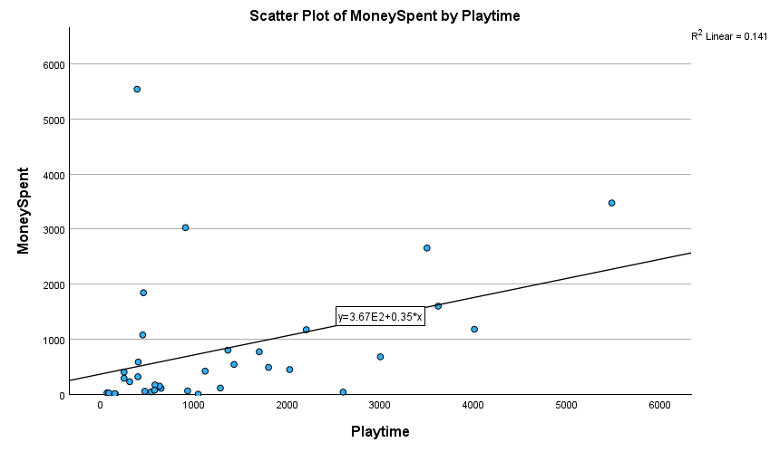

3.5 Analysis 2: Social Gaming Motivation and Money Spent
Results indicated no significant positive correlation between Social Gaming Motivation and in-game spending (ρ = -.002, p = .991), rejecting H2. Hence, Social motivation was not significantly correlated to the amount spent on in-game skins in Counter Strike.

3.6 Analysis 3: Competitive Gaming Motivation and Money Spent
Spearman correlation analysis revealed no significant relationship between Competitive Gaming Motivation and Money Spent (ρ = .032, p = .855), rejecting H3. Hence, Competitive Gaming Motivation was not significantly correlated to the Money Spent on in-game skins in Counter Strike.

3.7 Analysis 4: Aesthetic Motivation and Money Spent
Findings showed a statistically insignificant moderate positive correlation between Aesthetic Motivation and in-game spending (ρ = .30, p = .08), rejecting H4. Therefore, Aesthetic Motivation was not significantly correlated to the amount spent on in-game skins in Counter Strike.

Figure 2
Scatterplot illustrating Money Spent by Aesthetic Motivation
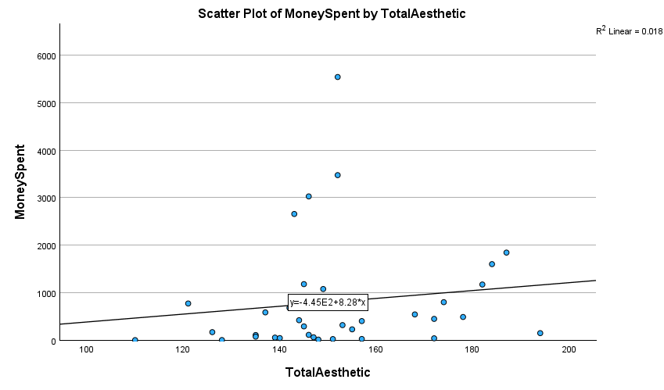

3.8 Analysis 5: Interrelationships Between Gaming Motivations
Hypothesis H5, concerning the interrelationships between gaming motivations, was explored using correlation analysis (Appendix M). Results revealed a moderate positive correlation between Aesthetic Motivation and Competitive Gaming Motivation (ρ = .394, p = .019), accepting H5. Therefore, Aesthetic Motivation was significantly correlated to Competitive motivation. A scatterplot of the findings is illustrated in Figure 3.
Figure 3
Scatterplot illustrating Aesthetic Motivation by Competitive Gaming Motivation
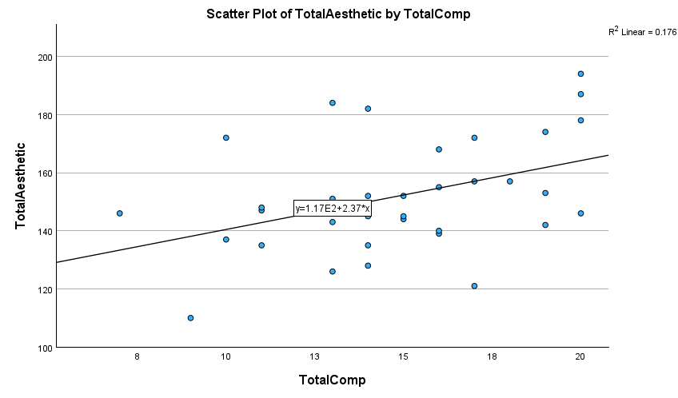

4. Discussion

4.1 Overview of Findings
The aim of this study was to explore the motivations behind gamers' monetary spending on virtual items within the game Counter Strike (CS2). Specifically, the study investigated the relationships between Time Spent playing Counter Strike and Money Spent in the game, as well as the influences of Social Gaming Motivation, Competitive Gaming Motivation, and Aesthetic Motivation on in-game Money Spent. The results provided insights into the complex interplay between these factors.

H1
The study supported the hypothesis that there is a positive relationship between time spent playing Counter Strike and Money Spent in the game, indicating that players who invest more time in the game are more likely to spend money on virtual items.
H2
However, the study did not find a significant positive relationship between Social Gaming Motivation and in-game spending. This suggests that players may not necessarily spend more on virtual items to enhance their social interactions within the game, challenging assumptions about the role of social motivation in driving in-game purchases.
H3
Similarly, Competitive Gaming Motivation did not show a significant relationship with Money Spent in Counter Strike, indicating that players' competitive drive may not directly influence their spending behaviour on virtual items. This finding contrasts with the notion that competitive gamers may invest more in in-game purchases to gain a competitive edge or showcase their status within the gaming community.

H4
In addition, while the study found a statistically insignificant moderate positive correlation between Aesthetic Motivation and in-game spending, the trend suggests that players with a higher desire for aesthetic appeal may be inclined to spend more on visually appealing virtual items. This finding underscores the importance of aesthetic factors in driving consumer behaviour, even in virtual contexts (Bonetti, 2023; Troisi et al., 2006).
H5
Furthermore, the study revealed a moderate positive correlation between Aesthetic Motivation and Competitive Gaming Motivation, indicating potential overlap between these motivational factors. This suggests that players who are motivated by aesthetics may also exhibit competitive tendencies.

4.2 Theoretical Implications
The findings of the present study both reject and support varied aspects of previous literature on the motivations of in-game spending. Factors relating to the Online Gaming Motivation Scale (OMGS), specifically Social and Competitive Motivation, were not found to influence Money Spent in-game. This rejects the previous theoretical framework cited in the present study relating to evidence of E-Sports players (Kim et al., 2023), and by extension, competitively motivated players, spending significantly more money in-game then those who are less competitively motivated to play games. In addition, socially motivated gamers, who were hypothesised to exhibit increased spending based on the findings of Sirola et al. (2020), due to their desire to be liked or relate to other players through the display of their in-game skins was not supported by the present study’s findings. Given the absence of a significant relationship between these factors and Money Spent in-game, it can be concluded that the Gaming Motivational factors of CS2 players, as measured by the MOGQ, are unrelated to differences of in-game financial decisions of said players.

In relation to Aesthetic Motivation, the findings of Bonetti (2023), Troisi et al. (2006) and Wu et al. (2023), indicated a relationship between increased Aesthetic Motivation and increased purchasing behaviour of artistic products, for non-gamers. Following that generalised theoretical basis, Reza et al. (2020) and Tosca and Klastrup’s (2009) findings that gamers, specifically, can be motivated by cosmetic and aesthetic factors to purchase in-game skins was not supported by the present study. Although there was a moderate positive relationship, it was not statistically significant. This finding, however, was close to significant (p = .08), this may be due to limitations of the present study, specifically its small sample size (N = 35), or others which are discussed below in their own section.
The significant strong positive relationship (ρ = .478, p < .01) between Time Spent in-game and Money Spent aligns with previous research highlighting the correlation between gaming engagement and in-game purchases (Zendle et al., 2020). This finding suggests that players who invest more time in playing CS2 are more likely to make in-game purchases. This result is consistent with the notion that in-game spending may be influenced by the level of involvement and commitment to the game. This could influence theories related to spending behaviour in other similar video games. Games with a similar free market player-driven skin economy may show similar results. Additionally, it could indicate a more general relationship between games featuring cosmetic skins and players’ spending behaviours, though this will be examined in its own section below.

4.3 Practical Implications
Practically, these findings have implications for game developers and marketers seeking to understand and target different segments of gamers based on their motivations and spending patterns. By recognizing the diverse motivations driving in-game purchases, developers can tailor their monetization strategies to better appeal to the preferences of their player base. For instance, game developers could focus on design features which extend players’ in-game Time Spent. This could be achieved by implementing regularly adding in-game content and features to encourage players to return to the game more frequently. Additionally, Time Spent in-game could be improved by developers creating ongoing in-game challenges with time-limited availability, potentially encouraging players to regularly engage with the game whenever such challenges are available to complete. Although not an extensive list of potential recommendations, the significant positive relationship between Time Spent in-game for players and monetary revenue for game developers would best be utilised on a per-game basis. Developers should therefore capitalise on factors they have uniquely found to increase Time Spent in-game for their specific player base, rather than a generalised guideline from the present study.

4.4 Strengths & Limitations
One strength of this study lies in its unique empirical investigation of gaming motivations and in-game spending behaviour, providing valuable insights into the factors influencing players' monetary decisions within the context of Counter Strike. The findings of this study contribute to the existing literature on gaming motivations and in-game spending. Additionally, the use of established scales, such as the Online Gaming Motivation Scale (OGMS) and the Desire for Aesthetics Scale (DFAS), enhanced the validity and reliability of the findings in either confirming or rejecting the theoretical framework of the present study. Another strength of this study is its novel exploration of variables, specifically Aesthetic Motivation, on virtual in-game spending behaviours. This is a relationship relatively unexplored in gaming or psychology literature, which provides an avenue for future research into this relationship.
However, some limitations should be acknowledged. Firstly, the study’s sample had relatively small number of participants (N = 39), which limits the potential generalizability of the findings. This sample size was limited by the purposive nature of participant recruitment, requiring specifically adult Counter Strike gamers who have spent money in-game on skins. Therefore, future research could possibly benefit from a stronger recruitment approach. This could be achieved by enhanced incentives for participants, such as an increased monetary equivalent skin giveaway. Additionally, the smaller sampling pool coupled with a lengthy time commitment to complete the survey (~15 minutes), lead to limited respondents. However, the length of the study was required to record participants’ valid spending data and complete the necessary surveys. Furthermore, the study relied on self-reported data, which could be subject to biases and recall errors, specifically with the external in-game spending measurement. Future research could accurately measure spending by developing an Internet plugin for the participants, drawing from their digital receipts of Steam Marketplace spending in an anonymised and confidential manner.

4.5 Future Research
Building on the findings of this study, future research could explore additional factors influencing in-game spending behaviour, such as personality traits, gaming preferences, and socio-economic factors such as income and nationality. Future research could benefit from recruiting a larger sample of gamers, by possibly expanding the types of games played beyond Counter Strike, or by incentivising recruitment for the target population with either in-game giveaways for participating or shortening the time commitment to complete the survey. Longitudinal studies could also investigate the dynamics of gaming motivations and spending patterns over time, potentially investigating the stability and evolution of these factors among gamers. Moreover, qualitative research methods, such as interviews and focus groups, could provide deeper insights into the underlying motivations and decision-making processes driving in-game purchases that are not indicated by existing literature on this topic. By adopting a multi-method approach, researchers could gain a more nuanced understanding of the complexities surrounding gaming motivations and in-game spending behaviour. Lastly, future studies could employ experimental or observational methods to complement self-report measures and provide a more comprehensive understanding of gaming motivations and spending behaviour.

4.6 Conclusion
In conclusion, this study aimed to investigate the motivations behind gamers' monetary spending on virtual items within the game Counter Strike (CS2), exploring the relationships between Time Spent playing and Money Spent in-game, as well as the influences of Social Gaming Motivation, Competitive Gaming Motivation, and Aesthetic Motivation on in-game spending. The findings revealed both supporting and conflicting evidence with previous literature on gaming motivations and in-game spending. While a positive relationship was found between Time Spent in-game and Money Spent, indicating that players who invest more time are more likely to make in-game purchases, the study did not find significant relationships between Social and Competitive Gaming Motivation and in-game spending. Similarly, while there was a moderate positive correlation between Aesthetic Motivation and spending, it was not statistically significant. These findings have theoretical implications, challenging assumptions about the role of social and competitive motivations in driving in-game purchases and highlighting the importance of aesthetic factors. Moreover, the practical implications suggest that developers could tailor monetization strategies to appeal to different segments of gamers based on their motivations and spending patterns. However, the small sample size of participants is an acknowledged limitation. Future research could explore additional factors influencing in-game spending behaviour, employ longitudinal or qualitative methods, and investigate gaming motivations across different game genres to provide a more comprehensive investigation of this topic. Overall, this study contributed valuable insights to the important literature on gaming motivations and in-game spending, paving the way for further exploration in this area.

References

Bandura, A. (1982). Self-efficacy mechanism in human agency. American Psychologist/the American Psychologist, 37(2), 122–147. https://doi.org/10.1037/0003-066x.37.2.122
Bartle, R. (1996). Hearts, clubs, diamonds, spades: Players who suit MUDs. ResearchGate. https://www.researchgate.net/publication/247190693_Hearts_clubs_diamonds_spades_Players_who_suit_MUDs
Bonetti, B. L. (2023). Impact of Incidental Aesthetics on Consumer Evaluations [Doctoral dissertation, Virginia Tech]. https://vtechworks.lib.vt.edu/bitstreams/27e4a74c-d672-40b1-bfdc-c8098affee1e/download
CSGO Case Tracker. (2024). 2023 year in review. https://csgocasetracker.com/blog/2023-Year-Review
Deci, E. L., & Ryan, R. M. (2008). Self-determination theory: A macrotheory of human motivation, development, and health. Canadian Psychology, 49(3), 182–185. https://doi.org/10.1037/a0012801
Demetrovics, Z., Urbán, R., Nagygyörgy, K., Farkas, J., Zilahy, D., Mervó, B., Reindl, A., Ágoston, C., Kertész, A., & Harmath, E. (2011). Why do you play? The development of the motives for online gaming questionnaire (MOGQ). Behavior Research Methods, 43(3), 814–825. https://doi.org/10.3758/s13428-011-0091-y
F2P games revenue worldwide 2018-2023. (2022, July 25). Statista. https://www.statista.com/statistics/324129/arpu-f2p-mmo/
Frostling-Henningsson, M. (2009). First-Person Shooter games as a way of connecting to people: “Brothers in Blood.” Cyberpsychology & Behavior, 12(5), 557–562. https://doi.org/10.1089/cpb.2008.0345
Gibson, E., Griffiths, M. D., Calado, F., & Harris, A. (2022). The relationship between videogame micro-transactions and problem gaming and gambling: A systematic review. Computers in Human Behavior, 131, 107219. https://doi.org/10.1016/j.chb.2022.107219
Hsu, C., & Lu, H. (2007). Consumer behavior in online game communities: A motivational factor perspective. Computers in Human Behavior, 23(3), 1642–1659. https://doi.org/10.1016/j.chb.2005.09.001
Kim, H. S., Leslie, R. D., Stewart, S. H., King, D. L., Demetrovics, Z., Andrade, A. L. M., Choi, J. S., Tavares, H., Almeida, B., & Hodgins, D. C. (2023). A scoping review of the association between loot boxes, esports, skin betting, and token wagering with gambling and video gaming behaviors. Journal of Behavioral Addictions, 12(2), 309–351. https://doi.org/10.1556/2006.2023.00013
Lundy, D. E., Schenkel, M. B., Akrie, T. N., & Walker, A. M. (2010). How Important is Beauty to You? The Development of the Desire for Aesthetics Scale. Empirical Studies of the Arts, 28(1), 73–92. https://doi.org/10.2190/em.28.1.e
Martela, F. (2020). Self‐Determination Theory. The Wiley Encyclopedia of Personality and Individual Differences, 369–373. https://doi.org/10.1002/9781118970843.ch61
McClelland, D. C., & Kirshnit, C. (1988). The effect of motivational arousal through films on salivary immunoglobulin A. Psychology & Health, 2(1), 31–52. https://doi.org/10.1080/08870448808400343
Nicholls, J. G. (1984). Achievement motivation: Conceptions of ability, subjective experience, task choice, and performance. Psychological Review, 91(3), 328–346. https://doi.org/10.1037/0033-295x.91.3.328
Raneri, P. C., Montag, C., Rozgonjuk, D., Satel, J., & Pontes, H. M. (2022). The role of microtransactions in Internet Gaming Disorder and Gambling Disorder: A preregistered systematic review. Addictive Behaviors Reports, 15, 100415. https://doi.org/10.1016/j.abrep.2022.100415
Reza, A., Nedd, A., Chu, S., Castillo, A., Khan, Z., & Gardner, D. L. (2020, March 23). “‘“I like the way the skin looks”’: Player perspectives on aesthetic appeal and self-representation with video game ‘ “Skins”’” | IDEALS. https://hdl.handle.net/2142/106593
Ryan, R. M., & Vansteenkiste, M. (2023). Self-determination theory : metatheory, methods, and meaning. http://hdl.handle.net/1854/LU-01HRCMM640511RK99H40PKVEPN
Silvia, P. J., & Christensen, A. P. (2020). Looking up at the curious personality: individual differences in curiosity and openness to experience. Current Opinion in Behavioral Sciences (Print), 35, 1–6. https://doi.org/10.1016/j.cobeha.2020.05.013
Sirola, A., Savela, N., Savolainen, I., Kaakinen, M., & Oksanen, A. (2020). The Role of Virtual Communities in Gambling and Gaming Behaviors: A Systematic review. Journal of Gambling Studies, 37(1), 165–187. https://doi.org/10.1007/s10899-020-09946-1
Tomić, N. (2019). Economic model of microtransactions in video games. Journal of Economic Science Research, 1(1). https://doi.org/10.30564/jesr.v1i1.439
Tosca, S., & Klastrup, L. (2009). “Because it just looks cool!” - Fashion as character performance: The Case of WoW. Journal of Virtual Worlds Research, 1(3). https://doi.org/10.4101/jvwr.v1i3.305
Troisi, J. D., Christopher, A. N., & Marek, P. (2006). Materialism and money spending disposition as predictors of economic and personality variables. North American Journal of Psychology, 8(3), 421. https://digitalcommons.kennesaw.edu/facpubs/421/
Urdan, T., & Kaplan, A. (2020). The origins, evolution, and future directions of achievement goal theory. Contemporary Educational Psychology, 61, 101862. https://doi.org/10.1016/j.cedpsych.2020.101862
Wahba, M. A., & Bridwell, L. G. (1976). Maslow reconsidered: A review of research on the need hierarchy theory. Organizational Behavior and Human Performance, 15(2), 212–240. https://doi.org/10.1016/0030-5073(76)90038-6
Wu, F., Reimann, M., Pol, G., & Park, C. W. (2022). The scarcity of beauty: how and why product aesthetics mobilize consumer acquisition effort. Journal of the Academy of Marketing Science, 51(6), 1245–1265. https://doi.org/10.1007/s11747-021-00831-w
Yee, N. (2006). Motivations for play in online games. Cyberpsychology & Behavior, 9(6), 772–775. https://doi.org/10.1089/cpb.2006.9.772
Yokomitsu, K., Irie, T., Shinkawa, H., & Tanaka, M. (2021). Characteristics of Gamers who Purchase Loot Box: a Systematic Literature Review. Current Addiction Reports, 8(4), 481–493. https://doi.org/10.1007/s40429-021-00386-4
Zendle, D., Meyer, R., Cairns, P., Waters, S., & Ballou, N. (2020). The prevalence of loot boxes in mobile and desktop games. Addiction, 115(9), 1768–1772. https://doi.org/10.1111/add.14973

Appendices

Appendix A

Appendix B

Appendix C

Appendix D
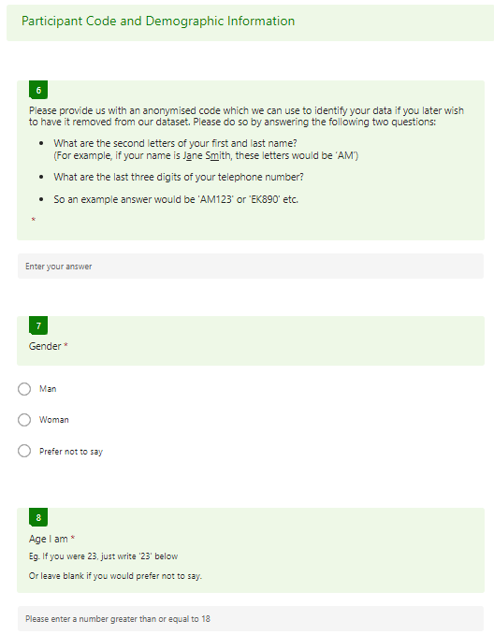

Appendix E
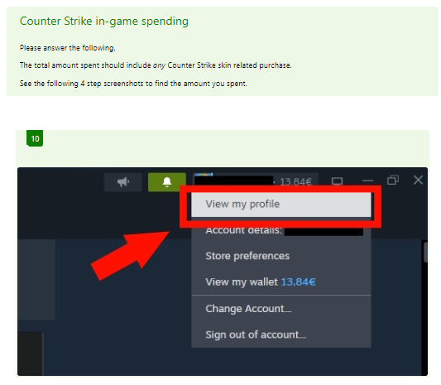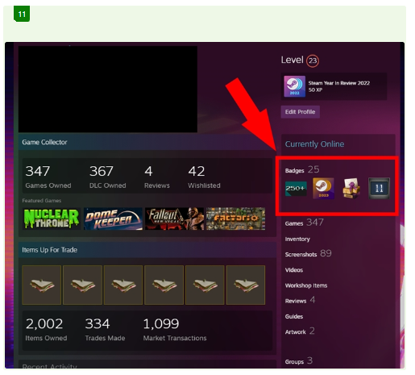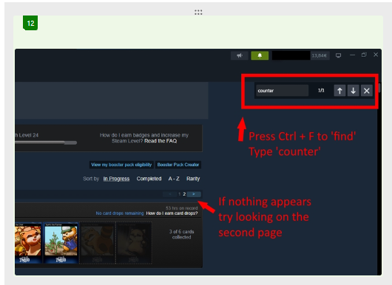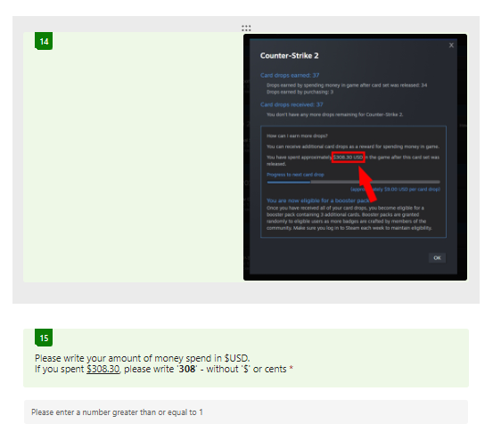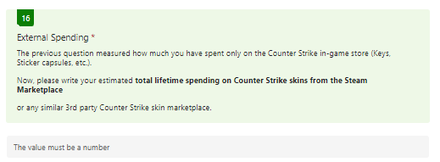

Appendix F
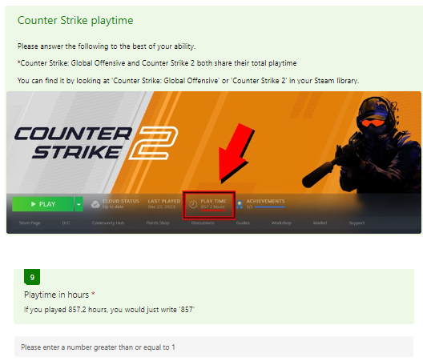

Appendix G

Appendix H
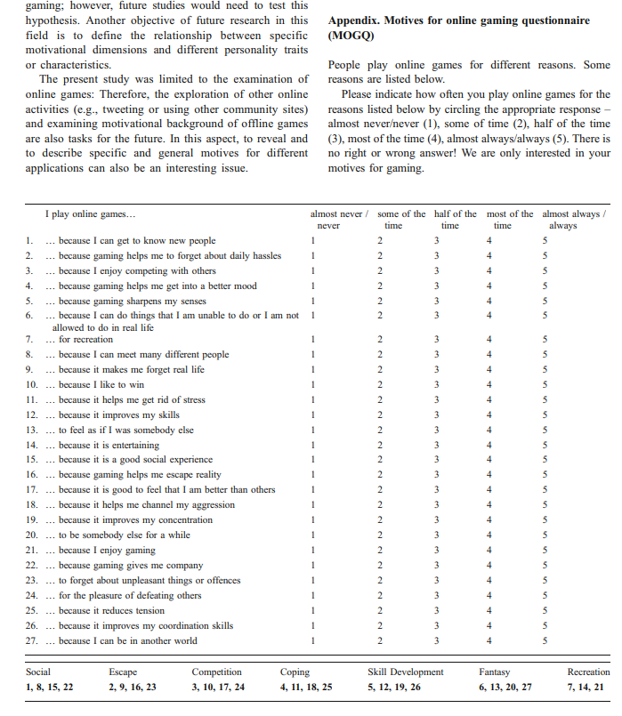

Appendix I

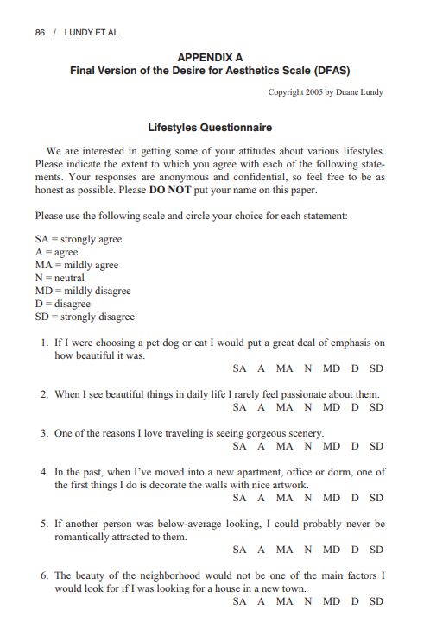
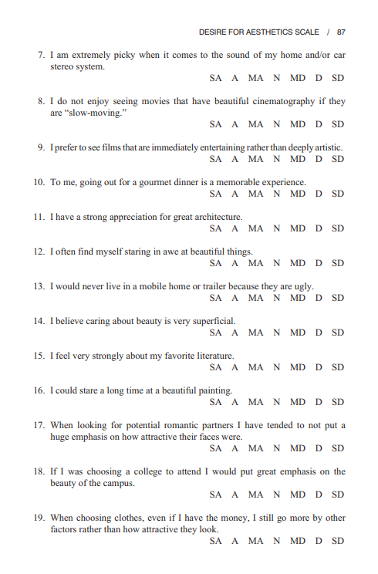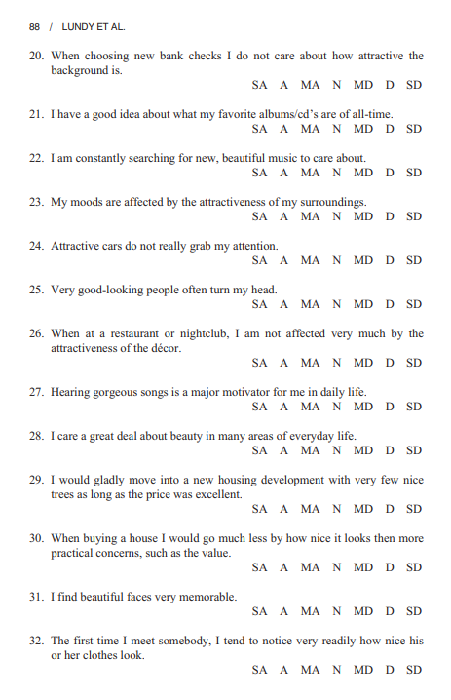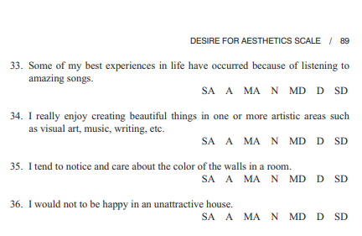

Appendix J

Z score greater than or less than 2.68
Id | Z Score | Variable
28 | 5.36 | money
18 | 3.40 | Playtime
29 | 3.08 | Playtime
27 | -2.81 | Competitiveness

Left with 35 participants after removing variables
From 39 participants

Appendix K

One-Sample Kolmogorov-Smirnov Test
 |  |  | MoneySpent
N |  |  | 35
Normal Parameters^{a,b} | Mean |  | 811.96
 | Std. Deviation |  | 1203.584
Most Extreme Differences | Absolute |  | .250
 | Positive |  | .247
 | Negative |  | -.250
Test Statistic |  |  | .250
Asymp. Sig. (2-tailed)^{c} |  |  | <.001
Monte Carlo Sig. (2-tailed)^{d} | Sig. |  | <.001
 | 99% Confidence Interval | Lower Bound | .000
 |  | Upper Bound | .000
a. Test distribution is Normal.
b. Calculated from data.
c. Lilliefors Significance Correction.
d. Lilliefors' method based on 10000 Monte Carlo samples with starting seed 1535910591.

Appendix L

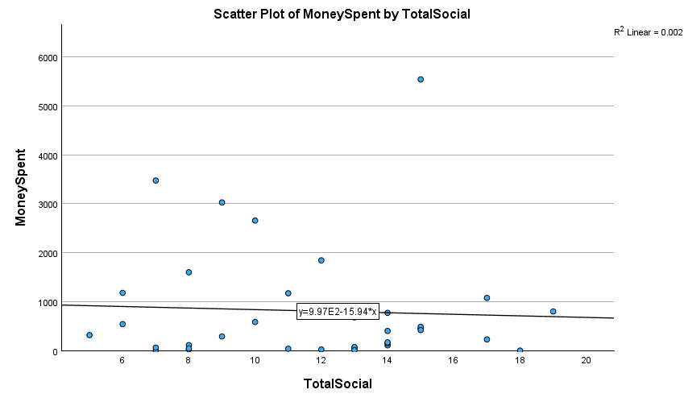

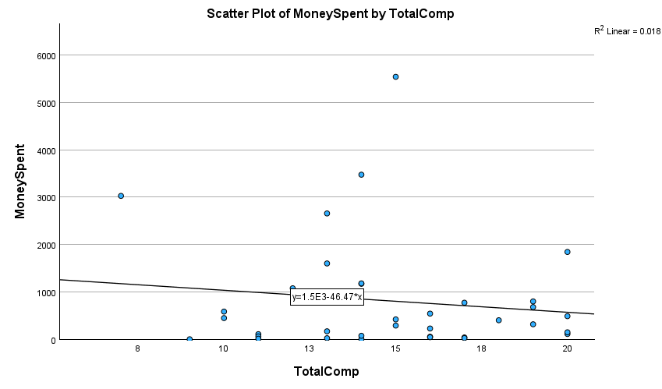

Appendix M

Correlations
 |  |  | MoneySpent | Playtime | TotalSocial | TotalComp | TotalAesthetic
Spearman's rho | MoneySpent | Correlation Coefficient | 1.000 | .478** | -.002 | .032 | .300
 |  | Sig. (2-tailed) | . | .004 | .991 | .855 | .080
 |  | N | 35 | 35 | 35 | 35 | 35
 | Playtime | Correlation Coefficient | .478** | 1.000 | -.083 | .005 | .113
 |  | Sig. (2-tailed) | .004 | . | .634 | .976 | .519
 |  | N | 35 | 35 | 35 | 35 | 35
 | TotalSocial | Correlation Coefficient | -.002 | -.083 | 1.000 | .001 | .003
 |  | Sig. (2-tailed) | .991 | .634 | . | .996 | .984
 |  | N | 35 | 35 | 35 | 35 | 35
 | TotalComp | Correlation Coefficient | .032 | .005 | .001 | 1.000 | .394*
 |  | Sig. (2-tailed) | .855 | .976 | .996 | . | .019
 |  | N | 35 | 35 | 35 | 35 | 35
 | TotalAesthetic | Correlation Coefficient | .300 | .113 | .003 | .394* | 1.000
 |  | Sig. (2-tailed) | .080 | .519 | .984 | .019 | .
 |  | N | 35 | 35 | 35 | 35 | 35
**. Correlation is significant at the 0.01 level (2-tailed).
*. Correlation is significant at the 0.05 level (2-tailed).

Appendix N
