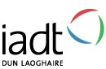

NEW MEDIA STUDIES

Submission Form
This cover sheet must be completed, signed, and attached to the back of every assignment that is submitted for continuous assessment on this programme.
NAME: Benedit Akemba
STUDENT NUMBER: N00201362
YEAR: Fourth Year
MODULE: Journalism
ASSIGNMENT: Journalism Story
Word count: 1866

By ticking the boxes below, I declare that I have:
Read IADT’s plagiarism policy (available on Blackboard): yes
Acknowledged all sources used in completing this assignment: yes
Referenced all sources, in text, at the point that they have been cited: yes

Signed: Benedit Akemba (Student) (on date of submission of an assignment)

Date: 7th January 2024

Framing the Lens of Equality.

Navigating the underrepresentation of women in the Irish film industry and the journey to parity.
By Benedit Akemba

‘The most recent job I worked on I was the only woman on a camera team of 17. I was the trainee and every time I did a task that was done right, the man I worked under would almost be shocked that I was able to do certain things. I know he probably didn’t mean to say it in a condescending way but it did feel like he didn’t even think I could do it in the first place.’
Encounters with gender related challenges in your career
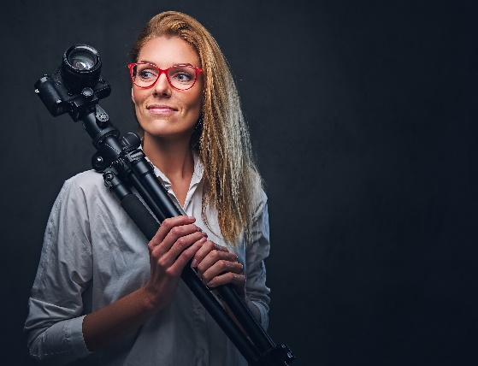
Katelyn Markham O’Halloran is a 23-year-old cinematographer and photographer who recently graduated from the National Film School in IADT. In her course, there was 9 girls out of a total of 27. The number of women enrolled in film courses is extremely low and this is reflected in the film industry. The Celluloid Ceiling has recently come out with a report tracking the employment of women in 250 high grossing films from the last 26 years. Women made up 16% of directors, 17% of writers, 26% of producers, 24% of executive producers, 21% of editors, and 7% of cinematographers. Films that were directed by women tended to employ more women in higher roles rather than films directed by men. Film plays a profound role in the cultural and economic life in individuals, our communities and our country. It dates back to the 1900s. Films were included in music hall shows, screened in town and village halls, markets and any location that could hold an audience and where a travelling projectionist could set up. Despite this, there aren't many figures available that can measure women’s participation in the Irish film industry. Women continue to face difficulties in getting jobs such as screenwriters, directors, producers, cinematographers, editors and crew. They generally find ways by making short films, documentaries and low-budget features.
Figure 1
Katelyn refrains from telling herself that she is being treated a certain way because of her gender. She explains that, ‘It’s easy to become stuck in that mindset especially when this industry is what I hope to work day to day in, it can become very toxic. However, I have definitely encountered older men that have looked at me in a way that they have no idea how I’ve managed to get in the position I am in or they don’t have any hope in me. They treat me like I don’t know what I am doing and they have to teach me everything.’

What are some initiatives that you’ve seen or participated in that aim to address gender disparity…?

Wiktoria Weinreitt is a 21-year-old filmmaker and photographer currently studying at the National Film School in IADT. The school offers advanced facilities for education and training in film, television and radio production, design for stage and screen, and modelmaking. Wiktoria recalls attending a two- day programme aimed at young women in secondary school who were interested in studying film. It was created as part of the national strategy to ensure the growth of women in the film industry. The masterclasses were led by industry experts including Stefanie Preissner, Neasa Hardiman, Mary-Kate O Flanagan and Rachel Lysaght along with IADT staff and mentors. Wiktoria expressed that, ‘It was such a safe space as it made it clear that we are here and able to make it. By not having enough women tell stories we are limiting the consumption of art and media. Certain feelings, experiences and stories need to be told by women on a larger scale. When you see women in high roles, you have inspirations and people to look up to. It makes you believe that you can do it too.’
‘It was such a safe space as it made it clear that we are here and able to make it. By not having enough women tell stories we are limiting the consumption of art and media.’
With the ever-growing shift of our time, having workshops directed towards women allows them to immerse in the craft and picture a future in film.
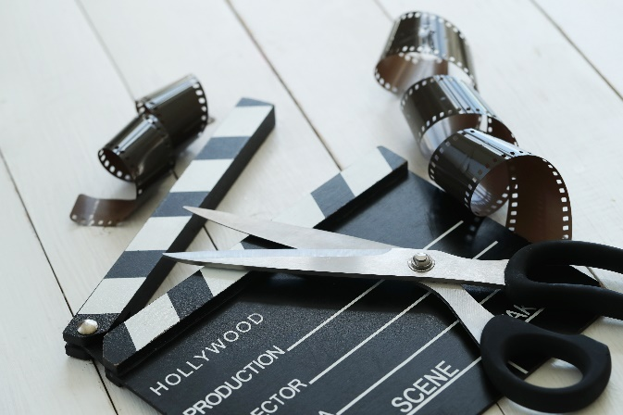
The IFI (Irish Film Institute) recently introduced the F-rating to its monthly and festival showcasing. This highlights the significant role of women to the film industry. Any film directed or written by a woman receives an F-rating. It was originally developed by the Bath Film Festival in 2014 as a way to champion creative achievements by women. Several cinemas and festivals worldwide subscribed to the campaign. By August 2017, IMDb had over 22,000 films classified as ‘F’. The IFI has an F rated archive player strictly consisting of Irish women. It presents a varied series of stories told through the sphere of the female gaze. The collection includes 36 films made by Irish women over four decades. Many of the films are written by women, however they are all directed by them. The film archive player includes an array of genres made with substantial funding and films made with little to none. There are films in Irish, in English (one in Polish, one in Ukranian) and independent films that were seen by a small audience, and films that recieved global attention. Katelyn regularly tunes into the IFI F rated archive and shares, ‘I don’t want to say that a woman should be given a chance because they are a woman but it’s what I believe. When people are given opportunities it’s because they are chosen as the best candidate. You get a slice of life from every film you watch. Not considering the films you watch closes you off to a world of incredible cinema.’
Figure 2
Olamide Soleye is a 20-year-old filmmaker, graphic designer and photographer originally from Nigeria but studied film in Griffith College in Dublin. He recognises the gender disparity in the Irish film industry but senses that it is getting better in Ireland compared to other countries. ‘There’s definitely a big gender disparity in recognised filmmakers everywhere but from my experiences, half of the filmmakers whose set I worked on in Ireland were female, that’s more than anywhere else I’ve ever been. I feel that the community is growing fast and it’s very pleasant to see’
What sets Ireland apart from many other countries was the introduction of a gender policy by Screen Ireland. The Six Point Plan was announced in December 2015 and became public in early 2016. The plan aims to:
- Collect, publish and monitor data on gender inequality
- Engage with production companies and organisations to raise awareness and work with them in education and training initiatives
- Enhance the skills and capacities of people in regards to diversity and equality issues in the creative decision-making process
- Develop skills and mentor initiatives
- Support the drive for film in schools and colleges in the area of Irish culture
- Working with their partners in funding film and screen content, including RTÉ and TG4, as well as the Broadcasting Authority of Ireland (BAI) Sound and Vision Scheme, to promote gender equality in publicly funded film and tv content
Despite the introduction of this gender policy, applications by women have been lower than expected. With the exception of short film grants, female writers and directors continue to be underrepresented in funding awards (though there were tentative signs of improvement in late 2018). Screen Ireland took notice to this and launched a number of schemes specifically at female writers, directors and producers, in order to directly increase female representation in the Irish film industry. Screen Ireland recognises that not enough has been done in terms of increasing the actual funding applications received by female talent attached.

What do you think people within and outside the industry can do to continue promoting inclusivity in film/filmmaking?

Arann McCormack is a 21-year-old photographer studying photography in IADT. She has worked as a BTS (behind the scenes) photographer on many films sets. She has worked on sets consisting of mainly women, mainly men but occasionally sets that contain very few women. Being on these sets expands Arann's network while meeting other women in a similar field. She says there is some sort of unspoken bond with women in film and creative spaces because they’re all just trying to navigate through it together. The photography courses aren't as unequal as film courses however they are still heavily male dominated. Arann believes that the future of film is bright, ‘Cinema should be reflective of life and life doesn’t consist of only men. Affirmative action should be made to bring cinema to its truest form.’
‘Cinema should be reflective of life and life doesn’t consist of only men. Affirmative action should be made to bring cinema to its truest form.’

Wiktoria argues that there needs to be a shift in the study of filmmaking. ‘What I would like to see more especially in film education is learning about female filmmakers. It always tends to be the same thing being taught and maybe that’s because the films aren’t as big or mainstream. When I started doing my own research I’ve found a plethora of inspiring women still making films although they aren’t getting the attention they deserve. If we added these films into the curricular it would hold so much value and importance to the future of filmmaking.’
The more emphasis being put on gender parity in film will encourage more women to work in the film industry. There’s almost a domino effect, when you see a woman in a high position on a film set you feel inspired to keep pushing so you could also be like her.
Gender disparity is quite clear in the Irish film industry. The narrative is far from complete, hearing each individual speak out about their experiences or what they’ve seen urges us to take a step towards equal consumption of cinema. It is a call to rewrite the narrative to ensure that every voice, regardless of gender, is not only heard but celebrated. The future of Irish cinema has the opportunity to have a more diverse, vibrant, and equal industry. Support the stories from the people you want to see more of. Be vocal and constructive in critiques towards what has already been out there.
Bibliography
F-rated: Short films by Irish women (2021) IFI Archive Player. https://ifiarchiveplayer.ie/f-rated/
F-rating (2022) Irish Film Institute. https://ifi.ie/f-rating/

Gender and diversity Screen Ireland. https://www.screenireland.ie/about/gender

Lauzen, M. (2016) Research, Center for the Study of Women in Television & Film. https://womenintvfilm.sdsu.edu/research/#:~:text=Overall%2C%20women%20accounted%20for%2022,5%20percentage%20points%20since%201998.

Liddy, S. (2020) Women in the Irish Film Industry: Stories and Storytellers. Cork: Cork University Press.

Markham O’Halloran, Katelyn, Gender Disparity in Film Interview 3, 2024

McCormack, Arann, Gender Disparity in Film Interview 4, 2024

Rockett, K, Gibbons, L, & Hill, J (2013), Cinema and Ireland, Taylor & Francis Group, London

Soleye, Olamide, Gender Disparity in Film Interview 1, 2024

Weinreitt, Wiktoria, Gender Disparity in Film Interview 2, 2024

Young women in film + TV masterclass (2020) IADT. https://iadt.ie/gallery/young-women-in-film-tv-masterclass/

Markham O’Halloran, Katelyn, Gender Disparity in Film Interview 3, 2024
Lauzen, M. (2016) Research, Center for the Study of Women in Television & Film. https://womenintvfilm.sdsu.edu/research/#:~:text=Overall%2C%20women%20accounted%20for%2022,5%20percentage%20points%20since%201998.
Rockett, K, Gibbons, L, & Hill, J (2013), Cinema and Ireland, Taylor & Francis Group, London, p.p 5
Markham O’Halloran, Katelyn, 2024
Young women in film + TV masterclass (2020) IADT. https://iadt.ie/gallery/young-women-in-film-tv-masterclass/
Weinreitt, Wiktoria, Gender Disparity in Film Interview 2, 2024
F-rating (2022) Irish Film Institute. https://ifi.ie/f-rating/
F-rated: Short films by Irish women (2021) IFI Archive Player. https://ifiarchiveplayer.ie/f-rated/
Markham O’Halloran, Katelyn, Gender Disparity in Film Interview 3, 2024
Soleye, Olamide, Gender Disparity in Film Interview 1, 2024
Gender and diversity Screen Ireland. https://www.screenireland.ie/about/gender
Liddy, S. (2020) Women in the Irish Film Industry: Stories and Storytellers. Cork: Cork University Press.
Gender and diversity Screen Ireland. https://www.screenireland.ie/about/gender
McCormack, Arann, Gender Disparity in Film Interview 4, 2024
Weinreitt, Wiktoria, Gender Disparity in Film Interview 2, 2024
Weinreitt, Wiktoria, 2024

