The Lived Experience of Social Camouflaging in Autistic Females: An Identity-Based Perspective

Orla Reynolds
Applied Psychology
N00202911

Research Supervisor:
Dr Irene Connolly

Dissertation Submitted as a requirement for the degree of Bachelor of Science (Honours) in Applied Psychology, Dun Laoghaire Institute of Art Design and Technology, 2024
Declaration

I hereby declare that this submission is my own work and has not been copied from any other source. All work that has been consulted with or used in the writing of this dissertation has been acknowledged.

Word Count: 6990

Signed:
Date: 4th April 2024

Acknowledgements

I would first like to thank my supervisor, Dr Irene Connolly, who has been a consistent support throughout the writing of this dissertation. Your positive outlook, constructive feedback and words of encouragement have helped guide me through all stages of the project; driving me forward on days that felt slow and long.

I would further like to thank my parents, Susan and Peter for their unwavering belief in me; a belief founded upon years of unconditional love through days thick and thin. Without you, nothing I do would be possible. I am incredibly lucky to be your daughter. I would also like to thank my brothers, Conor and Daniel for punctuating my days with levity and laughter; bringing a smile to my face at times when I needed it most.

To my friends, these past four years have taught me how it feels to be truly accepted. I owe this to you. I am grateful to each and every one of you for being exactly who you are, and for reminding me it is truly our differences that make us remarkable. Also to Polly; I could write ten thousand words but I will spare you (for now). Go raibh míle maith agat a chara. Thank you for being you.

Finally, to all the Applied Psychology lecturers and faculty members of IADT, I thank you for your passion and ongoing commitment to student’s well-being and learning. My years at IADT have been more formative in terms of academic and personal development than I ever could have imagined. I owe such growth to your consistent hard work and dedication.
Table of Contents

Table of Contents …………………………………………………………………………………………………………. 3

List of Tables and Figures ……………………………………………………………………………………………… 5

Abstract ………………………………………………………………………………………………………………………. 6

- Review of Literature ………………………………………………………………………………………………. 7
  - Introduction …………………………………………………………………………………………………………. 7
  - Social Camouflaging in Autistic Females .…………………………………………………………….....7
  - Identity-Based Theoretical Perspectives on Social Camouflaging …………………………… 9
  - Factors Influencing a Disclosure of Autistic Identity ……………………………………………….11
  - The Present Study ………………………………………………………………………………………………… 12
  - Research Questions ……………………………………………………………………………………………… 12

- Methodology ………………………………………………………………………………………………………….. 13

  - Design …………………………………………………………………………………………………………………… 13
  - Participants …………………………………………………………………………………………………………… 13
  - Ethical Considerations…………………………………………………………………………………………... 15
  - Materials ………………………………………………………………………………………………………………. 16
  - Procedure ………………………………………………………………………………………………………………16

- Results ……………………………………………………………………………………………………………………. 19

  - Themes and Subthemes ……………………………………………………………………………………..19

    - Theme One: Internalised Stigma Driving Campaigns for
Neurotypical Acceptance …………………………………………………………………………………19
    - Theme Two: Maintaining Functionality with Significant Personal Costs…………….21
    - Theme Three: Gender Introducing Additional Stressors ……………………………………23
    - Theme Four: Camouflage Reduction: A Rewarding Pursuit Shaped by
Significant Challenges ………………………………………………………………………………………25
    - Theme Five: Identifying Safe Environments for Self-Expression …….………………….27
    - Theme Six: Self-Acceptance Supported by Alignment
with Autistic Identity………………………………………………………………………………... 29

- Discussion ……………………………………………………………………………………………………………………. 31
  - Overview of Findings ……………………………………………………………………………………………. 31
  - Strengths and Limitations …………………………………………………………………………………….. 35
  - Theoretical Implications ………………………………………………………………………………………. 36
  - Practical Implications …………………………………………………………………………………………… 36
  - Suggestions for Further Research …………………………………………………………………………. 37
  - Conclusion ……………………………………………………………………………………………………………. 37

- References ……………………………………………………………………………………………………………… 38

- Appendices ………………………………………………………………………………………………………………43
Appendix A: Sample Screenshots of Analysed YouTube Accounts …………………………43
Appendix B: Characteristics of Analysed YouTube Videos ……………………………………..45
Appendix C: Extended Overview of Thematic Analysis Procedure ………………………….46
Appendix D: Sample of Coding Process …………………………………………………………………. 49
Appendix E: Sample Thematic Maps …………………………………………………………………….. 53
Appendix F: Dissemination Component ……………………………………………………………….. 55

List of Tables and Figures

Table 1. Characteristics of Analysed YouTube Accounts ……………………………………………..14
Table 2. Participant Demographics ……………………………………………………………………………….15
Table 3. Sample of Coding Process ……………………………………………………………………………….17
Table 4. Paraphrased Quotes Illustrating theme and subthemes of
‘Internalised Stigma Driving Campaigns for Neurotypical Acceptance’ ……………20
Table 5. Paraphrased Quotes Illustrating theme and subthemes of ‘Maintaining
Functionality with Significant Personal Costs’ ………………………………………………….22
Table 6. Paraphrased Quotes Illustrating theme and subthemes of ‘Gender
Introducing Additional Stressors’ ……………………………………………………………………. 24
Table 7. Paraphrased Quotes Illustrating theme and subthemes of ‘Camouflage
Reduction: A Rewarding Pursuit Shaped by Significant Challenges’ ……………….. 26
Table 8. Paraphrased Quotes Illustrating theme and subthemes of
‘Identifying Safe Environments for Self-Expression’ …………………………………………28
Table 9. Paraphrased Quotes Illustrating theme and subthemes of ‘Self-
Acceptance Supported by Alignment with Autistic Identity-……………………………..30

Figure 1. Final Thematic Map ………………………………………………………………………………………. 18
Figure 2. Theme One with Subthemes ………………………………………………………………………… 19
Figure 3. Theme Two with Subthemes ………………………………………………………………………… 21
Figure 4. Theme Three with Subthemes ………………………………………………………………………. 23
Figure 5. Theme Four with Subthemes ………………………………………………………………………… 25
Figure 6. Theme Five with Subthemes ………………………………………………………………………… .27
Figure 7. Theme Six with Subthemes …………………………………………………………………………. 29

Abstract

Clinical diagnoses of Autism Spectrum Disorder (ASD) have been demonstrated to be of high and rising prevalence across surveyed populations such as the United States; research indicating incremental increases from measurements of previous years. However, ratio estimates simultaneously capture notable gender differences in diagnosis rates; the number of diagnosed males significantly higher than that of females. Social camouflaging refers to a broad range of behaviours commonly employed by autistic individuals to cope with, or adapt, to predominantly neurotypical societies. Although such behaviours are common to both genders, empirical studies suggest it is more frequent among autistic women; potentially accounting for greater incidences of missed or late diagnoses in female populations. Using Braun and Clarke’s (2006) thematic analysis, the present study investigates the lived experience of engagement in social camouflaging and reductions of the behaviour among 18 autistic women featuring as speakers in YouTube videos. The analysis generated 6 themes, capturing an array of personal and structural challenges; particularly emphasizing the applicability of identity-based theories in conceptualizing the phenomenon. Future research suggestions pertain to the practical implications of the study findings; namely further investigating the utility of community-based supports in reducing social camouflaging within autistic female populations.

- Review of Literature

  - Introduction
Autism Spectrum Disorder (ASD) is a neurodevelopmental disorder characterised by repetitive, restricted behavioural patterns and sustained deficits in social communication; often manifesting as difficulties regarding non-verbal communication or socio-emotional reciprocity across several contexts (American Psychiatric Association, 2013). ASD is currently referred to as a spectrum condition, given the high degree of heterogeneity within diagnostic criteria, and the varied categories of trait severity; each corresponding to distinct levels of clinical and social support (Hodges et al., 2020). In recent years, ASD has become increasingly prevalent within researched populations such as the United States. For instance, in the year 2020, one in 36 children in the general US population were estimated to meet clinical diagnostic criteria as per the DSM-5, demonstrating an exponential increase in light of previous measurements (Maenner et al., 2023). However, despite rising prevalence, accessed surveillance data notably illustrates a significant gender imbalance in terms of diagnosis rates. Within the same research, Maenner et al. (2023) further found that the percentage of males exhibiting behaviours consistent with DSM-5 criteria, or with an established diagnosis, was approximately four times higher than that of females; corroborating ratio disproportionalities previously captured by Loomes et al. (2017). In recent years, research has investigated a plethora of factors to account for such gender discrepancies in diagnosis rates consistent throughout literature. The findings of Fusar Poli et al. (2020), for instance, indicate that males more frequently present to clinicians with externalized traits such as hyperactivity, while females more often internalize such traits, presenting with anxiety or depression (Fusar Poli et al., 2020). In addition to hypothesized presentational and behavioural factors influencing the under-identification of ASD in females is frequent engagement in social camouflaging behaviour (Schuck et al., 2019).

  - Social Camouflaging in Autistic Females
Social camouflaging broadly refers to a host of strategies or behaviours employed by autistic individuals to cope with or adapt to a neurotypical society (Cook et al., 2021). Currently, conceptualisations of the phenomenon, and developed psychometric measures, are informed by the qualitative research of Bargiela et al. (2016) which aimed to investigate the impact of ASD phenotype on female participants’ respective late diagnoses. Such research employed a framework analysis to data produced by semi-structured interviews involving fourteen women. The generated theme of ‘pretending to be normal’, pertaining to coping with challenges associated with group socialisation, captured a number of strategies which participants described as “wearing a mask” or “adopting a persona”. Among the frequent techniques reported were the conscious learning of behaviour and body language from fictional media. Social mimicry was also frequently cited, with several women noting tendencies to imitate accents or inflexions of conversational partners. While the transferability of the study’s findings was constrained by a sample solely representative of a British population, strengths of the study resided in the employed methodology. The consensus approach to theme development, for instance, mitigated risks of researcher bias, while the transparent process of the framework analysis provided strong foundations for the development of a theoretically informed psychometric measure.
The Camouflaging of Autistic Traits Questionnaire (CAT-Q) (Hull et al., 2018) was developed based on the data of Bargiela et al. (2016) aiming to quantify the frequency and severity of camouflaging traits while outlining three core categories of social camouflaging. Compensation encompasses strategies such as social mimicry to counteract social difficulties. Meanwhile, assimilation captures forced gestures or interactions, and masking broadly describes behavioural or trait concealment across social contexts. Research applying the measure suggests that while social camouflaging is common to both genders, the phenomenon is of greater frequency in autistic women. Hull et al. (2019) for instance, employing a covariate analysis adjusting for age, found that among 306 respondents of both genders, autistic females scored significantly higher in both masking and assimilation categories than autistic males. Notably, such research was limited due to the exclusion of participants unable to format written responses to questionnaire items; hence individuals in high-support diagnostic categories were insufficiently represented in the sample. However, the recruitment of a large sample and the high validity of the CAT-Q fortified the generalizability of the findings.

  - Identity-Based Theoretical Perspectives on Social Camouflaging
Recent research has investigated the utility of Identity-based theoretical frameworks in conceptualizing the phenomenology of social camouflaging in females. One such theory, Social Identity Theory (SIT), posits that individuals shape their self-concept based on affiliations with select social groups; a process significantly influenced by the presence of stigma; namely the devaluation of discreditation of an individual’s traits (Tajfel & Turner, 1979; Subu et al., 2021). Research indicates that autistic individuals are often subject to such stigma in the form of labelling, with one study finding that nine of the ten most frequent terms applied to ASD by neurotypical individuals were negative in nature (Wood and Freeth, 2016). SIT suggests that stigmatized individuals may counteract negative self-conceptualizations by employing 'individualistic strategies’; namely detaching from their relevant 'in-group' to align with a higher-status 'out-group' (Tajfel & Turner, 2004). In the context of ASD social camouflaging can be conceptualized as an individualistic strategy to distance from a stigmatized autistic community to align with less stigmatized neurotypical social groups. Perry et al. (2021) explored the applicability of SIT through an investigation of the relationship between camouflaging and autism-related stigma in 223 diagnosed participants. Results garnered support for the utility of the framework; indicating that higher perceived stigma was correlated with increased camouflaging, as per the CAT-Q, and a greater use of individualistic strategies. The research, however, was subject to limitations due to the lack of directionality associated with the employed correlational analyses, and the imbalance in participant demographics; the sample largely consisting of university-educated females. However, although the research findings may not extend to general populations, they may provide insight into experiences of social camouflaging in select sub-populations of autistic females.
The Minority Stress Model (MSM), devised by Meyer (2003), is a second identity-based framework of theoretical relevance to the motivations and implications associated with female camouflaging. Originally developed for sexual minority groups, the MSM explains how external stressors such as discrimination can be internalized, leading to proximal stressors such as identity concealment; consequently posing harm to both physical and mental health (Frost et al., 2013). Botha and Frost, (2020), through a cross-sectional design, investigated the relationship between minority stressors and mental health in 111 autistic participants. Findings suggested that the concealment of ASD was a predictive factor of reduced emotional, social and psychological well-being while increasing subjective psychological distress. The study, however, was limited due to a requirement to adapt particular measures such as the scale for internalised stigma, originally devised for sexual minority groups (Meyer & Dean, 1998). Aspects unique to an autistic experience may not have been aptly captured as a result. Additionally, within the sample, the number of female participants was disproportionate to that of males. However similar to Perry et al., (2021) the research findings may have reflected experiences of autistic women; frequently under-represented in literature. Autistic women may face unique minority stressors such as pressure associated with societal expectations surrounding gender roles (Mo et al., 2021).
Although the application of identity-based theories to camouflaging is currently preliminary in terms of empirical research, findings of qualitative research exhibit consistencies with the results of both Perry et al. (2021) and Botha and Frost (2020). Leedham et al. (2019) for instance, employed an interpretative phenomenological analysis to interview responses provided by 11 late-diagnosed females, generating the theme of a ‘hidden condition’. Female participants recalled unsuccessful past social connections, attributing such events to feelings of persistent inadequacy or defectiveness. Such internalisations motivated strong desires for neurotypical acceptance. To align with social norms, women reported adopting ‘ego-dystonic’ personas; often informed by comparisons to peers in positions of high social standing. While some reported their camouflaging strategies as an important survival function, other participants described how such strategies negatively impacted their psychological health; corroborating the results of Botha and Frost (2020). Similarly, Grove et al. (2023) found camouflaging was motivated by shame surrounding identity leading to internalised stigma. In the major theme ‘Living in a world that’s not about us’ 31 female-identifying participants described receiving messages surrounding cultural and societal expectations for gender. The pressure to comply with gender norms or roles led to significant time spent adapting to societal needs; resulting in exhaustion, and notably, a loss of identity. Both aforementioned studies succeeded in employing rigorous methodologies to produce nuanced data; moderated in the case of Grove et al. (2023) by an advisory board consisting of autistic women. However, it is notable that both studies were limited by the sample; the findings of Leedham et al. (2019) confounded by varied ages of diagnoses, and Grove et al. (2023) recruiting participants predominantly European and of Caucasian ethnicity.
.
1.4 Factors Influencing a Disclosure of Autistic Identity
While literature thus far has investigated the experiences of social camouflaging in ASD, present research has yet to directly investigate female experiences of pursuing efforts to reduce such behaviour. Studies, however, have provided insight into the motivations informing a disclosure of an ASD status, and subsequent outcomes in general autistic populations. In a recent study, Social Identity Theory (SIT) was applied to examine the role of social identity in 175 Irish autistic adults disclosing their diagnosis to others (Togher & Jay, 2023). Using a survey-based cross-sectional method, the researchers employed hierarchical multiple regressions to explore predictive factors for a likelihood of identity disclosure across a number of contexts. Results indicated that social identification with ASD significantly predicted disclosure in social and occupational settings. Similarly, collective strategy use, aligning with and advocating for ASD communities, positively predicted disclosure in social, educational, and familial contexts; while individualistic strategy employment demonstrated a converse effect. Interestingly, an awareness of stigma negatively predicted disclosure in specific contexts such as family and the workplace. This particular study had merits in the strong theoretical foundations basing lines of enquiry; one of the first empirical studies to examine predictors of ASD disclosure in the context of social identity. However, incidences of disclosure in each setting were evaluated using only a single item measure; generating broad findings. Data nuances, such as varied types of disclosure, were not reflected in the results.

Huang et al (2022) similarly provided insight into the complex motivations and consequences underlying a disclosure of an ASD diagnosis. A content analysis of open-ended questions provided by 393 adults suggested that in many participants, disclosure decisions were founded on desires to raise awareness, or combat negative stereotypes surrounding ASD; consistent with collective strategy use postulated by SIT (Tajfel & Turner, 2004). Several participants reported positive subsequent outcomes including greater self-understanding, improved relationships, and increased social and clinical support. However, other participants reported adverse experiences; hesitant to disclose based on fears of being subject to misconceptions, stereotyping and negative repercussions in occupational contexts. Among the most frequent negative outcomes reported were feeling dismissed or misunderstood in social or professional relationships. Strengths of the research resided in the mixed method approach and the inclusion of a large sample of adults spanning a broad age range. However, the content analysis methodology, although effective in summarising large quantities of data, may have negated capturing contextual information and nuances in the responses.

1.5 The Present Study
Current literature has accounted for the manifestations, motivations and outcomes associated with social camouflaging in general populations. However, thus far qualitative research applying identity-based theories to conceptualize the autistic female experience of social camouflaging is lacking. Hence, the present study aims to draw on the SIT (Tajfel,1979) and the MSM (Meyer, 2003) to investigate autistic women’s experiences of social camouflaging. As noted by Rivera and Bennetto (2023), an integration of identity-based theories may assist in providing a holistic understanding of the impacts of identity-based stigma and camouflaging in the lives of autistic people; informing appropriate social clinical and community-based interventions. Furthermore, while literature has accounted for identity disclosure in terms of predictive factors, and outcomes in the general autistic populations there is currently a lack of research directly addressing autistic females’ experiences of reducing social camouflaging behaviour as a form of disclosure following diagnosis. The present study aims to address such a gap in research.

1.6 Research Questions
The research questions under investigation are as follows:
- An investigation of the lived experiences of autistic women engaging in social camouflaging
- An investigation of the lived experiences of autistic women reducing social camouflaging

2. Methodology

2.1 Design
The current study utilised a qualitative research design, employing a reflexive thematic analysis method outlined by Braun and Clarke (2006; 2012). Thematic analysis has merits in its flexible approach to data analysis, capturing nuances in data sets; often omitted in fixed methodologies (Braun & Clarke, 2019). Such methodology is particularly appropriate in addressing research questions pertaining to lived experience due to its compatibility with phenomenology; emphasizing the subjective emotions and cognitions of research participants (Guest et al., 2012).

The present research aimed to investigate the lived experience of social camouflaging in autistic women, and the experience of reducing such behaviour respectively. Multiple online platforms were considered for data collection and analysis including Reddit and Twitter. However, YouTube, a video streaming and sharing platform, was selected due to the site’s frequent use by Autistic content creators in providing subscribers with personal insights into ASD (Bellon-Harn et al., 2019; Bakombo et al., 2023). The high volume of accessible data, relevant to the research questions under investigation, rendered YouTube an appropriate platform for analysis.

2.2 Participants
The participants of the present study consisted of a total of 18 participants (N=18) featured in 15 separate publicly available videos sourced on YouTube. The videos selected for analysis were published under 13 named YouTube accounts (See Appendix A). Descriptive information on the YouTube videos subject to analysis is tabulated in the appendices section of the research (See Appendix B), while characteristics of the corresponding accounts are presented in the table below (See Table 1).

Table 1
Characteristics of Analysed YouTube Accounts
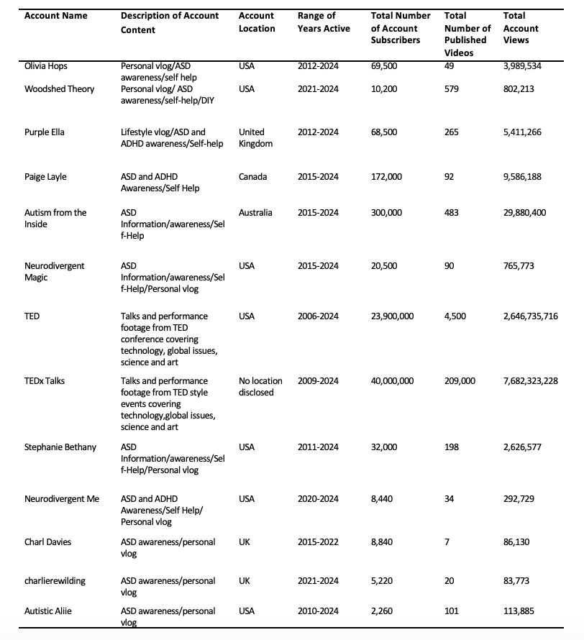

Regarding participants, 10 were content creators; managing their accounts. Four participants were guest speakers, featuring in an interview hosted by a single YouTube account, while the remaining four were guest presenters, speaking at conferences published under two distinct TED accounts. All participants in the study identified as female. Among the 18 females, the mean age calculated was 29.44 years; ages ranging from 19 to 56 years. All participants had received a clinical diagnosis of ASD. The majority of the participants (N=12) resided in, or were from, the United States, while the remaining six were from the United Kingdom, Germany, Canada and Australia. Participant demographics are displayed in the table below (See Table 2).
Table 2
Participant Demographics

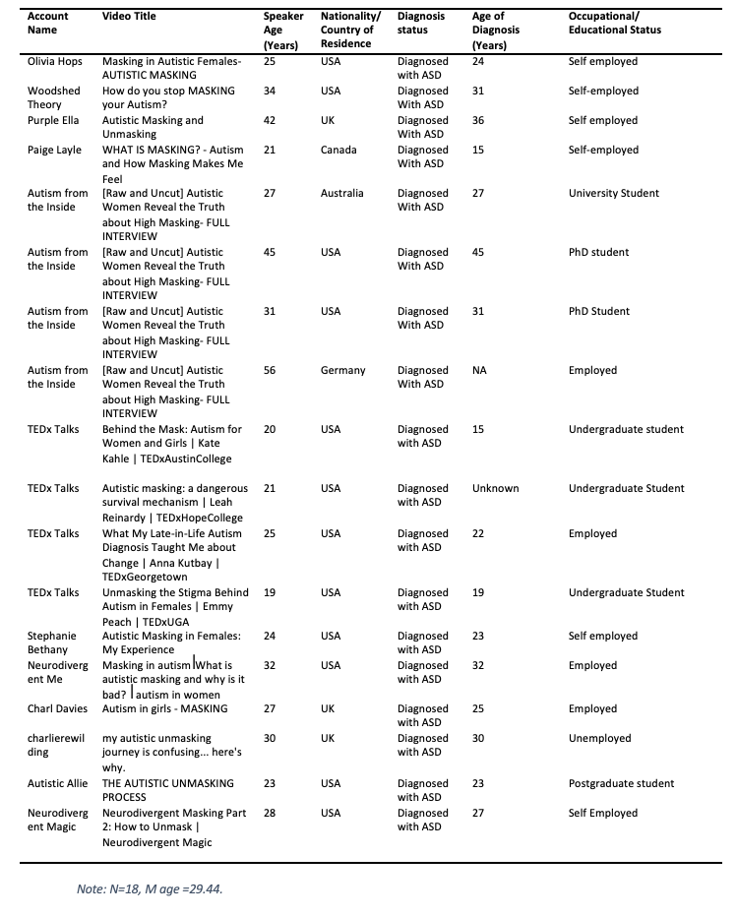
2.3 Ethical Considerations
Ethical approval for the present study was granted by the IADT Department of Technology and Psychology Ethics Committee (DTPEC). Criteria for a green route application were satisfied on the basis that the data was extracted from online platforms that were publicly available; accessible without the creation of a user profile or password to log in to the resource. Furthermore, there was no direct contact with the participants of the present study in all stages of the research process. The present study adhered to principles outlined by the British Psychological Society (2021) for internet-mediated research in order to ensure participant well-being. Data collected was publicly available; accessed without the creation of an online account. Additionally, video transcripts were edited to paraphrase quotations, removing potentially identifying information. Participant age verification was conducted to address integrity concerns; only those 18 years or older included in the analysis. Age was verified by reviewing account details or noting disclosures of age within transcripts.

2.4 Materials

Data was acquired using publicly accessible YouTube videos presenting social camouflaging in Autistic women as a discussion topic. Videos were located through a manual search on the Safari web browser; relevant videos obtained by searching key terms including ‘ASD Camouflaging’, ‘Masking’, ‘Autistic traits in women’ and ‘Unmasking Experience’. A Microsoft Word document was created to compile information on videos including the video title, name of the account, a brief description of the content, video duration and a link to the video. The initial number of videos considered for analysis was 22.

Following the compilation of information, each video was re-accessed through a link provided in the Word document. Videos meeting the criteria of discussing topics pertaining to a subjective experience of ASD camouflaging presented by, or including, a diagnosed female speaker over the age of 18 were retained for analysis. The final number of videos meeting such criteria was 18. Otter.ai, a web-based transcription program was employed to transcribe audio from each video into text. Each video was played through once in its entirety as the programme recorded the audio. Once the transcripts were obtained, they were reviewed with a playback of the video audio, to ensure accuracy, and were edited accordingly. Transcripts were subsequently copied, compiled and collated in a separate Word document. The Word document, containing the 18 transcripts was worked through rigorously.

2.5 Procedure
The six phases of reflexive thematic analysis, outlined by Braun and Clarke (2006; 2012) guided the procedure of the present study (See Appendix C). As discussed by Finlay (2021) phases in thematic analysis are not intended to be linear, hence a flexible approach was employed; meaning stages were revisited recursively. Data familiarization involved multiple read-throughs of video transcripts and audio playback to understand the dataset's content and identify potential patterns. Initial Coding involved generating both semantic and latent codes (See Appendix D). As explained by Byrne (2021), semantic codes contextualised information, while latent codes, requiring increased interpretative proactivity, captured hidden concepts underlying the data. The table below displays a sample of the coding process employed in the present research (See Table 3). Codes were modified throughout the process.
Table 3
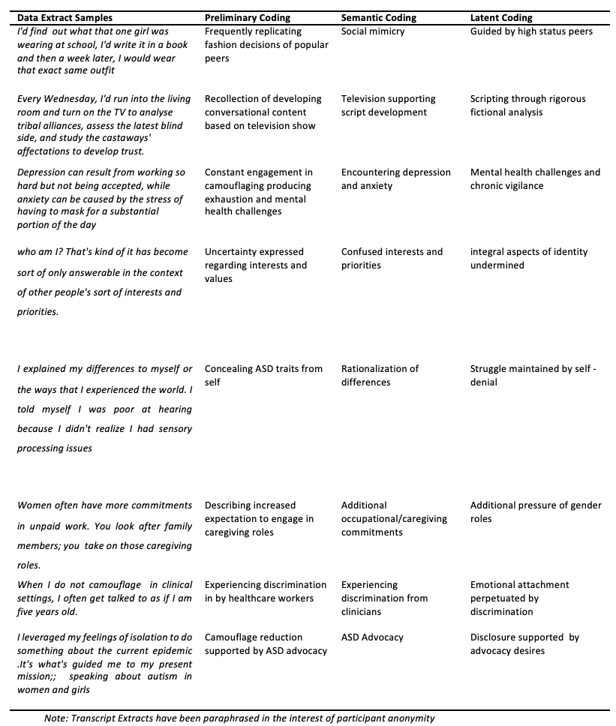
Sample of Coding Process
Following the coding phase, initial themes were devised, produced by collapsing codes into candidate themes; visualized by thematic maps (See Appendix E). The figure below displays a finalized thematic map; containing themes and subthemes (See Figure 1). A review of potential themes ensured themes represented meaningful data interpretations; adhering to Braun and Clarke's guidelines (Braun & Clarke, 2012). Themes were subsequently named and defined, with consideration of internal consistency and assessment procedures proposed by Terry et al. (2017). The last phase, producing the report, involved presenting themes in a coherent order; beginning with those informed significantly by semantic codes.

Figure 1
Final Thematic Map
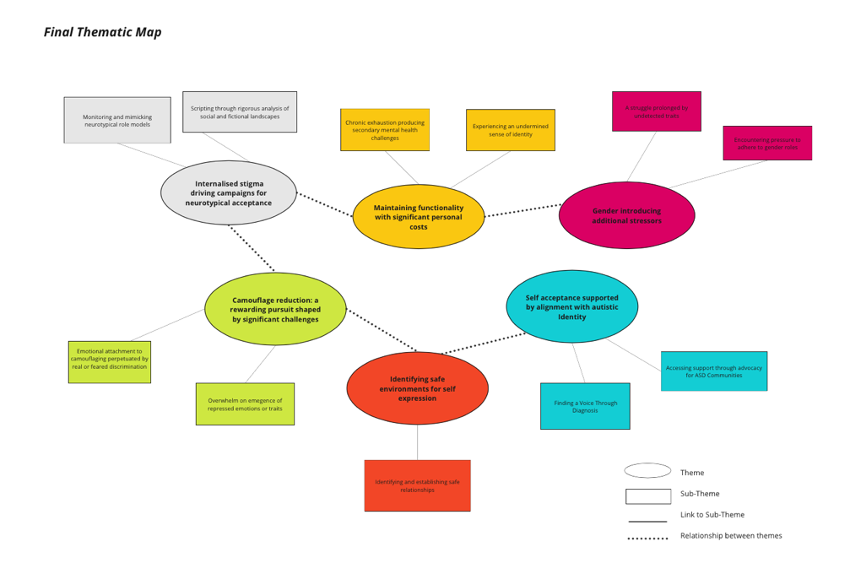

3. Results
3.1. Themes and Subthemes
A total of 6 major themes were identified in the data set, accompanied by subthemes. Transcript excerpts have been paraphrased to mitigate the potential of identifying speakers’ quotes with their respective YouTube accounts. However, elements of the original text have been retained in the interest of maintaining scientific integrity. All themes and subthemes capture the female participants’ lived experience of both engaging in and reducing social camouflaging behaviour. Defined themes and subthemes will be further discussed within the discussion section of the present study
3.1.1. Theme One: Internalised Stigma Driving Campaigns for Neurotypical Acceptance
Figure 2
Theme One with Subthemes
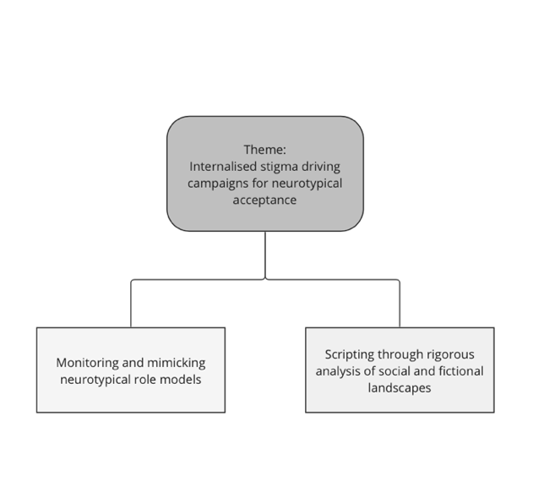

The first main theme refers to the negative beliefs held by participants regarding personal identity. Early experiences of rejection, and the internalisation of societal messages, including misconceptions of ASD, were regarded as formative in instilling a sense of inadequacy or defectiveness. Such negative self-conceptualisations were considered instrumental in motivating persistent efforts to present as and be accepted as a neurotypical individual. Participants used the phrase ‘masking’ as a broad term to capture an array of social camouflaging techniques employed to attain such acceptance. Two techniques frequently described are reflected in the associated subthemes (See Figure 2)
The subtheme Monitoring and mimicking neurotypical role models refers to the replication or mirroring of the body language, gestures, interests and cosmetic presentation of neurotypical peers. A number of participants valanced peers of high social ranking as particularly reliable figures from which to model their behaviour. Behavioural data was either consciously, or unconsciously, observed, recorded, and adopted in order to blend in.
An alternative camouflaging technique, frequently described, is reflected in the second subtheme, Scripting through rigorous analysis of social and fictional landscapes. This subtheme refers to drawing upon observed social interactions and media sources to develop explicit guidelines for conversations. Participants described a sustained cognitive effort to learn and apply phrases, dialogue, and vocal cadence to support communication and attain peer acceptance (See Table 4).
Table 4
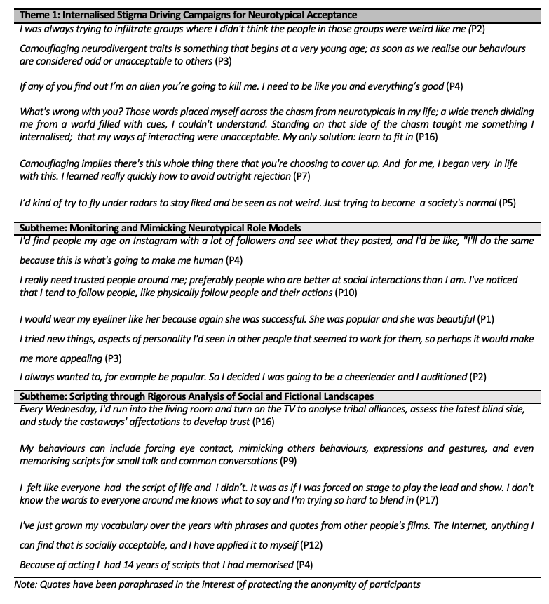
Paraphrased Quotes Illustrating theme and subthemes of ‘Internalised Stigma Driving Campaigns for Neurotypical Acceptance’
3.1.2. Theme Two: Maintaining Functionality with Significant Personal Costs
Figure 3
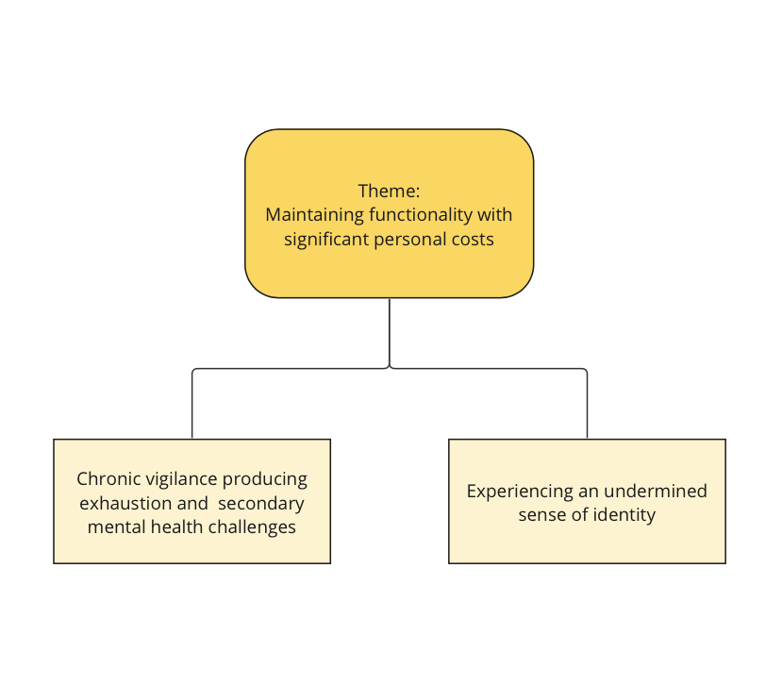
Theme Two with Subthemes

The second main theme refers to the utility of social camouflaging in maintaining functionality across social and occupational contexts. Workplace progression, academic achievements, and the maintenance of personal relationships were frequently attributed to the consistent and successful employment of social camouflaging techniques. However, the majority of participants also acknowledged that such functionality was caveated by significant challenges posed to their psychological well-being and sense of identity. Such challenges are reflected in the subthemes (See Figure 3)
The first subtheme Chronic vigilance producing exhaustion and secondary mental health challenges refers to the psychological difficulties arising from the significant cognitive demand of sustaining camouflaging behaviour. Participants described experiencing frequent burnout, a state conducive to the onset and maintenance of mental health issues including depression, anxiety and suicidal ideation.
A second challenge faced by participants seemed to pertain to identity loss. The subtheme Experiencing an Undermined Sense of Identity refers to the detrimental impact social camouflaging posed on the participants’ sense of self. The process of adopting behaviour interests and personas, dystonic to authentic values, was instrumental in reducing self-insight and instilling low self-esteem (See Table 5)

Table 5
Paraphrased Quotes Illustrating Theme and Subthemes of Maintaining Functionality at Significant Personal Costs
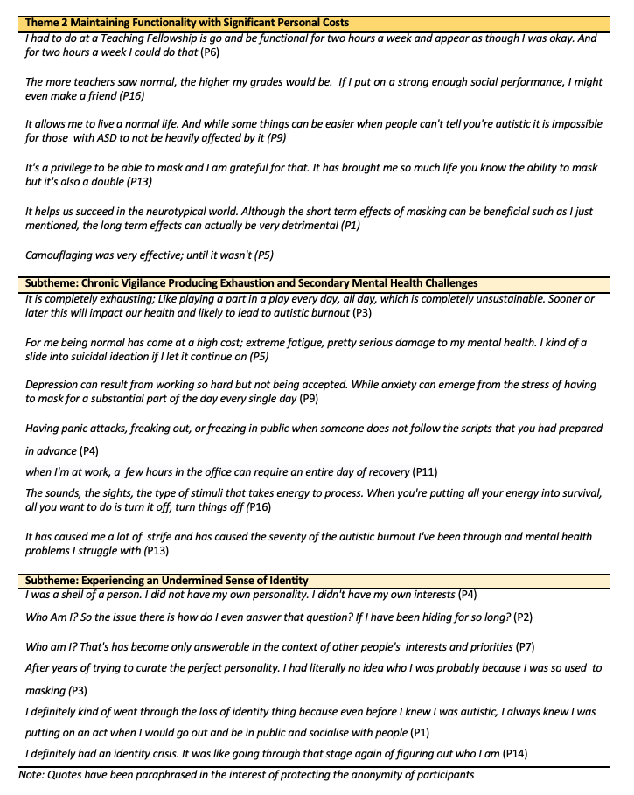
3.1.3 Theme Three: Gender Introducing Additional Stressors
Figure 4
Theme Three with Subthemes

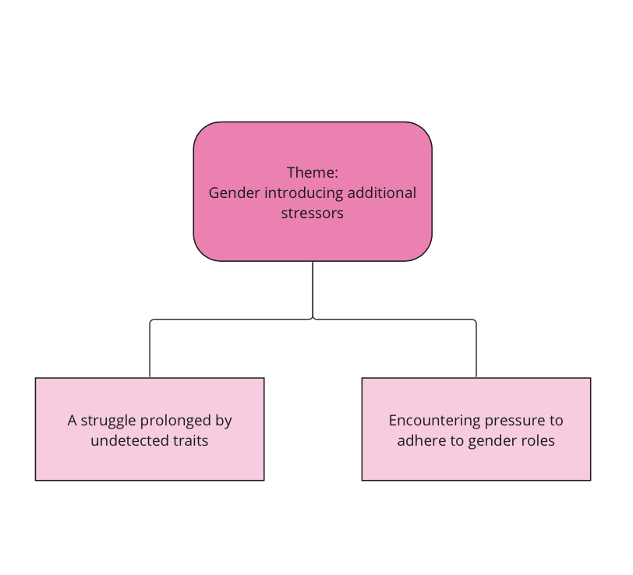

The third theme refers to the additional stressors or barriers, pertaining to social camouflaging, considered unique to participants’ identity as an autistic female. Two types of challenge are categorised in subthemes (See Figure 4)
The first subtheme A struggle prolonged by undetected traits refers to the challenge of traits being overlooked, discredited or dismissed by peers, family members and clinicians. Such a lack of detection extended to the participants themselves, with several reflecting on a denial and rationalization of their own lived experience. Such challenges were commonly attributed to the frequency and efficacy of trait concealment, an experience conceded to be particularly prevalent in autistic women. Consequently, females often receive a late or misdiagnosis.
A second challenge, reflected in the second subtheme, manifested as Encountering pressure to adhere to gender roles; capturing a pervasive pressure to conform to gender norms shaped by internal, familial, peer and broad societal expectations As a result, participants felt mandated to expose themselves to uncomfortable situations, adopt ego dystonic interests or duties, and present favourably in public settings. In the case of a number of participants, a failure to align with restrictive definitions of gender invoked hostile responses from peers and members of the general public. (See Table 6)
Table 6
Paraphrased Quotes Illustrating theme and subthemes of Gender Introducing Additional Stressors
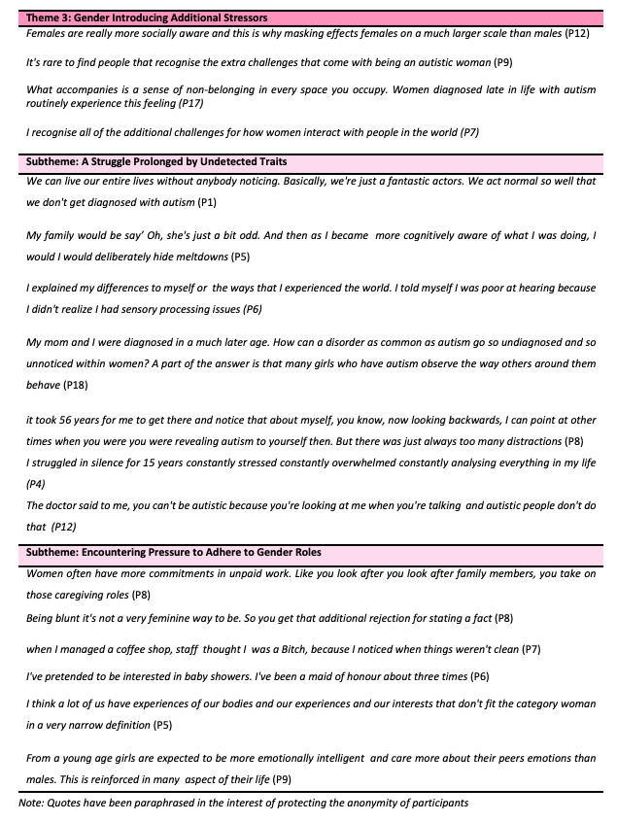

3.1.4 Theme Four: Camouflage Reduction: A Rewarding Pursuit Shaped by Significant Challenges
Figure 5
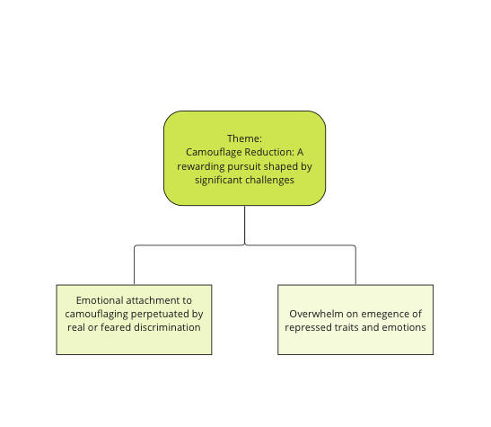
Theme Four with Subthemes

The fourth theme refers to the intrinsically rewarding experience of camouflage reduction conveyed by the majority of participants committed to the process. Several expressed positive emotions such as relief, validation and excitement in the pursuit of authenticity. However, an ambivalence in attitude towards such a pursuit was also apparent, with a number encountering significant internal and structural barriers to their efforts. Such challenges are conveyed in the sub-themes (See Figure 5).
One such challenge, captured in the first subtheme, was experiencing an Emotional attachment to camouflaging perpetuated by real or feared discrimination. This subtheme refers to the continual use of camouflaging as a coping strategy in social contexts whereby rejection or discrimination is a feared or tangible outcome of disclosure. Participants either unconsciously or consciously engage in camouflaging behaviour in contexts where emotional or physical well-being cannot be ensured. Fears seemed to be grounded in reality for select participants, a number recalling events whereby they were subject to discreditation or stereotyping upon surrendering protective behaviours.
A second challenge is described in the second subtheme; Overwhelm on emergence of repressed traits and emotions; referring to the challenging affective states experienced when traits or emotions, previously repressed, resurface following efforts to reduce camouflaging behaviour. Participants described coping with trauma, and anxiety upon a heightened awareness of ASD traits, previously disregarded (See Table 7)
Table 7
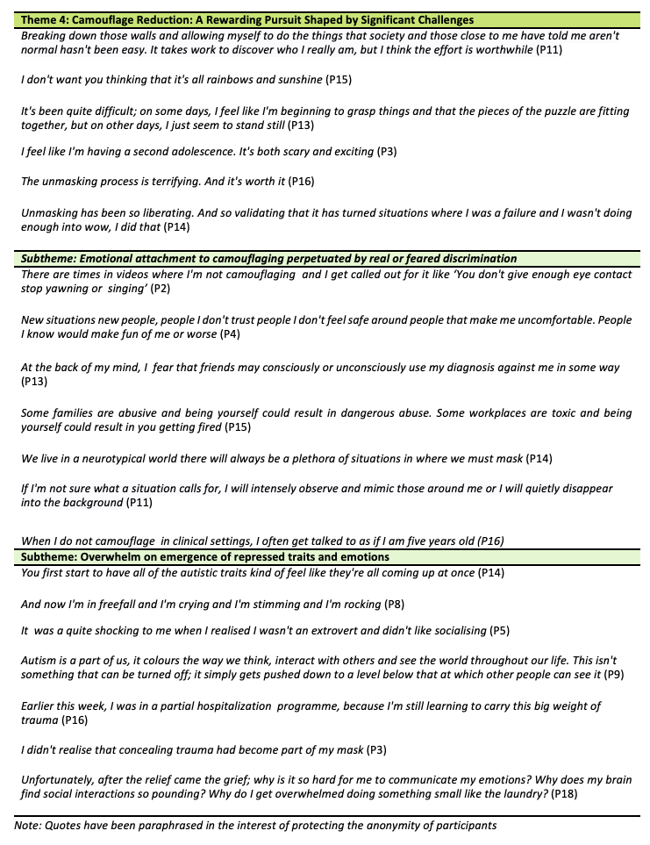
Paraphrased Quotes Illustrating theme and subthemes of Camouflage Reduction: A Rewarding Pursuit Shaped by Significant Challenges

3.1..5. Theme Five: Identifying Safe Environments for Self-Expression

Figure 6
Theme Five with Subthemes

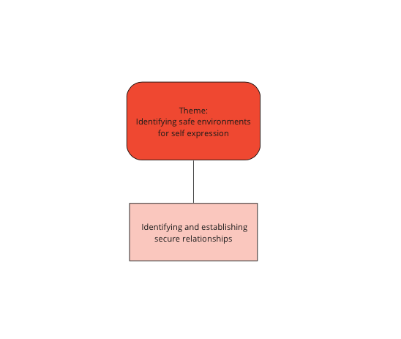

The fifth theme refers to the value assigned by participants to identifying and availing of environments which support emotional and physical safety throughout the process of camouflage reduction. Environments satisfying safety requirements included online spaces, supportive work environments, therapeutic settings, and isolated spaces free from overstimulation. A need for safety further extended to relationships; captured in the subtheme (See Figure 7)

The subtheme, Identifying and establishing secure relationships, refers to the supportive role of relationships which allow one to feel comfortable to express themselves in an authentic manner. Participants, in particular, valued small friendship groups, which negate endorsement or adherence to cultural and societal norms. Regular communication and boundary setting, in the case of select participants, helped maintain and establish secure and healthy social environments. (See Table 8)

Table 8
Paraphrased Quotes Illustrating theme and subthemes of Identifying Safe Environments for Self-Expression
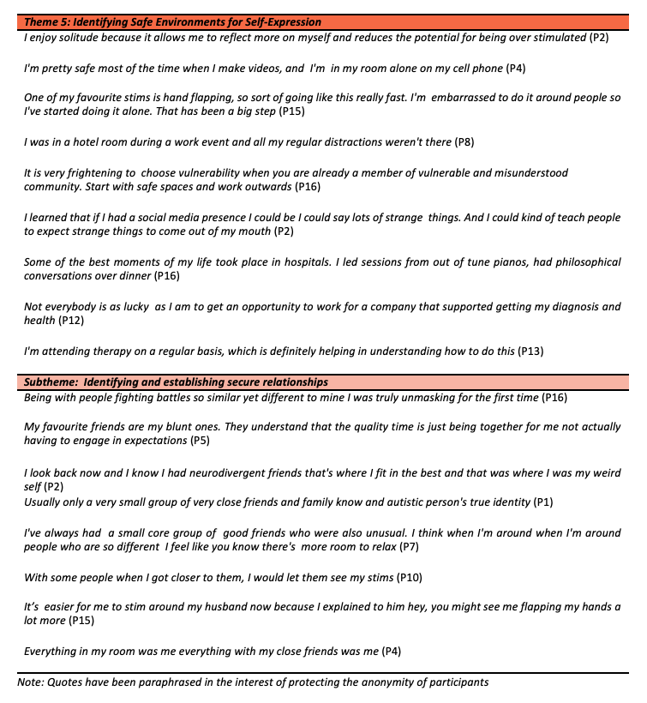

3.1.6. Theme Six: Self-Acceptance Supported by Alignment with Autistic Identity
Figure 7
Theme Six with Subthemes
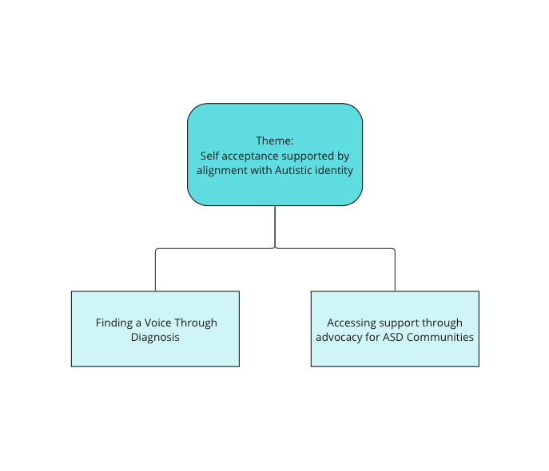

The final theme refers to the mediating role of alignment with autistic identity in obtaining self-acceptance and reducing camouflaging behaviour. Participants’ feelings of pride, ownership and security pertaining to their status as an autistic female, were frequently accompanied by increased incidences of disclosure in both the public sphere and immediate social circles. Camouflage- reduction, facilitated through self-identification with ASD, was further supported by receiving a clinical diagnosis and advocating on behalf of ASD communities. Such supports are reflected in subdivisions of the main theme (See Figure 8)

The first subtheme, Diagnosis supporting a process of self-acceptance refers to the significant role a clinical diagnosis assumed in terms of initiating participants’ alignment with an ASD social identity. Receiving a diagnosis established robust foundations for participants to generate self-insight through researching and applying ASD literature to their lived experiences. Such identification and resonation with traits enhanced self-acceptance, consequently leading to an increased frequency and ease in camouflage reduction over time.

Support was alternatively accessed through Advocacy for ASD Communities The second subtheme refers to how advocating for the ASD community served as both a support and motivation in participants’ reduction of social camouflaging. A surrendering of coping mechanisms was frequently attributed to a desire to help fellow autistic people by actively challenging stigma and educating peers, family or members of the general public. Engaging in advocacy seemed to further support participants by facilitating connections with other neurodivergent people, and providing access to educational resources (See Table 9)

Table 9
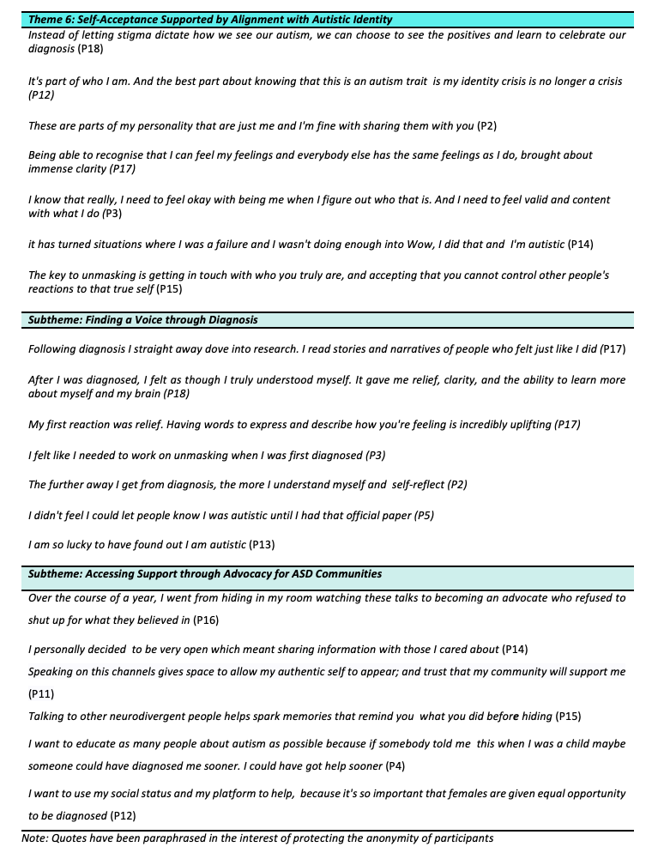
Paraphrased Quotes Illustrating theme and subthemes of Self-Acceptance Supported by Alignment with Autistic Identity
4. Discussion

The present study aimed to address two lines of enquiry; namely an investigation of the lived experiences of autistic women engaging in social camouflaging behaviour, and the lived experience of autistic women reducing such behaviour. Through the employment of a thematic analysis, six main themes were generated in response to both research questions; emphasizing in particular, the role of internalized stigma and social identity alignment as predictors for both camouflaging engagement and reduction. Lived experiences further capture personal costs of camouflaging, gender-related stressors, personal and societal barriers to camouflage reduction, and the integral of role secure environments throughout pursuits for authentic expression.

4.1. Overview of Findings
Participants of the present study frequently recalled early life events in which they were subject to discriminatory behaviour. Such adverse experiences were deemed formative in developing negative self-perceptions; consequently motivating campaigns for acceptance as a neurotypical individual. The theme of Internalised Stigma Driving Campaigns for Neurotypical Acceptance aligns with the research of Perry et al. (2021) which found that a heightened awareness of Autism related stigma was positively correlated with an increased use of social camouflaging behaviour and individualistic strategies; namely dissociating from one’s in-group to associate with a higher status out-group (Perry et al., 2021; Tajfel & Turner, 2004). Participants in the current research similarly expressed desires to deviate from their identity as an autistic individual, to fit in with perceived ‘high status’ neurotypical social groups: “I was always trying to infiltrate groups where I didn’t think the people were weird like me”(P2). Stigma as a predictive factor for social camouflaging found by Perry et al.(2021), is further exhibited, participants’ conveyed experiences consistent with conceptualizations of internalised stigma. In line with Botha and Frost (2020), external stressors such as bullying and labelling appeared to be predictive of proximal stressors in the form of negative self-labelling and identity concealment. Support is yielded for the applicability of identity-based theories which will be subject to further discussion within the theoretical implications of the present chapter.

Subthemes illustrating techniques to attain the aforementioned neurotypical acceptance, fortify phenomenological data captured by Bargiela et al. (2016). Social mimicry and script development through reference to media were of particular prevalence across the sample: “I have grown my vocabulary over the years with phrases and quotes from other people’s films” (P12). Notable, was the role of high-status neurotypical peers as models for mimicry; behavioural data often accessed through environmental observation. Such findings again pertain to the findings of Perry et al. (2021) given the particular value assigned to ‘in-group’ affiliates. Furthermore, such data is indicative of the adaptive nature of camouflaging, the behaviour responding accordingly to environmental cues; demonstrating consistency with current conceptualizations of the phenomenon (Cook et al., 2021). However, engagement in such techniques, while considered beneficial by select participants in terms of social and occupational functioning, was predominantly regarded as detrimental to emotional wellbeing; pervasive exhaustion leading to low mood, anxiety and burnout frequently cited, along with a loss of identity. “I was a shell of a person. I did not have my own interests” (P4). Such findings corroborate with the research of Leedham et al. (2019) which indicated that reported identity concealment in female interviewees frequently contributed to exhaustion, feelings of isolation and a sense of living on the periphery. Additionally, the findings of Botha and Frost (2020) can be drawn upon to explain such adverse outcomes; quantified ASD concealment being a predictive factor of reduced levels of psychological wellbeing and increased distress. Through the findings of the present research, further support is yielded for the risks of camouflaging, and by extension the importance of its efficient identification in autistic women.

In extension to wellbeing challenges posed, gender identity seemed to introduce further challenges to participants; its role reflected in the main theme Gender Introducing Additional Stressors. Participants emphasised a pressure to adhere to rigid gender roles, describing prescribed guidelines for navigating friendships, occupations and romantic relationships. Expectations to assume particular social responsibilities and adopt stereotypical feminine interests were further expressed. Such results pertain to generated subthemes of Grove et al. (2023), whereby participants discussed the negative impact of culture-bound messages that hold females to a separate standard from their male counterparts. Participants described adapting behaviour to meet the needs of others; sentiments reiterated in the present study. “You look after family members. You take on those caregiving roles” (P8). Similarly, the overlooking of ASD traits by others, including clinicians, extend upon findings of current literature. The participants of Leedham et al. (2019) conceptualized ASD as a ‘hidden condition’ in females, leading to inaccurate diagnoses such as Borderline Personality Disorder. In the current study, such struggles were considered unique to the identity of an autistic female and seemed to be internalized to an extent where select participants dismissed or rationalized their own experiences. Consequently, diagnosis and recognition were prolonged. Additional challenges faced by autistic women, captured in the present study are largely consistent with the research of Mo et al., (2021); which investigated the impact of cultural values on eight autistic females’ life experiences. In line with the present study, the perpetuation of cultural stereotypes, including the notion that ASD is unique to males, led to participants feeling dismissed. Additionally, gender expectations to be socially agreeable juxtaposed with behaviours deemed unacceptable, correspond with accounts of participants of the present research. Further data is provided regarding contributors to higher incidences of camouflaging in females; potentially accounting for the diagnosis gender gaps within select populations (Maenner et al., 2023).

Further to informing camouflaging behaviour in early years , stigma presence also appeared to act as a barrier during efforts to reduce the mechanism. The subtheme Emotional attachment to camouflaging perpetuated by real or feared discrimination encapsulates participants’ continued employment of camouflaging behaviours due to real or feared discrimination or discreditation. Experiences of rejection align with Huang et al. (2022) which found that on disclosure Autistic adults reported dismissal or misunderstanding in both social and occupational relationships. In the present study, it is notable that a number of participants had experiences of such dismissal by healthcare professionals: “When I do not camouflage in clinical settings I get talked to as if I am five years old” (P16). Such findings align with the extended periods of low healthcare support described by participants in the research of Grove et al. (2023); emphasising a need for structural revision regarding supports offered by clinical programmes.

Regarding feared stigma, while participants conveyed general fear, such concerns seemed to be particularly heightened in settings where participants sensed their psychological wellbeing or safety was insecure. Such findings are partially consistent with those of Togher and Jay (2023), which indicated that stigma consciousness and reduced identity disclosure were contingent upon social context. Stigma awareness, for instance negatively predicted identity disclosure in work environments; similar to the present study. However, to extend upon current literature, transferable characteristics of environments conducive to a sustained use camouflaging are indicated. Settings supporting psychological safety, for instance, were deemed important in efforts to reduce social camouflaging; as captured by the main theme Identifying Safe Environments for Self-Expression. Participants conveyed that being surrounded by groups of like-minded peers, helped to facilitate the process of camouflage reduction, through instilling a sense of security.

Lastly, the theme Self-Acceptance Supported by Alignment with Autistic Identity captures how participant’s alignment with their diagnosis status and identity as an autistic female, positively supported efforts to reduce camouflaging; identity alignment expressed through terms indicative of pride and ownership of traits and experiences: “These are parts of my personality that are just me and I'm fine with sharing them with you” (P2). Receiving a clinical diagnosis and accessing support through advocating for ASD communities, appeared to further strengthen a positive sense of identity; and by extension reduce camouflaging efforts. Such findings extend upon Cage and Troxell-Whitman (2020), diagnosis disclosure significantly mediating the relationship between ASD identity and reduced levels of social camouflaging. In the current study, aspects of post-diagnosis experience are suggested, which may account for previous research results. For instance, participants in the current study described feelings of validation and self-understanding upon diagnosis

The relationship between Identity alignment and advocacy indicated in the current study further align with previous research exploring predictive factors of ASD disclosure. The subtheme Accessing Support through Advocacy for ASD Communities, encompasses how advocacy can serve as a motivation to reduce social camouflaging, a strong desire to combat stigma and to help other members of the community overriding safety needs associated with the mechanism:” I want to use my social status and my platform to help.” Such results yield support for the findings of Huang et al. (2022), whereby autistic adults’ rationale for disclosure, was based upon a desire to challenge stereotypes and garner awareness for ASD lived experience. Additionally, support is garnered for the impact of collective strategy use; namely engaging in activism for one’s social group, in reducing camouflaging. The research of Togher and Jay (2023) is supported; again demonstrating the applicability of identity-based theories within the phenomenon.

4.2. Strengths and Limitations
A strength of the present study resides in the use of YouTube as an online platform for data collection. The combination of visual and audio input introduced nuances to the data; manifesting as physical gestures, tonal inflexions and alterations to speech pitch. The rich data collected facilitated the development of latent codes on which to base themes; hence an in-depth interpretative analysis was achieved (Byrne, 2021) Furthermore, the employment of a thematic analysis approach was facilitative in terms of flexibility on behalf of the researcher. As noted by Braun & Clarke (2006), the research direction and framework could be adapted accordingly to reflect the data set; ensuring important information was not omitted from the analysis. Lastly, although the phenomenon of social camouflaging in females has been addressed in past research, the present study further investigated the less researched lived experience of reducing the behaviour. Consequently, preliminary applications of theoretical frameworks have been extended; cultivating a stronger base for future research.

However, despite the aforementioned strengths, limitations pertaining to the demographics of the sample are significant; the majority of participants residing in the United States. While YouTube was an appropriate platform in light of the research questions and the high accessibility of relevant phenomenological data (Bellon Harn et al., 2019), it is notable that such a platform is frequented by American users; the United States currently ranking second in global rates of user engagement (Ceci, 2024). Hence, the transferability of the present study’s findings to other populations may be reduced. Similarly, the majority of the sample consisted of YouTubers who create and share content with an aim to educate internet users on ASD. Hence, the sample may not be representative of broader Autistic populations, limiting the applicability of identity-based theoretical insights generated.

4.3. Theoretical implications
As aforementioned, The phenomenological data garnered in the present study yields support for the applicability of identity-based theories in conceptualizing both social camouflaging engagement and reduction in Autistic females. Social Identity Theory (Tajfel & Turner, 2004), previously explored by Perry et al. (2021) and Togher and Jay (2023), has been further supported in the present research; particularly concerning collective strategy use. In line with theoretical proposals, participants’ attachment to their social identity, operationalized through contact and advocacy for the Autistic community, is construed as predictive of reduced engagement in social camouflaging. Conversely, desires to deviate from one’s Autistic social identity appear to be frequently accompanied by an increased engagement in individualistic strategies; namely identity concealment manifested as camouflaging techniques.

Similarly, the applicability of the Minority Stress Model (Botha & Frost, 2020; Meyer, 2003) has been demonstrated. Across the sample, a number of distal stressors are expressed including experiences of rejection, stereotyping and gender expectations. Internalized stigma, manifested as negative self-labelling or shame surrounding identity, similarly seem to operate as proximal stressors; instigating concerted efforts to camouflage from an early age. Consistent with the findings of Botha and Frost (2020), the transference of distal challenges to proximal stressors, gave rise to adverse effects on participants' emotional wellbeing, in the form of secondary mental health issues and crises of identity.

4.4. Practical Implications
The support garnered for identity-based theories gives rise to a number of practical implications. First, participants’ positive experiences of engaging in advocacy and maintaining contact with ASD communities suggest the benefits of accessing community-based supports post-diagnosis. Asiam.ie is an Irish organisation offering an Autistic Adult Support and Wellbeing Programme. Such a programme includes access to self-advocacy events, social activities and gender-specific peer support groups, which may assist Autistic females in accepting and disclosing their diagnosis. Initial contact with such services may be facilitated by clinicians following assessment, as part of a multi-faceted approach to wellbeing. Second, the role of past discriminatory behaviour in informing motivations to camouflage, indicate a need for increased ASD education and awareness to reduce harmful stigma. Such a requirement may be facilitated through employing preventative measures such as anti-bullying workshops in educational institutions. FUSE, accessed through antibulltingcentre.ie/fuse/, is an antibullying and Online Safety Programme consisting of educational resources and student-led workshops. The incorporation of such programmes into school curricula can help to build safe and supportive environments; in which autistic students may feel secure to express themselves authentically.

4.5 Suggestions for further research
The present study illustrates how identity-based stressors and internalized stigma can influence the employment of maladaptive coping techniques; consequently impacting the psychological wellbeing of Autistic females. Hence, in line with recommendations proposed by Rivera and Bennetto (2023), further research applying identity-based theories would be beneficial in terms of practical and theoretical advancement to the field. In particular, longitudinal research assessing the mediatory roles of identity alignment and peer-led support group attendance, on females’ social camouflaging may be of merit. The purposive sampling of female participants from organisations such as As I am, and the employment of mixed method approach, using focus groups and the CAT-Q (Hull et al., 2018), would expand the scope of current literature. Such methodology would facilitate capturing nuanced, quantifiable data to evaluate the efficacy of community- based interventions in reducing social camouflaging.
4.6. Conclusion
The present study yields support for the application of identity-based theories in conceptualizing the motivations and implications of social camouflaging in a sample of Autistic females. In line with previous research, the application of Social identity theory (Tajfel & Turner, 2004) and the Minority Stress Model (Meyer, 2003) demonstrates utility in accounting for elements of females' lived experiences with the phenomenon; particularly with regard to social identity deviation, reduced mental health, and coping strategies motivated and maintained by the presence of stigma (Botha & Frost, 2020; Perry et al., 2021). Additionally, findings imply the potential benefits of community-based interventions in reducing camouflaging behaviour; ultimately supporting the psychological and emotional wellbeing of autistic females.
References
American Psychiatric Association. (2013). Neurodevelopmental disorders. In Diagnostic and Statistical Manual of Mental Disorders (5th ed., text rev.).

Bakombo, S., Paulette, E., & Konkle, A. T. M. (2023). The influence of social media on the perception of autism Spectrum Disorders: Content analysis of public discourse on YouTube videos. International Journal of Environmental Research and Public Health, 20(4), 3246. https://doi.org/10.3390/ijerph20043246

Bargiela, S., Steward, R., & Mandy, W. (2016). The Experiences of Late-diagnosed Women with Autism Spectrum Conditions: An Investigation of the Female Autism Phenotype. Journal of Autism and Developmental Disorders, 46(10), 3281–3294. https://doi.org/10.1007/s10803-016-2872-8

Bellon-Harn, M. L., Manchaiah, V., & Morris, L. R. (2019). A cross-sectional descriptive analysis of portrayal of autism spectrum disorders in YouTube videos: A short report. Autism, 24(1), 263–268. https://doi.org/10.1177/1362361319864222

Botha, M., & Frost, D. M. (2020). Extending the minority stress model to understand mental health problems experienced by the autistic population. Society and Mental Health, 10(1), 20–34. https://doi.org/10.1177/2156869318804297

Braun, V., & Clarke, V. (2006). Using thematic analysis in psychology. Qualitative Research in Psychology, 3(2), 77–101. https://doi.org/10.1191/1478088706qp063oa

Braun, V., & Clarke, V. (2012). Thematic analysis. In American Psychological Association eBooks (pp. 57–71). https://doi.org/10.1037/13620-004

Braun, V., & Clarke, V. (2019). Reflecting on reflexive thematic analysis. Qualitative Research in Sport, Exercise and Health, 11(4), 589–597. https://doi.org/10.1080/2159676x.2019.1628806
British Psychological Society. (2021). Ethics Guidelines for Internet-Mediated Research. https://explore.bps.org.uk/binary/bpsworks/64374754e0c1dd30/5a757d7c2d39a9837f0eedec1b9ba28fa5e9e38f0bffa9950b678ab727803959/rep155_2021.pdf.

Byrne, D. (2021). A worked example of Braun and Clarke’s approach to reflexive thematic analysis. Quality & Quantity, 56(3), 1391–1412. https://doi.org/10.1007/s11135-021-01182-y

Cage, E., & Troxell-Whitman, Z. (2020). Understanding the relationships between autistic identity, disclosure, and camouflaging. Autism in Adulthood, 2(4), 334–338. https://doi.org/10.1089/aut.2020.0016

Ceci, L. (2024, February 13). Countries with the most YouTube users 2024. Statista. https://www.statista.com/statistics/280685/number-of-monthly-unique-youtube-users/

Cook, J., Crane, L., Hull, L., Bourne, L., & Mandy, W. (2021). Self-reported camouflaging behaviours used by autistic adults during everyday social interactions. Autism, 26(2), 406–421. https://doi.org/10.1177/13623613211026754

Finlay, L. (2021). Thematic Analysis: The ‘Good’, the ‘Bad’ and the ‘Ugly’. European Journal for Qualitative Research in Psychotherapy, 11, 103–116. Retrieved from https://ejqrp.org/index.php/ejqrp/article/view/136

Frost, D. M., Lehavot, K., & Meyer, I. H. (2013). Minority stress and physical health among sexual minority individuals. Journal of Behavioral Medicine, 38(1), 1–8. https://doi.org/10.1007/s10865-013-9523-8

Fusar-Poli, L., Brondino, N., Politi, P., & Aguglia, E. (2020). Missed diagnoses and misdiagnoses of adults with autism spectrum disorder. European Archives of Psychiatry and Clinical Neuroscience, 272(2), 187–198. https://doi.org/10.1007/s00406-020-01189-w

Grove, R., Clapham, H., Moodie, T., Gurrin, S., & Hall, G. (2023). ‘Living in a world that’s not about us’: The impact of everyday life on the health and wellbeing of autistic women and gender diverse people. Women’s Health, 19. https://doi.org/10.1177/17455057231189542

Guest, G., MacQueen, K. M., & Namey, E. (2012). Applied Thematic Analysis. Sage Publications. https://doi.org/10.4135/9781483384436

Hodges, H., Fealko, C., & Soares, N. (2020). Autism spectrum disorder: definition, epidemiology, causes, and clinical evaluation. Translational Paediatrics, 9(S1), S55–S65. https://doi.org/10.21037/tp.2019.09.09

Huang, Y., Hwang, Y. I., Arnold, S. R. C., Lawson, L. P., Richdale, A. L., & Trollor, J. N. (2022). Autistic adults’ experiences of diagnosis disclosure. Journal of Autism and Developmental Disorders, 52(12), 5301–5307. https://doi.org/10.1007/s10803-021-05384-z

Hull, L., Lai, M., Baron‐Cohen, S., Allison, C., Smith, P., Petrides, K. V., & Mandy, W. (2019). Gender differences in self-reported camouflaging in autistic and non-autistic adults. Autism, 24(2), 352–363. https://doi.org/10.1177/1362361319864804

Hull, L., Mandy, W., Lai, M., Baron‐Cohen, S., Allison, C., Smith, P., & Petrides, K. V. (2018). Development and Validation of the Camouflaging Autistic Traits Questionnaire (CAT-Q). Journal of Autism and Developmental Disorders, 49(3), 819–833. https://doi.org/10.1007/s10803-018-3792-6

Leedham, A., Thompson, A. R., Smith, R., & Freeth, M. (2019). ‘I was exhausted trying to figure it out’: The experiences of females receiving an autism diagnosis in middle to late adulthood. Autism, 24(1), 135–146. https://doi.org/10.1177/1362361319853442

Loomes, R., Hull, L., & Mandy, W. (2017). What is the Male-to-Female Ratio in Autism Spectrum Disorder? A Systematic Review and Meta-Analysis. Journal of the American Academy of Child and Adolescent Psychiatry, 56(6), 466–474. https://doi.org/10.1016/j.jaac.2017.03.013

Maenner, M. J., Warren, Z., Williams, A. R., Amoakohene, E., Bakian, A. V., Bilder, D. A., Durkin, M. S., Fitzgerald, R. T., Furnier, S. M., Hughes, M. M., Ladd‐Acosta, C., McArthur, D., Pas, E. T., Salinas, A., Vehorn, A., Williams, S. P., Esler, A., Grzybowski, A., Hall-Lande, J., Shaw, K. A. (2023). Prevalence and characteristics of autism spectrum disorder among children aged 8 years — Autism and Developmental Disabilities Monitoring Network, 11 sites, United States, 2020. Morbidity and Mortality Weekly Report, 72(2), 1–14. https://doi.org/10.15585/mmwr.ss7202a1

Meyer, I. H. (2003). Prejudice, social stress, and mental health in lesbian, gay, and bisexual populations: Conceptual issues and research evidence. Psychological Bulletin, 129(5), 674–697. https://doi.org/10.1037/0033-2909.129.5.674

Mo, S., Viljoen, N., & Sharma, S. (2021). The impact of socio-cultural values on autistic women: An interpretative phenomenological analysis. Autism, 26(4), 951–962. https://doi.org/10.1177/13623613211037896

Patton, M. Q. (2002). Qualitative Evaluation and Research Methods (3rd ed.). Sage Publications.

Perry, E., Mandy, W., Hull, L., & Cage, E. (2021). Understanding Camouflaging as a Response to Autism-Related Stigma: A Social Identity Theory approach. Journal of Autism and Developmental Disorders, 52(2), 800–810. https://doi.org/10.1007/s10803-021-04987-w

Rivera, R. M. R., & Bennetto, L. (2023). Applications of identity-based theories to understand the impact of stigma and camouflaging on mental health outcomes for autistic people. Frontiers in Psychiatry, 14. https://doi.org/10.3389/fpsyt.2023.1243657

Schuck, R. K., Flores, R., & Fung, L. K. (2019). Brief Report: Sex/Gender Differences in Symptomology and Camouflaging in Adults with Autism Spectrum Disorder. Journal of Autism and Developmental Disorders, 49(6), 2597–2604. https://doi.org/10.1007/s10803-019-03998-y

Subu, M. A., Wati, D. F., Netrida, N., Priscilla, V., Dias, J. M., Abraham, M. S., Slewa‐Younan, S., & Al‐Yateem, N. (2021). Types of stigma experienced by patients with mental illness and mental health nurses in Indonesia: a qualitative content analysis. International Journal of Mental Health Systems, 15(1). https://doi.org/10.1186/s13033-021-00502-x

Tajfel, H., & Turner, J. C. (1979). An integrative theory of intergroup conflict. In W. G. Austin, & S. Worchel (Eds.), The Social Psychology of Intergroup Relations (pp. 33-37). Monterey, CA: Brooks/Cole.

Tajfel, H., & Turner, J. C. (2004). The Social Identity Theory of Intergroup Behaviour. Key readings in social psychology. In J. T. Jost and J. Sidanius, (Eds.), Political psychology: Key readings, Key readings in Social Psychology (pp. 276-293). New York, NY: Psychology Press.

Terry, G., Hayfield, N., Clarke, V., & Braun, V. (2017). Thematic Analysis. In C. Willig, & W. Stainton Rogers (Eds.) The SAGE Handbook of Qualitative Research in Psychology (2nd ed., pp. 17–37). Sage Publications. https://uwe-repository.worktribe.com/output/888518

Togher, K. L., & Jay, S. (2023). Disclosing an autism diagnosis: A social identity approach. Autism Research. https://doi.org/10.1002/aur.2990

Wood, C., & Freeth, M. (2016). Students’ stereotypes of autism. Journal of Educational Issues, 2(2), 131. https://doi.org/10.5296/jei.v2i2.9975

Appendices
Appendix A
Sample Screenshots of Analysed YouTube Accounts
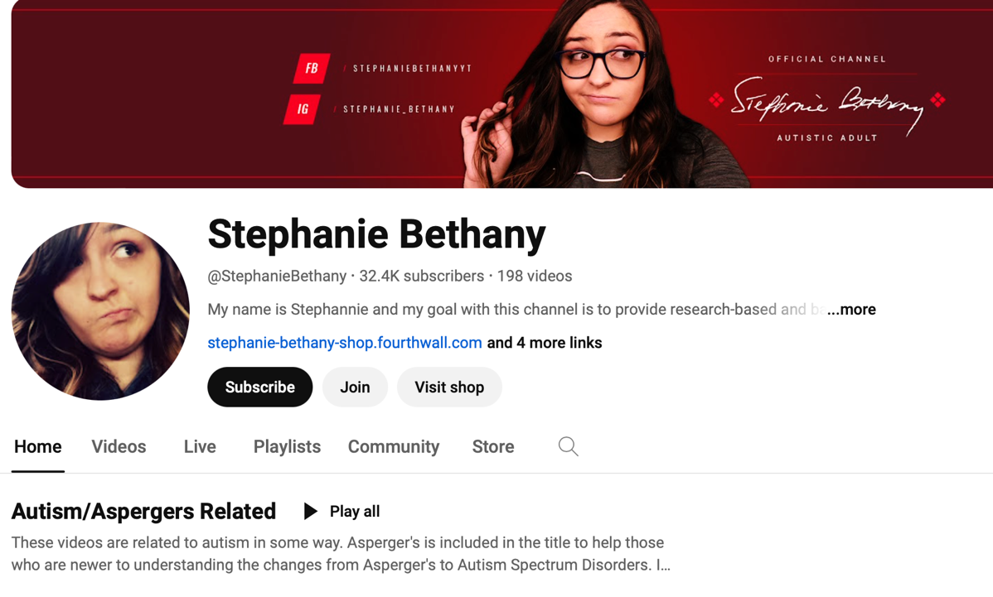

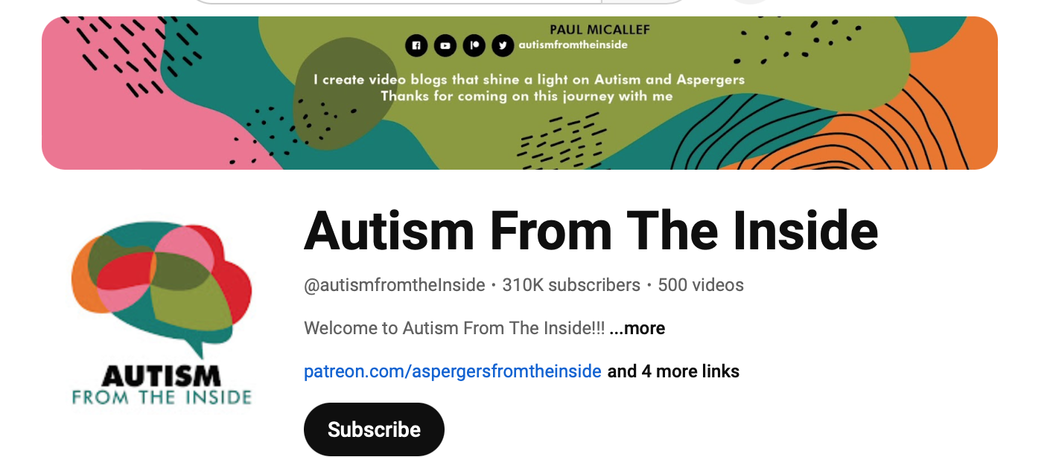
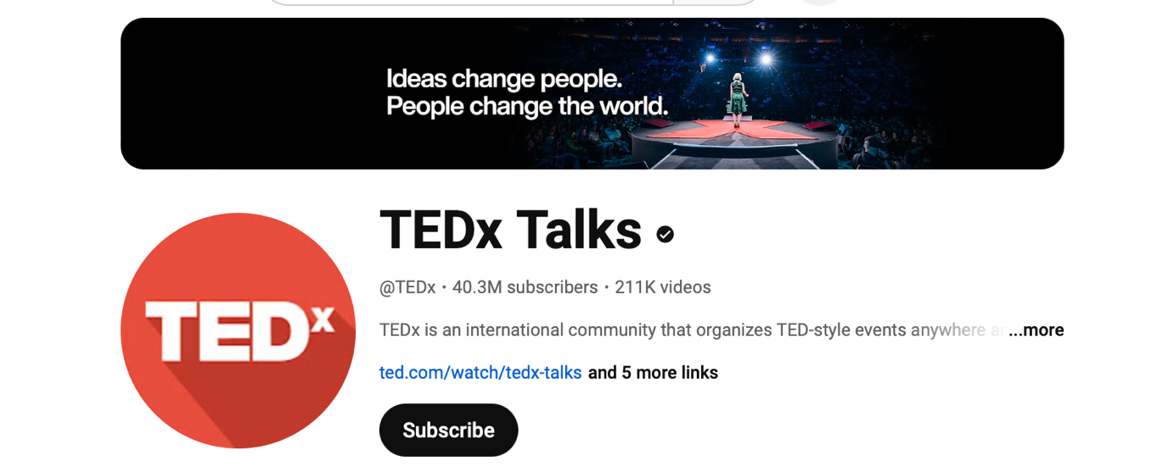
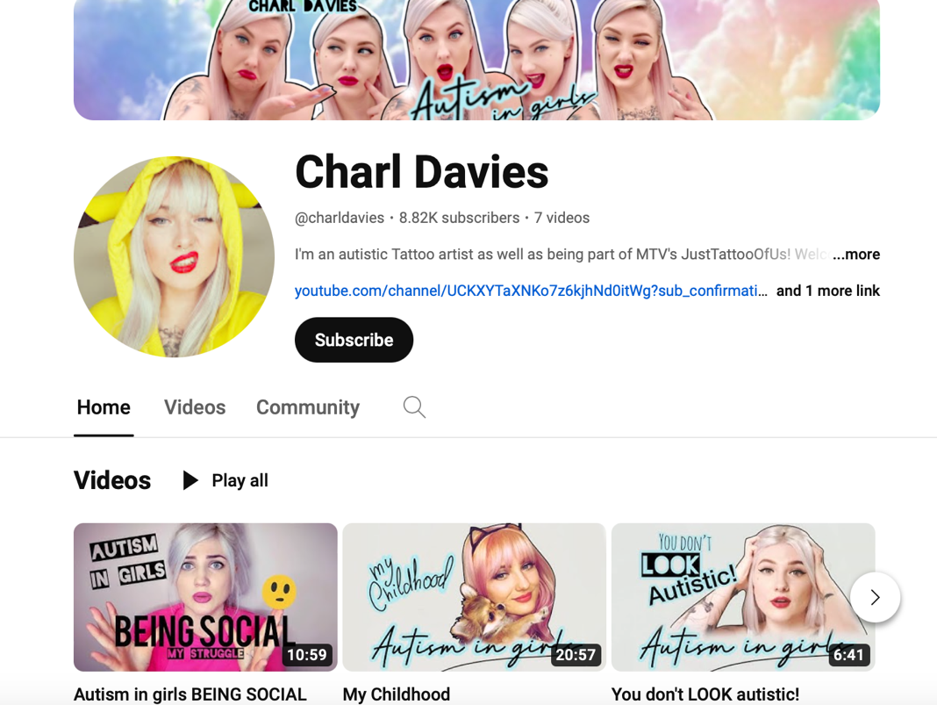
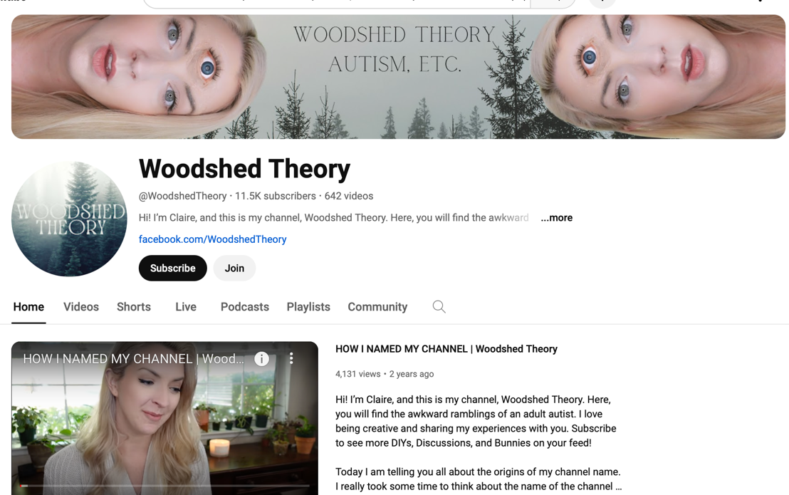
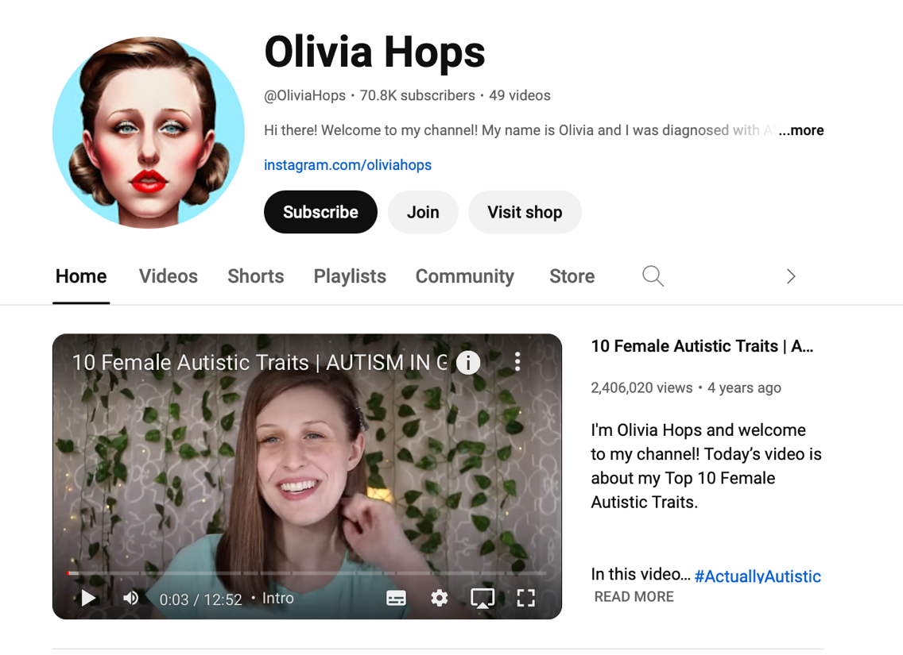
Appendix B
Characteristics of Analysed YouTube Videos
Video Title | Account  Name | Date of  Publication | Total Video Duration  (Minutes) | Total  Number of  Video Views | Total Number of Speakers Analysed
Masking in Autistic Females- AUTISTIC MASKING | Olivia Hops | 5/3/2021 | 14.68 | 65,855 | 1
How do you stop MASKING your Autism? | Woodshed Theory | 30/9/2022 | 18.22 | 13,103 | 1
Autistic Masking and Unmasking | Purple Ella | 30/9/2022 | 12.25 | 19,202 | 1
WHAT IS MASKING? - Autism and How Masking Makes Me Feel | Paige Layle | 4/9/2021 | 18.07 | 101,746 | 1
[Raw and Uncut] Autistic Women Reveal the Truth about High Masking- FULL INTERVIEW | Autism from the Inside | 22/12/2022 | 74 | 184,275 | 4
Behind the Mask: Autism for Women and Girls | TED | 7/4/2023 | 13.27 | 62,789 | 1
Autistic masking: A dangerous  survival mechanism | TEDx Talks | 17/3/2022 | 16.70 | 123,059 | 1
What My Late-in-Life Autism Diagnosis Taught Me about Change|Anna Kutbay| TEDxGeorgetown | TEDx Talks | 30/6/2023 | 11.10 | 6,758 | 1
Unmasking the Stigma Behind Autism in Females | Emmy Peach | TEDxUGA | TEDx Talks | 13/7/2022 | 10.87 | 126,694 | 1
Autistic Masking in Females: My Experience | Stephanie Bethany | 17/1/2019 | 8.25 | 30,662 | 1
Masking in autism⎥What is autistic masking and why is it bad? ⎥ autism in women | Neurodivergent Me | 7/1/2022 | 5.32 | 2,183 | 1
Autism in girls - MASKING | Charl Davies | 11/7/2019 | 10.10 | 11,721 | 1
My autistic unmasking journey is confusing... here's why. | charlierewilding | 26/1/2023 | 10.62 | 4,522 | 1
THE AUTISTIC UNMASKING PROCESS | Autistic Allie | 19/7/2020 | 12.33 | 9,293 | 1
Neurodivergent Masking Part 2: How to Unmask | Neurodivergent Magic | Neurodivergent Magic | 8/3/2022 | 6.85 | 4875 | 1
Appendix C
Extended Overview of Thematic Analysis Procedure

Phase One : Data Familiarisation

On collecting the data, the data set was familiarised with by the researcher. Such a process incorporated several read-throughs of the collated video transcripts accompanied with playbacks of the complementary audio. Upon the initial reading, each transcript was read without recording notes. This afforded the researcher scope to understand the content of the data set, broadly, and begin the process of identifying potential patterns in the collation of transcripts. On the second reading session, preliminary notes were recorded, which included identifying extracts of interest within the transcript and recording any initial trends which were of significance in the data set. On the third reading, commonalities or congruencies within the data were considered. The purpose of the final reading was to revise the data set ensuring all items of interest were captured and recorded.

Phase Two: Initial Code Generation
Initial codes were generated in the second phase of the research, which would inform the generation of themes in the later phases of analysis. Transcripts were read through rigorously.
Preliminary coding was conducted, which took the form of descriptions of relevant content. Initial coding was categorised into two types as outlined by Braun and Clarke (2012). Semantic coding, as described by Byrne (2021), refers to the examination of the surface meaning of data, and solely aims to identify and present content as it is communicated by the participant. In contrast, latent coding involves an in-depth interpretation of information in order to extract and identify meanings or assumptions which inform the content of the data set.

Both types of coding were completed in the research process. The researcher generated semantic codes to contextualise the information presented by participants, while latent codes, requiring increased proactivity in terms of interpretation, were generated to capture hidden concepts or meanings in the transcripts.

Phase 3: Generating Initial Themes
Following the generation of initial codes, codes were collated and collapsed to form candidate themes. In order to visualise such themes, and accompanying subthemes, a thematic map was constructed. Phase three was repeated several times, and involved the development of several thematic maps, following the revision of codes. The revision process involved the comparison of codes to evaluate if they conveyed similar meaning to other codes generated in phase two. Codes which shared features were allocated to an existing theme or subtheme or were collated and collapsed to form a new overarching theme or subtheme.

Phase 4: Reviewing Potential Themes
The review of potential themes was a process which involved investigating if each theme met the criteria of representing a meaningful interpretation of the data. In order to assess this issue, a series of guidelines proposed by Braun and Clarke (2012) were adhered to. Such guidelines included assessing if themes adequately addressed the two research questions, identifying the boundaries of each theme, evaluating if there was sufficient data to support each theme and determining if each theme exhibited sufficient coherence. The data set was revisited to ensure candidate themes were appropriate interpretations of the data in light of the research questions. A number of themes were rephrased using the initial codes developed in phase two of the research process.

Phase 5: Defining and Naming Themes
In the fifth phase of the analysis, both the data set and the research questions were considered in expressing individual themes and subthemes previously generated. The aim was to produce ensure that each theme met criteria for providing an account of the data that was internally consistent and coherent while being independent of other themes (Patton, 2002).
In naming and defining themes, an assessment proposed by Terry et al. (2017) was applied to ensure the reporting style employed by the researcher was analytical rather than illustrative or descriptive. This test involved removing extracts which informed themes, or subthemes, and evaluating if the name and definition remained applicable. If the write-up no longer made sense upon the removal of data, it was likely an interpretative approach, considering both the nuances of the data and theoretical frameworks was adopted. If a write-up of a theme did not satisfy the requirement of the test, theme names and definitions were adapted through consulting data items, the literature and the research questions.

Phase 6: Producing the Report
In the final phase of the research process, the aim was to develop an account of the data that followed a coherent and meaningful order. Themes and subthemes were collected and presented in a manner where each theme built upon a previous theme. Themes considered the most prevalent in the data set, and significantly informed by semantic coding, were reported first within the results section. The purpose of this process was to ensure findings were communicated to the reader in a manner that was cogent and comprehensible.

Appendix D
Sample of Coding Process

Data Extract Samples | Preliminary Coding | Semantic Coding | Latent Coding
I was always trying to infiltrate groups where I didn't think the people in those groups were weird like me | Expressing negative self-perception and motives to fit in | Formative negative self- conceptualization | Internalized Stigma informing ​camouflaging
By the time I turned eight, four more dehumanising words were added to that question. What's wrong with you? | Early experience of discriminatory behaviour informing motivation to camouflage | Dehumanizing childhood experience | Adverse impact of early experiences
Camouflaging is often motivated by a desire to blend in, or at least not stand out as much for myself. I began as early as I can remember. | Recalling desire to fit in with others initiated at an early age | Motivation to blend in | Camouflaging motivated by Desire for ​acceptance
I'd find out what that one girl was wearing at school, I'd write it in a book and then a week later, I would wear that exact same outfit | Frequently replicating fashion decisions of popular peers | Social mimicry | Guided by high-status peers
Trying new things, aspects of personality I've seen and other people that seem to work for them, so perhaps it would make me more appealing | Constant behavioural monitoring in order to inform acceptable presentation | Social monitoring for appealing presentation | Social monitoring forming favourable presentation
I would dress like them, speak like them, mirror what they did in order to fit in. | Mirroring physical presentations and behaviour of neurotypical peers | Presentational and behavioural  Mirroring | Attaining acceptance by Behavioural Adoption
Every Wednesday, I'd run into the living room and turn on the TV to analyse tribal alliances, assess the latest blind side, and study the castaways' affectations to develop trust. | Recollection of developing conversational content based on television show | Television supporting script development | Scripting through rigorous fictional analysis
I definitely will go back on certain conversations I've had with people and be like, Okay, I shouldn't have said this. I should have said this. | Concerted conversational adaption based on analysis of past interactions | Analysing past conversations | Scripting by analysis of social landscapes
while it's true that some things can be easier when people can't tell you're autistic it's impossible for a person with ASD to not be heavily affected by it | Camouflaging supports social life; but caveated by overarching negative long term impacts | Heavy emotional effect of camouflaging | Functionality caveated by adverse emotional implications
The higher my grades would be if I put up a strong enough social performance | Camouflaging supporting academic accolades | Camouflaging conducive to higher grades | Camouflaging supporting academic progression
Depression can result from working so hard but not being accepted, while anxiety can be caused by the stress of having to mask for a substantial portion of the day | Constant engagement in camouflaging producing exhaustion and mental health challenges | Encountering depression and anxiety | Mental health challenges and chronic vigilance
my mental health really declined sort of mimicking other people and pretending to be the socially acceptable version of myself | Mental health decline arising from persistent efforts to mimic | Mental health decline | Camouflaging producing acute mental health risks
I lost my sense of self and my true identity, resulting in a great identity crisis | Loss of self arising from engagement in camouflaging | Identity loss | self-concept loss from persistent camouflaging
who am I? That's kind of it has become sort of only answerable in the context of other people's sort of interests and priorities. | Uncertainty expressed regarding interests and values | Confused interests and priorities | integral aspects of identity undermined
Girls are thrown into a more socially rigorous environment that increases the pressure to camouflage | Social environment places increased pressure on autistic females to camouflage | Females and Increased environmental pressure | Significant social/cultural influence: gender norms
I’d have a meltdown almost every night; but my family would say “Oh she’s being so emotional” | Autistic traits dismissed by family members as emotionality | Traits concealed from peers and family | A struggle prolonged by undetected traits
It does seem to be a more common experience among girls and women. This is likely why so many women don't receive a diagnosis until later in life. | Frequency of camouflaging in females leading to later diagnosis | Late ASD diagnosis in women | Camouflaging frequency ​and late diagnosis
I explained my differences to myself or the ways that I experienced the world. I told myself I was poor at hearing because I didn't realize I had sensory processing issues | Concealing ASD traits from self | Rationalization of differences | Struggle ​maintained ​by ​self -denial
Women often have more commitments in unpaid work. You look after family members; you take on those caregiving roles. | Describing increased expectation to engage in caregiving roles | Additional occupational/caregiving commitments | Additional pressure of gender roles
Breaking down those walls and allowing myself to do the things that society and those close to me have told me aren’t normal hasn’t been easy. It takes work to discover who I really am but I think the effort is worthwhile | Conveying ambivalence; positive overarching experience subject to frequent challenges | Challenging but worthwhile pursuit | Camouflage reduction: A rewarding experience marked by challenges
At the back of my mind, I fear that friends may consciously or unconsciously use my diagnosis against me in some way | Fearing peer rejection upon reduced camouflage | Fearing peer discrimination | behaviour perpetuated by rejection fears
When I do not camouflage in clinical settings, I often get talked to as if I am five years old. | Experiencing discrimination in clinical settings | Experiencing discrimination by healthcare workers | Emotional attachment perpetuated by discrimination
I can't be around new people or places for very long because often I will go back to camouflaging | Resorting to camouflaging in new situations | Triggered by Unfamiliar environments | Behaviour informed by wellbeing insecurities
earlier this week, I was in an outpatient programme, because I'm still learning to carry this big weight of trauma | Prevalence of trauma upon reducing camouflaging | Processing trauma | Challenged by repressed emotions
you first start to have all of the autistic traits kind of feel like they're all coming up at once | Overwhelm conveyed regarding ASD traits emerging | emergence of ASD traits | Overwhelm on emergence of repressed traits
I've always had a small core group of good friends who were also unusual. I think when I'm around when I'm around people who are so different I feel like you know there's more room to relax | Experiencing a sense of comfort in small friend groups | Support from close friends and family | Support ​in small ​circles deviating from norms
Not everyone is as lucky as I am to get an opportunity to work for a company that supported my diagnosis and health | Importance of supportive workplace | supportive ​workplace ​cultures | Identifying safe environments ​for ​authenticity
Following diagnosis I straight away dove into research. I read stories and narratives of people who felt just like I did | Diagnosis initiating efforts to understand lived experiences | Importance of diagnosis | Diagnosis fortifying self-insight
I felt like I needed to work on unmasking when I was first diagnosed | Unmasking efforts employed following diagnosis | Unmasking informed by diagnosis | Diagnosis preceding camouflage reduction
After I was diagnosed, I felt as though I truly understood myself.  It gave me relief, clarity, and the ability to learn more about myself and my brain | Diagnosis providing acceptance and understanding of lived experience | Embracing diagnosis | Embraced diagnosis informing identity acceptance
I leveraged my feelings of isolation to do something about the current epidemic .It's what's guided me to my present mission;; speaking about autism in women and girls | Camouflage reduction supported by ASD advocacy | Advocacy | Disclosure supported by advocacy desires
I want to educate as many people about autism as possible because if somebody told me this when I was a child maybe someone could have diagnosed me sooner. I could have got help sooner | Camouflage reduction motivated by desire to help others | motivated by desire to help autistic children | ​advocacy ​desires ; a motivation for disclosure
Note: Quotes have been paraphrased to protect the anonymity of participants

Appendix E
Sample Thematic Maps

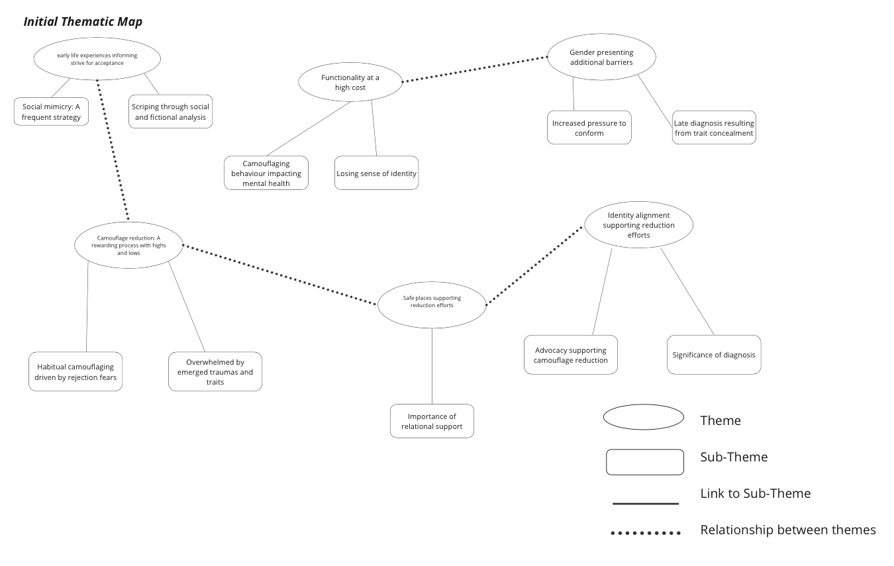
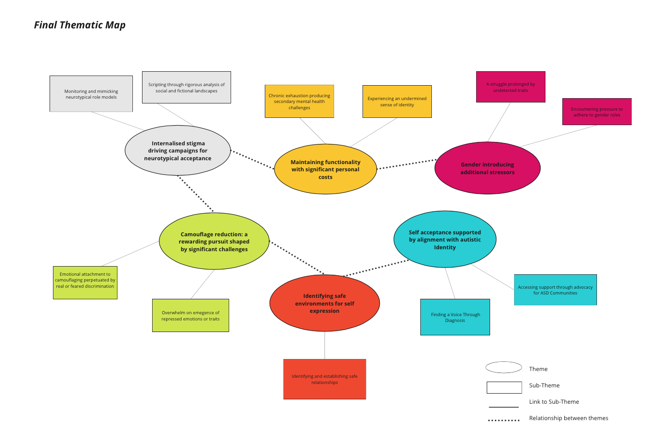
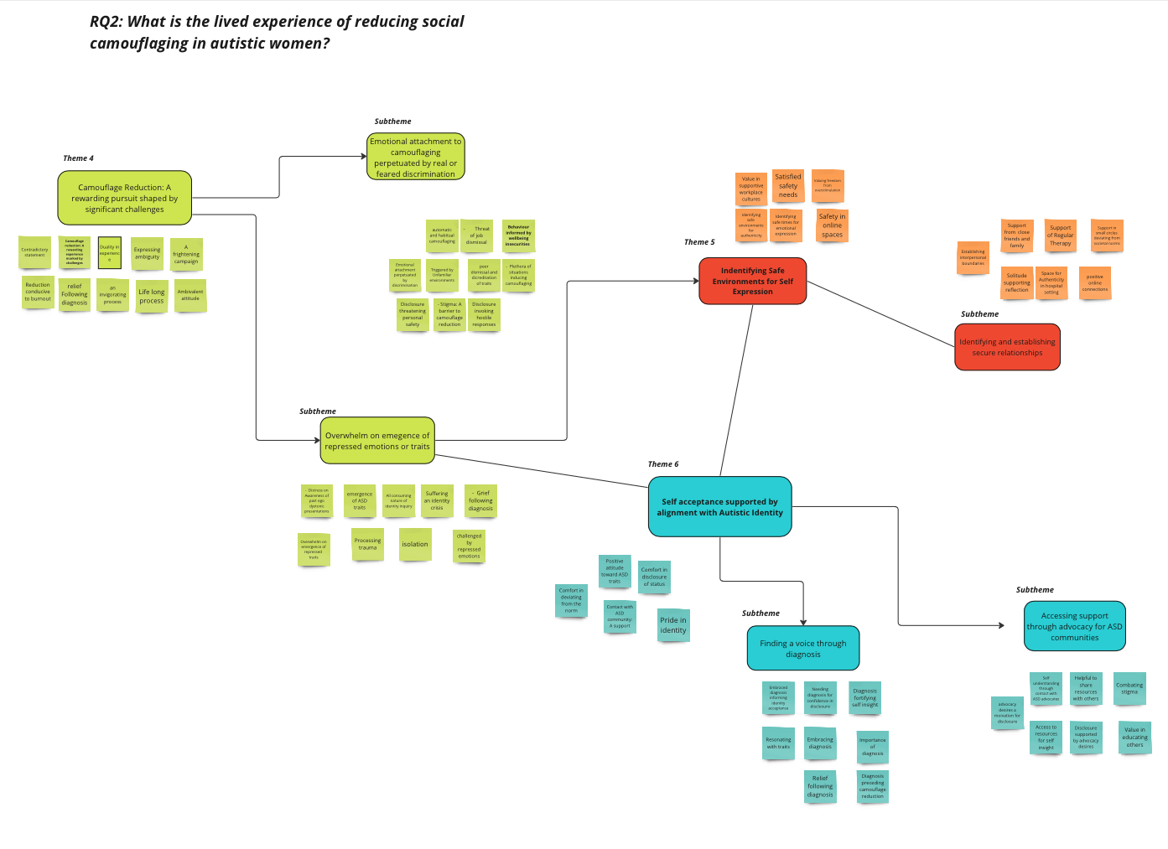
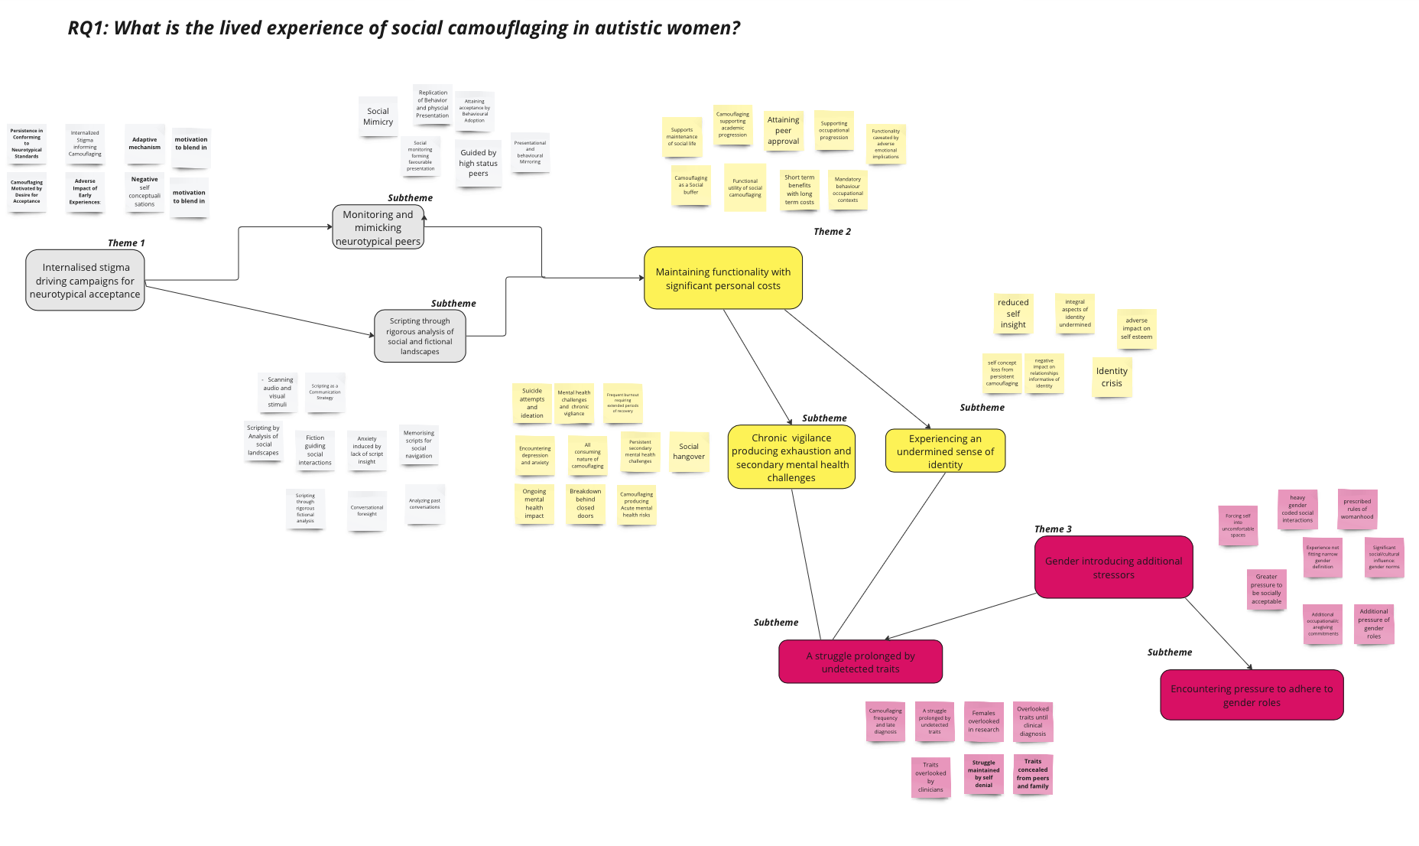

Appendix F

This dissertation is disseminated in the IADT On Show Graduate Exhibition

