Zach Ryan
N00202458
Research Supervisor: Dr John Greaney
Dissertation submitted as a requirement for the degree of BSc (Hons) in Applied Psychology, Dun Laoghaire Institute of Art, Design & Technology
2024

Declaration
I declare that this submission is my own work. Where I have read, consulted, and used the work of others, I have acknowledged this in the text.
Word Count: 5,000
Student Signature: Zach Ryan
Date: 17/04/2024
Title

‘Níl aon tinteán mar do thinteán féin

A Study on the Sense of Belonging Among Irish Emigrants and the Impact of Emigration and Return

Abstract
Title: ‘Níl aon tinteán mar do thinteán féin’ A Study on the Sense of Belonging Among Irish Emigrants and the Impact of Emigration and Return
Objective: This thesis explores the psychological effects of emigration and return among contemporary Irish emigrants, with a focus on how these experiences affect their sense of belonging to Ireland. The study aims to fill a gap in current research by providing up-to-date insights into the emotional and cultural challenges faced by today’s emigrants and returnees.
Methods: Employing a quantitative cross-sectional design, this study analyses the sense of belonging among 133 Irish citizens using a modified version of the Sense of Belonging in Social Context Questionnaire. Participants were divided based on their current location (Ireland vs. abroad) and experiences (time spent abroad and involvement in return migration). Data were analysed using independent t-tests and descriptive statistics to compare the sense of belonging among different groups.
Results: The results highlight a significant difference in the sense of belonging to Ireland between residents and those living abroad, with former residents feeling more connected to Ireland. Interestingly, cultural connections and feelings of home did not significantly differ based on geographic location, suggesting that Irish cultural identity is robust and transcends physical borders. Return migration was shown to have a nuanced impact on this sense of belonging, with some returnees experiencing challenges in readjusting to life in Ireland.
Keywords: Irish emigrants, sense of belonging, return migration, cultural identity, diaspora studies.

Acknowledgments
I would like to express my deepest gratitude to my supervisor, Dr. John Greaney, for his invaluable guidance and dedicated support throughout the course of this research. His insights and expertise have been instrumental in shaping both the direction and execution of this study, and his patience and commitment have been a constant source of strength for me.
I am also extremely thankful to Dr. Christine Horn and Dr. Grainne Kirwan for their assistance and advice. Their contributions have been immensely helpful in refining my research methods and analysis, providing me with a broader perspective on my work.
I must also extend a special thank you to my family. Their endless love, encouragement, and support have not only sustained me through the challenges of this academic journey but have also been my main source of motivation and inspiration.
Finally, I would like to acknowledge all my peers and colleagues who have offered their help and made this journey a memorable and enriching experience. Thank you to everyone who has been a part of this process.

Table of Contents
Abstract…………………………………………………………………….……….....1
Acknowledgments………………………………………………………….…….…...2
Table of Contents……………………………………………………….……….……3
Introduction……………………………………………………………………….….4
•1.1 Research Question………………………………………………….…….6
•1.2 Hypothesis…………………………………………………………….….6
Method………………………………………………………………………………..7
•2.1 Participants……………………………………………………………….7
•2.2 Materials…………………………………………………………………7
•2.3 Pilot Study……………………………………………………………….8
•2.4 Procedure………………………………………………………….……..8
Results……………………………………………………………………………….10
•3.1 Summary of Findings……………………………………….…………...10
•3.2 Interpretation of Results…………………………………………………11
•3.3 Comparison to Previous Research………………………………………11
•3.4 Integration and Spatiotemporal Commitment…………………………..11
•3.5 Temporal Dimensions of Belonging……………………………………12
•3.6 Cultural Identity Preservation…………………………………………..12
Discussion…………………………………………………………………………..13
4.1 Sense of Belonging and Cultural Identity………………………………13
4.2 Cultural Institutions and Diaspora………………………………………13
4.3 Cultural Identity as a Cornerstone of Belonging………………………..15
4.4 The Role of Cultural Institutions………………………………………..16
4.5 Navigating Time Abroad and Return Migration………………………...16
4.6 Insights and Implications for Policy…………………………………….16
4.7 Limitations and Further Research……………………………………….17
4.8 Conclusion……………………………………………………………….17
References…………………………………………………………………………..18
Appendices………………………………………………………………………….21

1.0 Introduction

Global migration has moulded countries in many ways. Most recent estimates put the number of global migrants at 280 million, with Europe and The United States being the most common destinations (United Nations, 2019. Forced migration also should not be ignored as wars throughout history have caused massive displacement. Millions of people were displaced as refugees, and post-war periods saw the rebuilding of nations and movements of people seeking better opportunities (Spaaij et al., 2023). Economic opportunities continue to be a major driver of migration. People move across borders for better job prospects and improved living standards. This is evident in movements from less developed to more developed countries. The subjective experience of emigrants from developed nations is not well researched (Ette & Erlinghagen 2021). Therefore, the purpose of the present study is to explore migration in relation to sense of belonging. In the wake of increasing global mobility, understanding the psychological effects of emigration and return is becoming ever more crucial. Recent demographic shifts have seen a significant number of Irish citizens moving abroad, with a considerable number eventually returning home. This thesis aims to delve into the current generation's experiences with emigration to uncover how these movements affect their sense of belonging and overall psychological well-being. The need for contemporary research is underscored by the changing dynamics of global migration and the unique challenges faced by today’s emigrants and returnees

Sense of belonging can be defined as an individuals’ experience or connection to a structure or environment in order that said individual believes themselves to be an important aspect of said environment (Hagerty et al., 1992). The need to relate and belong to a community or other people is a basic requirement for individuals (Deci & Ryan, 2000). There are a variety of factors that may influence a person’s sense of belonging. These may include the quality of one’s personal relationships, religious beliefs, sense of commonality and socioeconomic status (Lambert et al., 2013). Hou et al. (2017) conducted a study on immigrants in Canada. Four groupings were utilised - economic immigration, family reunification, and humanitarian obligations. 93% of the immigrants expressed a very strong or strong sense of belonging to Canada, 66% expressed a strong sense of belonging to both their home nation and host nation. Additionally, only 3% of participants stated a strong sense of belonging to their home nation and a weak sense of belonging to host nation. However, this study did not account for “honeymoon period” of migration as well as time spent abroad.

Hickey and Amador-Moreno (2020) explored cultural identity formation from a sociolinguistic perspective. A series of letters written by Irish migrants were analysed. One observation that was analysed was that Irish migrants referenced ‘Home’ more than any other nation. This suggests that Irish migrants carried their cultural identity with them. This may have contributed to the preservation and spread of Irish culture in the diaspora. Moran (2021) investigated how Irish immigrants in New York retained their identity. The research indicated that Irish immigrants tended to find solace in institutions reminiscent of their homeland, with the Catholic Church playing a crucial role in offering stability and guidance, especially in the United States. In major urban hubs like New York, the church and its parish evolved into integral aspects of the immigrants' lives. They established welfare clubs to support individuals during illness and unemployment, promoted abstinence from alcohol through temperance associations, and enlisted priests to mediate in disputes and represent them in dealings with authorities. Another institution which played a role in providing Irish culture abroad was the Gaelic Athletic Association (GAA). The GAA acted as a connection for Irish people to not only be reminded of ‘Home’ but as a way to integrate into local communities and secure jobs, especially in the United Kingdom (Harkin, 2021). A similar study concluded that Gaelic sports can function in a way so that Irish culture can be actively mobilised, fostering community for Irish away from home as well as forging of social bonds, celebration, teaching, and the preservation of Irish cultural heritage.

Repatriates may find it challenging to return and readjust to their home nation after extended periods of living abroad. People who have a strong cultural connection may find it easier to readjust after living abroad. Conversely, those feeling conflict between home and host culture had a more difficult readjustment period (Altweck & Marshall, 2015). There is vast and expansive research into how occupations can impact a persons’ life satisfaction upon immigration. However there is little research exploring personal aspects in relation to migration. One research paper found that factors such as personal history, “cultural comfort” and the quality of relationships at home seem to be a clearer indicator on individuals connection to their home country (Trąbka et al., 2022)

Return migration refers to the process in which individuals or groups of people move back to their home country or region after having previously migrated away (Gmelch, 1980). There has been an uptake in academic research in return migration due to COVID-19 and the policies that followed the pandemic (Rajan & Arcand, 2023). Return migration can be a complex topic to breakdown due to the wide variety of factors influencing people to return to their source country. Farrell et al. (2014) carried out a comparative analyses on both Irish and Lithuanian return migrants. In interviews, participants expressed a connection to their homeland and almost all participants said they had intended to return home after spending time abroad. The familiar setting of “home,” family and support systems were mentioned by both nationalities as a factor in their decision to come home. Finally, those who had returned home, felt that their goals had been achieved and was time to return. In contrast to Lithuanian participants, Irish individuals seemed to have difficulties seeking the appropriate resources upon their return home. Most participants were content with their decision to return home. However, some expressed a difficult adjustment period once they had arrived home.
Fitzgerald and Lambkin (2008) identified common historical patterns of return migration dating from the 18th to 20th centuries. Whilst return migration is a common phenomenon amongst Irish people there seems to a lack of academic research in terms of the possible effects of return migration especially in relation to migrants sense of belonging to their community and country.

1.1 Research Question
“To what extent does the experience of emigration among Irish Citizens impact their sense of belonging to Ireland, and how do factors such as time spent abroad and return migration influence this sense of belonging?”

1.2 Hypothesis
Hypothesis 1: Irish emigrants living abroad will report a lower sense of belonging to Ireland compared to those residing in Ireland. Result: Supported. There was a statistically significant difference, with those in Ireland reporting a higher sense of belonging.
Hypothesis 2: Time spent abroad and return migration significantly impact the sense of belonging among Irish emigrants. Result: Partially supported. While time spent abroad did not significantly affect the sense of belonging, return migration presented as a factor that could potentially influence reintegration and the sense of belonging, meriting further investigation.

2.0 Method

The current study has employed a quantitative, cross-sectional, between groups design. Experience of emigration amongst Irish citizens was the independent variable in the current study. The dependent variable in this study was sense of belonging to Ireland. Two covariates that were also tested were time spent abroad and return migration. Three independent T-Tests were performed to measure sense of belonging based on participants sense of belonging and whether they were in Ireland or abroad. Bar charts were employed to show in whether the participants associate their life in Ireland with the recent past, present, near future or distant future. Percentages were also calculated to measure participants plans for emigration.

2.1 Participants

Participants were gathered using convenient sampling. 135 participants were gathered via social media distribution. Approximately 2 participants were removed due to an incompletion of the survey. 1 was removed due to lack of anonymity. 57% of the participants were male, 42% were female and 1% identified as other genders. All participants were above the age of 18. All participants and data were dealt with in a way that complied with the standards of The Psychological Society of Ireland (Psychological Society of Ireland, 2019). The current study also followed the ethical guidelines of the British Psychological Society (British Psychological Society, 2021). Ethical approval was also granted by the Department of Technology and Psychology Ethical committee of IADT.

2.2 Materials

Sense of Belonging in Social Context Questionnaire was used in a similar way when applied by Kolesovs (2019). The relevant part of the questionnaire was added to Microsoft forms and as well as an information sheet, debrief form and consent information. Participants sense of belonging to Ireland was measured using a seven-point scale from Strongly Disagree to Strongly Agree. This scale was chosen as it had been employed by Kolesovs (2019) in a similar way, but the study looked at Latvia, whereas the current study focuses on Ireland. The current studies results could then provide a comparison to the aforementioned study. The same study noted a Cronbach’s Alpha of 0.80, revealing a satisfactory internal reliability for the questionnaire. The reliability enabled the study to progress as planned.

2.3 Pilot Study

Before sending the questionnaire to potential participants, a pilot study was done. (N=4, 75% male, 25% female). The initial test was carried out to ensure the questionnaire was not confusing, to get an idea for how long it might take as well as making sure that the survey was not missing anything. After the pilot study the participants gave feedback regarding the phrasing of some questions. Upon receiving the feedback, the suggestions were noted, and some things were altered. For example, one participant noticed that the seven-point scale for one question was in the wrong order. This item was changed to keep consistency throughout.

2.4 Procedure

Data collection began on the 15th of February and once the study reached the desired number of participants (130+) the data collection stage was terminated. The questionnaire was posted on social media and could be accessed through a link. The questionnaire was also distributed to peers via online chat spaces. A data collection fair was held in IADT to assist students in gathering participants for their various projects. Participants willingly took part in the study. They were given a consent form, a debrief form and an information sheet prior to taking part in the survey. Finally, the participants were asked to complete some demographic information as well as giving consent for their data to be used in the form of a ‘tick the box’ on the survey. When participants gave consent for their data to be used in the study, they were met with the SBSCQ.

Participants were asked 16 questions that applied to the data. Firstly, they were asked where they were living, with the option to answer Ireland or Abroad. This data was gathered to later group the participants. Next the participants were asked ‘If abroad how long (to the nearest year) have you been living there?” This aspect of the questionnaire was to analyse if time spent abroad has an effect on Irish citizens sense of belonging to Ireland. Questions 10-12 (10. I associate my life with where I am currently living) (11. I feel accepted where I am currently living) (12. I feel a commonality with the people where I am living) were answered using a seven point scale from Strongly Disagree – Strongly Agree, whereby higher scores meant higher sense of belonging.

A single question (‘I feel at home anywhere in Ireland.’) was asked to assess if there was parity for both subscales by gauging the sense of belonging to the country. Respondents indicated their level of agreement with the statement: "I feel a sense of belonging to Latvia." This statement was rated on a seven-point scale, as described previously. Four questions were asked to test whether there was a spatiotemporal aspect to the participants sense of belonging to Ireland.

14. My life period that I associate with Ireland the most is the recent past
15. My life period that I associate with Ireland the most is the present
16. My life period that I associate with Ireland the most is the near future
17. My life period that I associate with Ireland the most is the distant future

The participants used the aforementioned seven point scale for these four items.

IBM SPSS Statistics was used to test and analyse the data collected from the SBSCQ questionnaire. Microsoft Forms was used to collect and observe the results of the questionnaire. Subsequently the data on MS Forms was placed in Microsoft Excel to change the layout of the data as well as remove incomplete data that could not be analysed or computed. Similarly, some participants inputted the year in which they emigrated as opposed to the total amount of years they have been abroad, therefore this data was edited and resubmitted in the desired format in order for test statistics to be computed.

3.0 Results

The Independent Samples T-Test was conducted to compare the sense of belonging to Ireland for participants living in Ireland (n = 111) and those living abroad (n = 23). The results indicated that there was a statistically significant difference in the scores for individuals living in Ireland (M = 17.00, SD = 4.470) and those living abroad (M = 13.74, SD = 5.092); t(132) = 3.108, p = .002 (two-tailed). The magnitude of the differences in the means (mean difference = 3.261, 95% CI: 1.185 to 5.337) was large (Cohen's d = 4.580, Hedges' g = 4.606, Glass's delta = 5.092).

For the measure of cultural connection to Ireland, there was no significant difference in the sense of belonging between those living in Ireland (M = 5.61, SD = 1.557) and those living abroad (M = 5.87, SD = 1.576); t(131) = -.728, p = .468 (two-tailed). The magnitude of the differences in the means (mean difference = -.260, 95% CI: -.968 to .447) was very small (Cohen's d = -1.560, Hedges' g = -1.569, Glass's delta = -1.576).
Feeling at Home in Ireland and Living Location

The third set of analyses assessed the feeling of being at home anywhere in Ireland. This analysis did not reveal a significant difference in the scores for those living in Ireland (M = 4.54, SD = 1.882) compared to those living abroad (M = 5.13, SD = 1.984); t(132) = -1.356, p = .178 (two-tailed). The difference between the means was minor (mean difference = -.590, 95% CI: -1.451 to .271) and the effect size was small (Cohen's d = 1.560, Hedges' g = 1.576, Glass's delta = 1.576).

Questions 18-21 taken from the pertained to participants likelihood and desire to emigrate from Ireland. 60% (n=81) revealed they were looking for information on emigration opportunities. 42% (n=56) of the participants revealed that they had chosen the country they will live in. 25% (n=34) stated they had a clear emigration plan, and 29% (n=39) of the participants revealed they were fulfilling their emigration plan step by step.

3.1 Summary of Findings
The analysis of the survey data reveals that the sense of belonging to Ireland is significantly higher among those residing in Ireland compared to those living abroad. However, when it comes to cultural connection and feeling at home in Ireland, there is no significant difference between the two groups. These findings suggest that while geographical location may impact the overall sense of belonging to a country, it does not necessarily affect the cultural connection and feeling at home among the Irish diaspora.

3.2 Interpretation of Results
The significant difference in the sense of belonging between residents and the diaspora could be attributed to the direct experience and daily living in the cultural context of Ireland. In contrast, the lack of significant differences in the measures of cultural connection and feeling at home suggests that Irish individuals, regardless of their current residence, maintain a strong cultural identity and a sense of 'home' connected to Ireland.
These results contribute to a deeper understanding of the migration experience and its psychological impacts, particularly in the context of Irish emigration. The substantial effect sizes indicate that these findings are robust and carry practical significance, warranting further investigation into the factors that may mediate or moderate the relationship between living location and sense of belonging.

3.3 Comparison to Previous Research
Kolesovs' research on the sense of belonging to a country primarily investigates the integrative relationships and commitment to a country across different time periods. This is similar to the current study's focus on how time spent abroad and the act of return migration can influence an individual’s sense of belonging to their homeland, specifically among Irish citizens.

3.4 Integration and Spatiotemporal Commitment
Kolesovs' (2019) study utilized a sense of belonging in a social context questionnaire, measuring the participants' sense of belonging on a seven-point scale, which aligns with the methodology employed in the current study. Kolesovs found that sense of belonging is intricately tied to both integrative relationships within the host country and the temporal dimension of the individual's life (Kolesovs, 2019). In contrast, the present study suggests that while geographical location may impact the overall sense of belonging, it does not significantly affect individuals' cultural connections or feelings of being at home when abroad. This indicates that integrative relationships might maintain or even strengthen cultural identity despite physical distance from the homeland.

3.5 Temporal Dimensions of Belonging
Regarding spatiotemporal commitment, Kolesovs highlighted the role of time in fostering a sense of belonging, with longer durations in a country potentially leading to stronger attachments (Kolesovs, 2019). However, the current study's findings suggest a more nuanced interpretation, where time abroad does not necessarily diminish the cultural connection to the homeland, as evidenced by the nonsignificant differences in feelings of being at home for participants abroad compared to those in Ireland. These results propose that the temporal aspect may interact differently with cultural identity compared to overall belonging, a distinction not explicitly drawn in Kolesovs' work.

3.6 Cultural Identity Preservation
Both studies underscore the importance of cultural identity preservation among migrants. Kolesovs (2019) suggested that belonging to a country involves active engagement with cultural practices and institutions. This is reflected in the current study's observations regarding Irish migrants' engagement with cultural institutions like the Gaelic Athletic Association, which may help sustain their cultural identity and provide a semblance of 'home' irrespective of their physical location (Harkin, 2021).

Discussion
4.1 Sense of Belonging and Cultural Identity
The construct of a 'sense of belonging' intertwines deeply with the cultural identity of individuals, particularly within the diaspora. In the context of Irish emigrants, belonging emerges not only as a connection to the geographical entity of Ireland but also as an anchorage in the shared cultural narrative that defines Irishness. Hagerty et al. (1992) posited that sense of belonging is a fundamental human experience, emphasizing the psychological importance of feeling valued and integral to a larger community. This is reinforced by Deci and Ryan (2000), who argue that the need to belong and relate to others is a universal psychological necessity.
Irish cultural identity, characterized by a rich history, traditions, and community values, plays a pivotal role in the diaspora’s sense of belonging. Even when physically removed from Ireland, the diaspora carries with them a portable cultural identity, a phenomenon evidenced in this study’s findings, where Irish emigrants abroad still reported a strong sense of cultural connection and the feeling of 'home'. These findings resonate with Kolesovs (2019), whose research suggests that while integrative relationships within the host country and temporal dimensions are influential, they do not entirely override the innate cultural identity nurtured from the homeland.

4.2 Cultural Institutions and Diaspora
The Gaelic Athletic Association (GAA) and the Catholic Church are quintessential Irish institutions that have historically fostered a sense of community and cultural solidarity, both in Ireland and across the Irish diaspora. These institutions provide a framework for social interaction and collective identity that can sustain a sense of belonging, irrespective of geographic dispersion. Hickey and Amador-Moreno (2020) highlight how Irish migrants have maintained their cultural identity through social practices and institutions, such as the GAA, that promote a sense of unity and cultural continuity.
The Catholic Church has also played a vital role in offering stability and guidance for Irish immigrants, especially in countries like the United States, as documented by Moran (2021). The church's role extends beyond religious services, providing social support and fostering community ties that align with the values and culture of the homeland. Such institutions act as cultural beacons, helping to preserve the Irish heritage and enabling migrants to integrate into their new locales without relinquishing their cultural identity.
These findings parallel those of the current study, where Irish emigrants exhibited a robust sense of belonging that transcended physical boundaries. Furthermore, they align with Kolesovs' (2019) work, emphasizing the spatiotemporal commitment to one's nation through ongoing cultural practices. The study underlines that cultural institutions like the GAA and the Catholic Church not only preserve Irish culture abroad but actively facilitate the diaspora's sense of belonging by providing familiar social structures in an otherwise foreign environment.
In summary, the Irish experience of belonging and cultural identity abroad is multifaceted and resilient. It is maintained through traditional institutions and a shared cultural heritage, echoing within the global Irish community. This dynamic interplay between cultural identity and a sense of belonging, as revealed in the current study, corroborates the broader implications of Kolesovs' (2019) findings and highlights the importance of cultural institutions in sustaining the diaspora’s connection to their homeland.

Exploring the impact of time spent abroad and the phenomena of return migration reveals significant dimensions of the sense of belonging among the Irish diaspora. Previous research, including that of Altweck & Marshall (2015), suggests that individuals who maintain strong cultural ties during their time abroad tend to experience a smoother transition upon their return. This aligns with the notion that the duration and quality of an expatriate's experience overseas can significantly influence their reintegration into their homeland's social and cultural fabric.
The current study's findings indicate that while time spent abroad does affect the intensity of belonging to Ireland, it does not necessarily weaken the cultural connections that individuals feel. This observation is particularly relevant in light of Kolesovs' (2019) findings, which highlighted the role of temporal elements in fostering a sense of belonging. Kolesovs suggested that longer durations abroad might lead to stronger attachments to the host country, yet this study proposes a more nuanced view where the Irish cultural identity remains influential regardless of the length of time spent overseas.
Furthermore, the role of return migration in shaping an individual's sense of belonging is complex and layered. Farrell et al. (2014) noted that returnees often express a renewed connection to their homeland, driven by familiarity and nostalgia. However, the transition is not always seamless; some individuals face significant challenges in readjusting to life in Ireland, echoing the findings of Gmelch (1980) who discussed the multifaceted nature of return migration. These challenges can include socio-economic and psychological adjustments, depending on the changes that have occurred in their absence and the expectations upon return.
This study confirms that return migration can influence the sense of belonging in diverse ways. For many participants, returning to Ireland reignites feelings of connection and community that were attenuated during their time abroad. However, for others, the reality of returning can lead to a sense of alienation, as they struggle to reconcile their idealized memories of home with the contemporary reality.
The complexity of these experiences underscores the importance of supportive structures and policies that can facilitate the reintegration of returnees, as suggested by Rajan & Arcand (2023), who emphasized the need for comprehensive returnee support systems post-COVID-19. These systems could mitigate the challenges of return migration and enhance the overall sense of belonging, ensuring that returnees can successfully reintegrate both socially and culturally.
In conclusion, time abroad and return migration are critical factors that shape the dynamics of belonging among the Irish diaspora. The enduring strength of Irish cultural identity suggests that cultural ties can provide a stable anchor of belonging, irrespective of geographical distances or the length of time spent overseas. This insight is valuable for policymakers and community leaders who aim to support the diaspora and returnees, aligning with broader research that highlights the need for targeted support to maximize the benefits of return migration for individuals and the community at large.

4.3 Cultural Identity as a Cornerstone of Belonging
Central to this study's findings is the assertion that the sense of belonging for Irish emigrants is intrinsically linked to their cultural identity. This identity, characterized by shared history, traditions, and values, persists as a stable anchor of their lives, irrespective of their geographic locations. Drawing on psychological frameworks proposed by Hagerty et al. (1992) and Deci & Ryan (2000), it is evident that belonging is a fundamental human need, essential for personal and communal well-being. The durability of Irish cultural identity not only supports this theoretical stance but also enhances it by adding a layer of cultural continuity that spans global boundaries.

4.4 The Role of Cultural Institutions
The Gaelic Athletic Association (GAA) and the Catholic Church have emerged as vital conduits for maintaining cultural ties. As noted by Hickey and Amador-Moreno (2020) and Moran (2021), these institutions do more than preserve traditions; they actively foster community cohesion and provide emotional and social support to emigrants. This thesis has highlighted their role not just in cultural preservation but in strengthening the diaspora’s emotional and psychological connection to Ireland, thus supporting their overall sense of belonging.

4.5 Navigating Time Abroad and Return Migration
The challenges and opportunities presented by time spent abroad and subsequent return migration have been another focal point of this study. Aligning with previous research by Farrell et al. (2014) and Gmelch (1980), the findings suggest that while return migration can renew and reinforce a sense of belonging, it can also pose significant reintegration challenges. These challenges underscore the necessity for supportive structures that can facilitate a smoother transition for returnees, thereby enhancing their ability to reconnect with their homeland both socially and culturally.

4.6 Insights and Implications for Policy
This research holds valuable implications for policy formulation, particularly in the creation of support systems for the Irish diaspora. Policies aimed at bolstering cultural institutions abroad could play a crucial role in maintaining the cultural ties that underpin the sense of belonging. Additionally, programs designed to assist returnees could mitigate the challenges of re-adaptation, fostering a more inclusive and supportive environment for those who choose to come back.

4.7 Limitations and Further Research
The present study, while providing valuable insights into the sense of belonging among Irish emigrants, is not without limitations that must be acknowledged. The sample size, particularly of participants residing abroad, was modest (n = 23), and the use of convenience sampling through social media platforms may not yield a sample representative of the broader emigrant population, thus potentially limiting the generalizability of the findings (Lakens, 2022). As with many studies relying on self-report measures, responses are subject to individual subjectivity and may not entirely reflect objective experiences (Del Boca & Noll, 2000).The cross-sectional design of this research precludes tracking the evolution of the sense of belonging over time, presenting a static picture of a dynamic construct. Moreover, while the role of cultural institutions in maintaining identity abroad is recognized, the current study does not quantify the extent of engagement with such institutions, which could be instrumental in understanding the nuances of cultural connectivity (Gamlen, 2014).
Future research should address these limitations through longitudinal designs that capture the temporal aspects of belonging (Kolesovs, 2019). An expanded and diverse participant pool, alongside the incorporation of mixed methodologies, could offer a more comprehensive understanding of the migratory experience and its impact on belonging (Castles, 2010). Comparative cultural studies are also warranted to discern universal versus culture-specific patterns related to migration and belonging, contributing to the broader field of psychology of migration (Kolesovs, 2019; Salami et al., 2019). Such studies could build upon the foundations laid by both the current research and the seminal work of Kolesovs (2019), enriching the dialogue on the complex interplay between cultural identity, temporal dimensions, and geographical location in the context of global migration.

4.8 Conclusion
In summary, this thesis reinforces the critical importance of cultural identity in shaping the sense of belonging among Irish emigrants. Through the lens of cultural institutions and the experiences of time abroad and return migration, it is clear that maintaining strong cultural ties is essential for fostering a deep and enduring connection to Ireland. As the global landscape continues to evolve, the insights from this study highlight the enduring value of cultural continuity and community cohesion for diaspora populations worldwide.

References
Altweck, L., & Marshall, T. C. (2015). When you have lived in a different culture, does returning ‘Home’ not feel like home? Predictors of psychological readjustment to the heritage culture. PLOS ONE, 10(5), e0124393. https://doi.org/10.1371/journal.pone.0124393

Castles, S. (2010). Understanding Global Migration: A Social Transformation Perspective. Journal of Ethnic and Migration Studies, 36(10), 1565–1586. https://doi.org/10.1080/1369183x.2010.489381
Deci, E. L., & Ryan, R. M. (2000). The “What” and “Why” of goal pursuits: human needs and the Self-Determination of behavior. Psychological Inquiry, 11(4), 227–268. https://doi.org/10.1207/s15327965pli1104_01
Del Boca, F. K., & Noll, J. A. (2000). Truth or consequences: the validity of self‐report data in health services research on addictions. Addiction, 95(11s3), 347–360. https://doi.org/10.1046/j.1360-0443.95.11s3.5.x
Department of Foreign Affairs. (n.d.). Black ’47 Ireland’s Great Famine and its after-effects - Department of Foreign Affairs. https://www.dfa.ie/irish-embassy/usa/about-us/ambassador/ambassadors-blog/black47irelandsgreatfamineanditsafter-effects/#:~:text=6%20million%20people%20left%20between,half%2C%20to%20just%204.4%20million.

Ette, A., Décieux, J. P., Erlinghagen, M., Auditor, J. G., Sander, N., Schneider, N. F., & Witte, N. (2021). Surveying across borders: The experiences of the German emigration and remigra- tion panel study. In M. Erlinghagen, A. Ette, N. F. Schneider, & N. Witte (Eds.), The global lives of German migrants. Consequences of international migration across the life course. Cham: Springer.

Farrell, M., Kairytė, E., Nienaber, B., McDonagh, J., & Mahon, M. (2014). Rural Return Migration: Comparative Analysis between Ireland and Lithuania. Central and Eastern European Migration Review, 3(2), 127–149. http://ceemr.uw.edu.pl/sites/default/files/Farrell_Kairyt%C4%97_Nienaber_McDonagh_Mahon_Rural_Return_Migration.pdf
Fitzgerald, P., & Lambkin, B. (2008). A Three-Way process: immigration, internal migration and emigration. In Palgrave Macmillan UK eBooks (pp. 34–61). https://doi.org/10.1057/9780230581920_3
Gamlen, A. (2014). Diaspora institutions and diaspora governance. the International Migration Review/International Migration Review, 48(1_suppl), 180–217. https://doi.org/10.1111/imre.12136

Gmelch, G. (1980). Return migration. Annual Review of Anthropology, 9(1), 135–159. https://doi.org/10.1146/annurev.an.09.100180.001031
Hagerty, B. M., Lynch-Sauer, J., Patusky, K. L., Bouwsema, M., & Collier, P. (1992). Sense of belonging: A vital mental health concept. Archives of Psychiatric Nursing, 6(3), 172–177. https://doi.org/10.1016/0883-9417(92)90028-h
Harkin, F. (2021). ‘It’s a Cultural Pull for the Irish Abroad’: Gaelic Games and the Irish Community in Twentieth and Twenty-first Century London. Immigrants & Minorities, 39(1), 78–100. https://doi.org/10.1080/02619288.2021.1982701
Hickey, R., & Amador-Moreno, C. P. (2020). Irish identities: Sociolinguistic Perspectives. Walter de Gruyter GmbH & Co KG.
Hou, F., Schellenberg, G., & Berry, J. W. (2017). Patterns and determinants of immigrants’ sense of belonging to Canada and their source country. Ethnic and Racial Studies, 41(9), 1612–1631. https://doi.org/10.1080/01419870.2017.1295162
Irish identities. (n.d.). Google Books. https://books.google.ie/books?hl=en&lr=&id=12zcDwAAQBAJ&oi=fnd&pg=PA283&dq=irish+emigration+identity+formation&ots=IY4cgUqH-z&sig=3bA3iO8epYSrTamAXmTVjZxdbr4&redir_esc=y#v=onepage&q=irish%20emigration%20identity%20formation&f=false

Lakens, D. (2022). Sample size justification. Collabra. Psychology, 8(1). https://doi.org/10.1525/collabra.33267

Lambert, N. M., Stillman, T. F., Hicks, J. A., Kamble, S. V., Baumeister, R. F., & Fincham, F. D. (2013). To belong is to matter. Personality and Social Psychology Bulletin, 39(11), 1418–1427. https://doi.org/10.1177/0146167213499186
Migration in Irish history, 1607-2007. (2009). Choice Reviews Online, 47(01), 47–0494. https://doi.org/10.5860/choice.47-0494
Mayblin, L. (2021). Migration studies and colonialism. Polity.
Moran, G. (2021). Retaining their Irish identity: Marriage and the Famine Irish in five points, New York, in the 1850s. New Hibernia Review, 25(3), 111–125. https://doi.org/10.1353/nhr.2021.0034
Nagy, A. (2021). Gaelic Sports, Home and Away: Building Community and Identity through Sport. http://dspace.library.uvic.ca/handle/1828/12994
Rajan, S. I., & Arcand, J. (2023). COVID-19 return migration phenomena: experiences from South and Southeast Asia. Journal of Ethnic and Migration Studies, 1–20. https://doi.org/10.1080/1369183x.2024.2268963
S alami, B., Salma, J., Hegadoren, K., Meherali, S., Kolawole, T., & Díaz, E. (2019). Sense of community belonging among immigrants: perspective of immigrant service providers. Public Health, 167, 28–33. https://doi.org/10.1016/j.puhe.2018.10.017
Trąbka, A., Klimavičiūtė, L., Czeranowska, O., Jonavičienė, D., Grabowska, I., & Wermińska-Wiśnicka, I. (2022). Your heart is where your roots are? Place attachment and belonging among Polish and Lithuanian returnees. Comparative Migration Studies, 10(1). https://doi.org/10.1186/s40878-022-00301-4
United Nations. (n.d.). International migration | United Nations. https://www.un.org/en/global-issues/migration#:~:text=According%20to%20the%20latest%20estimates,per%20cent%20of%20international%20migrants.

Appendices

Appendix A

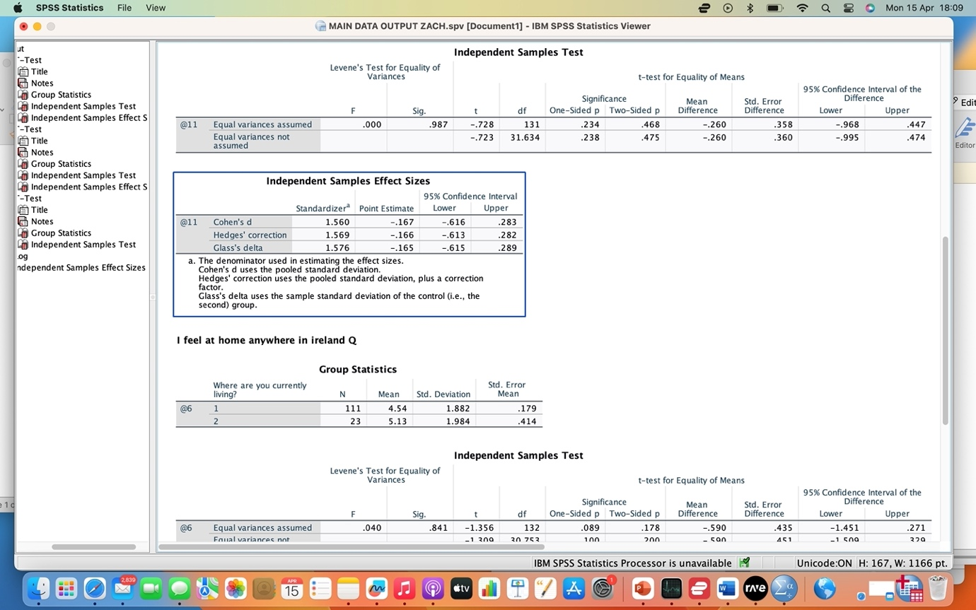

Appendix B

Appendix C
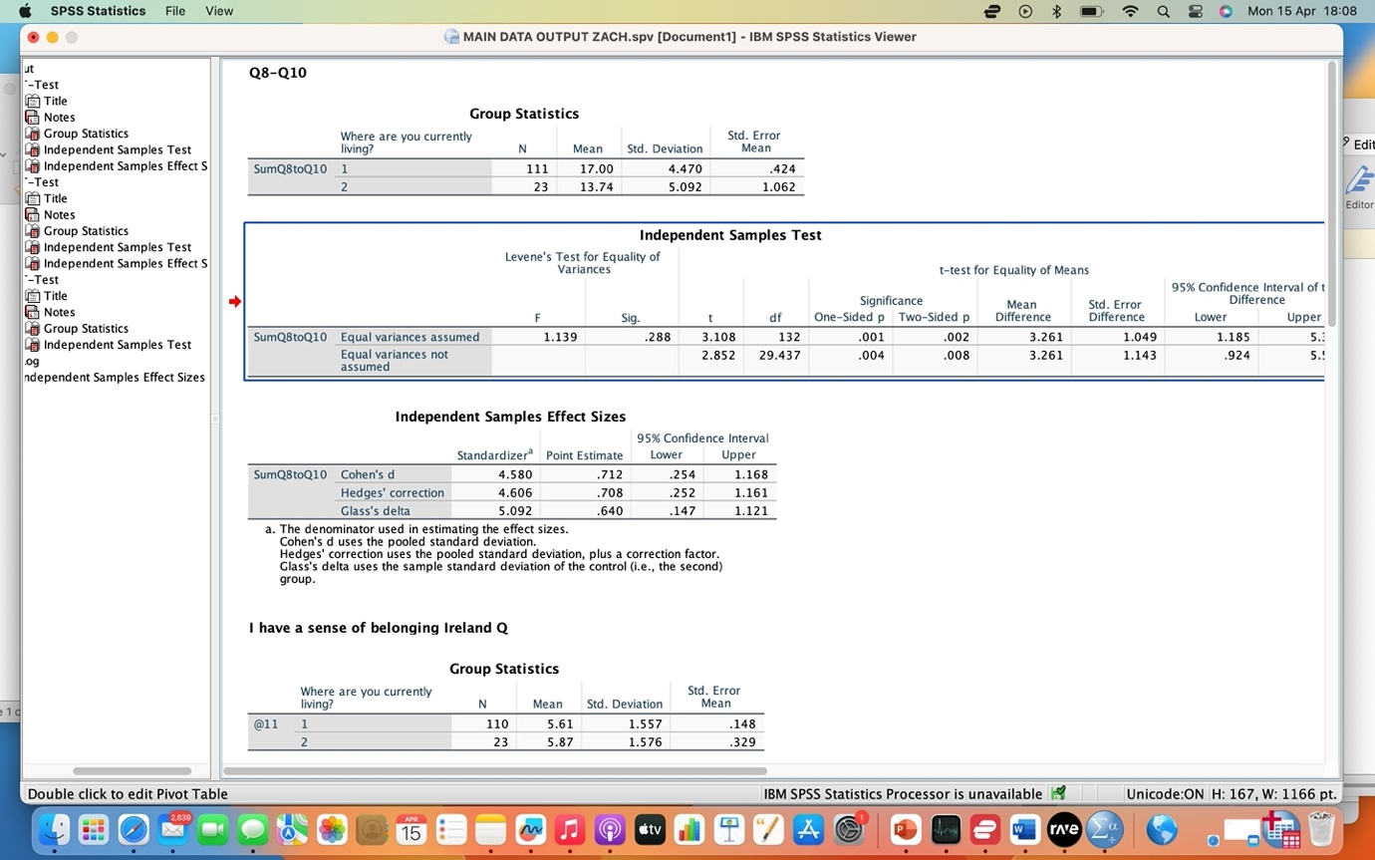

Appendix D

Appendix E
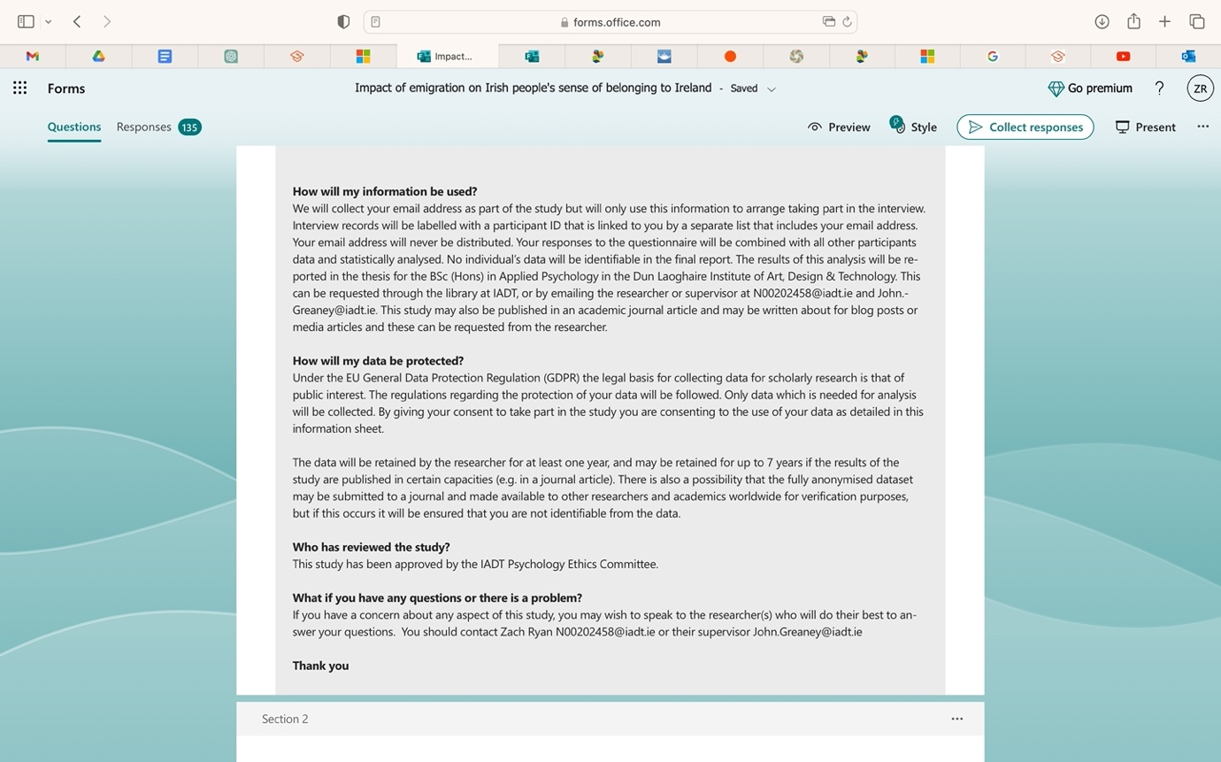

Appendix F

Appendix G

IADT Psychology Ethics Committee (PEC)
Application Form 2023-2024

Instructions:
- Please read all sections carefully, include all of the information relevant to your project, and include all necessary appendices.
- All students must complete Sections 1, 2, 3, and 4. You will also need to complete at least one other section, depending on the type of research that you plan to do.
- Email the completed form to your supervisor for approval.
  - If your project is a Red route application then it must be submitted to your supervisor by 5pm on Monday 20th November 2023.
  - If your project is a Green or Amber route application then it must be submitted to your supervisor by 5pm on Monday 27th November 2023.
- Your supervisor will then complete Section 0 and will forward the application to the ethics committee.
- If your application is under the Red Route, then you may also be required to submit four printed copies of your application (including all appendices). You will be advised closer to the deadline if this is necessary or not.
- If your study changes from how you have described it in this form then you will need to reapply for approval from the PEC. The PEC does not guarantee that a revised project will be approved, even if the original project was approved.
- All communication between students and the PEC will occur via the student’s project supervisor.
- The PEC will consider all of the information provided in the form when making their decision. Incomplete forms (including forms which do not include all of the necessary Appendices) will be rejected.
- If the PEC’s decision is that a revised application must be made then they will provide a list of required changes which are necessary to ensure participant wellbeing. Even if all of these are followed, the PEC makes no commitment to approve a revised application.
- It is highly recommended that ‘Red Route’ students continue to formulate ideas for projects which fit the criteria for ‘Green Route’ and ‘Amber Route’ submissions until they are advised that their application has been approved. This is to ensure that the student can still complete the module, even if their ‘Red Route’ project does not receive approval from the PEC.
- There is an obligation on the researcher to bring to the attention of the PEC any issues with ethical implications not clearly covered by the checklist in Section 6 of this form.
- ‘Signatures’ may be typed, scanned in, or digitally signed.
- The Psychology Ethics Committee can refuse any application which they consider unsuitable for student research.
- Occasionally further information may be requested by the PEC with regard to Green and Amber route project applications where there is uncertainty regarding these applications. In some cases a Green or Amber route project ethics application may need to be reformatted and resubmitted as a ‘Red’ route application.
- If you receive approval from the Psychology Ethics Committee to proceed with your research, this is valid for 2 calendar years from the date approval is issued by the PEC chair. All data collection must be completed within these 2 calendar years. If this time lapses during the course of your project data collection then you must reapply for ethical approval.
- If your project when conducted does not conform to the project as described in your ethics application then you may be subject to certain outcomes. Depending on the circumstances, these can include a reduction in grade, a capping of the project module grade at a ‘C’, receiving an ‘F’ grade on the module, and/or potential invocation of the IADT Student Disciplinary Procedures.
- Occasionally students wish to conduct projects on highly sensitive topics which would not be suitable for primary data collection. In these cases the student can consider ‘Green’ route methodologies (e.g. analysis of existing datasets, completing a Rapid Structured Literature Review, or similar). Approval by the PEC for all projects relating to sensitive topics is dependent on an appropriate and willing supervisor being available for such projects, and on the student’s recognition that their pursuance of such a project is not mandatory and that they voluntarily chose such a project. Students should ensure that they are familiar with the supports available to them (for example, the student counselling service) and should ensure that their actions follow relevant legal statutes and requirements at all times. In exceptional cases a student can cease work on projects on highly sensitive topics and prepare a new project idea, although this may result in the need for a deferral or leave of absence in some cases.

Section 0: For Completion by the Supervisor
I confirm that this application to the PEC by __Zach Ryan______________________ (student name) accurately reflects all of the ethical implications in the project.
Application type (tick all that apply for mixed methods): Green Route _____
Amber Route __ ✓___
Red Route _____
Signed ____Zach Ryan___________________________ Date: _____21/11/2023___________________

Section 1: Project Information

Student Name: ___________Zach Ryan__________________________________________________
Student Email Address: _______n00202458@iadt.ie_______________________________________________
Supervisor Name: _____John Greaney______________________________________________________
Working Project Title: _To what extent does the experience of emigration among irish citizerns impact their sense of belonging to Ireland
Main Variables Being Investigated: _____experience of emigration among irish citizens, time spent abroad _and return migration_______________________________________

Section 2: External Agencies
Does your project involve recruitment from any external agency (e.g. a school, sports club, medical centre, voluntary organisation, or any other organisation outside of the IADT)? | Yes* | No ✓
* You must include a letter from a senior manager of each organisation stating that you have approval to collect data within that organisation. Include copies of each of these letters in the Appendices to your application. If the organisation has its own ethical review board (which is very common in some settings, such as hospitals), then you are also required to get ethical approval from that board prior to starting data collection, and to submit notice of this approval to your supervisor so that it can be forwarded on to the ethics committee. Some online forums also require permission to post requests for participants – make sure to check the relevant forum/organisation’s code of conduct or terms and conditions. You do not need to include approval letters if you are conducting recruitment using mainstream social media routes (e.g., Twitter, Instagram, Facebook, Snapchat, TikTok) to your own followers, and/or snowball sampling/word of mouth recruitment.

Section 3: Project Methodology – Please tick which type of project you are seeking approval from the PEC for. If your project involves mixed methods, then tick all which apply.
Route Type | Methodology | Tick here
Green Route (no direct contact with participants required, and no data is collected/recorded which could identify participants) | Theoretical paper / systematic literature review / Rapid Structured Literature Review (RSLR)
 | Novel analysis of an existing dataset gathered by another researcher or group which you are certain has abided by appropriate ethical procedures for the relevant discipline
 | Observation of participants in a public place in which they could reasonably be expected to be observed by strangers or in an online space which does not require users to log in to access.
 | Content analysis of material which is publicly available and does not require users to log in to access content.
 | Other method without direct contact with participants **
Amber Route (direct contact with participants, but no additional ethical considerations beyond the minimum requirements) | Requirements gathering for and/or user testing of a prototype which is highly unlikely to cause any harm or distress to participants and which does not aim to collect data from a potentially vulnerable group
 | An experiment which is highly unlikely to cause any harm or distress to participants and which does not aim to collect data from a potentially vulnerable group
 | A survey/questionnaire design which is highly unlikely to cause any harm or distress to participants and which does not aim to collect data from a potentially vulnerable group | ✓
 | An observational study which is highly unlikely to cause any harm or distress to participants and which does not aim to collect data from a potentially vulnerable group
 | Content analysis research which is highly unlikely to cause any harm or distress to participants and which does not aim to collect data from a potentially vulnerable group
 | Interviews and/or focus groups which are highly unlikely to cause any harm or distress to participants and which do not aim to collect data from a potentially vulnerable group | ✓
 | Other method which is highly unlikely to cause any harm or distress to participants and which does not aim to collect data from a potentially vulnerable group **
Red Route (direct contact with participants, including one or more project aspects which require special ethical consideration) | Requirements gathering for and/or user testing of a prototype which may cause harm or distress to participants and/or which involves collecting data from any potentially vulnerable group
 | An experiment which may cause harm or distress to participants and/or which involves collecting data from any potentially vulnerable group
 | A survey/questionnaire design which may cause harm or distress to participants and/or which involves collecting data from any potentially vulnerable group
 | An observational study which may cause harm or distress to participants and/or which involves collecting data from any potentially vulnerable group
 | Content analysis research which may cause harm or distress to participants and/or which involves collecting data from any potentially vulnerable group
 | Interviews and/or focus groups which may cause harm or distress to participants and/or which involves collecting data from any potentially vulnerable group
 | Any project which includes use of any illegal materials or substances as part of the materials for the study, regardless of methodology employed.
 | Any project which includes use of any dangerous materials or substances as part of the materials for the study, regardless of methodology employed.
 | Any project employing ethnographic or autoethnographic methodologies.
 | Other method which may cause harm or distress to participants and/or which involves collecting data from any potentially vulnerable group **
** If you are using a methodology not listed above then provide a short description (fewer than 100 words) here:

Section 4: Checklist of Attached Appendices and Other Completed Sections
Applicable Project Ethics Route Colour Guide |  |  |  |  | Section / Item | I have attached this item/completed this section | I have checked with my supervisor and we have agreed that this item/section is not relevant to my project
 |  |  |  | 1 | Section 1 | ✓
 |  |  |  | 2 | Section 2 | ✓
 |  |  |  | 3 | Section 3 | ✓
 |  |  |  | 4 | Section 4 | ✓
 |  |  |  | 5 | Letters of permission from any external agencies to be used for data collection
 |  |  |  | 6 | Statement of approval from ethical review boards in external agencies
 |  |  |  | 7 | Section 5 (Green Route Projects only)
 |  |  |  | 8 | Section 6 (Amber and Red Route Projects only) | ✓
 |  |  |  | 9 | Section 7 (Amber Route Projects only) | ✓
 |  |  |  | 10 | Section 8 (Red Route Projects only)
 |  |  |  | 11 | Section 9 (Red Route Projects only)
 |  |  |  | 12 | Evidence of why you need to complete a Red Route Project (see note in Section 8)
 |  |  |  | 13 | Project Information Sheet (Red Route Projects only)
 |  |  |  | 14 | Project Consent Form (Red Route Projects only)
 |  |  |  | 15 | Project Demographic Questionnaire (Red Route Projects only)
 |  |  |  | 16 | All Other Questionnaires and Data Collection Materials (Red Route Projects only)
 |  |  |  | 17 | Project Debrief (Red Route Projects only)

Section 5: Declaration of a Green Route project
I hereby declare that [all of / this aspect of (delete as appropriate)] my project involves no direct interaction between me and any research participants, and that having checked with my supervisor, that I do not need to seek informed consent from those whose data I use in my research. In addition, I will ensure that all data which I do gather is held in a manner which is compliant with GDPR, and will be deleted once it is no longer required (and definitely within 6 years of collection). At all times my study will be conducted in adherence to the ethical policies of the Psychological Society of Ireland and the British Psychological Society.
Student Signature: ________Zach Ryan_________________________ Date: _____21/11/23__________________

Section 6: Confirmation of Adherence to Basic Ethical Principles for Amber and Red Route Projects
Complete the Table below with guidance from your supervisor. If you need to tick any of the ‘red’ boxes, then your project must be submitted under the ‘Red Route’.
 |  | Yes | No | N/A
6.1 | I will describe the main research procedures to participants in advance so that they know what to expect. I will use the sample Information Sheet provided by PEC to do this. | ✓
6.2 | I will tell participants that their participation is voluntary. | ✓
6.3 | I will obtain written consent from participants using a ‘tick’ consent form which follows the current template provided by PEC prior to starting data collection. | ✓
6.4 | I will verify that participants still wish to include their data in online studies by including a final indicator of consent at the end of the questions. | ✓
6.5 | If my research involves content analysis or observation in any private or partially private setting then I will ensure to obtain informed consent prior to collecting data. | ✓
6.6 | I will explain to participants that they can withdraw from the study at any time and for any reason. | ✓
6.7 | I will ensure that participants know that they can refrain from answering any question that they don’t want to, even if this is part of a psychometric scale. | ✓
6.8 | If using an online data collection method I will ensure that the only questions which require answers in order to proceed are the questions relating to providing informed consent, and I will ensure that participants are provided with an option which indicates that they do not give their consent. | ✓
6.9 | I will inform participants that their data will be treated with full confidentiality, and that, if published, it will not be identifiable as theirs. | ✓
6.10 | I will debrief participants at the end of their participation (i.e. give them a brief explanation of the study, whether or not deception was involved) following the current template provided by PEC | ✓
6.11 | I will obtain passive consent from parents/guardians for studies involving people aged between 16 and 18 years, as well as active consent from the participant and their school/organisation |  |  | ✓
6.12 | I will obtain active consent from parents/guardians for studies involving people aged under 16 years. Where feasible I will also obtain active consent from the participant themselves. I will ensure that the parent/guardian or their nominee (e.g. a teacher) will be present throughout the data collection period. |  |  | ✓
6.13 | I will ensure that my project supervisor has full access to the data that I collect and will only use data collection software which permits this. | ✓
6.14 | I will ensure that my project supervisor retains full rights to the data collected, including the ability to delete all data at any time, and that third-parties (e.g., software companies) will not ‘own’ the data collected. | ✓
6.15 | I will ensure that participants in studies involving Virtual Reality (VR) are not susceptible to extreme motion sickness or other physical conditions which may result in harm to the participants. I will ensure that a chaperone is present during VR sessions, and that the participant has the option of also having a nominee of their choosing present as well. |  |  | ✓
6.16 | I will ensure that any equipment used in this study is cleaned and disinfected after each participant, and that appropriate hygienic barriers (e.g. masks) are used by all participants |  |  | ✓
6.17 | Is there any realistic risk of any participant experiencing either physical or psychological distress or discomfort? |  | ✓
6.18 | I plan to use animals as part of my research study |  |  | ✓
6.19 | I plan to tell participants their results on a task or scale which I am using in my research. |  | ✓
6.20 | I am researching a sensitive topic which may cause some participants distress (such as, but not limited to, religion, sexuality, alcohol, crime, drugs, mental health, physical health, parenting, family relationships) |  | ✓
6.21 | One or more aspects of my study is designed to change the mental state of participants in a negative way (such as inducing aggression, frustration, sadness, etc.) |  | ✓
6.22 | My study involves deception or deliberately misleading participants in some way. |  | ✓
6.23 | My target population includes people who have learning or communication difficulties |  | ✓
6.24 | My target population includes patients (either inpatient or outpatient) |  | ✓
6.25 | My target population includes people in custody |  | ✓
6.26 | My target population includes people who may feel under personal or professional pressure to take part in my research (for example, close friends; family; employees or staff of managers or school principals who may support the research). |  | ✓
6.27 | My project includes the use of any illegal materials or substances as part of the materials for the study, regardless of methodology employed. |  | ✓
6.28 | My project includes the use of any dangerous materials or substances as part of the materials for the study, regardless of methodology employed. |  | ✓
6.29 | My project employs ethnographic or autoethnographic methodologies. |  | ✓

Section 7: Declaration of an Amber Route project
I hereby declare that [all of / this aspect of (delete as appropriate)] my project involves no risk of physical, emotional, social or cognitive harm to participants; that I will obtain full informed consent from all participants and provide a full debrief afterwards (using the templates provided); that I will provide full anonymity and/or confidentiality to participants; and that my participants are not a potentially vulnerable population. In addition, I will ensure that all data which I gather is held in a manner which is compliant with GDPR, and will be deleted once it is no longer required (and definitely within 6 years of collection). At all times my study will be conducted in adherence to the ethical policies of the Psychological Society of Ireland and the British Psychological Society.
Student Signature: ___Zach Ryan______________________________ Date: ______21/11/23_________________

Section 8: Additional Information For Red Route Projects
8.1 What are the aims of your research? Include your research question and hypotheses for all studies which are not exploratory in nature (Max. 100 words)

8.2 What is the specific reason(s) why this is a Red Route project? (Max. 100 words)

8.3 How will you ensure that participants are not harmed as a result of participation in your research, given your answer to 8.2 above (Max. 100 words)

8.4 Why do you need to do this project at this stage in your career? For example, is there a specific postgraduate programme which you wish to apply for which requires you to have completed research in this area? Do you have specific additional qualifications or experience which equip you to manage the additional ethical implications in this project? Bear in mind that if your main reason for wishing to do this research is because the area of study is important then your application is likely to be refused – in general it is better for research with important societal implications to be conducted at a time when you have more research experience. (Max. 100 words)

8.5 Provide rationale as to why other methodologies related to your chosen topic (such as a systematic review, RSLR, theoretical paper, content analysis, or analysis of an existing dataset) cannot be done in your case (Max. 100 words)

8.6 List supporting documentation which you have included in an Appendix to this application to justify the need for you to do a Red Route project (this might be: the list of entry requirements for a specific postgraduate programme which you are planning on applying for, along with the link to the website where you found this information; a transcript or certificate for a training course related to the area; a letter from your manager or supervisor where you are engaged in voluntary work related to the area, etc.).

1.
2.
3.
4.
5.
6.

8.7 List below the final grades that you received in each module in your most recent completed year of study in IADT (i.e. Fourth year students should provide their 3rd year end-of-year results; Third year students should provide their 2nd year end-of-year results; MSc students should provide their grades to date in each module, ‘provisional’ grades are acceptable when final grades are not yet available). A Red Route ethics project requires a very high level of competence and attention to detail which we have found often correlates with higher grades in earlier modules.

1.
2.
3.
4.
5.
6.
7.
8.

8.8 Planned Study Design (Max. 50 words)

8.9 Description of Planned Materials (Max. 200 words). All materials should be included as Appendices to this application. Materials include information sheets, consent forms, debriefs, demographic questionnaire, attitude or psychometric questionnaires, intervention materials, score sheets, technical equipment, and anything else that will be used during data collection. If you intend to use a video/game/app/other media, then you must provide the committee with full access to this through a video file or access to the game/app/media.

8.10 Planned Participant Population and Recruitment Method (Max. 100 words)

8.11 Planned Procedure (Max. 100 words)

Section 9: Declaration of a Red Route project
I hereby declare that [all of / this aspect of (delete as appropriate)] my project involves no ethical implications other than those listed and described in Section 8. It involves no risk of physical, emotional, social or cognitive harm to participants other than those outlined in Section 8. It involves no deception other than that indicated in Section 8. I will obtain full informed consent from all participants and provide a full debrief afterwards (using the templates provided) and I will provide full anonymity and/or confidentiality to participants, except where explicitly explained otherwise in Section 8. Unless stated otherwise in Section 8, my participants are not a potentially vulnerable population. In addition, I will ensure that all data which I gather is held in a manner which is compliant with GDPR, and will be deleted once it is no longer required (and definitely within 6 years of collection). At all times my study will be conducted in adherence to the ethical policies of the Psychological Society of Ireland and the British Psychological Society.
Student Signature: ___Zach Ryan______________________________ Date: ____21/11/23-___________________

